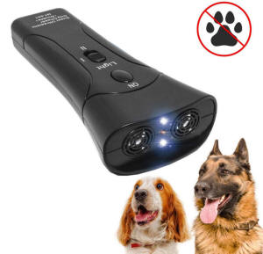**Instruction**

**Work Principle:**

1. This product adopts double channel enhanced, double dog training, excitation drive dogs, lighting function in one of the super ultrasonic drive dog unit, the appearance design is exquisite, easy to carry, especially suitable for outdoor work, outdoor travel and security night patrol, and all kinds of dog training use.

2. It send out powerful ultrasonic and infrared laser role can effectively drive 20 meters outside of the dog, the Wolf.

**Operation Method:**

**1. Lighting:** Slide the function switch to the "Light" site. Press the "ON" button on the top. The machine can be used as a lighto.

**2. Training Dogs:** Slide the function switch to the " I " site. Press the "ON" button on the top, the machine can be used as a training dog.

**3. Chasing Dogs:** Slide the function switch to the " II " site. Press the "ON" button on the top. Send out ultrasonic and infrared, drive dogs, wolves a way.

**Note:**

The following conditions had no significant effect of chasing the dog:

(1) They are breeding dogs, dog knows that his owner will not hurt him.

(2) A dog with the owner or a well-trained dog.

(3) When the battery voltage is too low, the ultrasonic energy issued by products will be reduced.