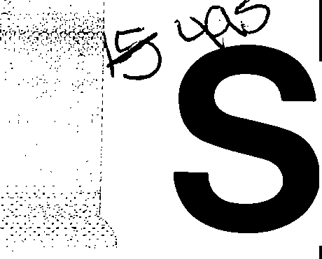**erv1ce..**-----

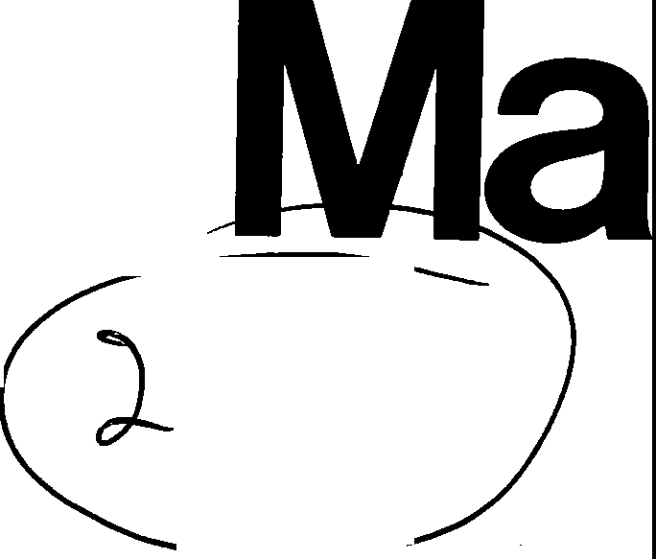

■

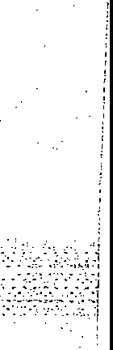Stereo Integrated Amplifier

ORDER NO. AD9501024A1

Amplifier

**ni.Jal**

□**o**\***.,..D..-D-LB_Y_B_UR_R_D_UN_D. ,I**

PRO• LOGIC

l7-£

**Area**

##### SU-G75

**Colour**

I (K) ... Black Type

|  |  |  |
| --- | --- | --- |
| Suffix for Model No. | Area | Colour |
| (PP1) | U.S.A. and Canada. | (K) |

* 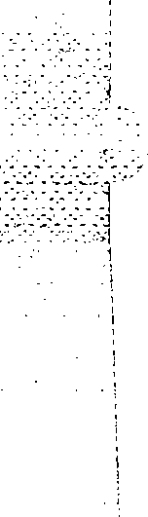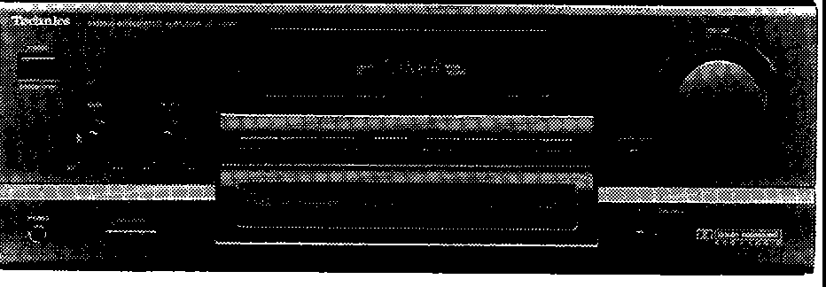**System No.: SC-S2600,**

**SC-S2650, SC-S160, SC-S165**

* Manufactured under license from Dolby Laboratories

Licensing Corporation. Additionally licensed under one or

more of the following patents: U.S. numbers 3,632,886, 3,746,792 and 3,959,590; Canada numbers 1,004,603 and

1,037,877.

"Dolby" and the double-D symbol are trademarks of Dolby Laboratories Licensing Corporation.

**Please file and use this manual together with the service manual for Model No. SU-G95 (PP), Order No. AD9401013C1, and the supplement manual for Model No. SU-G75 (PP), Order No. AD9402038S1 and AD9406179S1.**

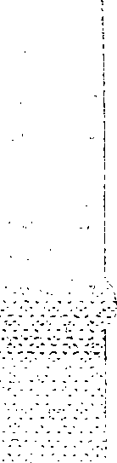**Notes:** •This simplified service manual is provided to indicate the main differences between the original model No.

SU-G95 (PP) and the subsequent model No. SU-G75 (PP1).

* Refer to the printed circuit board **(l!J** MAIN P.C.8.) of this service manual.
* **LINE-UP OF COMPONENTS**

|  |  |  |  |
| --- | --- | --- | --- |
| System Name | Unit | | |
| *SC-S2600 (for U.S.A.)  SC-S2650 (for U.S.A.) | SU-G75 (PP1) | : | Amplifier |
| ST-K55 (PP) | : | Tuner |
| RS-TR170 (PP) | : | Cassette deck |
| SL-PD665 (PP1) | : | CD changer |
| SB-A26 (P) | : | F. speakers (Made In MEP) |
| SB-C926 (P) | : | C. speakers (Made In MEP) |
| SB-S926 (P) | : | S. speakers (Made In MEP) |
| SH-KS26 (P) | : | Ruck (Made In MEP) |
| **SH-WA26(P)** | : | **Accessories box** |

|  |  |  |  |
| --- | --- | --- | --- |
| System Name | Unit | | |
| *SC-S160  (for Canada)  SC-S165  (for Canada) | SU-G75 (PP1) | : | Amplifier |
| ST-K55 (PP) | : | Tuner |
| RS-TR170 (PP) | : | Cassette deck |
| SL-PD665 (PP1) | : | CD changer |
| SB-A16(PC) | : | Speakers (Made in MEP) |
| SH-KS16 (PC) | : | Ruck (Made In MEP) |
| **SH-WA816 (PC)** | : | **Accessories box** |

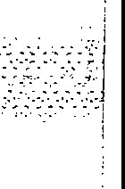**Note:**\* The SB-model speakers and the SH-model rack used with this system have a wood-grain-effect finish. ;

c,_

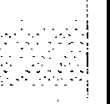

**TechnicS**

© 1995 Matsushita Electric Industrial Co., Ltd. All rights reserved. Unauthorized copying and distribution is a violation of law.

.6 **WARNING**

This service information is designed for .experienced repair technicians only and is not designed for use by the general public. It does not contain warnings or cautions to advise non-technical individuals of potential dangers in attempting to service a product. Products powered by electricity should be serviced or repaired only by experienced professional technicians. Any attempt to service or repair the product or products dealt with in this service information by anyone else could result in serious injury or death.



* 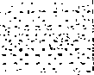SPECIFICATIONS

CHANGES

SU-G95 (PP) SU-G75 **(PP1)**

* **MAIN** AMPLIFIER SECTION

**Rated minimum sine wave RMS power**

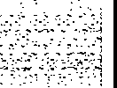**output 20 Hz-20 kHz both channels driven 0.9**% **total harmonic distortion**

130 W per channel (8 Q)

**1 kHz continuous power output both channels driven**

**0.9% total harmonic distortion** 135 W per channel (8 Q)

**Total harmonic distortion**

**rated power at 20 Hz-20 kHz** 0.9% (8 Q)

**half power at 1 kHz** 0.05 % (8 Q)

**Power output at the Dolby Pro Logic operation**

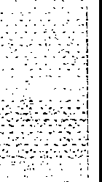**0.9% at 1 kHz Front** 2 x 70 W (8 Q)

**Center** 70 W (8 Q)

**Rear** 70 W (4 Q)

* **GENERAL**
* **MAIN AMPLIFIER SECTION**

**Rated minimum sine wave RMS power**

**output 40 Hz-20 kHz both channels driven 0.9** % **total harmonic distortion**

120 W per channel (8 Q)

**1 kHz continuous power output both channels driven**

**0.9% total harmonic distortion** 125 W per channel (8 Q)

**Total harmonic distortion**

**rated power at 40 Hz-20 kHz** 0.9% (8 Q)

**half power at 1 kHz** 0.05 % (8 Q)

**Power output at the Dolby Pro Logic operation**

**0.9% at 1 kHz Front** 2 x 50 W (8 Q)

**Center** 50 W (8 Q)

**Rear** 50 W (4 Q)

* **GENERAL**

**Power consumption Power supply Dimensions {W** x **H** x **D)**

**Weight**

270 W, 360 VA

AC 120 V, 60 Hz

430 x 158 x 352 mm (16-15/16" X6-7/32" X 13-27/32")

9.4 kg (20.7 lb.)

**Power consumption Power supply Dimensions {W** x H x **D)**

**Weight**

210 W, 280 VA

AC 120 V, 60 Hz

430 x 158 x 352 mm (16-15/16" X 6-7/32" X 13-27/32")

* 1. kg (20.2 lb.}
     + **CHANGE IN REPLACEMENT PARTS LIST** (SU-G95 service Manual of pages ao, 33~37..L.­

**Notes:** • Mentioned in this parts list is only those different from Model No. SU-G95 (PP).

All other parts are the same as for SU-G95 (PP).

* + - * Important safety notice:

Components identified by .&. mark have special characteristics important for safety.

Furthermore, special parts which have purposes of fire-retardant (resistors), high-quality sound (capacitors), low-noise (resistors), etc. are used.

When replacing any of components, be sure to use only manufacturer's specified parts shown in the parts list.

|  |  |  |  |  |
| --- | --- | --- | --- | --- |
| Change of Part No.  Ref. No. SU-G95 (PP) ... **SU-G75 (PP1)** | | | Part Name & Description | Remarks |
| INTEGRATED CIRCUIT'(S) | | | | |
| IC602 | SVl3204B | **SVl3102D** | POWER AMP (SURROUND/CENTER) |  |
| TRANSISTOR(S) | | | | |
| 0602 | 2SA1309AIRTA | -- | TRANSISTOR | Deletion |
| 0651 | 2SA1309AIRTA | -- | TRANSISTOR | Deletion |
| 0652 | 2SC3311AIRTA | -- | TRANSISTOR | Deletion |
| 0731 | 2SB1357DEFTA | -- | TRANSISTOR | Deletion |
| 0732, 733 | 2SC3311AIRTA | -- | TRANSISTOR | Deletion |
| 0734 | 2SD2037DEFTA | -- | TRANSISTOR | Deletion |
| 0735 | 2SA992EFPT A | -- | TRANSISTOR | Deletion |
| 0737 | 2SA992EFPTA | -- | TRANSISTOR | Deletion |
| DIODE(S) | | | | |
| D605 | MA165 | -- | DIODE | Deletion |
| D607, 608 | MA4033TA | -- | DIODE | Deletion |
| D654 | MA165 | -- | DIODE | Deletion |
| D656 | MA4047MTA | -- | DIODE | Deletion |
| D731 | MA4360MTA | -- | DIODE | Deletion |
| D732, 733 | MA165 | -- | DIODE | Deletion |
| D907 | MA165 | -- | DIODE | Deletion |

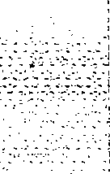

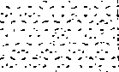

-

-2-

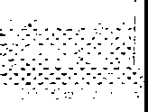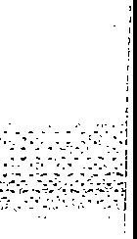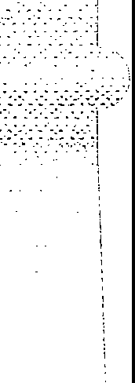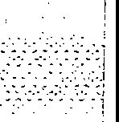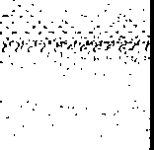

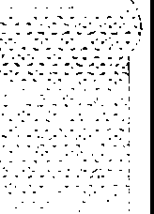

|  |  |  |  |  |
| --- | --- | --- | --- | --- |
| Ref. No. Chang13 of Part No. I Part Name & Description | | | | Remarks |
| SU-G95 (PP) **SU-G75 (PP1)** | | |  |
| TRANSFORMER(S) | | | | |
| T701 | RTP1P5C016-V | **RTP1P5C015** | POWER TRANSFORMER **(MAIN)** | .&. |
| RELAY(S) | | | | |
| RL602, 603 | RSY0013M-0 | -- | RELAY | .&. Deletion |
| JACK(S) AND TERMINAL(S) | | | | |
| JK602 | RJR0054 | -- | FRONT SPEAKERS 8 TERMINAL | Deletion |
| RESISTORS | | | | |
| R626, 627 | -- | **ERD2SFVJ180T** | 1/4W 180 | Addition |
| R630 | ERDS2TJ472 | -- | -- | Deletion |
| R632 | ERDS2TJ103 | -- | -- | Deletion |
| R634 | ERDS2TJ222 | -- | -- | Deletion |
| R636 | ERDS1FVJ821T | -- | -- | Deletion |
| R665 | ERDS2TJ563 | -- | -- | Deletion |
| R666 | ERDS2TJ104 | -- | -- | Deletion |
| R667 | ERD25FJ101 | -- | -- | Deletion |
| R671 | ERDS2TJ103 | -- | -- | Deletion |
| R674 | ERDS2TJ473 | -- | -- | Deletion |
| R676 | ERDS2TJ223 | -- | -- | Deletion |
| R677 | ERDS2TJ103 | -- | -- | Deletion |
| R678 | ERDS1FVJ821T | -- | -- | Deletion |
| R731 | ERD25FVJ180T | -- | -- | Deletion |
| R732 | ERDS2TJ153 | -- | -- | Deletion |
| R733 | ERDS2TJ273 | -- | -- | Deletion |
| R734 | ERDS2TJ223 | -- | -- | Deletion |
| R735 | ERDS2TJ333 | -- | -- | Deletion |
| R739 | ERD25FVJ180T | -- | -- | Deletion |
| R740 | ERDS2TJ393 | -- | -- | Deletion |
| R742 | ERDS2TJ393 | -- | -- | Deletion |
| R743 | ERDS2TJ183T | -- | -- | Deletion |
| R793, 794 | ERDS2TJ223 | -- | -- | Deletion |
| R797 | ERDS2TJ682T | **ERDS2TJ153** | 1/4W 15k!l |  |
| CAPACITORS | | | | |
| C659,660 | ECBT1H151KB5 | **ECBT1H821KBS** | 50V 820pF |  |
| C665 | ECA1HM4708 | -- | -- | Deletion |
| C667 | ECEA1JU220 | **ECA1JM330B** | 63V 33µF |  |
| C669 | ECEA2AN2R2SB | -- | -- | Deletion |
| C703, 704 | ECET1K123VWK | **ECES1K752VUX** | 80V 7500µF |  |
| C705, 706 | ECA1JM2228 | **ECA1HM222B** | 50V 2200µF |  |
| C731, 732 | ECKRi HT03ZF5 | -- | -- | Deletion |
| CABINET AND CHASSIS | | | | |
| 6 | RGR01868-A | **RGR0186A-A5** | REAR PANEL |  |
| 21 | RFKGUG95PP-K | **RFKGUG75PP-K** | FRONT PANEL ASS'Y |  |
| 23 | RGU1027-K | **RGU1027C-K** | SELECTOR/PRO. LOGIC BUTTON |  |
| PACKING MATERIAL | | | | |
| P1 | RPG1948 | **RPG1947** | PACKING CASE |  |
| ACCESSORIES | | | | |
| A1 | RFKSHWA22P-K | -- | INSTRUCTION MANUAL ASS'Y | SC-S3500/S3550 for  U.S.A. Deletion |
| RFKSHWA32P-K | -- | INSTRUCTION MANUAL ASS'Y | SC-S4500/S4505/S4550  for U.S.A. Deletion |
| RFKSHWA42PCK | -- | INSTRUCTION MANUAL ASS'Y | SC-S2500/S2550 for  CANADA Deletion |
| RFKSHWA62PCK | -- | INSTRUCTION MANUAL ASS'Y | SC-S3500/S3550 for  CANADA Deletion |
| A1* | -- | **RFKSHWA26P-K** | INSTRUCTION MANUAL ASS'Y | SC-S2600/S2650 for  U.S.A. Addition |
| -- | **RFKSHWA816PC** | INSTRUCTION MANUAL ASS'Y | SC-S160/S165 for  CANADA Addition |

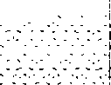-3-

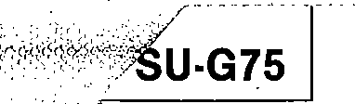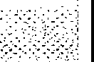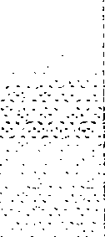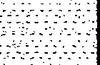-

|  |  |  |  |  |
| --- | --- | --- | --- | --- |
| Ref. No. | Change of Part No. | | Part Name & Description | Remarks |
| SU-G95 (PP) | **SU-G75 (PP1)** |
| A4 | RAK-SA112MH | -- | REMOTE CONTROL TRANSMITTER | SC-S2500/S2550 for  CANADA Deletion |
| RAK-SA723MH | -- | REMOTE CONTROL TRANSMITTER | SC-S3500/S3550/4500/ S4505/S4550 for U.S.A. SC-S3500/S3550 for  CANADA Deletion |
| A4'1< | -- | **RAK-SA112MH** | REMOTE CONTROL TRANSMITTER | SC-S160/S165 for  CANADA Addition |
| -- | **RAK-SA601M H** | REMOTE CONTROL TRANSMITTER | SC-S2600/S2650 for  U.S.A. Addition |
| A4-1 | RKK0057-K | -- | BATTERY COVER  (FOR R/C TRANSMITTER) | SC-S2500/S2550 for  CANADA Deletion |
| RKK0020-K | -- | BATTERY COVER  (FOR R/C TRANSMITTER) | SC-S3500/S3550/4500/ S4505/S4550 for U.S.A. SC-S3500/S3550 for  CANADA Deletion |
| A4·1* | -- | **RKK0057-K** | BATTERY COVER  (FOR R/C TRANSMITTER) | SC-S160/S165 for  CANADA Addition |
| -- | **RKK0020-K** | BATTERY COVER  (FOR R/C TRANSMITTER) | SC-S2600/S2650 for  U.S.A. Addition |
| A6 | XTN3+10AFZ | **XTN3+12AFZ** | SCREW |  |

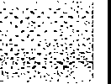

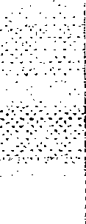**Notes:** • Parts identified by the "*'' mark are contained in the carton (accessories box) of SH-WA26 (P) or SH-WA816 (PC) listed in the table "LINE-UP OF COMPONENTS" on page 1.

* Refer to the packaging on page 4 of the Technical Information for Model No. SH-WA26/SH-WA36/SH-WA42/SH-WA816/ SH-WA826/SH-WA836, Order No. AD9501012T1.
* **WIRING CONNECTION DIAGRAM (SU-G9s service Manual ot page 22.)**

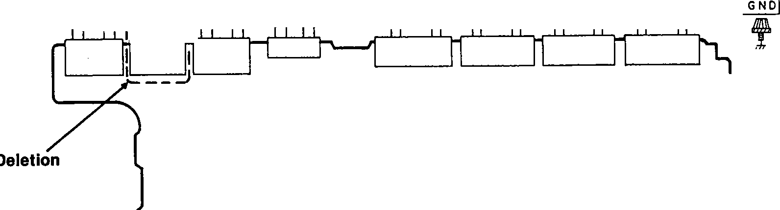

1

ISPEAKERSf-1---,

rlEO/VCR2h

r{FRONT!:J

r{A>-, friB'i; "'1 ,iREARh

0

CENTER

lvcR I I 1PLAY IREc !PLAY IREc [illITUNERI jPHONol

(IN]) (OUT)) (IN)) [OUT))

I

I

CP701A CP7018

**m**

TT

**MAIN** P.C.B.

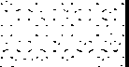

-4-

* 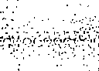**BLOCK DIAGRAM (SU-G95 Service Manual of pages 11,12.)**

**SU-G75**

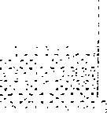

r 7

I I

I

16

·1

**0681**

**(0682 l**

**Muflng**

**drive**

r;;-:-;:-i. Jin HEADPHONES

**RL6O I**

. -0..,..-0------, tJ+--i

FRONT SPEAKERS

r_J

2

**-B**

**Q555**

-,

**{0556)**

**9** I

6

26

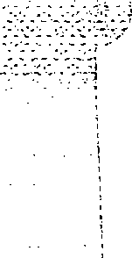12 **AC det.**

+a **13 MUTE C**

**re Over load**

**drive**

21

14 _8

1

I RS Nl33O6 I

I

I

I I

I

I

I

, _.,,I

**0771-775**

,- --

L _JPOWER·n·:(FRONT)1

**- J**

**Motor drive**

**FAN MOTOR**

**SV 13102D**

**mm**

**POWER AMP (REAR/CENTER)**

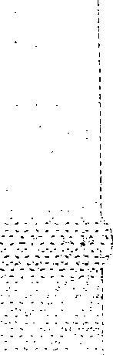**101-1103**

J7-

L-....., ------------;---- .-+....,e,---<[:B+

r_J

+7

I

I I

C

CENTER SPEAKER

Lch7

I

I

**----1**

I

I

.- I

I

j REAR SPEAKERS

_J */*

R ch

7

I

+ I

,.- _,I

**J D7O1-7O4**

I

**-+B.J-------,1,---,**

,-  **-a** , •

**T701**

r_J

FI

( 070 I

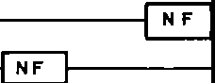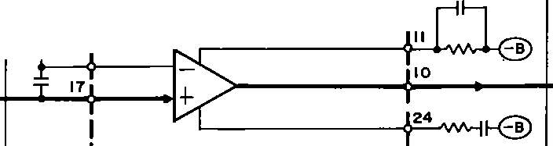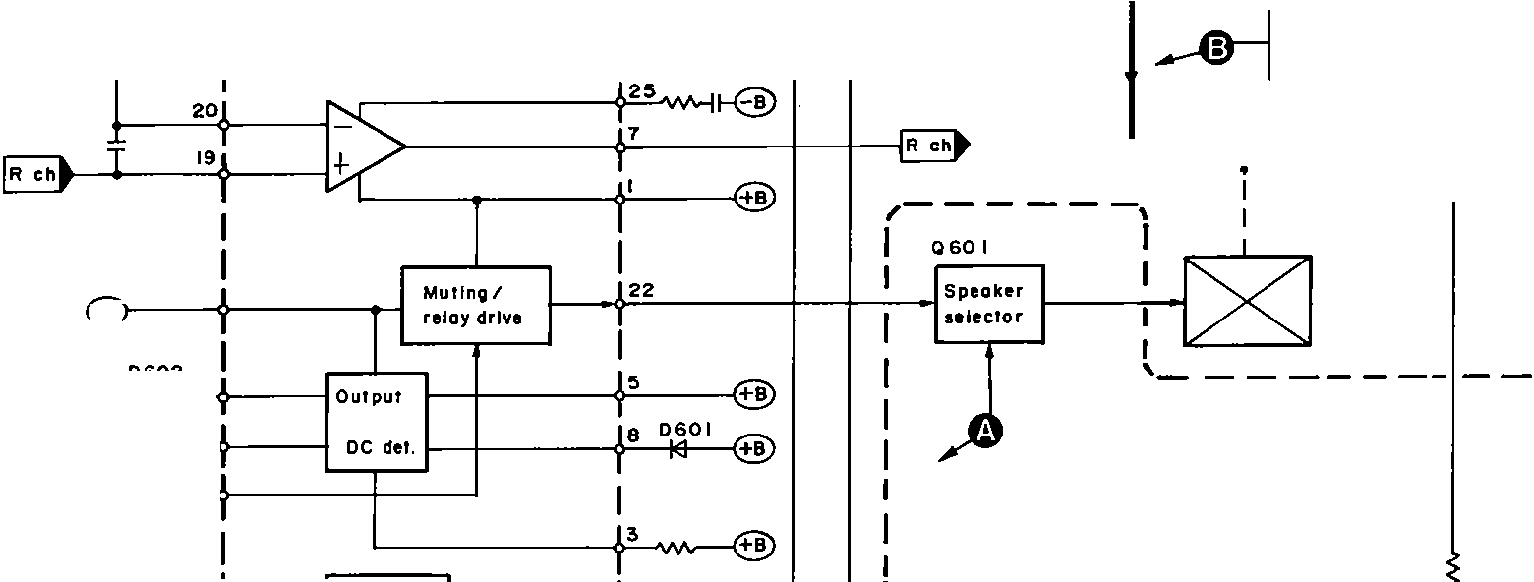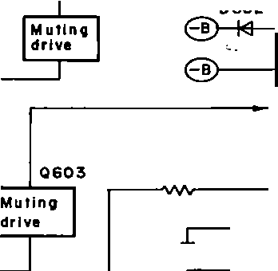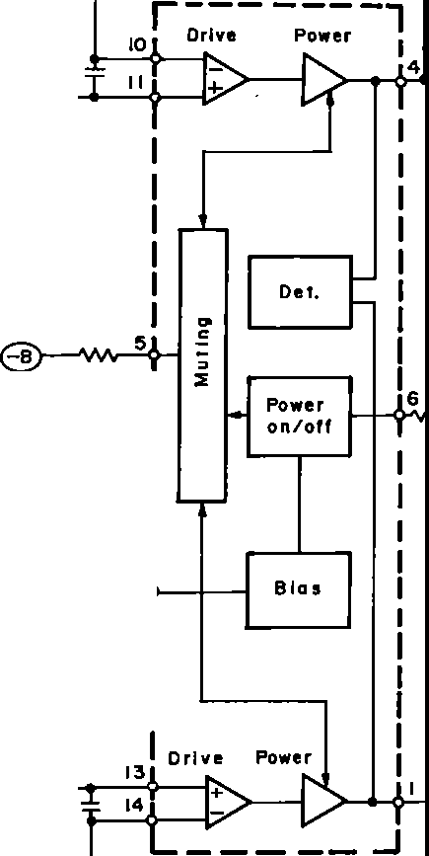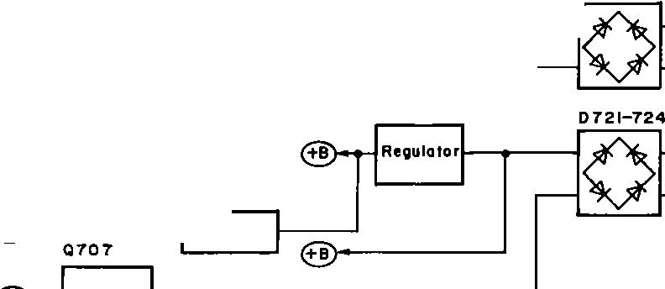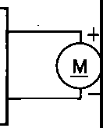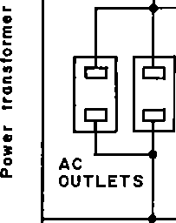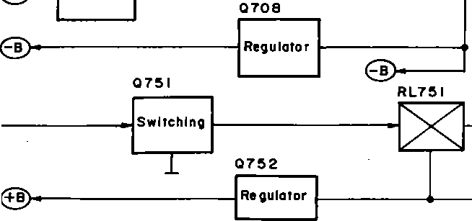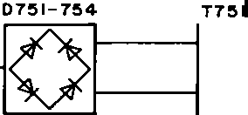

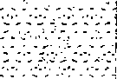I NF AC

I

IN

'-----; QIOO

**-+BSJ ,Rec;iulotor**

**Change** >------------ I

I I I I

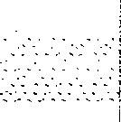**Sub power**

**transformer** I-----

-5-

;,,:*.;.,:+d* SU-G75 I

* 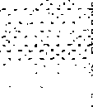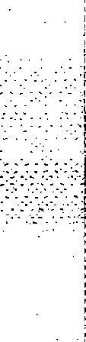SCHEMATIC **DIAGRAM** (SU-G95 Service Manual of pages 14~21.)

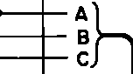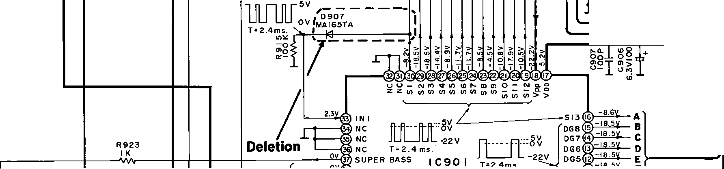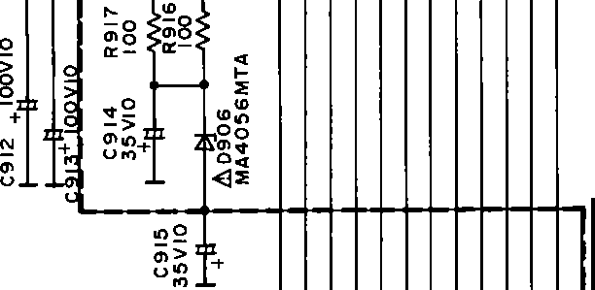

±

**1**

**El OPERATION CIRCUIT**

I

.,._

ug-r

**2**

**3**

**4**

I 2-11x12 13114115 16 17X18l19 2CI21

3

31 4 35t-l

T

JII

**B**

r<> N - om t-- u, 11> m

"

N

rm<> eI"n) rmt) mrt) NmmN Nen mN L'.t:'

c_ l-+-+-+-H-+-+- **A**

L'.t:' L'.t:' a:: 0:: 0:: 0:: L'.t:' 0::

IHGFEDCB A

1

C928 330P

1---<'-f-++-+-H-+-- **B**

7 330P

C

6 330P

I----+-+-+-..._.-+- D

25 330P

1----...._+-H-+- E '"'

rc_s_211,,4_3_a_o...._,+-HI-- F

3 330P G

2 330P H

I 330P I

**C**

0902

15S29 ITA

1

2

3

4

5

**liJ MAIN** CIRCUIT

INPUT SELECTOR/PHONO EQ AMP/DOLBY PRO LOGIC/BUFFER AMP/ATTENUATOR/)

(

REGULATOR/POWER AMP

D

I L ch E---'W\,-- i!; +--F*j*

VCR I :16 1

L

R ch

-----------

I

.,..

R431

IK

C435 (LI) IGVIO

E40 I

E

**Deletion**

**Change**

IC402 M5218AP

BUFFER AMP

I RI)

---- *I*/

11 .!....---++-- ;_---r ""'

- A

---- l-------------------

I '8":!!eL-----+--+----------,1 ,

I I I I I I I I I

6.JV

**B**

ABC

**----To**

F

**>---...+-+-+-=+ Gon**

,. **r page 7.**

CN902

Czl I::-::> :I::-:>- ...J ...J I-

N - I"'

;

Toll OPERATION CIRCUIT (CP903J

1. 0 0 LL LL m =>
   * *s:. s:.* I ::i::

r u u

.JO:

LL

"

**Change (E** _,. **C)**

*'----v 1*

ToB OPERATION CIRCUIT ICP902J

roll OPERATION CIRCUIT!CP90ll

G

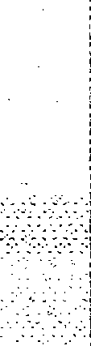

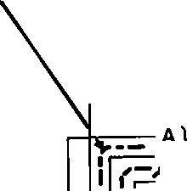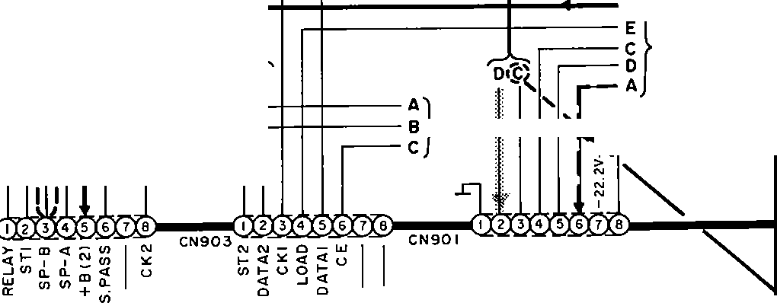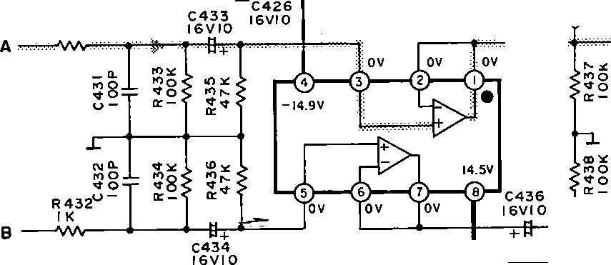

-6-

17 18 19 20 **21** 1 **22** 1 **23** 1 **24 25**

II MUTING CIRCUIT **liJ MAIN CIRCUIT** ( INPUT SELECTOR/PHONO EQ AMP/DOLBY PRO LOGIC/BUFFER AMP/ATTENUATOR/)

SU-G75

· 11

REGULATOR/POWER AMP

08

3.3

IC1501 M5218AL

- SIGNAL OET.

R 1503 680K

Rl504

OV OV 14.SV

Rl505 I

01503

MA700ATA

&.IC601 RSN3306

POWER AMP ( FRONT>

*,2*

01501 -+

MA4068MTA

IOK j :- [

o 15.Joz

MA4068MTA

0"'

01502

2SC331IA I RTA

*I*

Rlll7 220K

"3.l3rw'r

■

*g* +urt

Q:N

,o,t,ri.,r+

,n>

u

'e"r "'

.O..o"'fiOleN \!+.- i!i

SWITCHING

0150 I

2SC3311AIRTA

0:,:

;:i":

o:"

"I;;;

###### ....I

Change

**B** SWITCHING

II')

D6_06

u.,.,

I

er

B

Q

!!?!!?

01503 V ::.:: UN4211TA ;;;o!!?"'

C614P 1 14

68 , •

HI

R*w,* 613

f'6+ !:'9

, !:: *:* x

Ht j

IOOV 10

: 0 0 in . +

l I ~-- --

CO<O

MAl65TA

*-1-*

,..o,

Do'--.

I

J_

"'o.

A

=o

u-

0::: o:::

MUTING ir Q:rt)

CG 13 I K 680P

R622

R623

680K

e!o +

\ow O *i* +

--~~~--

IRGI

.,.<..t.

--

oin

OV

,r- +

av v

Rl511 I OOK

I

0.7V

-56.TV'

cs-0·1R6O1

50V3.3 I K

,,.

I

120 K

rn: ,Sifoo

-

J

*y*

----+ +<·

0::i:

rt7

uin

I

,nN

;;:N

Q 1502

:,:

I ,{:

B ,...C..,

0.

0

,n

0

F A

D E -I II

-···

::: 1rn

4,S

TTTI

CP 1502

CN 1502

e ili 7

J

.. LGOI

I I

I I

*l* ------

I ,- - -, I

... ,

W ·

tX2I3Y4 5

1r2y3y4y5·

M.°4';,0832MTA N ;1! J",,

R609

I I : : I I

C 'ITIµ

,

I

l --=

,----- -- ---' *,ni*

:,: 47

0

CD

I I I

I

I I N N I

io: uR60856K

*I*

L602

1

I I - I I

I er .I.... ,

I

-14.9\1

I +------< er

I *:* C608 IOP

I :ii:: + C607 IOtP

0.7pH

oi

! I

- - *_)* I

,-,------

EGO I SPEAKERS

CS2>

I ,-1--....---1------+--+-'. w- 1---' I

01101

MAl65TA

Rll32 3.3K Rll34

/"B v -3.SV_\

.0,,:,,:,

?_A I

(C2l *r*

. B

0601 '-, *:; x*

2SAl309AIRTA "I -o.•v -o,v:3:il + :;:

l .

RELAYDRIVE

R618 47K

-,

:

: *r--*

R6/6 150K

II

I

;;Jfo 1 6g 1 i I

,n"'

.C.J>..C.J.>

---

"... 'N"

;;; I c *-+----ft 'VVv- .,.,,,.* • I

er er

01102 _ 011030SAIRTA

"0:N'.

L_ !. 1 8 i'o(fJ) *}:, i.J: 69* I

<S3>

01101,11

2 SA 13 T

MUTING CONR.1139 4.7 K

.J .....

--'-®------ --'

I :I II , :: .-.

DI 2SC3311

To Qon_ page 6.

MUTING

r-----------------------

1 I

_jf

R62 I 18K

&.IC602 SVl3202D

!CENTER/ "N0

,t,.R620 D609 l/4W22 M l65TA

m:.:

NN N

'--

IC,31

I.,-

JK604

l TER--

'e C A

f:. R 03

96

l/2W 10

B CD IE

ntI

I

D701-704 P300D 002T

F A

C 652 50V3.3

REAR)

R652 IK

....m

.---' ,

"'m

"'3

O:N

<J,

?1.3V :g J: I

&.R626

A-ll­

B A C

I 05

5cot5313 •s J

.t:-;-J>

::i

I 1,,,-snv

l/4W 18

® ,WnOCO

"inY

*.L*

WN '-"rtl +

U

'Ill ]

,150MTA

a-i

-32.SV

I

.ihR 724 > I

erN

<:J::O

,-3'

ID

CD

l/2WIO " I

...0o

f +

o>

<lg

_:,:

.,o

.,

"er' g

0

C702f-(J

"'"--<

uw *w'-"*

er"'

B " K

um uw

R673

f?l;l9K

P

R669

1-T,

D655 MAl65TA

*A*

.0707 258621AOSTA

REGULATOR

-- l'l')Y

-22.6V 1--:

<C uo a:,;- 0

I I I

* 5 6. 7V

I

&.R627

l/4Wl8

.,.g +

gon

0 ...

-(Ji;

CD

<l 0.1

"g

H

0

<l

I

R658 56K

...,,

"::':",n'

+

68

VIOt

22K

L65I 0.7µH 659

r

47

L652 0.7eH

l

t;l2

R660 C\lr--

47 I

I 1

CP701A W701

I : A'Jtj i

!

.:,.S.. 1---t---'

U>0N I

r9-t 65BIOP

o,._

uD CJI!!

r--2 N +

ON -> UQ

6: 0 + "EJ

I I

"':.:

er-

lOQ

"e'rl<N

.....

lI -(j::O

I B4 m-----

<l"

-(J:,,

752

u,3

er"

<J::O

F

I

I

SC3940AOSTA

I

GULATOR

I

"

I

,n

,-:.:

,r- I

,._.",.,.".,

.",'"-'

o;

-,...

..c--© ,

I F II

G

I E 9,l ,

I 727 T CP7018 l/4W5.6

I

,A B C I

'-------------- -------•----- ------•--- --------- --

D E HI

----- -- .,I

-7- -8-

**•RINTED CIRCUIT BOARD**

**SU-G75 SU-G75**

*l* **4 I 5 6 7 8** 9 **10 11 12 13**

P.C.B. (REP1739A-M)

, f:8 ' ';":,'--' . ··- .•• . ..

·· ,,,,,r·· *".:),* **lM** u ,yn 10 fg s *1* & 5 4 3_:2 **,4.,:_**, **-** ... •. ,.

Ct-!, 01'."

" T"t'77-"

1J·2 L

'1"3 I

Jf/

,/; • ltt"tJs:j:_h:

::· , •

'11 • , 1ri;:.m2.::, ••.J,c;,c::-:, .-••• , •

'·r :'t1

,,,, - ""' '' / , -,_,.,,.,.. 't;,l,

/,///,/4Nf§J0'-2

:ill: I/ *z t*

i '

rillI,5;1

•• - cl,! L O;•r•:1,1li;,<:ihrrl,,

l" ;J' :-H'" ."'"' '111,!'I'l, 1:

·-· f 1i

il,tiJl]

,i;'/lr :,

r J1!li!:11

:ff,f :fc ;: -#

r

. ;;;!Jr !'

i l:g **: 1;**"**•**

'! l,'.1: /R680¼,/ C(t Qtf;I

l '\\ii I *,1;'7* , *litf!*j

o/"

', gJ '.t i/, •ii:!' ff! *1/. ((* / 4-3:;,1211J:

, <'"'," f ·!rr' .::.r j II ks -

-- *)),* · I· $:; h 1"'l!'fi II " ,:S!!l'llf

0-'.*r ••* I· • *>if:); fi•· ; :*

• ,. , •., ,,;.; ' *@;,/'.* •"'--.o ·-""-- II-Ci

"' - */. // ;%",J.f,1////1/:, --::-::-* -

':_ - ", *r: r-/'T-"")* j 0;/. { i(t0 t-- **a)**

1sr

*fiii .* tli-1:idt:··1/1lf-it J4t

*....a.-----1. .-:0'*

·- ' I " 1jfft '"it.;§:{, :

11,··r 1'" 11;, ,&',4,_,

IPLAY(IN)l

.,r ' ,lf I{T'° «>+,\-"' - '

==0:11;m CD H-,"'.'rc2

C . '.· •

,,.,I:.::. *y,,;f ::tJ;';"t"* l

- ,\

-:J' \ iJ\.1 **QI**

1,,,j,.,1

I REC (OUT)>

'; *)!!,!£r;* £' \iii· t1 & *!B"* J

.\ ',fi.113e, · Tj!9'fio't<f:'"1,

I

]:t ,, *··r* J .;•/...,_·:.-_<r*·

uT-t • =-,.

1,1 "':i"."

-".v' R13. -I,,,._- ••y;ffe,:-:'-

f,= I,•" :::k,,*·*.,*.£7R'A*f*>*-*f;;:;*,*_*,*:,*

'-l- *-'i,*

*:=*o•*i*"*h -/;:d1i:*

*. :(·*

-*~t-*:*::"'*J*_r1*;

0::

*7, ,*1u:1 0., ·l+.i';+'i§:i:1:i+.. - .l;:¾:< _,.:;:rf) : ,_ k 't·".s.:?F_>' - fj11••._:,' /1· i+

;;:J !t11 11 }if{·Jitisi/:i

·t-: < fil+ '::; Tt'-'=r - l f l®f.'"' - ·- ,;

I TUNER I

IPHONOI

,.,..,.,.,..,.,.,.,.;,.,...,;;.,/..,../I'' /Y.• " ' oJ: oI-+F ,J;c' CD,.),,<>_Llt> '.'.) •;::1· .; ''<!·@\"" ... ", uT: 'f,

l H, ! •, .i ;

, ,,.,,,..,.,;,;,o;l'l;'l P2'•3!>isl!lP,lll ?3!2 *,>::::*0 '."rF ii i, '-·fff,) .... *,;{,*2',? l2Cl !8!Z 1 14,13 ; 1'.lf. I°"' 16 !5, !4 13.12:J:( JO

7

1

'., :1,(/,:\, '¾; }:-:.,,,· :;;; ==.'ii:".:[:=:@:. 1 CF 1• .·,{Z ? *:r i;•1 ,·.• · d.. •:.'

0

* 2f ¥ ;)i , C: 2 J £_ff;cc5"9:j ,,;.i J :jiJ ff f) :[tj:{ lb\,l : 'i!J7t ) i 2, ;

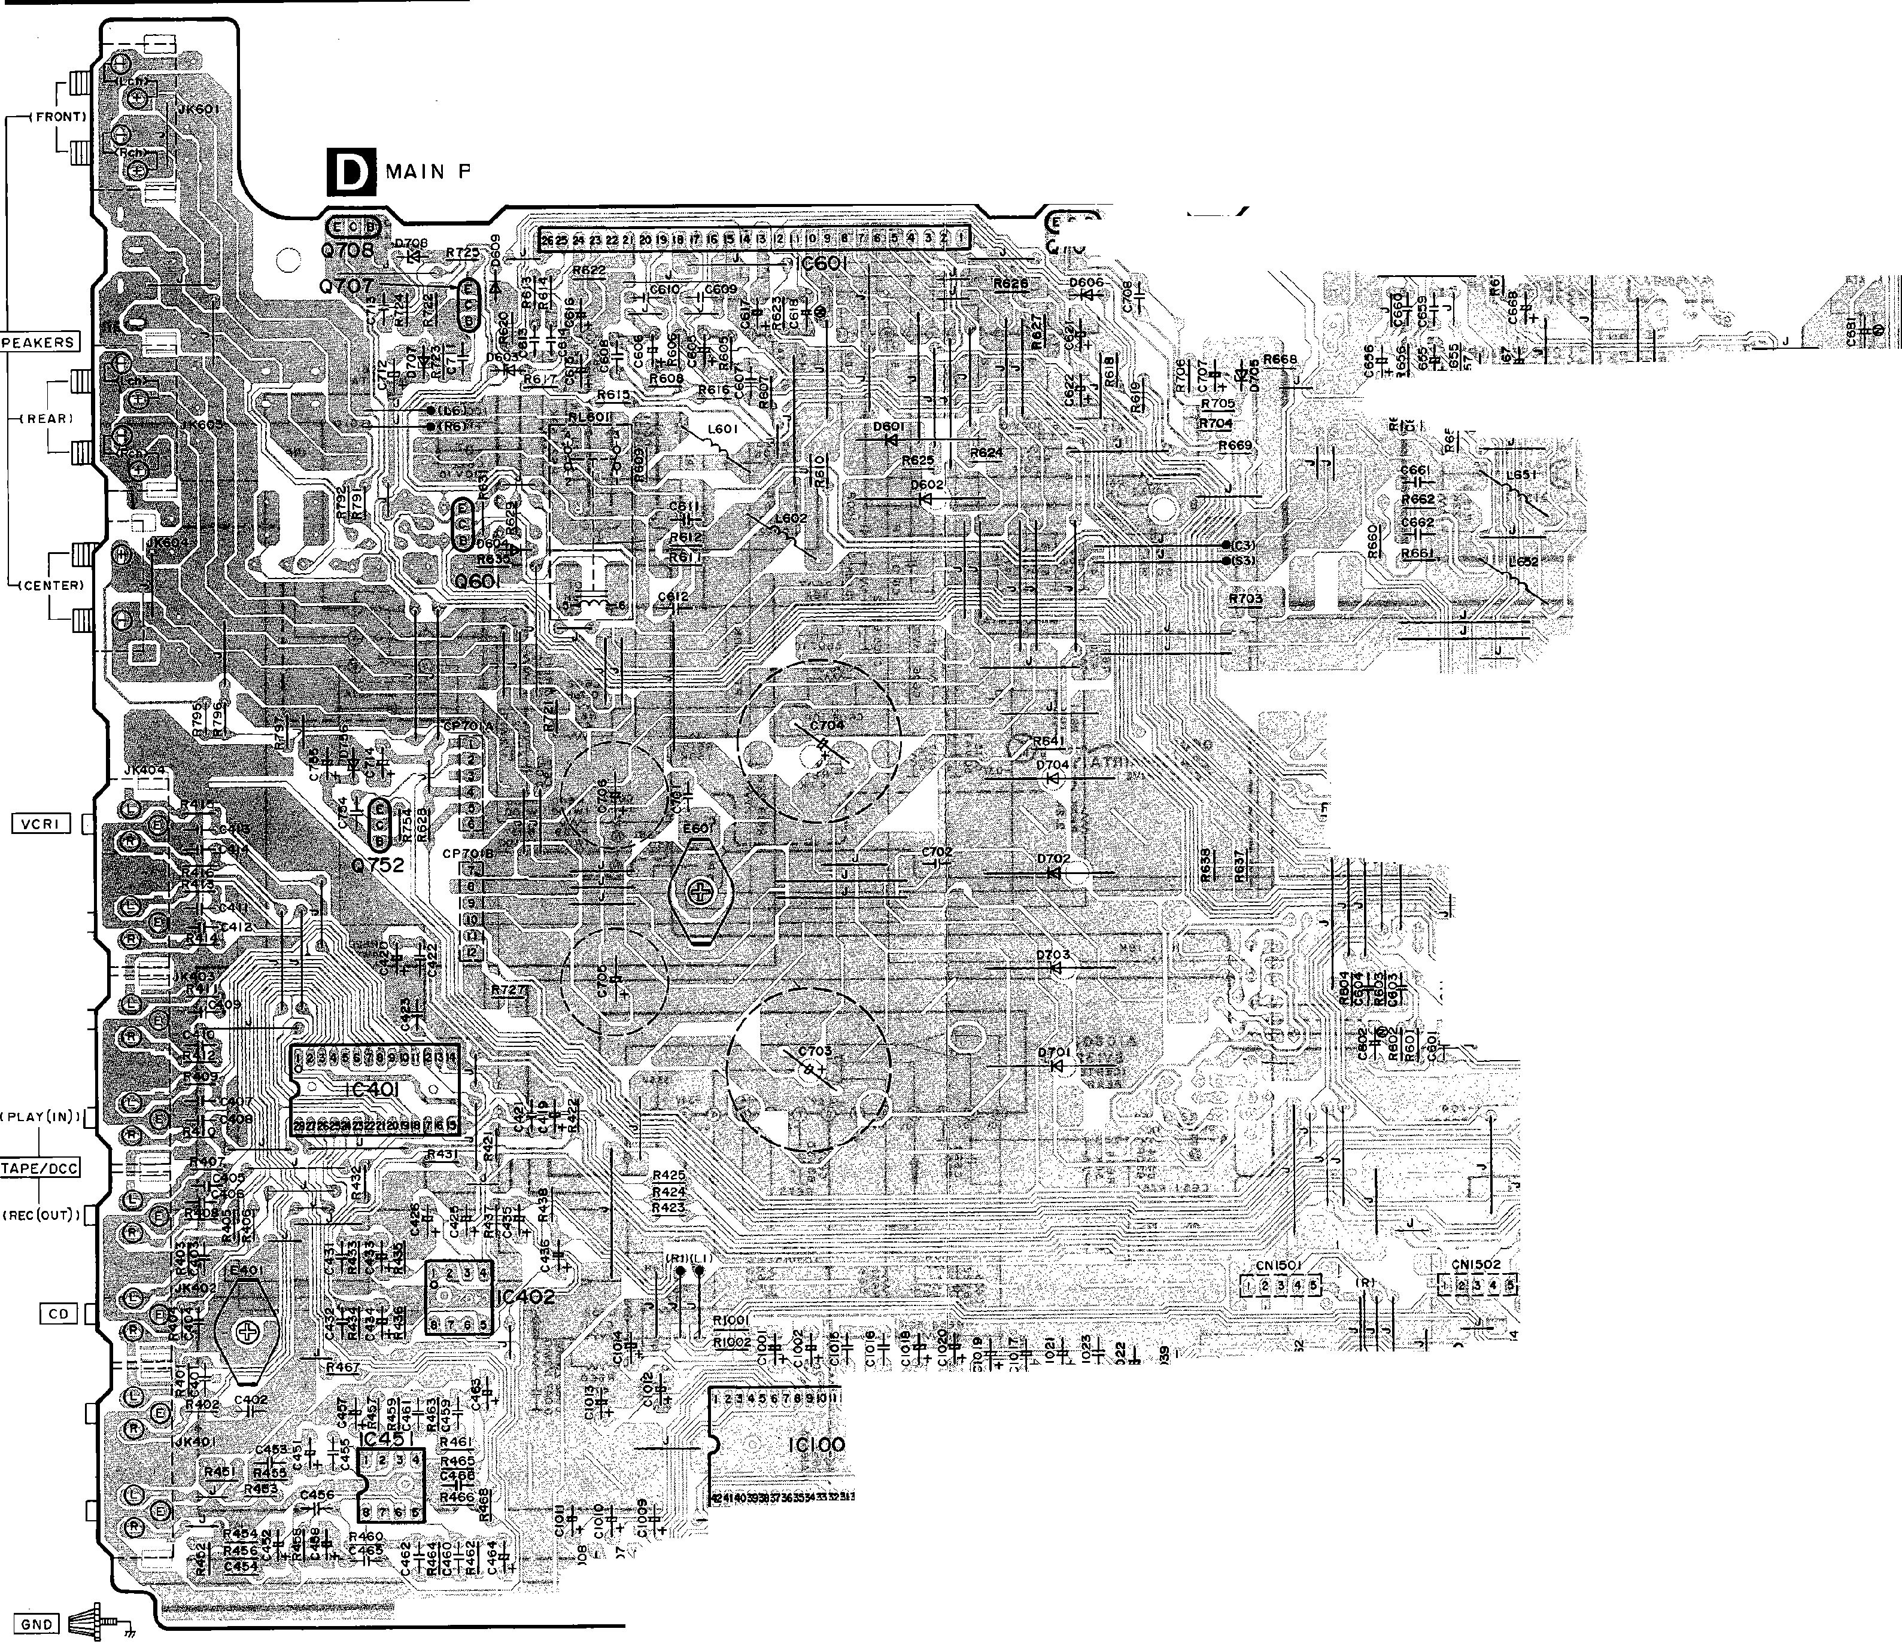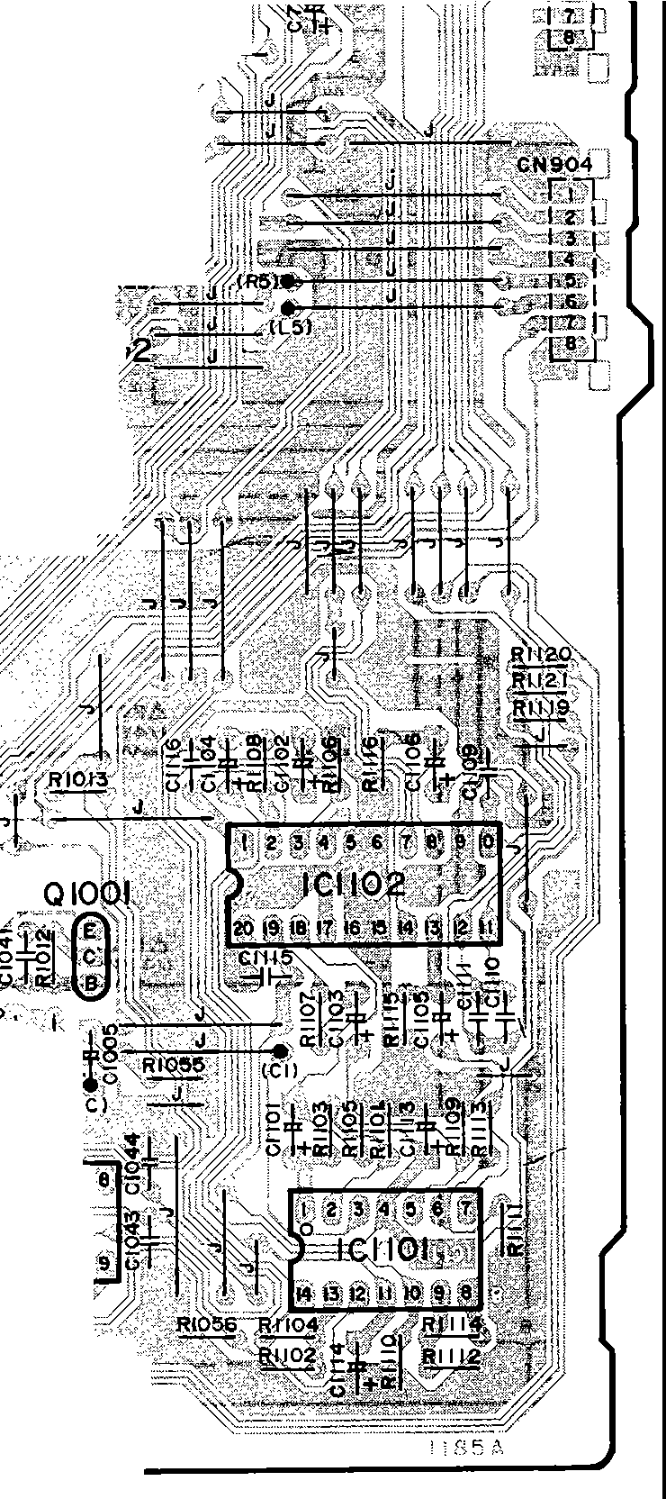

;.,.J -== t•--- A =::::•2,!::. ;:7¥7 11 t .f ::c t1'.;::';;1\,1;f;tf,:; ;/7/ °'"C

-9- -10-

Printed in Japan

H950102800 NH/HH/KK

: ■ . , t _fDER NO. A"'1401013C1 "-._.

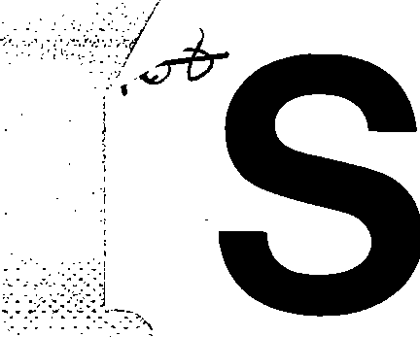

'", *f.D* ',\

**er**

**v1ce Manual**

Stereo Integrated Amplifier Amplifier

SU-G95

* ,

□[JI I

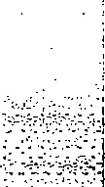DOLBY SURROUND

PRO• LOGIC

**Area**

**Colour**

I (K)...Black Type

|  |  |  |
| --- | --- | --- |
| Suffix for Model No. | Area | Colour |
| (PP) | U.S.A. and Canada. | (K) |

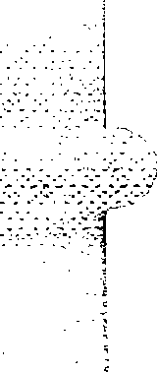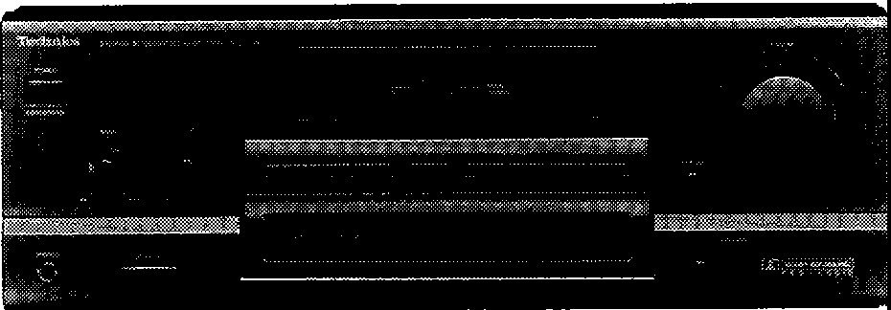l

* **System No.: SC-S3500, SC-S4505**

**R f t**

**SC-S3550, SC-S4550 e er o**

**SC-S4500 page** 3•

SPECIFICATIONS (IHF '78)

* **MAIN** AMPLIFIER SECTION

**Rated minimum sine wave RMS power**

**output 20 Hz- 20 kHz both channels driven 0.9% total harmonic distortion**

130 W per channel (8 Q)

**1 kHz continuous power output both channels driven**

**0.9% total harmonic distortion** 135 W per channel (8 Q)

**Total harmonic distortion**

* Manufactured under license from Dolby Laboratories Licensing Corporation. Additionally licensed under one or more of the following patents: U.S. numbers 3,632,886, 3,746,792 and 3,959,590; Canada numbers 1,004,603 and

1,037,877.

"Dolby" and the double-D symbol are trademarks of Dolby Laboratories Licensing Corporation.

**S/N (IHF, A)**

**PHONO** 70 dB (78 dB, IHF '66)

**TUNER, CD, TAPE/DCC, VCR 1, EQNCR 2**

75 dB (90 dB, IHF '66)

**Frequency response**

**PHONO** RIAA standard curve ±0.8 dB

**TUNER, CD, TAPE/DCC, VCR 1, EQNCR 2**

10 Hz-70 kHz, ±3 dB

**Tone controls**

**rated power at 20 Hz-20 kHz** 0.9% (8 Q)

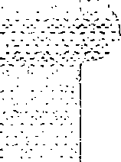half **power at 1** kHz 0.05% (8 Q)

**Power output at the Dolby Pro Logic operation**

**0.9% at** 1 **kHz Front** 2 x 70 W (8 Q)

**Center** 70 W (8 Q)

**Rear** 70 W (4 Q)

**SMPTE intermodulation distortion** 0.5 % (8 Q)

**Dynamic headroom** 2.0 dB (8 Q)

**Low frequency damping factor** 30 (8 Q)

**Load impedance**

**AorB** an

**Center** 8 n

**M** 40

**BASS TREBLE**

**Super bass**

* **GENERAL**

**Power consumption Power supply Dimensions r,/** x **H** x **D)**

**Weight**

**Notes:**

50 Hz, +10 dB to -10 dB

20 kHz, + 10 dB to -10 dB

80 Hz, +6 dB/oct

270 W, 360 VA

AC 120 V, 60 Hz

430x 158x352 mm (16-15/16" X 6·7/32" X 13-27/32")

9.4 kg (20.7 lb.}

* + **PREAMPLIFIER SECTION**

**Input sensitivity/Impedance**

**PHONO** 0.3 mV (2.5 mV, IHF '66)/47 kQ

**TUNER, CD, TAPE/DCC, VCR 1, EQNCR 2**

15 mV (150 mV, IHF '66)/22 kQ

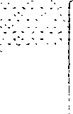**Technics**

1. Disign and specifications are subject to change without notice.

Weight and dimensions are approximate.

1. Total harmonic distortion is measured by the digital spectrum analyzer.

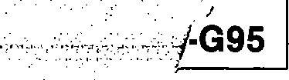

* + - CONTENTS

Page

**Page**

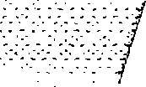SAFETY PRECAUTION 2

PROTECTION CIRCUITRY 2

BEFORE REPAIR AND ADJUSTMENT 2

LINE•UP COMPONENTS 3

FRONT PANEL CONTROLS 3

DISASSEMBLY INSTRUCTIONS 4~8

FAN MOTOR TROUBLE SHOOTING GUIDE 9

BLOCK DIAGRAM 10~12

SCHEMATIC DIAGRAM 13~21

WIRING CONNECTION DIAGRAM 22

PRINTED CIRCUIT BOARDS 23~27

TERMINAL GUIDE OF IC'S, TRANSISTORS AND DIODES 28

TERMINAL FUNCTION OF IC 29

REPLACEMENT PARTS LIST 30

CABINET PARTS LOCATION 31, 32

REPLACEMENT PARTS LIST 33, 34

RESISTORS AND CAPACITORS 35~37

PACKAGING 37

**Note:** Refer to the placement, Equipment connections and Remote control operation of Service manual for Model No. ST-K55 (PP), Order No. AD9401001C1.

* + - **SAFETY PRECAUTION** (This "safety precaution" is applied only in U.S.A.)
      1. Before servicing, unplug the power cord to prevent an electric shock.
      2. When replacing parts, use only manufacturer's recommended components for safety.
      3. Check the condition of the power cord. Replace if wear or damage is evident.
      4. 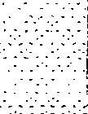After servicing, be sure to restore the lead dress, insulation barriers, insulation papers, shields, etc.
      5. Before returning the serviced equipment to the customer, be sure to make the following insulation resistance test to prevent the customer from being exposed to a shock hazard.

;l/{\j

* **INSULATION RESISTANCE TEST**
  1. Unplug the power cord and short the two prongs of the plug with a jumper wire.

! 2. Turn on the power switch.

! 3. Measure the resistance value with ohmmeter between the jumpered AC plug and each exposed metal cabinet

I

part, such as screwheads, antenna control shafts, handle brackets, etc. Equipment with antenna terminals should read between 3MO and 5.2Mn to all exposed parts. (Fig. A) Equipment without antenna terminals should read approximately infinity to all exposed parts. (Fig. B)

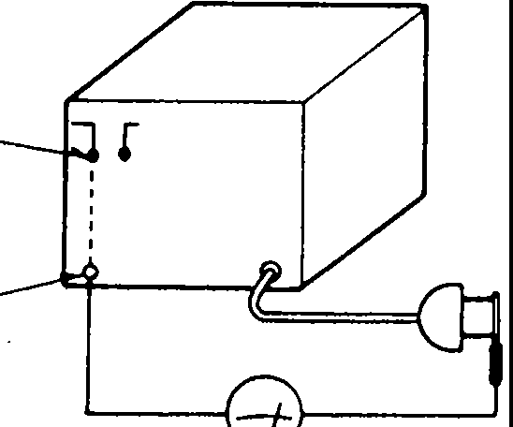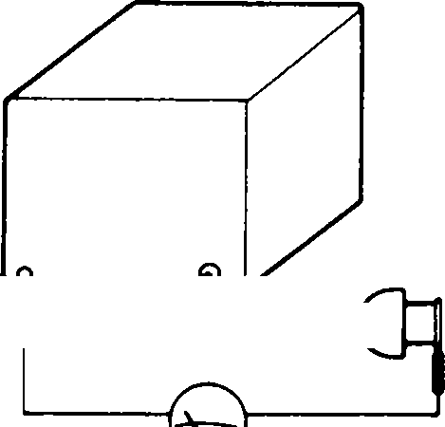**Note:** Some exposed parts may be isolated from the chassis by design. These will read infinity.

Antenna terminal

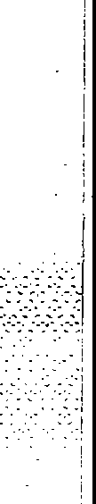Exposed metal part

(Fig. A)

Ohmmeter

Exposed- --- .;;,

metal '-:::::===f

part

Ohmmeter

(Fig. B)

Reslstance=3MO-5.2MO Resistance=Approx. co

4. If the measurement is outside the specified limits, there is a possibilty of a shock hazard. The equipment should be repaired and rechecked before it is returned to the customer.

■

**PROTECTION CIRCUITRY**

The protection circuitry may have operated if either of the following conditions is noticed:

* + No sound is heard when the power is turned on.
  + Sound stops during a performance.

The function of this circuitry is to prevent circuitry damage if, for example, the positive and negative speaker connection wires are" shorted", or if speaker systems with an impedance less than the indicated rated impedance of the amplifier are used.

* + - **BEFORE REPAIR AND ADJUSTMENT**

If this occurs, follow the procedure outlines below:

1. Turn off the power.
2. Determine the cause of the problem and correct it.
3. Turn on the power once again after one minute.

**Note:**

When the protection circuitry functions, the unit will not operate unless the power is first turned off and then on again.

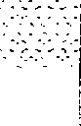Disconnect AC power, Discharge both Power Supply Capacitors C703 and C704 (80V 1200µF), C705 and C706 (63V 2200µF) through a 100, 5W resistor to ground. DO NOT SHORT-CIRCUIT DIRECTLY (with a screwdrive blade, for instance), as this may destroy solid state devices. After repairs are completed, restore power gradually using a variac, to avoid overcurrent.

Current consumption at 120V, 60Hz in NO SIGNAL mode should be 410~810mA.

-2-

l**SU-G95**

* + - 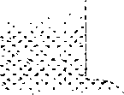**LINE-UP OF COMPONENTS** ■**FRONT PANEL CONTROLS**

***No. Name***

|  |  |
| --- | --- |
| System Name | Unit |
| *SC-S2500  (for Canada)  SC-S2550  (for Canada) | ST-K55 (PP) : Tuner |
| SU-G95(PP) : Amplifier |
| - : Graphic equalizer |
| RS-TR170 (PP) : Cassette deck |
| SL-PD665 (PP) : CD changer |
| SB-A35 (PC) : Speakers (Made In MEP) |
| SH-KS35 (PC) : Ruck (Made In MEP) |
| SH-WA52 (PC) : Accessories box |
| *SC-S3500 (for U.S.A.)  SC-S3550 (for U.S.A.) | ST-K55 (PP) : Tuner |
| SU-G95 (PP) : Amplifier |
| SH-8017 (PP) : Graphic equalizer |
| RS-TR170 (PP) Cassette deck |
| SL-PD665 (PP) : CD changer |
| SB-A55 (P) : F. speakers (Made in MEP) |
| SB-C55 (P) : C. speakers (Made in MEP) |
| SB-S35 (P) : S. speakers (Made In MEP) |
| SH-KS55 (P) : Ruck (Made In MEP) |
| SH-WA22 (P) : Accessories box |
| *SC-S3500  (for Canada)  SC-S3550  (for Canada) | ST-K55 (PP) : Tuner |
| SU-G95 (PP) : Amplifier |
| SH-8017 (PP) : Graphic equalizer |
| RS-TR270 (PP) : Cassette deck |
| SL-PD665 (PP) : CD changer |
| SB-A55(PC) : Speakers (Made In MEP) |
| SH-KS55 (PC) : Ruck (Made In MEP) |
| SH-WA62 (PC) : Accessories box |
| *SC-S4500 (for U.S.A.)  SC-S4505 (for U.S.A.) | ST-K55 **(PP)** : Tuner |
| SU-G95 (PP) : Amplifier |
| SH-GS71 (P1) : Graphic equalizer |
| RS-TR270 (PP) : Cassette deck |
| SL-PD665 (PP) : CD changer |
| **SB-A65** (P) : F. speakers (Made in MEP) |
| SB-C55 (P) : C. speakers (Made In MEP) |
| SB-S35 (P) : S. speakers (Made In MEP) |
| SH-KS65 (P) : Ruck (Made In MEP) |
| SH-WA32 (P) : Accessories box |
| SC-S4550 (for U.S.A.) | ST-K55 (PP) : Tuner |
| SU-G95 (PP) : Amplifier |
| SH-GS91 (P) : D. sound processor |
| RS-TR270 (PP) : Cassette deck |
| SL-PD665..(ePJ : CD changer |
| SB-A65 (P) : F. speakers (Made In MEP) |
| SB-C55 (P) : C. speakers (Made In MEP) |
| SB-S35 (P) : S. speakers (Made In MEP) |
| SH-KS65 (P) : Ruck (Made In MEP) |
| SH-WA32(P) : Accessories box |

CD **Power "STANDBY<!) /ON" switch (POWER, STANDBY<!) /ON)**

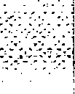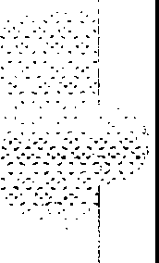Press to switch the unit from on to standby mode or vice ver­ sa. In standby mode, the unit is still consuming a small amount of power.

(2) **Bass control (BASS)**

@ **Treble control (TREBLE)**

@ **Remote control signal receptor (SENSOR)**

@ **Display**

@ **Test signal ON/OFF button (TEST)**

*(J)* **Center level adjust button (CENTER LEVEL)**

@ **Rear level adjust button (REAR LEVEL)**

CID **Super bass ON/OFF button**

@) **Volume control (VOLUME)**

--------------------- -a '

Q]) **Headphone jack (PHONES)**

@ **Speaker ON/OFF button (SPEAKERS)**

@) **DOLBY PRO LOGIC SURROUND**

**ON/OFF button (SURROUND)**

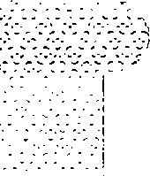

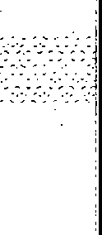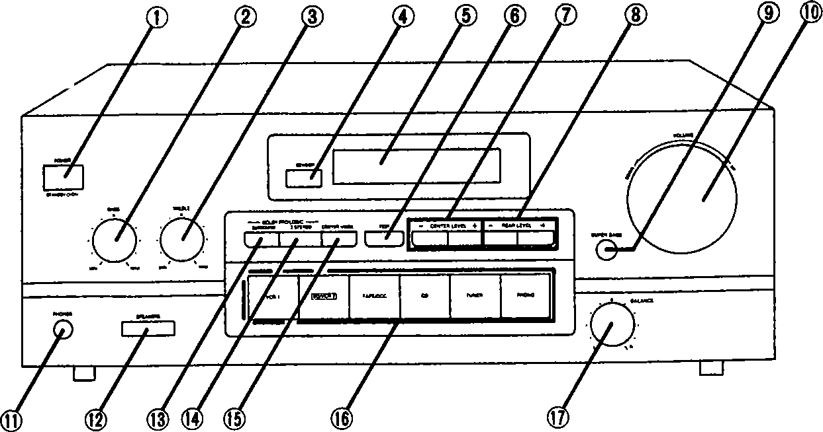**Note:**\* The SB-model speakers and the SH-model rack used with this system have a wood-grain-effect finish.

-3-

**DOLBY PRO LOGIC 3 STEREO**

**ON/OFF button (3 STEREO)**

@ **Centermode select button (CENTER MODE)**

@) **Input select buttons**

@ **Balance control (BALANCE)**

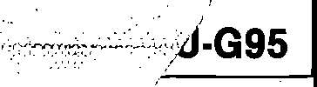

* 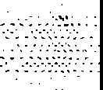**DISASSEMBLY INSTRUCTIONS**

**"ATTENTION SERVICER"**

Some chassis components may have sharp edges. Be careful when disassembling and servicing.

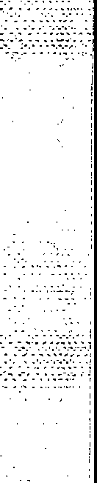

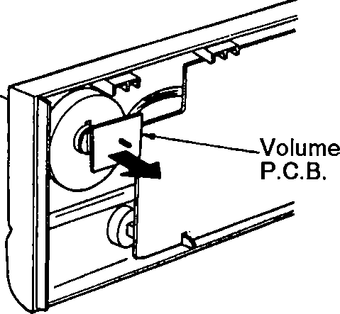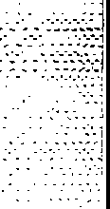

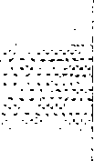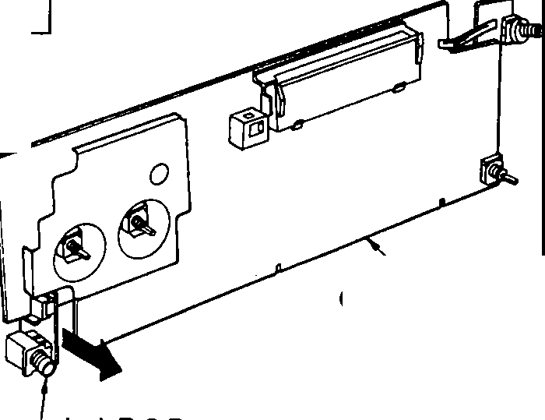

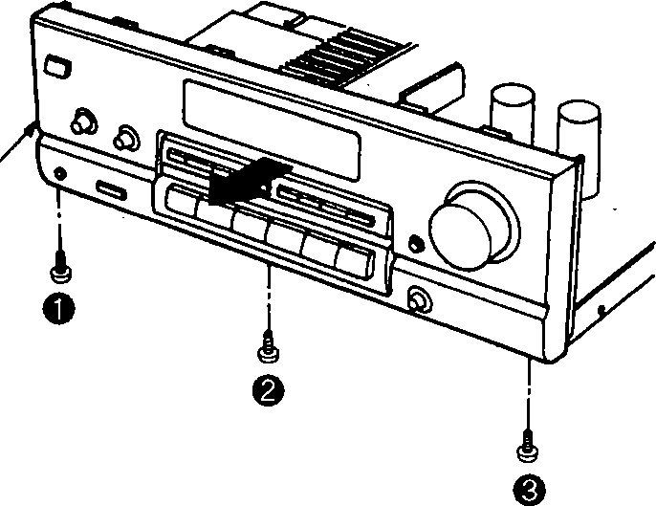

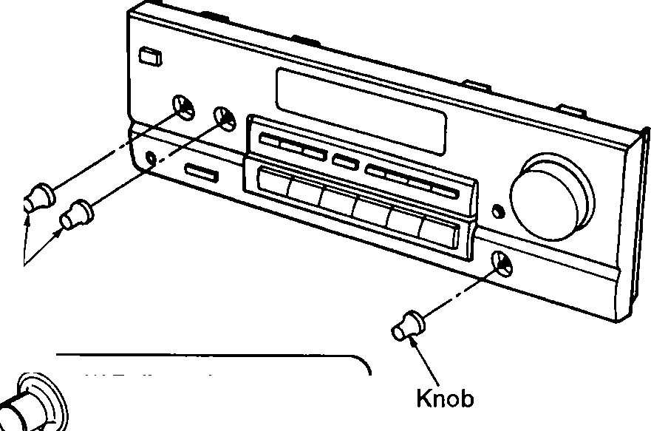

-4-

|  |  |  |  |  |
| --- | --- | --- | --- | --- |
| **Ref.No.**  **1** | | **Removal of the cabinet** | **Ref.No.**  **2** | **Removal of the front panel ass'y** |
| **Procedure**  **1** | |  | **Procedure**  **1 -+2** |  |
| * Remove the 6 screws( **0- (D**). | | | Front panel ass'y   1. Remove the 3 screws( **0-@)** ). 2. Remove the front panel ass'y in the direction of arrow. | |
| **Ref.No.**  **3** | | **Removal of the volume P.C.B.** | **Ref.No.**  **4** | **Removal of the operation P.C.B.** |
| **Procedure**  **1 -+2-+3** | |  | **Procedure**  **1 -+2-+4** |  |
| ,  Vol"me lmob *r-*  Nut   1. Pull out the volume l<nob-;- 2. Remove the nut. 3. Remove the volume P.C.B. in the direction of arrow. | | | Knobs  *Pullout the knobs with using adhesive tape when removing the1uiobs.  Adhesive tape   1. Pull out the 3 knobs.      1. Remove the 13 screws( **0-@)** ). | |
| **Ref.No.**  **5** | | **Removal of the headphones jack P.C.B.** |
| **Procedure**  **1-+2-+4-+5** |  |  |
|  | |
| Operation P.C.B.  Headphones jack P.C.B.   * Pull out the headphones jack P.C.B. in the direction of arrow. | | |

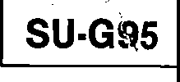

**Ref.No.**

**6**

**Procedure**

**1-s**

**Removal of the rear panel**

**Ref.No.**

**7**

**Procedure**

**1-1**

**Removal of the muting P.C.B.**

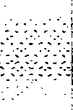

**©4D**

ID

**o**

**8**

.. **0@0@(308**

. **_.en>**

... @

I

'

Muting P.C.B.

Cla

1. 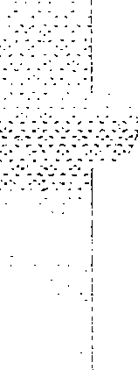Remove the 16 screws( **0-** ID).
2. Remove the rear panel in the direction of arrow.

* Release the 2 claws and then remove the muting P.C.B. in the direction of arrow.

**Ref.No.**

**8**

**Procedure**

**1-2-s-1**

-a **0**

**Removal of the main P.C.B.**

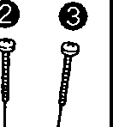1--- **\_rr=====e=$=**

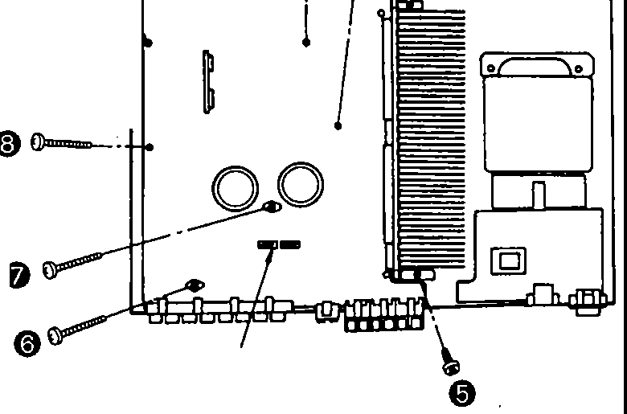

CN701A/B

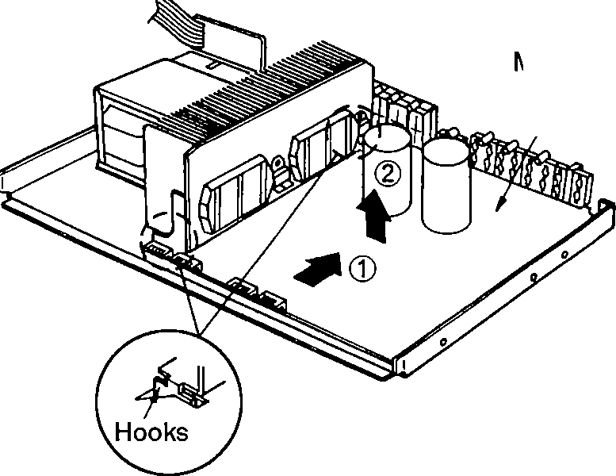

Main P.C.B.

1. 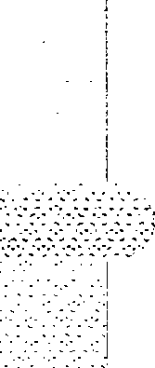Remove the 1 flat cable(CN701NB).
2. Remove the 8 screws( **0-@)** ).
3. Release the 2 hooks by sliding the main P.C.B. in the direction of arrow(D, and then remove the main P.C.B. in the direction of arrow®.

**Ref.No.**

**9**

**Procedure**

**1-s-9**

**Removal of the power supply P.C.B.**

**Ref.No.**

**10**

**Procedure**

**1-s-10**

**Removal of the power transformer P.C.B.**

Power transformer P.C.B.

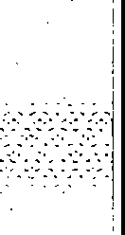 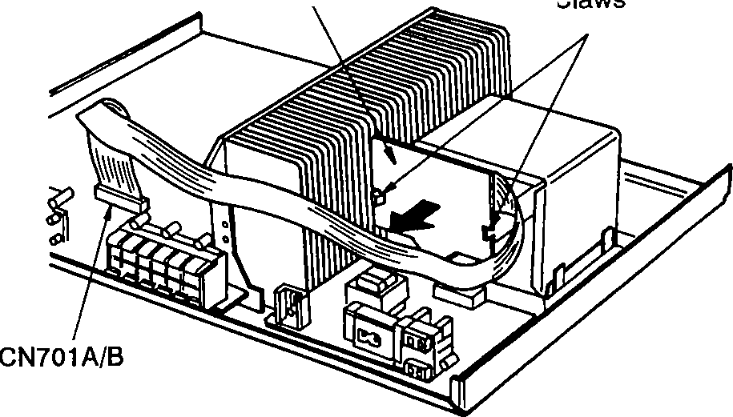

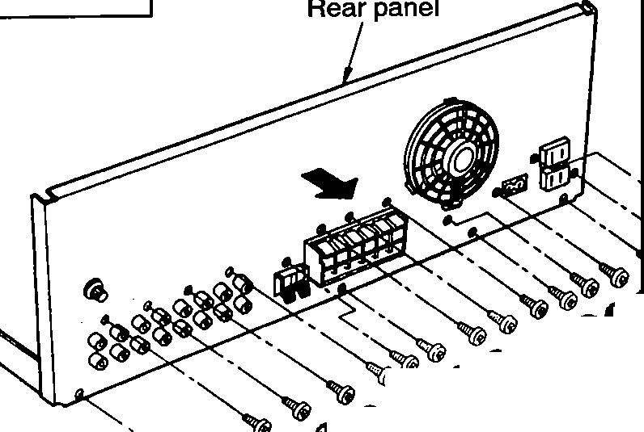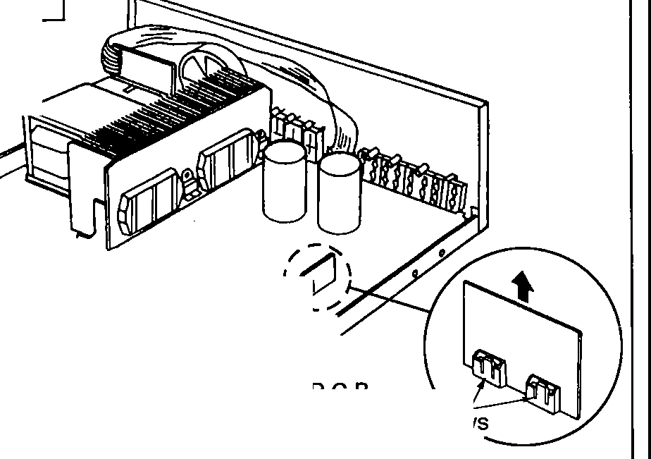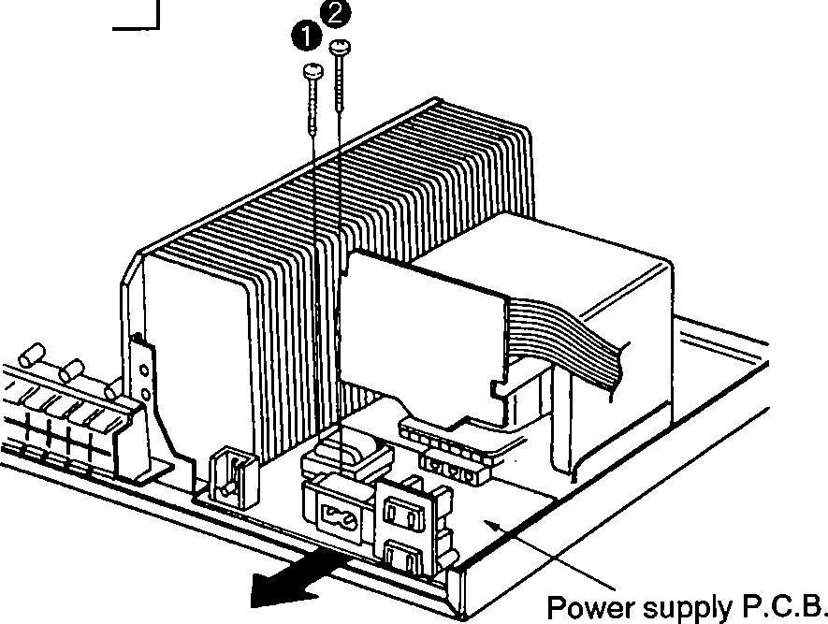

* 1. 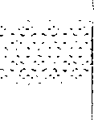Remove the 2 screws( **0. 8** ).
  2. Remove the power supply P.C.B. in the direction of arrow.

-5-

1. Remove the 1 flat cable(CN701NB).
2. Release the 2 claws.
3. Remove the power transformer P.C.B. in the direction of arrow.

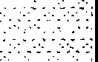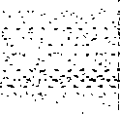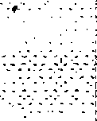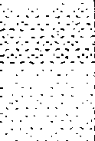, **;;Jll-G95**

|  |  |  |
| --- | --- | --- |
| **Ref.No.**  **11** | **Removal of the power transformer** | **0 e**  r |
| **Procedure**  **1--+6--+9--+10**  --+ **11** |  |
| * Remove the 4 screws( **0- 8).** | |
| **Ref.No.**  **12** | **Removal of the power IC and regulator transistor** | Power IC  Power IC  Transistor holder |
| **Procedure**  **1 --+2--+6--+7**  **--+8--+12** |  |
| 1. Unsolder the power IC or regulator transistor. 2. Remove the 6 **screws(O-(;}).** 3. Remove the **2** transistor holders.    * **When mounting the power IC or regulator transistor.** Apply silicone compound(RFKX0002) to the rear side of power IC or regulator transistor. | |
| **Ref.No.**  **13** | **Removal of the cooling fan motor** | FancapD ( **Fig.2)**  \  tt_ Fan terrnirnal cap  **(Fig.4)**  t;,' ncase Motor Projection  **(Fig.6)**  Fan case  ( **Fig.5)** |
| **Procedure**  **1 --+6--+13** |  |
| Claws  □  □□ 88888888  Fan unit Rear panel ( **Fig.1)**   1. Release the 3 claws. (See **Fig. 1)** 2. Insert a screwdriver at the foot of the fan. Force it out of the moror shaft. (See **Fig. 2)** 3. Remove the fan cap by used e screwdriver. (See **Fig. 3)** 4. Remove the fan terminal cap in the direction of arrow. (See **Fig. 4)** 5. Remove the motor from the fan case. (See **Fig. 5)** 6. When mounting the motor, align the fan casing's projection with the hole of the motor. (See **Fig. 6)** | |

-6-

* + 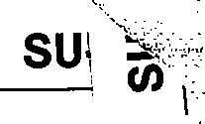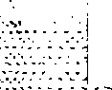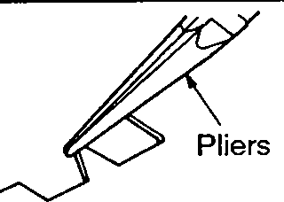**HOW TO REPLACEMENT THE POWER IC AND REGULATOR TRANSISTOR**

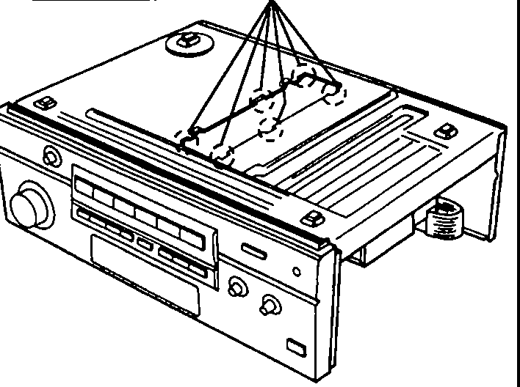

Locate the nipper to the thin portion of the joint.

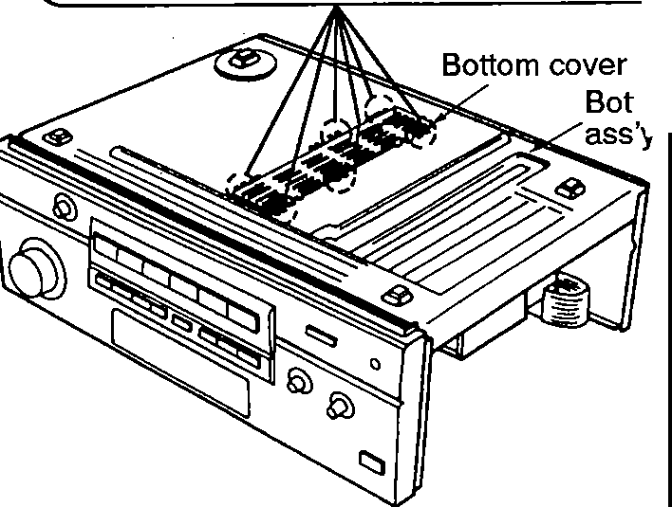

*.<) 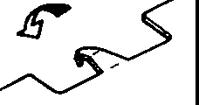*

Cut the joint.

ttom chassis

'

1. 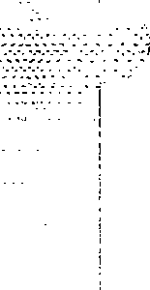Cut the joints(6 portions) between bottom cover and bottom chassis ass'y with nipper.

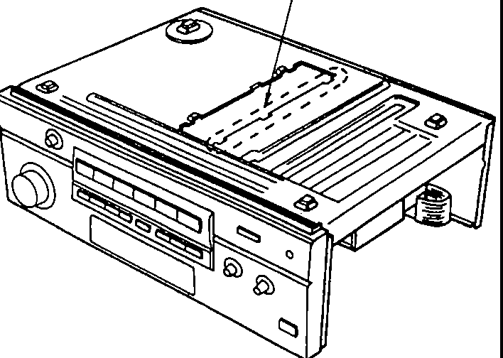Unsolder the terminals of power IC or regulator transistor

* 1. When replacing the power IC or regulator transistor, unsolder the terminals of power IC or regulator transistor on the soldered surface.

Bottom

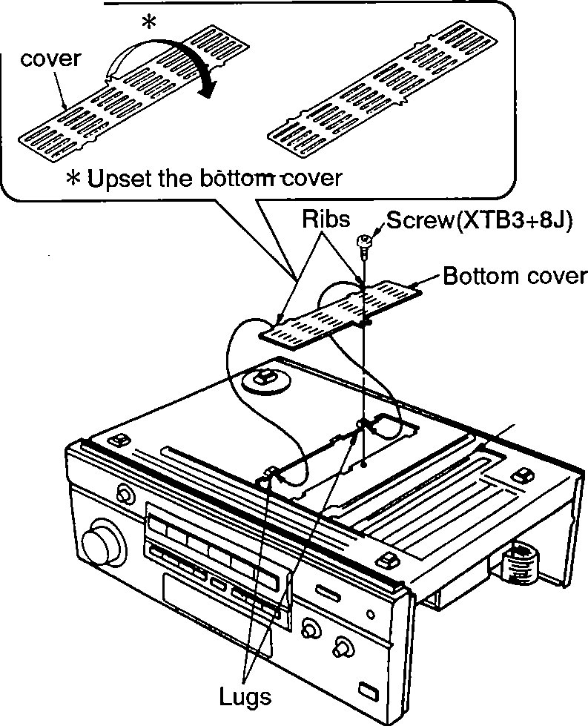

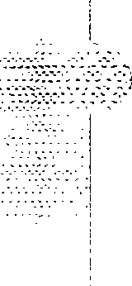

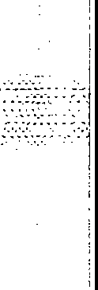Bottom chassis ass'y

1. After replacing the power IC or regulator transistor, upset the bottom cover and align the ribs of the bottom cover to the lugs on the bottom chassis ass'y.
2. After mounting the bottom cover on the bottom chassis ass'y, fix it with a screw(XTB3+8J).
3. After cutting the joints(6 portions), bend the portions of the bottom chassis ass'y in the direction of arrow with pliers.

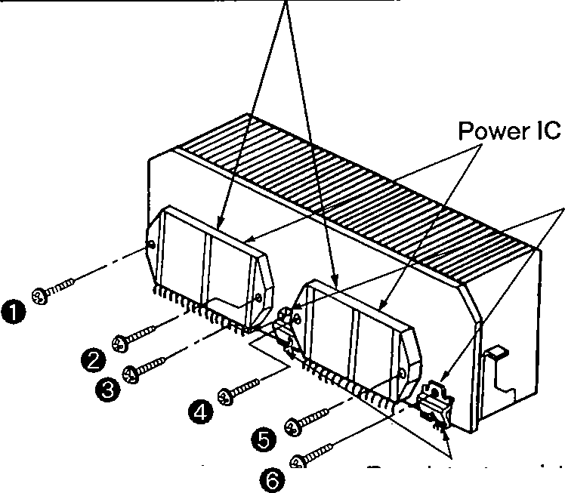

---

CAUTION ---

* After replacing the power IC or regulator transistor, apply a sufficient quantity of compound grease (RFKX0002) between the heat sink and the power IC or regulator transistor.(Radiation of power IC & transistor)
* Tighten enough the screws( **0-** (;)) after replacing the power IC or regulator transistor.

Otherwise, the heat radiation works little.

Muting P.C.B.

* Release the 2 claws of muting P.C.B. and remove it because of using the long screwdriver to tighten the screw firmly.

Transistor holders

Regulator transistors

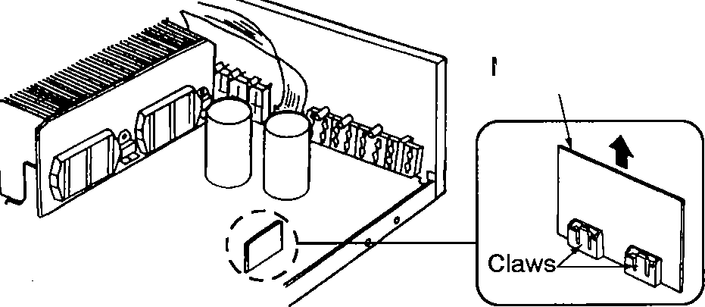4. Then remove the 6 screws( **0-** (;)) fixed to the power IC or transistor holders.

-7-

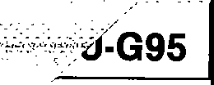

* **HOW TO CHECK THE MAIN P.C.B.**

1. 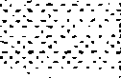Remove the cabinet according to the disassembly instructions, procedure 1 " Removal of the cabinet " on page 4.
2. Remove the front panel ass'y according to the disassembly instructions, procedure 2 " Removal of the front pannel ass'y " on page 4.

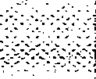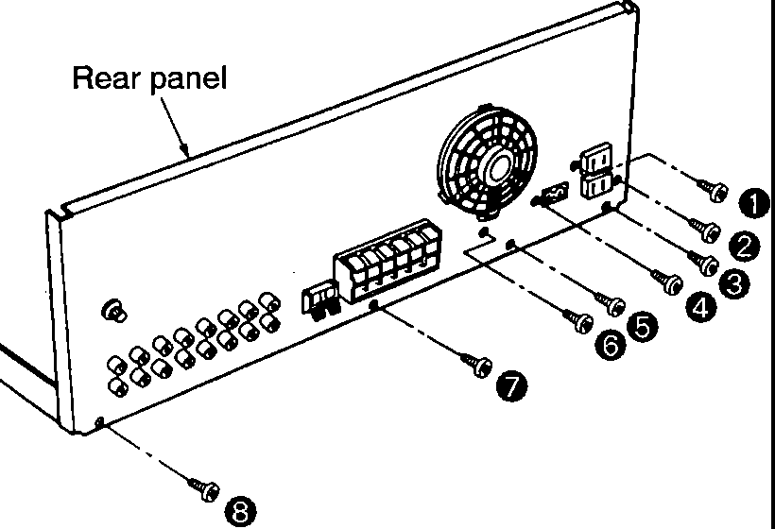

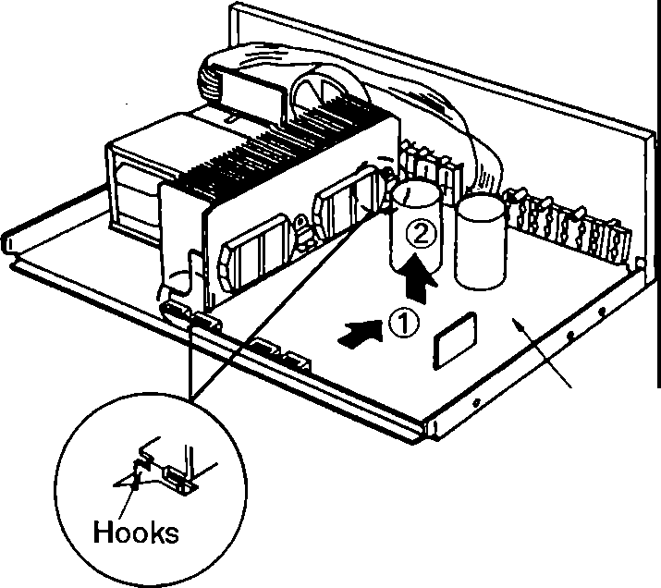

Main P.C.B.

1. Remove the 8 screws( **0-@)**).
2. Release the 2 hooks by sliding the main P.C.B. in the direction of arrow CD, and then remove the main P.C.B. equipped with rear panel in the direction of arrow (2) .

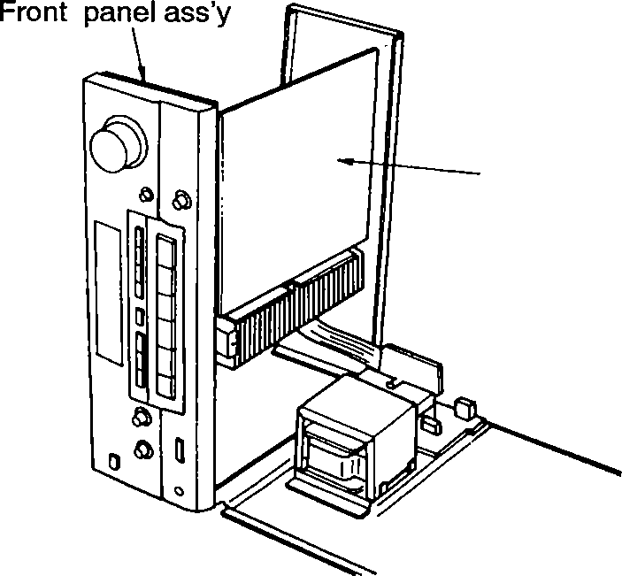**Main P.C.B.** --- ,...:--,

1. Reinstall the front panel ass'y to the main P.C.B.
2. When checking the soldered surface of the main

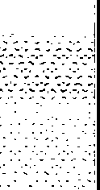P.C.B. and replacing the parts, do as shown in above.

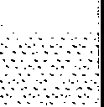

-8-

* **FAN MOTOR TROUBLESHOOTING GUIDE**

The Models SU-G75/G95 employ fan motor error sensing electronics.

If the cooling fan is not operation and "OVER LOAD" is displayed on the FL display, check the fan motor and its

* **BLOCK DIAGRAM**

NJU7312AL

**E1!III**

1

LA2785 s

,,

driving circuit.

INPUT SELECTOR

e

IBr!ml

DOLBY PRO·LOGIC CONTROL

+1,5 +I,6•,,r

18 +i 19

+120

"OVER LOAD" is displayed on the FL display.

AN6558-FSG

**mm**

Pho no PHONO , ---• EQ omp.

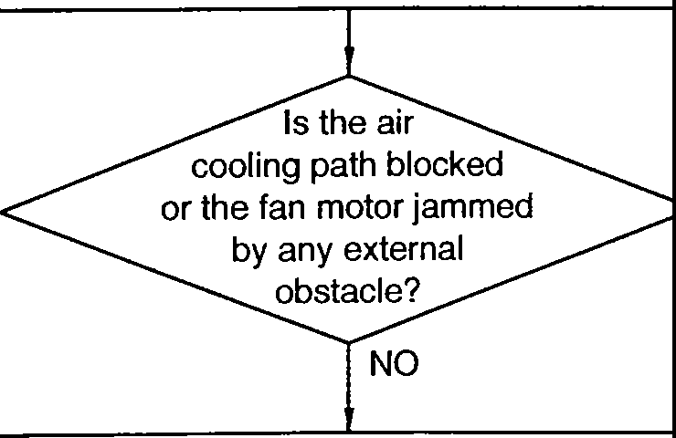

YES

Remove the obstacle.

I

Ir-V,s --VD0D ---,

I

2 I r--- I

1271 XI 7

I : I

I I I

I I

r-----------

**1**

I

r

I

I

**t** I

1,231)I"130)I('429)

f28)

(27) (26)

125}

124)

12ll_

I

I'.

TUNER'

12631}1------<> rX-2- _TI.

II M5218AP I

2 • I

**mm**

1,

34 ,

co@ l

**41** r--

1 I

I

I

**61** ,--

1117)

Buffer amP.

+ 1101

33

42

Remove the fan from the unit.

IRECIOUT' @

TAPE/DCC I

12X14: 41

rlrx,- -+ 40

·--- :--l_ I

LPLAY(IN) I•«• I

**.1** -- i

X6 j I

-"'

VCR I (INJ '

fill I I **L**

10 **35**

; 1:,

NO [PLAYi INfI

Fan motor failure

Short circuit: DC resistance below 5 Q

Open circuit: DC resistance over 1k Q

EC/ VCR 2

LRECIOUTl

e,eea

(

II

""'I

I

I

Reinstall the fan on the unit.

1 i

L ;;

01501,1502

M**m**521**m**BAL **-**

SiQna I

1--.. t detector

NO 1

Check the integrity of 0771, 0772, 0773 and the fan motor driving circuit. (see fig. 1.)

1 1 I

rl7 B

01503,1051

**(Voltage table)**

**YES**

r1.1tftorr"·ov

U.N.ON" -06 Y

...

**0771,772, 774,775**

2SAl309AIRTA

MOTOR 0111 VE

1. --- 1 ---

16 12 ]3 14

h-l-!"=..!L._:•nt,ol

191l13

7

43 I 3 141

(VOVLURME! 901n

45--- 62- 6-3 -

s_J!_

46 144

**E** ff773

|  |  |
| --- | --- |
| **fan. off** | **fan. on** |
| **ov** | **ov** |
| **-0.65V** | **-0.1V** |
| **ov** | **-0.65V** |
| **ov** | **ov** |
| **-0.1V** | **-8.2V** |
| **-0.65V** | **-0.1V** |
| **ov** | **-7.5V** |
| **-14V** |  |
|  | |

Q77 I

----1 o v,.,

r:.:: ....

...

"' ""'

."..' >

"' ."..

"u'

**0771** I**e**

**B**

., ·r.·g

1u cr-

.

Q774

,A1.8,0

**A B**

I O Ul

I

I

N

8« 3'"

z

"'

N N

:,

"h. ""

"

E

j 0772 le

**B**

t<1.1t" orrp

ni,· -•

NT

.0,A114

'"""on· -oP,

UN.ON" -0.SY

L CB A008C 54 77

**llmDI**

1. MIC ROCO **M** PU TE R
2. ,. .

" E l/2WI I N

0773 le

**B**

**-0.1V**

OS C

OUT NR IN

our 7K LP.f. INI '

A T B

Ul CD >- >- N

L---1.a-fs,---@,;;B- ,**\.**r**f;;.-J ,}**

F.u"or-,:" •l<IY_,. 6.077]

r•N'"cu,· -1nv 2SB621AQSTA

REGULATOR

---

**(Table 1)**

**Fig. 1**

L_ - - L!I:I ..v '....- _j

* LVIOIO

**5**

**nm**

6

0901 ,902 ItJ ll I □

ti **NO**

The power IC (IC601 or IC602) is defective.

□

DOLBY PRO. LOGIC

+BH*:: ;:.1*

_L_ CF901

FL DISPLAY -0 0-

DRIVE

-

lj

CFI051

\

I

'

I

}1

The fan motor, power ICs and fan driver are functioning normally.

FL901 KEY MA.TRIX

REMO

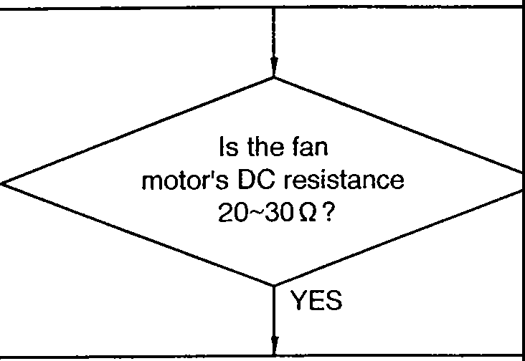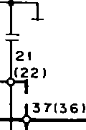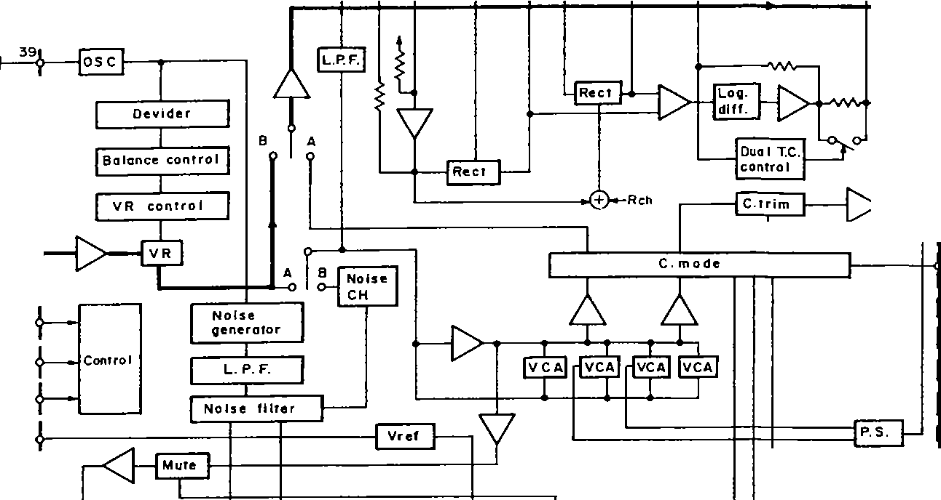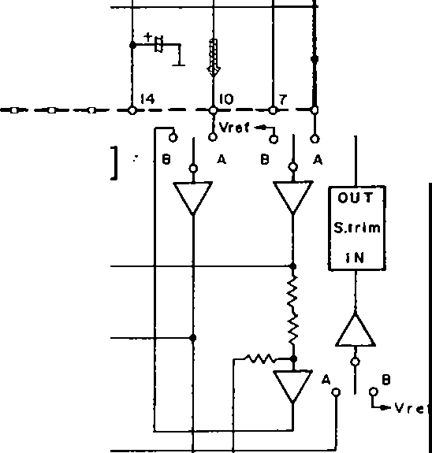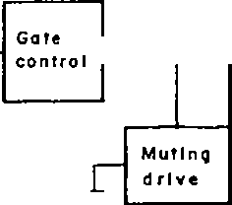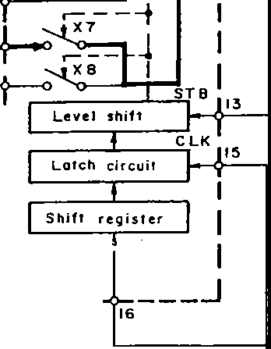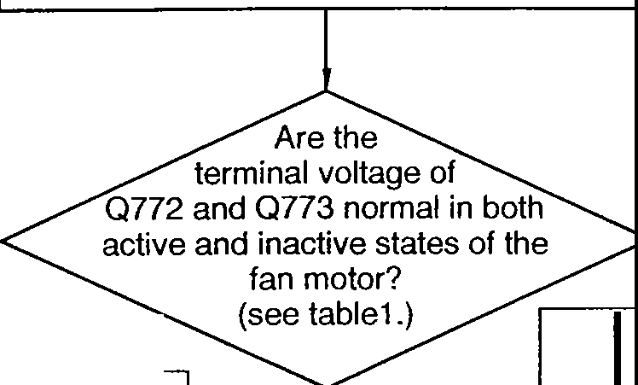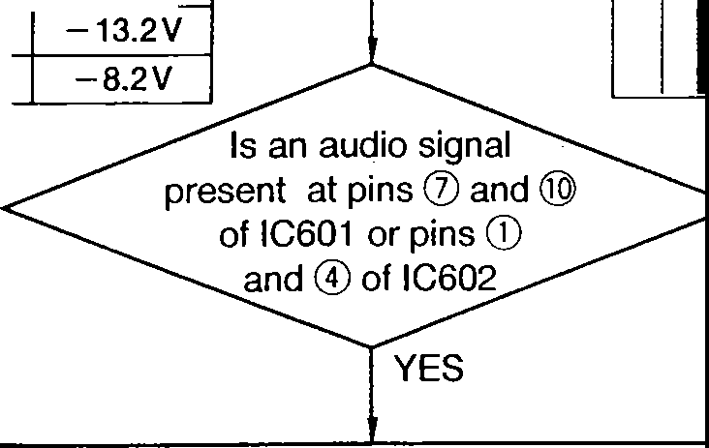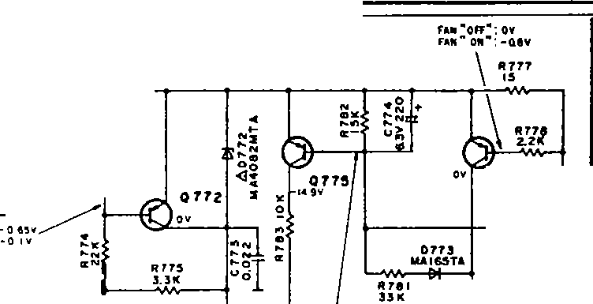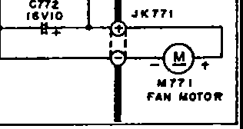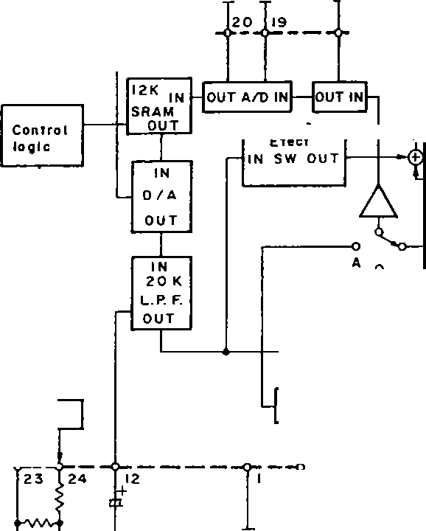

i

;il

-9- -- lO -

j

l

1

j

TC9214P

IIE!!I

M5218AP

TC9212P

mu

ATTENUATOR

•1_,_5 •116 •,, 7

l

+I 18 +j_l_S

+120

SURROUND SELECTOR

,2r---7,,

161

**mm** UPnC4m57OC

r 7

' 81 12711261

( 5!_24 ----

12ll_ I I

917)

VR551

I BALANCE J

1.

1,3

Bass M5218AP

055 l-553

mm

I 111

16

10

24 I-@)

I-@

,,a0s682l HEADPHONES

I Muting I

drive

i

34

i 32 +

+

:] 33

I I I I

i

'

I

r----:nr----_J

I

*1*

ri®

AN6554F

1 ia, ' I: :: :: s

I I

I I

I I

I

114

171

LI ..J

TC9212P

**mm**

ATTENUATOR

0555

I 0556)

26

7

I

7

..E_

5

le oso1

r

I

2 .

A ch

*......*RL6O1*., -r=-----,.--* .•Ci'l--i

r_jl {

'

FRONT SPEAKERS

*/* I •©7J

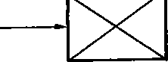r_j

_

- f3

1 *l+*

"

*l.* +u 13tMUTE C

181 _

I

_, 5L

Over load

I

drive

I I

114

_J1 RmSN3m3O6

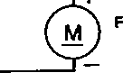0771-715

r-rL~~-1~~  ---

POWERAM(FPRONT)

Motor drive

FANMOTOR

01501,1502

, .

M52l8AL

ILD!D

Stona I

d,etector

12

---------- NF 1------------+-------

----- NF 1 +-

r ,

14 I

12

RL6O3

...a,...-•...,.,

01503,1051

13 """' f o I I I"""' IL-,. o 1-_,_-

f---@

j ' I

I' - I

I - .

I - ,-©~~-~~B-,mm

""""

151 ~ T 1/7 I

*n*

11

IL-,. 0 1

6

IVVOLURMEI 901n

.i

I

4:,_ -- 62_ s.,: _

$

6- -

4 4..J:'o j;' .k'J:....

. I

I

I,_., CD7

C_Jch7

REAR SPEAKERS

r"'

l

I

43 /3

.1,-

....

1- C 0

,.

N

"1:,-' >

I

*:it: <t:* 0 LI.It.I) 0 Q P-7_3

; N II.I -- G:.u-,

a a -,

I

* 1---- r

1-

41

"' ...

C

*·u* I

j I

., 8 em

"' "'

z z

.....

LCBAOO8C5477

**mm**

o I- g;: 'Ill > > Vee

u,m

I

I

I 91

I

I I

110

I

I

Q731-733

**3"·_J**

l I MIC ROCO M PUTE R

I

j I

l

RELAY

I

I

LL-------------------1- • •

d}- j

L-J- c: ; II

T701

FI

1

I

L _

' --1-

FL DISPLAY I -0 0--

FL901 KEY MATRIX

j

CF9O1

,l : I c-e)----IReQula1or1---------------

Z9O1

o 0751

REMOTE SENSOR

+e, --_J

0751-754

..

,cT.:.7.=5.cl

Sub power

AC

IN

I I

I

I

I

Note:

-

Phono (front SP) signal Rear SP drive signal

J......-----..-tronsformer 1 J

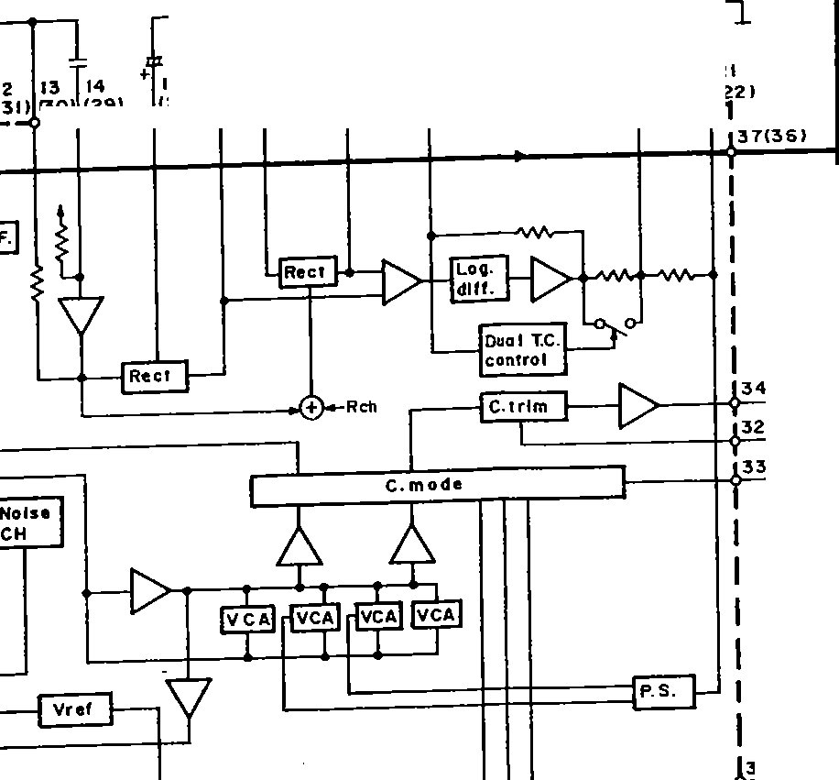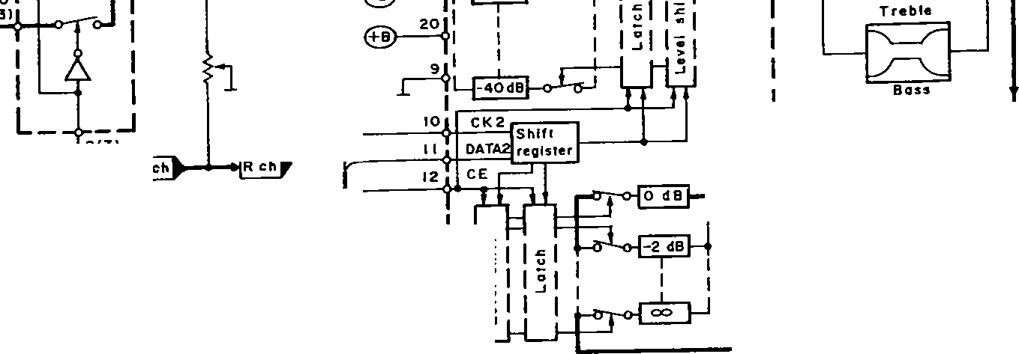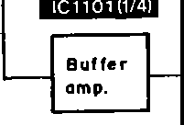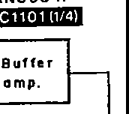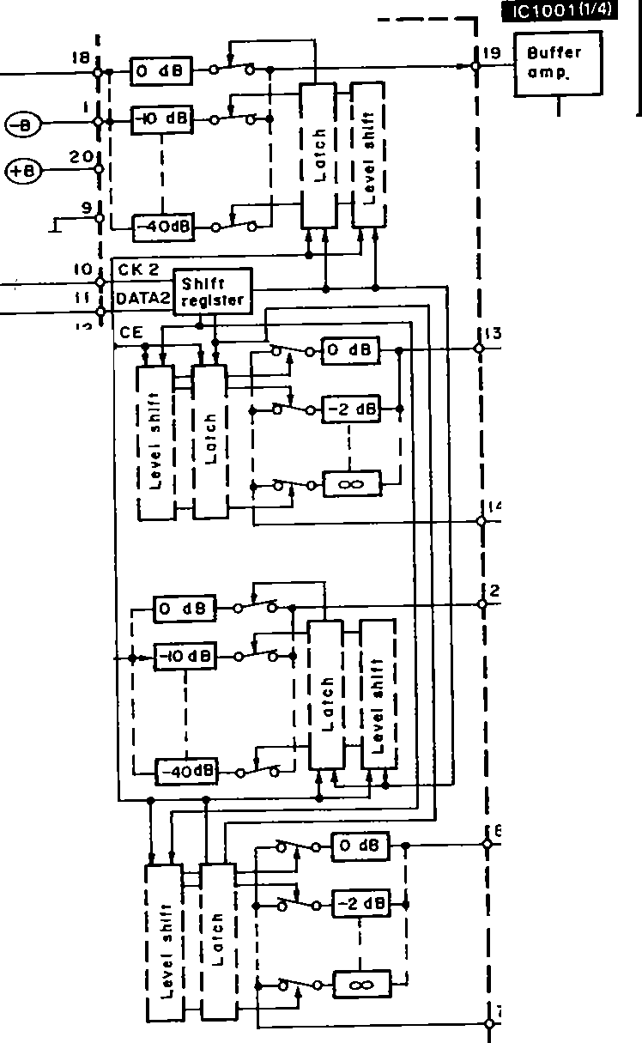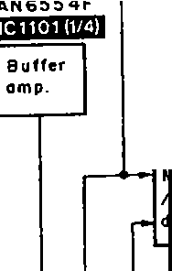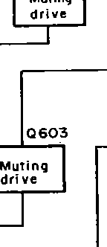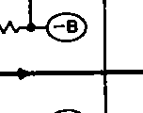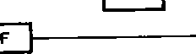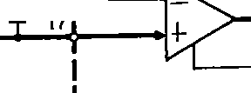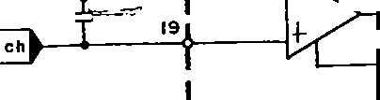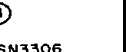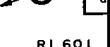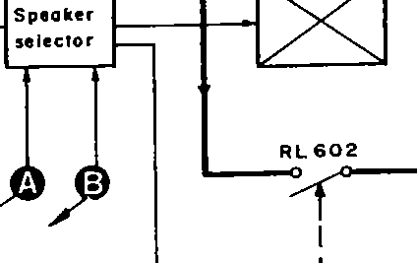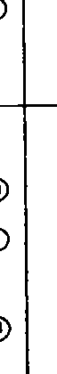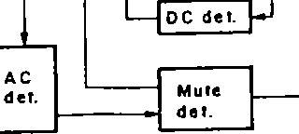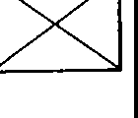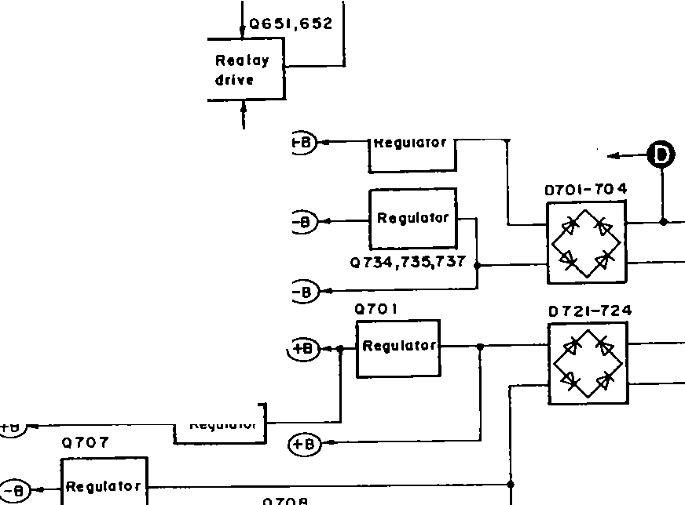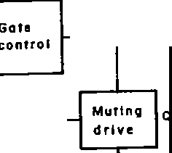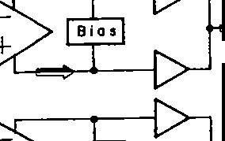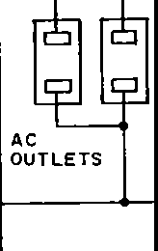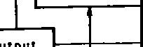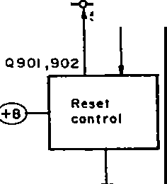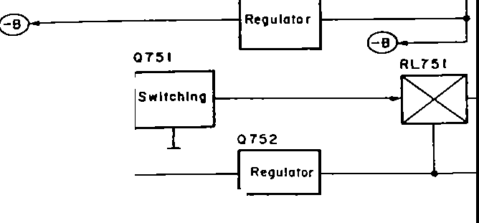

- ll -- - 12 -

==!>

Rec output signal

: Center SP drive signal

* + **SCHEMATIC DIAGRAM** (Parts list on pages 33~37.)

(This schematic diagram may be modified at any time with the development of new technology.)

.• _._ ·- *"JI(;_'_*

**SU-G95 SU-G95**

**A**

1 2 3 4 5 6

Iii **MAIN** CIRCUIT { INPUT SELECTOR/ PHONO EQ AMP/ DOLBY PRO LOGIC/ BUFFER AMP/ ATTENUATOR/ REGULATOR/

**7*r*1**/(

GND PHONO SIGNAL

JK401 FRONT SP DRIVE, Leh)

**Note 1:**

* **S901** : Speaker ON/OFF (SPEAKERS) switch.

**Note 2:**

**CAUTION:** FOR CONTINUED PROTECTION AGAINST FIRE HAZARD, REPLACE ONLY WITH SAME TYPE 6.3A 125V FUSE.

RISK OF FIRE-REPLACE FUSE AS MARKED.

I L C h E<r.---' +A

PHONO I

LR ch o; B

**l** r=R:4w2 I:IK

**l**

IC401

NJU7312AL

IINPUT SELECTOR

1. SV\
   * **S902-907:**

Input select switches.

JK401 I

R401

I K

ABDECGF

'" Tl I I I I I [ 11 [ _ I

R42.3 IOK

ls • •-

A 8 C O E F G

S902: VCR1, S903: EQ/VCR 2,]

I

!Ler-h

,o-K--:

[ S904: TAPE/DCC, S905: CD,

S906: TUNER, S907: PHONO

TUh:ch

02 ± 1111111 A

u r , v,lHJ H1J

x,}xaJ

* + **S908** : Rear level adjust (REAR LEVEL(-)) switch.

JK402 I

:a3 £I *(*

* + **S909** : Center level adjust (CENTER LEVEL (- )) switch.
  + **S910** : Power "STANDBY <!J /ON" (POWER, STANDBY <!J

1Leh

**B**

&

{

11 1I

/ON) switch.

* + **S913** : Dolby pro logic surround ON/OFF (SURROUND) switch.
* **S914** : Dolby prok>gic 3 stereo ON/OFF (3 STEREO) switch.
* **S915** : Center mode (CENTER MODE) select switch.

'L,'"

I

,.!if !ii 1 •

EI ;;

1

J K402 R4073 I

L Ch

IRELC(OUTI R40jij $-3 11111 D

I

0"'

"N '

"er

**------FUSE CAUTION ­**

**.-33--** This symbol located near the fuse indicates that the fuse used is fast operating

type. For continued protection against fire hazard, replace with same type fuse. For fuse rating, refer to the marking adjacent to the symbol.

**-E3-** Ce symbole indique que le fusible utilise est a rapide. Pour une protection permanente, n' utiliser que des fusibles de meme type. Ce dernier est indique la qu le present symbole est appose.

ABC DEF

:M

* + **S916** : Test signal ON/OFF (TEST) switch.
  + **S917** : Rear level adjust (REAR LEVEL(+)) switch.

R ch I K

TAPJ K 403E/RD40 gICC

I

L

Lehr -

E

R468 IK

C464 R464 R462

er'° R460 C462 C460

A B I1+1 I

L- 2 -

* + **S918** : Center level adjust (CENTER LEVEL(+)) switch.

'IL';:: i&:' ,,,Jij 11 ,,

"""' ' 35V4.7 12K IBOK

IC451

CF 1051

* + **S919** : Super bass ON/OFF (SUPER BASS) switch.
  + Signal line

,,,_,.,,.,+;.,.,,-,.,.,., Phono signal line

R454C452

N 8 20 .35V4.7

I

68 6B_OOP 0.022

-;

AN6558-FSG

PHONO EO AMP

{ 8MHz)

*czzzrd)>* Rear SP drive signal

- Positive voltage line

C

J K403

REC(OUTI

R41I 31

$¥3 I

NY B -.--'V111r-*.-...----..------,f----...-H---.

"' o

*q-*

N !£ ¢1'-

IOO o::N

"'>

Recording signal

Center SP drive signal

[Leh

I R412;'; r REC OUT/

r

I I c

*:* a,:::l -1-

£

ICI002

- Negative voltage line

* + Important safety notice

L

EQ/VCR2

R ch IK SIGNAL(Lch)

,

- ":l!'. .,. >

,nQ uO

¢N - ,-..

O::N 1()0

LVIOIO

DOLBY PRO LOGIC DRIVE

Components identified by A mark have special

l r- "c•ho•E ;-; r7

R ;sa3 ·=

characteristics important for safety. Furthermore, special parts which have purposes of fire-retardant

PLAY I (N) =-;;

L !14 1

1r------_l, ,I G

8

A-'--'\IVv-1'1-c<'

35V4. 7

";;':"'

(resistors), high-quality sound (capacitors), low-noise (resistors), etc. are used as occation calls. When

Reh ::• :N:O.:I -r I

**D** I

*w-=1_*

! T

R 459

68

*w"'*

*q<D*

"'

JK404

r 1

R1!'5 I

R463 R461

er"'

replacing any of components, be sure to use only

I

-14_9vJ

12K 100K L-

manufacturer's specified parts shown in the parts list.

* + The supply parts number is described alone in the replacement parts.

VCLR I

L eh fO'---'VI/'

• .•,&'; I

R ch .,..1

F

R 431 IK

Fs4•l1t

.r::-+"

C426

i *sv,* a

C43S (Lil

IGVI0

Part No. Original Part No. Su.pply Part No. IC1501 M5218AL M5218L

* + **Caution!**

E401

)--i

-0 r

'--

A + •

;;;0n. "*rt*'*i*"*o*'

T *:*

(\IQ. ¢::i,:: \O:.:_

g 8 C436

"'O

e<rto-

"'

h..

.". "o'

<to

Ir--

B RI

1. --i c --"'
   1. RI

IC and LSI are sensitive to static electricity.

Secondary trouble can be prevented by taking care

i

R432u- 0:::- o:: 16VIO

IK

B + +

E

C4.34

during repair.

* Cover the parts boxes made of plastics with alminum foil.

IGVI0 IC402 M5218AP

BUFFER AMP

,no

.N-,>,I+

u

-!WI j

1

1BJ..!

i • Ground the soldering iron.

flI

I' :

* Put a conductive mat on the work table.
* Do not touch the legs of IC or LSI with the fingers

c

_ C

I =::!:=--

I

L=B- A} AB _

I directly.

I ;} ;J •"_ffin_,:1 I [

l

,. IL''

s

"'" '

I!

>l

F

@

- II  ~~.c~~i - - -

I

CN903 N N - a - wII

i

-14 '3V _.._-t-----------

l

CN902 >- - a:, <l - *u,* N

I

<l I- 1 I Cl) ":l!'.

I-<( ::i,:: <l <( u

,T2Y,1•I5'f(fiX•

CN90 I a I- 1- _ N_ *w*

I,_

z::::,::::, _. _J

*e*ti

*!*

- 13- G

_.JC/) a. a. a:,<( u

Cl)C/)+

TorJ OPERATION CIRCUITICP9021

On page 20

- 14 -

tfJ u 13 t

a a

'-roB OPERATION CIRCULTICP903)

On page 20

l!) 0 0 LL LL CD ::::,

:i .c ..c I

u u "-

"

-'"'

roB oPERATJON CIRCUIT !CP901 I

On page 20

:/ **SU-G95 SU-G95**

I 5 6 7 **8** 9 **10 11 12 13 14**

I

I

' ;GIC *I* BUFFER AMP/ ATTENUATOR/ REGULATOR/ POWER AMP l

IC40I

# :r

NJU7312A L

INPUT SELECTOR

14.SV\

"\D'O"-f"'1f:!lil l

u'° o::st

2"I ..

N

14.5V)

-N "'1

-r4.9V

+

Cll04 50V3.3

"O'N"'

l,.Q 1001 25C3940AQSTA

REGULATOR

ICI 10 I AN6554F

BUFFER AMP

•

*f*

(rN

LJt)

--_......-N-+ ,tCII

ia O:s::

9V ;:;O

CENTER SP. -1-

·,i

0"'

..

"'

l"'IQ.

Rl052

a,,:

o"'0,-

o:N

""'"o'

OCN

..

:.:- *..r:-* l"'I

I+

*ztz*

U-

DRIVE SIGNAL

!, n

+- U +POINT)

--...JVIMV.-◄

**A B** C D E F G +

D

uo + *:;;* g

*2* l y

) +§"'-

I ¥ I

I

-

CFI051

0 "'

ir

I

1

15},\:;\',

f'

_-:

=

IC451

( 8MHz)

-

,

AN6558-FSG

PHONO EO AMP

"'-

t

..J '.:=====:::i::===l==i----J -' l_-_--:_-_-'_ _. J

ICI00I LA2785

H H '

ICU

4,IV

.,.cJt--I"'l""'ls"f t.O-.I

UdTU tu

Ost O> -0

0 O'I Ill t-- lO .n

;:;o U +U +U -tU t-U +U

0 •

TP2

7

I ! I

C459 O.R22

C463 3 V4.7

""=

ICl002 LVIOI0

DOLBY PRO LOGIC DRIVE

iloev

NOSi E

?.'y.yJy.

',si/f--<.14)..-m'>--6i\.--611--<.iil\--6ro--t'2it,...-{;'71---,26),-,{is,,-...r,;i)--<.m---t

I r.=--

11+ .,

GENERATOR

LPF

*--LB*

### I B

;;c:

R461

1801(

J

|  |  |  |  |  |  |  |  |
| --- | --- | --- | --- | --- | --- | --- | --- |
| .",..  ug-r | | ""a.  ugI- | "'a.  ug-I | ION  o_N>t  0 | + | ;0;0;>,.,1  ii:"' | |
| Rl009 | 3.3K |  |  | ;28 | + | o ,-- | ;;:c |
| **B** | |  |  |

\!

"*.-*'*w*"'

"'"'

C435 {LI) 16VIO I

o o Ox

O:!i::: Ox Oo

8 Jt

u"'

LOG OIFF

DUAL

CONTROL

""'O""'

"a'=-t: ·

Q:- i;rN

--1,n oo G

oc-

.. 0

A I I

II I I IR I ( S)

o 1° o I o

*x*

'

i ½

-ero- ov

"'sn

..

a 1os1

I l cir

··TB l

'" ADJ.

u 1 uOl JO

+

2SJ40C0TA

== ==:2)

I'-----

41V

i- +

>i *V* •••I

I **111** rl C • • • • • • • • : : : ----v-c ----- --- ------G Rs ::_GA.:.:NR.::A:::c_P_D_R ivE ===]::+:::::-::-:-:-:-:-:-=--=-=---_-_-_-_-_:_:_:_:_:_:_:_=--==

, t . --4+-t-=== ==::' =--=-= ==

!

--=-=----=--::..-::..-::..-=--::..========== -===-=-===_= = j

== = - ---=========== = = = = = = = = = = = +F

*T* ..

I

r

'-.....14,SV 1

14SV

,I

a

l

-149v-'

l -15- - 16-

I

-:*:_t* ?--'.5-,. ,<

**15 16 17 18 19 20 21 22 23 24 25**

II MUTING CIRCUIT

-14.9V'1

R/108 IK

-t-H

C 1102

50V3.3

ICII02 TC9212P

ATTENUATOR

.; l.

CII06

I E-

so\/ 3.3

-"-

*R* II 16

470 K

Cl108 SOV 3.3

.,.-11-

.,,.

-o

=N

QCN

1

&IC60I RSN3306

POWER AMP ( FRONT)

*f*

{

14.SV Cl 105 SOV3.3

_,.----.,

Ov lov 76v I

;h 0

-.=-11

Rltl7 220K

/3 r..vv

|  |  |  |
| --- | --- | --- |
|  | 1Ct501 M5218AL  SIGNAL DET.  01503  MA 700A *TA*  0150 I 01502  MA4068MTA 0"' 2SC3311AIRTA  "'"' SWITCHING  QC  .o,l1,l.,f+  "_',, ,n>  ,nN u 65ffir<'!+ 0150 I  ;N 1 2SC3311AIRTA  NN uO.., O., SWITCHING  ,,o, ! QC  1°1503  T;;GI I TA | ;...  0,:  ;:; |
| lrt | .,,._. *OV 0.1V* IOOK  .O,".' . .0.> -1 IOK1 "'  o<t o Ql502  " uon QCN  ] *_q*  x,x•X5) JJJJ:J.. | |
|  |
|  | - | |

...

I 5C0IVI033.3 "IKti-J 1

"'":'f ric 3.3.".J I I

r-l

ci *1*

... ·-·

C"IIOI

"'"'

B .'13 _l J

Rll 20 .• &.."

_J I I

*ih"e* ,.

=oJ. ._loo. J_ "'o. **A B**

**A**

t-----, r-- C62 I

C613 R613 C6!6 OOVI *(D* + 100\110

M0A6l6056TA

o-,J---r--.----------1r ;

----1----cv33 1

O=,o­

QC.,

I I I§ ,I

680 p I K + 62 3

+ { LGI

J K 60 I

R 1511

-58.<V R622 680K + 7

C601 R601 120K **l, }--1----..l t---11--'+-+-I......I** C622 IRGl _Jehl

50V3.3 I K 100 *V* 10 .'

__,,:

rl

i

e = . -+ - J_j.. + - •

- +

ICI004 TC9214 P

@ R602

A IK n. -

B <:, I

*D* E

'--

gr ;r

;g;~·•.a

SURROUND

CG,2 ci 6 **a.-i----t--:t-- f---1- -....J** F

"'"' ,._

I I :·:":.:·

-@:! ;.;. ---_-_-_-_-_-_-_- - _- _--_-_-_ *1-J*

50V3.3 QC"' u"I !.'!

0603

;I·;

=- _,._

fil.RL60 I

:;;;;!;

11

87654*Y..* :.Y\y21

"t::" .J

l 1 n

===-" , ,_,

,....

MA4082MTA

r

$

! .::::·

jj II

LZJ

-o

L602

---

IUc III

,1,1 ,1

I ·JK·60"2

RIO 14 CI043

01101

-l4,9V

R/132 3.3K

IS21

0"' "u'

0_ 7uH <(J::::

,--;:C';:6;;0 8-;,;;0:P-i--f-+---+-+ .::6!'.10 =-l

47

RG 16

IT' s

**A-** *._,*I*I*O*V*O*\,*K *.*

0*,*1.01--i

MAl65TA

B--W. ::7, ;;.;,,,--eaa;l>-f-_...-A

""' ---+--'-' + *:* R618 ISOK *c:f.;*

QC 61 -I

**------+---t--<**

B;..a

o,,

<C2l \ ,.

B

,.,N r- , 4 7 K I.Oq I

N -31 JV A1 C682 R640uoR638

h-o

060 I ,602 8 E SOVIO IWIOO IWIOO

1S31

JK603

RIO 13

QC

RI 13 I 3.3K

.A _..,.,.,,f'v :c::,r"" -;,-c; +-+-

j

2SAl309AIRTA "' csa,@

I 11· 3

* I :'o, 11 (145V

QII0I 4.7K

01101,1102

®

A 0605

RELAY DRIVE O "e f-'-50,_Vc.:l.o:O-jj._;_,:,;v:;:_::

:,:;,,;'.

MA165TA

BA

gq

I u

-o

, I II 8t

2SC331IAIRTA

MUTING

J

,!,.R620

0609

- • • ·• • ■ - ,

0.,,.

"Q'C""''

L

4.2V

060R3679 2.2K ,_

UN41I ITA

MUTING CONT.

=====================;:==========t:

R62 I 18K I

f &IC602 SVl3204B

I CENTER/

R636,!,.

o

_&R635 1/2W 820

.. ,­

l/4W22 MAIGSTA

.,,,

IC31

9

NN

N

Ji( 604

1::1--,

TEF

&0701 .

H

2S017610EF & 6 **B**

REGULATOR *R* 704 R 703

14.SV - l/2W10 l/2WIO

g

C A. B CD E

0732,733

2SC33 I IA I RTA

STABILIZER

&0731

0701-704

F A P30005002T

t

REAR)

C 652 50\13.3

I-

"o"::l

c"'.o,..

..

"

:":l

*1..* -t-&0708

:g I+

::;;;1¥

<J<P

- n:

::;

2 SB1357DEFTA

REGULATOR .6_R *73* I

_ 58.2V l/4W 18

'--

A--!!­

®

I-

.o".'.o., .

0655

MAI65TA

2S811870EF ,!,.R724

rN'-° -3: > I

*;i;;* "' re

-14,9V REGULATOR -J8_6V

**j,-.--1--<-'f--** "'-&0770

l/2WIO

.. '

"' 0

in a:- C702

........,.,....---, - ,(J 0.1

..

a

,(J

**A**'**B**-­

I ,

{R5)

.,:, ;::o 2S8621A0STA

;:: > + -15.SVTUO REGULATOR

u Qt_ -22.2V - -37.BV

IH25

.1-- "'"'

"Q"C.,

"' +-+-t-3-4:.7-V-t1

<['It *i*

1-0 r--

f-

,._

"1 _2:t;;: o a

<(l <(J <J

0652

2SC33IIAIRTA

OVER LOAD OET.

r.;.;..;--

l. MA4150MTA

D708,!,.

LSK

-22.av ;::: ::::!I'-:

c.,

* 1. R671 IOK

QC'°

''7

"'"'

R65B 56K

- -,, >---- ,

1

-14.9V

<i: uo cc c

I- 0---+- C

"

o o +o"'C" \

f'-N N- I'->

ON -> U

::h:: <(J<C

,._r-- 0732, 733

a::N MAl65TA

&

N

'°N

..

>

,, 3I

u + uO

IOOµH

: + '(11 I

*ov* d·' 73s

0735

"' 0651

.U.,lQ.

c-©----

<J::S

"i"'

> 2SA992EFPTA

R666 100K

"QC'N"'

2SA1309AIRTA li

0-©---­

60752

2SC3940A0STA

REGULATOR

<D

I""'

"'"'

"'

0*&*73*-;*7*J:i*

·Se.sv

-sa,.-i1v-r,.- --r. r--.v

0

STABILIZER

•• ft ", •• ft

RELAY DRIVE

,-. 09V-03V

."."'o

'11/I"D'"='

tI".."-'

"

.._,-

E r-@l---

I --@}--

1 IF , ,

CN o ::, z - - - -

go '?

6.IV -- IOV

0 a·

l 0 73 7

*tl\l* Tu

;-s}. t\tflJ?0

QC- c"

'G.&._R727 CP701a l/4 WS.6

c:icu.curt10::J

; + <I: ;;

uO 1- 6_8V udT ""'

P9041

+,

r-- .tp.·

o.,

.,.,

">

U<O

cr­

A 8 C

STABILIZER &0734 2S02037DEFTA

REGULATOR

-

2SA992EFPTA._ ..-5B.5V I

*1*

-149\i-'

y

On P0CJe 21

CTIoRCBUoI

.

*<3*"*"*

I - 17 - -18-

d

,,;):'.::,_,_ ·-- . -"-'- - - -- .....

**19 20 21 22 23 24 25 26 27 28**

**su.:,Gss**

rlMUTE

]

ICl501 M5218AL

SIGNAL OET.

I.SV

l 101503

i MA700ATA

-

0"'

01502

"0:'"'- SWITCHING

2SC33IIA IRTA

O:<

i

J:; r

0150 I

;:;

>

u:;:

2SC33IIAIRTA -'"

SWITCH IN

! y

inO inm

Rl509OV-..-, -

10 K

er- crr<1

lov

)

-o - •

.,

0:N

II POWER SUPPLY CIRCUIT

**&IC601 RSN3306**

POWER AMP ( FRONTJ

077 I, 772,774,775

'

2SAl309AIRTA

MOTOR DRIVE

FAN "oFF": OV FAN" ON":-a.av

R777

,

{

;>; I >I

,-------, 1

C614 7 1.q

0606

MAl65TA

RIO77K3

*Q77* I

N

I­ oc-

..

v I+

, >

, N

~~u~~..,

\ 15

l \ R778

68

R613 +

!:" -

" "'

IL610--,'f""="""'f-"""°~""""'"""';;,.e.,,,;,;--,. ._'4r'"- ---.+t{±;

JK601

-tN

N:,;

"k,, N'°

Oo

-EJ:

<!!

*(5)* 2.2K

OV 774

Icg 13

wI K

1-616,

" "'

{R6)

:,; "' !75

680P R622

-58.4V\ ..._- I 20_K_ I

;U:); N""'!

*"'<D*

"'

J

uo

:AN" OFF"·-

FAN" ON": _g: v V

0

***Q*** 772

._.,<-oC_:v .J

R780 33K

o<::e ,,

., 0773

_.,.

,{:

**B**

c-1

FRONT

J

QCN

R775 3.3K

<,-_O

*a:*

MA165TA R781

33 K

0603

"''

J]

-o,

*I!;!.*

.

09

"N'1-N"'l"N 'I"N '

sch7

B

>

OV

&R776

l/2Wl5 OV

FAN110FF" '.-14V 73

FAN110FF" :-O.IV FAN110N" .-0.BV

"'

C772 16VIO

-11+

o,.,

r--:

"N:<

""''""

MA4082MTA

--

., 1

N N N N

JK602

,-:

FAN" ON" :-13.ZV z 5862 IA0STA

REGULATOR

M77 I

FAN MOTOR

"'"

0"'

r"--'I"rN--'I "r"--''"I,.."'

1S21

**J_A**

##### _f

C21

**B**

0"'

""''

p:

+ "'"

, [

U)r--

I

C608 I0P

I

£ R61B

47K

N

"'

"N '

I I I {'I 7JJH

R616 150K

- 2 '

4

cc *a: a:* a::

"'

rrl

cil

SPEAKERS

,,---1ov

I

if

.-a.---·.....,...

**01103**

OCN

**2SAl309AIRTA**

MUTING CONT.

o601 602 :L

**2**RE**SAl309AIRTA** '

-3' UV

**'** *r*

LAY DRIVE

""'' E

--------+---+--< D

C681 @)

*"*""'N*"*'- *'i*

S0Yl.0._...

®

Q

---

(S31 "'

0751 -754

¢

-EJN □

-El

I SR35200T8

- Rll394.7K

OV

A--+---------

0605

MA165TA

I

11 •

- :: ."-

N

,ti

' f®'° lov ..,.+. ->

"'

-a

rnY

-o

*---3*

<(j

{ SWITCH EDI

I

" U -0 u"

t,.R620

0609 O"

---+ +-+-+-*1*'

R62 I !BK

&I C602 SVl32048

(CENTER/

REARJ

R636,t,.

o

.&_R635 J/2W 820

.,.._ ,-­

J

0

, :,;

01l

T.h;J

l/4W22 MAIGSTA

'N°N"'

N

(C3l

t!

J K 604

I' -l TER-

- •X5J[4)r,JJJ::,

-11 I I -, W752

--1

5 rhmmw

T'¥¥¥l

752

5.IV *r_-,,--*

.,_ 0151

l

o UN421FTA

u0 RELAY DRIVE

I

t,.JK792

-LI ':ci

..

AC 120V

"l'

{ 60H:z l

I - 1

@) ;i;d;-;"'i , g

D721-724

C 652 50V3.3

A-ll­

R652 IK

U)IXI U)U)

! '--

'F° A' 1

0701-704

P 30005002T

UU> a:IO

! 0655

,-r"O' "'

"'

:2

:"2

C65 I R651I 50V3.3 IK

"''"

"'­

R673 61;1 OK

*r*

*+*

68

VIOi!

I_ i

MAl65TA

I

□

t,.0722

P3000LF

0721

C N75 I

·ou>

:,q'lt

,1.-,-0 -

'.if!-El

'J",4.

0

-El

OVER LOAD OET.

R671 IOK

.-;;;--

"'"'

B ,

® y

"uu''°>I aU):Ull)l u.>.not+

0652

2SC3311AIRTA ....

"'"'

R658 si::;1<

1

': 1

r

R669 22K

L65 I 0.7µH

I ,,,-

1

4J

-

;:::==I----

- W.,J

---------

CP70IA W701

N- ..I.

ci--r-

*t:.o·,2•* I*t:.o* ,23

**B.** ill'"------- -------- L-+-+--+-: -_-_-:_ = == i . J -_;· --:::

C ------1, >-------<I 39.GV

--- !c_ l -

, ,,

"""'

,""

c102f-EJ 0,1

f

H

!

"'

*t*

52V

C651

&

735

**0735**

**2SA99 2EFPTA**

R666 IOOK

UIN

ocN

0651

2SAl309A

i

! IOP

, "i•-o--<fJ>--t--,e""-----_J

o'

-::!'.:'-I

iRTA (<l:::::

1 1 L,," :

R660 5

47 NT'-- [L---

0654 -

, , LJ:

_L STABILIZER

0656

RELAY DRIVE

-o.,v

:::

""''

, ..

UC) MA165TA

1

:s0r I

*:;::: _;'* :>---------<, ;

#### i

·.-.-

MA4047MTA

i

"c',"<-'I

::e

I I

ACZ.ZV

·39 1a

r

-14.9V

1/4 WS.6

L

_J

1 0:FTA l j

*I*

- 18 -

**m** POWER TRANSFORMER CIRCUIT

-19-

--

**ithG95 SU-G95 SU-G95**

**1 2 3 4 5 6 7 8 9**

on pag 14

To6JMAIN CIRCUITCCN902J

On page 4 Tom MAIN

CIRCUI_TCCN9031

0

On page 14 Tom MAIN

CIRCU!T(CN9011

On page 17

roEIMAIN CIRCUITCCN9041

,----" ,

* **WIRING CONI'**

*g* = llJ

Z.e.ez.e==

**A**

z z >::::-, >::::-,

* -

nrrr

...J - I I - <tI

II -N I"

d CD <I: N *VI*

**N**

N ...J_ O.c.c.

Ni- i

0--ooo-­

.c C.,uuCluumm

1- <IX><( llJ

... ...J ...J m LL..

r

**f,loPERATION** CIRCUIT

CP904 0...J CC lna:: ...J .f-- I

CP902 t; e; : G CP903 Ul o U O U CP90 I I l:_ LL LL.. 1 <(

**•Yi)'.,** '

1"234567 -

**C**IOO**9**P**f**-**fi-H4** I

- llh

FL901 C RSL0167-Fl

_r-14.5V

0"-05

;;;

;011-ifi---:_-_-"""."-"""'"""'------------- ***10*** ...JK

E

Ec4IT

AJ!,

uOJ J -- *4* ---,l

' · 1~~:·~~ •

L.. ;

FL DISPLAY'

r

--- 0

-,.- -

,,,., ,,. RS68 3_3K

CS62 5, 556 -

*L+*

'·

II POWER SUPPLY P.C_

CN751

2 3

RSOI

-,>tlj"

**B** e I

x P£1 XI xp p•q I =:1 x

r1<Nlr1<~J1r0<1l<r<n"1)1N<NDN1,N01 0::

## :•tt

-o

«-

mo f:

0

L 6

">-

"*<D*

*s* 14l sx,,xm

l

T-· : • c:;;:;:;

""" "·"'':l!,I;

·--c-s-7--1-•Q-·c:-;7-·::-r. N*o*i*.*:*f*..*.*.*.*

,n>

......,.......·.·.-.·.·..Y.:-_;;.i_._. ., ..... I...

*L---l-*

C573

,_'-- 3.3KI'

u

IC501 M5218AP

BUFFER AMP

IAc ouTLErsj

mm mm mm en m cc a: cc ccc::: cc cc cc

IHGFEDCB **A**

!;; J,

e +

·m.,

o-,

**,(J,S**

**-4 --1--1-44+!-H+H-h**

C928 330P **j** 111

330P

6 330P

I

l­

1111 A

I C

**B**

.r

N,<

50VI

'®

Q556

.h_ R57E

,oO

;;;;:,..I..

u T-1'

; s 330P I

C924 330P 11

I I

:

l I I I I I I 1111 III II II I! l E *330*

I

D

**E** }-,

220K

g .

« ..-

1 C504 --- C572

TC9212P 35V4_7

*(* 'H IK

-4.6V

OV

:"'t";'

RS02 3.3K

'«"

R506 -

*:*

C92 330P

,r **H**

£0.r

ATTENUATOR +

R2.2K57RS4BO "'t-"-N'

1 n n n ,sv

LJLJ LJLJ OV D 907

C

C92,I. 330P

I

D902

I SS29 ITA

dI

B

c;-

C535

IGVIO C536 16VIO

W

3V

" :::

r{

"' "'

0

*·l··*

4.7K (0

0571 R577 MAl§5TA I.SK

I ~w NUJ

1. ---i-'- f ;;;«;Oyw" ID

> e:

.L g

;";';".,'

«-'

T :g



T701

!Power transformer)

iW75_

**m**

POWER •--

TRANSFORMER P.C.8_

- -

-----+..--'VV\r---f---1-----Jl---+-----r------""-{, SUPER BASS 1 C90 I T=2.4ms -22v D E

R,9/3

NC f=2.4ms. -22V :6 g

**----.J**

:- «-

(POWER)

;;;g

470K

C515

W711B==O_ I

I 6-

-

SOLDER SIDE

S910

R515

;;;g

""

* 1. TUNER LC8A008C5477 o F

MICROCOMPUTER D G

8 CEfVOLI o H

-+------4---0_j_<>--::J..

I

5901

(S ERSI

"" \ - (b;. I 2. 0P

o.J.1 "'

C DATAI fSELECTORl O I 0

u-.l

=

in ;;;g

a::-

**D 0681,682**

\ I I I ! s

c"E roR, -20

,,, rs 0--

S902 ,-,.

G

I DOLBY

j

IC 502

"u-O'a-

**2SC3327ABTP**

MUTING

"N'"O'

"«'o-

1. OATA2(SUR/VOLl A

nn Al*"..!/* -::;::;:_-=.-=.:.-:::. -=-=0

VCRII

_j_

0--

<'!

OCN

PRO LOGIC!

UPC4570C

TONE AMP

**B**

**A**

.,J

OV 4 S-6 *J* V V t

I 4 SURR PASS /F=GMHz

<C ID 8z

', l---"' -1---1 C

S

\....-

mN I )EO/VCR2!) I SURROUND

N-

:u:Ol T

I

::N

C685 33

**N**

::i

**OCN**

R700 470K

- _No;: z38

11 O

a,:: 890_j 3 09-1--13.-

""'o'

""

! ,:

*.*"*,*' *:;;* "'

N?

X

«-

_c-i, I "J

.,

<DN

"

*<D*

*<D* ::i

*=*

«N

••• I I

R699 3.3K

:l ;m

**H>+­**

S904 :;;::.:: S914

::; IT CCI *g;'.:* 13S::::1

;f,,:

"

"'"'

fSCD9I 0J;j.;..t.:SI C9EN1TESR MODE

Hc4s-,=_-f.1,- _._------- -.!-

- !,.r

R516 l()T'°O

470K R518 C522 u- cr-

0551

470 35V4.7

_.

::i

_.

-'--0--

2SK301RSTA

t

0'.li:'.

R526 m

; 113.411

ov

E

I

**Q681**

£.4V

**Q682**

::N

0901 L901

ISS291TA 100 H

:t2g *(*

**0**

.,, ----+---"AA- :-; **iA i23o9AIRTA'"**

u0I ov C91050VI

"'"' 5906

OCN !TUN ER I

_j_

0---

,:/:,-",' S 907

"C'"l.'!

a:;N

'.li:'.

5916

( TESTl

-'--0--

5917

SWITCH INGIS.BASS I R557

DOV 6.8K

s "'"' ::: ;;:; _

a:: is3 T o T 0

NCD 2.2K NO

I(). l()U)

0::- Ulll

N ~

?---'-+_. _,. :.::



I rrncPGOI

«

csss

R555

ID g;

« f

!6VIO

56K

N,C -

,ON

--- -------- 0

"'

"'

.".'

-: u:i REGULATOR

« ( PHO NOi

_J

m IREAR

-'--

0--­

a:: LEVR-tl

p ------

.".' "'

OCN

N

::N

**0901**

rr,1- m": o>

O'° a::'1' mo

<l !'.:Ii:'. +m-

""'-'

5908 ( REAR

S918

": ( CENTER

0--- ,.

0

«N ::N

"'

"

**UN4214TA** m u

"" _L.EVEL-I "" LEVEL+! o

:u2oQ-I

"' ""'

\rs-,v

RESET o«

0--- -- 1---o_. 0-­

Ill> I+

<DN<

" <

::N

R906 >-

""''""'

5909

I CENTER

"C'"l'!

5 919 *l*

I SUPER

CP60I UI I TJI

**F**

r CN601

-,,

120

--1: I

'

":,;

d;

,mO.o,

o-,

,():,;

*"*"*'*'*°*-

LE._VEL-J ""'

0--

BASS I

-'--

0--

*r*

.;.J;

IC505 M5218AP

SUPER BASS AMP

HEADPHONES

rn

l:r,IJACK p_c.s.

. ,

' I u>::,,::

HP601

HEADPHONES -

c ::c:.:_,1

I OV R565 2

I 5.3V 56K O::N G

1 0.61/ 0:::.::

1. I S *<DO*

I Z901 I 0553 "':::

* 1. HEADPHONES I.IJACK CIRCUIT

•

* 1. VOLUME

**1:1** Cl RCUIT

RCOHC-27BN r- --;_..J I UN41I ITA 0552 "

(REMOTE L J SWITCHING CONT. 2SK301RSTA

SENSORI SWITCHING t S.BASSJ

I PHONESI

**G** -20 - -21-

5 6 7 8 9

On paoe 17

ToliJMAIN CIRCUIT(CN904l

,--------"----

**SU-G95 SU-G95**

* + - **WIRING CONNECTION DIAGRAM**

I ISPEAKERS! I

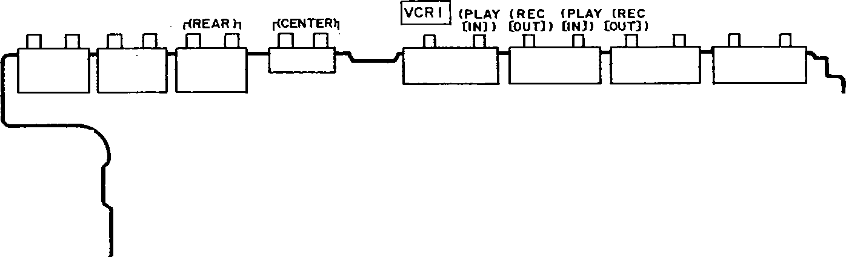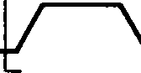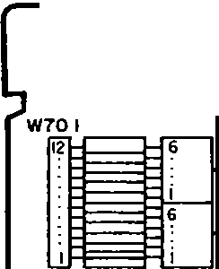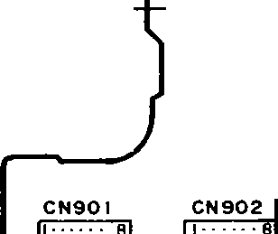

r{FRONTJ-i

**,-<A>-,**

**_rB>-:,_**

!TUNER! jPHONOI

FAN MOTOR

jAC OUTLETS!

I:

L, I

00

JK 771

II POWER SUPPLY P.C.B.

TCPTOIA TCP701B

**m**MAIN P.C.B.

CN751 W752

2 3

f!!!i.i:.

I

II MUTING P. C.B.

T701

IPower rronsrormer)

CNl50ll'ICP1501

**m** TRANSFORMER PCB. *---;;<(*

-------

W75**l**,

POWER

6-

CNl502I= )CPl502

SOLDER SIDE

L--- ---

::=r-

,,

\.'::::::F=' ,.. ':::=:f:::'./

rrC::N:::9::0:3ID rCr=N:9::0::4:ll _,,,..



I

I- 1-

t

z z :::, ::,

z.c.cz.c==

o--aoo--

.c

e>uuCluumm

CP904 ci..Jo: via: ..J+. I

67 3 3K C562 n.

**A B** C

R505 220 K

.,,o

,

{

IC501 M5218AP

BUFFER AMP

*_-:-i"i.*

+

01

;

_.,_31(

-e>o-

-W1

°'c ! lt:N

I

'"'"

00

KlN

r

>-

* "

0 0"

N

"' N

"'

5.02 -•

•

1·

3 !K

or ATTENUATOR H+

dI

R574 en,:

2.2K R580

!,"N

4.7K o:cti

li1 --

.il,

:,oc,oo<XJ,r

LJJJ

o

N(n

eNnNt--1 .L

"'"f

LrI

*.*,*'J*, .-.

0902

ISS291TA

L1 +H

I()' IOO

Q:l'"J

in: I-

;;;1. q a::-=

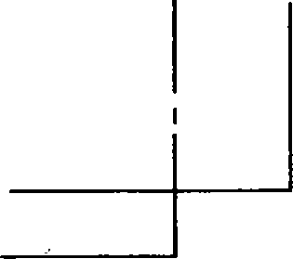f,: *V*

,(.

MAl65TA

I.SK

C535 +M

0571

R577 uo

16VIO C536

16Vt0

0

r i >

*:.*

9

C

*->-------*

3V O

"en"o'

oc-

r{: .

S910

(POWER!

--1-

;e;;n"

oc..:

ino+ .nin ,-..

UQ u,., NQ R525 T :g 2.2

=a.

..

""''"""

---

f1 F

-+----------0 0 i.

a :;

·1

,;

I

S901

;+ ! g

' 0--1-0--

I SPEAKER SI

10 ::C:

902

. **A**

:::-

.:.:_" I:::"'

i

: !2 > '

'-- I I

o-----

0

N,: 903

IIEC/VCR21Ji

-,.

WN

IC 502

PRO

UPC4570C

TONE AMP

j

f DOLBY

LOGICI

{SUSR9R1O3UND

u- J_ Ia::-

0 OC-

.

:

T

!_

0-----

"'

-'-

5914

.,,....

"'"

!"o

I :a;il:f!:"t{:T9AP0E/4OCCJ oc r,;TE;:J

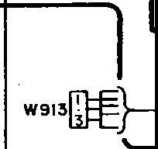

....1""

QC-

-'-

<>--

h L0-

- -o

.u,-.,I.noo:_-

:f4,7

35

470K : be

R516

C522

**l:IVOLUME**

-en:"ll,"Ll•os

**lr:ilP.C.B.**

0901 L901

n::-

( CO I

-'- <>--

0551

2SK301RSTA

o vi ,Hx

n.

t--t.R25.22K6 mo

W913

1S5291TA 10

es *?*

0902

2SA 1309A I RTA

"'"

NLl906

o:N fT

:..:::;L!907

"I'O-: -1()-

T O T o

IR555

NCI) ll)N Ill>

..:. a::N U +

NO

N -w

'u ,

N -.,

- "'w

""''O

o,o_c

:<e>N "

::;.;

t,i

1:;:

m-,Cio c5ss

l56K

'°N

16Vl0

I >-_

6 s 9 r a

QCN oc

:m;·; u!R•EoARa

*o:*

co-.:.:: S909

m

I CENTER

..,.,

"e'mn.

CCENTER

LEVEL+I

----10--

S919

{SUPER

, .o

6 Jt

*Bo*I

**m**

v:l;

q

Oo

"

-El;

] r 7

a: *w* LEVEL-I "'"'

-'- <>--

BASS I

L---;,-'-o-

J,"

r

;Jt

:;:OM C556

LON 16VIO

QCN H

R552

470

R15i4 I isKs

IC505

M5218AP

SUPER 8ASS AMP

**m**RHpEADP=HONiESrn,..,

OPERATION P.C. B.

I

, I

I

0

,,uK JV

R565 56K

*<*"'*D*"'*O*

<ON

QCN

I

..

I E:31 rr:::::31

c:c:::]]

rr::=::E

I

I

I

N L ...J

,,

0553

UN411 ITA

SWITCHING CONT

0552

2SK301RSTA

SWITCHING IS.BASSI

IPHONES!

!CP902 I

ICP903 I

I CP9D4 I

i -21- - 22-

'



**1 2 3 4 5 6 7 8 9 10**

* **PRINTED CIRCUIT BOARDS**

**A**

**POWER TRANSFORMER P.C.8.IREP1741A-Pl**

**B**

**C**

1-',[\ ':

r

IL

FRONT!

lr,

L

**P.C.8. IREP17398-MI**

**D** *,Sj'\i'*

T701

**(Power transformer I**

**POWER SUPPLY**

**(j**

**P.C.8. IREP 174 IA- Pl**

1-·7

: i

I I

LJ

51

f_-_Ii-

ii

- - -i *lrE!tD*

L

*01V*' *2'11·..w.* 1:I

7

I

1

··: 1L• !7_,:t,.flp.

(PLAY(IN)l

1eo,j,.,1

< REC (our)>

**E** ,· ·rl? ,

I I

*01'1 _,1;\· ;,w*

*1*

i

":*_***·-***,***-***0***c***7***,7***7***74***Z, )t*

.-.. ... . *·.*-- *:.;.'*..*"*.*·*.*.*

,. IJ ¾ ift:: .;:;:rtn--: -

L _. y /i"''. ,:;-·:r-c*-!* :

**5** .li'"'.,·:._,!-?.p.-•:·.!'Cii 1l !

**'9iQ:174"'-,** !;

',:iifS , i:j JE; ;/R;,Cs :!lJi! iJl ;

\ f -

t bn

1'-

' ti**,:P**.,.1<:l

_9_Ll \

"- ;c , ; t:'1;. ::t:E'- -f·;..& • / V.-:tt,< f 'ij/ f°:;,v !i'-':-..-..,,_i ';.,,.-t: ;,;;,, **:CNl501** 1,-. ,- .. **CN1502** '

. :, ,:,it,;-',:;;i?;.Jf f' -0, t '.:;' ·•, *' i*

, **,cJ\T+**

:i:+it t11 ..,t2xJl r- *:;*

<T•

**;.,.,. • ·! (•,-:.:,f'!}'''**

(S), -=-UM S:.,"- o----

"" --g;J? ]±I'cs· *, ti! _;, ,!ii!ii tfli: 1\,;; .- :£,,yfc J;;i'·i>If c:t Q:,:, o·: 5/.,: •e';• *t::*

miil

--'-.u"¾-li;,+; - uI+.:A .s..:' 0-c;/,.f, -(I:+;:,;,"TIt-0G' ·u.O-:tU-0...:;f-OU-;rt,\'!·i V*:t,*!*r*f*e*i,*'*.,,-,, ''" • <**Q**lh**.:**.**:**,**:**,.**: ,u** - '

0·f··· ,0- -.,lol

**)775**

. •·"•·;0'"', I

**F** ., ·I \ ,'-[:L..,,-

-·¥ft _ } !: ,,

:

*'.)*

fuiiiiliiii.l

I TUNER I

' '-:!,¼_, ' *:fr-* -? ,.,.., H - 0 { 1t'O **'4" '-\. in 0 rr,......'¢'_ ,Ol"** -. , ,_,- **-s** - - - -

t HHtlllfi<i[t"& • l5K\•f '? ·,, . i-'. -ir- fft;; iF :, I::;f

-f - -: Iii::·\\ 1 ;;J-i:. 0 *1:* : ,.;

,r: :,y;--,, -- e>:"- f: ,- :f'.21i·;;1}1!,r t "'.i:s',;:." -.• ... \a: -- *,: : <;,·ar* : *··,:,·:·* ·• ,-,,

.J "I

1c1001. *:* . *<.)* 0 - I'.. 0 ·, .;; ,,2l456789101112 •8 a , 2 3 4?

:;°•f, -"'-.-'-., ..,."'-, , ,, ,_, ',," ' '' , , ,, *-::-7* ,,, *:: ,* , IO _'"? **0_** ,.. , , *,.r_•* ..::, - **S?:**

-··•e•,,,.h *ch,~ (* ,, y, · - !-- 1!;'Hci'ltl1r,•-" ·•· - -, 'O;L,_,_ "· •kJC1Q02•·,·"Y ", of+ JCIO(

( SWITCHEO J ( **120V 60Hz)**

"; • • • 0•-- :.1°:...J;;; **?O.J!. ,,• ;croeci {f ;:_,** '"'.'"': *.::. - ;j-* t,- h,:•/':, ,' • - *C..:* **0**

IPHONol

,, 1!,\i39'!1i'. :i3 ?3\.J119 .!_z :.J oi ,;;t =I: ,;; :. *p,;;ci)/'.,•* .2!232'l2f l:,!tJi ,B '.• -g±'. °', •· 1*,*6*2*' *\4:* 13_ 12_

t-1", i ;;, •, it frtfZ0,;, flil' fi[if fq'ifi !tt % *A<,*

5

'" '' ·,· • TEST PO INTI

ti

,@, **G**

- 23 - ·-· 2.1 -

,;

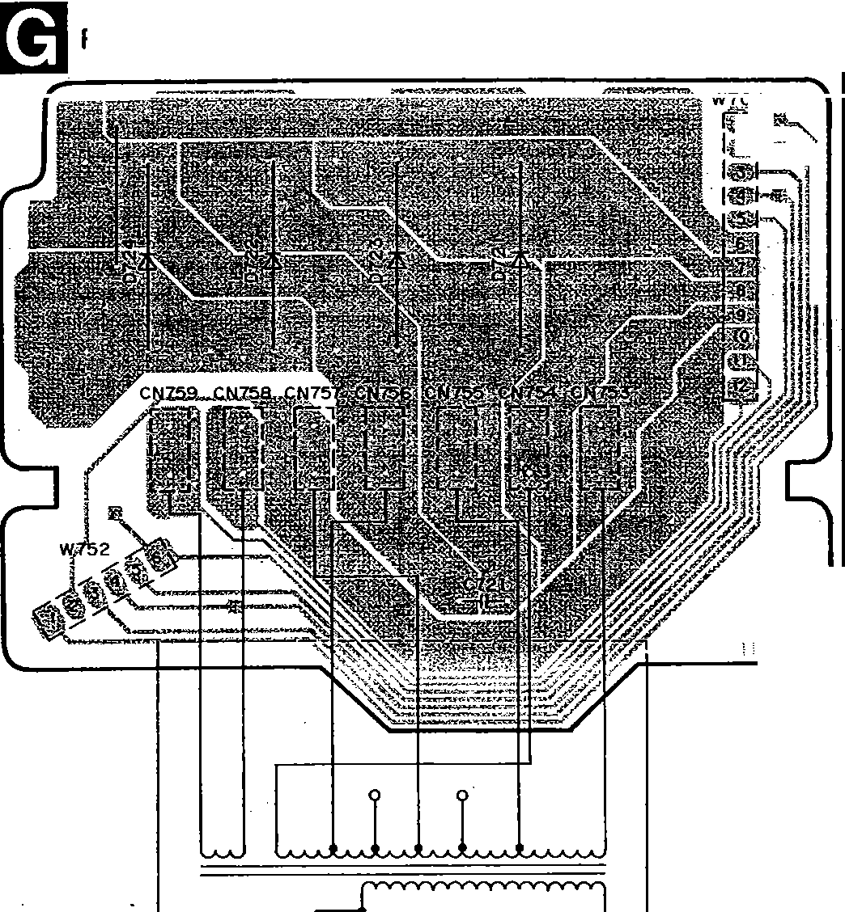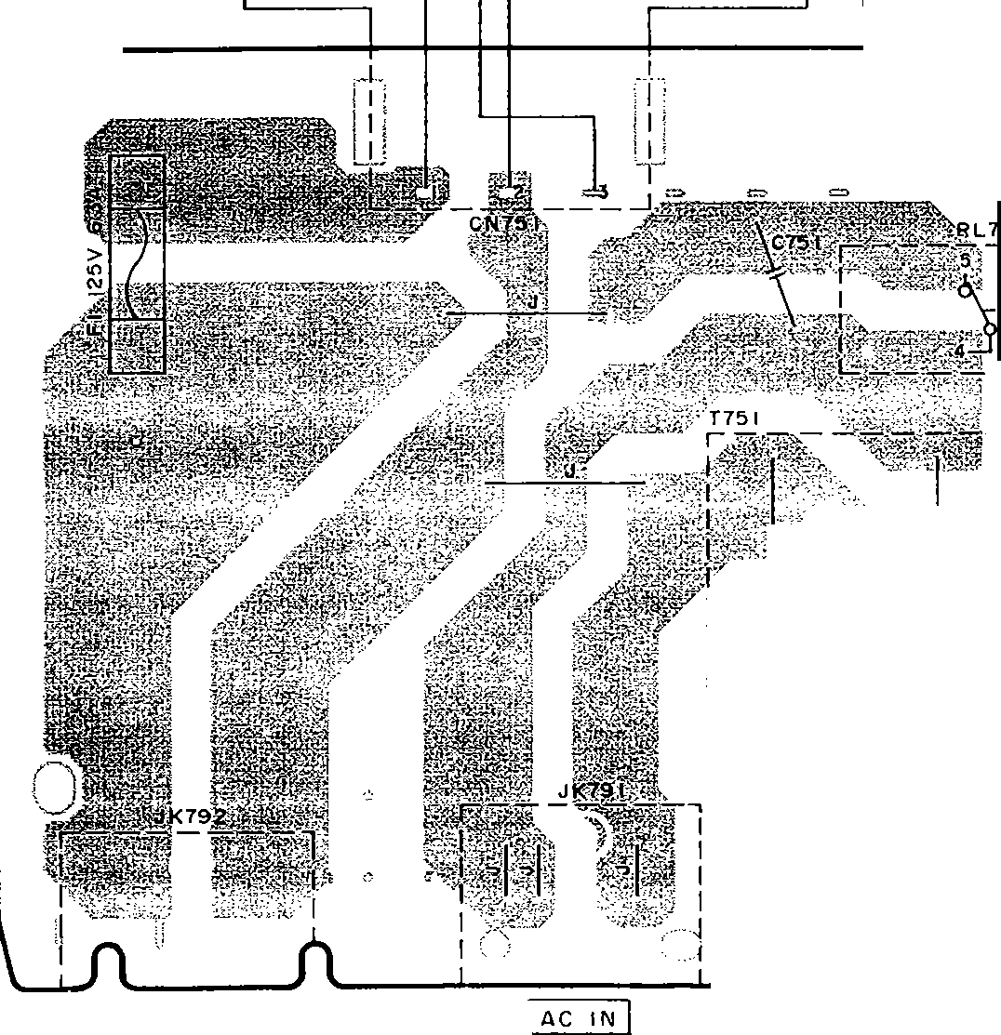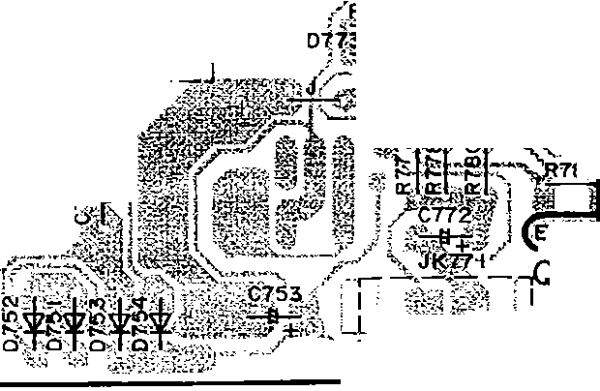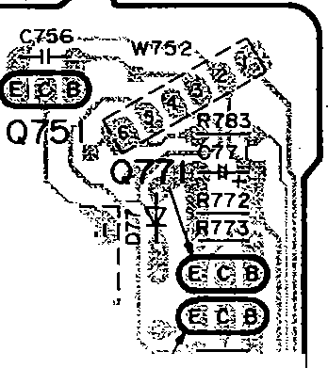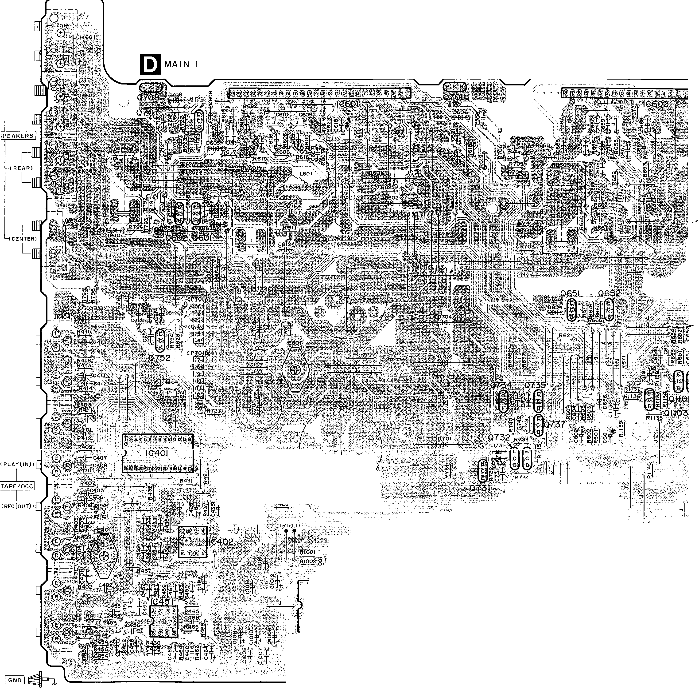

;:J

I

i . I **5** I **6**

I

**,e'**

**7 8 9 10 11 12 13 14**

**su;;G95**

I

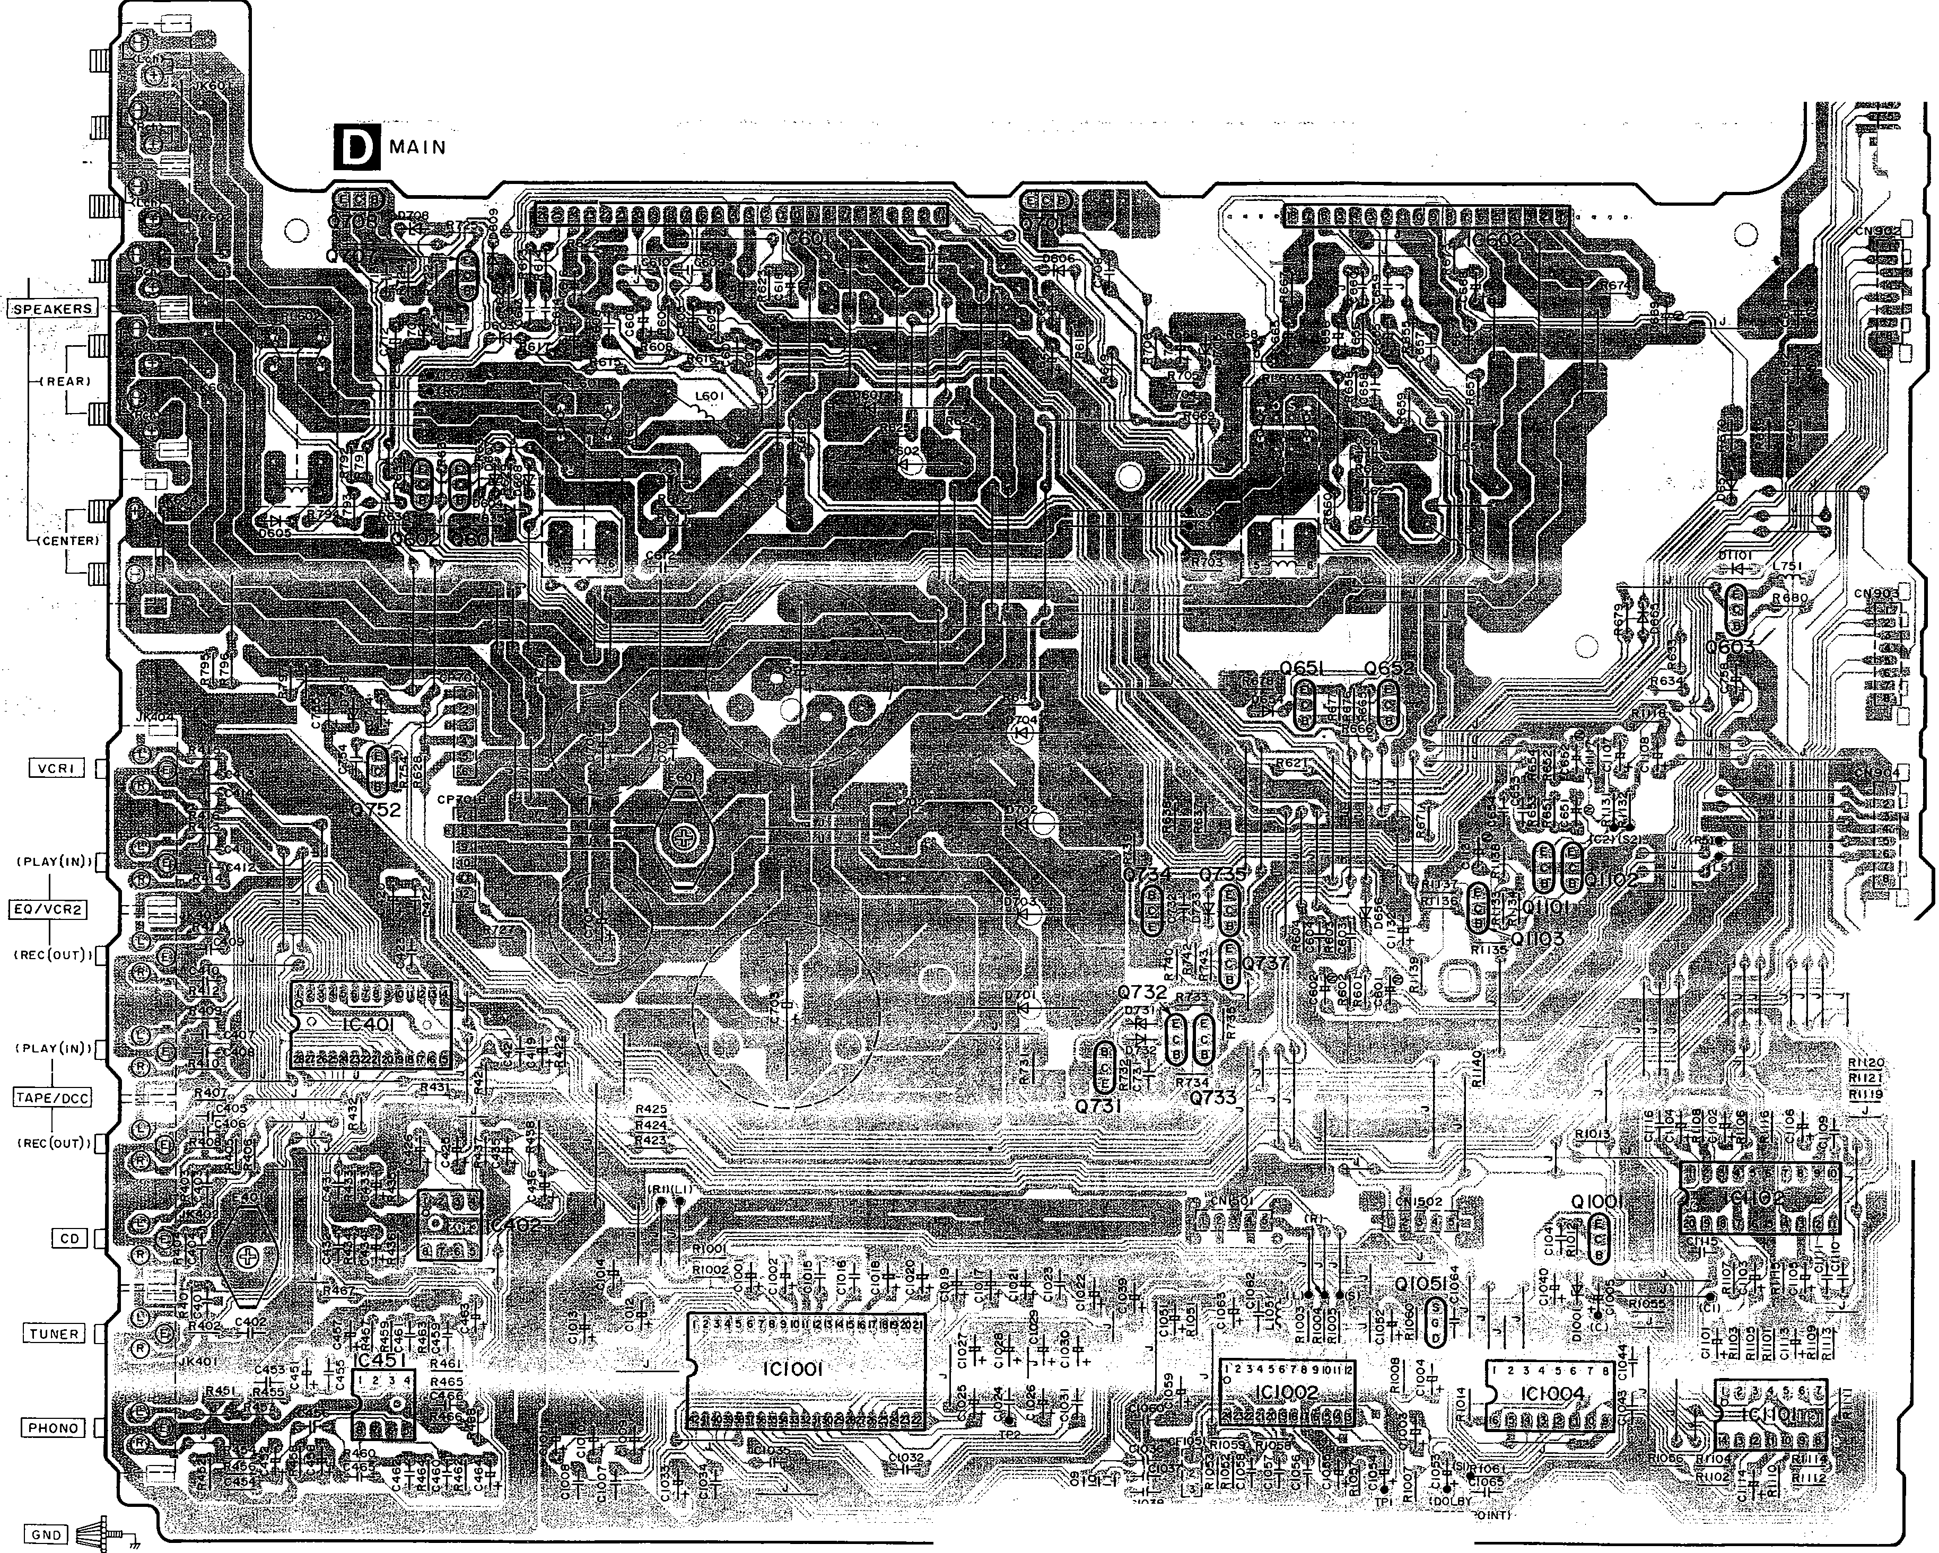

l

i

**IA.)**

L

FRONT)

I lt

I I

**P,C.8.** I **REP 17398-M** I '5

i

/

I, {

't

!>

i _':"1.

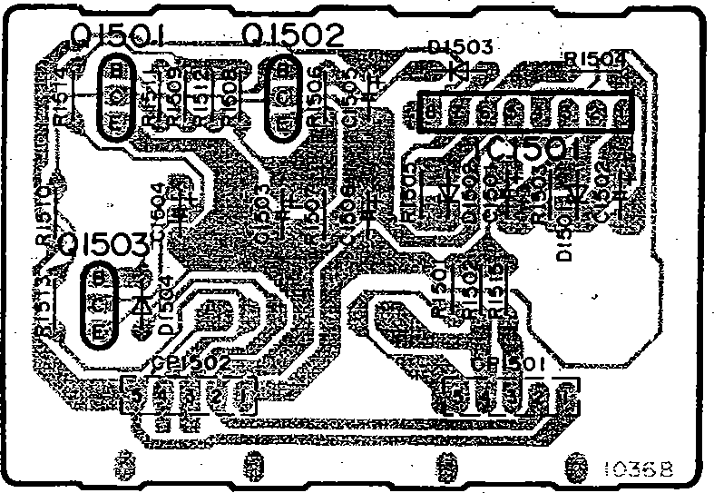, **[El MUTING P.C.8.IREP1565B-TI**

--

I

1

:f

J::!i

I

1:

'

t

l

I

1

l

l

I

I

j

i

'•0:1·01Q·f'

l

*0::* --:.lt. I.:

·'_:;_\;IV.:Kl

·-c.i,· , <:,- •••':' ·-.

!

1 - 24 - -25-

**,U-G95**



**1** 2 3 **4** 5 6 7 8

**SU-G95 SU-G95** j

9

.,_-.- --- - - -

* **TERMINAL GUii**

r-

**A B** OPERATION P.C.8.(REPl7408-SI

, -2

*·.:*

*q*

1

LCBA00805477 I AN!

*·*

33 32

AN6558-FS, 1LA2785

. {

**B** No. I

2SA992EFPTA I 2SC394

2S8621AQSTA

E --'

£ 8 CB

**C** 2S81357DEFTA

2SO2037DEFTA

2SJ4I

###### •,, -· I

0

_G_i..:.

:\

:1

,..;

**D**

:·

*R*

*i1*

tJ

*;2*

'1

li

I

,,;-- Cathode

Anode

**A1/**

MA4033M MA4039M MA4047M. MA4056M MA4068M MA4082M.

I mHEADPHONES

**r.iiJ** VOLUME PC.B.

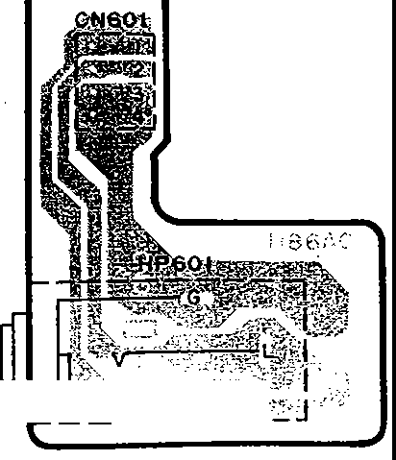, E

'ij

I

JACK PC.B.

(REP17408-SI

---

**l..!J** (REP 17408-S I

u*l*

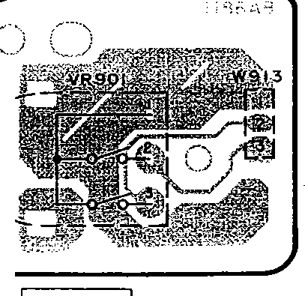

t:

:

f►

t.\.._

r ;y.

1

Ci PHONES1'-\J U'- < .:... ·s_

F

i

I --

lvoLUMEI

l" **G**

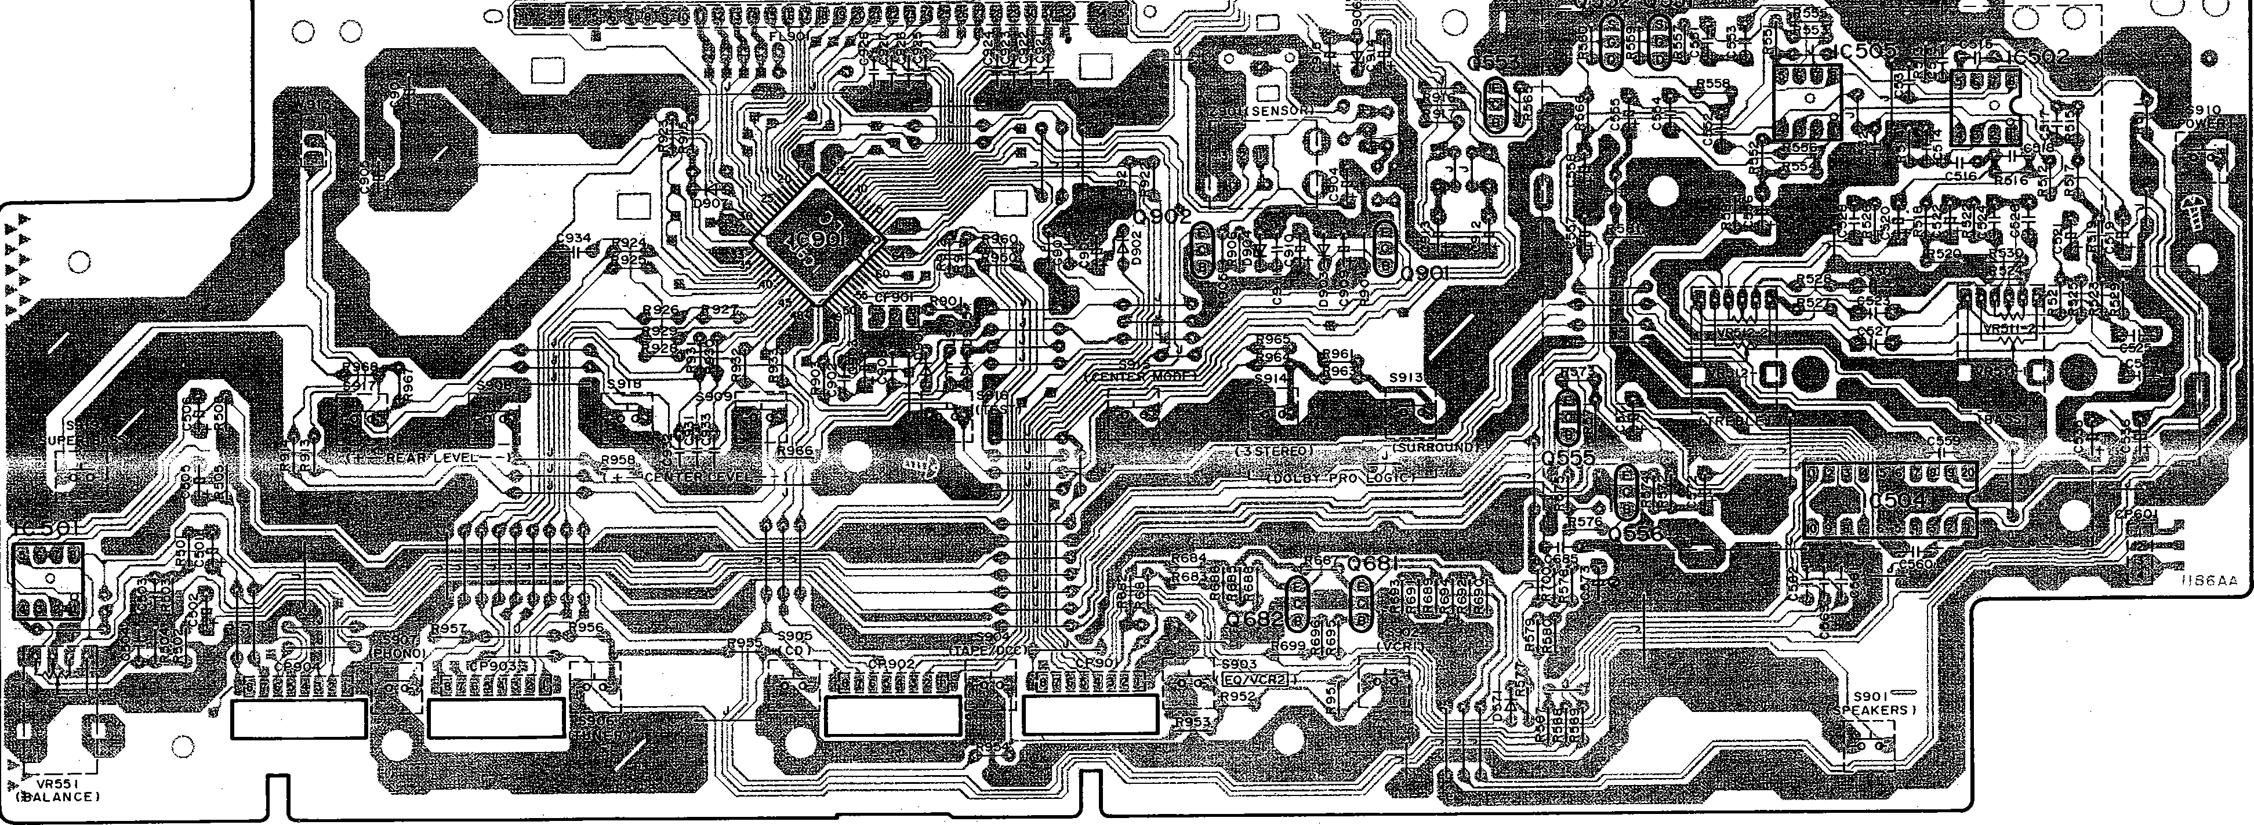

-26- -27-

r  **SU-G95 . SU-G95**

,! 5 6 7 8 9

j

l

j

j

* **TERMINAL GUIDE OF IC'S, TRANSISTORS AND DIODES**

'

AN6554F

*q*

*q*

TC9212P

l20Pinl

8

14

*0*

7

I

No.I

No.I

I AN6558-FSG I BPlnl

l42Pinl

**,qlc=**

No. I

*q*

No.I

MA4100MTA MA4150MTA MA4220MTA MA4360MTA

f**A**tCa **1**Cath**/**ode

Anode

MA4033MTA MA4039MTA MA4047MTA MA4056MTA MA4068MTA MA4082MTA

*)<* Cathode A1/

Anode

Anode

P300DLF P300D5002T SB3606501T

Co

. -

Anode

MA165TA MA700ATA 1SS291TA

1SR35200TB

Co .

*f***A***f* **1**Cath**/**ode

2SK301RSTA

..D

s

0

2SJ40CDTA

CE

8

>

2S81357DEFTA

2SD2037DEFT A

2SD1761DEF

E

2S81187DEF

.,

- E

2SC3327ABTP

B

2SA130.9AIRTA

2SC3311AIRTA UN4111TA UN421FTA UN4211TA UN4214TA

·

Ecp

B

2SC3940AQST A

B

E

2SA992EFPTA

2S8621AQSTA

I NJU7312Alt 28Pinl

IUPC4570C I apinl

**8**

·

M5218AL

RSN3306

(l)"

26

SVl3204B

Q)

18

l24Pinl

LV1010

l16Pinl

TC9214P

I 8Pinl

M5218AP

I

64

0

rr

16

*..s,·*

/-

•

4·9 .

LC8A00805477

33 32

*N*

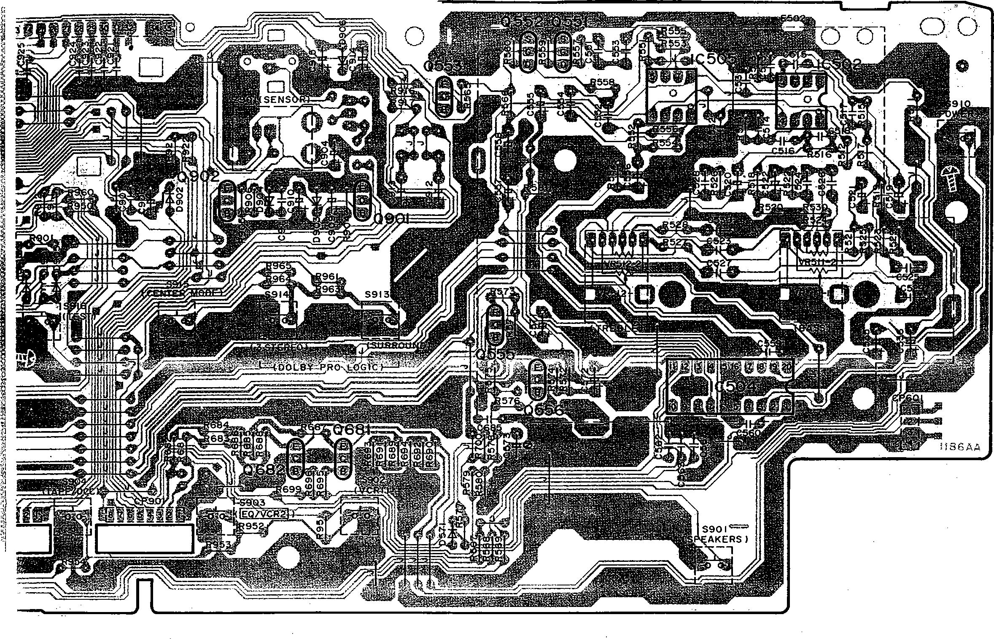- ,

I

.:,--

.. j

i

i

,,·

{

*_.-,1*

-·-

lt

I

i

i5j

**r.J** VOLUME PC.B.

**L!J** (REP 17408-S I

###### I

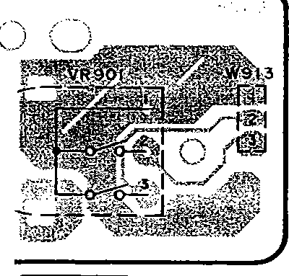

l).

*t.r,*

*trrl,l>,.,*

t iv

"\..

,;-

'i<·"

l

'j

·;i,.

j

1

I

I VOLUME I

1·

'

-27- -28-

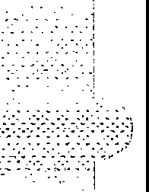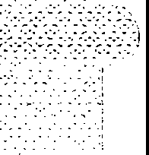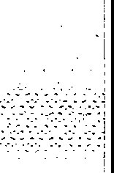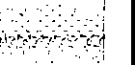 

* + 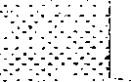**TERMINAL FUNCTION OF IC**
* 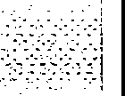**IC901 (LC8A008C5477): Microcomputer**

|  |  |  |  |
| --- | --- | --- | --- |
| **Pin No.** | **Mark** | **1/0**  **Division** | **Function** |
| .1  2 | S.PA  SPB | 0 | Speaker select control terminal |
| 3 | ST1 | 0 | Level shift control terminal |
| 4 | NC | - | Not used, open |
| 5 | RELAY | 0 | Relay control terminal |
| 6 | AF MUTE | 0 | Muting control terminal |
| 7 | -20d8 | 0 | Muting control (-20d8) terminal |
| 8  \  15 | DG1  \  DG8 | 0 | Digit signal of FL display |
| 16 | S13 | 0 | Segment signal of FL display |
| 17 | VDD | I | Power supply terminal |
| 18 | VPP | I | Power supply terminal of FL display |
| 19  \  30 | S12  \  S1 | 0 | Segment signal of FL display |
| 3.1  32 | NC | 0 | No connection |
| 33 | INI | - | Not used, connected to resistor |
| 34 | NC | I - - | No connection |
| 35 | NC | I | No connection |
| 36 | NC | I | No connection |
| 37 | SUPER BASS | - | Super bass control terminal |
| 38 | TUNER | 0 | Not used, open |
| 39 | VIDEO | 0 | Not used, open |
| 40 | CE | 0 | Chip enable terminal |

|  |  |  |  |
| --- | --- | --- | --- |
| **Pin No.** | **Mark** | **1/0**  **Division** | **Function** |
| 41 | DATA1 | 0 | Serial data signal |
| 42 | OVER LOAD | I | Over load detect terminal |
| 43 | CK1 | 0 | Serial clock signal |
| 44 | DATA2 | 0 | Serial data signal |
| 45 | ST2 | 0 | Level shift control terminal |
| 46 | CK2 | 0 | Serial clock signal |
| 47 | 5-6 | 0 | Remote control terminal |
| 48 | SURR BASS | 0 | Surround selector terminal |
| 49 | NC | - | No connection |
| 50 | RESET | I | -  Reset detect terminal |
| 51 | XT1 | - | Not used, connected to power supply |
| 52 | XT2 | - | Not used, open |
| 53 | vss | - | GND terminal |
| 54 | CF1 | ,.,.  I | Crystal oscillator |
| 55 | CF2 | 0 | Terminal (6MHz) |
| 56 | VDD | I | Power supply terminal |
| 57  \  60 | KEY1  \  KEY4 | I | Key matrix detect terminal |
| 61 | STANDBY | 0 | Power detect terminal |
| 6.2  63 | ENCO.DEA ENCODES | - | Not used, connected to power supply |
| 64 | REMOCON IN | I | Remote control terminal |

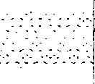-29-

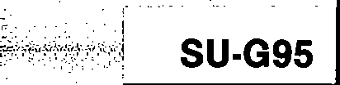

* + - 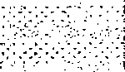**REPLACEMENT PARTS LIST**

**Notes:** • Important safety notice:

Components identified by ,t,. mark have special characteristics important for safety.

Furthermore, special parts which have purposes of fire-retardant (resistors), high-quality sound (capacitors), low-noise (resistors), etc. are used. When replacing any of components, be sure to use only manufacturer's specified parts shown in the parts 11st.

*The "(SF)" mark denotes the standard part.

|  |  |  |  |  |  |  |  |
| --- | --- | --- | --- | --- | --- | --- | --- |
| Ref. No. | Part **No.** | Part Name & Description | Remarks | Ref. No. | Part **No.** | Part Name & Description | Remarks |
|  |  |  |  |  |  | ACCESSORIES |  |
|  |  | CABINET AND CHASSIS |  |  |  |  |  |
|  |  |  |  | Al • | RFKS!fl\'A22P-K | INSTRUCTION MANUAL ASS' **Y** | SC-S3500/S3550 |
| 1 | RG\\0197-K | BASS/I'REBLE/BALANCE KNOB |  |  |  |  | for U.S. A. |
| 2 | RG\\0199-K | VOLUME KNOB |  | Al • | RFKS!fl\'A32P-K | INSTRUCTION MANUAL ASS' Y | SC-S4500/S4505/S4550 |
| 3 | RHD30035-K | **SCREW** |  |  |  |  | for U.S. A. |
| 4 | RI00041A-K | CABINET |  | Al • | RFKS!fl\'A42PCK | INSTRUCTION MANUAL ASS' Y | SC-S2500/S2550 |
| 5 | XTBS3+8JFZ1 | **SCREW** |  |  |  |  | for CANADA. |
| 6 | RGR0186B-A | REAR PANEL |  | Al • | RFKS!fl\'A62PCK | INSTRUCTION MANUAL ASS' Y | SC-S3500/S3550 |
| 7 | HMC0158 | TRANSISTOR OOLDER |  |  |  |  | for CANADA. |
| 8 | RFKJUG75PP-K | BOTTCl!I CHASSIS ASS' Y |  | A2 • | RQA0085 | WARRANTY CARD | for U.S. A. |
| 8-1 | SKL293 | RUBBER FOOT |  | A2 • | SQX7183 | WARRANTY CARD | for CANADA. |
| 9 | HMN0217-1 | P. C. B. OOLDER |  | A3 • | RQCB0391 | SERVICENTER LIST | for U.S. A. |
| 10 | SNE4021-1 | NUT |  | A3 • | SQX9131 | SERVICENTER LIST | for CANADA. |
| 11 | REZ0645 | FLAT CABLE (W913) (3P) |  | A4 • | RAK-SA112MH | REMOTE CONTROL TRANSMITTER | SC-S2500/S2550 |
| 12 | HMN0195 | FL HOLDER PIECE |  |  |  |  | for CANADA. |
| 13 | SHE187-2 | P. C. B. SUPPORT |  | A4 • | RAK-SA723MH | REMOTE CONTROL TRANSMITTER | SC-S3500/S3550/S4500, |
| 14 | RFKEUG75PP-K | CONNECTOR ASS' Y(W701) (12P) |  |  |  |  | S4505/S4550 |
| 15 | RWJ1806110KK | FLAT CABLE (W752) (6P) |  |  |  |  | for U.S. A. |
| 16 | HMN0260 | FL HOLDER |  |  |  |  | SC-S3500/S3550 - |
| 17 | XTB3+20JFZ | SCREW |  |  |  |  | for CANADA. |
| 18 | XTB3+8JFZ | **SCREW** |  | M-1 • | RKK0057-K | BATTERY COVER | SC-S2500/S2550 |
| 19 | XTW3+15T | **SCREW** |  |  |  |  | for CANADA. |
| 20 | REl!II020-1 | FAN UNIT |  | M-1 • | RKK0020-K | BATTERY COVER | SC-S3500/S3550/S4500, |
| 20-1 | MDN-4RB4MRC | l!IJTOR |  |  |  |  | S4505/S4550 |
| 20-2 | SHE232-1 | FAN |  |  |  |  | for U.S. A. |
| 20-3 | HM00209-K | FAN CASE |  |  |  |  | SC-S3500/S3550 |
| 20-4 | HM00208-K | FAN CAP |  |  |  |  | for CANADA. |
| 20-5 | SUS271 | SPRING |  | A5 • | RSA0006_ | FM INDOOR ANTENNA | for IUNER |
| 20-6 | **HM00212-K** | FAN -TERM!NAL CAP |  | A6 • | RSAOOlO | **AM** LOOP ANTENNA SET | for IUNER |
| 21 | RFKGUG95PP-K | FRONT PANEL ASS' Y |  | A6-1 • | HMN0244 | **AM** ANTENNA HOLDER | for IUNER |
| 21-1 | RK\\0327-K | TRANSPARENT PLATE |  | A6-2 • | XTN3+10AFZ | SCREW | for IUNER |
| 22 | RGU0882-K | POWER BUTTON |  | A7 • | SJA172 | AC POWER SUPPLY CORD | &(SF) |
| 23 | RGU1027-K | SELECTOR/PRO. LOGIC BUTTON |  | AB • | SJPK2203-2 | STEREO CONNECTION CABLE | (40cm) |
| 24 | RHD26016 | **SCREW** |  | A9 • | SJP2249-3 | STEREO CONNECTION CABLE | (80cm) |
| 25 | RFKNUG75PPAK | SPEAKERS BUTTON ASS' Y |  | **Note:•** Parts identified by the":!<'' mark are contained in the carton **(accessories box)** of **SH-WA22 (P), SH-WA32 (P), SH-WA52 (PC) or SH-WA62 (PC)** listed in the table **"LINE-UP OF COMPONENTS"** on **the page 3.**  **Refer** to the **packaging** on page **3, 4** of the Technical **Information** for **Model No. SH-WA12/SH-WA22/SH-WA32/ SH-WA42/SH-WA52/SH-WA62, Order No. AD9401009T1.** | | | |
| 26 | RFKNUG75PPBK | SUPER BASS BUTTON ASS' Y |  |
| 27 | XTBS26+8J | **SCREW** |  |
| 28 | SNE2123 | GND TERM!NAL |  |
| 29 | RSC0105-2 | SHIELD PLATE |  |
|  |  |  |  |
|  |  | PACKING MATERIAL |  |
|  |  |  |  |
| Pl | RPG1948 | PACKING CASE |  |
| P2 | RPN0682-2 | CUSHION |  |
| P3 | XZB60X65A01Z | PROTECTION BAG |  |
|  |  |  |  |

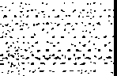

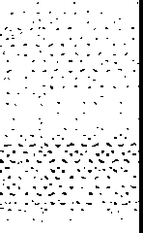

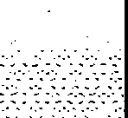

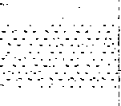

-

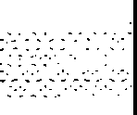

-30-

**1** 2 3 **4** 5 6 7 8 9

* **CABINET PARTS LOCATION**

**,.SU-G95**

/ 18

14 6---i

JK792 17

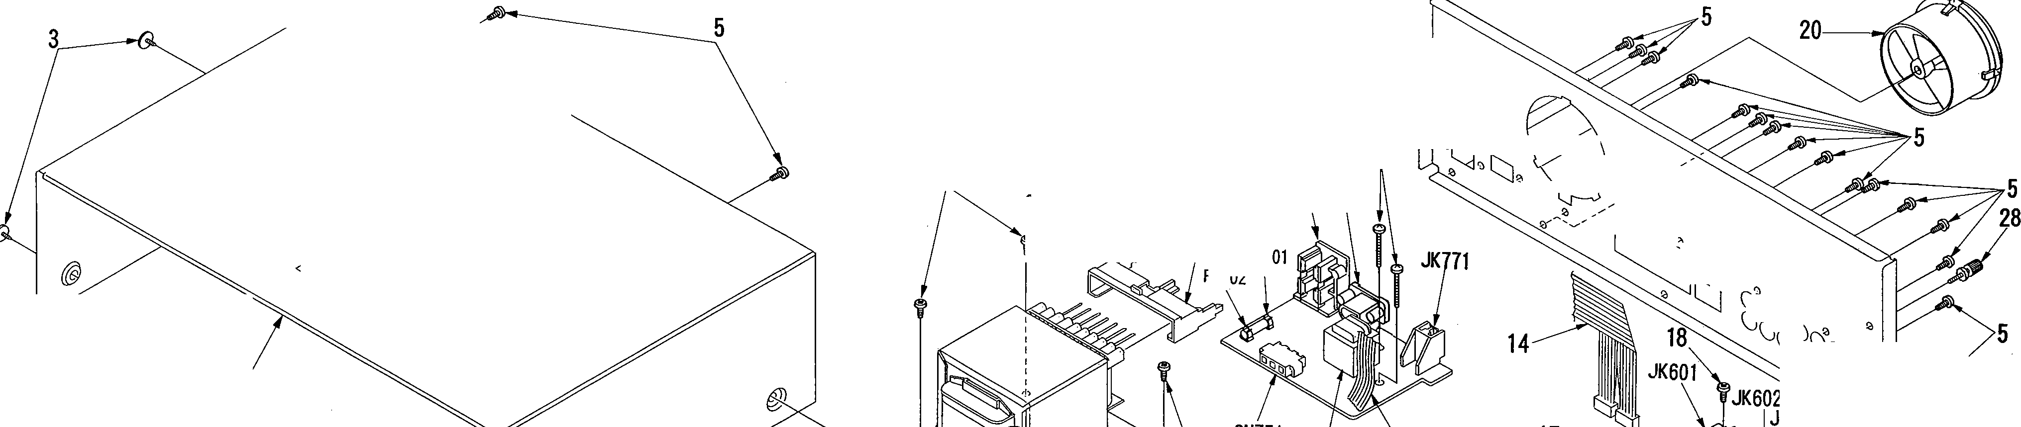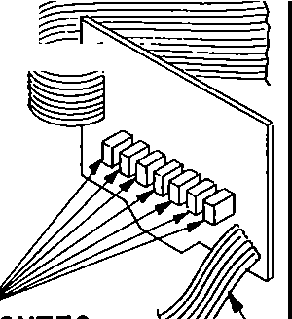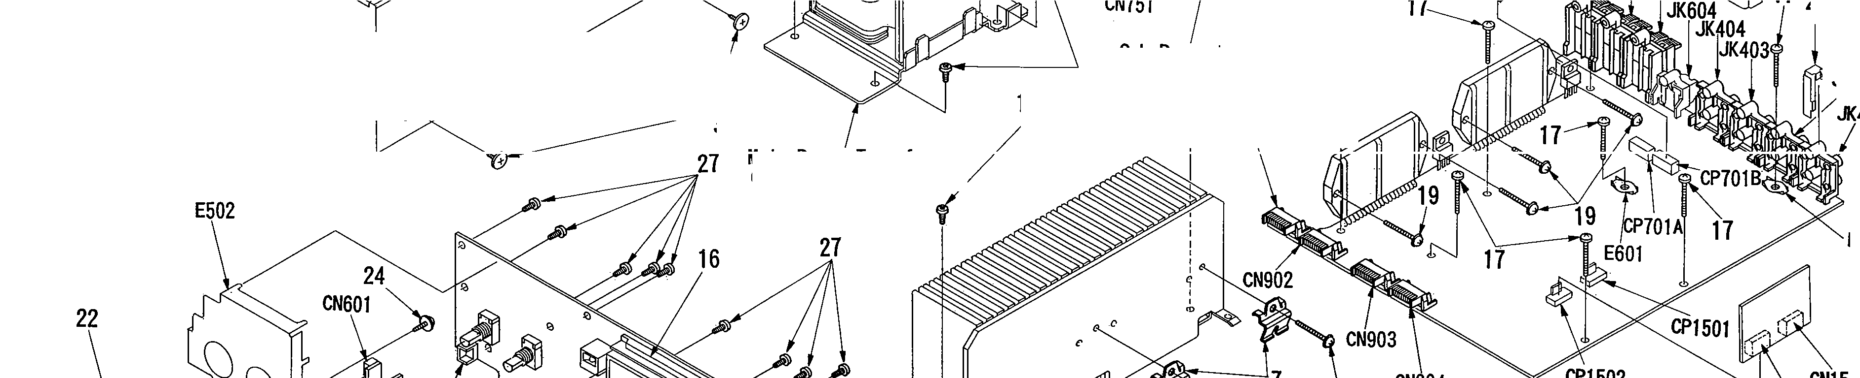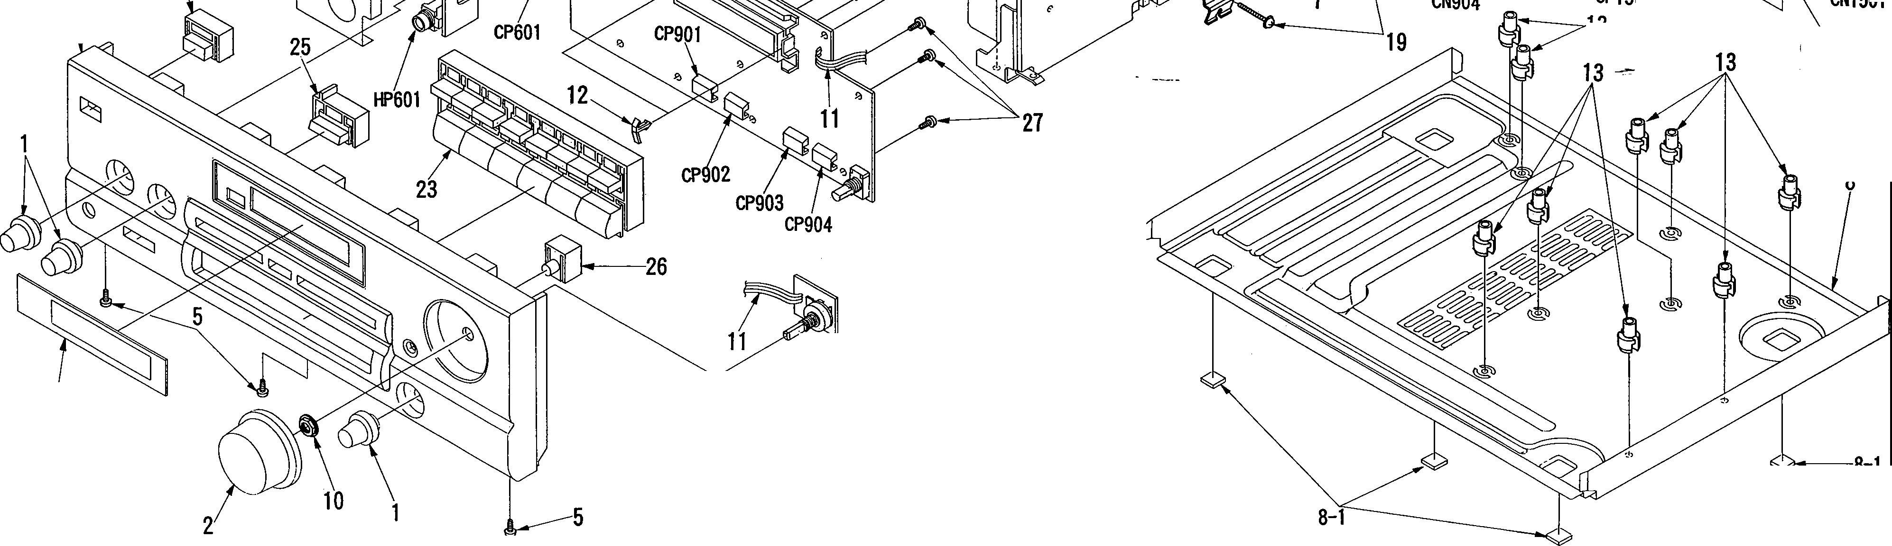

CN753~CN759 W \ \ JK79

't:;i" \ ;:::::l: ,,

'\. .,,,,,,...,,,..

//,-. ll

,, I'-. ll

f g 15FC

FC '

4

15 18

' ll

*c}'*

- s(J\jC\J)\J\Jll f*V*

·

29

_,/

Sub **Power** Transformer!

18

(T751)

, JK402

3

Main Power Transformer

(T701)

**l *B*** CN901

401

...a.--

E401

21

02

13

CN1502

--· *lw*//,;o-/41 I

// 20-1 *,J* I

21-1

// ///

* II

,,,, . I

_J

4 8-1

,, ---

20- ,

---- 20-5 20-3

20-s II

-31- -32-

""-

**I REPLACEMENT PARTS LIST**

*Important safety notice:

Components identified by <!!. mark have special characteristics Important for safety.

Furthermore, special parts which have purposes of fire-retardant (resistors), high-quality sound (capacitors), low-noise (resistors), etc. are used. When replacing any of components, be sure to use only manufacturer's specified parts shown in the parts list.

**SU-G95 SU-G95**

---"!---'-'C'"

|  |  |  |  |  |  |  |  |
| --- | --- | --- | --- | --- | --- | --- | --- |
| Ref. **No.** | Part No. | Part Name & Description | Remarks | Ref. No. | Part No. | Part Name & Description | Remarks |
|  |  | COIL (S) |  | RL601-603 | RSY0013M-O | RELAY | & |
|  |  |  |  | RL751 | RSY0019M-O | RELAY | & |
| L601, 602 | RLQYR73M | COIL |  |  |  |  |  |
| L651, 652 | RLQYR73M | COIL |  |  |  | CONNECTOR (S) AND SOCKET(S) |  |
| L751 | ELEPK101KA | COIL |  |  |  |  |  |
| L901 | RLQZP101KT-Y | COIL |  | CN601 | RJU057W004 | SOCKET(4P) |  |
| Ll051 | ELEPK101KA | COIL |  | CN751 | SJS305-1 | CONNECTOR (3P) |  |
|  |  |  |  | CN753-759 | RJS1A1101Tl | CONNECTOR(lP) |  |
|  |  | TRANSFORMER (S) |  | CN901-904 | RJU003K008Ml | SOCKET(8P) |  |
|  |  |  |  | CN1501 | RJU060G05T | SOCKET(5P) |  |
| T701 | RTP1P5C016-V | POWER TRANSFORMER **(MAIN)** | & | CN1502 | RJU060G05T | SOCKET(5P) |  |
| T751 | RTP1H5C001-V | POWER TRANSFORMER(SUB) | & | CP601 | RJT057W004-1 | CONNECTOR ( 4P) |  |
|  |  |  |  | CP701A | RJT039W06T | CONNECTOR (6P) |  |
|  |  | COMPONENT COIIBINATION (S) |  | CP701B | RJT039W06T | CONNECTOR(6P) |  |
|  |  |  |  | CP901-904 | RJT003K008-1 | CONNECTOR(8P) |  |
| 2901 | RCDHC-278N | REMOTE SENSOR |  | CP1501 | RJT060R05 | CONNECTOR (5P) |  |
|  |  |  |  | CP1502 | RJT060R05 | CONNECTOR (SP) |  |
|  |  | OSCJLLATOR(S) |  |  |  |  |  |
|  |  |  |  |  |  | JACK(S) AND TERMINAL (S) |  |
| CF901 | EFOEC6004T4 | OSCILLATOR(6MHz) |  |  |  |  |  |
| CF1051 | EFOEC8004T4 | OSCILLATOR(8MHz) |  | HP601 | QJA0455ZC | HEADPHONES JACK |  |
|  |  |  |  | JK401 | SJF3069N | PHONO/flJNER TERM!NAL |  |
|  |  | DISPLAY TUBE (S) |  | JK402 | SJF3069N | CD/fAPE,tOCC TERMINAL |  |
|  |  |  |  | JK403 | SJF3069N | TAPE/OCC;VCR2 00T TERMINAL |  |
| FL901 | RSL0167-F | DISPLAY TUBE |  | JK404 | SJF3069N | VCR2 IN;VCRl IN TERMINAL |  |
|  |  |  |  | JK601 | RJR0054 | FRONT SPEAKERS A TERMINAL |  |
|  |  | FUSE (S) |  | JK602 | RJR0054 | FRONT SPEAKERS B TERMINAL |  |
|  |  |  |  | JK603 | RJR0054 | REAR SPEAKERS TERMINAL |  |
| Fl | XBA1C63NBAU | FUSE, 125V 6. 3A | & | JK604 | SJF5201M-1 | CENTER SPEAKER TERMINAL |  |
|  |  |  |  | JK771 | RJS1A7402-1 | FAN MOTOR TERMINAL |  |
|  |  | Sn'JTCH(ES) |  | JK791 | SJSD16 | AC INLET | & |
|  |  |  |  | JK792 | RJS2A0102-S | AC OUTLET | & |
| S901 | EVQ21405R | SPEAKERS |  |  |  |  |  |
| S902 | EVQ21405R | VCRl |  |  |  | GND PLATE (S) |  |
| S903 | EVQ21405R | EQ;VCR2 |  |  |  |  |  |
| S904 | EVQ21405R | TAPE/OC-B· - |  | E401 | SNE1004-1 | GND PLATE |  |
| S905 | EVQ21405R | CD |  | E502 | RSC0371 | GND PLATE |  |
| S906 | EVQ21405R | TIJNER |  | E601 | SNE1004-1 | GND PLATE |  |
| S907 | EVQ21405R | PHONO |  |  |  |  |  |
| S908 | EVQ21405R | REAR LEVEL- |  |  |  | FUSE HOLDER (S) |  |
| S909 | EVQ21405R | CENTER LEVEL- |  |  |  |  |  |
| S910 | EVQ21405R | POWER |  | FC701, 702 | EYF52BC | FUSE HOLDER |  |
| S913 | EVQ21405R | SURROUND |  |  |  |  |  |
| S914 | EVQ21405R | 3 STEREO |  |  |  |  |  |
| S915 | EVQ21405R | CENTER MODE |  |  |  |  |  |
| S916 | EVQ21405R | TEST |  |  |  |  |  |
| S917 | EVQ21405R | REAR LEVEL+ |  |  |  |  |  |
| S918 | EVQ21405R | CENTER LEVEL+ |  |  |  |  |  |
| S919 | EVQ21405R | SUPER BASS |  |  |  |  |  |
|  |  |  |  |  |  |  |  |
|  |  | RELAY(S) |  |  |  |  |  |
|  |  |  |  |  |  |  |  |

-33- -34-

|  |  |  |  |  |  |  |  |
| --- | --- | --- | --- | --- | --- | --- | --- |
| - | Part No. | Part Name & Description | Remarks | Ref. No. | Part No. | Part Name & Description | Remarks |
|  |  |  |  | QllOl, 1102 | 2SC3311AIRTA | TRANSISTOR |  |
|  |  | INTEGRATED CIRCUIT(S) |  | Ql103 | 2SA1309AIRTA | TRANSISTOR |  |
|  |  |  |  | Q1501, 1502 | 2SC3311AlRTA | TRANSISTOR |  |
|  | NJU7312AL | INPUT SELECTOR |  | Q1503 | UN4211 | TRANSISTOR |  |
|  | M5218AP | BUFFER AMP |  |  |  |  |  |
|  | AN6558-FSG | PHONO EQ. AMP |  |  |  | DIODE(S) |  |
|  | M5218AP | BUFFER AMP |  |  |  |  |  |
|  | UPC4570C | TONE AMP |  | D571 | M.A.165 | DIODE |  |
|  | TC9212P | ATTENUATOR |  | D601, 602 | SB3606501T | DIODE |  |
|  | M5218AP | SUPER BASS AMP |  | D603 | MA4082MTA | DIODE |  |
|  | RSN3306 | POWER AMP(FRONT) | & | D604-606 | M.A.165 | DIODE |  |
|  | SVI3204B | POWER AMP(CENTER/REAR) | & | D607, 608 | MA4033TA | DIODE |  |
|  | LC8A008C5477 | MICROCOMPUTER |  | D609 | M.A.165 | DIODE |  |
|  | LA2785 | OOLBY PRO. LtxiIC CONTROL |  | D654, 655 | M.A.165 | DIODE |  |
|  | LV1010 | OOLBY PRO. LtxiIC DRIVE |  | D656 | MA4047MTA | DIODE |  |
|  | TC9214P | SURRClJND SELECTOR |  | D657 | M.A.165 | DIODE |  |
|  | AN6554F | BUFFER AMP |  | D701-704 | P300D5002T | DIODE | & |
|  | TC9212P | ATTENUATOR |  | D705 | MA4150M | DIODE | & |
|  | M5218L | SIGNAL DETECTOR |  | D707 | MA4220MTA | DIODE | & |
|  |  |  |  | D708 | MA4150M | DIODE | & |
|  |  | TRANSISTOR (S) |  | D721-724 | P300DLF | DIODE | & |
|  |  |  |  | D731 | MA4360MTA | DIODE | & |
|  | 2SK301RSTA | TRANSISTOR |  | D732, 733 | M.A.165 | DIODE |  |
|  | UN4111 | TRANSISTOR |  | D751-754 | 1SR35200TB | DIODE | & |
|  | 2SC3311AIRTA | TRANSISTOR |  | D755 | M.A.165 | DIODE |  |
|  | 2SA1309AIRTA | TRANSISTOR |  | D756 | MA4068M | DIODE | & |
|  | UN4111 | TRANSISTOR |  | D771 | M.A.165 | DIODE |  |
|  | 2SA1309AlRTA | TRANSISTOR |  | D772 | MA4082MTA | DIODE | & |
|  | 2SC3311AIRTA | TRANSISTOR |  | D773 | M.A.165 | DIODE |  |
|  | 2SC3327-A | TRANSISTOR |  | D901, 902 | 1SS291TA | DIODE |  |
|  | 2SD1761DEF | TRANSISTOR | & | D903 | M.A.165 | DIODE |  |
|  | 2SB621AQSTA | TRANSISTOR | & | D904 | MA4039MTA | DIODE | & |
|  | 2SB1187DEF | TRANSISTOR | & | D905 | M.A.165 | DIODE |  |
|  | 2SB1357DEFTA | TRANSISTOR | & | D906 | MA4056MTA | DIODE | & |
|  | 2SC3311AIRTA | TRANSISTOR | & | D907 | MA165 | DIODE |  |
|  | 2SD2037DEFTA | TRANSISTOR | & | DlOOl | MA4100MTA | DIODE | & |
|  | 2SA992EFPTA | TRANSISTOR | & | DllOl | MA165 | DIODE |  |
|  | 2SA992EFPTA | TRANSISTOR | & | D1501, 1502 | MA4068M | DIODE |  |
|  | UN421FTA | TRANSISTOR |  | D1503 | MA700 | DIODE |  |
|  | 2SC3940AQSTA | TRANSISTOR | & | D1504 | MA165 | DIODE |  |
|  | 2SA1309AIRTA | TRANSISTOR |  |  |  |  |  |
|  | 2SB621AQSTA | TRANSISTOR | & |  |  | VARIABLE RESISTOR (S) |  |
|  | 2SA1309AIRTA | TRANSISTOR |  |  |  |  |  |
|  | UN4214TA | TRANSISTOR |  | VR511, 512 | EVJYA1F02C15 | TONE CONT. BASS/TREBLE |  |
|  | 2SA1309AIRTA | TRANSISTOR | & | VR551 | EVJ02QF02G15 | BALANCE |  |
|  | 2SC3940AQSTA | TRANSISTOR | & | VR901 | EVQ!l'QAF2524B | VOLUME |  |
|  | 2SJ40CDTA | TRANSISTOR |  |  |  |  |  |

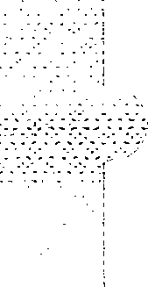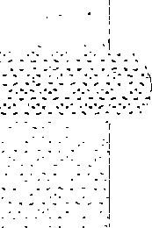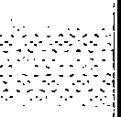**SU-G95**

* **RESISTORS AND CAPACITORS**

Notes : • Capacity values are in microfar-ads (uF) unless specified otherwise, P=Pico-farads (pF) F=Farads (F)

* + 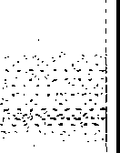Resistance values are in ohms, unless specified otherwise, lK=l,000 (OHM), lM=l,000k (OHM)

|  |  |  |  |  |  |  |  |  |  |  |  |  |  |  |  |
| --- | --- | --- | --- | --- | --- | --- | --- | --- | --- | --- | --- | --- | --- | --- | --- |
| Ref. No. | Part No. | Values & | | Remarks | Ref. No. | Part No. | Values & Remarks | | | | Ref. No. | Part No. | Values & | | Remarks |
|  |  |  | | | R601, 602 | ERDS2TJ102 | l/4W | lK |  |  | R706 | ERDS2TJ471 | l/4W | 470 |  |
|  |  | RESISTORS | | | R603, 604 | ERDS2TJ563 | l/4W | 56K |  |  | R721 | ERDS1FVJ6R8T | 1/2W | 6. 8 | & |
|  |  |  | | | R605, 606 | ERDS2TJ182 | l/4W | 1. 8K |  |  | R722 | ERD25FJ101 | 1/4W | 100 | & |
| R401-404 | ERDS2TJ102 | **l/4W** | lK | | R607, 608 | ERDS2TJ563 | **l/4W** | 56K |  |  | R723 | ERDS2TJ472 | **l/4W** | 4. 7K |  |
| R405, 406 | ERDS2TJ104 | **l/4W** | lO0K | | R609, 610 | ERDS2TJ470 | **l/4W** | 47 |  |  | R724 | ERDSlFVJlO0T | 1/2W | 10 | & |
| R407-416 | ERDS2TJ102 | **l/4W** | lK | | R611, 612 | ERDSlFVJlO0T | 1/2W | 10 | & |  | R725 | ERDS2TJ152 | **1/4W** | 1. 5K |  |
| R421, 422 | ERDS2TJ102 | **l/4W** | lK | | R613, 614 | ERDS2TJ102 | l/4W | lK |  |  | R727 | ERD25FVJSR6T | **1/4W** | 5. 6 | & |
| R423-425 | ERDS2TJ103 | **l/4W** | lOK | | R615 | ERDS2TJ184T | **l/4W** | 180K |  |  | R731 | ERD25FVJ180T | **1/4W** | 18 | & |
| R431, 432 | ERDS2TJ102 | **1/4W** | lK | | R616 | ERDS2TJ154 | **l/4W** | 150K |  |  | R732 | ERDS2TJ153 | **1/4W** | 15K |  |
| R433, 434 | ERDS2TJ104 | **1/4W** | lO0K | | R617, 618 | ERDS2TJ473 | **l/4W** | 47K |  |  | R733 | ERDS2TJ273 | **1/4W** | 27K |  |
| R435, 436 | ERDS2TJ473 | **l/4W** | 47K | | R619 | ERDS2TJ223 | **l/4W** | 22K |  |  | R734 | ERDS2TJ223 | **1/4W** | 22K |  |
| R437, 438 | ERDS2TJ104 | l/4W | lO0K | | R620 | ERD25FJ220 | **l/4W** | 22 | & |  | R735 | ERDS2TJ333 | **l/4W** | 33K |  |
| R451, 452 | ERDS2TJ224T | **1/4W** | 220K | | R621 | ERDS2TJ183T | l/4W | 18K |  |  | R739 | ERD25FVJ180T | 1/4W | 18 | & |
| R453, 454 | ERDS2TJ821 | l/4W | 820 | | R622 | ERDS2TJ124T | **l/4W** | 120K |  |  | R740 | ERDS2TJ393 | **1/4W** | 39K |  |
| R455, 456 | ERDS2TJ563 | **l/4W** | 56K | | R623 | ERDS2TJ684 | l/4W | 680K |  |  | R742 | ERDS2TJ393 | 1/4W | 39K |  |
| R457, 458 | ERDS2TJ271 | **l/4W** | 270 | | R624, 625 | ERDS2TJ563 | l/4W | 56K |  |  | R743 | ERDS2TJ183T | **l/4W** | 18K |  |
| R459, 460 | ERDS2TJ680T | l/4W | 68 | | R628 | ERDS2TJ223 | 1/4W | 22K |  |  | R754 | ERDS2TJ102 | **1/4W** | lK |  |
| R461. 462 | ERDS2TJ184T | 1/4W | 180K | | R629, 630 | ERDS2TJ472 | l/4W | 4. 7K |  |  | R772 | ERDS2TJ104 | 1/4W | lO0K |  |
| R463, 464 | ERDS2TJ123 | **1/4W** | 12K | | R631, 632 | ERDS2TJ103 | **l/4W** | lOK |  |  | R773 | ERDS2TJ103 | 1/4W | lOK |  |
| R465, 466 | ERDS2TJ563 | 1/4W | 56K | | R633, 634 | ERDS2TJ222 | **l/4W** | 2. 2K |  |  | R774 | ERDS2TJ223 | 1/4W | 22K |  |
| R467, 468 | ERDS2TJ102 | **l/4W** | lK | | R635, 636 | ERDS1FVJ821T | l/2W | 820 | & |  | R775 | ERDS2TJ332 | l/4W | 3. 3K |  |
| R501, 502 | ERDS2TJ332 | l/4W | 3. 3K | | R637-640 | ERGlSJlOlE | **lW** | 100 |  |  | R776 | ERDS1FVJ150T | l/2W | 15 | & |
| R503-506 | ERDS2TJ224T | **l/4W** | 220K | | R641 | ERDS2TJ684 | **l/4W** | 680K |  |  | R777 | ERDS2TJ150T | **1/4W** | 15 |  |
| R511, 512 | ERDS2TJ471 | l/4W | 470 | | R651, 652 | ERDS2TJ102 | 1/4W | lK |  |  | R778 | ERDS2TJ222 | 1/4W | 2. 2K |  |
| R513, 514 | ERDS2TJ104 | 1/4W | lO0K | | R653, 654 | ERDS2TJ563 | l/4W | 56K |  |  | R779 | ERDS2TJ103 | 1/4W | lOK |  |
| R515,. 516 | ERDS2TJ474 | 1/4W | 470K | | R655, 656 | ERDS2TJ182 | 1/4W | 1. 8K |  |  | R780, 781 | ERDS2TJ333 | 1/4W | 33K |  |
| R517, 518 | ERDS2TJ471 | 1/4W | 470 | | R657, 658 | ERDS2TJ563 | 1/4W | 56K |  |  | R782 | ERDS2TJ153 | 1/4W | 15K |  |
| R519, 520 | ERDS2TJ182 | l/4W | 1. BK | | R659, 660 | ERDS2TJ470 | l/4W | 47 |  |  | R783 | ERDS2TJ103 | 1/4W | lOK |  |
| R521, 522 | ERDS2TJ223 | l/4W | 22K | | R661, 662 | ERDSlFVJlO0T | l/2W | 10 | & |  | R791-796 | ERDS2TJ223 | l/4W | 22K |  |
| R523, 524 | ERDS2TJ392T | l/4W | 3. 9K | | R665 | ERDS2TJ563 | l/4W | 56K |  |  | R797 | ERDS2TJ682T | l/4W | 6.8K |  |
| R525, 526 | ERDS2TJ222 | 1/4\\L-2. 2K | | | R666 | ERDS2TJ104 | 1/4W | 100K |  | -. | R901 | ERDS2TJ102 | 1/4W | lK |  |
| R527, 528 | ERDS2TJ122 | 1/4W | 1. 2K | | R667 | ERD25FJ101 | 1/4W | 100 | & |  | R903 | ERDS2TJ104 | l/4W | 100K |  |
| R529, 530 | ERDS2TJ473 | 1/4W | 47K | | R668 | ERDS2TJ154 | l/4W | 150K |  |  | R904 | ERDS2TJ472 | l/4W | 4.7K |  |
| R551, 552 | ERDS2TJ471 | 1/4W | 470 | | R669 | ERDS2TJ223 | 1/4W | 22K |  |  | R905 | ERDS2TJ271 | l/4W | 270 |  |
| R553, 554 | ERDS2TJ102 | 1/4W | lK | | R670 | ERD25FJ470 | 1/4W | 47 | & |  | R906 | ERDS2EJ121 | 1/4W | 120 |  |
| R555, 556 | ERDS2TJ563 | 1/4W | 56K | | R671 | ERDS2TJ103 | l/4W | lOK |  |  | R911, 912 | ERDS2TJ104 | 1/4W | 100K |  |
| R557, 558 | ERDS2TJ682T | 1/4W | 6. BK | | R673 | ERDS2TJ684 | l/4W | 680K |  |  | R913, 914 | ERDS2TJ102 | 1/4W | lK |  |
| R559, 560 | ERDS2TJ824 | 1/4W | 820K | | R674 | ERDS2TJ473 | 1/4W | 47K |  |  | R915 | ERDS2TJ104 | 1/4W | 100K |  |
| R565 | ERDS2TJ563 | 1/4W | 56K | | R676 | ERDS2TJ223 | 1/4W | 22K |  |  | R916, 917 | ERDS2TJ101 | 1/4W | 100 |  |
| R566 | ERDS2TJ224T | 1/4W | 220K | | R677 | ERDS2TJ103 | 1/4W | lOK |  |  | R921 | ERDS2TJ104 | 1/4W | 100K |  |
| R567-569 | ERDS2TJ332 | 1/4W | 3. 3K | | R678 | ERDS1FVJ821T | 1/2W | 820 | & |  | R922-927 | ERDS2TJ102 | 1/4W | lK |  |
| R571, 572 | ERDS2TJ474 | 1/4W | 470K | | R679 | ERDS2TJ222 | 1/4W | 2.2K |  |  | R928 | ERDS2TJ104 | 1/4W | 100K |  |
| R573, 574 | ERDS2TJ222 | 1/4W | 2.2K | | R680 | ERDS2TJ333 | 1/4W | 33K |  |  | R929-933 | ERDS2TJ102 | 1/4W | lK |  |
| R575, 576 | ERDS2TJ102 | 1/4W | lK | | R681-694 | ERDS2TJ270T | 1/4W | 27 |  |  | R950 | ERDS2TJ103 | 1/4W | lOK |  |
| R577 | ERDS2TJ152 | 1/4W | 1.5K | | R695, 696 | ERDS2TJ102 | l/4W | lK |  |  | R951 | ERDS2TJ102 | 1/4W | lK |  |
| R578 | ERDS2TJ474 | 1/4W | 470K | | R699 | ERDS2TJ332 | 1/4W | 3. 3K |  |  | R952 | ERDS2TJ122 | 1/4W | 1. 2K |  |
| R579 | ERDS2TJ822 | 1/4W | 8. 2K | | R700 | ERDS2TJ474 | 1/4W | 470K |  |  | R953 | ERDS2TJ152 | 1/4W | 1. 5K |  |
| R580 | ERDS2TJ472 | 1/4W | 4. 7K | | R703, 704 | ERDSlFVJlO0T | 1/2W | 10 | & |  | R954 | ERDS2TJ182 | 1/4W | 1. 8K |  |
| R581, 582 | ERDS2TJ224T | 1/4W | 220K | | R705 | ERDS2TJ472 | 1/4W | 4. 7K |  |  | R955 | ERDS2TJ222 | 1/4W | 2. 2K |  |

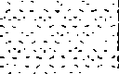-35-



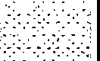

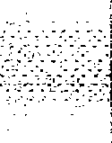

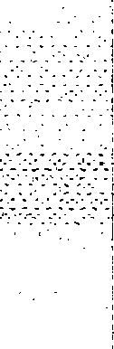

-

|  |  |  |  |  |  |  |  |  |  |  |  |  |  |
| --- | --- | --- | --- | --- | --- | --- | --- | --- | --- | --- | --- | --- | --- |
| Ref. No. | Part No. | Values & Remarks | | Ref. No. | Part No. | Values & Remarks | | Ref. No. | Part No. | Values & | | Remarks | |
| R956 | ERDS2TJ332 | **1/4W** | 3. 3K | R1510 | ERDS2TJ472 | 1/4W | 4. 7K | C617 | ECEA1JIJ220 | 63V | 22U |  |  |
| R957 | ERDS2TJ472 | **1/4W** | 4. 7K | R1511 | ERDS2TJ104 | **1/4W** | 100K | C618 | ECEA2AN2R2SB | 100V | 2. 2U |  |  |
| R958 | ERDS2TJ682T | **1/4W** | 6. SK | R1512 | ERDS2TJ392T | 1/4W | 3. 9K | C621, 622 | ECEA2AU100 | 100V | IOU |  |  |
| R960 | ERDS2TJ103 | **l/4W** | lOK | R1513 | ERDS2TJ223 | **1/4W** | 22K | C651, 652 | ECEA1HKN3R3B | 50V | 3. JU |  |  |
| R961 | ERDS2TJ222 | **1/4W** | 2. 2K | R1514 | ERDS2TJ101 | 1/4W | 100 | C653, 654 | ECBA1H681KB5 | 50V | 680P |  |  |
| R963 | ERDS2TJ152 | **1/4W** | 1. 5K | R1515 | ERDS2TJ223 | 1/4W | 22K | C655, 656 | ECEA1CKA220B | 16V | 22U |  |  |
| R964 | ERDS2TJ182 | **1/4W** | 1. SK |  |  |  | | C657, 658 | ECCR1H100K5 | 50V | lOP |  |  |
| R965 | ERDS2TJ222 | **1/4W** | 2. 2K |  |  | CAPACITORS | | C659, 660 | ECBT1H151KB5 | 50V | 150P |  |  |
| R966 | ERDS2TJ332 | **1/4W** | 3. 3K |  |  |  | | C661, 662 | ECQV1H473JM3 | 50V | 0. 047U |  |  |
| R967 | ERDS2TJ472 | **1/4W** | 4. 7K | C401-414 | ECBT1Hl01KB5 | 50V | 100P | C665 | ECA1HM470B | 50V | 47U |  |  |
| R968 | ERDS2TJ682T | **1/4W** | 6. SK | C419,420 | ECEAlVKA4R7B | 35V | 4. 7U | C667 | ECEA1JIJ220 | 63V | 22U |  |  |
| RlOOl, 1002 | ERDS2TJ222 | **1/4W** | 2. 2K | C421,422 | ECBT1E103ZF | 25V | 0. OlU | C668 | ECEA2AU100 | lOOV | IOU |  |  |
| R1003, 1004 | ERDS2TJ102 | **1/4W** | lK | C423 | ECBT1Hl01KB5 | 50V | 100P | C669 | ECEA2AN2R2SB | 100V | 2. 2U |  |  |
| R1005 | ERDS2TJ203T | 1/4W | 20K | C425, 426 | ECEAlCKAlOOB | 16V | IOU | C681, 682 | ECEAlHNlOOSB | 50V | IOU |  |  |
| R1007, 1008 | ERDS2TJ473 | **1/4W** | 47K | C431, 432 | ECBTlHID1KB5 | 50V | 100P | C685 | ECBT1H331KB5 | 50V | 330P |  |  |
| R1009-1011 | ERDS2TJ332 | **1/4W** | 3. 3K | C433-436 | ECEAlCKAlOOB | 16V | IOU | C701 | ECBT1El03ZF | 25V | O.OlU |  |  |
| Rl012 | ERDS2TJ102 | 1/4W | lK | C451, 452 | ECEAlVKA4R7B | 35V | **4.** 7U | C702 | ECQE2104KF3 | 250V | O. lU |  |  |
| R1013 | ERDS2TJ103 | **1/4W** | lOK | C453, 454 | ECBT1H101KB5 | 50V | 100P | C703, 704 | ECETlKl23YII?{ | 80V | 12000U | & |  |
| Rl014 | ERDS2TJ104 | 1/4W | 100K | C455, 456 | ECBT1H102KB5 | 50V | 1000P | C705, 706 | ECA1JM222B | 63V | 2200U | & |  |
| Rl051 | ERDS2TJ393 | 1/4W | 39K | C457, 458 | ECEA1AKA330B | lOV | 33U | C707 | ECAlVMlOlB | 35V | lOOU |  |  |
| R1052 | ERDS2TJ105T | **1/4W** | **IM** | C459, 460 | ECFR1E223KR | 25V | 0. 022U | C708 | ECKR1Hl03ZF5 | 50V | 0. OlU |  |  |
| R1053 | ERDS2TJ102 | 1/4W | lK | C461, 462 | ECFR1E682KR | 25V | 6800P | C711 | ECKR1H103ZF5 | 50V | O.OlU |  |  |
| R1055, 1056 | ERDS2TJ473 | 1/4W | 47K | C463, 464 | ECEAlVKA4R7B | 35V | **4.** 7U | C712 | ECEAlHKAlOOB | 50V | IOU |  |  |
| R1057 | ERDS2TJ564 | **1/4W** | 560K | C465, 466 | ECBT1E103ZF | 25V | 0. OlU | C713 | ECKR1H103ZF5 | 50V | 0. OlU |  |  |
| R1058, 1059 | ERDS2TJ274 | 1/4W | 270K | C501, 502 | ECEAlVKA4R7B | 35V | 4. 7U | C714 | ECEA1CKA4 708 | 16V | 47U |  |  |
| R1060 | ERDS2TJ104 | 1/4W | 100K | C503, 504 | ECBT1Hl01KB5 | 50V | 100P | C721 | ECQE2104KF3 | 250V | O. lU |  | - |
| R1061 | ERDS2TJ222 | 1/4W | 2. 2K | C505, 506 | ECEAlCKAlOOB | 16V | IOU | C731, 732 | ECKR1H103ZF5 | 50V | 0. OlU |  |  |
| RllOl, 1102 | ERDS2TJ222 | 1/4W | 2. 2K | C513, 514 | ECBT1Hl50J5 | 50V | 15P | C751 | ECKWNS102MBM | 400V | 1000P | & |  |
| R1103, 1104 | ERDS2TJ682T | **1/4W** | 6. SK | C515, 516 | ECBT1H221KB5 | 50V | 220P | C752 | ECKR1H103ZF5 | 50V | 0. OlU |  |  |
| R1105, 1106 | ERDS2TJ474 | 1/4W | 470K | C517, 518 | ECBT1H470J5 | 50V | 47P | C753 | ECA1EM102B | 25V | lOOOU | & |  |
| R1107, 1108 | ERDS2TJ102 | **1/4W** | lK | C519-522 | ECEAlVKA4R7B | 35V | 4.7U | C754 | ECBT1El03ZF | 25V | 0. OlU |  |  |
| R1109, 1110 | ERDS2TJ104 | 1/4W | 100K | C523, 524 | ECFR1El23KR | 25V | 0. 012U | C755 | ECEA1CKA470B | 16V | 47U |  |  |
| Rllll,1112 | ERDS2TJ122 | **1/4W** | 1. 2K | C525, 526 | ECQV1H683JM3 | 50V | 0. 068U | C756 | ECBT1El03ZF | 25V | O.OlU |  |  |
| R1113, 1114 | ERDS2TJ822 | 1/4W | 8. 2K | C527, 528 | ECFRlE562KR | 25V | 5600P | C758 | ECEAlAKAlOlB | lOV | lOOU |  |  |
| R1115, 1116 | ERDS2TJ474 | **1/4W** | 470K | C529, 530 | ECFR1E273KR | 25V | 0. 027U | cm | ECEA1HKA2R2B | 50V | 2. 2U |  |  |
| R1117, 1118 | ERDS2TJ224T | * ***I14W-*** | 220K | C531, 532 | ECBT1E103ZF | 25V | 0. OlU | C772 | ECEAlCKAlOOB | 16V | IOU |  |  |
| R1119-1121 | ERDS2TJ332 | **1/4W** | 3. 3K | C535, 536 | ECEAlCKAlOOB | 16V | IOU | C773 | ECBT1E223ZF | 25V | 0. 022U |  |  |
| R1131, 1132 | ERDS2TJ332 | **1/4W** | 3.3K | C551-554 | ECQV1H104JM3 | 50V | O. lU | C774 | ECEAOJKA221B | 6. JV | 220U |  |  |
| R1133, 1134 | ERDS2TJ102 | **1/4W** | lK | C555-558 | ECEAlCKAlOOB | 16V | IOU | C901 | ECAOJMI02B | 6. JV | lOQOU |  |  |
| R1135 | ERDS2TJ474 | 1/4W | 470K | C559, 560 | ECBT1El03ZF | 25V | O.OlU | C902 | ECBT1EI03ZF | 25V | O.OlU |  |  |
| Rll36 | ERDS2TJ103 | **1/4W** | lOK | C561-563 | ECBT1Hl01KB5 | 50V | 100P | C903 | ECEAOJKAlOlB | 6. JV | lOOU |  |  |
| R1137 | ERDS2TJ332 | **l/4W** | 3.3K | C571, 572 | ECEAlVKA4R7B | 35V | 4.7U | C904 | ECEAlCKAlOOB | 16V | IOU |  |  |
| R1138 | ERDS2TJ104 | l/4W | 100K | C573 | ECEAlHKNOlOB | 50V | 1U | C905 | ECAOJM471B | 6. 3V | 470U |  |  |
| R1139 | ERDS2TJ472 | **1/4W** | 4.7K | C601, 602 | ECEA1HKN3R3B | 50V | 3. 3U | C906 | ECEAOJKA101B | 6. 3V | lOOU |  |  |
| R1140 | ERDS2TJ152 | 1/4W | 1. 5K | C603, 604 | ECBT1H471KB5 | 50V | 470P | C907 | ECBT1H101KB5 | 50V | 100P |  |  |
| R1501, 1502 | ERDS2TJ223 | 1/4W | 22K | C605, 606 | ECEA1JIJ220 | 63V | 22U | C908 | ECBT1H104ZF5 | 50V | O. lU |  |  |
| R1503 | ERDS2TJ684 | 1/4W | 680K | C607, 608 | ECCR1H100K5 | 50V | IOP | C909, 910 | ECEAlHKAOlOB | 50V | 1U |  |  |
| R1504 | ERDS2TJ103 | **1/4W** | lOK | C609, 610 | ECBT1Hl51KB5 | 50V | 150P | C911 | ECBT1El03ZF | 25V | 0. OlU |  |  |
| R1505 | ERDS2TJ104 | **1/4W** | 100K | C611, 612 | ECQV1H473JM3 | 50V | 0. 047U | C912, 913 | ECEA2AU100 | 100V | IOU |  |  |
| R1506 | ERDS2TJ102 | **l/4W** | lK | C613, 614 | ECBA1H681KB5 | 50V | 680P | C914, 915 | ECEAlVKAIOOB | 35V | IOU |  |  |
| R1507 | ERDS2TJ104 | **1/4W** | 100K | C615 | ECA1HM470B | 50V | 47U | C921-928 | ECBT1H331KB5 | 50V | 330P |  |  |
| R1508, 1509 | ERDS2TJ103 | **l/4W** | lOK | C616 | ECEA2AU100 | 100V | IOU | C931-934 | ECBT1Hl01KB5 | 50V | 100P |  |  |

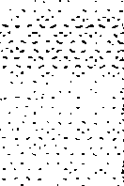

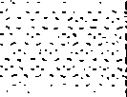

- 36-

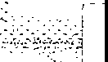**SU-G95**

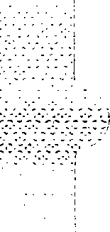

|  |  |  |  |  |  |  |  |  |
| --- | --- | --- | --- | --- | --- | --- | --- | --- |
| Ref. No. | Part No. | Values & Remarks | Ref. No. | Part No. | Values & Remarks | Ref. No. | Part No. | Values & Remarks |
| ClO0l, 1002 | ECEAlHKAOlOB | 50V 1U | C1028 | ECEA1HKAR47B | 50V 0.47U | C1058 | ECFR1E333KR | 25V 0. 033U |
| C1003, 1004 | ECEA1HKA3R3B | 50V 3. 3U | Cl029 | ECEAlVKA4R7B | 35V 4.7U | C1059 | ECEA1CKA101B | 16V lO0U |
| C1005 | ECEAlHKAlllOB | 50V 1U | C1030 | ECEA1HKAR47B | 50V 0. 47U | C1060 | ECBT1E223ZF | 25V 0. 022U |
| C1007 | ECFR1E223KR | 25V 0. 022U | Cl031, 1032 | ECQV1H104JM3 | 50V 0. lU | C1062 | ECBT1E223ZF | 25V 0. 022U |
| C1008 | ECFR1E473KR | 25V 0. 047U | Cl033 | ECEA1CKA470B | 16V 47U | C1063 | ECEA1CKA101B | 16V lO0U |
| C1009 | ECEA0JKA221B | 6. 3V 220U | C1034 | ECQVl11474JM3 | 50V 0. 47U | C1064 | ECBT1H104ZF5 | 50V 0. lU |
| ClOl0-1013 | ECEAlCKAl00B | 16V lOU | Cl035 | ECBA1H681KB5 | 50V 680P | C1065 | ECBA1H681KB5 | 50V 680P |
| C1014 | ECEA0JKA221B | 6. 3V 220U | Cl036-1038 | ECBT1Hl01KB5 | 50V 100P | Cll0l-1108 | ECEA1HKA3R3B | 50V 3. 3U |
| C1015, 1016 | ECQV1H104JM3 | 50V 0. lU | Cl039 | ECEA1CKA101B | 16V lO0U | C1109-1111 | ECBT1H101KB5 | 50V 100P |
| C1017 | ECEA1HKAR47B | 50V 0. 47U | Cl040 | ECEAlCKAlO0B | 16V lOU | C1113, 1114 | ECEAlCKAlO0B | 16V lOU |
| C1018 | ECEA1VKA4R7B | 35V 4. 7U | Cl041 | ECBT1El03ZF | 25V 0. 0lU | C1115, 1116 | ECBT1El03ZF | 25V 0. 0lU |
| C1019 | ECEA1HKAR47B | 50V 0. 47U | Cl043, 1044 | ECBT1El03ZF | 25V 0. 0lU | C1131 | ECEAlHKN0lOB | 50V 1U |
| C1020 | ECEA1VKA4R7B | 35V 4. 7U | Cl051 | ECEA1HKA2R2B | 50V 2. 2U | C1132 | ECEA1HKA3R3B | 50V 3. 3U |
| Cl021 | ECEA1HKAR15B | 50V 0. 15U | Cl052 | ECEAlHKA0lOB | 50V 1U | C1501 | ECEA1HKA3R3B | 50V 3. 3U |
| C1022 | ECEA1HKA3R3B | 50V 3. 3U | Cl053 | ECEAlHKA3R3B | 50V 3. JU | C1502 | ECEAlHKAOlOB | 50V 1U |
| C1023, 1024 | ECQV1Hl54JM3 | 50V 0. 15U | C1054 | ECEAOJKA221B | 6. 3V 220U | C1503 | ECEA1HKA2R2B | 50V 2. 2U |
| C1025 | ECEA1HKA3R3B | 50V 3. 3U | C1055 | ECEAlHKAOl0B | 50V 1U | C1504 | ECEAlHKAOlOB | 50V 1U |
| C1026 | ECEA1HKAR15B | 50V 0.15U | Cl056 | ECFR1E333KR | 25V 0. 033U | C1505, 1506 | ECEA1HKA3R3B | 50V 3. 3U |
| C1027 | ECEA1VKA4R7B | 35V 4. 7U | C1057 | ECFR1E152KR | 25V 1500P |  |  |  |
|  |  |  |  |  |  |  |  |  |

* **PACKAGING**

dP2 ( CUSHION@!

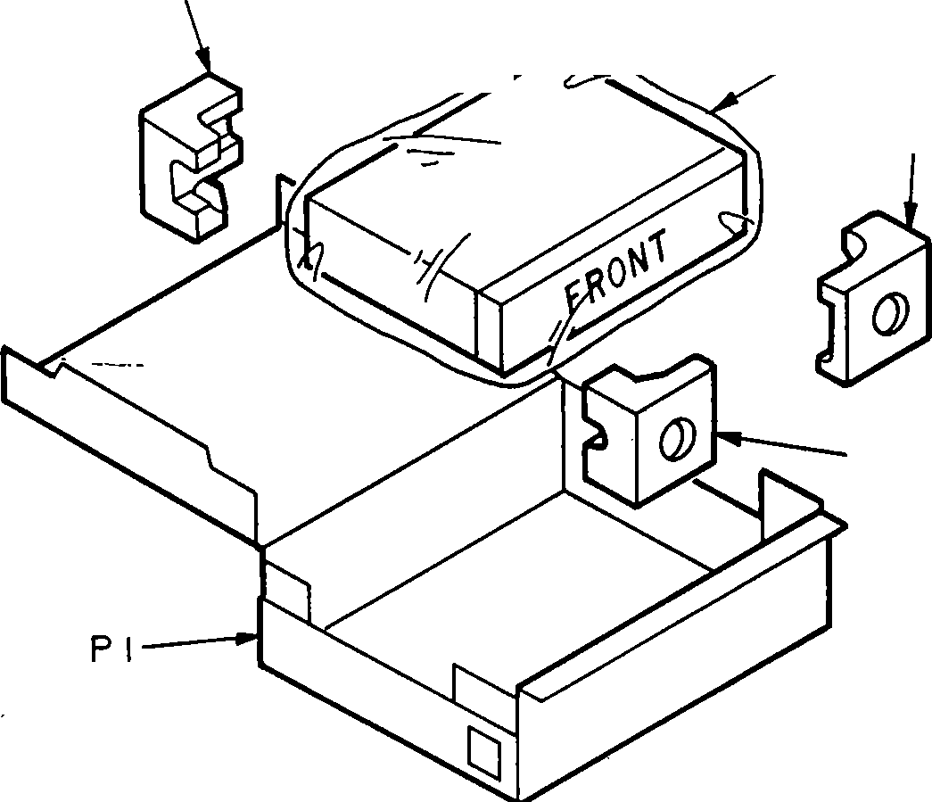P2 (CUSHION@)

P3

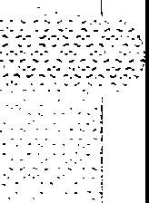P2 ( CUSHION@!

P2( CUSHION@ l

( CUSHION@@@@

: Part No. RPN0682-2)

-37-

Printed in Japan H940103000 NH/YU/TN

