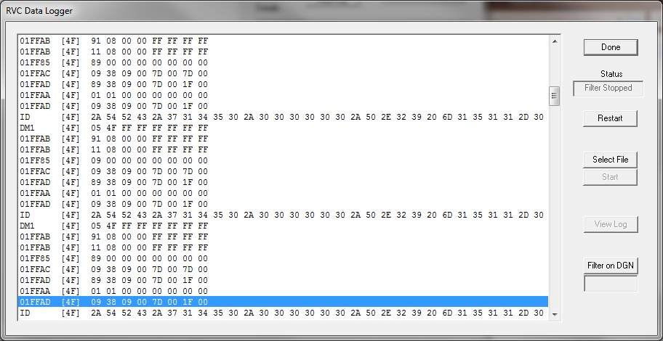

Rvc messages:

FFAC RVCLoadACStatus2() peak volts, peak current, see rvc specification

FF85 RVCLoadACStatus4(0) line1 faults: line low, line hi, line open

RVCLoadACStatus4(1) line2 faults: line low, line hi, line open

FFAD RVCLoadACStatus1(0) line1 volts, current, phase

RVCLoadACStatus1(1) line2 volts, current, phase

ATS puts out address 4F

TM102 puts out address FA