**Basic Inverter Check:**

When inverter is turned on you will have a green LED lit above the INV button.

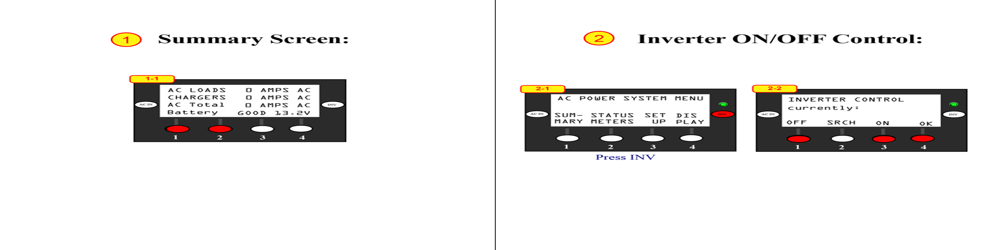

If screen backlight is pushing any button only turns on backlight.

Shortcut: Pressing 1 and 2 simultaneously in any screen takes you back to AC Power System menu. (Be carefull you are not in a screen that will change a setting if you push one harder or quicker than the other).

Press OFF / ON to turn inverter off or on. Then OK to go back to AC Power Systems Menu. A good way to do a quick inverter reset is turn OFF for 5 seconds then ON again. Also, unplugging the Cat 5 from the Mate is a good remote reset.