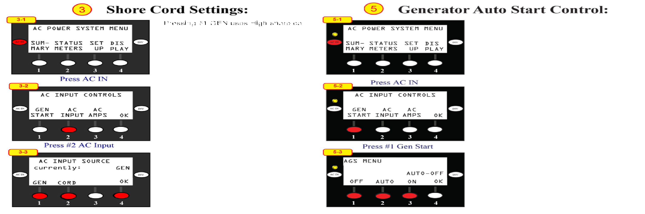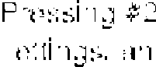

After starting generator or plugging into shore power yellow LED above AC IN button blinks for 30 seconds then becomes solid indicating it has connected to input power. If yellow LED does not blink it is an indication that you do not have live AC input. If LED flashes but does not become **so**lid it is indicating input voltages or hertz is too low or high and it will not charge and you are still running off of batteries.