# Release document

This file contains information about OMEGA Platinum ® Controllers LABVIEW Driver and DLL Driver for .NET.

The LABVIEW Driver and DLL Driver for .NET supports Modbus RTU/ASCII protocol over Serial or Ethernet.

June, 2015

# Supported Development Environments

* LABVIEW 2013 +
* Microsoft Visual Studio – Requires following Run-time engine
  + NI LABVIEW Run-time Engine 2013 (32 bit or 64 bit)
  + NI VISA Run-time Engine 14.0.1

# Installing OMEGA Platinum ® LABVIEW Driver

* The file OmegaPlatinumModbusDriver.llb contains necessary library files
* Platinum Serial Modbus (USB Virtual Comport and RS232, RS485) includes the following VIs
  + Platinum_MB_SerOpen.vi
  + Platinum_MB_SerRead.vi
  + Platinum_MB_SerWrite.vi
  + Platinum_MB_SerClose.vi
* Platinum TCP Modbus (Ethernet) includes the following VIs
  + Platinum_MB_TcpOpen.vi
  + Platinum_MB_TcpRead.vi
  + Platinum_MB_TcpWrite.vi
  + Platinum_MB_TcpClose.vi

# Example LABVIEW applications

* The OmegaPlatinumModbusDriver.llb library contains two example VIs

Platinum_MB_Example Serial Master.vi

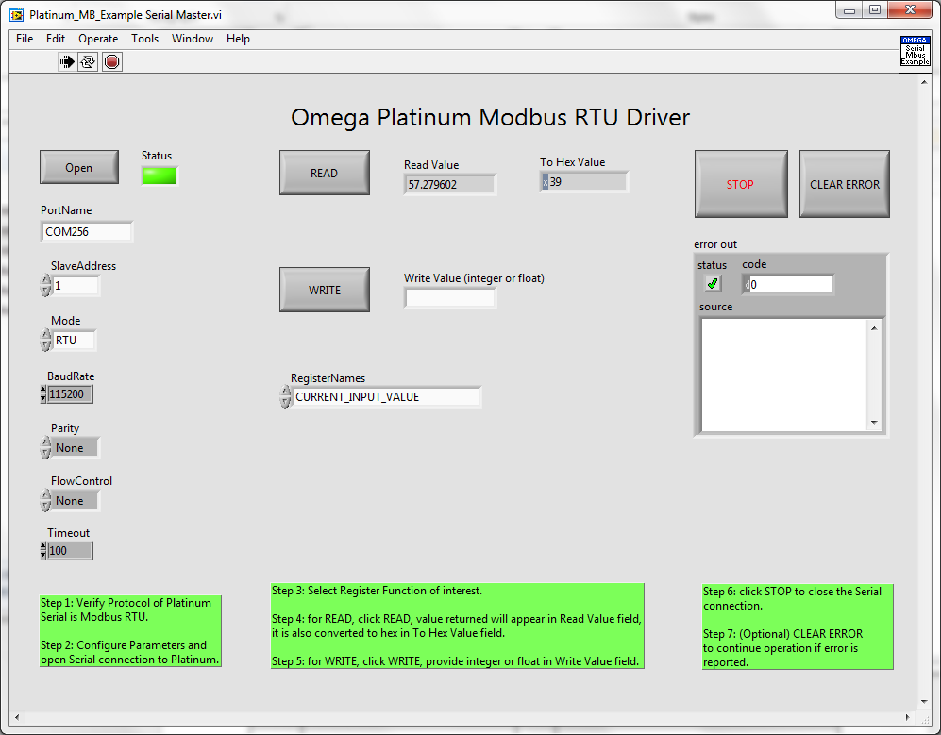

To use Example VI to read Values from Omega Platinum ® controllers:

1. Configure Serial Port parameters
2. Click OPEN (the Green status indicator will turn on if Serial Port is opened successfully)
3. Select Parameter to read in RegisterNames drop down box.
4. Click Read (The parameter returned will display in Read Value field)
5. When done, click STOP to close communication and abort the VI.

Platinum_MB_Example TCP Master.vi

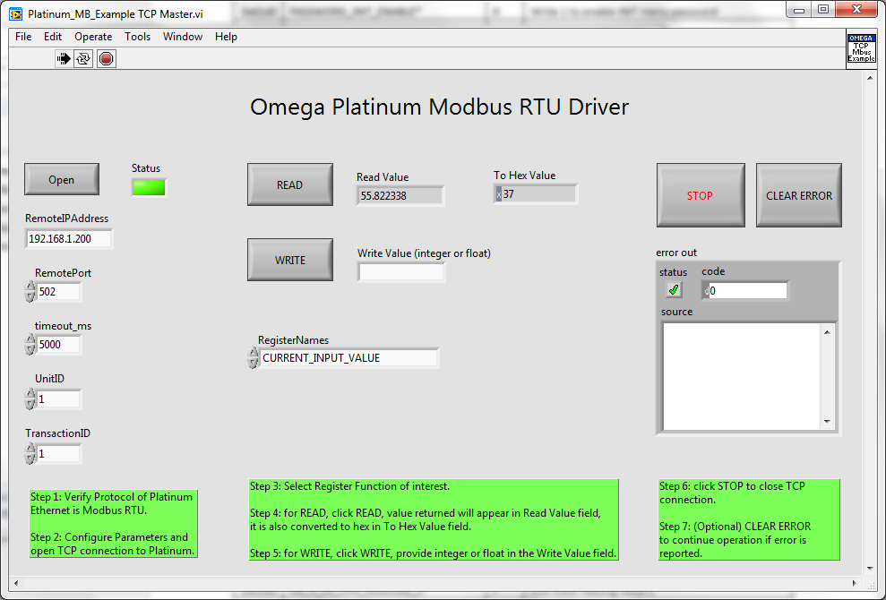

# Build .NET DLL driver

* The build specification of the Omega Platinum LABVIEW Driver project contains a pre-configured Build for .NET DLL driver
* An x86 .NET DLL driver is included in the Builds folder of this project.

# Using .NET DLL driver

Requirements:

* LABVIEW Run-time Engine 2013+ must be installed to run Omega Platinum .NET DLL driver.
* NI VISA 14.0.1+ must be installed to run Omega Platinum .NET DLL driver.
* Reference NationalInstruments.LABVIEW.Interop.dll must be imported to your Microsoft Visual Studio project. The file can be found at %PROGRAMFILES%\National Instruments\Shared\LABVIEW Run-Time directory.

Usage:

* Start by importing PlatinumModbusDriver.dll to your Microsoft Visual Studio project references. The list of functions definitions and datatypes can be viewed in the Object Browser.
* A provided PlatinumModbusDriver.dll is compatible with x86 targets. Visual studio project Settings/Build may need to configure Platform Target to x86 for compatibility.

# Omega Platinum Modbus protocol

Register Names, Starting address, data types, data range and descriptions are available in [Omega Platinum Modbus Protocol Reference](http://www.omega.com/manuals/manualpdf/M5458.pdf). Please consult Omega Platinum Modbus Protocol Reference before using OMEGA Platinum ® LABVIEW Driver and DLL Driver for .NET

# Release Notes

OMEGA Platinum ® LABVIEW Driver and DLL Driver for .NET was developed by Omega Engineering. [NI-MODBUS 1.2](http://www.ni.com/example/29756/en/) was used in the core Modbus driver. The example program and drivers are provided on “AS-IS” basis are without warranty of any kind.