5 to 9-Axis Conversion Kit Instructions for a Machine with Teknic Servos

This document covers most of the 5-axis machines with Teknic Servos. Some alternate connection options will be addressed in other documents.

The first picture shows the tilt-a-jet interface board, #1 and the standard X-Y and relay cable, #6. The original ‘standard’ machine had a black 24 position connector instead of the tilt-a-jet interface. If mounted on a bridge machine, a dual XY and relays interface board, would be in place of #6.

Disconnect items 1, 4, 5 and 6 from the USB Controller. Cut wires 2 and 3 close to the ten position connector that is plugged into the top of the board. Those two wires will be re-connected to terminals of the board stack later. After those parts are disconnected the USB Controller can be slid upward until it comes off of the panel. The red lines on the picture show where to cut the cable trays to shorten them so that the new board stack can be installed.

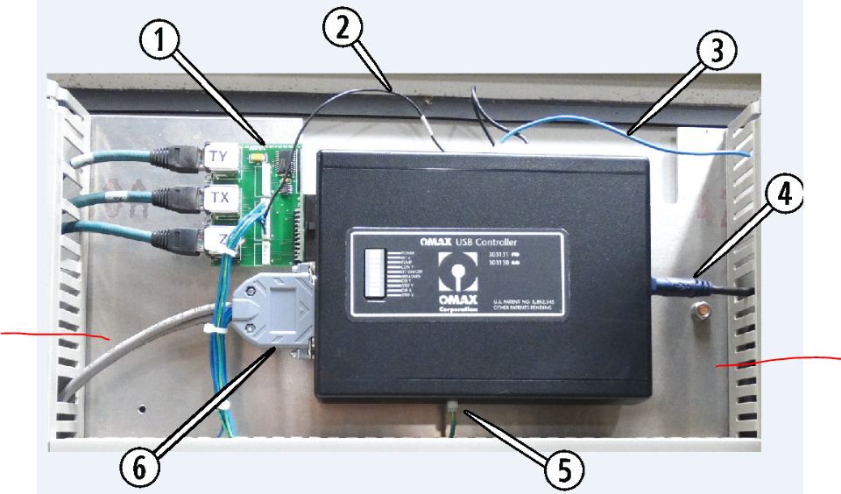

There is a nut shown below item 4 that will be used to locate the position of the board stack. The base plate that the board stack, shown below, has a slot in it large enough to fit over the nut. The slot is designed so the plate slides over the nut until it stops. There are no connections to be made along the right side of the boards and the board stack is considerably longer than the 5-axis USB Controller that the board stack replaces, so sliding the board stack as far as possible to the right, makes all other connections easier.

The base plate has four holes in the corners with clearance holes for self-tapping screws in the kit. There are a couple of options for attaching the screws. The preference is to use a Sharpie pen to mark the spots on the back panel to drill pilot holes. The size of drill to use should be just a little smaller than the thread diameter of the screws. Pre-drilling pilot holes will allow use of a simple screwdriver, but an electric screwdriver, with extensions, can be used as well.

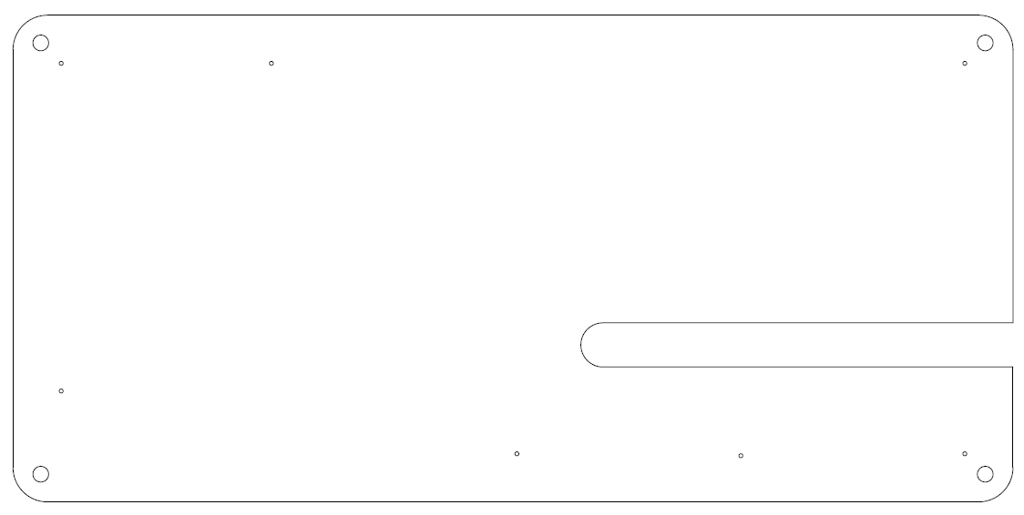

There are two screws shown below that are holding part of the shield that covers the back side of the front panel switches. Remove those screws and set aside.

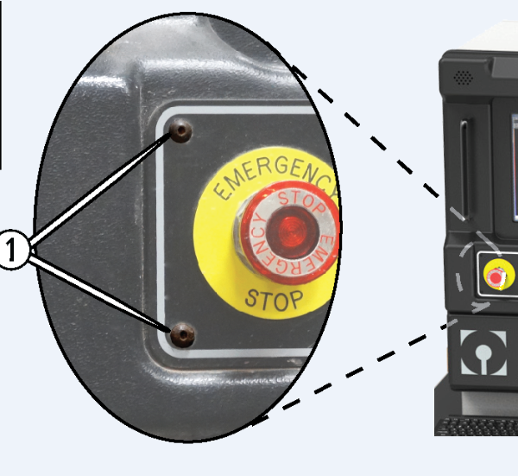

When you remove the screw pointed to on the left of the picture below, the shield can be removed. The shield must be re-installed after testing has been performed. The kit can be installed in the very earliest controller cabinets, before flat LCD displays were available. Early machines, built with Teknic servos, had a shelf to hold a huge monitor strapped in place to keep the monitor screen visible through the window in the front face of the controller cabinet. The next picture shows the second version of the controller cabinet, with a flat screen monitor mounted to the side rails of the controller cabinet. The bulk of Teknic equipped, 5-axis controllers looked like this.

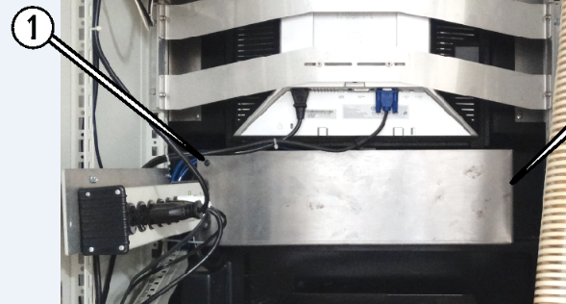

With the shield out of the way the Reset/Override switch will be exposed. An extra contact block needs to be mounted on the existing contact block.

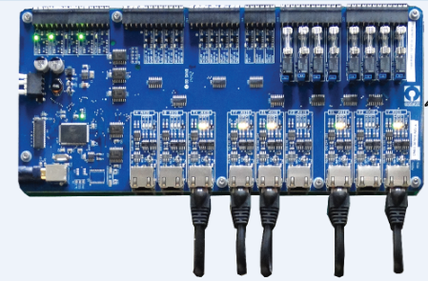

The 9-axis board shown in the picture above, is the top board of the stack. The conversion board is mounted underneath and items 1 and 6, shown in the first picture of these instructions, attach to the corresponding receptacles on the conversion board. The USB cable must be routed through the horizontal wire tray and connects to the mating receptacle in the lower left area of the top board.

The picture immediately below shows a 30 Watt – 24 Volt power supply mounted to the right hand DIN rail on the back door of the controller cabinet, with a 10 Watt – 5 Volt supply mounted directly above. A 10 Watt – 24 Volt supply needs to be added above the 5 volt supply and all three supplies will need black wires from the ‘L’ terminal of each to a gray ‘1’ terminal, along with white wires between the ‘N’ terminals on the supplies to the gray ‘N’ terminals.

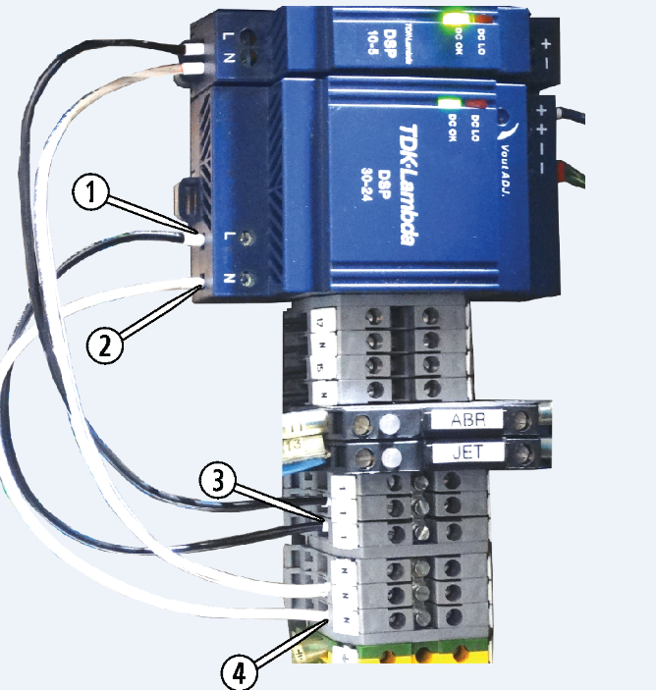

The next picture is the wiring diagram for the board stack. The lines running from the conversion board on the right to the 9-axis board on the left, represent point to point wires pre-installed by an assembler at our factory. The items circled in red are not part of the initial board stack. The Reset/Override contact block will be pre-connected with enough wire to run from the 9-axis board, through the wire trays on the back door to the lower right area of the back door. From that point the wires will be run along the side of the cabinet and the switch contact block will be mounted to the existing contact block on the back of the Reset/Override switch. The three power supplies are to be mounted on the right hand DIN rail on the back door. The 10 Watt – 24 Volt power supply on the far left needs a white with blue stripe wire running from the ‘-‘ terminal of the power supply to the ‘-‘ terminal of the 9-axis board. A second white with blue stripe wire runs from the second ‘-‘ terminal on the 9-axis board to a green with yellow ground terminal on the DIN rail. A blue wire runs from a ‘+’ terminal of the supply to a ‘+’ terminal on the 9-axis board.

The 30 Watt – 24 Volt power supply above the 9-axis board has a single blue wire running from it to the J12 terminal strip, position 2 as shown. The 10 Watt – 5 Volt power supply above the conversion board has a single blue wire running from it to the conversion board’s J8 terminal strip, position 3 as shown.

The conversion board’s J13 terminal strip position 1 shows a wire labeled ‘From DIN rail terminal 2’. The very first picture of this document shows a blue wire, item 3. In the second paragraph, the instructions said to; “Cut wires 2 and 3 close to the ten position connector that is plugged into the top of the board.” The blue wire that was cut connects to the conversion board. The black wire, item 2, would only be present if a Tilt-A-Jet interface board is in place and that wire would need to be connected to the conversion board’s J8 terminal strip, position 5. When a standard motorized Z is present, a black, 24 position connector with wires for the motorized Z would be present.

