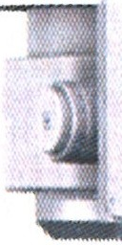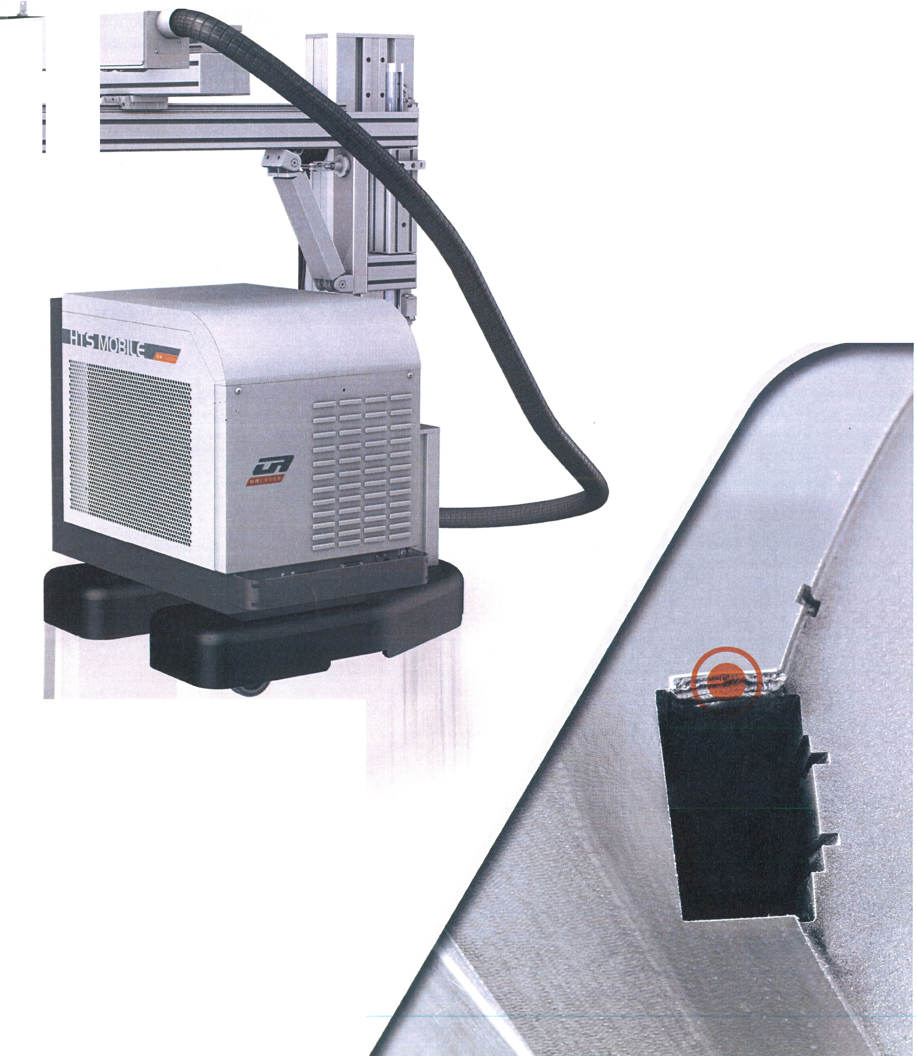
www.or-laser.com

Operating Instruction - EN
Date 16.09.2013

-

Conformity Declaration 1
- Product description 2
  - Note 2
  - Intended use 3
  - Operation and control elements of the machine 4
  - Operation elements on the display 5
    - Main Menu 6
    - Possible system state 8
    - Selection menu 11
    - Settings 12
    - Service menu 13
    - Loading and Saving of Parameters 14
    - Loading the parameter file 14
    - Saving the parameters 15
    - Pulse shape editor 16
    - Event display 19
  - Function description 21
    - The principle of laser beam generation 21
    - Schematic diagram 22
    - Implementation of the resonator. 23
    - Beam deflection 90° and stereoscopic microscope 23
    - Mains power supply 23
    - Internal cooling system with a water/air heat exchanger 24
- General safety notes 25
  - Obligation for due diligence on the part of the operator. 25
  - Explanation of the safety symbols that are used 26
  - Basic safety measures for normal operation and maintenance 27
  - Hazard for eyes and skin 28
  - Risk of Fire 29
  - Risk from high voltage 30
  - Hazards from the operation of the laser processing station 31
  - Legal regulations for the operation of laser installations 32
- Transport. 33
- Installation 34
  - Electrical installation 34
  - Conditions for the surroundings around the installation 35
- Start-up 37
  - Checks before switching the power ON 37
  - Initial start-up of the laser processing station 38
  - Adaptation of the laser beam to the microscope reticle 39
  - Function check for the safety devices 40
  - Checks after first Operation 40
- Operation 41
  - Switching the System ON 42
  - Adaptation of the laser beam to the microscope reticle 43
  - Operation 44
  - Working 45
  - Joystick 46
    - Operation mode "MODE O" 48
      - "Jog" operation 48
      - "Run" operation 48
      - Synchronization 48
    - Operation mode "MODE 1" - Line mode 49
      - "Jog" operation 49
      - "Run" operation 49
      - Synchronization 49
    - Operation mode "Mode 2" - Circle mode 51
      - "Jog" operation 51
      - "Run" Mode 51
      - Synchronization 51
  - Switching off the laser installation 53
- Help in the case of faults 54
- Maintenance 55
  - Safety notes 55
  - Wear parts 56
  - Maintenance intervals 56
  - Maintenance work on the resonator 57
    - Housing cleaning 57
    - Measuring the laser power 58
    - Access to the optical components 59
    - Close the cover and fasten it. 60
    - Calibration of the optical holders - Laser class 4 61
    - Lamp replacement 62
    - Calibration of the beam deflection 90° 65
  - Maintenance work on the cooling system 66
    - Cooling system COR 12: 66
    - Cooling system COR 13: 68
    - Cooling system COR 14: 71
    - Cooling system COR 15 (at 300 W) 73
    - Cooling system COR 16 (at 300 W) 75
    - Replacement of the Deionization Cartridge 77
- Shut-down 79
  - Temporary Shut-down 79
  - Final Decommissioning, Removal, Disposal. 80
- Technological appendix 81
  - Electrical connection values 81
    - Monitoring relay 82
CM-ESS.1; CM-ESS.2: 82
CM-MPS 41: 83
  - Resonator 84
    - Construction 84
    - Specifications 86
  - Mains power supply 87
    - Block diagram mains power supply 87
  - HTS Mobile Data 90
  - Internal cooling system with a water/air heat exchanger 91
    - Specifications 91
  - Internal Compressor Cooling System 92
    - Specifications 92

Type of machine/installation:
Laser processing machines
Conformit1 Declaration

HTS Mobile 120 / 160 / 200 / 300
CE

Machine number: HTS /8 160180911

The machines have been developed, constructed, and manufactured in compliance with the regulations of the following directives:

- EC Directive Machines (2006/42/EG)
- Health Protection (2009/104/EC)
- Low-voltage Directive (2006/95/EC)
- EMC Directive (2004/108/EC)
- RoHs Directive (2002/95/EC)
- OstRV Directive (2006/25/EC)

The following harmonized standards have been applied:
- EN ISO 12100-1 Safety of machinery (Basic terminology)
- EN ISO 12100-2 Safety of machinery (Technical principles)
- DIN EN 60204-1; Safety of machinery; electrical equipment of machines
- DIN EN 61000-6-4 EMC - Generic standards; generic standard interference emission for industrial environment
- DIN EN 61000-6-2 EMC - Generic standards; interference resistance for industrial
environment
- EN ISO13849-1; Safety of machinery; safety-related parts of control systems
- DIN EN ISO 11553-2 Safety of machinery; laser processing machines
- EN 207 Laser radiation safety filters and eye protection
- DIN EN 60825-1;4 Safety of laser devices

The following national standards, directives, and specifications have been applied:
- DIN 24420.2 / 33402.1 / 33402.2 / 33402.3 / 33 402.4

Person responsible for the documentation: O.R.Lasertechnologie GmbH -
Dieselstrasse 15 - 64807 Dieburg - Germany

Date of construction:
2018

Date of the document:
2018

Yhushua Resnik Managing director

O.R. Lasertechnologie GmbH
Headquarters: Dieselstrasse 15, 64807 Dieburg Registered court: District Court Wiesbaden, HRB 10571
Managing director: Yhushua Resnik
Telephone: +49 60 71/20 989 0
Fax: +49 60 71/20 989 99

0 R. Lasertechno/ogie GmbH - Dieselstrasse 15 - 64807 Dieburg - Tel.: 0 60 71/209 890 Fax: 0 60 71/209 8999
0.R.
16.09.2013 HTS MOBILE - Page 1

1 Product description

IMPORTANT

Read this manual before operating or starting the laser welding machine. Incorrect settings or misuse of the laser welding machine and the resulting damage are not covered by the warranty.
1.1 Note

The operating instructions may not be copied or published completely or on part or be used or disclosed to others for competitive purposes without authorization.
Any infringements shall be subject to damages. All rights reserved.

Notes for use

We reserve the right to change the construction and the specifications in the interest of further development.
Accordingly, no claims can be derived from the information, images or drawings, and descriptions.
We accept no liability for errors!

Please observe the general safety notes in Chapter 2 and the accordingly marked texts in the manual. Any disregarding of these instructions can lead to injuries up to death and property damage that may exceed loss of the machine.

Please inform yourself of the measures for installation, operation and maintenance before starting operations.

OR. Lasertechnologie GmbH-Dieselstrasse 15-64807 0ieburg -Tel.. o 60 71/209 890 Fax: o 60 71/209 8999
0.R.
16.09.2013 HTS MOBILE - Page 2

1.2 Intended use

The HTS Mobile 120/160/200/300 laser processing stations are intended for joining, build-up, expanding, and repairing of precision parts made of aluminum, steel, copper, titanium and chrome-nickel alloys using laser deposition welding. Patented special filler materials have been adjusted especially for precision mold construction. Laser micro processing can be performed at locations in the micrometer range without heat influence zones and as such, without stresses, cracks, distortions, and undercuts. Restoration of graphite electrodes also is possible.

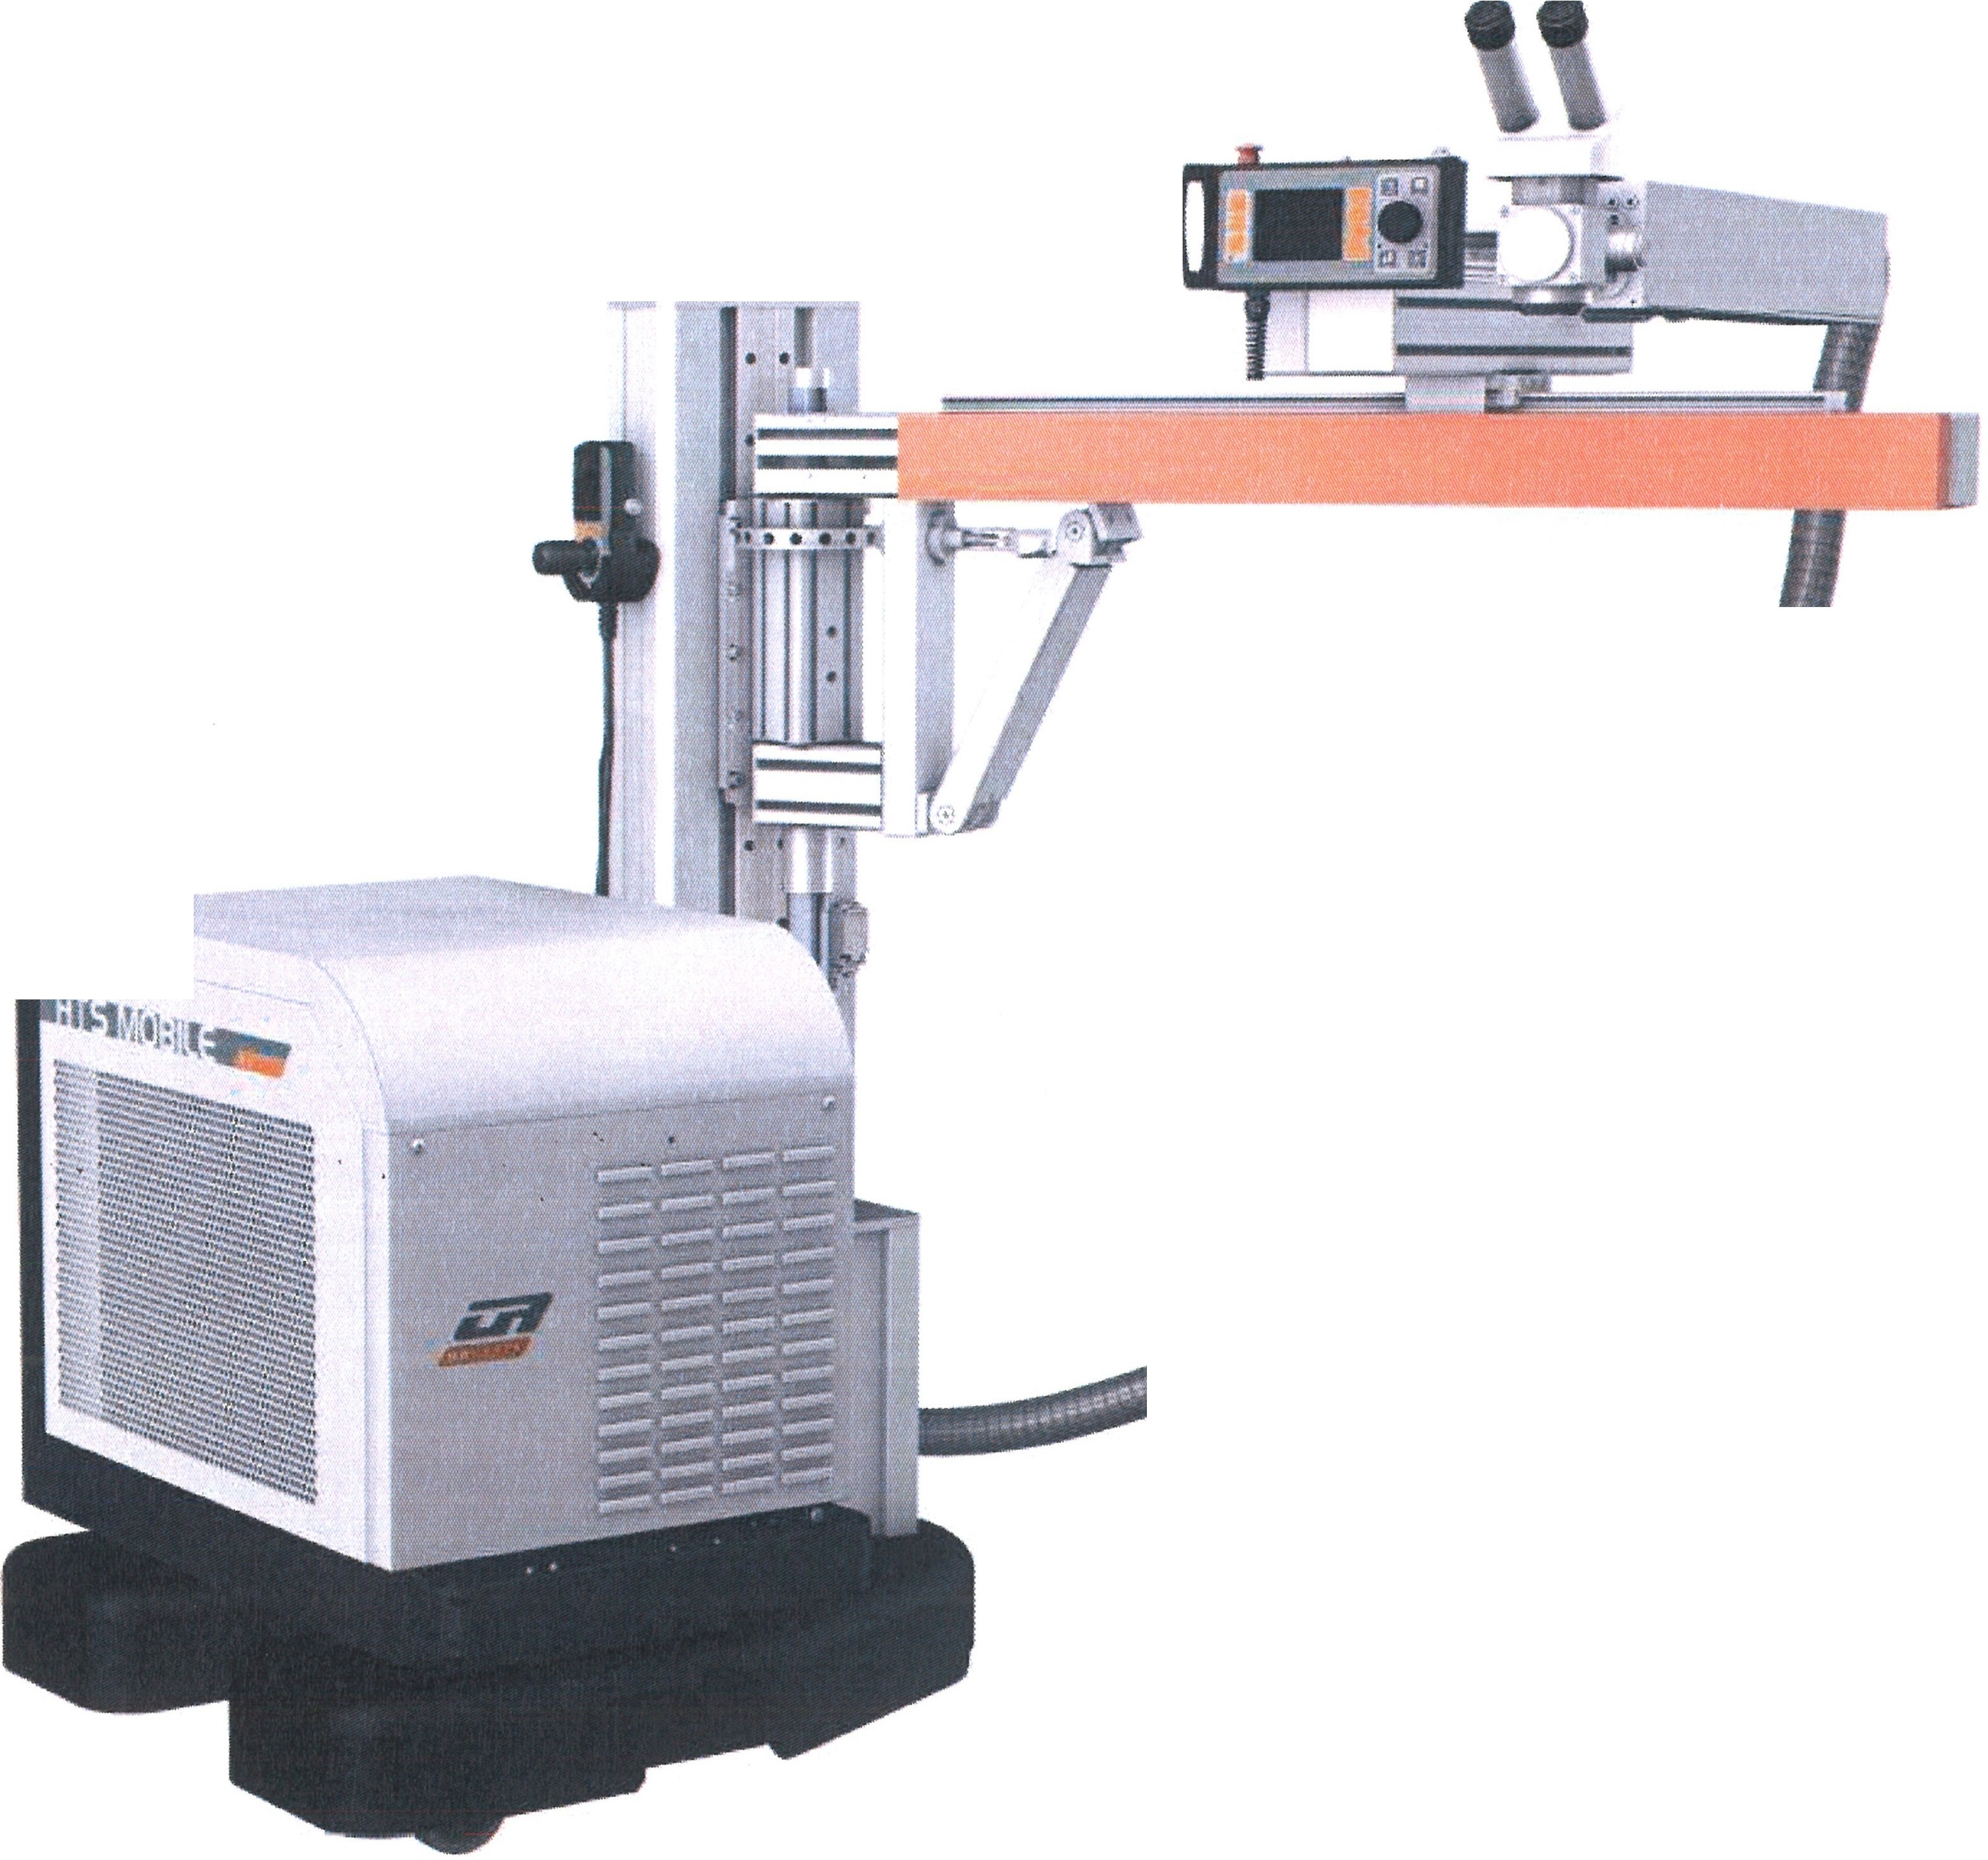
:1L.,.f.r11on
/

When the laser processing station HTS Mobile 120/ 160/ 200/ 300 is not used
according to this intended use, safe operation of the laser installation is not assured.
DANGER
The operator of the laser processing station shall be responsible for all personal injuries and property damage resulting from use that is not
intended, not the manufacturer!

OR. Lasertechnologie GmbH-Dieselstrasse 15-64807 Dieburg -Tel.. 0 60 71/209 890 Fax: 0 60 71/209 8999
O.R.
16.09.2013 HTS MOBILE - Page 3

  - Operation and control elements of the machine

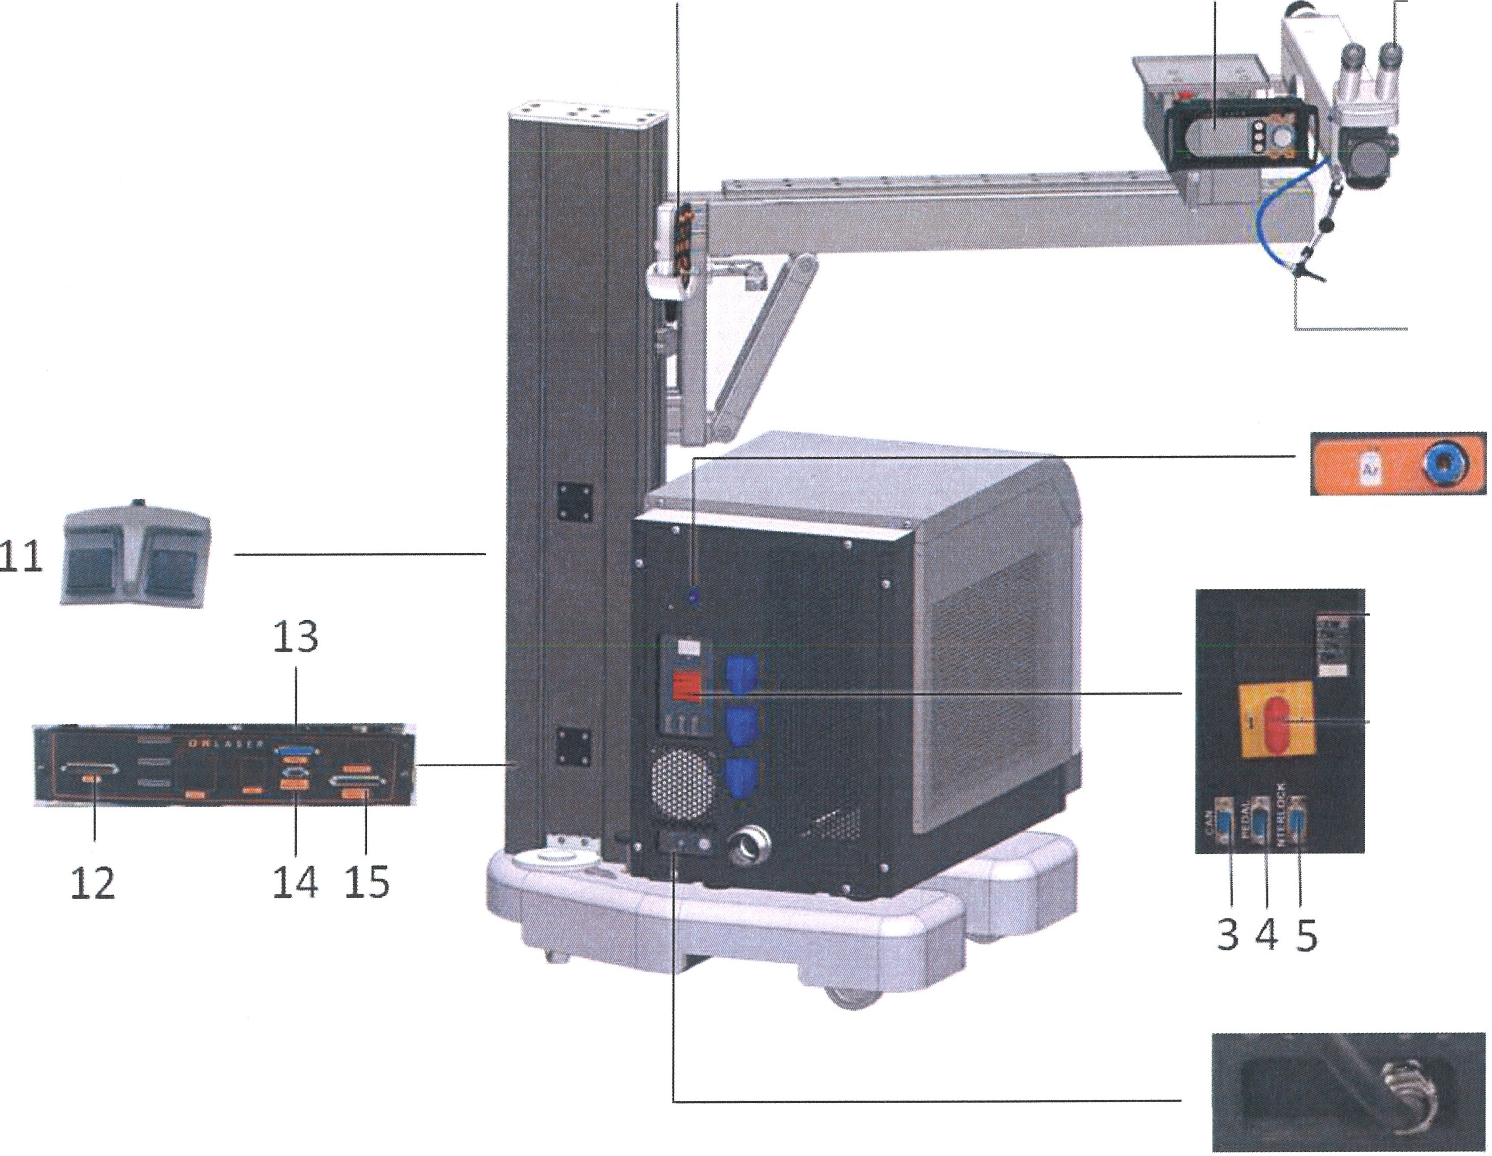7 6 10
--9
8
--16

--2
1

Position Function

    - Power connection
    - Main switch
    - CAN connection for maintenance
    - Connection 0-Sub 9 for foot switch
    - Interlock connection
    - Operating display
    - Joystick
    - Gas connection
    - Gas supply
    - Processing optics
    - Foot pedal
    - Connection joystick
    - Connection for the display
    - Connection for rotating axis
    - Connection for axis drive
    - Monitoring relay

OR. Lasertechnologie GmbH- Dieselstrasse 15 - 64807 Dieburg - Tel.. 0 60 71/209 890 Fax: 0 60 71/209 8999
O.R.
16.09.2013 HTS MOBILE - Page 4

1.4 Operation elements on the display

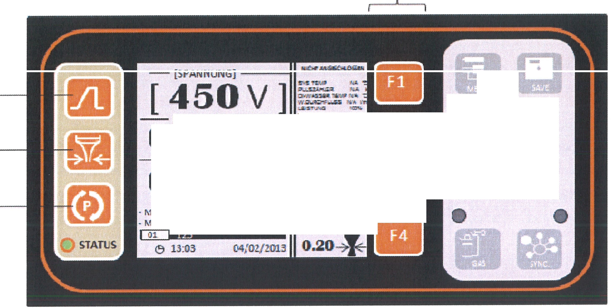Fl,F2,F3,F4
- [FREQUENZ] ---1 -
0[1PUL.S•LAOIIGE) ms- .,,@,._""',: .UG 0
::-,---.. :II-- -.:1;1:;;'I
03.0 Hz
:1"1 !!
,!AX.PULSU:l>TL,...
OC.9'1<'!11
l!!J
,'llll.L:.RE.FULSUISTUNG C2.67W ll------
#Q

1

2

3

Position Function

1
2

3
F1, F2, F3, F4

MENU - Menu selection
SAVE - Save button
Pulse shape
Selection of the spot diameter (only usable in connection with a motorized beam expander)
Program selection No functions

GAS - Gas supply (green LED - Gas supply switched on)
SYNC - Synchronization (green LED - Synchronization is switched on) [ ] - Activating of the parameter field for changing the parameters
Control button - Reduction/Increase of selected parameters. When the control button is pressed an you rotate it, the parameter is changed in larger steps

LED STATUS:
green - laser source is operational

flashing green - in operation, pulses are transmitted
e orange - laser source not operational
e red - error
e flashing red - pump lamp not illuminated
With red e LED: Error1: Interlock - door open, check and close
Error2: Laser head lock - resonator/welding head open
OR Lasertechnologie GmbH-Dieselstrasse 15-64807 Dieburg -Tel.. 0 60 71/209 890 Fax: 0 60 71/209 8999

O.R.
16.09.2013 HTS MOBILE - Page 5

The display has a touchscreen that requires careful handling. Avoid any scratches, use a styles for extended life.

ATTENTION

    - Main Menu

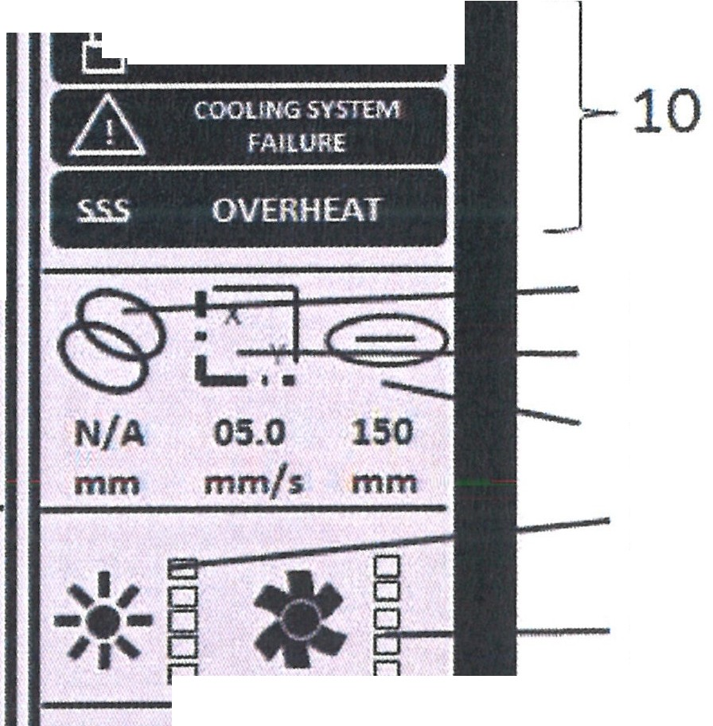9
I
-
[
450
[VOLTAGE]
Jl--(ALARM]
V]
IL.WiJlll:iiil■!U
1 01.0 ms
-
[DURATION] 1
- 03.0 Hz
-
[FREQUENCY
11
12
13
14
LI - 15
- (9 13:03
- MAX PULSE POWER
-AVARAGE PULSE POWER
irm. 123
00.91kW
0267W
i•1 L16
04/02/2013
0.20
J:
-
-
a-
17

1

2

3
4
5
6
7

8

Position

1
2
3
4
5
6
7
8
9
10

11

12

13
14
15
16
17

Function

Power scale Pulse length Pulse frequency Max pulse power Mean pulse power
Name of the current parameter file Current time
Current date
Current system state
List of system error messages:
See below
Overlapping of the spot (works only with the coordinate table)
Movement speed of the Coordinate table in X/Y Focal length of the lens Indication of the brightness
Indication of the suction strength Pulse shape
Indication and setting of the focus diameter

O.R. Lasertechnologie GmbH-Dieselstrasse 15-64807 Dieburg -Tel.. O 60 71/209 890 Fax: O 60 71/209 8999
O.R.
16.09.2013 HTS MOBILE - Page 6

Power: The power can be set via three variants:

Variant 1:
The laser power is set as a percentage by varying the power setting. This version is used as the standard for power setting.

Variant 2:
The laser power is specified as voltage in volts, which are applied to the laser lamp. When the percentage is pressed for a longer period (more than 2 seconds), the display is switched to the voltage mode.

Variant 3:
The laser power is set as a voltage and percentage. For this, select the desired voltage and then press the voltage value for a longer period of time in order to switch to the percentage mode. The status display shows the preset voltage that becomes the basis for the later percentage.
ATTENTION: Always pay attention to the set voltage in the status display.

Automatic frequency setting:

When the pulse frequency is pressed for a longer period (over 2 seconds), the software automatically sets the max. pulse frequency.
The pulse frequency is varied automatically depending on the pulse power and the pulse length. The following symbol appears: li.11 MAX
Focal length of the lens:
rn
The standard lens has a focal length of 160 mm. You can change the information for the value in the settings, if a different lens is installed. This way, the next user is informed of the lens being used.
Note

Synchronization:

The synchronization function can be used to synchronize the pulse frequency with the process speed. This way, a uniform pulse distance is obtained on the material surface.

OR. Lasertechno/ogie GmbH- Dieselstrasse 15-64807 Dieburg -Tel.. 0 60 71/209 890 Fax: 0 60 71/209 8999

O.R.
16.09.2013 HTS MOBILE- Page 7

    - Possible system state

- In the case of a malfunction - message concerning an error

LASER HEAD LOCK- open resonator/welding head
MALFUNCTION OF THE COOLING SYSTEM - check the cooling water level and contact the service line
OVERHEATING - supply temperature power is higher than is permitted OVERHEATING OF THE WATER - overheating of the water in excess of a preset temperature
START LOCK - triggered interlock
LOW COOLING WATER FLOW - the flow is below the threshold, contact the service line

- Standby

--{SHAPE SCALE]--
_[2 :!0/o]
08.0 ms
-· [FREQUENCY] . .
10.0 Hz
II1-,1-11-1

7 (STANDBY] -
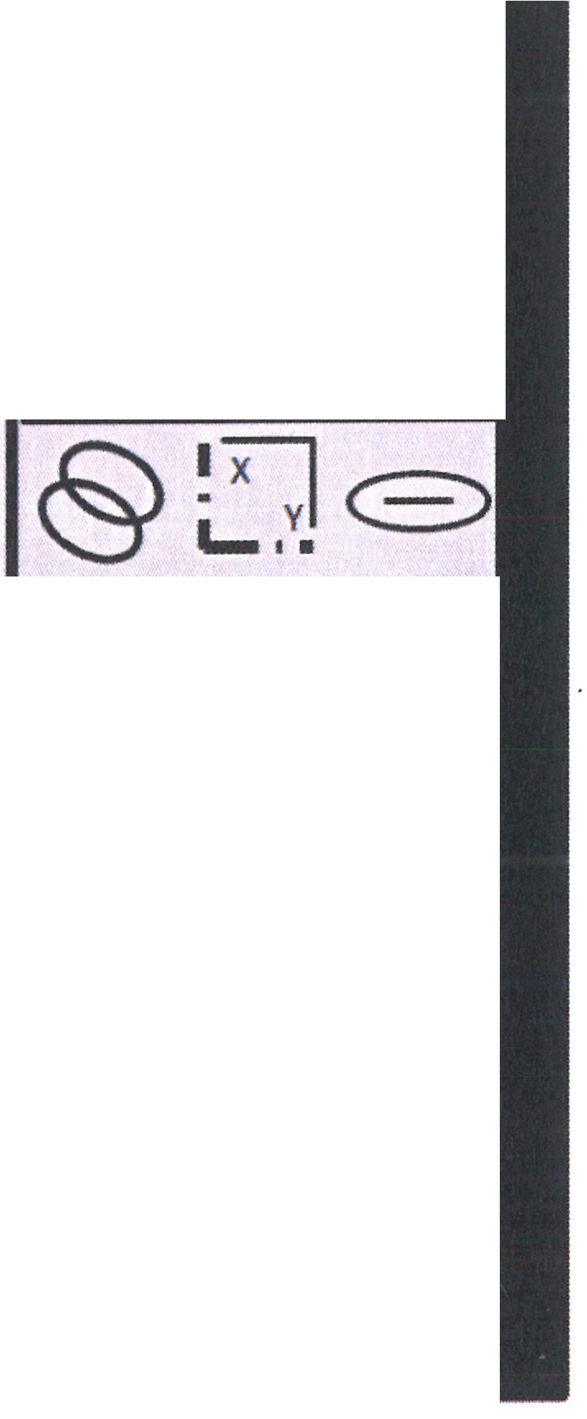SYS TEMP 19.1°C
PCOUNTER 000.3 k DI-WATER TEMP 00.1 •c WATER FLOW 00.0 1/m VOLTAGE 370V
UPTIME 02:13
N/A 05.0 150
mm mm/s mm
-,'•,,'-'B□-■• •-·yB□D
□ D

- MAX PULSE POWER
-AVARAGEPULSE POWER 00.37kW

D.11111 123
029.3 W

(9 13:03 04/02/2013
0.20-f

In this state, the ready lamp is off. No pulses can be triggered. The display has a low brightness.
Turn the key switch clockwise, so that the machine can operate.

OR Lasertechno/ogie GmbH-Dieselstrasse 15-64807 Dieburg-Tel.. 0 60 71/209 890 Fax: 0 60 71/209 8999

O.R.
16.09.2013 HTS MOBILE- Page 8

- Ready:
 | -[SHAPE SCALE]--  [ 2 0/o]  08.0 ms_{I}  -[FREQUENCY]--  10.0 Hz  - MAX PULSE POWER 00.37kW  -AVARAGE PULSE POWER 029.3 W  llmllll 123  (9 13:03 04/02/2013 | [READY] --
 |  | SYS TEMP 19.1•·
 |  | PCOUNTE:RR 000.3 k
 |  | DI-WATER TEMP 00.1 •
 |  | WATER FLOW 00.0 Vm
 |  | VOLTAGE
 |  | UPTIME
 |  | @: vlE)
 |  | N/A 05.0 150
 |  | mm mm/s mm
 |  | •'•'•'□8 -.._■ 8D
 |  | '•' DD • □□
 |  | l!!.1 1!!1
 |  | 0.20-f

The installation is ready for pulsing. Position
- System temperature
- Pulse counter

- Water temperature
- Inflow speed
- Operating time

1
2
3
4
5

Function

Internal air temperature
Number of pulses, with a lamp replacement the counter is reset to zero
Current water temperature in 'C
Speed of the inflow in I/min
Operating time since the system has been switched on

- System not ready:

Power supply is in charging state.

O.R. Lasertechno/ogie GmbH- Dieselstrasse 15-64807 Dieburg -Tel.. O 60 71/209 890 Fax: 0 60 71/209 8999
O.R.
16.09.2013 HTS MOBILE - Page 9

- Overload

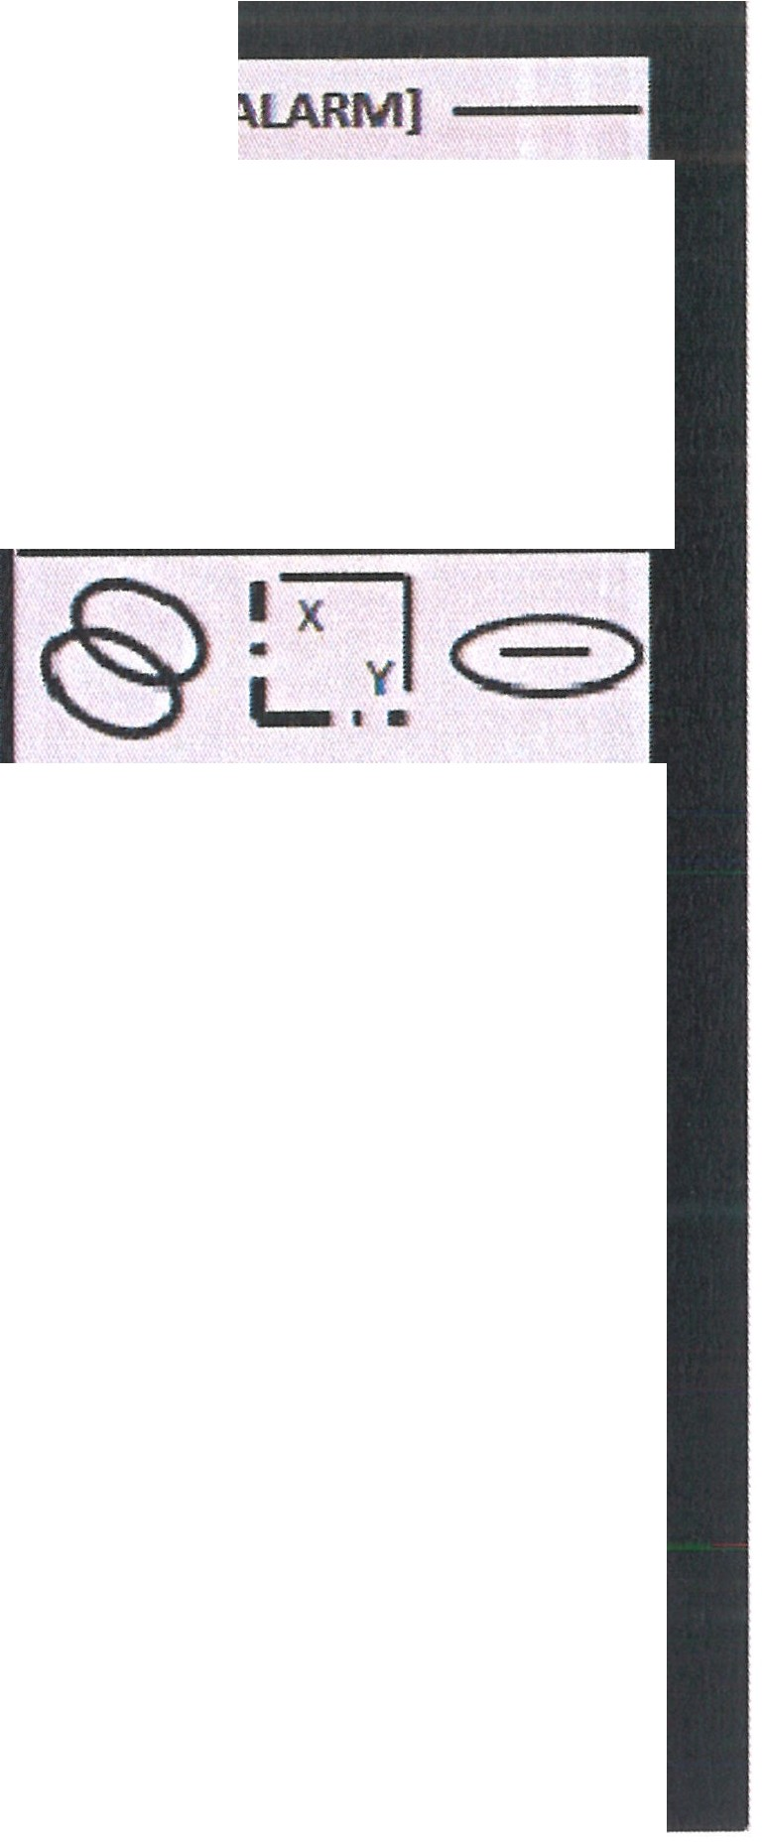
-[SHAPE SCALEJ
[ 034%]
[DURATION]
I
() OVERLOAD
-
08.0 ms
N/A 05.0
[FREQUENCY]
10.0 Hz
mm mm/s
-•-a
D
•,- D
,, D
*
150
mm

0
D
D
- MAX PULSE POWER
- AVARAGE PULSE POWER 029.3 W
llmllll 123
00.37kW II 1•11•11•1
(9 13:03 04/02/2013 o.2o T

This occurs when a higher than permissible parameter is reached with the set mode. To remove the overload, release the foot pedal and touch the overload message. To continue the work, the voltage, pulse length or the pulse frequency must be reduced.

It may be necessary to deactivate the automatic pulse frequency matching (see Chapter 1.4.1).
Note

OR Lasertechno/ogie GmbH-Dieselstrasse 15. 64807 Dieburg. Tel.: 0 60 71/209 890 Fax: 0 60 71/209 8999
O.R.
16.09.2013 HTS MOBILE - Page 10

    - Selection menu

1

2 5
X
SERVICE
MENU
EVENT
VIEWER
SHAPE
,I II WIZARD
I

SETTINGS

MAIN

3 4

Position Function

      - Main menu
      - Settings
      - Pulse shape editor
      - Service menu
      - Event display

OR. Lasertechno/ogie GmbH-Dieselstrasse 15-64807 Dieburg -Tel.. 0 60 71/209 890 Fax: 0 60 71/209 8999

0.R.
16.09.2013 HTS MOBILE - Page 11

    - 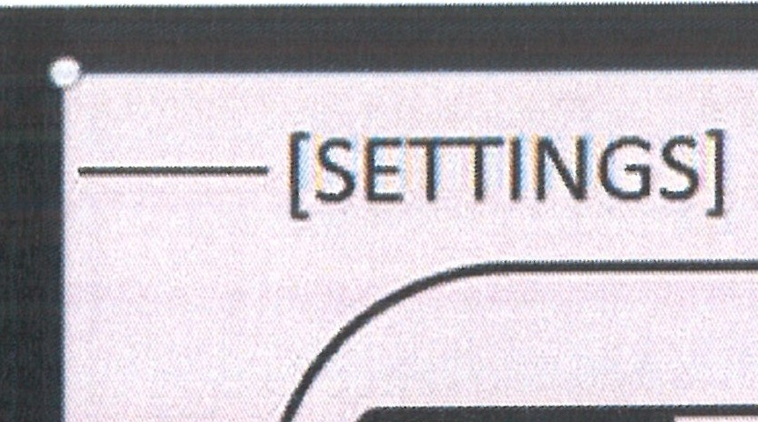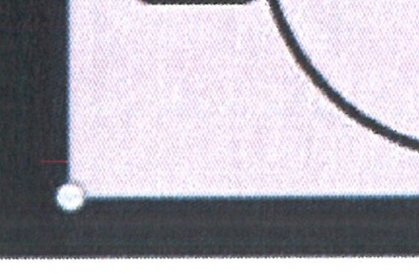Settings
- r ., J
- I:!!
IIIHII■
201,302,04) ! r+ ]
(
TIME
13:06 )
- 1¥1
- 13
(<==>LENS TYPE (mm] 150 )
(ID
l■
I■
<t
( fJ. LANGUAGE
ENGLISH I
- I
( ADJUST (sec per IJ).9JlthJ
+ 000
I I
,<,.I.,I
( SWITCHTOSTANOBYIN (min)
030)

1 7
2
3 8
4
5
6

Setting the parameters:

      - Selection using the touch screen or the control knob
      - Parameter change by turning the control knob
      - To change the parameter in larger steps, the control knob should be pressed faster
      - Press the knob SAVE to save the changed parameters

Position

1
2
3
4
5
6
7
8
Function

Setting the current date Setting the current time Lens type
Language Time correction
Setting the standby time Calibration of the touch screen Contrast setting

O.R. Lasertechnofogie GmbH-Dieselstrasse 15-64807 Dieburg -Tel.. o 60 71/209 890 Fax: o 60 71/209 8999

O.R.
16.09.2013 HTS MOBILE- Page 12

    - Service menu

System Info:

Information concerning the installation type, the serial number, the total memory and the software version.

(II
-[SERVICE MENU]
PLANT TYPE: EDELWEISS
0 INSTALLATION DATE: 27/08/2012
LI.
SERIAL NUMBER: 0492
::ii:: TOTAL PULSE COUNT: 329
LU
Iii
CB FIRMWARE VERSION: 3.3.SG
CSU FIRMWARE VERSION: 2.4.0
LI.
I TOTAL FLASH SIZE: 2011 KB
AVAILABLE SPACE: 1710 KB
..,
<II
'--

The total pulses are not reset even when the lamp is replaced. Service info:
Information concerning replaced laser crystals or pump lamps.
-[SERVICE MENU]
LAMPS COUNT: 001
LASER ROOS COUNT: 001
z
DATE
i.a@tii•iiti;ii
t;;
w
-
z
REPLACEMENT REPLACEMENT (T)(4)
LASER ROD
--
LAMP

CURRENT LAMP |  | 000000.3 | I 0000.0
CURRENT LASER ROD |  | 000000.3

When replacing the lamp, the "Replacement pump lamp" button should be pressed together with the "Gas" button. Once entered, information cannot be deleted.

D.R.

OR Lasertechnologie GmbH - Dieselstrasse 15 - 64807 Dieburg - Tel.. 0 60 71/209 890 Fax: 0 60 71/209 8999 16.09.2013 HTS MOBILE - Page 13

    - Loading and Saving of Parameters

Up to 15 modes related to the laser welding process can be saved. The length of the name is limited to 19 symbols.

    - 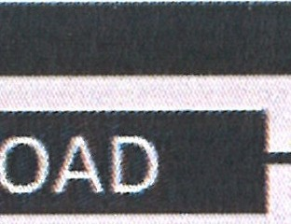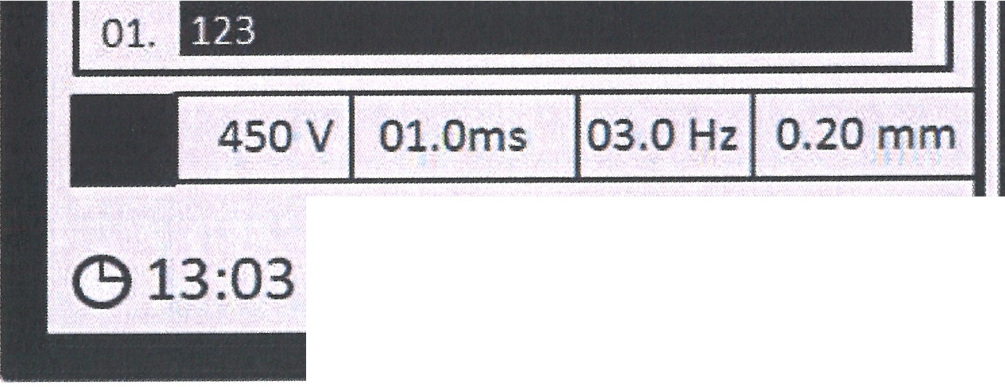Loading the parameter file

16. -1-2-3 ·  15. 123 - . ·  14. 123  13. 123 ·  12. -123 ·  11. 123 ·  10. 123-----------------------------------  09. 123 ·  08. 123 ·  07. 123 ·  06. 123 . ·  05. -123 ·  04. 123 ·  03. 123 --------------------------·  02. _123 -----------------------·  04/02/2013 | [STANDBY] -  SYS TEMP 19.1°C  PCOUNTER 000.3 k  DI-WATER TEMP WATER FLOW SHAPE SCALE UPTIME
\ .-:x:,'LJ,.E)
N/A 05.0 150
mm mm/s mm
,, □ B
,,, 8□ ••• B
□ □
, .. 1
 | 0.20


The 16 rows in the display can be edited as desired.
You can use the touch screen or turn the control knob for selection. For loading - the control knob is pressed.

O.R. Lasertechno/ogie GmbH- Dieselstrasse 15-64807 Dieburg -Tel.. 0 60 71/209 890 Fax: 0 60 71/209 8999

D.R.
16.09.2013 HTS MOBILE- Page 14

    - Saving the parameters

16. 123
15. 123
14. 123
13. 123
12. 123
11. 123
10. 123
09. 123 ------------------------------
08. 123 ------------------------------
07. 123
06. 123 ------------------------------
(STANDBY) -

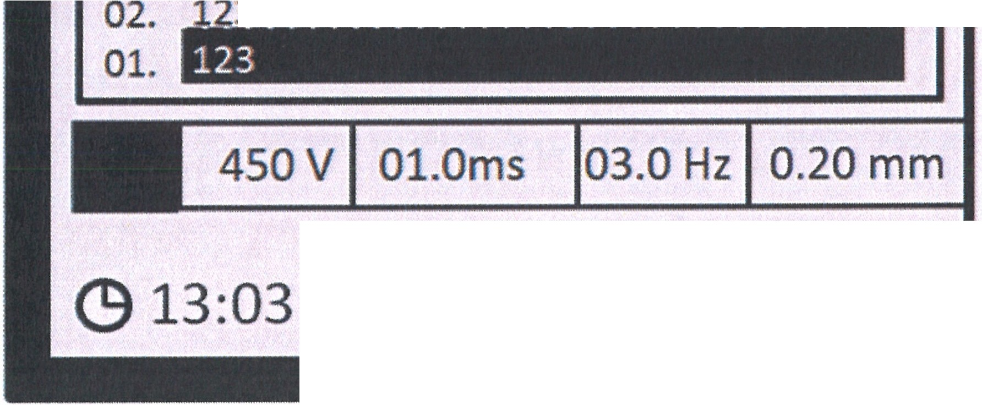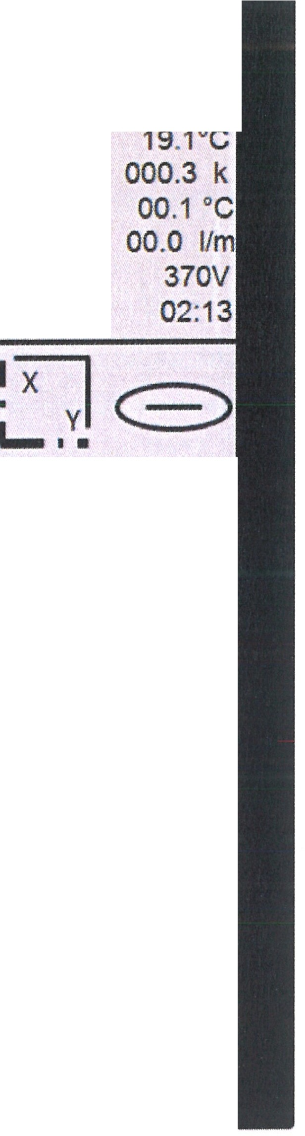SYS TEMP PCOUNTER
DI-WATER TEMP WATER FLOW SHAPE SCALE UPTIME
@
N/A 05.0 150
mm mm/s mm

'•'' 8 .,.. 8

05. 123
-,,,-□□
.•... □

04. 123 ------------------------------
03. 12.33.

04/02/2013
□ □

l!!] [ij]

0.20 -f<E--

This function permits the saving of pulse parameters.

You may not use Position1, as this is reserved for automatic saving.

ATTENTION

Before saving, you should set the following parameters:

- Pulse
- Pulse length
- Frequency
- Pulse shape

Press the SAVE knob. Select the desired row with the touch screen or the control knob. The parameters are saved when the SAVE button is pressed again; a beep confirms saving. The parameters are saved under current names (under 123 when not entered).

When the SAVE button is pressed for a longer period of time (more than 2 sec), a window with a virtual keyboard opens.

O.R Lasertechnologie GmbH-Dieselstrasse 15-64807 Dieburg -Tel.. o 60 71/209 890 Fax: o 60 71/209 8999
0.R.
16.09.2013 HTS MOBILE - Page 15

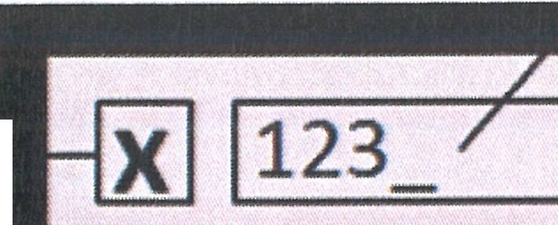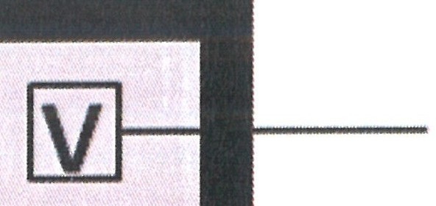2
[ru[A][[][g[Q] 1 I
rIJ
[£][§][8]OJ QJIBJ [!][I]
[g]oo rncruITJ [Q] [[] [[]
lliJ[Q] CoJ
rnoo
CQJ
G][J [J [J [ID[Q]
[WHRJ 00[I] rn00

1-- 3

To make an entry, empty the input field (2) with the"+-" button. Enter the name. To save, press the "Check mark" button (3) or press the control knob or press the SAVE button.
To leave the window without saving, Press the button "x" (1).

    - Pulse shape editor

Pulse shaping refers to each successive pulse.

For laser welding, there are settings for the pulse, where the power changes with the passage of time. The pulse shape can be adjusted to the temperature-dependent absorption behavior of the material by means of pulse shaping. This way, the weld pool can be stabilized and the material can be preheated and cooled in a defined way. This can prevent power excesses and with it, the overheating of the weld pool.
The quality of the weld surface is improved.
For example, the formation of spattering is prevented for copper alloys. This would otherwise occur with a sudden phase change.
Oxide layers can be removed and the formation of pores can be prevented via the prepulse phase.
The postpulse phases have a homogenizing effect; they can prevent the formation of pores by improving the degasification of the material. In addition, these can prevent hot cracks and the hardening of cracks in the case of materials with a higher carbon content.

As such, use of the pulse shape editor makes it possible to reduce the internal stress and the porosity of the weld. This is possible in the case of steel welding with a high carbon content, cast parts with cavities, the inclusion of contaminated substances and materials with different melting temperatures.

O.R. Lasertechno/ogie GmbH- Dieselstrasse 15-64807 Dieburg -Tel.: 0 60 711209 890 Fax: O 60 711209 8999
D.R.
16.09.2013 HTS MOBILE - Page 16

By means of pulse modulation, as is shown here for tool steel 1.2767, a more homogeneous remelting can be obtained (in the case of A) than without (B):
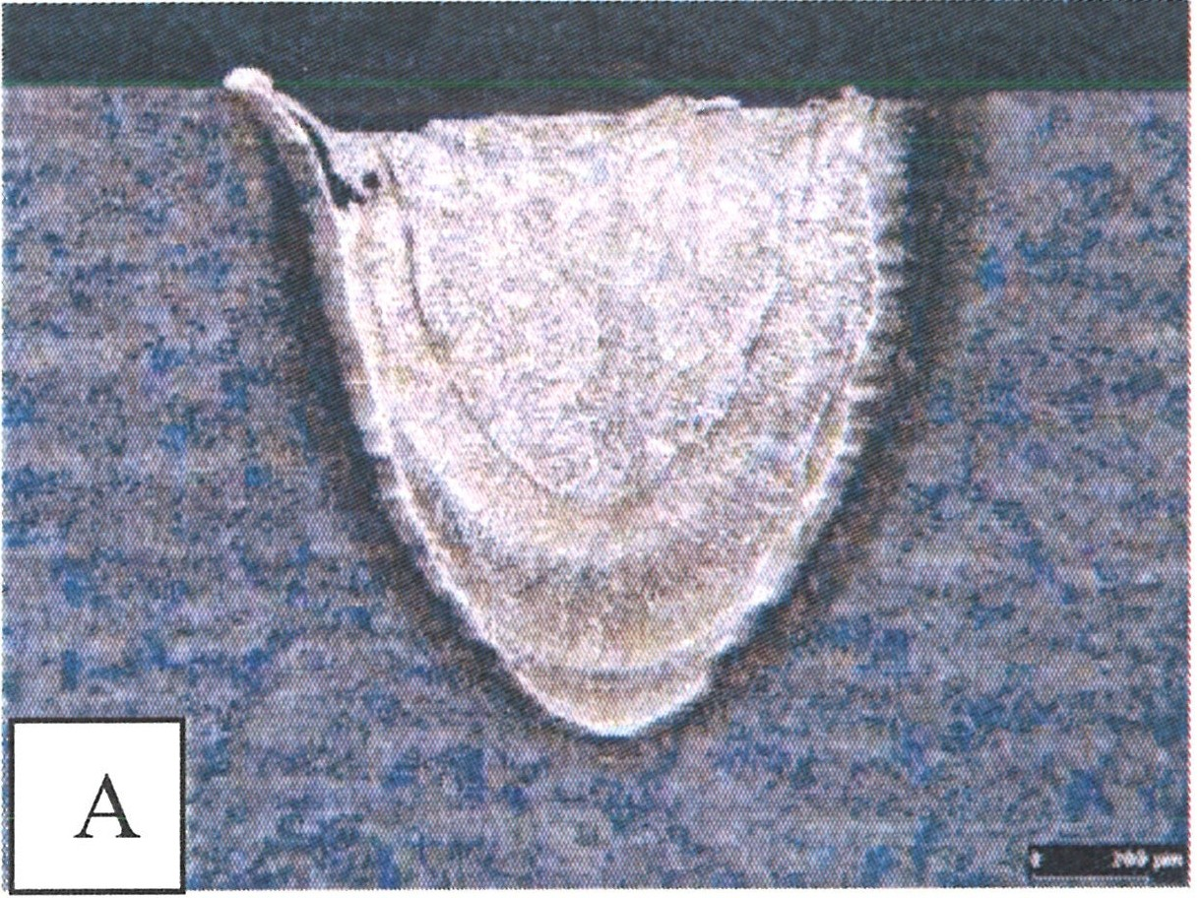
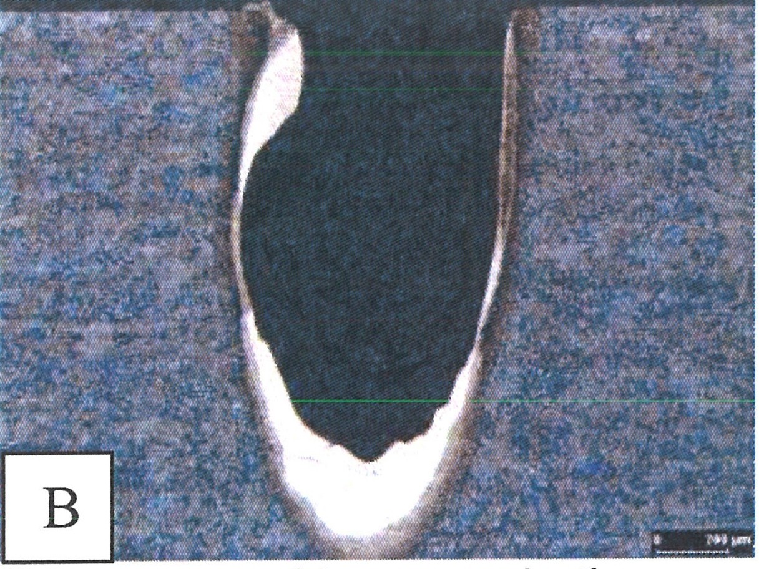
A: Homogeneous melting zone with a long pulse length. B: Porous remelting zone in the case of high pulse power.

[]
Note
When you select/newly shape a different pulse other than the full pulse, you must be aware that you should readjust the power later on in order to obtain the same energy for remelting the material.

The display is divided into three areas.
3

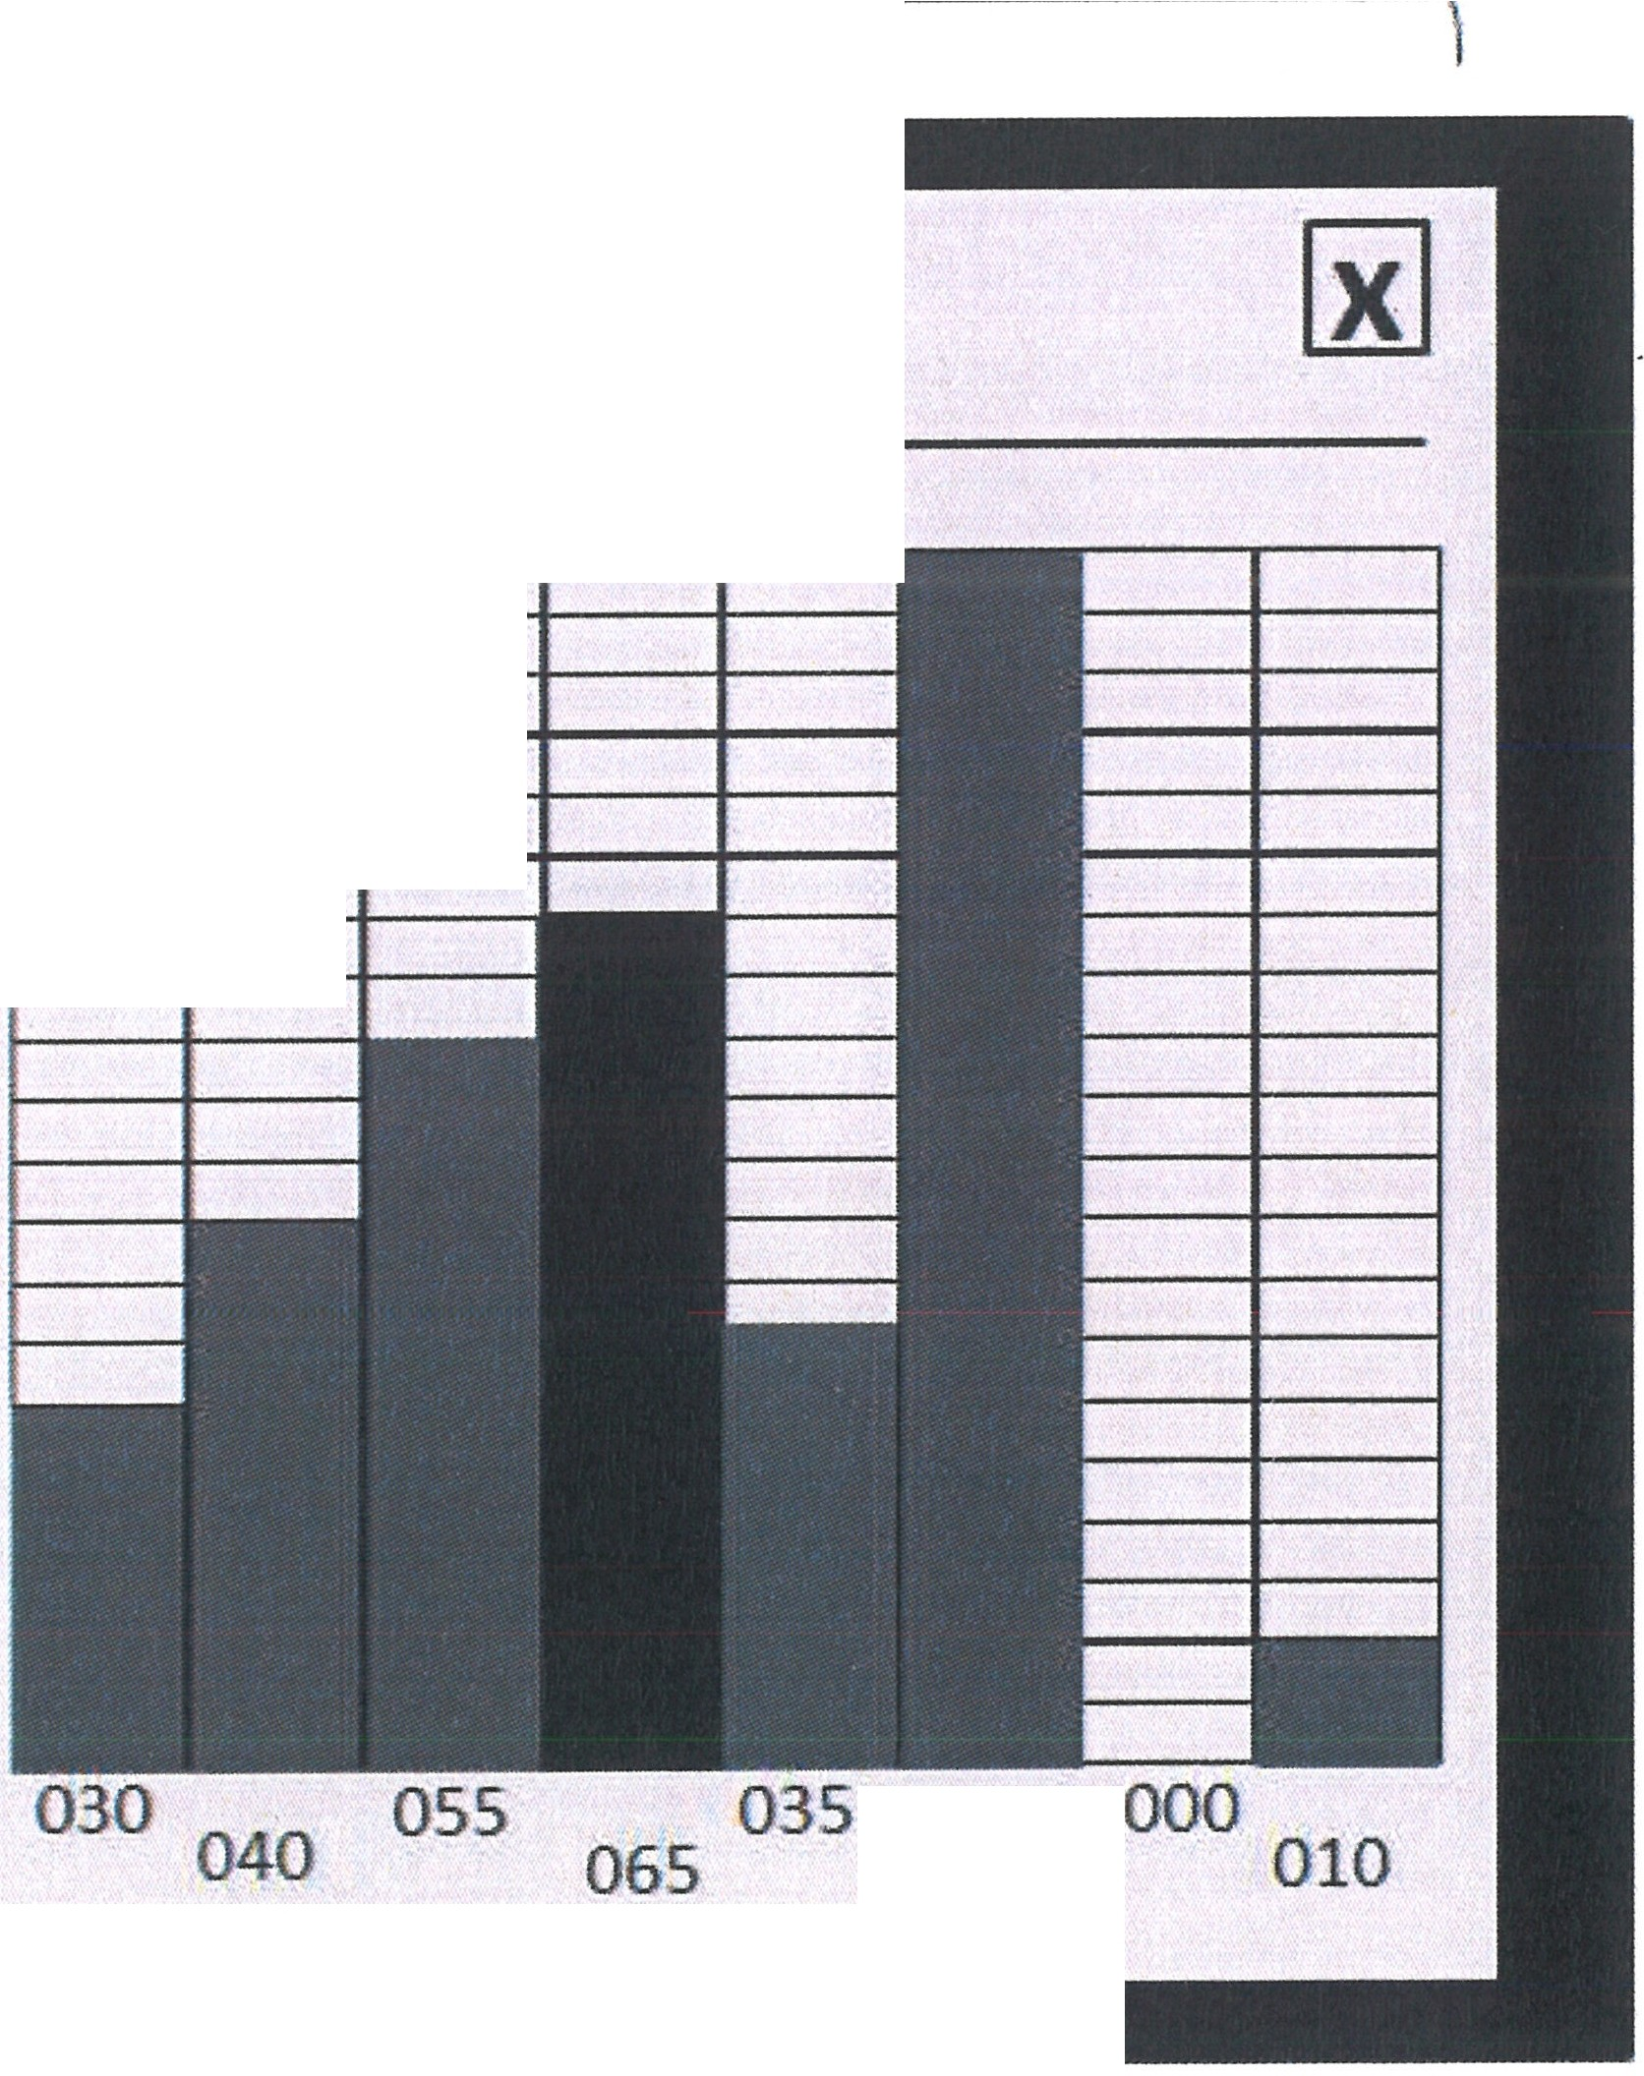1
riiiiiil I ◄I-
·[PRESETI . '. . IVI AKTIVE
- .
[SHAPE WIZARD]
111111111111
100%.-------.-----.-----r-------.-
I.- II..-I80%
---+--+------t---
[CUSTOM]
60% t----+---+--
111111 IIMII 40%
IIIWI 11111120%
1.-11-1
1111111.-.1
0%
100
1--+-

2

1. Standard pulse shapes
Permits the selection of preset pulse shapes.

OR Lasertechnologie GmbH-Dieselstrasse 15-64807 Dieburg - Tel.. 0 60 71/209 890 Fax: 0 60 71/209 8999

0.R.
16.09.2013 HTS MOBILE - Page 17

  - User shapes:
These user-defined pulse shapes can be freely changed.

For editing, select the pulse shape; the row should flash. You can enter the desired shape on the right side of the graphic editor.

  - Graphic editor
There are eight columns for shaping the required pulse.
You can select the column with the touch screen and set the height of the column with the control knob. You can then change to the next column and enter the height there. You can save the new pulse shape with the SAVE button.
[I]
Note
100 % of the pulse shape editor refers to the set pulse power in the main window.

Operation modes of the pulse shapes:

"V" active - permits the switching ON/OFF of the selected pulse shape in the list of pulse shapes shown in the main window. The activity is always switched on for a rectangular pulse.

Sequence for switching ON and OFF
- Select the pulse shape by pressing the corresponding symbol.
- Activate the "Check mark" box.
- Press the SAVE button.

When the symbol is switched off, the pulse color changes to gray.

OR. Lasertechnologie GmbH- Dieselstrasse 15-64807 Dieburg -Tel.: 0 60 71/209 890 Fax: 0 60 71/209 8999
O.R.
16.09.2013 HTS MOBILE - Page 18

    - Event display

The display shows all events that have occurred since the start-up, e.g.: Switching ON and OFF, hang-ups, warnings, etc.

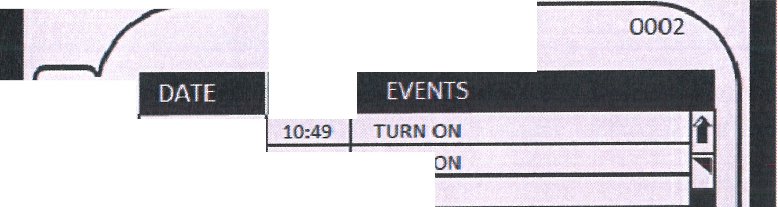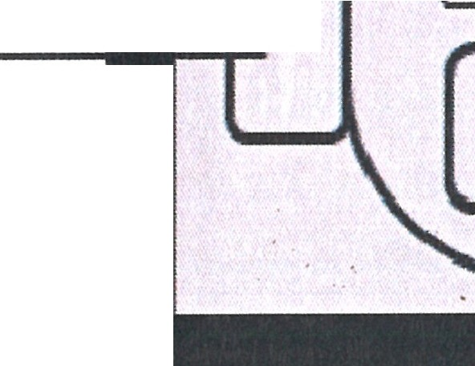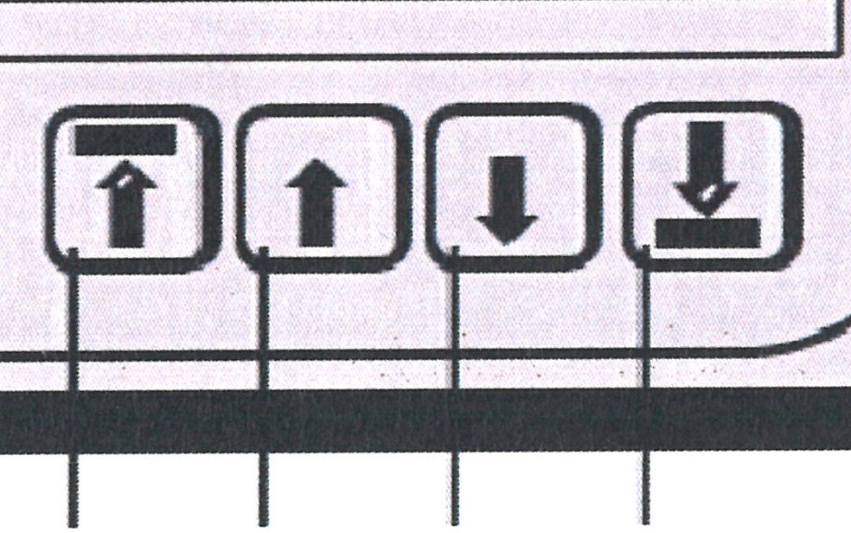Two tabs are available. Table of events and filter (convenient for monitoring). To switch between tabs, press the required tab, i.e. tab (1) or tab (2).
-
[EVENT VIEWER]
V)
1
z-
04.02.2013
>w
w
--
001/001
10:50 I TU
a:
w
u:
ti
CLEAR
D

1

I 2

'
I

3 4 5 6

1. Events

The lower buttons are used for movement through the table:

- To the start of the list
- One up in the list
- One down in the list
- To the end of the list

The "Delete" button cannot be accessed by the user.

OR. Lasertechnologie GmbH - Dieselstrasse 15 - 64807 Dieburg - Tel.. 0 60 711209 890 Fax: 0 60 711209 8999
O.R.
16.09.2013 HTS MOBILE - Page 19

- Filter

For sorting the events in the list.

Settings can be made for the following parameters:

  - By date

Year: Month: Day:

Current or set Current or set
Current, set, or all days

  - 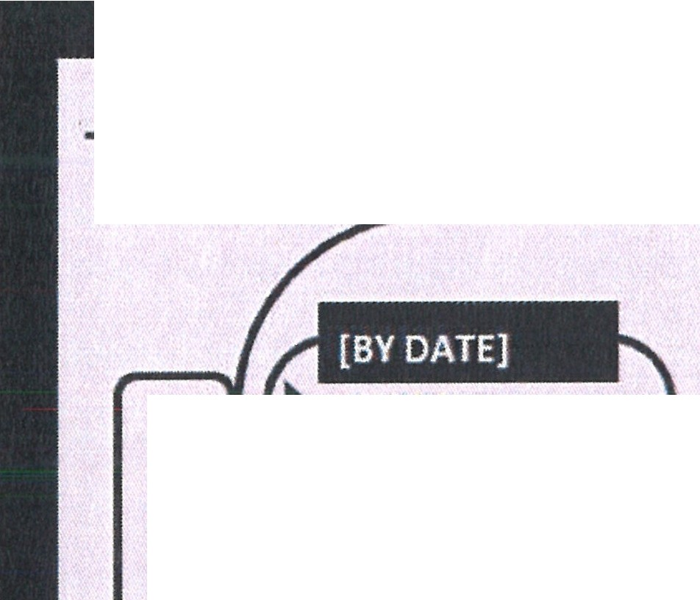By event (from the list of all possible events)
-[EVENT VIEWER]
001[001

[BY EVENT]
V)I -
z I 2013
- YEAR
c:,
a::
w
w
MONTH
[ CURRENT]
DAY
[CURRENT]
a::
(
APPLY
u.
,SET AS
DEFAULT
OVERHEAT LAMP FAILURE
LOW WATER FLOW DI-WATER OVERHEAT
LASER HEAD INTERLOCK SPI ERROR

ALL EVENTS
TURN ON
SHUT DOWN/pulse:
NEW DATE SET:
INTERLOCK
COOLING SYS FAILURE
SIMMER ERROR
OVERLOAD



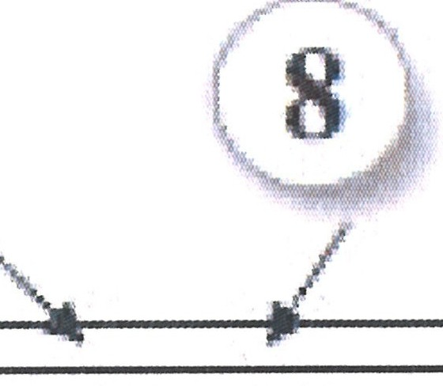
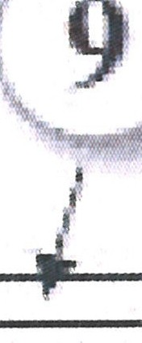lll] 00 l/O02

0017
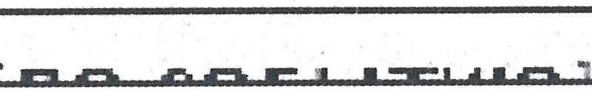

- - Current row
- - Number of events in the table
- - Total number of events (for the entire period since installation)

After making the required settings for the parameters, press the "Apply" button and go back to the "Events" tab. The settings apply for the current operation (until the display is switched OFF). The "Set as standard" button can be used to use the filter as a default option.

OR Lasertechnologie GmbH-Dieselstrasse 15-64807 Dieburg - Tel.. 0 60 71/209 890 Fax: 0 60 71/209 8999
O.R.
16.09.2013 HTS MOBILE- Page 20

1.5 Function description

1.5.1 The principle of laser beam generation

"Laser" is the acronym for "Light Amplification by Stimulated Emission of Radiation".
Although not all lasers emit a radiation in the range visible to the human eye (electromagnetic radiation with wavelengths of 400 nm to 750 nm), the laser is referred to as a light source and the radiation as laser light.

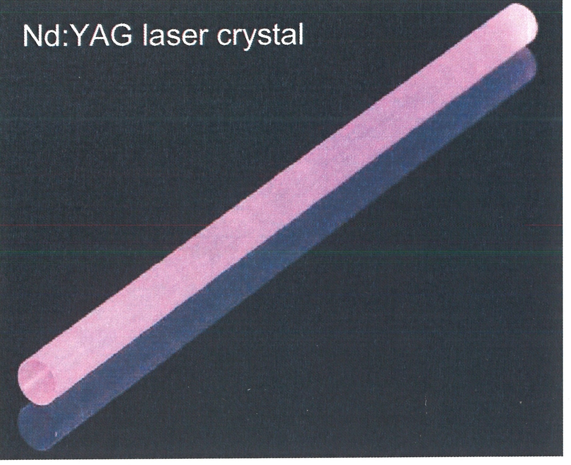
The laser used in the LRS system is an Nd:YAG solid-state laser emitting light with the wavelength of 1064 nm (near infrared range). Here, Nd:YAG stands for a approx. 1 % to 1.5 % Neodym-doped Yttrium-Aluminum-Garnet crystal, which is used as the laser medium.

In the resonator, a part of the electrical energy provided by the pump lamp power supply (4) is converted to laser light.

The electrical energy that is supplied is used first to create a non-directional light in the lamp-specific
wavelength range via a rod-shaped gas discharge lamp (pump lamp) (2). Only a part of the pump light is converted into laser light. A large part of the input energy is discharged by the cooling system as lost heat. In case of continuous pumping, the laser is in continuous operation (cw) which, with an optical connection, also emits laser pulses (QS). In the case of a pulse laser, the pump lamp and the laser light is pulsed.

The laser crystal (1) (also rod-shaped) is positioned parallel to the pump lamp in a highly reflective housing (the "cavity") (5). This is irradiated (pumped) from all sides. The crystal converts the absorbed light with different efficiency into light with preferred wavelengths. In case of so-called spontaneous emission, the light remains non-directional.

When the crystal is positioned longitudinally between two mirrors (3) (the physical resonator) the radiation portions are reflected by the mirrors through the crystal. These are amplified when passing through the crystal. Above a threshold, i.e. reaching the population inversion, laser radiation (i.e. amplified light where the wavelength, direction, phases, and polarization coincide) is generated during stimulated emission.

OR. Lasertechno/ogie GmbH-Dieselstrasse 15-64807 Dieburg -Tel.. 0 60 71/209 890 Fax: 0 60 71/209 8999
O.R.
16.09.2013 HTS MOBILE - Page 21

    - Schematic diagram

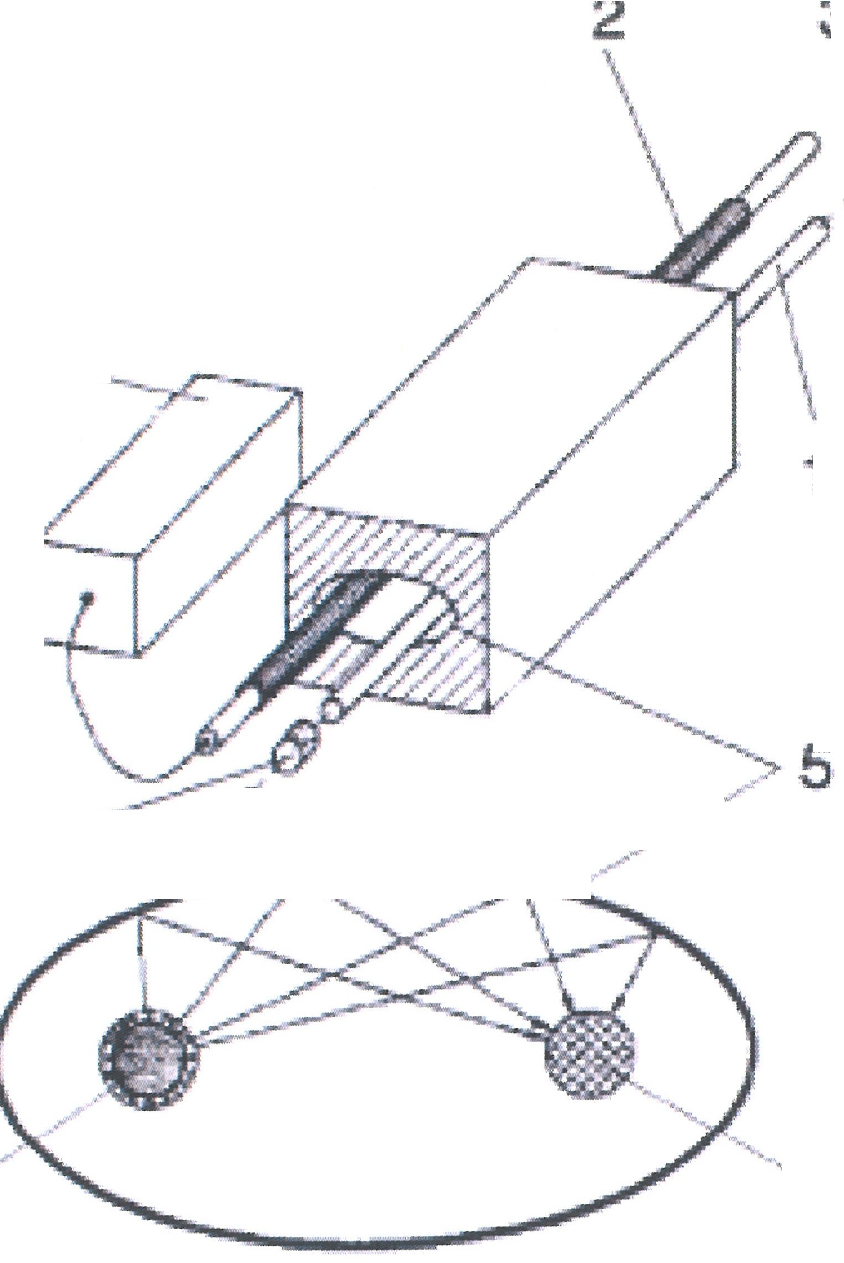
3
4
1
3------- ,1'
..pi)·<
- - ··
2
1

      - Laser rod
      - Lamp
      - Resonator mirror
      - Lamp supply
      - Mirrored elliptical cavity

The wavelength-specific reflection of the resonator mirrors selects the desired wavelength from the wavelengths generated by the laser crystal. The exit of the laser radiation portion available for use takes place through a partially transmitting mirror.

Without any further aids, several transversal and longitudinal modes (laser beams with different direction and wavelength) always form in the real resonator. Together, they form a multi-mode laser beam. Because of their small wavelength differences, the number of longitudinal modes is rarely important for material processing, but it is important for measuring jobs and for transferring information. The number of transversal modes and the wavelength determine the beam quality (product of the beam diameter at the beam waist and beam divergence). A smaller value indicates a better possibility of being able to focus the laser beam (influence area on the material) as well as larger energy/ power density per area unit.

Nd:YAG lasers can reach a pulsed output power of up to 10 MW. However, this requires an enormous cost, as each crystal can only take a certain amount of energy and would burst in the event of an overload. In order to generate such high energies, several cavities are arranged in the resonator in a row between the mirrors, and in an ideal set-up, the individual outputs combine to provide the total output power.

O.R. Lasertechnologie GmbH- Dieselstrasse 15 - 64807 Dieburg - Tel.. O 60 71/209 890 Fax: o 60 71/209 8999
O.R.
16.09.2013 HTS MOBILE - Page 22

    - Implementation of the resonator

In addition to the pump lamp, the laser crystal and cavity (which form the stimulation unit) and the resonator mirrors (the resonator assembly), other elements are also required in order to operate of the laser. These make the application of the laser radiation meaningful.
At both ends of the laser crystal, the optical components are mounted precisely and are stable in adjustable holders. This is done in order to insure optimum geometrical preconditions for the generation and shaping of laser radiation.
The dust-proof and water-protected housing insures protection of the built-in optical components and keeps mechanical and thermal influences away from the accurately calibrated resonator components.
A safety shutter behind the output coupling mirror prevents any uncontrolled exit of laser radiation.
The resonator housing also includes the circuit for igniting the pump lamp.
The resonator housing, together with the front panel, can be moved by a motor in a Z-direction to an individual work position

    - Beam deflection 90°and stereoscopic microscope

The laser beam is deflected downwards by 90 This results in the convenient and safe application of the focused laser beam to the manually fed workpiece. The effect is checked visually through the stereoscopic microscope. A protective filter in the beam path prevents the entry of Nd:YAG laser radiation through the observation beam path into the eye. An additional light-permeable LCD shutter is in place for the duration of a laser pulse. This protects against any blinding glare that is caused by secondary radiation that is generated during welding.

    - Mains power supply

On the input side, the mains power supply includes all of the components that are required for safe connection to the mains, e.g. mains circuit breakers, main contactors, mains protection, distributors as well as a motor circuit breakers for the coolant pump / other circuit breakers for a water-air cooling system.

On the output side, the integrated power supply provides the required power for the pump lamp, (adjustable to a suitable form), as well as the booster voltage that is required in order to switch the pump lamp on.
Two low-voltage power supplies provide the interface with a +24 V DC operating voltage as well as of peripherals to a limited extent.

The mains supply functions can be controlled and the operation states can be queried via the interface.

In the model for quality switch operation, the power supply additionally includes a +12 V DC low-voltage power supply as well as the driver for the quality switch with first pulse suppression logic (Q-switch).

O.R. Lasertechnologie GmbH-Oieselstrasse 15-64807 Dieburg -Tel.. 0 60 71/209 890 Fax: 0 60 71/209 8999
0.R.
16.09.2013 HTS MOBILE- Page 23

    - Internal cooling system with a water/air heat exchanger

The cooling system provides coolant for the transportation of the lost power from the resonator.

The secondary, closed coolant circuit holds deionized water as coolant. It is pumped by the reservoir pump through parts of the resonator, the heat exchanger, the particle filter, and in part the deionization filter, back to the reservoir. In the case of a water-cooled mains power supply, the water from the resonator flows through the mains power supply back to the cooling system.

The primary cooling circuit contains an easily boiling liquid as coolant. The coolant evaporates in the heat evaporator of the reservoir by absorbing the lost heat. It is sucked in and compressed by a compressor and at this time, it becomes warmer again. The compressed hot gas is cooled in the air-cooled heat exchanger/condenser. The heat is discharged to the ambient air, which is moved through the condenser by a ventilator. The cooled and liquefied coolant is expanded via an expansion valve/capillary whilst cooling further. It is then led back to the evaporator.

A temperature sensor detects the coolant temperature and controls the hot gas bypass valve in order to insure a constant coolant temperature.

Level temperatures, flow switches and a pressure controller monitor the functions of the cooling system.

The axial fan and the compressor are only switched on when the inlet temperature of the cooling water is above the set value for their connection.

O.R. Lasertechnologie GmbH - Dieselstrasse 15 - 64807 Dieburg - Tel.. O 60 71/209 890 Fax: 0 60 71/209 8999

O.R.
16.09.2013 HTS MOBILE - Page 24

- General safety_ notes
  - Obligation for due diligence on the part of the operator

The HTS MOBILE 120/160/200/300 laser processing station was constructed and built following consideration of a hazard analysis and after careful selection of the harmonized standards which are to be observed and further technological specifications. It meets the requirements of the DIN EN 60825-1/11.2001 (VOE 0837 Part 1) standard "Safety of Laser Systems". The invisible laser radiation used for deposition welding represents a hazard for the eyes and skin. As such, the device has been assigned to the laser class 4 classification.

In terms of operational practice, the necessary safety of the operator and others can only be achieved when all of the measures that are required are taken. The obligation for due diligence on the part of the operator for the laser processing station includes the planning of these measures and checking that they are observed.

In particular, the operator must insure that
  - the operation of the laser processing station has been registered with the relevant regulatory body for laboratory safety and the relevant professional society
  - a laser protection officer with the required expert knowledge is appointed in writing (see 2.8 for details)
  - the laser processing station is used only as intended and with extreme care. In particular, unsupervised operation is prohibited.
  - the laser processing station is only operated in a faultless, functional condition and the functionality of the safety devices is in particular, checked periodically
  - the required personal protection equipment (in particular protective laser goggles in accordance with the standard) are available for the maintenance and repair personnel and are also used
  - the operating instructions are available at the site of the laser processing station, that they are in a legible condition and can be viewed by the operator at any time
  - the laser processing station is only operated, maintained, and repaired by sufficiently qualified and authorized personnel. The training offered by O.R. acts as an introduction to the correct and safe use of deposition welding.
  - the personnel are instructed periodically (i.e. at least once a year) concerning all of the relevant matters concerning laser safety, general occupational safety, environmental protection and that they know the operating instructions, especially the safety notes contained in them
  - all laser instructions and warning signs on the laser processing station are not removed and remain legible.

OR Lasertechno/ogie GmbH-Dieselstrasse 15-64807 Oieburg -Tel.. 0 60 71/209 890 Fax: 0 60 71/209 8999
O.R.
16.09.2013 HTS MOBILE - Page 25

11. Check all water connections for leakage.

Voltage is applied to the device!
DANGER

ATTENTION
Only turn device on only when fully filled! - A dry run destroys the coolant pump.

A not completely closed coolant reservoir can cause direct leakage or early evaporation of coolant or formation of algae.

- Fasten the left side wall of the installation.

- Document all maintenance work and enter it into the logbook.

8.5.5 Cooling system COR 16 (at 300 W):

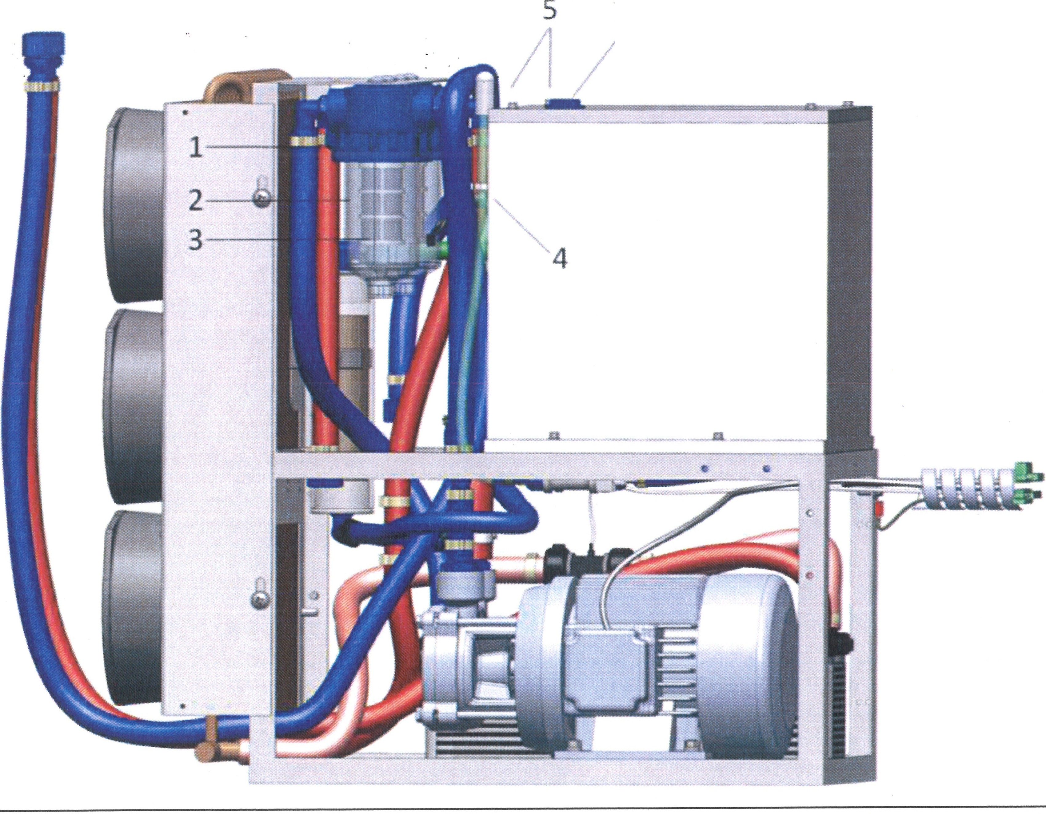
7
r6 \

O.R. Lasertechnologie GmbH-Dieselstrasse 15-64807 Dieburg -Tel.. 0 60 71/209 890 Fax: 0 60 71/209 8999
0.R.
16.09.2013 HTS MOBILE- Page 75

  - Explanation of the safety symbols that are used

The following safety symbols are used in these operating instructions. These symbols are intended to bring the attention of the reader to the safety notes following them.

This symbol indicates a risk to the life and health of persons.

DANGER
ATTENTION
This symbol indicates a hazard for equipment, material, or
the environment.
[I]
Note
This symbol indicates information that helps the reader to gain a better
understanding of the functions and characteristics of the device.

OR. Lasertechno/ogie GmbH-Dieselstrasse 15-64807 Dieburg -Tel.. 0 60 71/209 890 Fax: 0 60 71/209 8999
O.R.
16.09.2013 HTS MOBILE- Page 26

Basic safety measures for normal operation and maintenance

For all work with and concerning the laser installation:
- The accident prevention regulation BGV A 1 "General Regulations" should be observed.
  - The accident prevention regulation BGV B 2 "Laser Radiation" and the supplementary information BGI 832 "Operation of Laser Installations" should be observed.
  - The accident prevention regulation BGV B 2 "Electrical Installations and Equipment" should be observed for all work on the electrical equipment.
- The instructions of the instruction manual should be carefully observed.
- The laser beam should never be directed towards humans or animals.
  - It is necessary to insure that any person engaged in the operation, maintenance and repair of the laser machine has read the instruction manual and the safety notes and has understood them.

For all work with an open beam path
- there is a risk of burning eyes and skin
- suitable protective goggles for laser work should be worn
- never look into the laser exit opening, not even when the laser is switched off
- never hold tools or metal parts with reflecting surfaces into the path of the laser beam
  - limit the laser area using nonflammable, not reflecting, immovably-installed partition walls which preventing the path of the laser beam from being seen
  - optical elements must always be screwed tight - risk of laser radiation in the case of variable direction parts which are shifted by accident or where the position is spontaneously changed.

For all work on the pump lamp
- there is the risk of explosion associated with the pump lamp, which is under high pressure
- the pump lamp must be handled with extreme care
- full face protection should be worn which guard against injuries from glass splinters.
  - robust gloves should be worn which guard against injuries from glass splinters.
DANGER
Lh
If operating and calibrating devices other than those specified in this manual or applying other procedures, this can lead to dangerous radiation
exposure.

OR. Lasertechnologie GmbH-Dieselstrasse 15-64807 Dieburg -Tel.: 0 60 71/209 890 Fax: 0 60 71/209 8999

O.R.
16.09.2013 HTS MOBILE - Page 27

2.3 Hazard for eyes and skin

This laser device is a laser class 4 Nd:YAG solid-state laser (yttrium-aluminum-garnet crystal doted with neodymium as laser substance).

It emits a very high optical beam power in cw operation (continuous) as well as in QS operation (pulsed). This radiation in the near infrared range with a wavelength of 1064 nm is nearly invisible.

Lb.
DANGER
There is risk from:
- the direct laser beam
- reflected laser radiation
- diffusely scattered laser radiation

The eye is at particular risk from this invisible laser radic;1tion. This is because high radiation power additionally is bundled by the lens of the eye and is focused onto the retina. The high irradiation strength on the retina effects local heating and the burning of the retina tissue. This damage ranges from a reduction to vision which is not noticeable through to a complete loss of vision. The radiation of this device can be hazardous for the eyes, even over considerable distances.
Mark and flag the laser area where the laser beam is accessible (e.g.
by reflexes)!
Lb.
DANGER
For all work with an open laser resonator housing:
- interrupt the laser resonator or place an absorber block into the beam path!
- never look into the laser exit opening, not even when the laser is switched off!
- never hold tools or metal parts with reflecting surfaces into
the path of the laser beam!

Protective goggles offer protection against the direct beam and reflected or diffuse scattered radiation. Nevertheless, looking directly into the laser exit opening, even with protective goggles (and with switched-off laser) must be avoided. The intensive radiation of the laser cannot be kept back sufficiently due to damage. Alternatively, the protective filter may be destroyed.

When using protective goggles, care must be taken to insure that they have no defects, that they are suitable for the wavelength range (1064 nm) and that they correspond to the protection level (L7) of the laser output power. Any mixing-up of protective goggles is dangerous as the protective effect of the filters only exists for a narrow wavelength range and up to a defined performance limit. For example, goggles for CO2 lasers (10.6 µm) do not protect against the radiation of an Nd:YAG laser (1064 nm).

OR. Lasertechnologie GmbH - Dieselstrasse 15 - 64807 Dieburg - Tel.. 0 60 71/209 890 Fax: 0 60 71/209 8999
0.R.
16.09.2013 HTS MOBILE- Page 28

In comparison to the eyes, the skin can withstand considerably higher irradiation, but here as well, the tissue can be damaged or destroyed by burning (depending on the irradiation duration and the irradiation strength).
DANGER
A
When required, wear appropriate protective clothing!
When laser damage is suspected or found:
- Immediately switch off the laser
- Secure the laser against unintended switching on
- Inform your superior, the laser protection officer, the firm's doctor, and the safety specialist.
- In the case of possible eye injuries, visit an ophthalmologist immediately and get a fluorescence angiography for the retina!
- In case of skin injuries, visit a physician, a clinic, or a specialized clinic.

With this system, these hazards can only occur in the case of improper use or during maintenance work (which may only be performed by trained personnel).
2.4 Risk of Fire

The high output power of the laser processing station can also heat materials other than the material to be welded to the point when they become flammable.
DANGER
A
For all work, remove easily flammable materials from the work table of the processing station!
When using solvents and cleaning agents, always observe the respective warnings!

Flammable objects (e.g. paper, non flame-retardant/ non-impregnated curtains, wood panels, or similar) can be easily ignited by direct or reflected laser radiation.

In particular, containers with easily flammable or explosive solvents, cleaning agents and gases under pressure must be removed from the area of the accessible laser radiation or alternatively, they should be shielded using suitable measures. Any accidental hitting of these containers by laser radiation can very quickly and easily lead to large conflagrations or explosions. Refer to
j paragraphs 10 and 16 of the accident prevention regulation BGV B 2 "Laser Radiation".

OR. Lasertechno/ogie GmbH-Dieselstrasse 15-64807 Dieburg -Tel.: 0 60 71/209 890 Fax: 0 60 71/209 8999
O.R.
16.09.2013 HTS MOBILE - Page 29

2.5 Risk from high voltage

This laser processing station has been constructed according to the generally recognized rules of engineering. In particular, these are the relevant EC Directives, EN (European standards) and DIN standards, as well as the VOE terms of reference which are taken into consideration.
DANGER
A
Work on electrical components of the laser processing station may only be performed by electricians who are accordingly trained.
These persons also need to have been informed of the hazard from laser
radiation.
The accident prevention regulation BGV A 2 "Electrical Installations and Equipment" shall be observed for all work on the
electrical equipment.

Operation of the laser requires life-threatening high voltages. In particular, special care is required in order to work on supply parts of for the pump lamp. Here, life-threatening voltages up to several kV unconditionally require the observance of corresponding air and creep age distances. Furthermore, capacitors can be charged with high energies even a longer time after the device has been switched off. These can lead to deadly electrical shocks.
A .
DANGER
Never perform any maintenance or repair work alone!

A second person, at least informed about the hazard relating to laser radiation and the life­ threatening high voltage. This person should always stay in the immediate vicinity during the work. In an emergency, this person must be in a position to switch the equipment off and carry out first aid measures.
DANGER
A
Observe the five safety rules for work on electrical
components:
- isolation
- secure the laser from accidentally being switched on
- make sure that there is no voltage present
- ground and short-circuit
- cover and/or block off neighboring live parts

OR. Lasertechno/ogie GmbH- Dieselstrasse 15-64807 Dieburg -Tel.. 0 60 71/209 890 Fax: 0 60 71/209 8999
0.R.
16.09.2013 HTS MOBILE- Page 30

2.6 Hazards from the operation of the laser processing station

DANGER
For all work with the laser protection station, the accident prevention regulation
BGV B 2 "Laser Radiation" and the supplementary information BGI 832
"Operation of Laser Installations" must be observed.

This laser installation is equipped with a series of measures for protection against hazards from laser radiation and high electrical voltage. In case of damage or defects, unintended laser radiation may escape/damage the laser installation itself.
In the case of any damage or defects on laser installations, protective devices and accessories:

- Immediately switch off the laser
- Secure the laser from accidentally being switched on.
- Repair the defective parts.
DANGER - Only use spare parts which are expressly approved by the manufacturer.
- Check that all laser functions after repairs have been made.
- Carry out a test to make sure that protective devices and accessories work.

When materials are processed with laser radiation, harmful or injurious substances may be released from the processed material. Harmful vapor or dust may be caused, especially with the processing of plastics, coated or oiled metals. These products should not be inhaled or otherwise joined together when decomposing.

For the protection of human health and the environment, the decomposition of products occurring during processing must be separated by a sufficiently dimensioned exhaust plant, equipped with special filters and integrated into the system.
A.
DANGER
In case of doubt, the pollution should be measured and the
risk should be determined by the respective professional society.

OR. Lasertechnologie GmbH - Dieselstrasse 15 - 64807 Dieburg - Tel.. 0 60 71/209 890 Fax: 0 60 71/209 8999
O.R.
16.09.2013 HTS MOBILE- Page 31

2.7 Legal regulations for the operation of laser installations

The accident prevention regulation BGV B 2 "Laser Radiation".

According to the accident prevention regulation BGV B 2 "Laser Radiation", the initial start-up of the laser processing station (like any other laser installation of the classes 3B and 4) must be notified to the respective professional society and the authority responsible for laboratory protection (in most cases the trade supervisory board) without any undue delay. This requirement is satisfied when the notification includes information concerning the manufacturer, the laser type (for example pulse laser (qs), continuous laser (cw)), radiation power, possible pulse duration and wavelength of the radiation.

The laser protection officer

A competent laser protection officer shall be appointed in writing by the company that is operating this laser installation.

From his training and experience, the laser protection officer shall have sufficient knowledge in the field of laser radiation, protective measures and protective devices.

Through this appointment, the company transfers the responsibility for safe operation of the laser installation and the required protective measures to the laser protection officer.

The operating staff

Only competent qualified personnel may be used in the operation of the laser processing station.

In particular, the operating staff must be familiarized with all protective measures and devices, as well with the operation of the equipment. In addition, they need to have understood how to operate this equipment.

All persons with access to the laser area (not only the operating staff in the narrower sense) must be instructed periodically (at least once a year) concerning the laser protective measures. The required contents can be found in the accident prevention regulations BGV B 2 "Laser Radiation" and the supplementary information BGI 832 "Operation of Laser Installations".
It is recommended that the laser protection officer obtains written confirmation relating to the participation of each employee in the training session.

OR. Lasertechnologie GmbH-Dieselstrasse 15-64807 Dieburg -Tel.. 0 60 71/209 890 Fax: 0 60 71/209 8999
O.R.
16.09.2013 HTS MOBILE - Page 32

- Transport

The following items must be observed to prevent damage to the equipment or life-threatening injuries during transport of the HTS MOBILE 120/160/200/300 laser station:

Transport can only be executed by qualified and authorized personnel and in accordance with the safety instructions.
DANGER
A
Transport position and connection equipment must satisfy the requirements of the accident prevention regulations!

The storage and the connection equipment must be selected suitably, so that a weight of 200 kg can be maintained!
The transport routes shall be blocked and marked so that no unauthorized person can enter the danger area!

The laser processing station is delivered as a package and can be moved with the installed wheels.

OR. Lasertechno/ogie GmbH-Dieselstrasse 15-64807 Dieburg - Tel.: 0 60 71/209 890 Fax: 0 60 71/209 8999

O.R.
16.09.2013 HTS MOBILE - Page 33

- Installation

To prevent damage to the machine and life-threatening injuries during operation, the following warnings must be observed during the installation of the laser machine:
A
The installation should only be performed by qualified and authorized personnel and in accordance with the safety instructions.
DANGER
To prevent the risk of tripping, all cables and connections leading to the work place must be arranged so that tripping is ruled out (e.g. with cable ducts and bridges, etc.)!

Before the installation work starts, all components of the laser installation
ATTENTION
must be inspected for transport damage.

In addition, please refer to Chapter 2 "General Safety Notes".

  - Electrical installation

The power for the entire laser processing station is provided via a single CEE plug (ECO 100: CEE 7 / 20 A; ECO 120/160: CEE 17 / 3 x 16 A). The socket needs to have been installed according to the relevant VDE regulations and must be fully connected to a neutral conductor and protective conductor. The mains frequency must be 50/60 Hz. A 25A fuse is sufficient. The max. consumption power of the individual types of laser processing station can be found in the table on page 10-1.

OR. Lasertechnologie GmbH-Dieselstrasse 15-64807 Dieburg -Tel.. o 60 71/209 890 Fax: o 60 71/209 8999
0.R.
16.09.2013 HTS MOBILE - Page 34

4.2 Conditions for the surroundings around the installation

The space that is required for set-up of the processing station can see from the following drawing (in mm). In addition, free space (at least 500 mm) shall, in each case, be provided in all directions around the processing station for connections, maintenance work and regular operation.

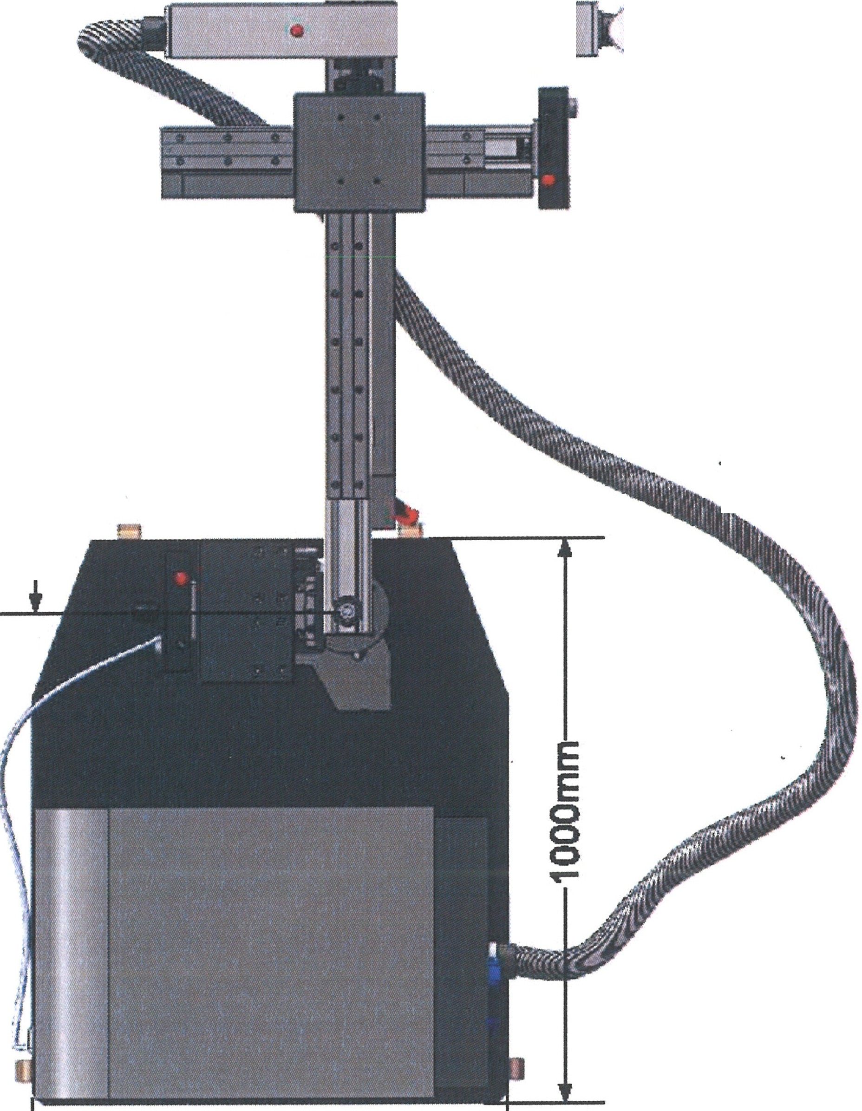 360mm--j
NT
E
E
.-
l
lo
-----800mm
•I

Bird's eye view of the installation
Before the start of the set-up work, prepare the installation place so that the processing station stands level on flat ground.
The foundation must support the 200 kg weight of the processing station. The ambient temperature must be between 10 and 32 °C.
ATTENTION

OR. Lasertechnologie GmbH-Oieselstrasse 15-64807 Oieburg -Tel.. 0 60 71/209 890 Fax: 0 60 71/209 8999

O.R.
16.09.2013 HTS MOBILE- Page 35

As a laser processing station is a class 4 laser installation, it must be possible to delimit the installation location so that it is radiation-safe. If a monitored and marked separate room with access (door contact switch/interlock) (warning signs, warning lamps) is not provided, there should be suitable protective curtains or partitions.

DANGER When the machine is used as intended, possible injury is limited to the skin (hands) of the operator of the machine. This can occur through the
incorrect operation of the laser.

In regard to eye protection, this device meets the requirements for a laser device of class 1 for the absolute safety of the machine operator and others in the laser operation zone.

O.R Lasertechnologie GmbH- Dieselstrasse 15-64807 Dieburg -Tel.. 0 60 71/209 890 Fax: 0 60 71/209 8999
O.R.
16.09.2013 HTS MOBILE - Page 36

- Start-UQ

The following items must be observed in order to avoid equipment damage or life-threatening injuries during start-up of the laser processing station:
The first start-up of the laser processing station may only be performed after the set-up and installation work has been officially completed by authorized employees of
O.R. Lasertechnologie GmbH
DANGER
The operation location must satisfy all safety requirements for a laser area. There should be protective goggles for all persons!

All tools and other reflecting or flammable materials should be removed from the radiation range of the laser!
In addition, please read Chapter 2 "General Safety Notes".

  - Checks before switching the power ON

Components | Type of check
Electrical connections | Are all required connections made and do all the plugs fit well?
Electrical connections | Insulation of all connection lines should be undamaged on the outside, lines should not be tensioned, squeezed or inadmissibly bent.
Cooling water reservoir | The reservoir should be filled with deionized water and closed tightly!
Cooling water circuit | Equipment housing and all connection tubes should be dry on the outside!
Gas connection | Connection lines should be connected securely to the equipment housing. Gas should not escape!
Processing stand | Have all transport locks been removed? Can all moving parts be moved over their entire range of motion without hitting something or causing any other hazard?
Interlock connection | Connection lines should be connected and not bridged!
Pilot lamps | Check that all of the necessary bulbs are in the lamps and work properly!

OR. Lasertechnologie GmbH-Dieselstrasse 15-64807 Dieburg-Tel.: 0 60 71/209 890 Fax: 0 60 71/209 8999

0.R.
16.09.2013 HTS MOBILE- Page 37

  - Initial start-up of the laser processing station

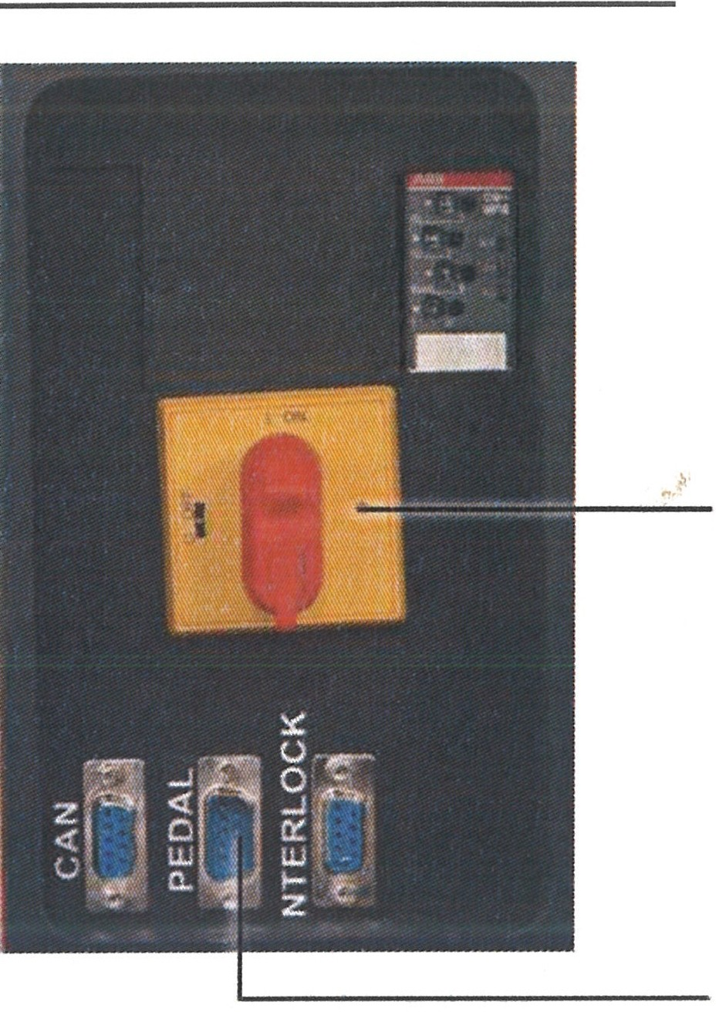
Rear of the installation

    - Before connecting to the mains, check that the main switch (1) is set to OFF (0).
    - Connection to the mains via power cable (2).
    - Inert gas supply via connection (4)
1 • Connect the foot pedal via the Sub-D 9 interface (3) with the installation.
'· • Switch on the main switch (1) in (I)
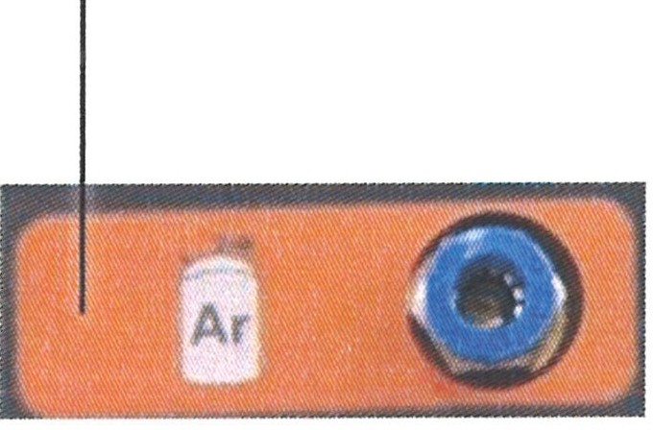
2 4
3
, -
...
,::- ..
;

Operating display

aE1f b
(.:i1 1rn■il'·'8
7
- [LEISTUNG] |  | ( (STAhlDIV]
[ 034%]  -- [PULSLANGE]  08.0 ms  -- [FREQUENZ]  10.0 Hz  - MAX.PULSLEISTUNG 00.37kW  - MITLLERE PULSLEISTUNG 029.3W  I ■ |  | "s,s'"'""""' " 0003'  DI-WASSER TEMP 00.l'C  WDURCHFLUSS 000 11n  "8E"T"R"IE"8S"lEIT 0'"21"3
@!<Je3
L. .•
N/A 05.0 150
mm mm/s mm
{+ ; *
 |  | l!!ll•ll!!l
01. ti  (9 13:03 04/02/2013 |  | 0.20

.)

- Turning the key switch (6) slightly counter clockwise switches on the power supply in the system. The display lights up and the installation is ready.

- When the display is in a state of readiness, (status message in the display (7)). Turning the key switch 90°clockwise (b) switches the cooling system on and brings the installation to a state of operational readiness.
- If the cooling system does not start, check if the emergency OFF switch (8) has been tripped.
- Operational readiness is signaled by the green LED (9).

During the first start-up, the cooling circuit of the
laser processing station must be vented completely before the laser
is switched on! This is absolutely necessary for flawless cooling of the
las.er.

The measures that are possibly required are described in Chapter 8 "Maintenance".

O.R.

O.R. Lasertechnofogie GmbH-Dieselstrasse 15 - 64807 Dieburg - Tel.. 0 60 71/209 890 Fax: 0 60 71/209 8999 16.09.2013 HTS MOBILE - Page 38

  - Adaptation of the laser beam to the microscope reticle

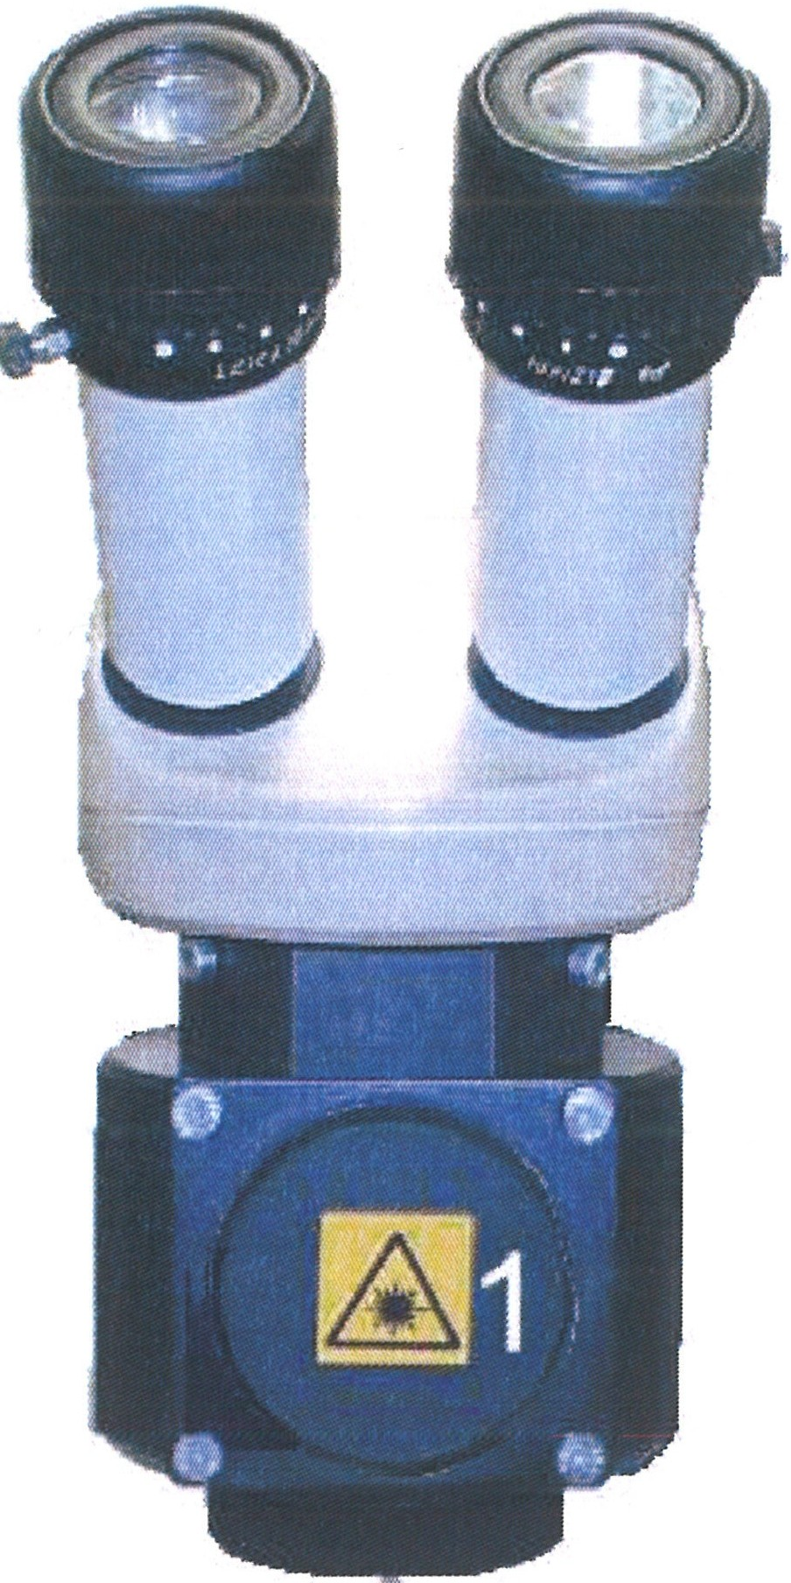
When the microscope ocular has to be readapted to the distance between the eyes, the laser beam also must be readjusted to the reticle!

    - For this, turn the lid (1) to open.

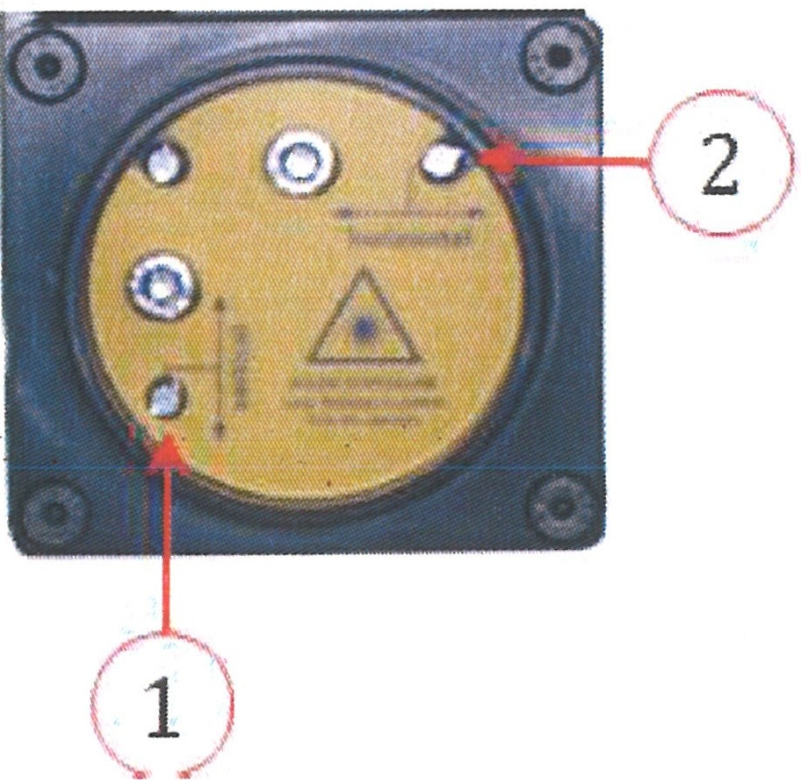
    - By turning the locking screws with a small screwdriver, the laser beam can be moved in vertical (1) and in a horizontal (2) direction.

ATTENTION
You may only turn the locking screws.
Do not turn the fillister-head screws, as these hold the deflection mirror in the correct position. When the deflection mirror has been moved, the installation no longer can be used and has to be be readjusted by the service department!

O.R. Lasertechnologie GmbH-Dieselstrasse 15-64807 Dieburg -Tel.. 0 60 71/209 890 Fax: 0 60 71/209 8999

D.R.
16.09.2013 HTS MOBILE - Page 39

  - Function check for the safety devices

xe the first start-up, before start-up after a longer down-time, and daily before the start of
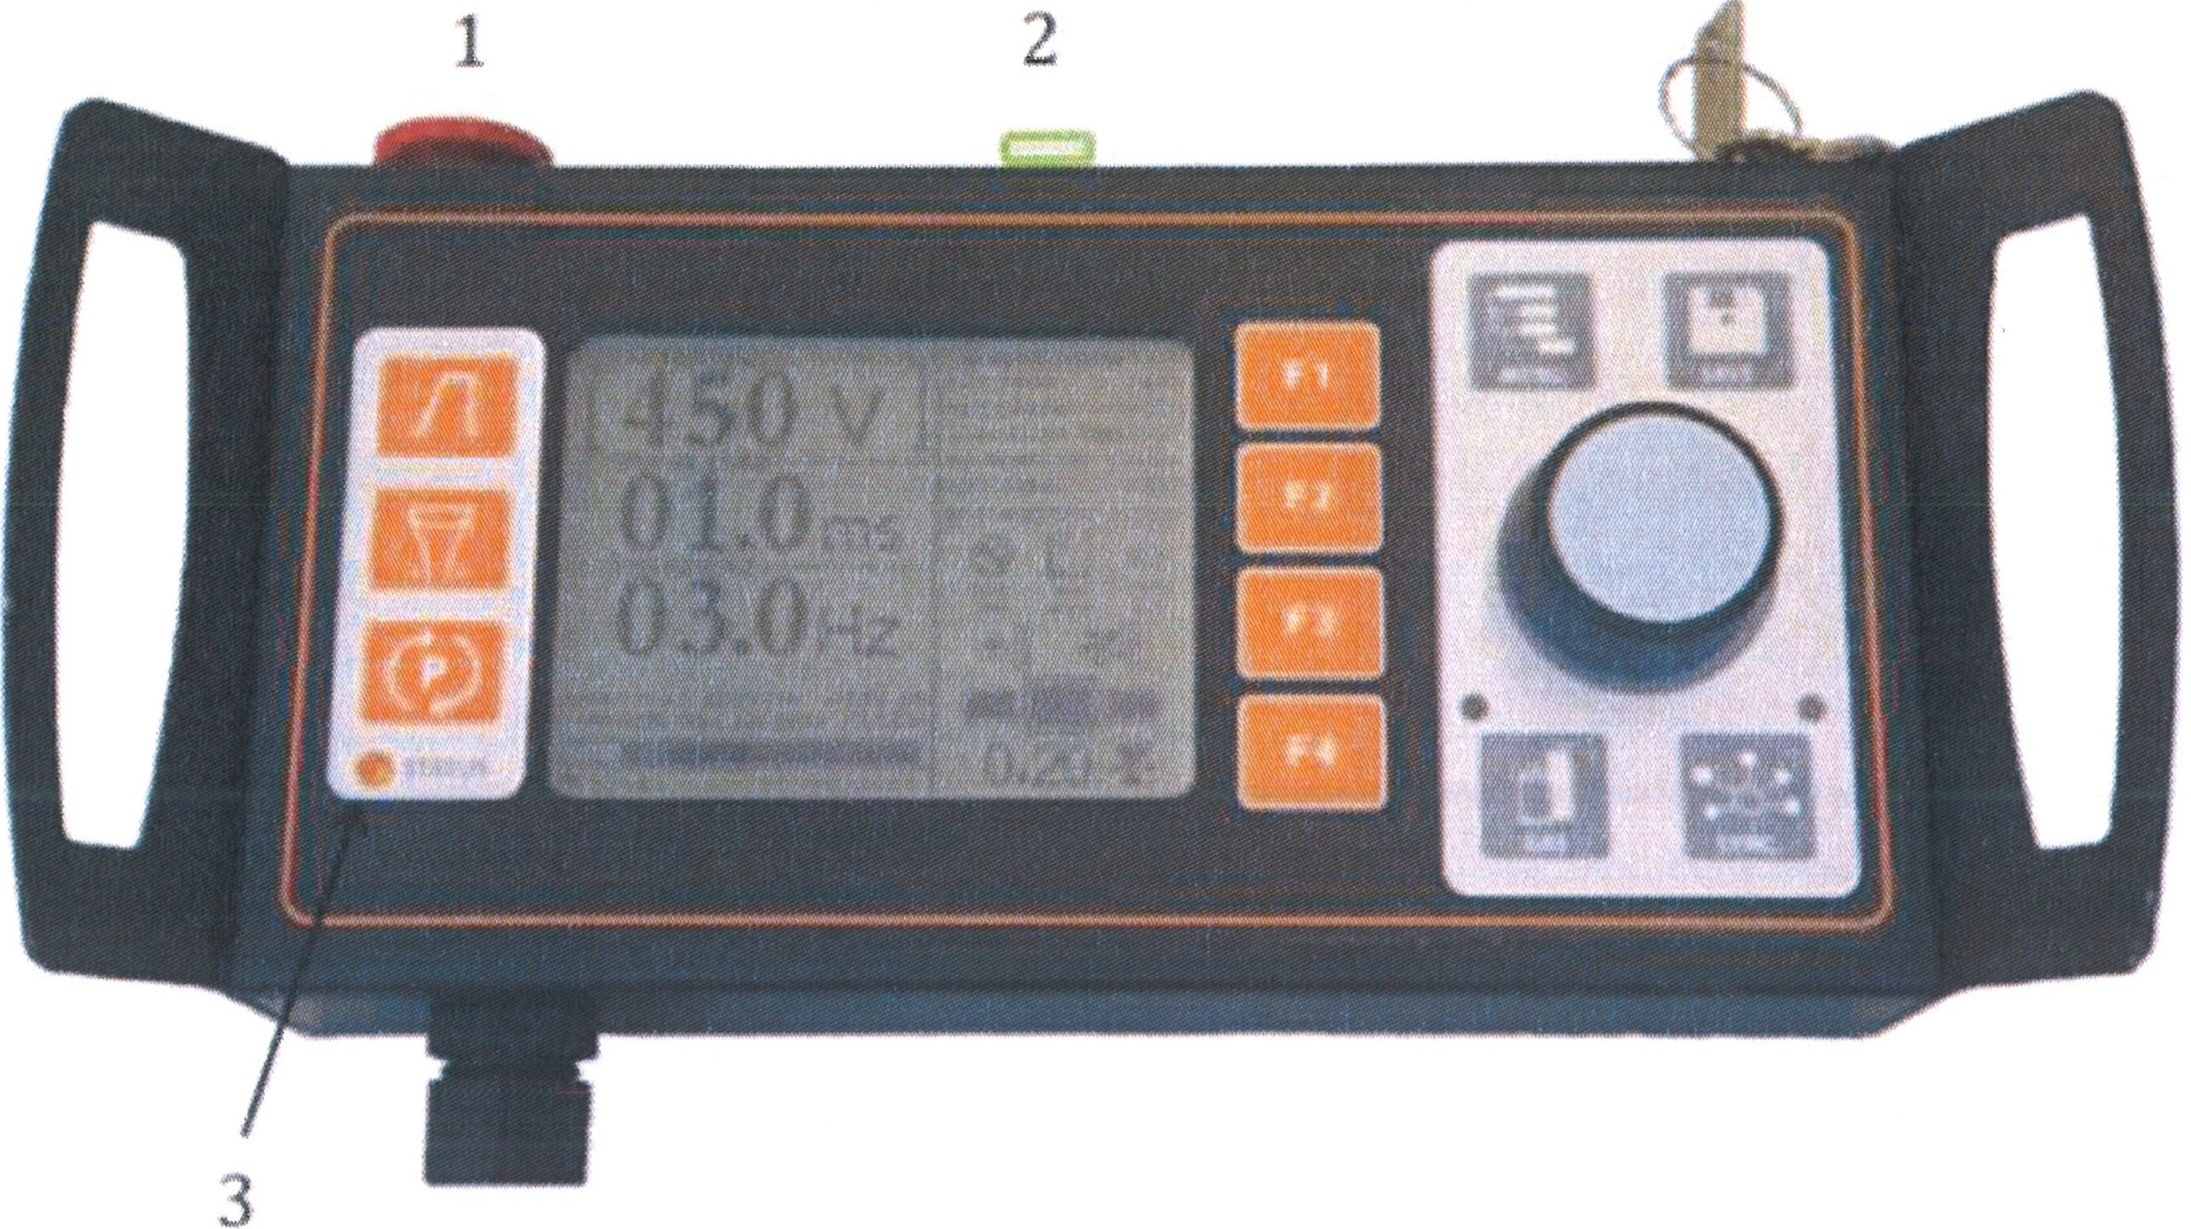
k, all safety equipment shall be checked for flawless function to avoid equipment damage or sonal injury!

Safety devices | Type of check
1 Emergency stop button | I  Operation must switch off the installation immediately.
2 Interlock | Opening of the door must cause immediate switching off of the laser, and the signal lamp must go out.
3 Warning lamp | The warning lamp must be lit when the laser is ready for operation.
Resonator housing | The laser must switch off when the resonator housing is opened.

  - Checks after first Operation

Component | Type of check
Cooling water circuit | Check that all connection tubes and the equipment housing are dry on the outside and that the water level in the reservoir has not changed!
Gas connection | Check that the connection tube is tight at the housing!
Optical components | Check whether the laser optics, the stereoscopic microscope, or the housing surfaces enclosing the laser radiation have warmed up.

O.R. Lasertechno/ogie GmbH- Dieselstrasse 15-64807 Dieburg -Tel.. 0 60 71/209 890 Fax: 0 60 71/209 8999

0.R.
16.09.2013 HTS MOBILE - Page 40

- Operation

The following items must be observed to avoid equipment damage or life-threatening injuries during operation of the laser processing station:

- The processing station shall be used only according to its intended use.

- Before powering the processing station on, inform yourself of the required laser protection measures and the correct action in case of problems.

- Perform function checks on the safety equipment before the first use and later periodically:

  - Function of the emergency stop button
  - Function of the limit switch of the laser arm and the workpiece table along the Z- axis
  - Testing of the laser switch-off when the resonator housing is opened
  - Flawless condition of the protective filters in the observation beam path
o Flawless condition of the protective filters in the vacuum aspiration

- Please read also Chapter 2 "General Safety Notes".

OR. Lasertechno/ogie GmbH-Dieselstrasse 15-64807 Dieburg - Tel.. 0 60 711209 890 Fax: 0 60 71/209 8999
D.R.
16.09.2013 HTS MOBILE - Page 41

  - Switching the System ON

Rear of the installation

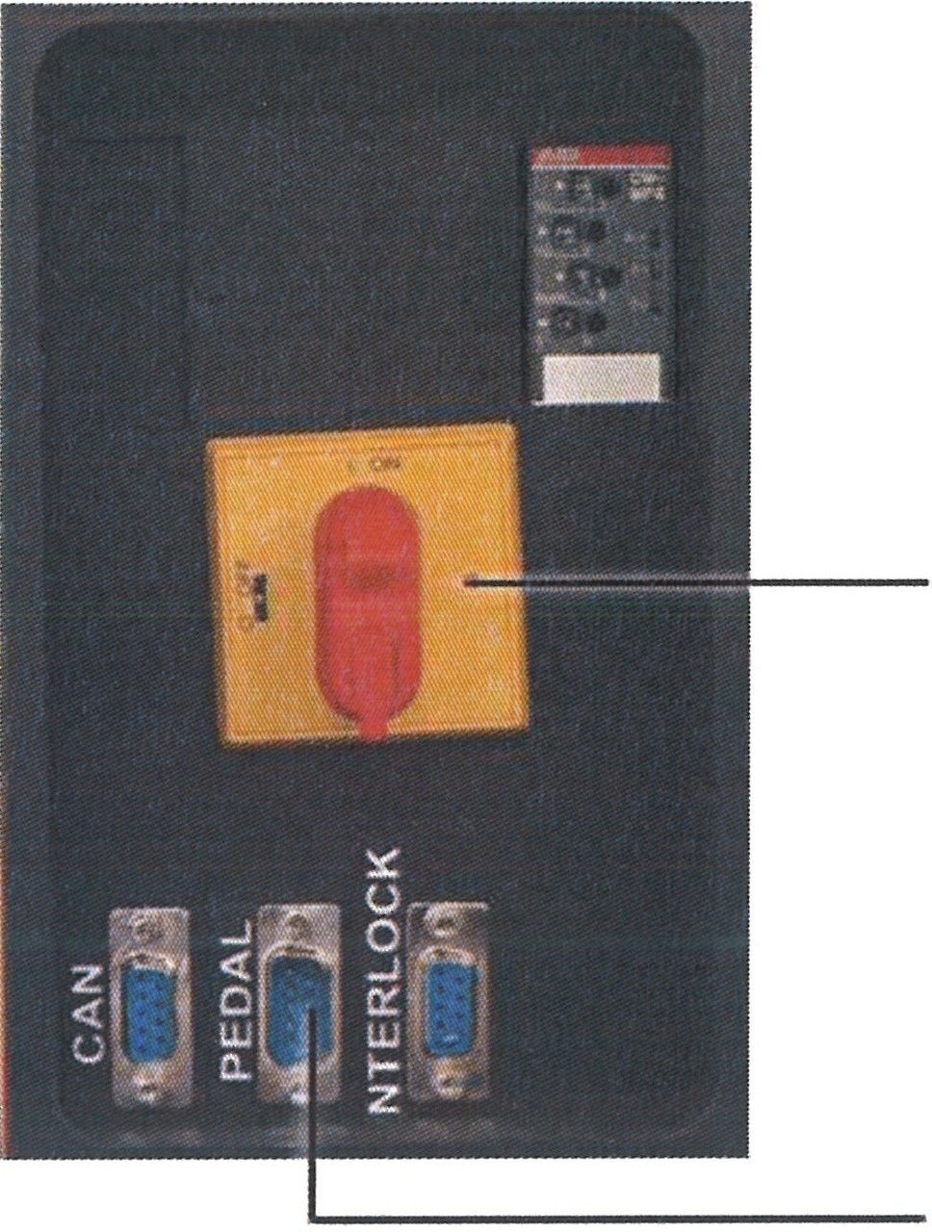
    - Before connection to the mains, check that the main switch (1) is set to OFF (0).
    - Connection to the mains via power cable (2).
    - Inert gas supply via connection (4)
    - Connect the foot pedal via the Sub-D 9 interface (3) with the
1 installation.
- Switch on the main switch (1) in (I)

3

Operating display
2 4

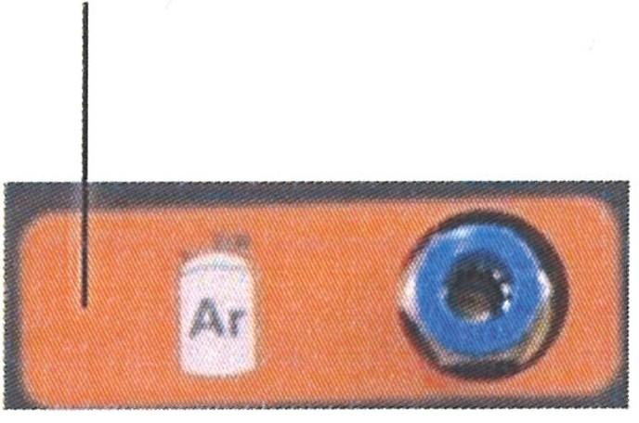
, .
.
"..
,

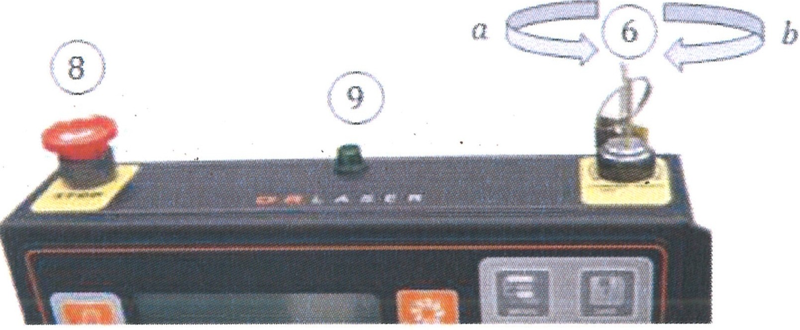
  - Turning the key switch (6) lightly counterclockwise switches the power supply in the system on. The display lights and the installation goes to readiness.

7
- [LEISTUNG)
[ 034%]
-- [PULSLANGE)
j I.(..,.),_[STANOSY)-
PU<.SlN«.ER 000.3k DI-WASSER TEMP 00 1 •c W OURCHFLUSS 00.0 o'I
SPANNUHG 310V
BETREBSZEIT 0213
I)
-- [FREQUENZ)
08.0 ms
@!'JG>
'-··
N/A 05.0 150
mm mm/s mm
10.0 Hz
- MAX.PULSLEISTUNG 00.37kW
- MmLERE PULSLEISTUNG 029.3 W
I 01. ■fl
+ *
l!!ll•ll!!l
0.20
04/02/2013
(913:03
  - When the display is in readiness, (status message in
the display 7), turning the key switch 90° clockwise
(b) switches the cooling system and the installation to operational readiness.
  - If the cooling system does not start, check if the emergency OFF switch (8) has been tripped.
  - Operational readiness is signaled by the green LED (9).

During the first start-up, the cooling circuit of the
laser processing station must be vented completely before the laser is switched on! This is absolutely required for flawless cooling of the laser.
ATTENTION

OR. Lasertechno/ogie GmbH-Dieselstrasse 15 - 64807 Dieburg - Tel.. 0 60 711209 890 Fax: 0 60 71/209 8999
O.R.
16.09.2013 HTS MOBILE - Page 42

Observe the accident prevention regulations BGV A 1, BGV A 2, and BGV B 2!
DANGER
The safety measures for work on laser installations and life-threatening high voltages must be observed.

Please observe also Chapter 2 "General Safety Notes".

  - Adaptation of the laser beam to the microscope reticle

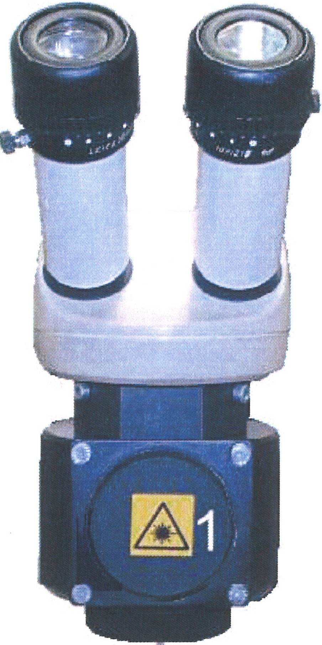
When the microscope ocular has to be readapted to the distance between the eyes, the laser beam also must be readjusted to the reticle!

    - For this, turn the lid (1) to open.

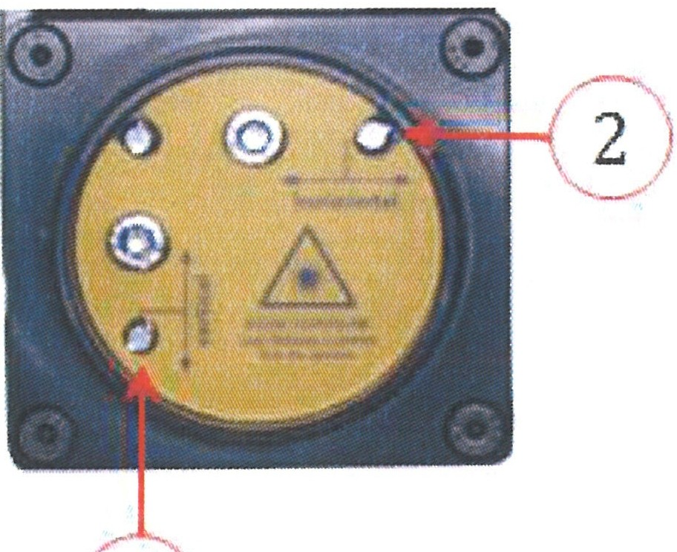
    - By turning the locking screws with a small screwdriver, the laser beam can be moved in a vertical (1) and horizontal (2) direction.

1
./

ATTENTION
You can only turn the locking screws.
Do not turn the fillister-head screws, as these hold the deflection mirror in the correct position. When the deflection mirror has been moved, the installation can no longer be used. It has to be adjusted by the service department!

OR. Lasertechnofogie GmbH-Dieselstrasse 15-64807 Dieburg - Tel.. 0 60 71/209 890 Fax: 0 60 71/209 8999
0.R.
16.09.2013 HTS MOBILE - Page 43

  - Operation

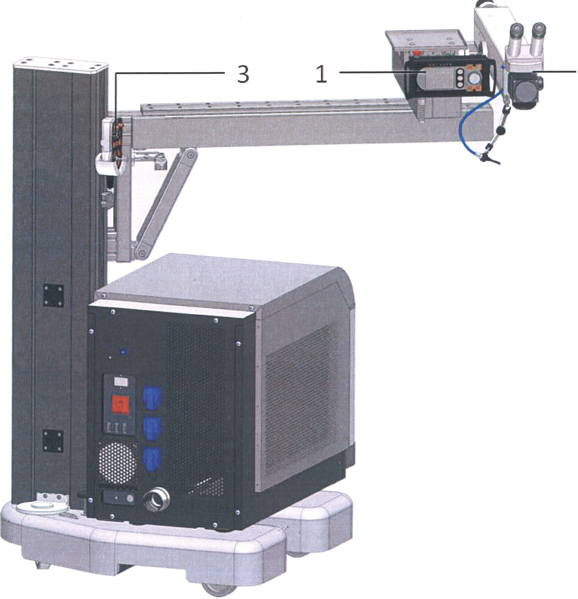
2

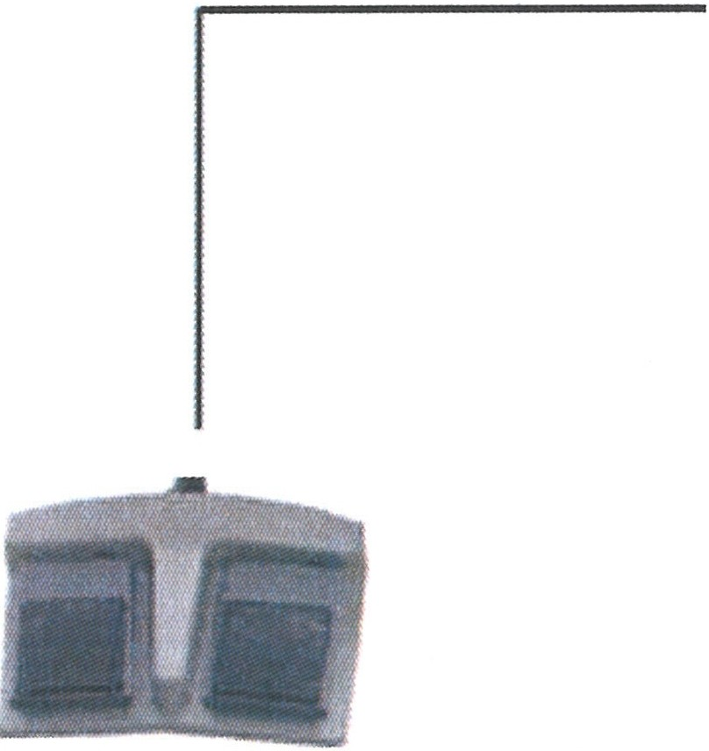
4

    - Place the laser beam (1) above the workpiece.
    - Accurate positioning is then done by means of the microscope optics (2) and via the joystick (3) which is used to move the motorized table in an X, Y, and Z direction.
    - The laser is triggered with the foot switch (4). The right momentary foot switch triggers individual pulses. With activation of the left momentary foot switch, continuous pulses are switched off, depending on the frequency.

OR. Lasertechnologie GmbH- Dieselstrasse 15-64807 Dieburg -Tel.. o 60 711209 890 Fax: o 60 711209 8999
0.R.
16.09.2013 HTS MOBILE -Page 44

6.4 Working

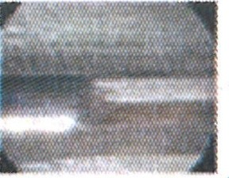
2 .7,
9
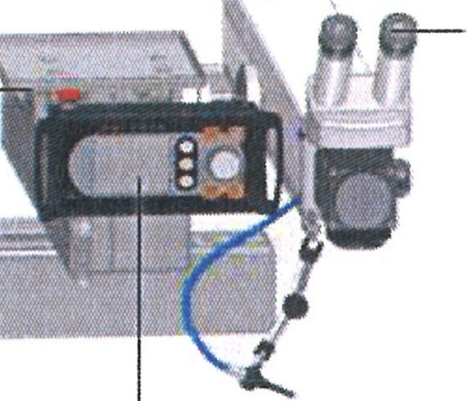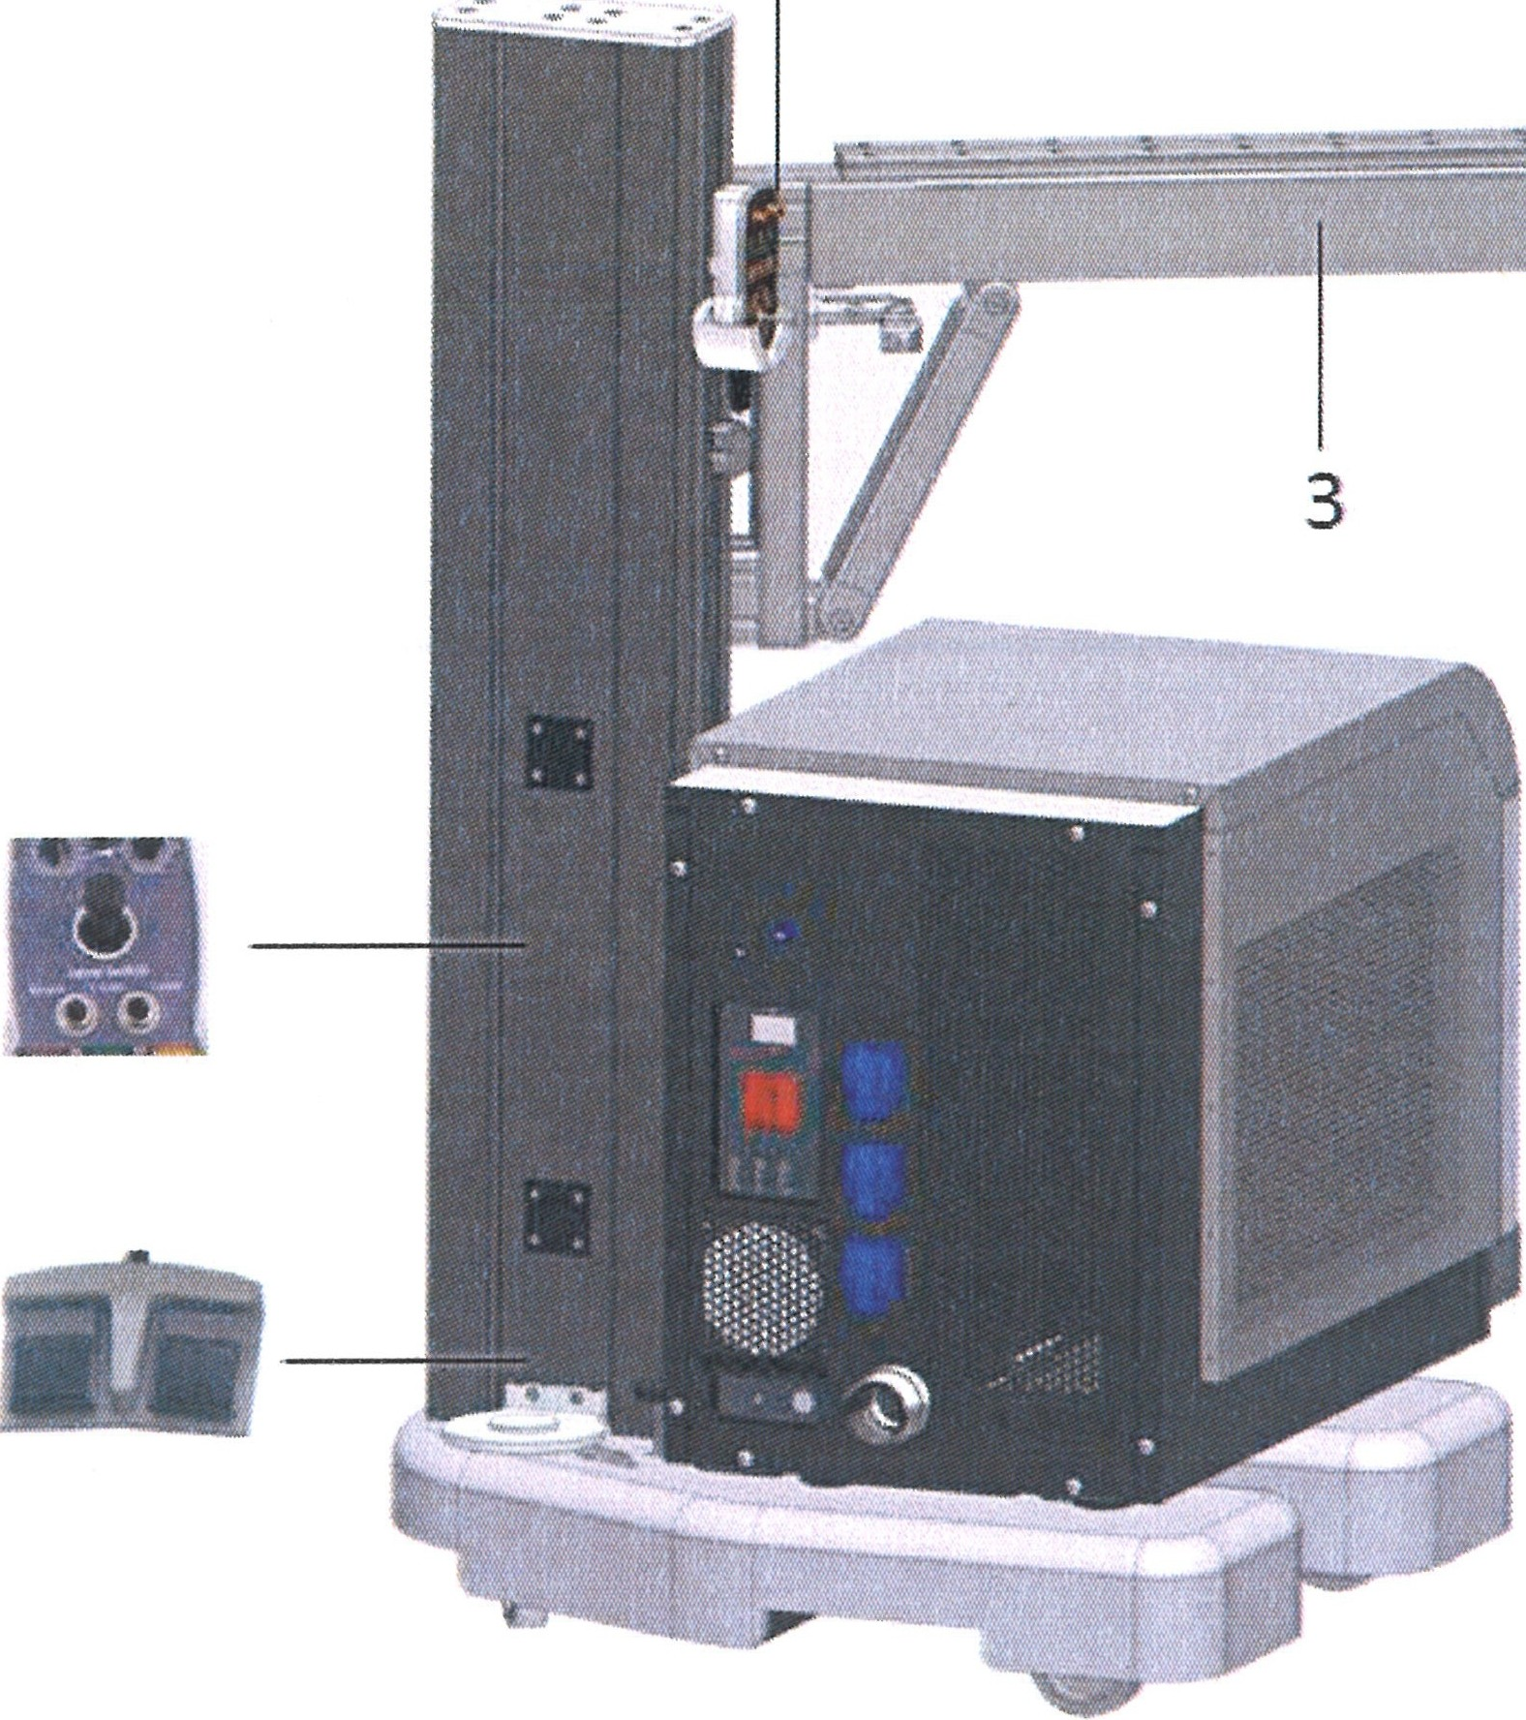4 1

  - The processing point is specified via the stereoscopic microscope (1): The marking in the microscope image (2) shows the impact point of
the laser radiation. The

i:ig
5
6
laser focus is in the sharpness plane of the microscope, i.e. when the surface is in focus, the laser also is focused to the surface.

    - The laser arm (3) can be moved with the
- joystick (4) in an X-, Y­
(5), and Z-direction (6).

- The laser is triggered with the foot switch (7). The left momentary foot switch triggers individual pulses. With activation of the right momentary foot switch, continuous pulses are switched off, depending on the frequency, until the momentary foot switch is released again.
- The supply of inert gas to the workpiece is switched on with the momentary foot switch. The gas supply is activated by light depression of the momentary foot switch, when this has been activated on the display (8).
- When the laser is triggered for the first time (new workpiece or after a longer pause), the gas supply should be activated for a few seconds (depending on the length of the feed line), so that there will be gas in the line when the laser is triggered for the first time.
- The laser processing station can be switched off at any time with the emergency stop button (9). This should only be done in situations of danger, as the emergency switch-off can cause damage to the laser source.

&
Please note that the lifetime of the flashbulb exponentially
shortens the pulse peak power. Avoid the power settings above 80%, because this makes the flashbulb age very quickly!
ATTENTION

OR Lasertechnologie GmbH-Dieselstrasse 15-64807 Dieburg - Tel.. 0 60 71/209 890 Fax: 0 60 71/209 8999

O.R.
16.09.2013 HTS MOBILE - Page 45

  - Joystick

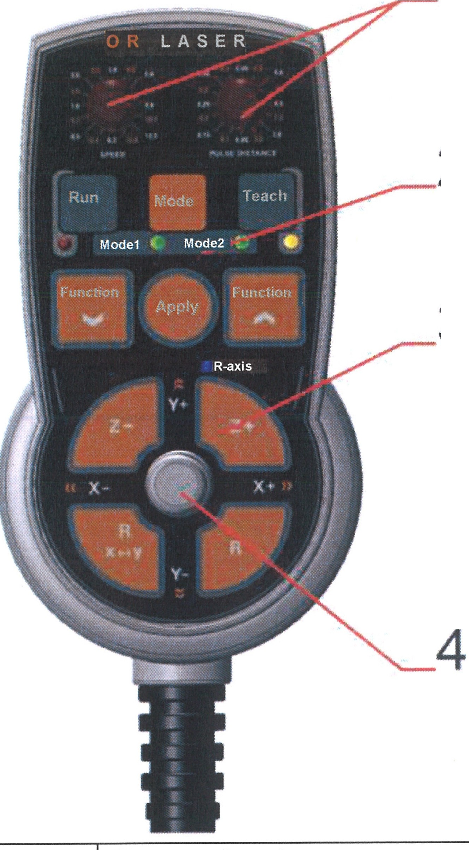
1

2

3

I
Pos. 1 | I Rotary knobs  The rotary knobs can be used to adjust the axis speed and the welding point distance.  "Speed" - rotary knob  This rotary knob can be used to adjust the process speed of the X­ and the Y-axis in 16 stef)_s (0.2 mm/s to 15 mm/s).  II] "Pulse Distance" - rotary knob  This rotary knob can be used to adjust the welding point distance  with svnchronized operation in 16 steps (0.05 mm to 3 mm,.
Pos. 2 | Function buttons  These function buttons can be used to control the synchronization functions and the laser parameters.
[ii "Run" button with LED
Running through the stored motion processes can be started by
pressing this button.
The "RUN" movement is interrupted by pressinci the button aaain.
"1"Teach" button with LED
In teach mode, points of a movement sequence can be stored by
pressing this button. Pressing the "Teach" button for 3 seconds deletes all oints and ossibl ends a movement sequence.
"Mode" button
Selection between different modes can be made by pressing this button.
"Mode 0" no LED is lit.

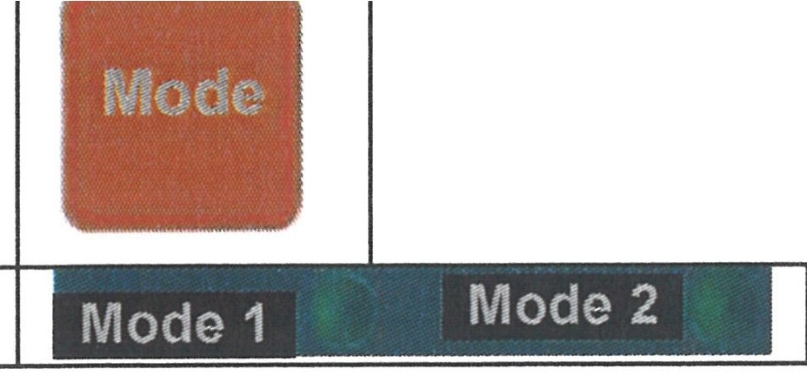

OR. Lasertechno/ogie GmbH-Dieselstrasse 15-64807 Dieburg -Tel.. 0 60 71/209 890 Fax: 0 60 71/209 8999
0.R.
16.09.2013 HTS MOBILE- Page 46

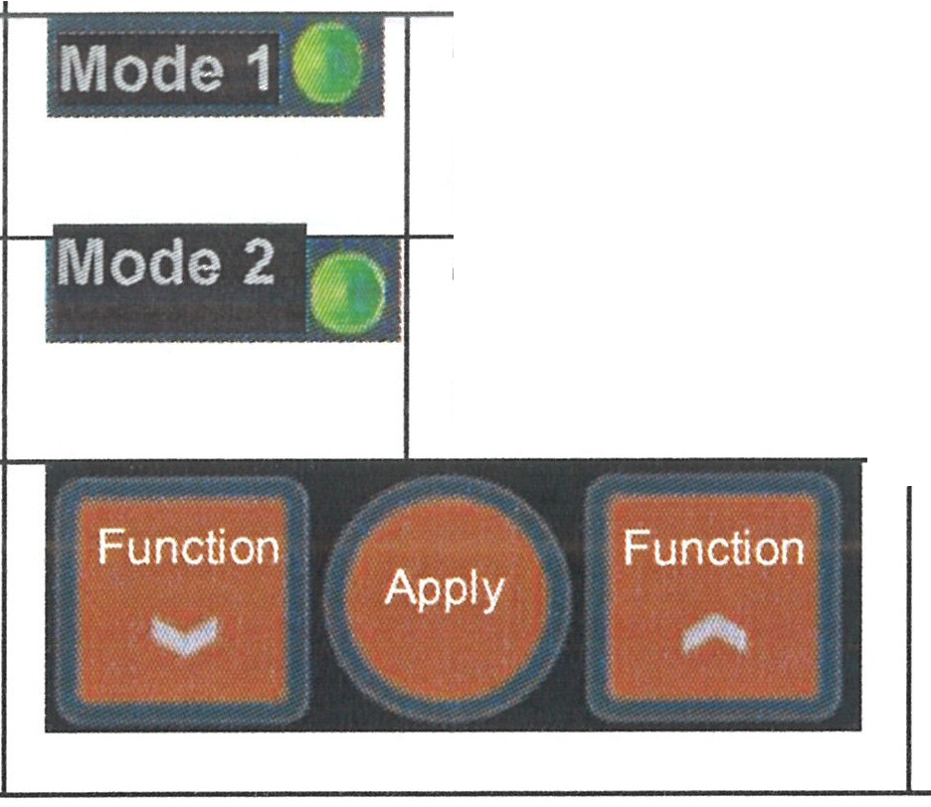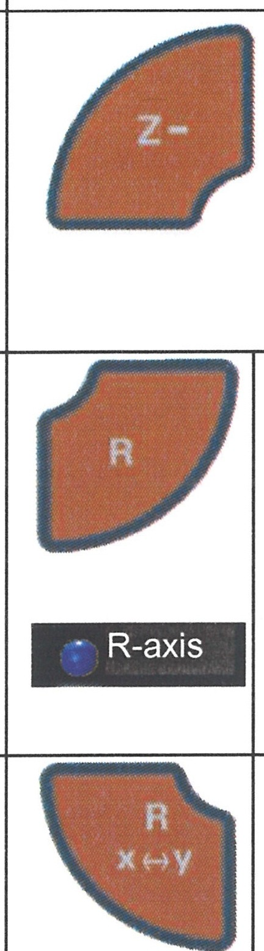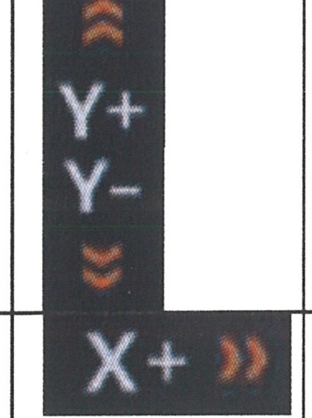Standard / Q_oint mode "Mode 1" LED
Line mode "Mode 2" LED
Circle/Arccm-orde 1
"Function / Apply" buttons
The laser parameters can be changed with these buttons.
Pos. 3 I Axis control buttons
The Z/axis and the optional rotary axis (R-axis) can be controlled with these function buttons.
"Z-/Z+" buttons
Direct movement of the Z-axis is possible by pressing these buttons.
"+" - the Z-axis moves up.
"-" - the Z-axis moves down. "R" button & "R-axis" LED
The rotary axis can be switched ON and OFF with this button (the LED is lit when the rotary axis is active).

"R X <-> y" button
The rotary axis can be assigned to the X-axis or the Y-axis of the joystick with this button.

Pos. 4 I Control lever
The axes or possibly the rotary axis can be moved in X- and Y-direction with the control lever.
"Y+ I Y-" direction
The Y-axis is moved in the corresponding direction.

"X+/X-" direction
-
The X-axis is moved in the corresponding direction.

General synchronization

The synchronization can be switched "ON" or "OFF" with the "Sync" button on the display (see Chapter 1.4, item 13).
When the synchronization is switched off, the right foot pedal (see Chapter 1.3, item 11) triggers individual pulses (normal operation).

OR. Lasertechnologie GmbH - Dieselstrasse 15 - 64807 Dieburg - Tel.. 0 60 71/209 890 Fax: 0 60 71/209 8999
O.R.
16.09.2013 HTS MOBILE - Page 47

    - Operation mode "MODE O"

The standard operation mode of the joystick is "Mode O".

      - "Jog" operation

In jog operation (Run LED not flashing), the axes can be moved in X-Y-direction with the control lever. With this, welding can be done with the foot pedal.

      - "Run" operation

In "Mode O", a reference position can be stored, which then can be reached at max. speed by automatically pressing a button.
For this, the respective position must be reached in the "Jog" operation and it has to be stored with the "Teach" button. Further operation of the "Teach" button at a different position overwrites the last stored position with the current one.
Pressing the "Teach" button for 3 seconds erases the stored position and stops the axes.
By pressing and holding the "Run" button, movement to the last stored position is made using max. speed. Pressing the "Run" button again stops the axis movement.

      - Synchronization
When the synchronization is switched on, the laser pulses according to the "Pulse Distance" parameter which is set on the joystick during movement of the axes while the right foot pedal is being operated.

© | IMPORTANT
Synchronization:
The laser pulse frequency is calculated from the pulse interval and the speed.
The max. frequency of the laser is 20 Hz. When the calculated frequency is higher, the speed is reduced so that the laser can operate with the max. frequency. However, it is still possible to overload the laser by exceeding the max. mean power. If the laser is overloaded, the pulse energy (pulse power x pulse duration) or the pulse frequency is required.

OR Lasertechno/ogie GmbH- Dieselstrasse 15-64807 Dieburg -Tel.. 0 60 71/209 890 Fax: 0 60 71/209 8999
O.R.
16.09.2013 HTS MOBILE - Page 48

LED signals
Mode 1 &  Mode 2 LEDs | Off | Mode O is active
Teach LED | On | A new position can be stored.
Run LED | On | Movement to a stored position is possible.
 | Flashing | Automatic movement of the axes
Teach LED & Run LED | Flashing alternately | The speed is reduced so that the max. pulse frequency is not exceeded.

    - Operation mode "MODE 1" - Line mode
In line mode, interpolated lines can be stored, traveled, and welded. In the plane, this line can be shifted in parallel for the quick and easy processing of areas.

      - "Jog" operation
In jog operation (Run LED not flashing), the axes can be moved in an X-Y-direction with the control lever. With this, welding can be done with the foot pedal.

      - "Run" operation
In the run operation, two positions connected by the line must be stored via the "Teach" button. By pressing the "Run" button, the leaser head can be moved at max. speed between the two positions as often as desired.
The complete line (length and orientation) is shifted in parallel by storing a new position. Pressing the "Run" button again during automatic movement ends the movement. Pressing the "Teach" button for three seconds deletes all of the stored positions and if necessary, ends the automatic movement.

Line 1

- Line 3
Fig.: Example for shifting the line
TP: Stored position

      - Synchronization

When the synchronization is switched on, the axes move to the line or travel it with the speed ("Speed") set on the joystick (as long as the right foot pedal is pressed). With this, the laser pulses with the set welding point interval ("Pulse Distance").

OR Lasertechno/ogie GmbH - Dieselstrasse 15 - 64807 Dieburg - Tel.. 0 60 71/209 890 Fax: 0 60 71/209 8999
0.R.
16.09.2013 HTS MOBILE· Page 49

© | IMPORTANT
Synchronization:
The laser pulse frequency is calculated from the pulse interval and the speed.
The max. frequency of the laser is 20 Hz. When the calculated frequency is higher, the speed is reduced so that the laser can operate with the max. frequency. However, the laser may overload as it is still possible to exceed the max. mean power. If the laser is overloaded, the pulse energy (pulse power x pulse duration) or the pulse frequency is required.

LED signals
Mode 1 LED | On | Mode 1 is active
Teach LED | On | A new or a further position can be stored or the stored line can be shifted in parallel.
Run LED | On | A position can be moved to in the "Run" operation.
 | Flashing | Movement of the axes
Teach LED &  Run LED | Flashing alternately | The speed was reduced so that the max. pulse frequency is not exceeded.

O.R. Lasertechno/ogie GmbH-Dieselstrasse 15-64807 Dieburg -Tel.: 0 60 71/209 890 Fax: 0 60 71/209 8999

0.R.
16.09.2013 HTS MOBILE - Page 50

    - Operation mode "Mode 2" - Circle mode
In the circle mode, circles or arcs can be stored, travelled, and welded via three arc points.

      - "Jog" operation

In jog operation (Run LED not flashing), the axes can be moved orthogonally in an X-Y-direction with the control lever, and welding also can be done.

      - "Run" Mode

Three positions must be stored with the "Teach" button to define a circle or an arc. These positions should be as far away from each other as possible. The radius of the stored circle or arc can be increased or decreased by later storage of a further point starting from the center of the circle.

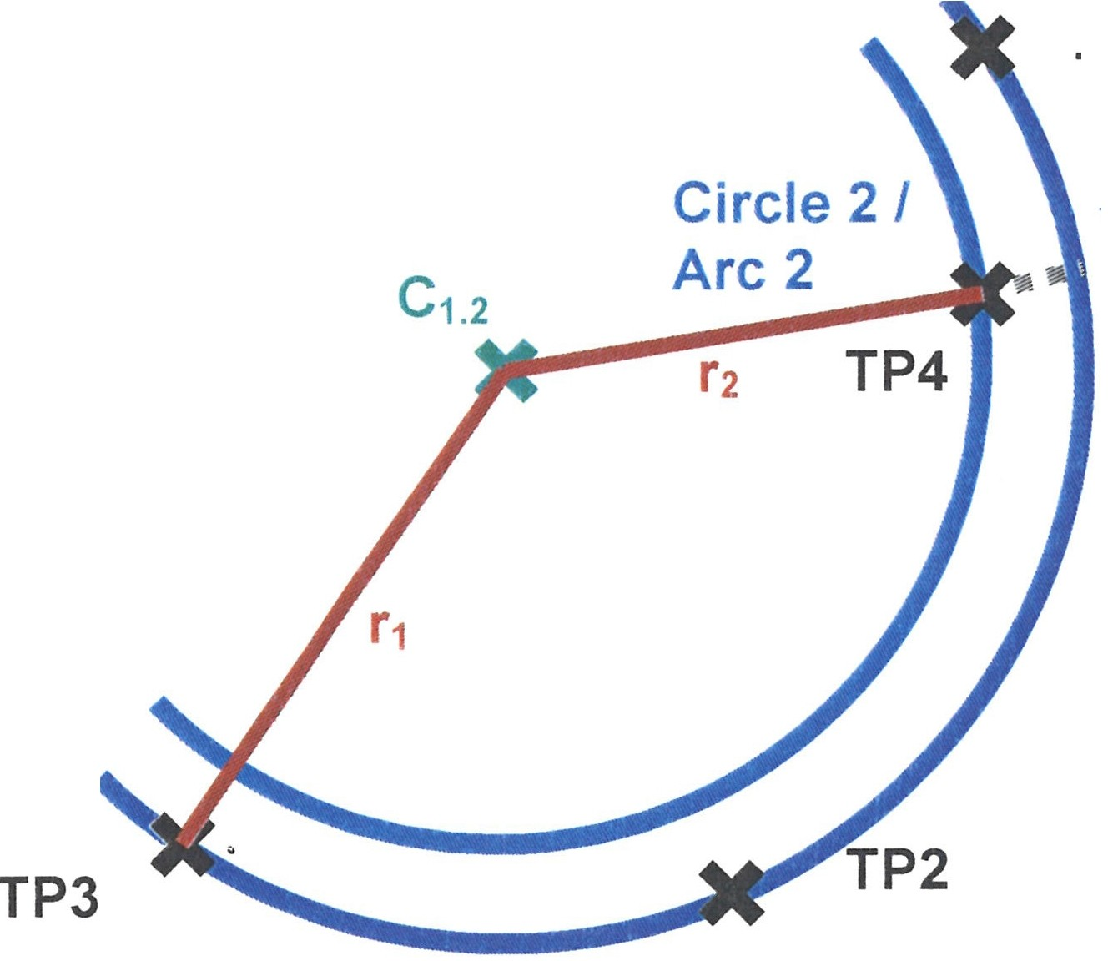le 1 /
TP1
Circ
Arc
1 TP: Stored position
C: Center of circle I and 2 r: Radius

Fig.: Example for creation of a circle and adaptation of the radius

The Run LED then signals that a circle has been stored. "Circle" mode then becomes active by pressing the "Run" button. The Run LED flashes when "Circle" mode is active. Travelling along the circle in clockwise or counter clockwise direction with the set speed ("Speed") is done by moving the control lever (X- or Y-axis) forwards or backwards. Pressing the RUN button again deactivates "Run" mode and switches to "Jog" mode. Afterwards, the axes can again be moved normally with the control lever. Pressing the "Teach" button for three seconds deletes all of the stored positions and possibly ends the automatic movement.

      - Synchronization
When synchronization is switched on, the axes travel along the circle with the speed set at the joystick ("Speed"). This happens as long as the right foot pedal is pressed and the control lever is moved in one direction.
With this, the laser pulses with the set welding point interval ("Pulse Distance").

OR. Lasertechnologie GmbH-Dieselstrasse 15-64807 Dieburg -Tel.. 0 60 71/209 890 Fax: 0 60 71/209 8999
0.R.
16.09.2013 HTS MOBILE - Page 51

© | IMPORTANT
Synchronization:
The laser pulse frequency is calculated from the pulse interval and the speed.
The max. frequency of the laser is 20 Hz. When the calculated frequency is higher, the speed is reduced so that the laser can operate with the max. frequency. However, it is still possible to overload the laser by exceeding the max. mean power. If the laser is overloaded, the pulse energy (pulse power x pulse duration) or the pulse frequency is required.

LED signals
Mode 2 LED | On | Mode 2 is active
Teach LED | On | Storage of a circle point and change of the radius are possible.
Run LED | On | A circle or an arc is defined by three points and can be  switched to "Run" operation.
 | Flashing | "Run" mode is active.
Teach LED & Run LED | Flashing alternately | The speed was reduced so that the max. pulse frequency is not exceeded.

OR Lasertechnologie GmbH- Dieselstrasse 15 - 64807 Dieburg - Tel.: 0 60 71/209 890 Fax: 0 60 71/209 8999
O.R.
16.09.2013 HTS MOBILE - Page 52

  - Switching off the laser installation

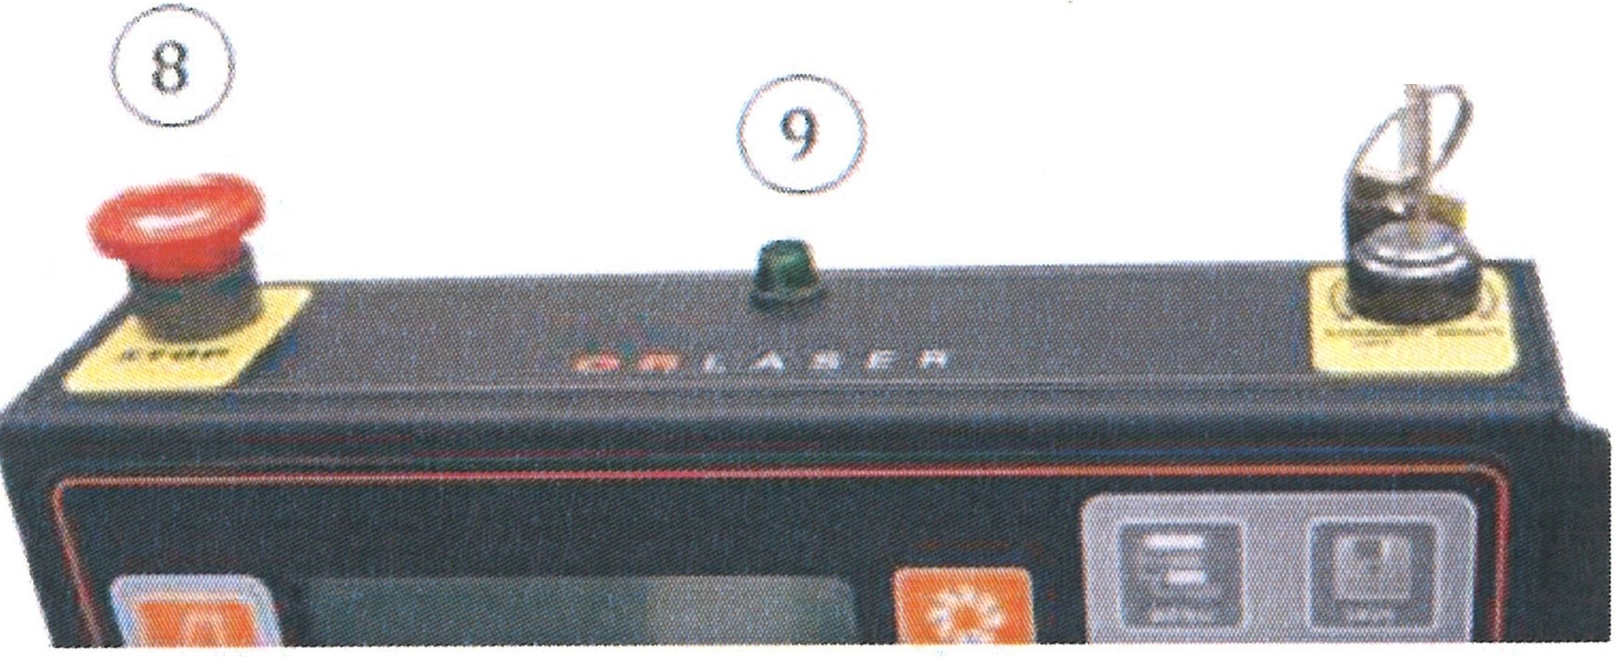
a @) b

    - The system is switched off by turning the key switch (10) counterclockwise (a). This brings the system into readiness mode.

    - The system is shut down by turning the key slightly counter clockwise.

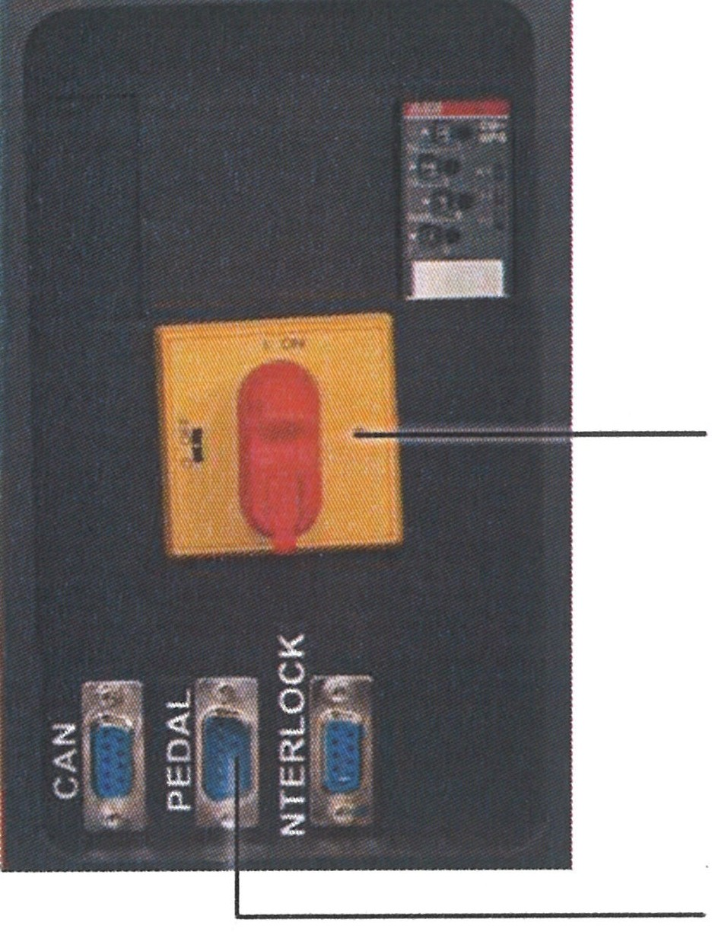
    - The entire installation is switched off by operating of the main switch (1) on the
rear of the laser installation. This deactivates all components of the installation.
1

3

ATTENTION
To prevent damage to the laser medium, switch the device off correctly.
The emergency stop switch is provided for emergencies, not for shutting down during normal operation.

O.R. Lasertechnologie GmbH-Dieselstrasse 15-64807 Dieburg -Tel.. 0 60 71/209 890 Fax: 0 60 71/209 8999
O.R.
16.09.2013 HTS MOBILE - Page 53

7 Help in the case of faults

As a rule, qualified specialists from O.R. Lasertechnologie GmbH must be called upon for repair if the laser processing station cannot be switched on or in case of malfunctions during operation. The following items must be carried out in order to prevent equipment damage or life­ threatening injuries:
DANGER
A
Work on the electrical equipment of the laser processing station may only be performed by qualified and authorized electricians!
Operators may only independently repair those faults which have obviously have been caused by operational or maintenance errors!

The following table provides an overview of such faults:

Type of fault | Cause of the fault I Operational or maintenance errors | Measures for eliminating the fault
The station cannot be switched on with the ON button. | 1. Main switch is not switched on. | Switch on the main switch.
 | 2. The emergency stop push-button  switch has been pressed accidentally. | Unlock the locked emergency  stop push-button switch (turn clockwise).
Operation of the foot switch does not trigger the laser. | 1. Foot switch line is not connected | Connect the foot switch, secure with bayonet catch.
 | 2. Interlock system is not connected | Check the plug and the door lock
The workpiece table | 1. The workpiece table has contact | Remove the obstacle.
cannot be moved down, | with an obstacle.
but can be moved up | 2. Electrical or electronic fault
or vice versa
Station is switched OFF, FAULT is illuminated. | The motor protection switch has been triggered. | Switch off normally and switch on again.
No inert gas is fed to the processing point. | 1. The inert gas source is not connected to the gas connection / the connection is not pressure- proof. | Connect a cleanly cut plastic tube of 0 ¼" all the way.
 | 2. Push the OFF push-button for the solenoid valve | Actuate the ON push-button.

OR. Lasertechno/ogie GmbH- Dieselstrasse 15-64807 Dieburg - Tel.. 0 60 711209 890 Fax: 0 60 711209 8999

0.R.
16.09.2013 HTS MOBILE - Page 54

- Maintenance
8.1 Safety notes

The following items must be observed in order to prevent damage to the laser processing station or life-threatening injuries:
Maintenance work may ONLY be performed by a correspondingly trained specialist!
DANGER
Observe the accident prevention regulations BGV A 1, BGV A 2, and BGV 8 2!
The safety measures for work on laser installations and life-threatening high voltages must be observed!
ATTENTION
Read the work instructions completely and follow them! Perform all work steps in the listed order!
Always ask in case of doubt!
Small mistakes during maintenance can cause expensive repairs. Check the work that has been done each time before switching on. Perform all work on optical parts quietly and with concentration!
Work extremely carefully - optical elements could be destroyed! Only use original spare parts!
Document all maintenance work in the logbook (supplied).

For all maintenance work, perform a visual inspection for contamination and damage. In addition, please follow Chapter 2 "General Safety Notes".
With respect to the manufacturer, incorrect or deficient implementation of the operating instructions renders warranty claims void.

It is recommended that the service technicians of O.R. Lasertechnologie GmbH are used for all maintenance and repair works, as well as the recommended yearly inspections. This permanently assures optimum and safe processing with the LSR system. The manufacturer assumes no liability for faulty repair work and the resulting damages!

OR. Lasertechno/ogie GmbH-Dieselstrasse 15-64807 Dieburg -Tel.. 0 60 71/209 890 Fax: 0 60 71/209 8999
O.R.
16.09.2013 HTS MOBILE - Page 55

  - Wear parts

It is recommended to keep a certain quantity of spare parts to avoid long down-times.

Description | Quantity
Pump lamp for laser | 1
Protective glass for lens | 1
Cleaning brush for pump chamber | 1
Optical paper for cleaning lenses
isopropanol for cleaning of very dirty pump lamps
Cleaning cloth for strongly contaminated pump lamps and optical systems

  - Maintenance intervals

as required, at least weekly

as required, at least monthly

Resonator
Cleaning the outside of the housing Cleaning the optical components at the beam exit
Cleaning of the microscope ocular

Resonator
Check of the laser power, beam diagnosis

as required, at least after 3 months

as required, min. semiannually
Internal cooling system
Checking and replacement of deionized water Cleaning of the particle filter

Laser control
Checking of all safety-relevant monitoring and switch-off functions Replacement of the protective glass
Cleaning and adjustment of all optical components

Internal cooling system
Replacement of the water and the deionization filter

As required Resonator
Lamp replacement after ca. 1000 hours of operation Calibration of the optical components

O.R. Lasertechnotogie GmbH-Dieselstrasse 15-64807 Dieburg -Tel.: o 60 71/209 890 Fax: o 60 71/209 8999
0.R.
16.09.2013 HTS MOBILE - Page 56

  - Maintenance work on the resonator

8.4.1 Housing cleaning

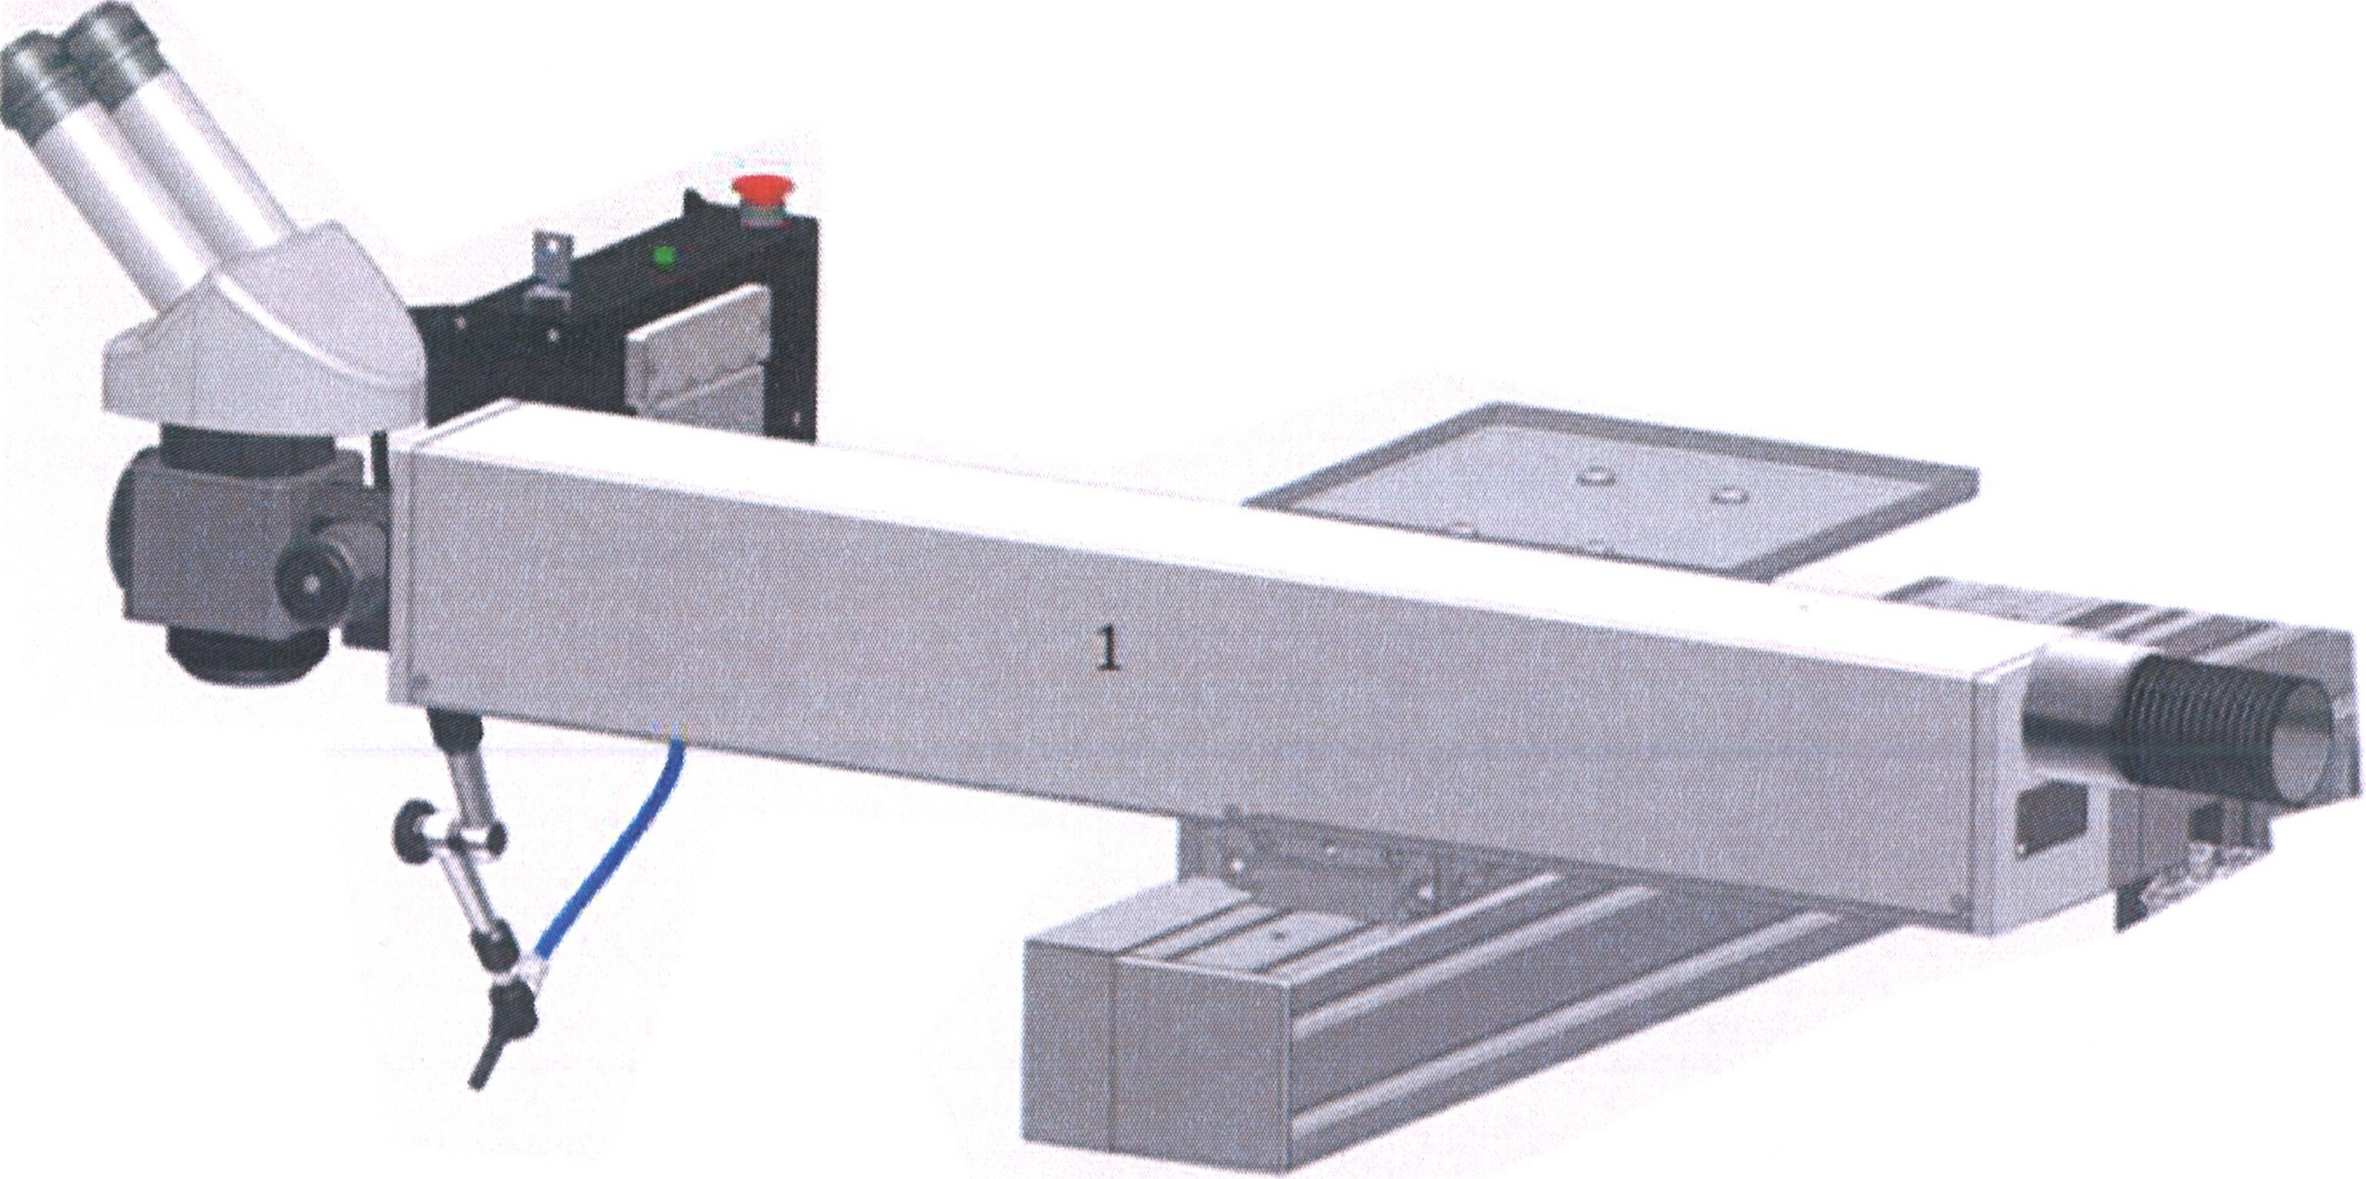
Remove dust from the resonator housing (1) and all housing parts accessible from the outside by dry wiping or wiping with a moist cloth and soap water.
AzTTErNTsION
Never use solvents or alcohol!

OR Lasertechnologie GmbH-Dieselstrasse 15-64807 Dieburg-Tel.: o 60 71/209 890 Fax: o 60 71/209 8999

O.R.
16.09.2013 HTS MOBILE - Page 57

    - Measuring the laser power

- Turn the equipment on.
DANGER
Voltage is applied to the device and laser radiation can be emitted. Interrupt the beam path in the resonator or use an absorber block!

- Specify the desired or known value for the laser power.

- Place the measuring instrument into path of the beam at a suitable position.

Always follow the operating manual for the measuring instrument!

ATTENTION Maintain a sufficient distance from optical components!
Do not measure at the focal point - risk of breaking the optical components and the measuring instrument.

- Trigger a laser pulse and document the measured result.
DANGER
Wear suitable protective goggles for laser work! - Laser radiation is emitted.
Mark and delimit the laser area!

- Verify the measured results according to the data sheet and earlier measurements.

O.R. Lasertechnologie GmbH-Dieselstrasse 15-64807 Dieburg -Tel.. 0 60 71/209 890 Fax: 0 60 71/209 8999

OR.
16.09.2013 HTS MOBILE - Page 58

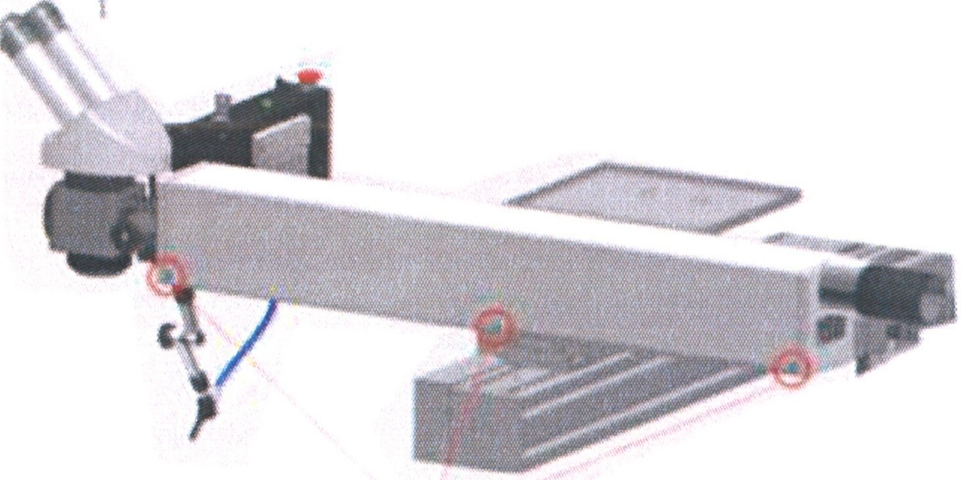
    - Access to the optical components

- Turn the device off, cut it off from the mains
and secure it from being turning on unintentionally.

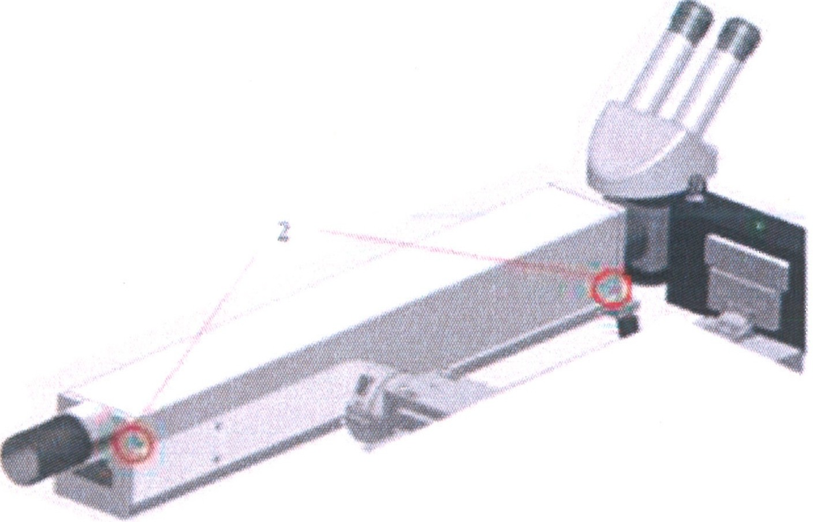
- Loosen the screws (1) under the microscope and remove the microscope.

- Remove the three screws at the front and the two screws at the rear. Then remove the protective cover (2).

- Place the cover onto a clean surface, preferably onto a paper towel prepared for this purpose.

Avoid any contamination inside the housing!
ATTENTION

Do not turn the device on with an open cover!
DANGER
- life-threatening high voltage

- with all open covers:
The beam path is openly accessible.
DANGER
Wear suitable protective goggles for laser work! - Laser radiation can be emitted. Mark and delimit the laser area!

OR. Lasertechnologie GmbH-Dieselstrasse 15-64807 Dieburg -Tel.: 0 60 711209 890 Fax: 0 60 711209 8999
0.R.
16.09.2013 HTS MOBILE - Page 59

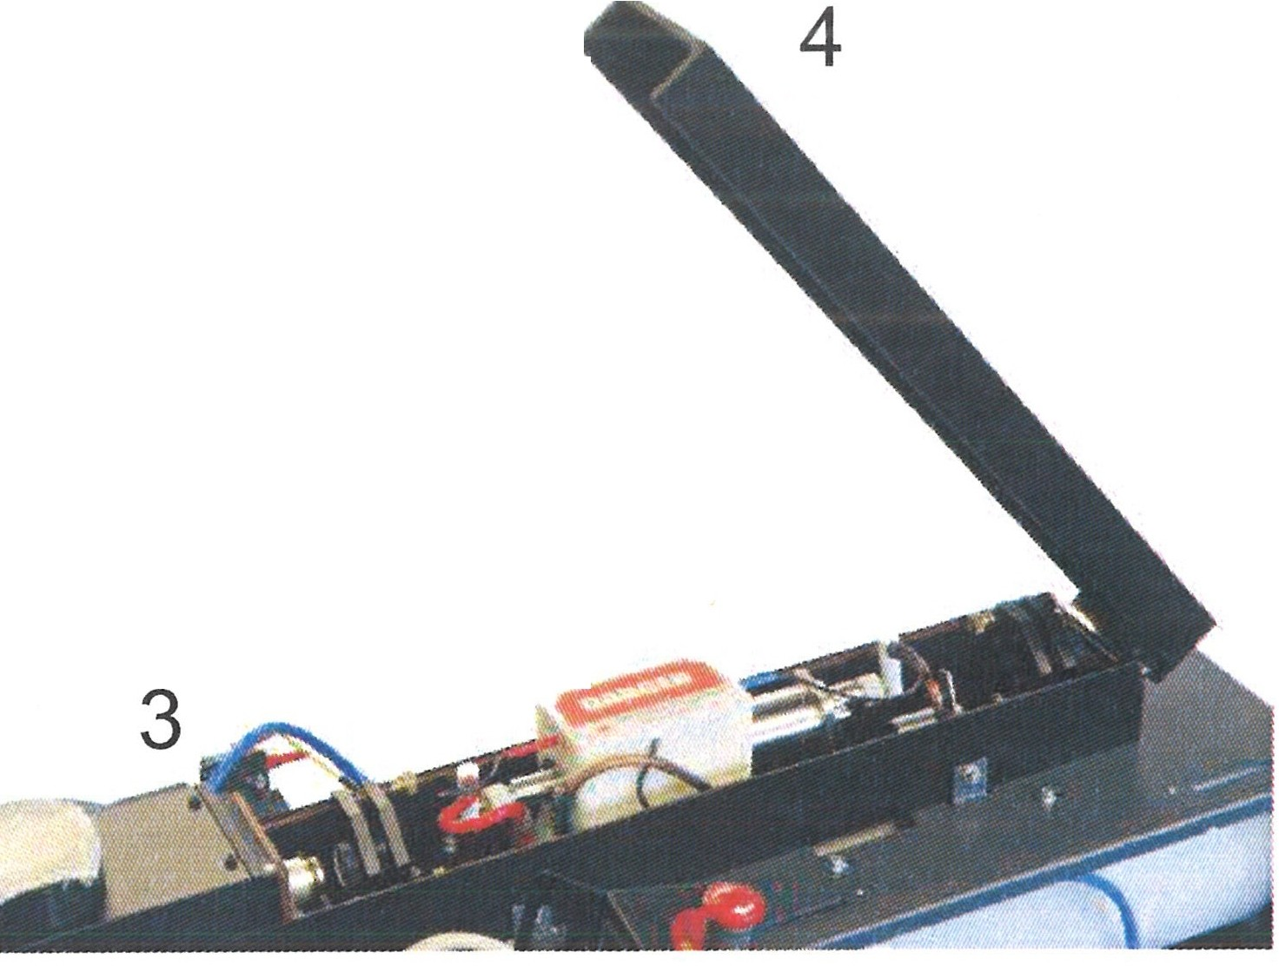8.4.4 Close the cover and fasten it.
I

- Check the underside of the cover for contamination and tilt it if required.

- Check the seal for integrity and position.

- Set the cover (4) onto the resonator.

- Lightly tighten the screws of the cover (3).

&
Observe max. torque of 0.25 Nm!
ATTENTION

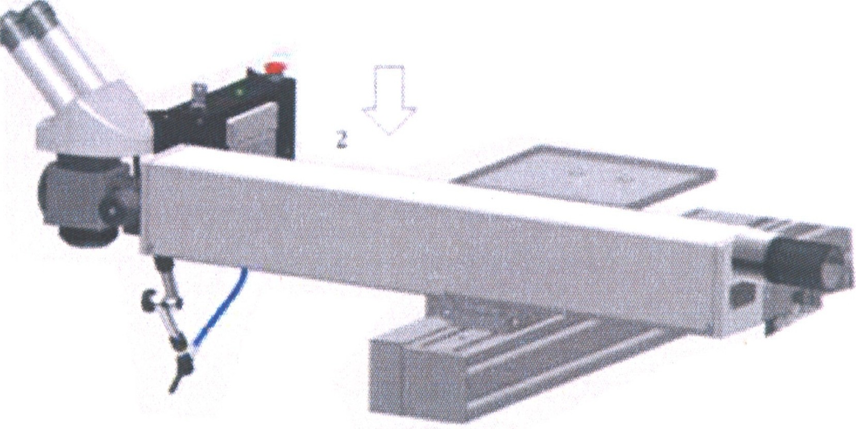
  - Set the protective cover (2) onto the resonator, press lightly to engage.

  - Place the microscope onto the unit.

  - Connect the device to the mains and turn it on.

Wear suitable protective goggles for laser work! - Laser radiation is emitted!
DANGER

OR. Lasertechnologie GmbH-Dieselstrasse 15 - 64807 Dieburg - Tel.: 0 60 71/209 890 Fax: 0 60 71/209 8999
D.R.
16.09.2013 HTS MOBILE - Page 60

    - Calibration of the optical holders - Laser class 4

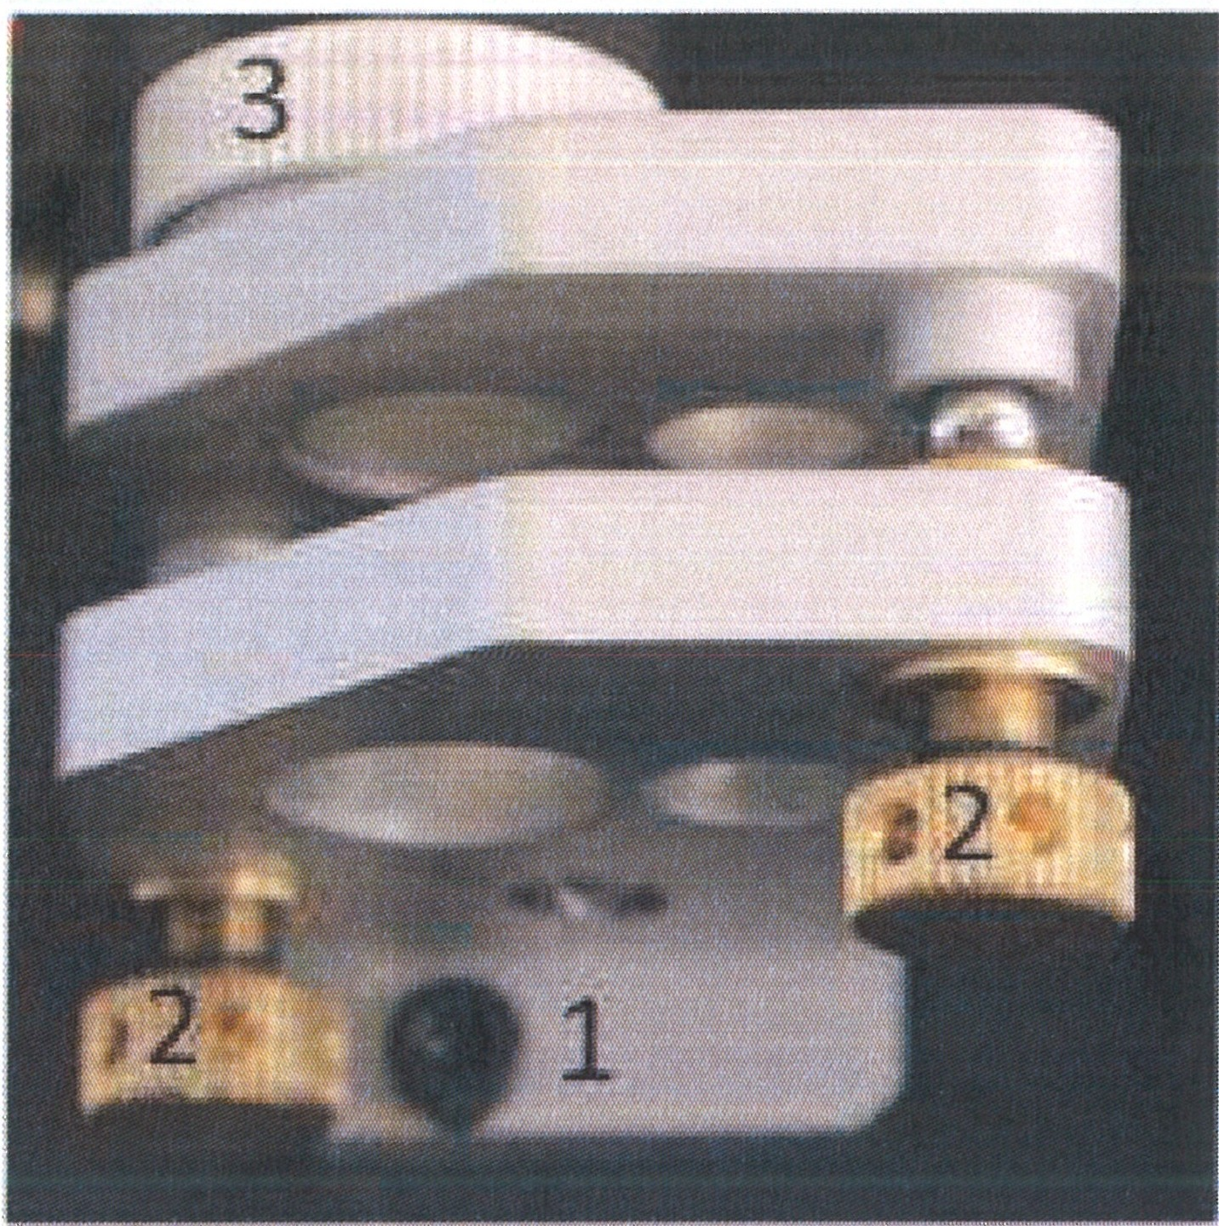
- The optical holder is fixed to the carrier with three screws (1).

- The two calibration screws (2) only serve to tilt the optical components (3)
mounted in the holder.

- The optical components can be tilted and brought to the
desired position by carefully turning the calibration screws.

O.R. Lasertechno/ogie GmbH- Dieselstrasse 15-64807 Dieburg -Tel.. 0 60 71/209 890 Fax: 0 60 71/209 8999
0.R.
16.09.2013 HTS MOBILE - Page 61

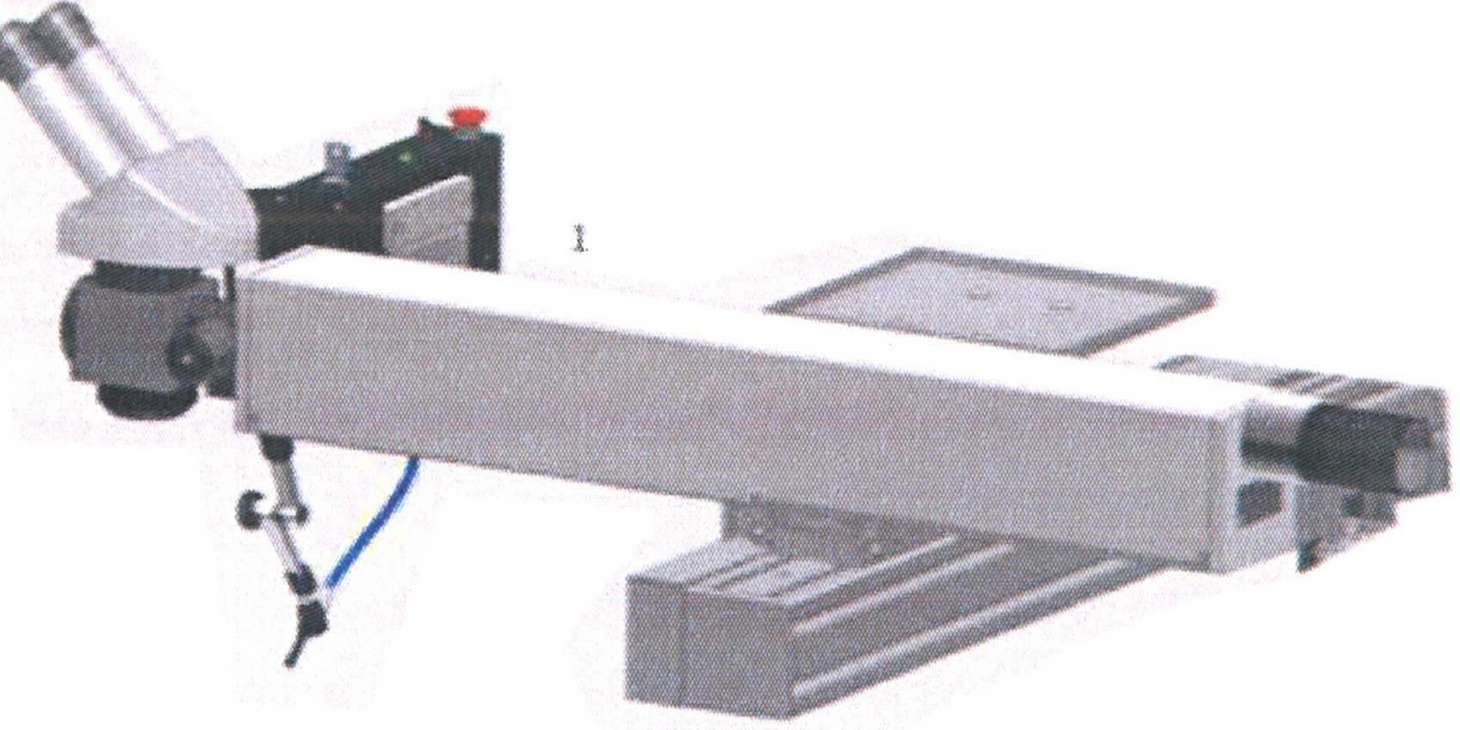
    - Lamp replacement

      - Turn the device off, cut it off from the mains, and secure it from being turned on unintentionallyon.

      - Wait for at least 15 minutes.

      - Prepare a clean surface, preferably a paper towel.

      - Remove the cover (1) of the resonator and place it onto the clean surface.
Check that no voltage is applied to the cavity and the lamp contacts!
A
Wear protective goggles and protective gloves!

Pump lamps are under very high pressure - risk of explosion.
DANGER

      - Carefully pull the plugs marked red (2) and blue (or black) (3) ("+" and "-") from the lamp contacts. For this, you first must turn the screws on the sides of the respective plugs counterclockwise.

2 3
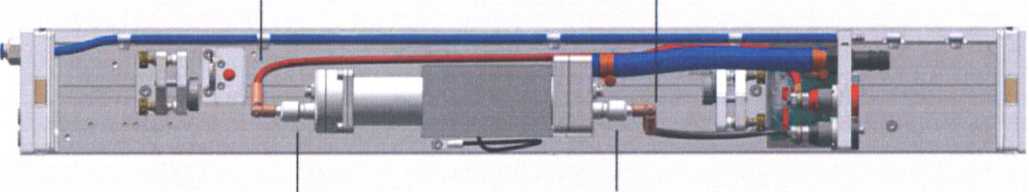
4 4

      - In order to replace the pump lamp, you now must unscrew the white cap nuts (4) carefully. For this, you should initially unscrew the respective plastic seals using only three turns. If there is still water in the tubes, turn the plastic seals again carefully for approx. three turns, until you can observe air bubbles in the tubes. The water now flows back to the reservoir.

      - Carefully unscrew the plastic seal on the cathode (red cable) and lay it down at a suitable place.

      - Carefully unscrew the plastic seal on the anode (blue cable). However, you do not have to unscrew it completely.

OR. Lasertechnologie GmbH- Dieselstrasse 15. 64807 Dieburg. Tel.. 0 60 71/209 890 Fax: 0 60 71/209 8999

O.R.
16.09.2013 HTS MOBILE - Page 62

  - Carefully unscrew the protective covers (1) and (2).
ATTENTION
&.
Touch the lamp contacts only with clean paper. Hold the lamp only at the contacts.

  - You can carefully pull the lamp from the cavity piece by piece in the direction the arrow by applying a slight counterpressure on the outside and simultaneously holding onto the cathode side.
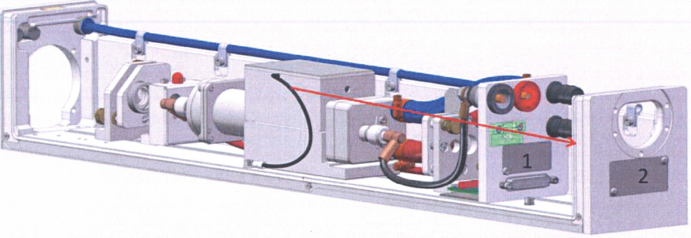

  - The resonator has holes through which you can remove the map in direction of the arrow.
ATTENTION
Do not tilt the lamp! - Risk of breakage
NEVER touch the lamp at places other than the contacts!

  - Package the removed lamp safely.

  - Check the components in the pump chamber for contamination and damage; if necessary, remove the glass splinters of a broken lamp carefully with the cleaning unit from the pump chamber.

  - In the case of severe contamination (grease stains), clean carefully with a fine dirt cloth and isopropanol
Observe the lamp polarity! - a lamp with incorrect polarity ages quickly after a short time.
ATTENTION
Electrode marked red: Electrode marked black:
+ (cathode)
- (anode)

OR Lasertechnologie GmbH- Dieselstrasse 15-64807 Dieburg -Tel.. o 60 71/209 890 Fax: o 60 71/209 8999
0.R.
16.09.2013 HTS MOBILE - Page 63

- With the cathode side first, insert the replacement lamp carefully through the holes intended for this purpose.

- Insert the replacement lamp carefully into the cavity. Take care that the lamp is positioned symmetrically in the cavity. You can recognize this by the fact that both end parts of the lamp project evenly from the cavity.

- Reattach the contacts for the anode and cathode.

- Reattach the intermediate cover.

Lt
Check all plug connections, covers, and seals for the correct connection.
ATTENTION

- The cover of the resonator can be set and screwed carefully.
A
Observe max. torque of 0.25 Nm!
DANGER

- Turn the equipment on.
ATTENTION
Wear suitable protective goggles for laser work! - Laser radiation is emitted.
Mark and delimit the laser area!

- Check the laser power and document all the maintenance work that has been performed in the logbook.

- After a few minutes, turn off the equipment again. Remove the cover of the resonator, and check the tubes in the resonator to ensure there is no leakage.

OR Lasertechnofogie GmbH-Dieselstrasse 15-64807 Dieburg -Tel.. 0 60 71/209 890 Fax: 0 60 71/209 8999
O.R.
16.09.2013 HTS MOBILE - Page 64

8.4.7 Calibration of the beam deflection 90°

- Remove the calibration screw cover (1).

.../
. I
...
.if
1 I

Avoid any contamination inside the housing!
DANGER

- Turn the equipment on.
DANGER
Wear suitable protective goggles for laser work! - Laser radiation is emitted.
Mark and delimit the laser area!
Never look directly into the laser beam or the pilot laser beam!
Even when wearing laser protective goggles, never look directly into the path of the laser beam!

- Set optimum power.

With high power: Risk of breaking the optical or mechanical components through intensive laser radiation

ATTENTION

- wait, until the final operating temperature has been reached (10 to 15 minutes).

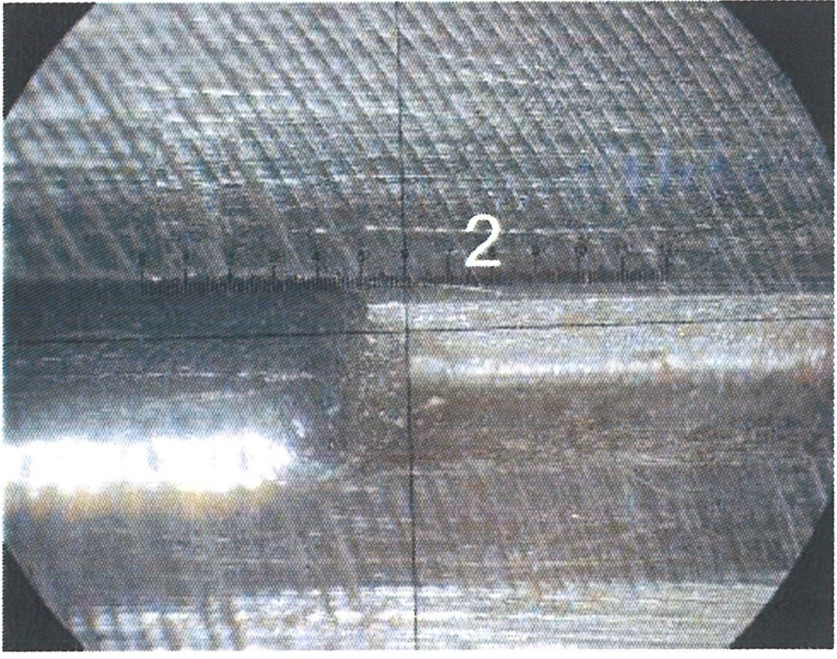
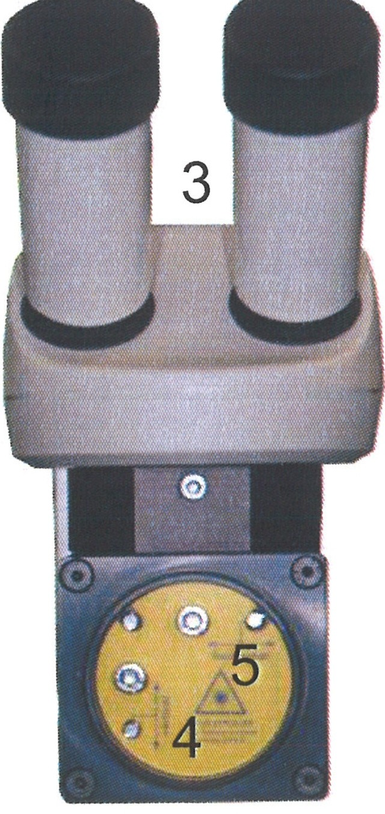
- Trigger a laser pulse.

- Observe the reticle (2) through the ocular (3).

- Use the adjustment screws (4) and (3) on the deflection mirror holder to center the laser beam on the reticle.

- If necessary, check and adjust optical components in the path of the beam.

- Close the path of the beam.

- Attach the calibration screw cover and screw it down.

O.R. Lasertechno/ogie GmbH-Dieselstrasse 15. 64807 Dieburg. Tel.. 0 60 71/209 890 Fax: 0 60 71/209 8999
O.R.
16.09.2013 HTS MOBILE· Page 65

Maintenance work on the cooling system

Cleaning and replacing the particle filter and the deionized water on the water-air heat exchanger

    - Cooling system COR 12:

      - 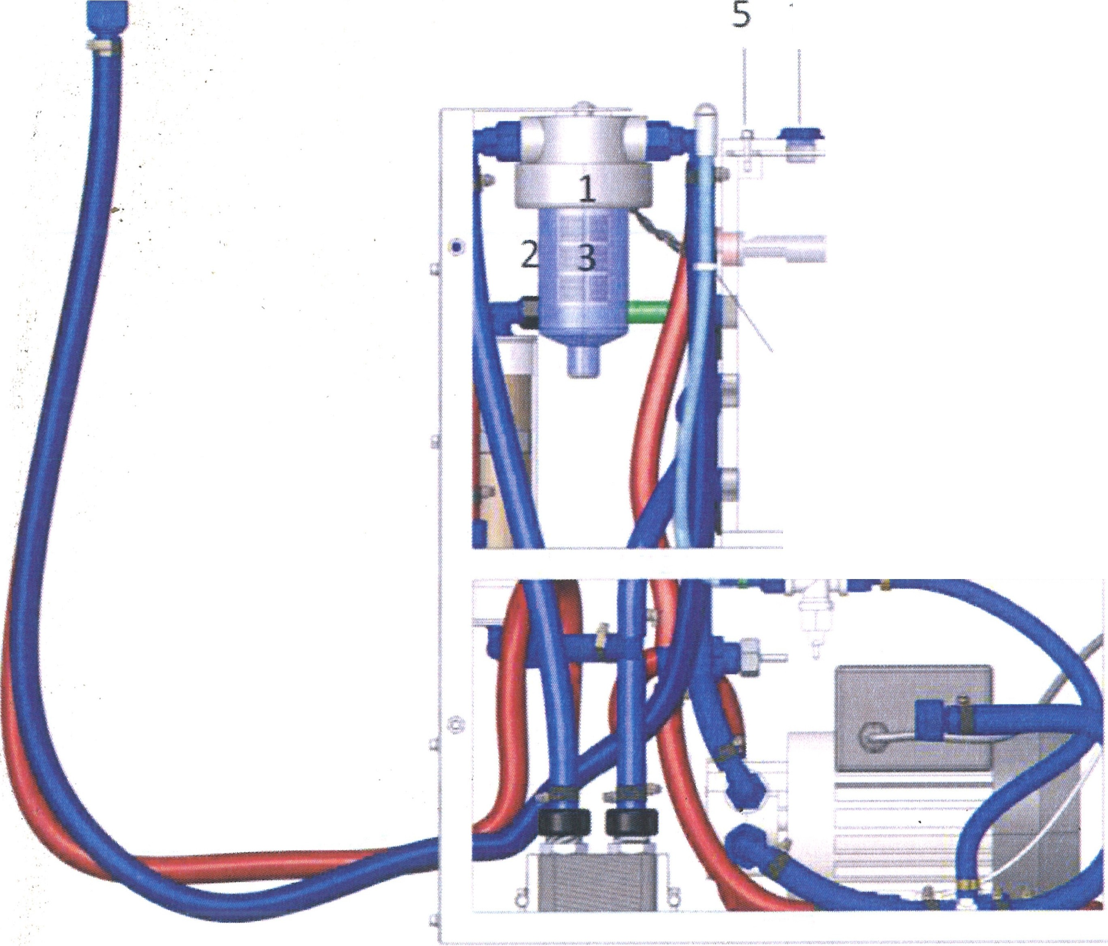- tt n -
7
6
...,
a
4
........
==---j_- -. -
0 o
o

(
0

1. Turn the device off, cut it off from the mains, and secure it from being turned on accidentally.

2; Interrupt the water supply in the outer circuit.

- Open the left side wall.

- Unscrew the counter nuts (1) of the filters.

- Unscrew the glass from the filters (2).

- Remove deposits with a cloth from the inside, rinse with water, clean with soap/detergent, dry, and reinsert.

- If necessary, remove and replace the sieve element (3).

OR. Lasertechnotogie GmbH - Dieselstrasse 15 - 64807 Dieburg - Tel.: 0 60 71/209 890 Fax: 0 60 71/209 8999
0.R.
16.09.2013 HTS MOBILE- Page 66

Only use original screws! - Risk of corrosion
ATTENTION

- Disconnect the tube (4) from the tube clamp and let the water run out.
When the inside of the water reservoir is very dirty:

Unscrew the upper lid at the power source and unscrew the two visible screws (5) on the water reservoir. Remove the lower clips fixing the cooling system and pull out the cooling system halfway, so that the remaining two screws (6) on the water reservoir can be removed. The lid can now be removed and the inside of the water reservoir can be wiped clean with a cloth.
Reattach the lid and reinsert the cooling system into the supply unit.

- Unscrew the cap (7) at the top of the water reservoir and fill with fresh deionized water using a funnel with a tube up to the upper (max) mark.

When replenishing water, air bubbles can be caused in the tube; to prevent this, operate the ON/OFF switch on the equipment two or three times.

This should be done once every three months.
Fill only deionized water without additives - other fluids lead to contamination and equipment faults.

Only turn the device on when fully filled! - A dry run destroys the coolant pump.
ATTENTION
Even with longer storage of DI water in a closed container, the water quality can deteriorate and algae can form.

- Insert the named parts in reverse order and screw on the counter nut.

- Check all water connections for leakage.

Voltage is applied to the device!
DANGER

O.R. Lasertechnologie GmbH- Oieselstrasse 15-64807 Dieburg -Tel.. 0 60 71/209 890 Fax: 0 60 71/209 8999

0.R.
16.09.2013 HTS MOBILE - Page 67

Only turn the device on when fully filled! - A dry run destroys the coolant pump.
ATTENTION
A coolant reservoir that is not completely closed can cause direct leakage, early evaporation of coolant or the formation of algae.

- Fasten the left side wall of the installation.

- Document all maintenance work and enter it into the logbook.

    - Cooling system COR 13:

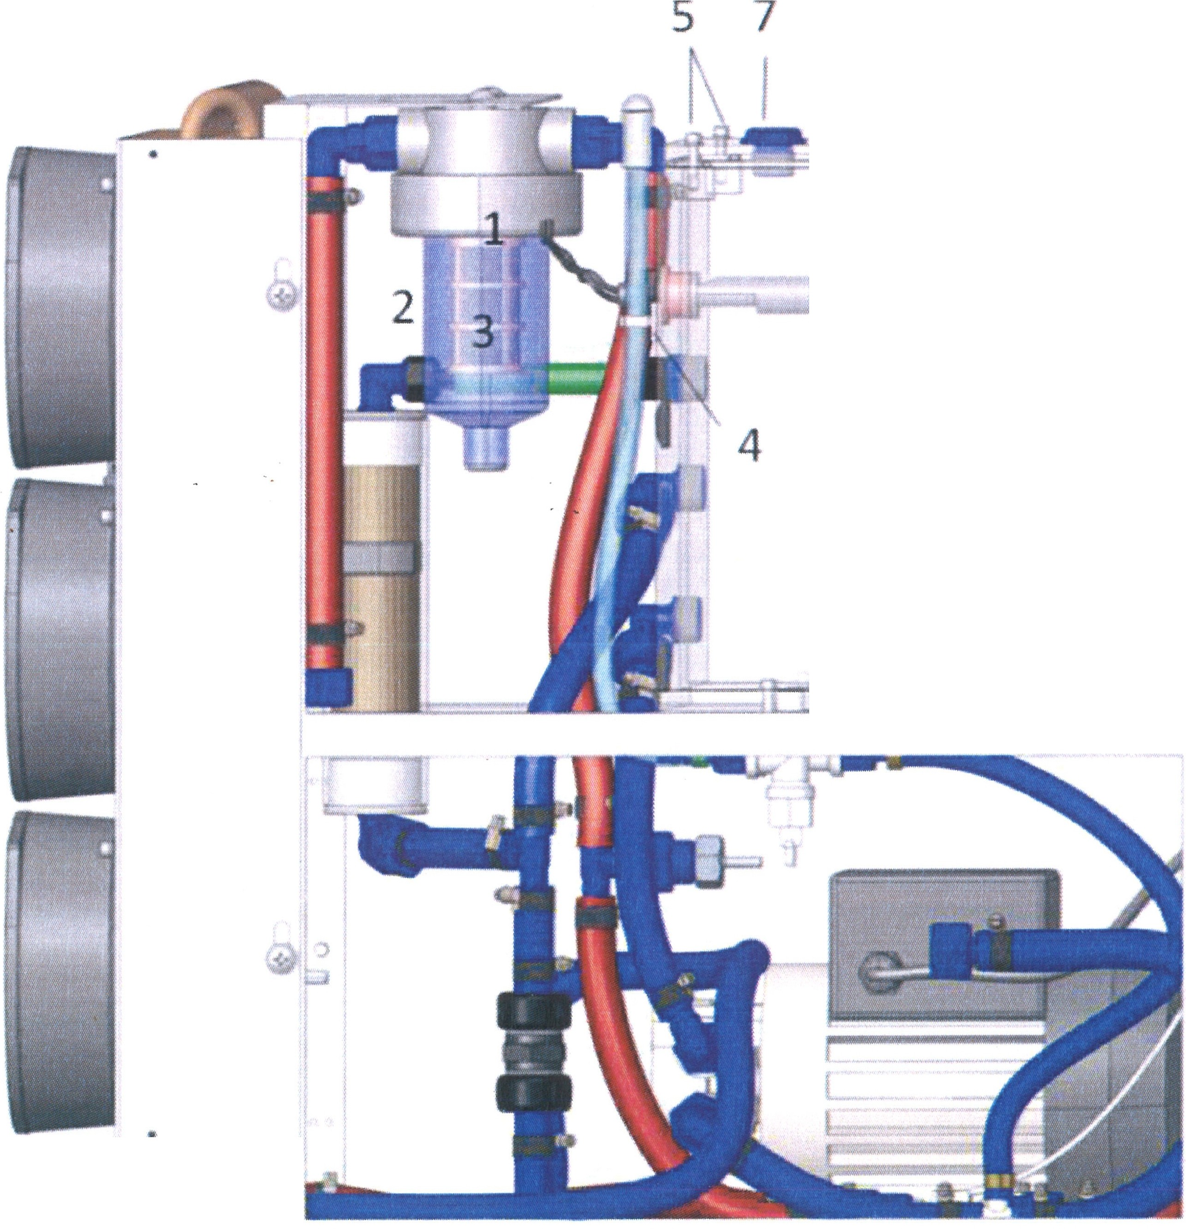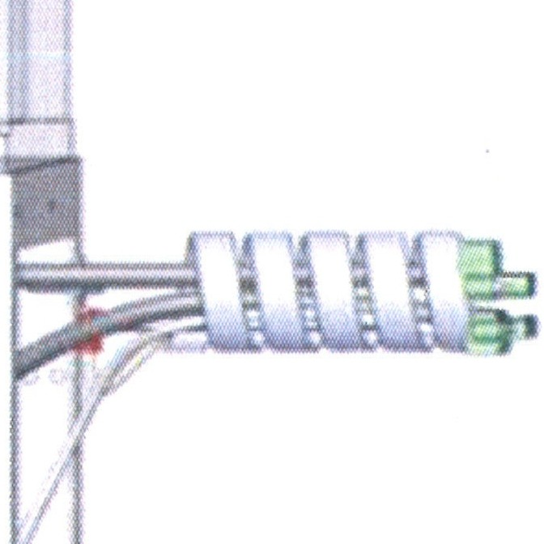
6
e
,.
C>

- Turn the device off, cut it off from the mains, and secure it from being turned on accidentally.

- Interrupt the water supply in the outer circuit.

- Open the left side wall.
O.R. Lasertechnologie GmbH-Dieselstrasse 15-64807 Dieburg - Tel.. 0 60 71/209 890 Fax: 0 60 71/209 8999

O.R.
16.09.2013 HTS MOBILE - Page 68

- Unscrew the counter nuts (1) of the filters.

- Unscrew the glass from the filters (2).

- Remove deposits with a cloth from the inside, rinse with water, clean with soap/detergent, dry, and reinsert.

- If necessary, remove and replace the sieve elements (3).

Only use original screws! - Risk of corrosion
ATTENTION

- Disconnect the tube 4 from the tube clamp and let the water run out.
When the inside of the water reservoir is very dirty:

Unscrew the upper lid at the power source and unscrew the two visible screws (5) on the water reservoir. Remove the lower clips fixing the cooling system and pull out the cooling system halfway, so that the remaining two screws (6) on the water reservoir can be removed. Now the lid can be removed and the inside of the water reservoir can be wiped clean with a cloth.
Reattach the lid and reinsert the cooling system into the supply unit.

- Unscrew the cap (7) at the top of the water reservoir and fill in fresh deionized water using a funnel with a tube up to the upper (max) mark.

When replenishing water, air bubbles can be caused in the tube;
to prevent this, operate the ON/OFF switch on the equipment two or three times.

This should be done once every three months.

Only fill using deionized water without additives - other fluids lead to contamination and equipment faults.

Only turn the device on when fully filled! - A dry run destroys the coolant pump.
ATTENTION
Even with longer storage of DI water in a closed container, the water quality can deteriorate and algae can form.

OR. Lasertechnologie GmbH-Dieselstrasse 15-64807 Dieburg - Tel.. 0 60 71/209 890 Fax: 0 60 71/209 8999
0.R.
16.09.2013 HTS MOBILE - Page 69

- Insert the named parts in reverse order and screw on the counter nut.

- Check all water connections for leakage.
A
Voltage is applied to the device!
DANGER

Only turn the device on when fully filled! - A dry run destroys the coolant pump.
ATTENTION
A coolant reservoir that is not completely closed can cause direct leakage, early evaporation of coolant or the formation of algae.

- Fasten the left side wall of the installation.

- Document all maintenance work and enter it into the logbook.

OR. Lasertechnologie GmbH- Dieselstrasse 15-64807 Dieburg -Tel.. 0 60 71/209 890 Fax: 0 60 71/209 8999
O.R.
16.09.2013 HTS MOBILE- Page 70

    - Cooling system COR 14:
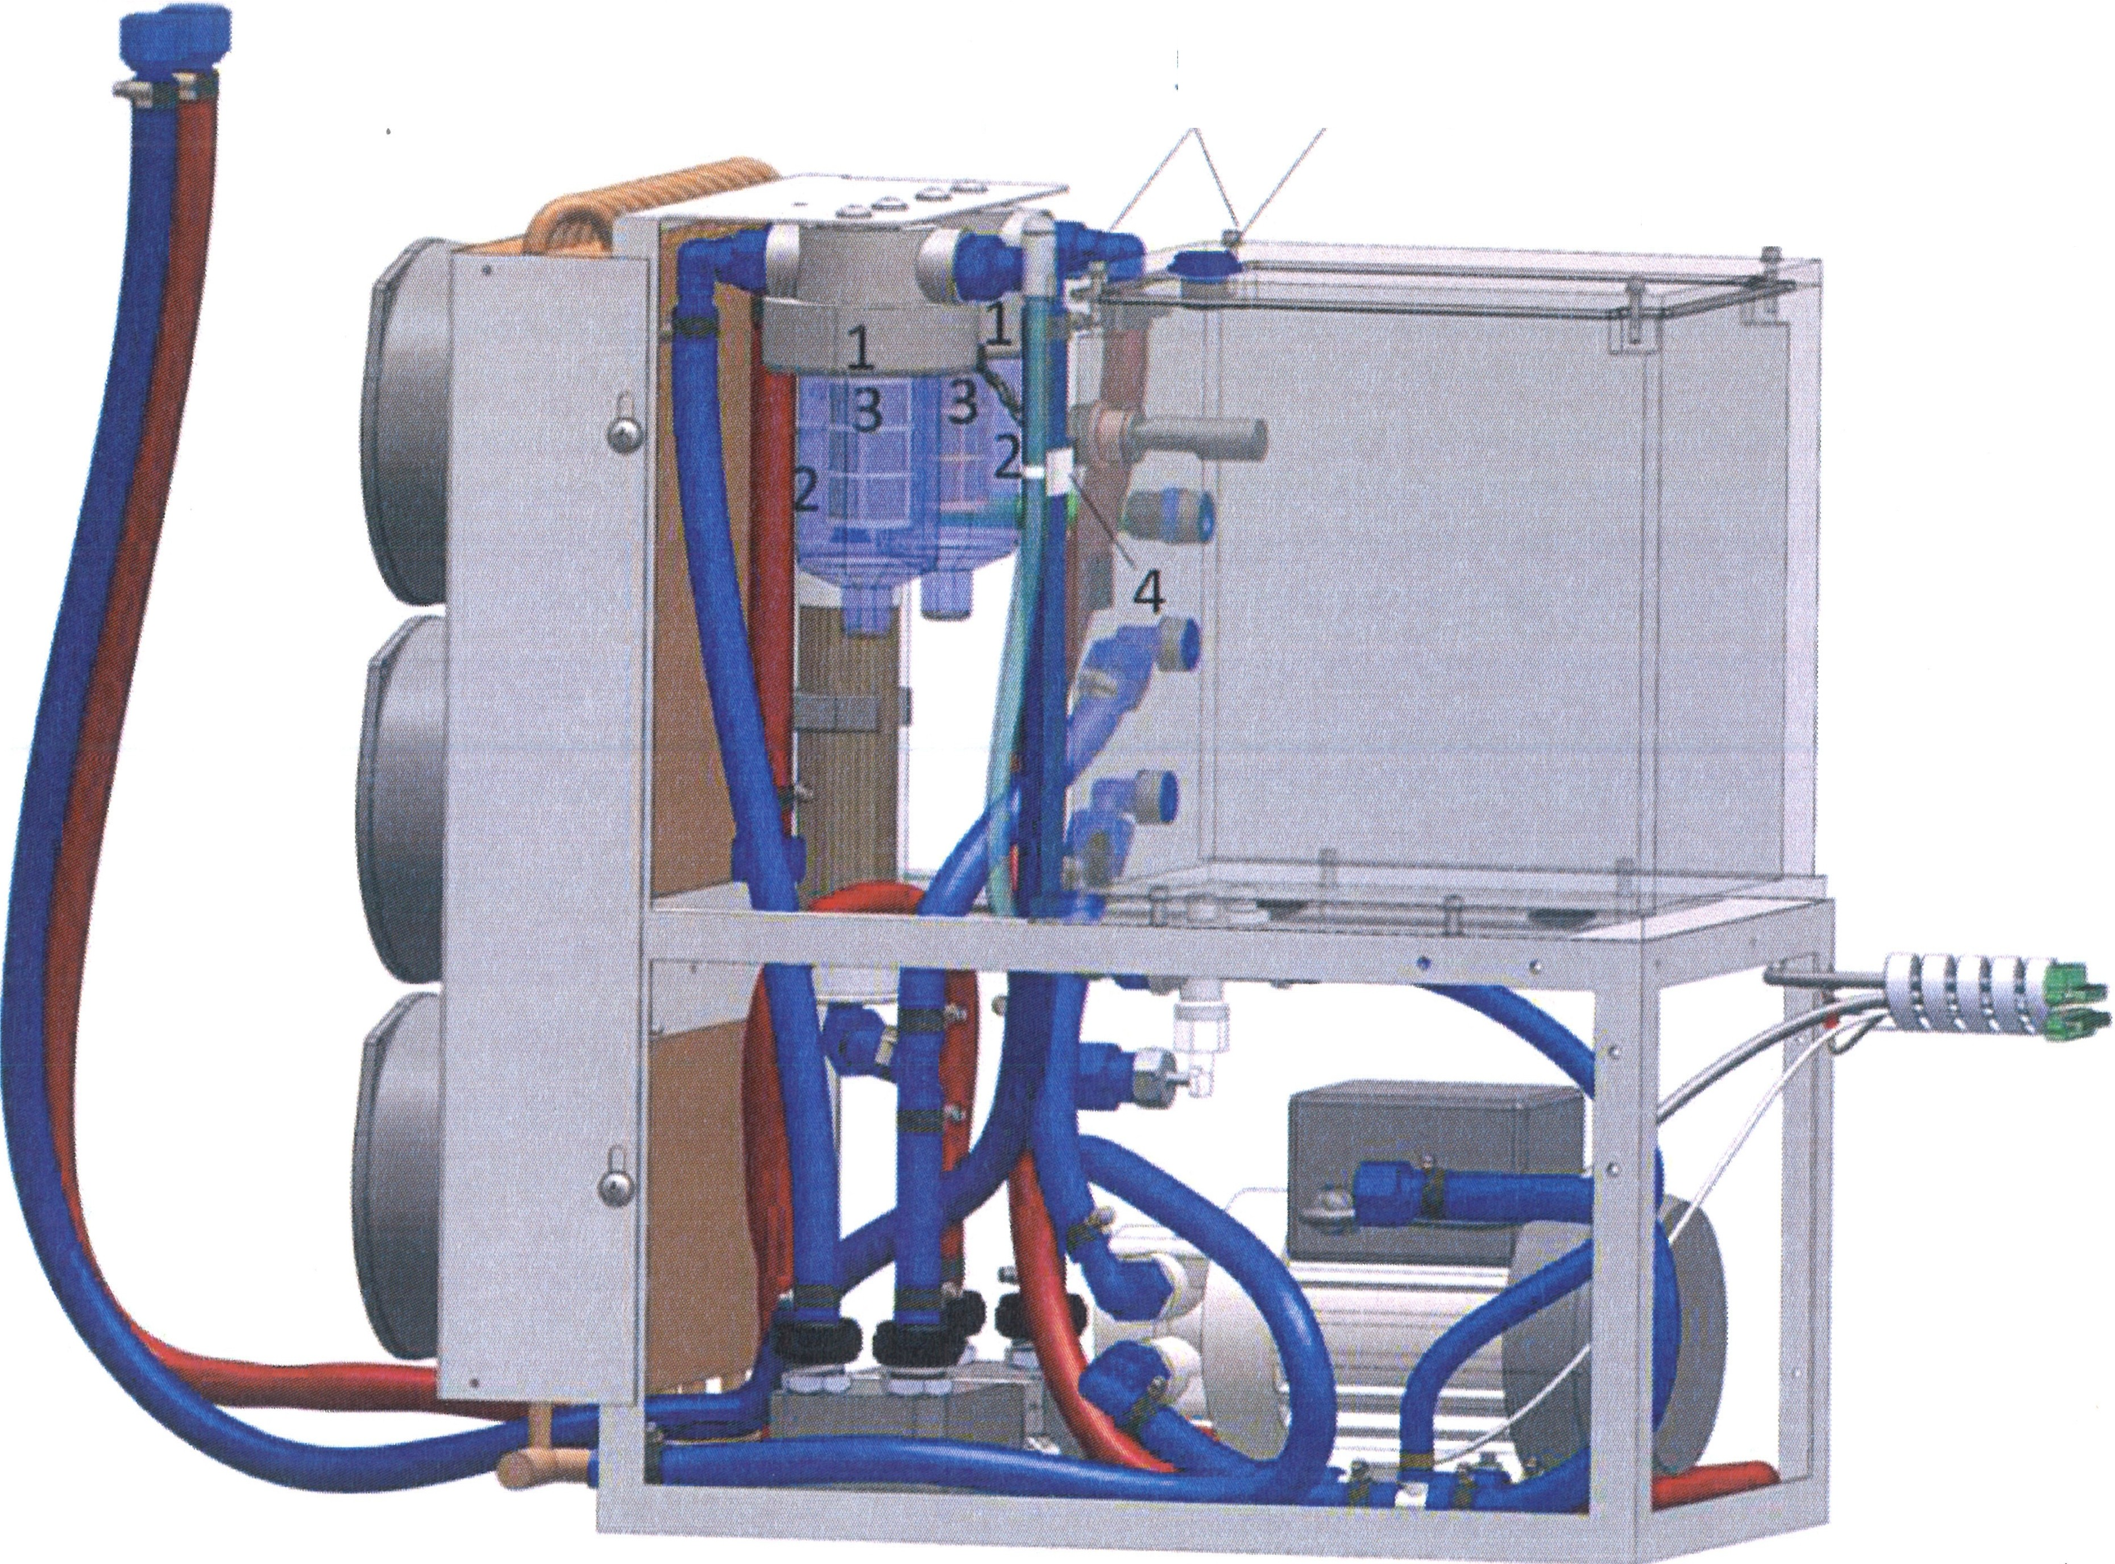
5
7
I\
6

- Turn the device off, cut it off from the mains, and secure it against unintentional turning on.

- Interrupt the water supply in the outer circuit.

- Open the left side wall.

- Unscrew the counter nuts (1) of the filters.

- Unscrew the glass from the filters (2).

- Remove deposits with a cloth from the inside, rinse with water, clean with soap/detergent, dry, and insert again.

- Possibly remove and replace the sieve elements (3).
Lti
Only use original screws! - Risk of corrosion
ATTENTION

OR. Lasertechnologie GmbH- Dieselstrasse 15-64807 Dieburg -Tel.. 0 60 71/209 890 Fax: 0 60 71/209 8999
O.R.
16.09.2013 HTS MOBILE- Page 71

- Disconnect the tube (4) from the tube clamp and let the water run out.
When the inside of the water reservoir is very gjcty:

Unscrew the upper lid at the power source and unscrew the two visible screws (5) on the water reservoir. Remove the lower clips fixing the cooling system and pull out the cooling system halfway, so that the remaining two screws (6) on the water reservoir can be removed. Now the lid can be removed and the inside of the water reservoir can be wiped clean with a cloth.
Reattach the lid and reinsert the cooling system into the supply unit.

- Unscrew the cap (7) at the top of the water reservoir and fill in
fresh deionized water with the aid of a funnel with a tube up to the upper mark (max).

When replenishing water, air bubbles can be caused in the tube;
to prevent this, operate the ON/OFF switch on the equipment two or three times.

This should be done once every three months.

Only fill using deionized water without additives - other fluids lead to contamination and equipment trouble.
ATTENTION
Only turn the device on when fully filled! - A dry run destroys
the coolant pump.

Even with longer storage of DI water in a closed container, the water quality can deteriorate and algae can form.

- Insert the named parts in reverse order and screw on the counter nut.

- Check all water connections for leakage.

Voltage is applied to the device!
DANGER

O.R. Lasertechno/ogie GmbH-Dieselstrasse 15-64807 Dieburg -Tel.. 0 60 71/209 890 Fax: 0 60 71/209 8999
O.R.
16.09.2013 HTS MOBILE - Page 72

Only turn device on only when fully filled! - A dry run destroys the coolant pump.
ATTENTION

A coolant reservoir that is not completely closed can cause direct leakage, early evaporation of coolant or the formation of algae.

- Fasten the left side wall of the installation.

- Document all maintenance work and enter it into the logbook.

    - Cooling system COR 15 (at 300 W):

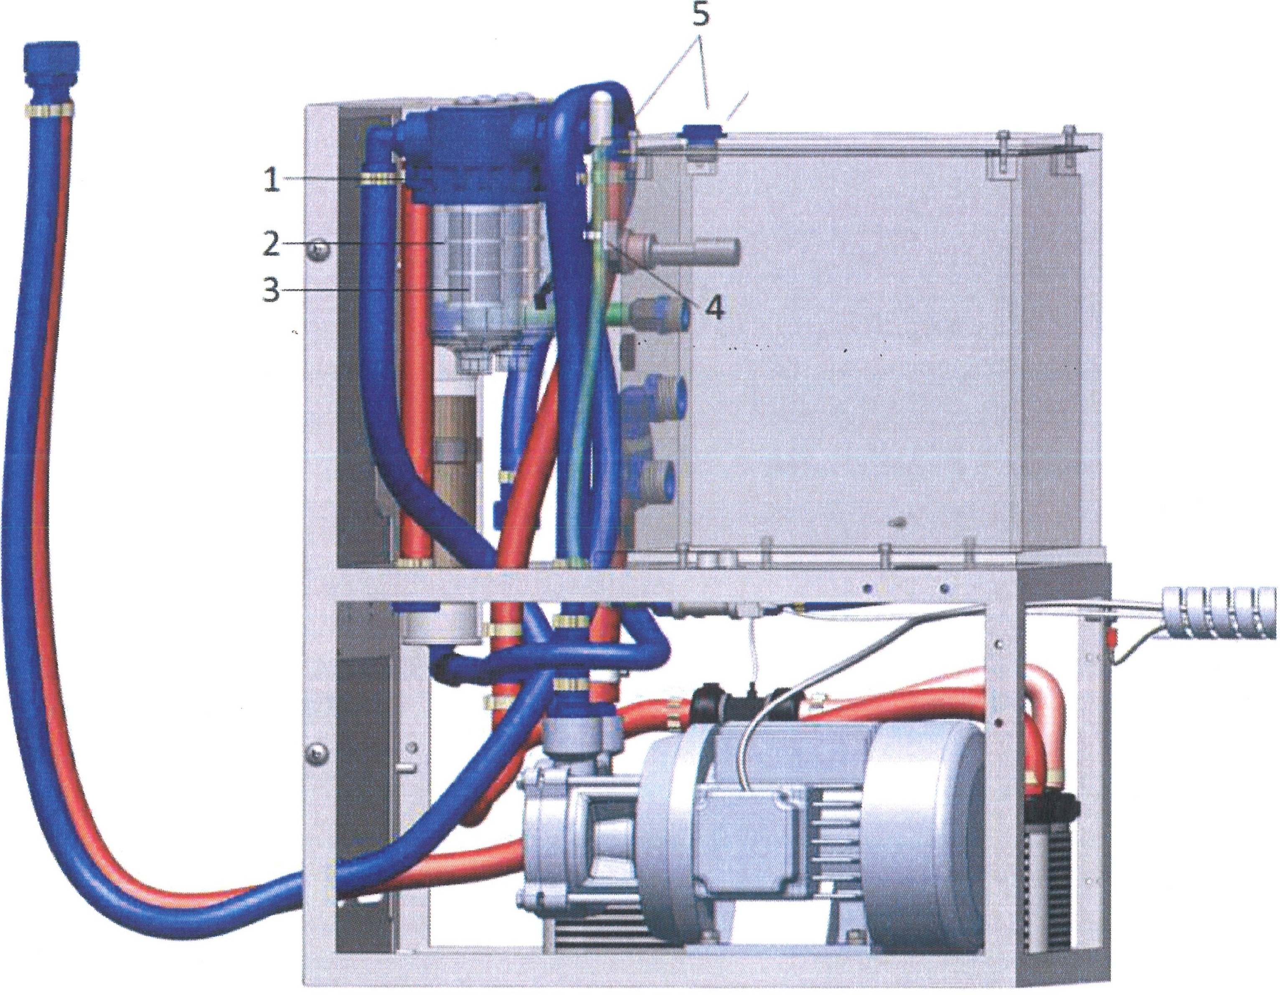
7
6
{\

- Turn the device off, cut it off from the mains, and secure it against unintentional turning on.

- Interrupt the water supply in the outer circuit.

- Open the left side wall.

O.R. Lasertechno/ogie GmbH - Dieselstrasse 15 - 64807 Dieburg - Tel.. 0 60 71/209 890 Fax: 0 60 71/209 8999
O.R.
16.09.2013 HTS MOBILE - Page 73

- Unscrew the counter nuts (1) of the filters.

- Unscrew the glass from the filters (2).

- Remove deposits with a cloth from the inside, rinse with water, clean with soap/detergent, dry, and insert again.

- Possibly remove and replace the sieve element (3).

Only use original screws! - Risk of corrosion
ATTENTION

- Disconnect the tube (4) from the tube clamp and let the water run out.

When the inside of the water reservoir is verY. Q.icty:

Unscrew the upper lid at the power source and unscrew the two visible screws (5) on the water reservoir. Remove the lower clips fixing the cooling system and pull out the cooling system halfway, so that the remaining two screws (6) on the water reservoir can be removed. Now the lid can be removed and the inside of the water reservoir can be wiped clean with a cloth.
Reattach the lid and reinsert the cooling system into the supply unit.

- Unscrew the cap (7) at the top of the water reservoir and fill in
fresh deionized water with the aid of a funnel with a tube up to the upper mark (max).

When replenishing water, air bubbles can be caused in the tube;
to prevent this, operate the ON/OFF switch on the equipment two or three times.

This should be done once every three months.

Only fill in deionized water without additives - other fluids lead to contamination and equipment trouble.

Only turn the device on when fully filled! - A dry run destroys
ATTENTION the coolant pump.

Even with longer storage of DI water in a closed container, the water quality can deteriorate and algae can form.

I 10. Insert the named parts in reverse order and screw on the counter nut.

O.R. Lasertechno/ogie GmbH-Dieselstrasse 15-64807 Dieburg -Tel.. 0 60 71/209 890 Fax: 0 60 71/209 8999
0.R.
16.09.2013 HTS MOBILE - Page 74

- Turn the device off, cut it off from the mains, and secure it against unintentional turning on.

- Interrupt the water supply in the outer circuit.

- Open the left side wall.

- Unscrew the counter nuts (1) of the filters.

- Unscrew the glass from the filters (2).

- Remove deposits with a cloth from the inside, rinse with water, clean with soap/detergent, dry, and insert again.

- Possibly remove and replace the sieve element (3).

Only use original screws! - Risk of corrosion
ATTENTION

- Disconnect the tube (4) from the tube clamp and let the water run out.
When the inside of the water reservoir is verY. Qlcty:

Unscrew the upper lid at the power source and unscrew the two visible screws (5) on the water reservoir. Remove the lower clips fixing the cooling system and pull out the cooling system halfway, so that the remaining two screws (6) on the water reservoir can be removed. Now the lid can be removed and the inside of the water reservoir can be wiped clean with a cloth.
Reattach the lid and reinsert the cooling system into the supply unit.

- Unscrew the cap (7) at the top of the water reservoir and fill in
fresh deionized water with the aid of a funnel with a tube up to the upper mark (max).

When replenishing water, air bubbles can be caused in the tube;
to prevent this, operate the ON/OFF switch on the equipment two or three times.

This should be done once every three months.

OR. Lasertechnotogie GmbH - Dieselstrasse 15 - 64807 Dieburg - Tel.. 0 60 71/209 890 Fax: 0 60 71/209 8999

0.R.
16.09.2013 HTS MOBILE - Page 76

Only fill in deionized water without additives - other fluids lead to contamination and equipment trouble.
ATTENTION
Only turn the device on when fully filled! - A dry run destroys the coolant pump.
Even with longer storage of DI water in a closed container, the water quality can deteriorate and algae can form.

- Insert the named parts in reverse order and screw on the counter nut.

- Check all water connections for leakage.

Device under voltage!
DANGER

&
Turn the device on only in fully filled condition! - A dry run destroys the coolant pump.
ATTENTION
A coolant reservoir that is not completely closed can cause direct leakage, early evaporation of coolant or the formation of algae.

- Fasten the left side wall of the installation.

- Document all maintenance work and enter it into the supplied logbook.

8.5.6 Replacement of the Deionization Cartridge for all Cooling Systems:

- Turn the device off, cut it off from the mains, and secure it against unintentional turning on.
- Disconnect the return tube of the consumer.
- Set a container for residual water under the tube end.
- Open the two cap nuts (1) (20 and 22 open-ended wrench) on the DI cartridge (2).Remove the old DI cartridge and replace it by a new one.

O.R. Lasertechnologie GmbH-Dieselstrasse 15-64807 Dieburg -Tel.. 0 60 71/209 890 Fax: o 60 71/209 8999

O.R.
16.09.2013 HTS MOBILE - Page 77

1
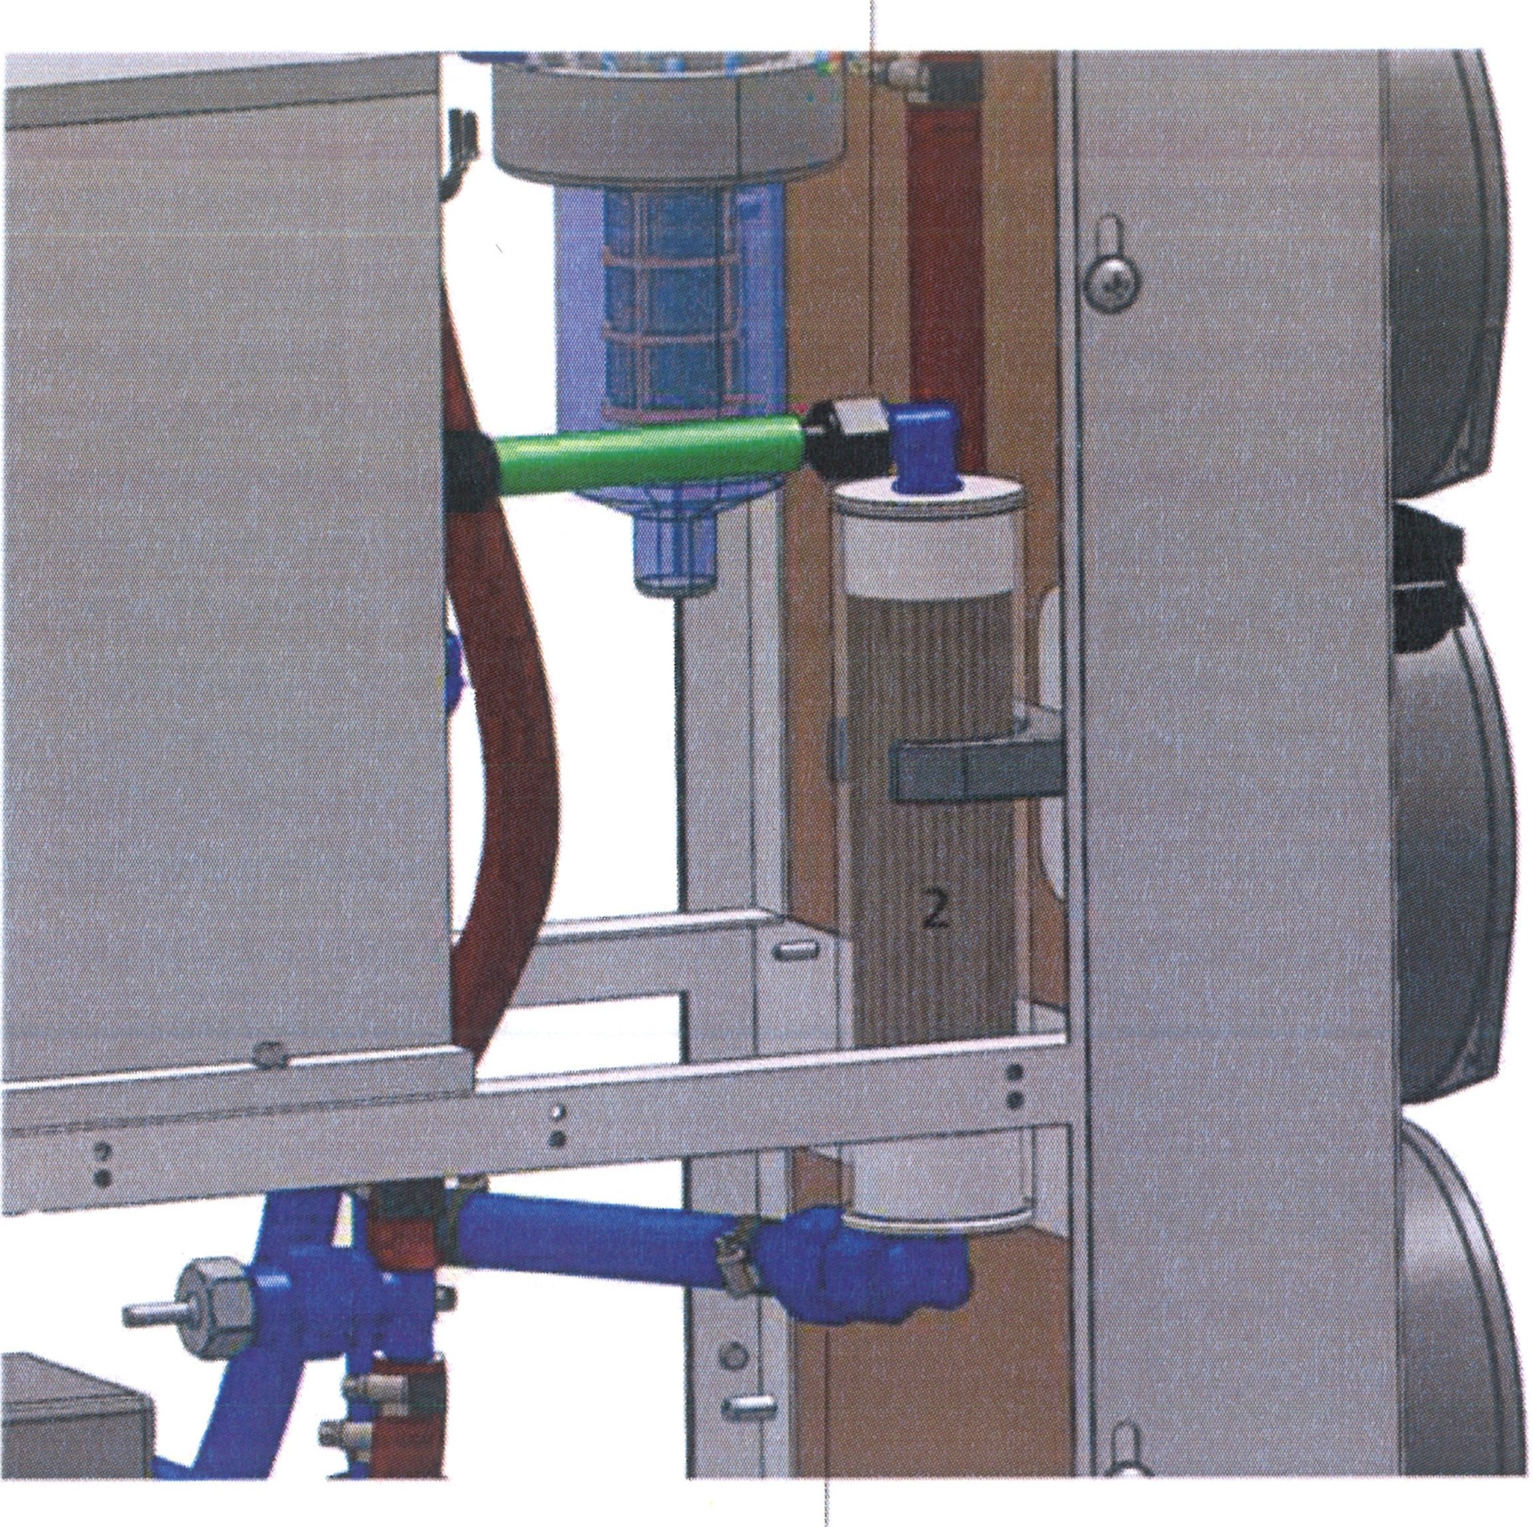
1
- Retighten the cap nuts.
- Reattach the tubes from the consumer.
- Check the cooling equipment for leakage.

Check the cooling unit for leakage after replacing the deionization cartridge.
ATTENTION
Replace the deionization cartridge immediately once "Conductivity too high" is displayed (at least every 6 months).

OR. Lasertechno/ogie GmbH - Dieselstrasse 15 - 64807 Dieburg - Tel.. 0 60 71/209 890 Fax: 0 60 71/209 8999
O.R.
16.09.2013 HTS MOBILE - Page 78

- Shut-down
  - Temporary Shut-down

For temporarily shut-down of the laser processing station - e.g. holidays -, the following measures are sufficient to prevent equipment damage or life-threatening injuries from the laser processing station being switched-on without authorization:

- 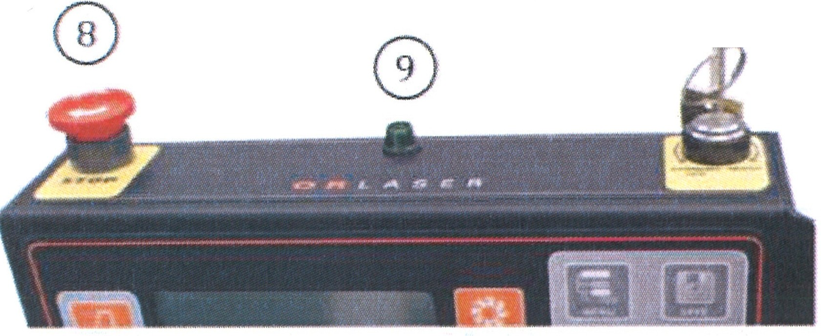By turning the key switch (10) b
a @
counterclockwise (a), the
system is brought to the readiness mode

- Slight turning of the key switch (10) in clockwise direction shuts the system down.

- 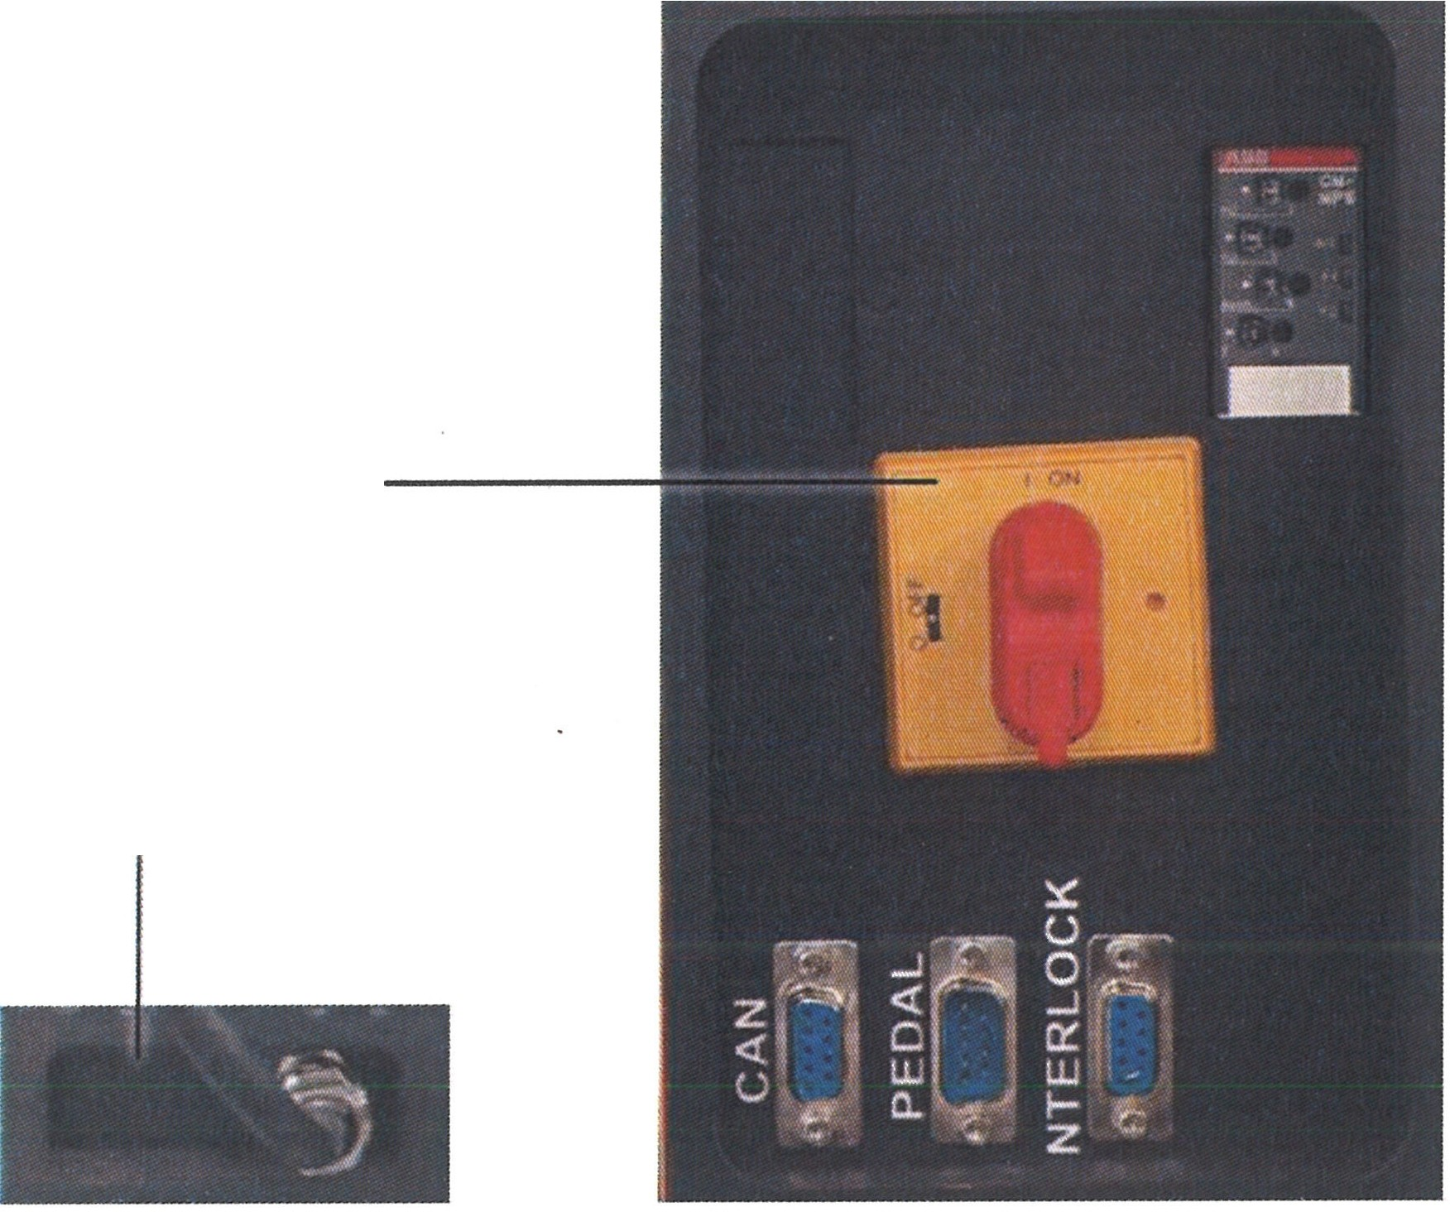Set the main switch (1) on the rear to the
1
2

- Pull the key (10) of the key switch.

- Disconnect from the mains by pulling the plug (2).

Without the plug and the key on the key switch, the laser cannot be switched on.

After this action, no part of the laser processing station can be operated. In particular, the processing stand cannot be moved by motor.

The ambient temperature of the temporarily shut down laser processing station should not drop below +5 CC!
ATTENTION

0.R. Lasertechnologie GmbH- Dieselstrasse 15-64807 Dieburg -Tel.. 0 60 71/209 890 Fax: 0 60 71/209 8999
O.R.
16.09.2013 HTS MOBILE- Page 79

  - Final Decommissioning, Removal, Disposal

The following items must be observed to avoid equipment damage or life-threatening injuries during transport of the laser processing station HTS Mobile:
Before the start of disassembly, the laser processing station should be disconnected from the mains by pulling the power plug.

The disassembly work should only be performed by qualified and authorized persons whilst following the safety notes.
ALil
Load suspension and hoisting devices should satisfy the accident
ATTENTION prevent·,on reguIta· ions.'
The weight of the processing stand (200 kg) should be taken into consideration when selecting the load suspension and hoisting devices!

The transport routes should be blocked and marked so that no unauthorized person can enter the danger area!

- The cooling system should be emptied as far as possible for each transport event (prevention of frost damage, risk of algae growth).

- All openings of the cooling system shall be closed to prevent leakage of residual water and to prevent contaminants from entering.

- All surfaces of the observation and processing optics shall be protected against scratching by covers.

- Openings for beam exit shall be closed to prevent contaminants from entering.

- Large shocks shall be avoided during transport.

The laser processing station does not contain any hazardous substances. Nevertheless, a qualified specialized company shall be called upon for final disposal in an environmentally friendly manner.

O.R. Lasettechnologie GmbH-Dieselstrasse 15-64807 Dieburg -Tel.. 0 60 71/209 890 Fax: 0 60 71/209 8999
0.R.
16.09.2013 HTS MOBILE - Page 80

- Technological appendix
  - Electrical connection values

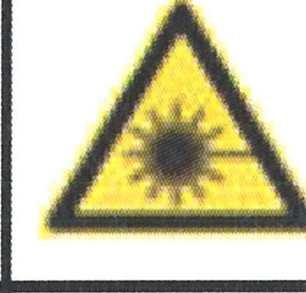
Name plate

ATTENTION &
MAINTENANCE AND REPAIR ONLY BY SPECIALISTS
CAUTION
REFER SERVICING TO QUALIFIED PERSONNEL
System: Laser beam source  Type: LS-PE 200  Power Consumption:  max. 8;9 kW  Power supply/  Mains voltage 3 x 400 V AC/N/PE Current consumption:  max. 3 x 8.5 A  Frequency:  50/60 Hz  Power output:  max. 200W  Ambient temp.:  +5 'C to +32 'C  Serial number: LS-PE 20091212  LASER CLASS 4  LASER CORRESPONDING TO EN 60825 -1/11.2001 | .::,:,  ORLASER  Guterstra e 7 • 64807 • Dieburg • Germany  (€  MADE IN GERMANY

Electrical connection values | HTS Mobile 120 | HTS Mobile 160 | HTS Mobile 200 | HTS Mobile 300
Power consumption ' | max. 6.7 kW | max. 8.9 kW | max. 8.9 kW | max. 8.9 kW
Power consumption 2 | max. 17.5 kW | max. 17.5 kW | max. 17.5 kW | max. 17.5 kW
Mains voltage | 3 * 400 V AC / N / PE | 3 * 400 V AC / N / PE | 3 * 400 V AC / N / PE | 3 * 400 V AC / N / PE
Current consumption 1 | max. 3 * 16 A | max.3*16A | max.3*16A | max.3*16A
Current consumption 2 | max. 3 * 25 A | max. 3 * 25 A | max. 3 * 25 A | max. 3 * 25 A
Mains frequency | 50 I 60 Hz | 50 I 60 Hz | 50 I 60 Hz | 50 I 60 Hz
Connector | Terminals | Terminals | Terminals | Terminals
Connection cable | 4 * 2.5 mm2 + PE | 4 * 2.5 mm2 + PE | 4 * 2.5 mm2 + PE | 4 * 2.5 mm2 + PE
Power plu | CEE17 / 16 A | CEE17 / 16 A | CEE17 / 16 A | CEE17 / 16 A
1 Without external consumers 2 With external consumers

Note: Technological changes and the further development of the installation can have such an affect that data in the technological appendix differs from the specifications of the supplied system.

OR Lasertechnologie GmbH-Dieselstrasse 15-64807 Dieburg -Tel.. 0 60 71/209 890 Fax: 0 60 71/209 8999
O.R.
16.09.2013 HTS MOBILE- Page 81

10.1.1 Monitoring relay CM-ESS.1 i CM-ESS.2:
CM-ESS.1 CM-ESS.2  A1 111!1 C Al 111!1 2125  @n@ @n@n@  8 B | Frontal view with controls ENGLISH  (D Operation state indication with LEDS  U: LED red - Indication of the measuring voltage  Switch setting l...zf:..1-  r--, 6vervoltage Switch setting l...::l:s:...1-
R: LED yellow ru-L Overvoltage
- Indication of the switching position
of the output relays
1--i Excited
U/T: LED green - Indication of the control feed voltage
and time sequence
r----i. Control feed voltage applied Triggering delay Tv active
n...rL
@ Setting of the reset threshold (hysteresis) @ Setting of the threshold value
© Setting of the triggering delay Tv[o; 0.1 to 30 s)
Setting of the measuring range
® (3 to 30 V; 6 to 60 V; 30 to 300 V; 60 to 600 V
i AC/DC)
0
0
.;.:,;1 ,, ,, I N
N ""''
02 LJ418 1211 Alj 2-tn 2228 A2 8
0
"'

II II DIP switch settings
o DIP switch for setting of:
1 ON = Response delay OFF= Reset delay
f/j 2 ON = Phase sequence monitoring deactivated
"8' OFF = Phase sequence monitoring activated
Factory setting: All DIP switches in position OFF

Ill Ill. DIP switch position
g
g
LL

'f!

0
8
N

IV. Wiring diagram
A1-A2 Control feed voltage
8-C Measuring voltage
IV 11 (1 S)-12(16)/14(18) Output relay 1
A1 I 11,. I C 21(25)-22(26)/24(28) Output relay 2
B I I
8 111• "g'
6--l .f,t
Po"-\ I ""
0
A1 "2 12,.14,. 8""
0
14,. I 12,. I 112 0 2
""

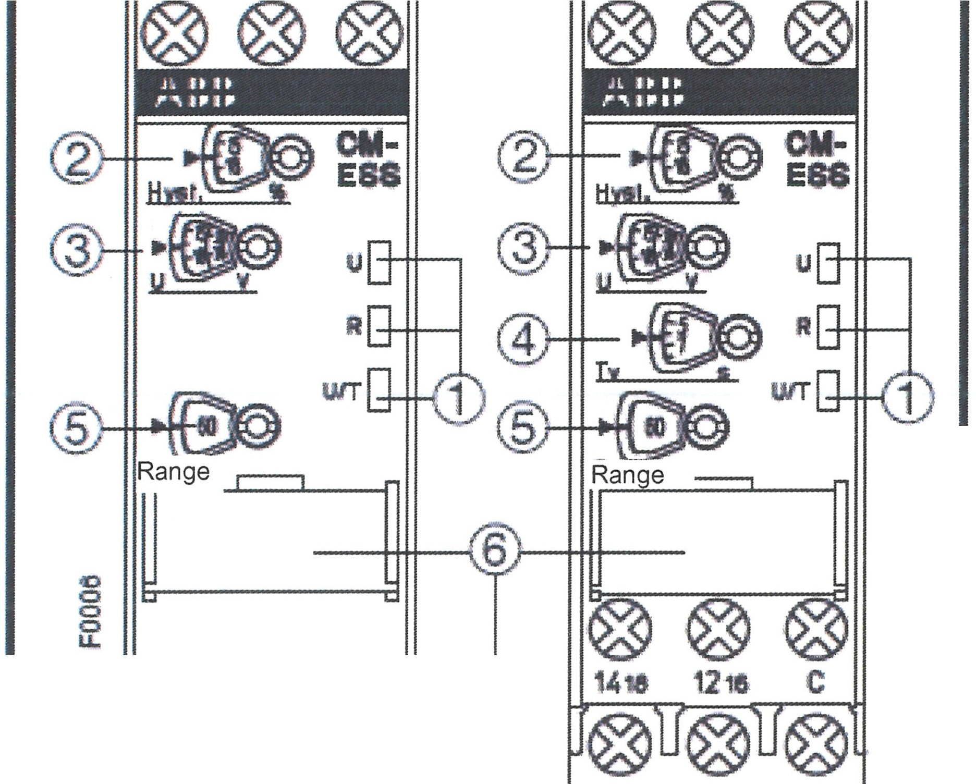

Positfon  ONt | 2 | 1
OFF |  | [zt]

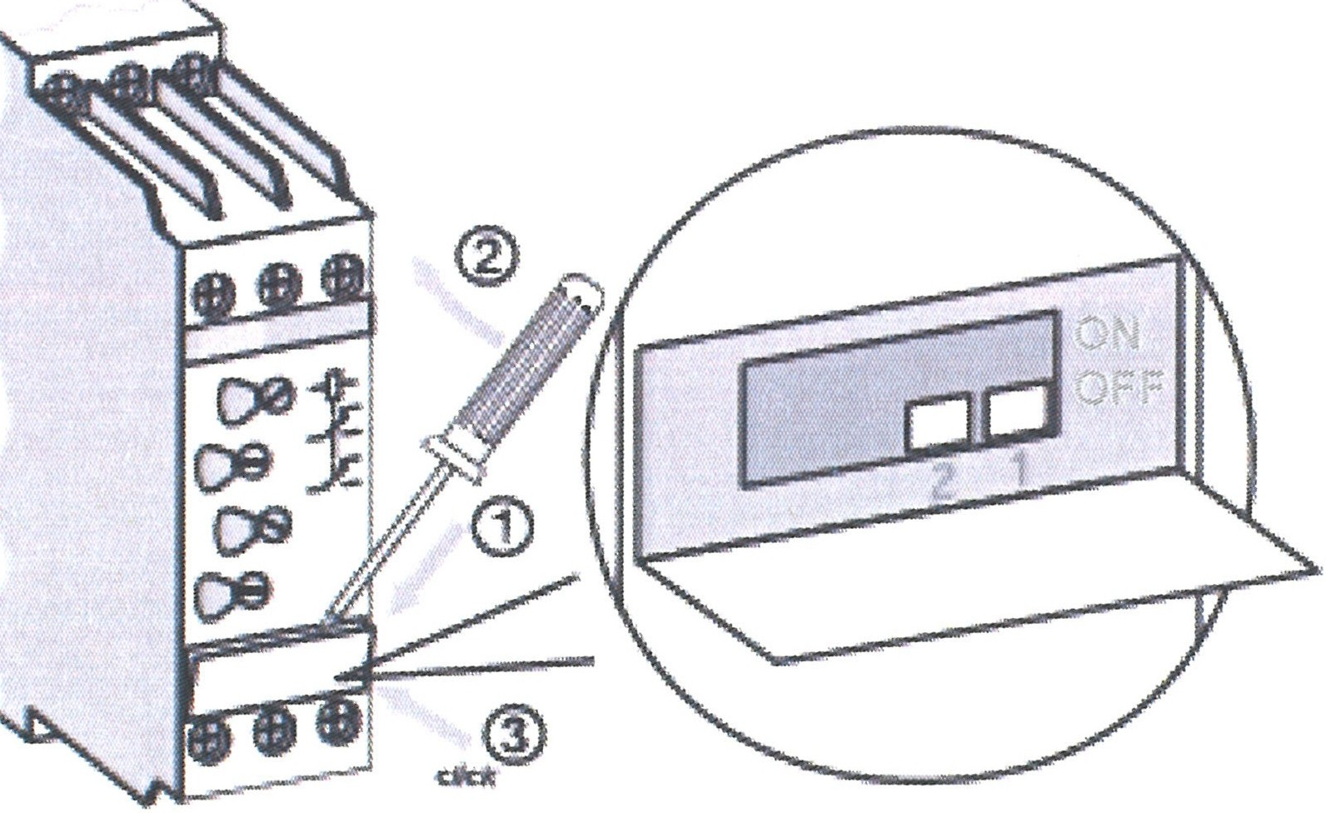

Al I 11,. I 21
B
B 11,. 2'1,.
:{ -/1--;I
Al
14
24

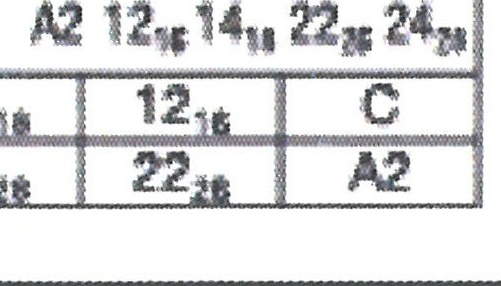
O.R. Lasertechnologie GmbH-Dieselstrasse 15-64807 Dieburg -Tel.: o 60 71/209 890 Fax: o 60 71/209 8999
0.R.
16.09.2013 HTS MOBILE- Page 82

CM-MPS 41:

Examples

L1 L2 l3
n©

JC
■
Mlh
-·f®
@·
1,/ 'I
® •fJ)@
@ IAs[x: t@
® --

§

l1 L1 l3

@n@n@
N
Frontal view with controls English
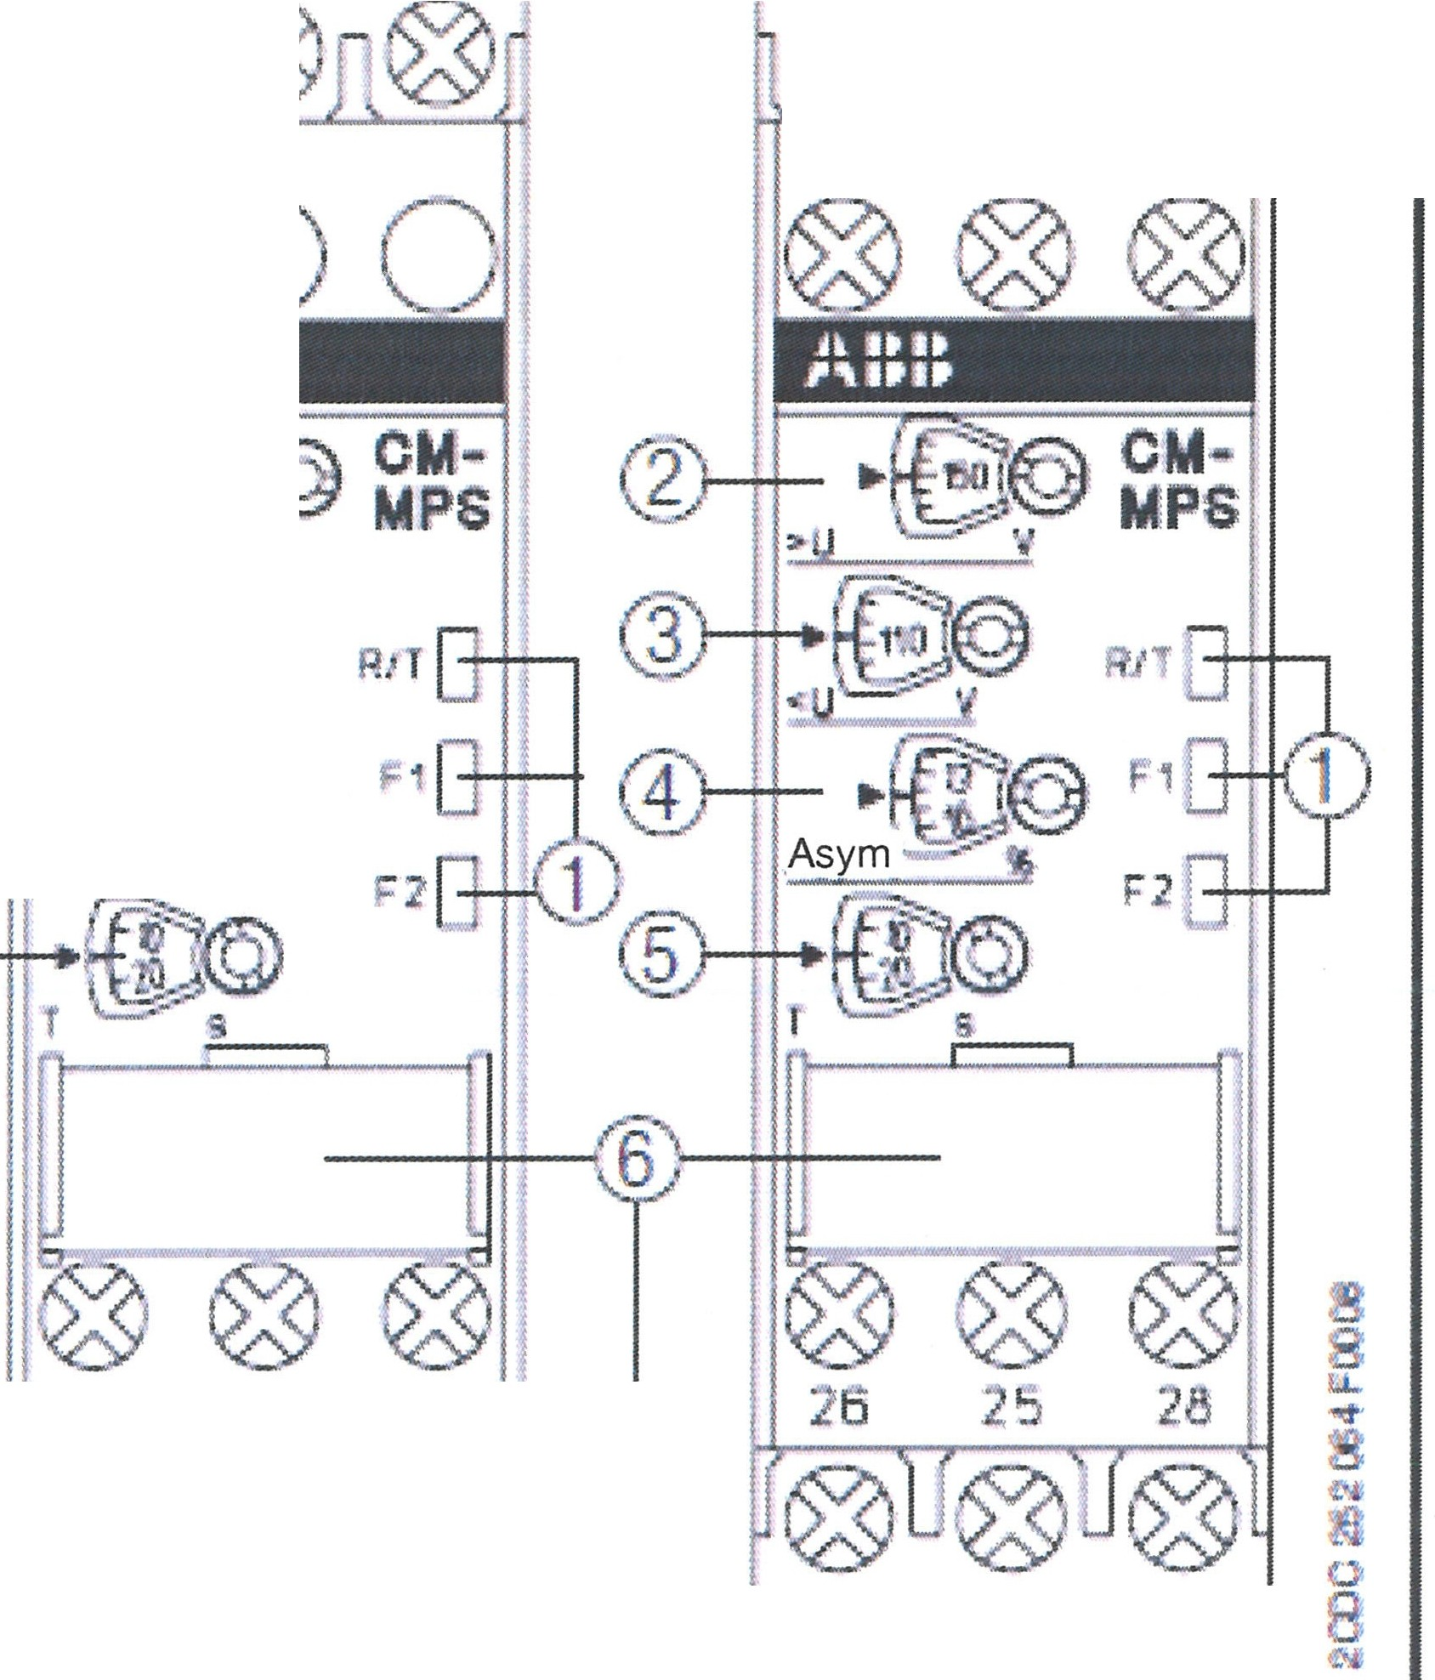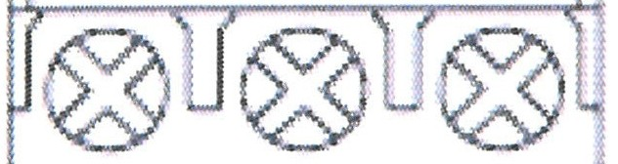Q) Operation state indication with LEDS
R/T: LED yellow - Indication relay and time sequence
r---7 Relay excited
n..rL Delay time running F1: LED red - Error message
F2: LED red - Error message
®Threshold setting for overvoltage
d') Threshold setting for overvoltage
© Threshold setting for asymmetry (2 to 25 %)
® Setting of the triggering delay tv (0 s; 0.1-30 s)

Error messages
Overvoltage: F1 ON Undervoltage: F2 ON Asymmetry: F1 and F2 ON Phase failure: F1 ON, F2 flashing
Phase sequence: F1 and F2 flashing alternately Neutral wire break: F1 ON, F2 flashing

i5'.' 11 2s :25 28 P I II 26
ii
0...
Q -
8,
I 113
,5 1e
I I I 16 15 18
II
-
Threshold overlap F1T, F1, and F2 flashing

II DIP switch settings
! o DIP switch for setting of:
Position | 2 | 1
ONr | rnJ | IZI
OFF | [IT]

i 1 ON = Response delay
OFF= Reset delay
2 ON = Phase sequence monitoring deactivated OFF = Phase sequence monitoring activated
Factory setting: All DIP switches in position OFF

H

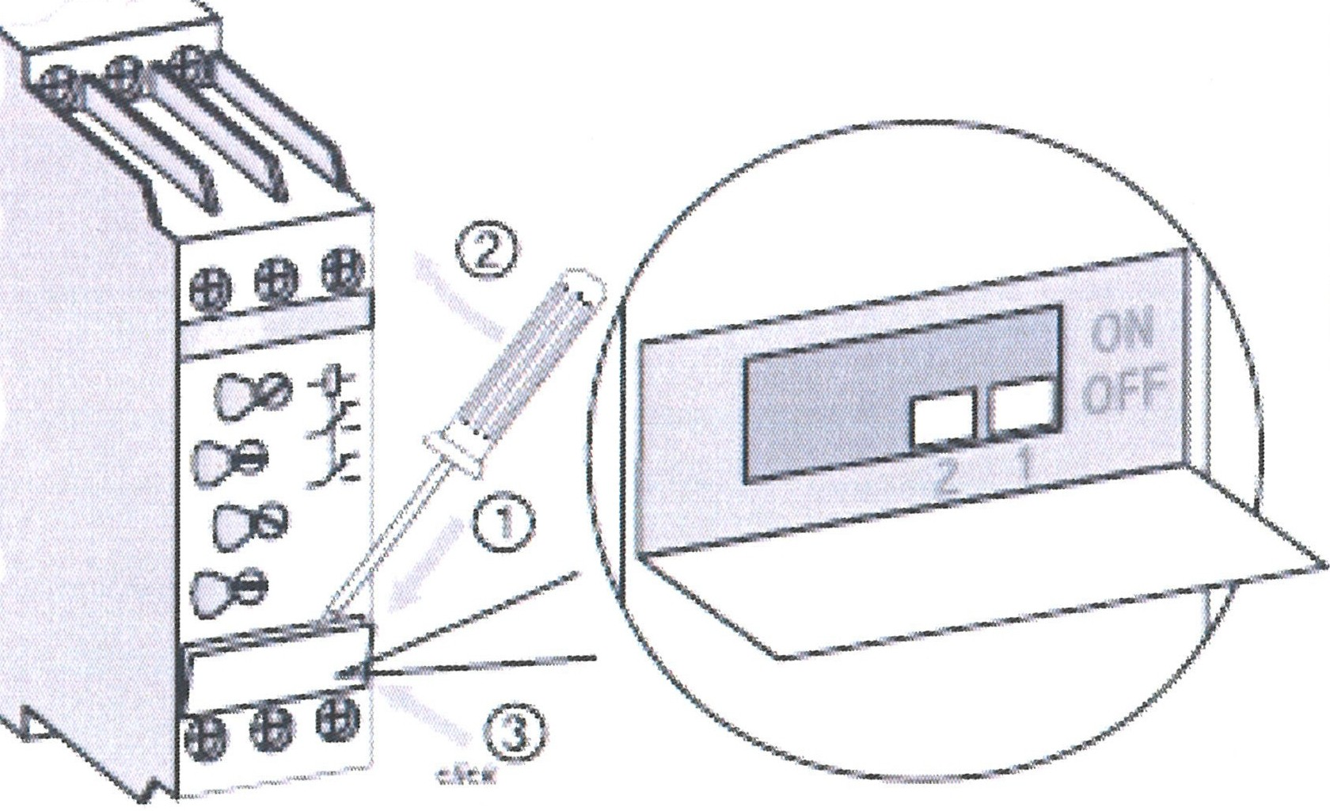
u8..
1!!
I
0
8
""
Ill. DIP switch position

IV. Electrical connection

L1, L2,L3 (N) Control feed voltage/
Three-phase measuring voltage Frequency 50/60 Hz
15-16/18 Output relay 1
25-26/29 Output relay 2

o CM-MPS.11 and CM-MPS.21 also are suited for monitoring of single-phase networks. Preconditions: DIP 2: ON and L1-L2-L3 bridged, threshold for asymmetry set to max. value (25 %)
n
ATTENTION:
With continuously applied voltages of
>120 V for CM-MPS.11: >240 V for CM-MPS.21
>220 V for CM-MPS.31: >400 V for CM-MPS.41
a device interval of at least 10 mm shall be maintained on the side!

OR. Lasertechnologie GmbH-Dieselstrasse 15-64807 Dieburg -Tel.. 0 60 71/209 890 Fax: 0 60 71/209 8999
O.R.
16.09.2013 HTS MOBILE - Page 83

  - Resonator

    - Construction

For 120-200W:
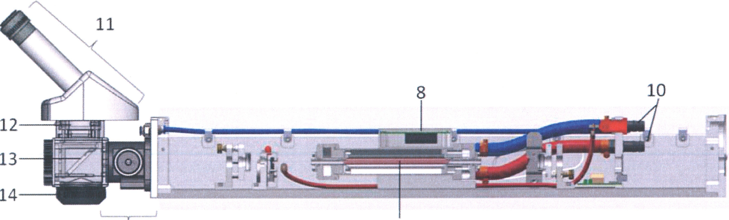
6 2

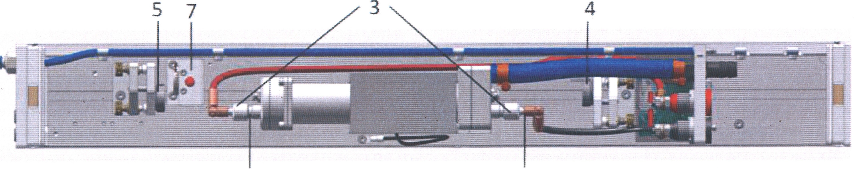
1 9

- High-voltage plug (+)
- Laser crystal
- Pump lamp
- Reflection mirror
- Output coupling mirror
- Telescope/Beam expander
- Safety shutter
- Green ignition device
- High-voltage plug (-)
- Water connection
- Microscope
- LCD shutter
- Deflecting mirror
- Focusing lens

O.R. Lasertechno/ogie GmbH- Dieselstrasse 15-64807 Dieburg -Tel.: 0 60 71/209 890 Fax: 0 60 71/209 8999
O.R.
16.09.2013 HTS MOBILE - Page 84

For 300 W:

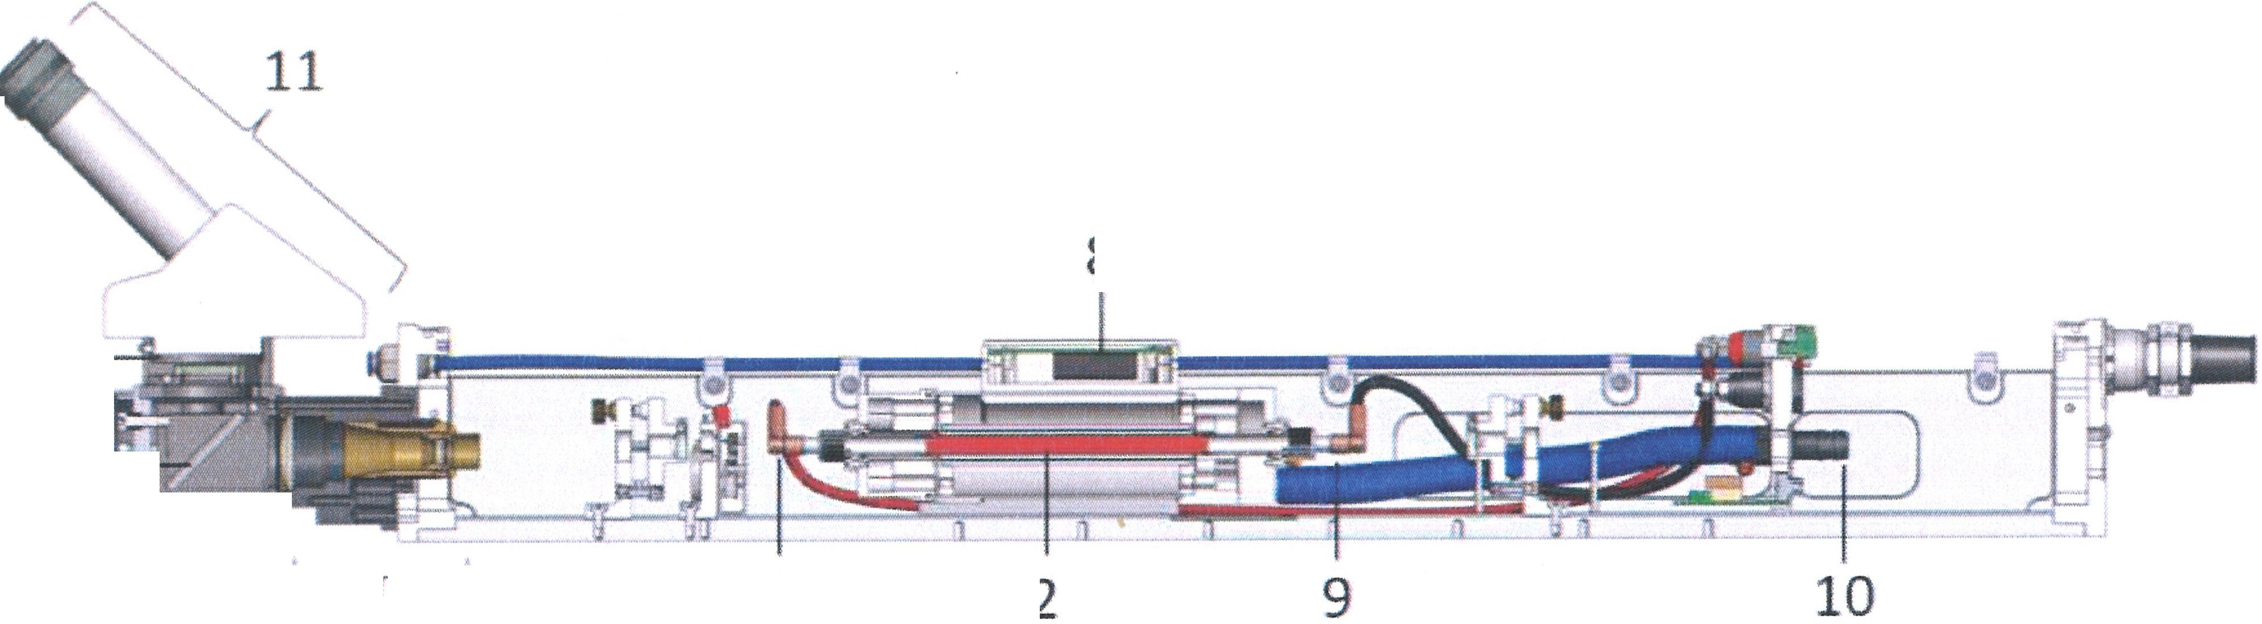8
12 1
13 iilirlalil
14- ... '--,---J
6 1

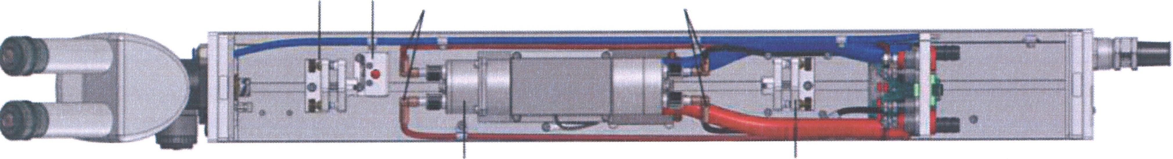
S 7 1 9

3 4

- High-'Voltage plug(+)
- Laser crystal
- Pump lamp
- Reflection mirror
- Output coupling mirror
- Telescope/Beam expander
- Safety shutter
- green ignition device
- High-voltage plug(-)
- Water connection
- Microscope
- LCD shutter
- Deflecting mirror
- Focusing lens

OR. Lasertechnologie GmbH- Dieselstrasse 15 - 64807 Dieburg - Tel.. 0 60 71/209 890 Fax: 0 60 71/209 8999
O.R.
16.09.2013 HTS MOBILE - Page 85

    - Specifications

Type Nd:YAG

Ambient temperature Dimensions
Weight

Coolant supply

Coolant
max. conductivity Flow volume Temperature inlet Tube connector
max. temperature inlet
BU xx

- 'C to 32 'C
70 mm * 91 mm * 600 mm
5 kg

deionized water
2 µSiem
ca. 720 L / h at 1.8 bar 23 'C ± 0.5 'C
cylindrical with diameter 12 mm 23 'C

Type Nd:YAG | BU 120 | BU 160 | BU 200 | BU 300
Pump power | 6.0kW | 7.5 kW | 9.0 kW | 14 kW
Wavelength | 1064nm
Laser power 0 | 120W | 160W | 200W | 300W
Mode M2 | Multi
Pulse rate | at 20 Hz
Pulse peak power | 6.0 kW | 7.5 kW | 9.0 kW | 14 kW
Max. pulse energy | 50 J | 60 J | 75 J | 150 J
Max. pulse width | 20 ms
Pulse-to-pulse stability | <5%

OR Lasertechnologie GmbH-Dieselstrasse 15-64807 Dieburg - Tel.. 0 60 71/209 890 Fax: 0 60 71/209 8999
0.R.
16.09.2013 HTS MOBILE- Page 86

0

r-
I
0,

:,
I

G)
3
:0-r
I
⁰;;;
i

r- -
I

I

- i
outsIde

v°" 0 oo

"'-' ..

el I

I J
I flap panel -- -- -- -- -- -- -- -- --,-- -- -- - --7 -- -- -- -- --
I
I
I
I
u ..,, \,i ,.
! J,J e l j
·:
,
'
•
•-·
' • ,-
'"·\i-l
,
,: ). f
•
·; -'
1'=1'":'=11-':--':-:1 - iN
:/ "
:fZ- . ') .
,. .
I
I
I
I I I--
-- --
-- Insidep n
' • ._·..,_·, ,'f"'•2PI.N.U
PaiNDER
,,;;r,;r.;,;;r;;i
$ ? ' • • •
[XJ
,E¥H33
' • ! • .
@
- .::-. ;::,. -- ;::,. -·
.., := la "''"' '=' ' l'N "',·
I
- \iWrlbl ,;
' -
<"
1l
•
, Jrf , ,@
•
l tri ]
1
j P,j : 9!J
:1'
··-·· "'" --··•M· ,, AS
12V
24V i]-.:'l' =·
i V f"• , a,..:,... •
.
--"::-"[;.:
I I
I II
· I , :
- /;,,/!,.\ -~·---=-·
.. ' ""-";
•M
I ...
=" ,., .
··- t:t'
·, -•-1' 1-,'
l.,..,,-"'
I
I

...I,
0
w
...I,

OJ
0
0

0...I,,
w
.

s:
Q)
::s
I..,
(/)

0
O"
(D

panel I ft '1'-'fi t,:C . MICROCONTROI.LER,0:'' .. @:" • . -J • I
1!111
ll'lll!!I - BOARD(CAt<) II", . I . p '"" -"" ' . . I
"a. (/)

<t>
I 23-0VAC _j .b • /'\ /I = "'; [M'""'. • . iili i, }g ,,
;;; ;..:;,_;Jil ;;:, - ' ., ,,_ I
Q) "C

a, .: ~·-_,,
"'
1-· ·- ,-
•
. ,II •=' , . !Y .
.:•:1iiEr ,
"-" "'"'.·" =• -- re -
(C

<> •om -
-, j

--J
Q
1·"1· I I ol . .,;:.Ii, :::.. -.. · r - ·::,;, I I
A4 IT. I ^{Q)}
(I)
""I

<t>
! " '< ! O,J_ A3 L, 2
:Jl i\,- R - -- COMMUTATION · 1 I-
(/)

O" -_;;,i.::.;u..,. SIMMER - I ' i. • J w eoARo :-:at!''• . 3
C:
DEVICE ., \ ::::=--=- -......._ ..,.,.
3
I
I
I
.a
C

--,
w "''"' ::-
-•,E,•a.,
il l,;,91 ol-l
J ""-'°""
I .--
J_- ; "r!!MlI_i!-
:'.' I Q) "C

1 I 1'\ :-;.. ,......"*''"" I i "' ,.
= --. _ iii:o. ::]::::.-- I
·1 ,r.c.:.,..
0 I .,.
a,
::s "C
(/)

0
::! I
- J = ......""". - --
· -
- .. ,dpp l .- I - --OC ;:.;;, ,,'.f. f
I I P""'1 - :: '<
----=-.: E· I "C
I

0"<O
<O
I .-08-SM """- I' I
.,,I ..,,..,,..,,..,,.r-1'1 -. •= I

0,
0 I IITTERLOCKarJ.1.:?.ivoc
~
I*
-
._.; ..... . n r (1+1= • • I
I
...
I iJ[ u ., •• ...,, 177 ....,. , 1r.1> .,,
J - I I I .:, ,,, j I ., ::;;.:[
-(I,)

0
I
0,
0
::!
"
0
<O
0,
<O
- "l l ••~• tcJ I I
I 1 1 11, - l.
I
I I I '--'--:;----t ifr: . :;::., 1,11 :;.,..
_J
08-!if e,..uCU•I== OUT"°""
I O " "'=\ I u \ / J e I I F' :rn-, - " . :;. .:t. J
l '- ·00 ·.,•-J I .
(/)
C
"C
"C
'<

<O l
<O
...! l"f\o'i @ 'fk I I ,m=••· tm&H @ @ © 1=0 I
=J·• I ''J 1
,, It rt, M.,.,.,, : =-- ,:,;
• •

- - I HEATSINK '"' - I I 1;p 0 1 I
i
A1 A2 ' l • •
I I
VOLTAGE : ·...::; DISCHARGE I .
UP-OOWN -6 SWITCH
I
I
CONVERTER .. n .Jfe" _ "" - _
. • - I • <),f<UU ;11p::::,Jflm!:'tt;r,..,,
I ..'' ITT @ · - ,.. I I I
t-------□. : - I
I
I
- ol ::.;:.,..,_;.:..,.. ·: ,

I : :OIJ£-,• ! .
'='= -
••IWI_""'' ,-
I

0, I
I o/'· - - [] i'i:t. n-j:,:..mr " .,_ ... , I
-- ..... ,- I-@i...
I POWERSUPPLY I

6
<O
"':1'
"'
::'i
U)
;::
0
rtl=l
m
.",ti
<g 0
0 · PSL•l•15{)0.4SIJ..G.

PICCO (eJoctrlc circuit)

Description of the module | Function purpose | Main data
Control panel | Lock check, mode setting and representation on the digital display | Push-button operation control (discharge pulse rate and duration, storage voltage) Control pulse formation for scintillation. Duration - of 0.2 msec to 20 msec, frequency - from 1 Hz to 20 Hz.  Digital indication of the operation values  LED indication of the lock status
Laser head (laser emitter) | Pulse formation of the laser radiation, assuring of visual checking of the welding process  through a microscope | Mean power of the laser radiation up to 100W
Power supply | Stabilization of the storage voltage  Auxiliary arc current formation Formation of the scintillation pulse in the lamp, formation of the auxiliary supply voltage for the electronic components of  the radiator | Supply - 380 V, 50 Hz  Storage voltage of 160 to 400 V Pump power 3500 W  Auxiliary arc current 0.7 A Pulse current - up to 600 A.
Cooling system control board | Status check for the cooling system | LED indication of the cooling system status  - HOPMA (standard, no deviations)
 | System function lock in case of • Power supply 220 V HOPMA (standard)
 | malfunction of the cooling  system | - Power supply 24 V HOPMA (standard)  - HET (no) flow  - Water temperature» more than 50°C  - Minor loop switched ON (water  temperature more than 20°C)
Additional connectors panel | Connection of the foot lever and the door lock system | Connection of the triple foot lever (total, individual operation, frequency operation) Connection of the door transmitter (door  closed - transmitter closed). Connection of the signal lamp (24 V AC, 20 V)
Cooling system | Pumping water through the laser radiator | Dual circuit cooling system. Internal circuit - distilled deionized water, external circuit - tap water.  With water temperatures below 20 °c in the internal circuit, the external circuit automatically closes off. With a flow velocity below 6 Umin in the internal circuit, the flow transmitter is triggered.  With water temperatures above 50 °c in the internal circuit, the overheat transmitter  is triggered.

O.R. Lasertechnologie GmbH-Dieselstrasse 15-64807 Dieburg -Tel.: 0 60 71/209 890 Fax: 0 60 71/209 8999

0.R.
16.09.2013 HTS MOBILE - Page 88

0
':o
[1l
!

:,
i

G)
'3
O-
J:
I
⁰ro·
i

,---- - - - - -1
I EMERGENCY STOP
'P2 KEY-STANDBY P3 \01 LASER!
lI ?-STAR "' I
I

I
I IDC•l□ I

inside panel PS XP26 -
MC1.5'10-STF-3,5
COOLING SYS CONTROL

S1 S2
lnterlock1 door chamber lnterlock2 door chamber

MCl,5114..,STFX-3P.5'9
LCOCONIROL

.... f'-1 .. .,i ..-

,;r;;

Q

GROUND-CASE,

I LASER HEAD J

^{I}-,
(/)

0
O"'
CD

<1>

.0, ..
I , ROUND CABLE 20-INire
ROUND CABLE, 16-V11re

GROUND-CA

c,.,i.,'" .aHc1
XP51 IDC16

GROUND-CASE

.._,
0
g

,. L

XP42 IOC20

0. ---(1
-,---i'o -cl
11_()-;::,-9

JOYSIICK

<1>
"
<=
-
<C
--<
!].
LASER HE.AU
O· --9
1
rFLAT CABLE 15-w,re

MC1,5/.l,STXFP31.58

xPf,O IOC-26
X-Y-ZlABI E

..
'o J
L r,-- q

MXPC171,5 STF-3,5
GAS CHARGING VALVE
VD4 MLR120(110010l

0
0,
0
::::!
0
<O
co
<O
0
;r
0
0,
0
::::!
0
<O
co
<O

JOYSTICK

'o.
10.: a
IOC-20

FLAT
CABLE
20-wire

9,
GAS SYNC
' ..,.,..,,,,,,.,,<(><O

"M'I"B25,16-SJf
CONIROL
EMERGf:cNCY STOP I
l<E'Y-STAt.OBY

KEY-START

XP.i
J J9
m
MSTB2 5!5.STF

TURBIN
JL,
'
- I+

COOLING SYSTEM

-I-, I
\.1
THERMOCOUPLE

HEAT-SENSOR

<O
<O X-Y-ZTABLE

)lf11,1
2PtN3.9
12VOQ_

?I

I

XP32 1 16/S.STF-1016
COOUtG SYS. 230\/AC

XF:,0
MSTB 2.513-STF
OtJt 2XJVAC

XP27
DI-WATER UP 50C
I
l t,• VLV4 FAN, A2123 HBL
I
r®
'@'@
Kl DUST CC,AN,NG HOOW
J

0,
0
<O
"'
S!
w
I
-u-,<

M l i;

Rt:U. "1rrlm
,-.;Sm
MSl82:i.12S1F
DUSI (l.t:ANING 2:JOVAt:

BLUE 4mm

I +1. c,

,::
0
IJJ

01 TRACO-W./V-24\IOC

---t '
CJ
LT T T [

;=
m

'mlil 0

GROUND-CASEJ,,_
C1, C2, C318000mkF x 500VDC

P/CCOLASER (electric circuit)

10.5 Internal cooling system with a water/air heat exchanger

10.5.1 Specifications

Rated cooling power | w | 800
Water temperature | 'C | 20
Rated volume flow water circuit | L/min | 10
Min. volume flow water circuit (equipment shut- down) | L/min | 6
Ambient temperature during rated operation | 'C | 25
Air volume flow at the ventilator | m3/h | 320
Ambient temperature min./max. | 'C / 'C | 10 / 32
Control thermostat ON/OFF | 'C / 'C | 30 / 27
Max. water temperature (equipment shut-down) | 'C | 50
Cooling medium type/quantity | - I kg | deionized water / 5
Water connection outlet |  | G 3/4
Water connection inlet |  | G 3/4

OR. Lasertechno/ogie GmbH - Dieselstrasse 15 - 64807 Dieburg - Tel.. 0 60 71/209 890 Fax: 0 60 71/209 8999

O.R.
16.09.2013 HTS MOBILE - Page 91

HTS Mobile

10.4 HTS Mobile Data

Type:
Input
Input voltage, V AC Efficiency, typical , % Power factor, typical

Output
Output voltage, V DC Voltage fluctuation,% Max. output current, A Peak power, kW
Max. output power, W Current fluctuation, A

Pulse data
Pulse frequency, Hz Pulse width, ms
Voltage range (virtual), V DC

Pulse clock
Pulse shaping mode (PS) Frequency modulation PS, kHz Minimal part (shape) pulse PS, mks

Periphery checking Interface for data exchange Heat protection, 'C
Flow sensor
Temperature of di-water, 'C

DIMENSIONS
Size, mm Weight, kg

PPS 21 xx A - 400

400* (50/60 Hz)
88
>0.93

500
+/- 1
600
10
1 500
0.5 to 1

0.5 to 20
0.4 to 30 100 to 500

YES 20
50

CAN
+75
FT-110 5... 65

332 X 250 X 200
9

Environment
Temperature range, 'C 0 to +35 (operation)
-20 to +85 (storage)

* 90 to 140 V AC version available

Capacitor bank

Ambient temperature Power supply weight Max. voltage
Max. current Capacity Connection type
PCB 40 -400

5°C to 32°C
6 kg
500 V DC
600 A DC
36 mF
Bolts

OR. Lasertechnologie GmbH-Dieselstrasse 15-64807 Dieburg -Tel.. 0 60 71/209 890 Fax: 0 60 71/209 8999

0.R.
16.09.2013 HTS MOBILE· Page 90

10.6 Internal Compressor Cooling System with Water/Air Heat Exchanger
10.6.1 Specifications

Model No. |  | P720-13948- 4
Rated cooling power | kW | 2.2
Water temperature | 'C | 35
Rated volume flow water circuit | m3/h | 0.6
Rated pressure cooling water circuit | bar | 2.5
Ambient temperature during rated operation | 'C | 35
Ambient temperature min./max. | 'C / 'C | 5 I 40
Condensation temperature | 'C | 64
Evaporation temperature | 'C | 11
Cooling medium type | - I - | R134a
Max. pressure in the compressor | bar | 18.5
Primary medium | - I - | Distilled water

OR Lasertechnologie GmbH-Dieselstrasse 15-64807 Dieburg -Tel.. 0 60 71/209 890 Fax: 0 60 71/209 8999
O.R.
16.09.2013 HTS MOBILE- Page 92

Operating Manual HTSb
Machine-Number: HTS /B 160180911
Version: 09/2013

This is a translation of the original operating manual.

© 2013 O.R. Lasertechnologie GmbH Dieselstrasse 15
D - 64807 Dieburg

All rights reserved. Reproduction, whether in whole or in part, is only permitted with the company O.R. Lastertechnologie's authorization.

