**Populating the subassembly shell in AS400**

1. 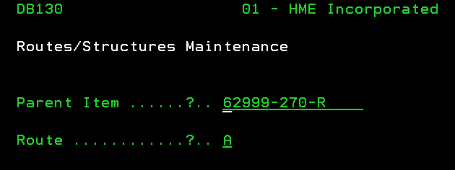Log into AS400
2. 61. Routes/Structures
3. Type in Parent Item
   1. Route will always be “A”
4. Push ENTER to get past summary screen

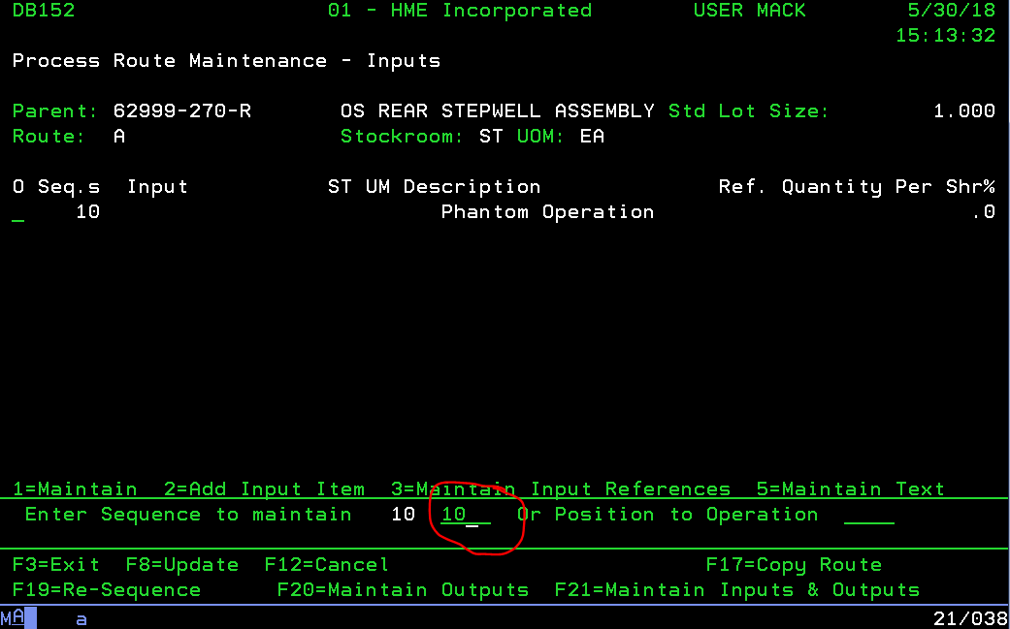

1. Type 10 to begin sequence.
   1. Factors of 10

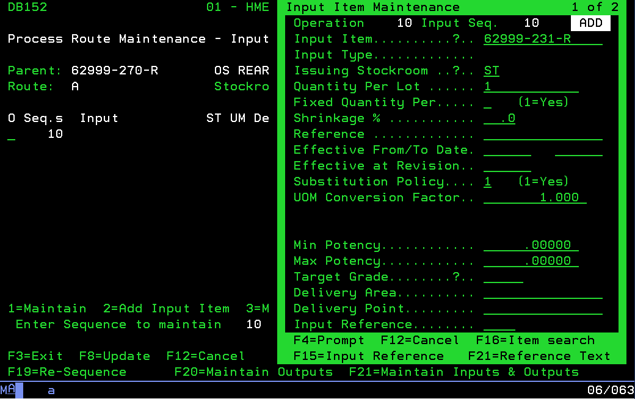

1. Type in BOM in SolidWorks assembly drawing one part at a time
   1. Issuing Stockroom: ST
   2. Be careful and be sure to get the quantity right.
2. Push Enter twice to enter next component
3. 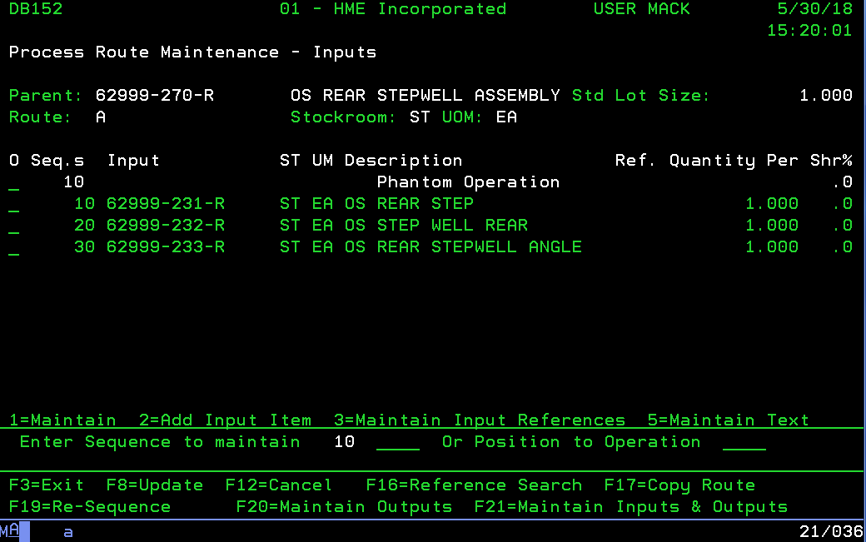F12 to close menu
4. Look over list to confirm
5. F8 to update
6. Done