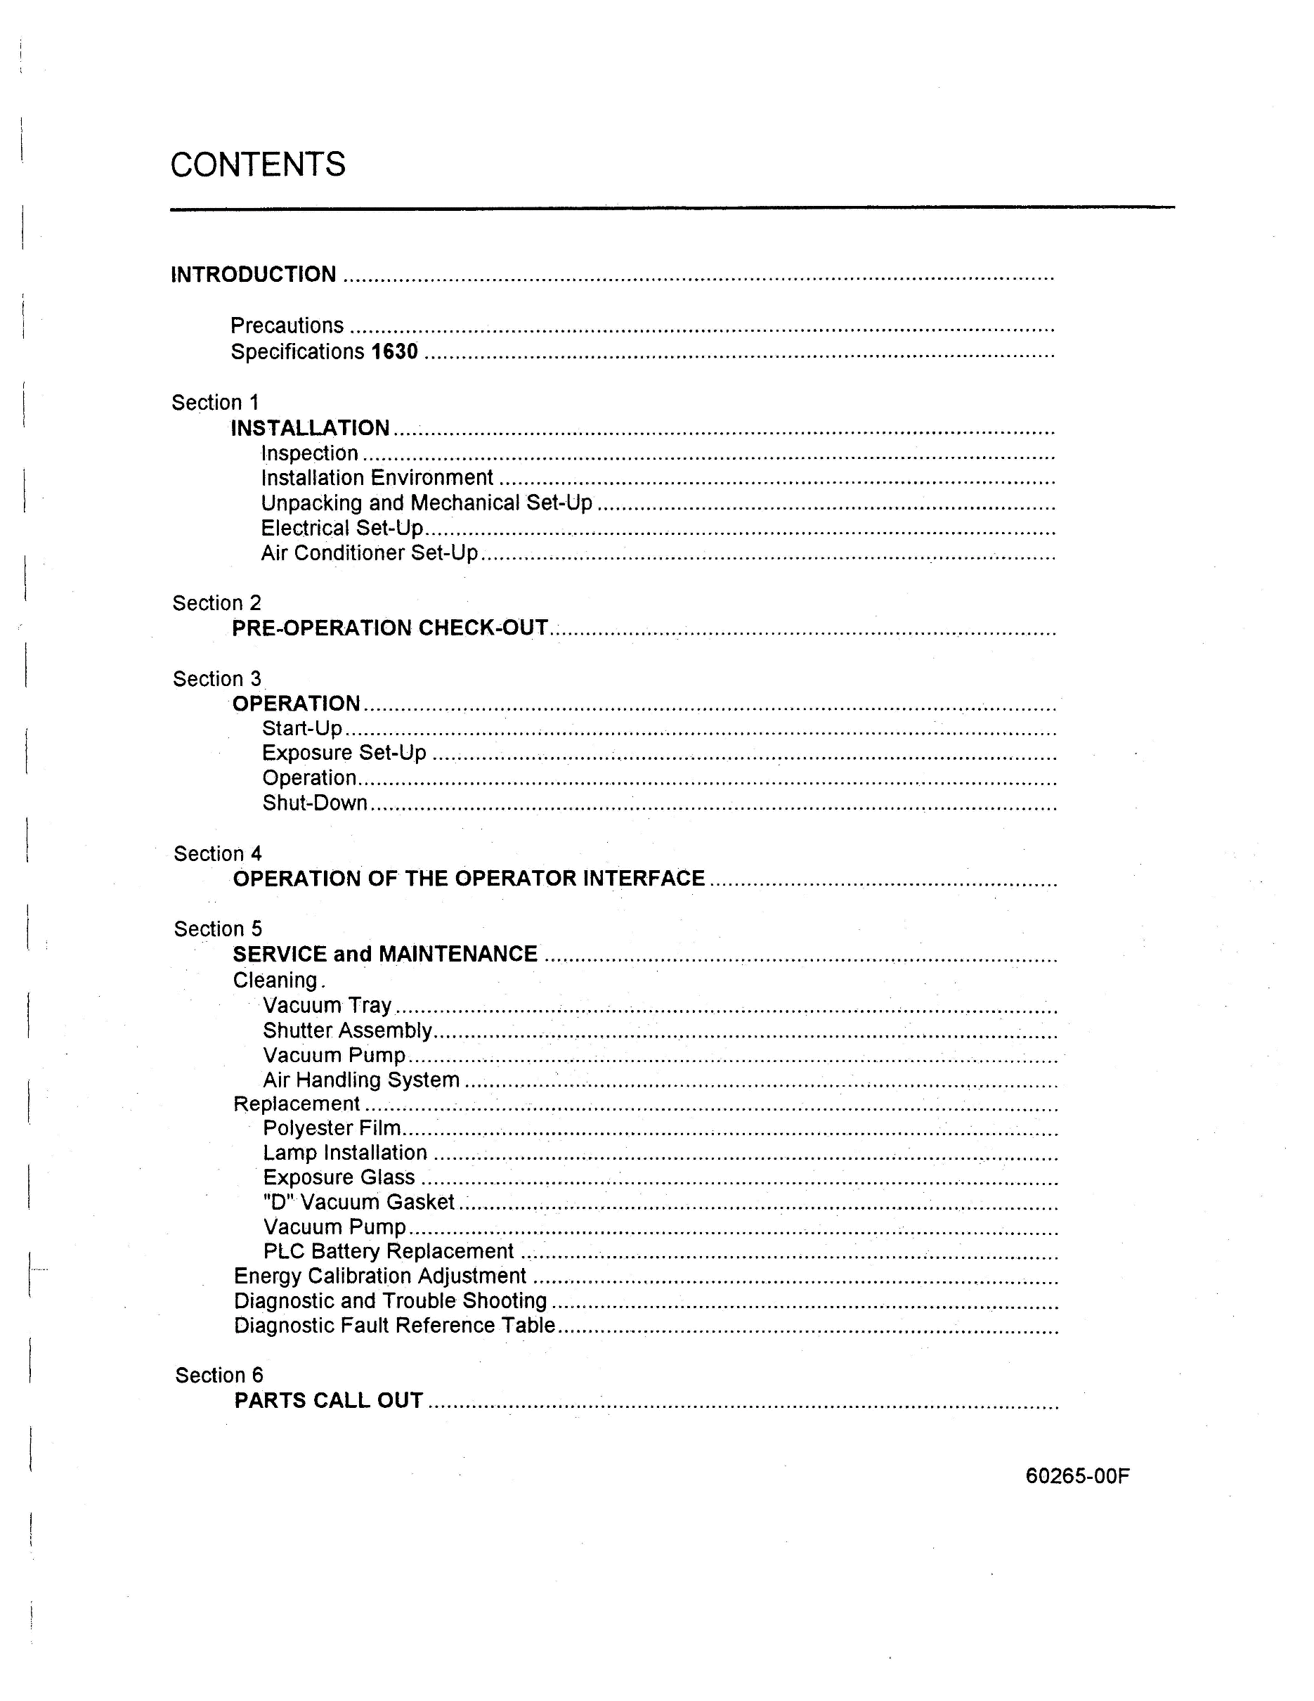
CONTENTS
INTRODUCTION .................................................................................................................. .
Precautions ................................................................................................................. .
Specifications 1630 ............ ... ...................................................................................... .
Section 1
INSTALLATION ............... .... ..... .. ................................................................................ .
Inspection ............................................................................................................... .
Installation Environment ......................................................................................... .
Unpacking and Mechanical Set-Up ........................................................................ ..
Electrical Set-Up .............................................................. .. ... .................................. .
Air Conditioner Set-Up ............................................................................................ .
Section 2
PRE-OPERATION CHECK-'OUT ............................................. ... ................................. .
Section 3
OPERATION .................... .................. ......................................................................... .
Start-Up ....................... ............ .. ............................................. ................................ .
Exposure Set-Up··················.··········································· ········································
Operation ..................................................................... ... ...... .................................. .
Section 4
OPERATION OF THE OPERATOR INTERFACE ... ... ........... ... ................................... .
Section 5
SERVICE and MAINTENANCE .................................................................................. .
Cleaning.
Vacuum Tray ..........................•....... , ...•..........................................•.........................
Shutter Assembly .................................. : .................................................................. .
Vacuum Pump ............... ...... .................................................................................. ..
Air Handling System ............................................................................................ .. . .
Replacement ............... ........... , ......... , .......................................................................... .
Polyester Film ......................................................................................................... .
Lamp Installation ........ ............................................................................................ .
Exposure Glass .................... , .................................................... .............................. .
"D" Vacuum Gasket ...................... ..................................................... ~ .................... .
Vacuum Pump ........................ ....................................................... , ........................ .
PLC Battery Replacement .............. ........................................ ~ .......... , .................... .
Energy Calibration Adjustment ......... ........................................................................... .
Diagnostic and Trouble Shooting ................................................................................. .
Diagnostic Fault Reference Table .. .... .. ................................... ..................................... .
Section 6
PARTS CALL OUT ........ .. .......................................................................................... ..
60265-00F

