

**Service Manual**



01546200 Orig. 9/98

Printed in USA

**915 EZRIDER SERVICE MANUAL**

**FOREWORD**



##### THE MANUAL

It is the purpose of this manual to provide complete instructions for service, maintenance, disassembly, repair, and installation of the mechanical components for the Ariens EZRider.

Dealer trained service personel should use this manual as a supplement to and reminder of the training sessions conducted by the company.

Read all information for servicing a part or system before repair work is started to avoid needless disassembly.

**Contents**

Contents are arranged in a clear, concise numerical and sequencial order for quick and easy reference. Refer to the Table of Contents to identify paragraph titles and the sections or sub-sections by which they are divided.

Section numbers are located to the left of titles and set in bold type.

The Appendix includes a Safety Considerations and Inspection Check List, Maintenance Schedule, Maintenance Record, and Metric & English Bolt Torque Specification Charts.

The types of section and page number identifiers follow:

1. Sections ....................... 1, 2, 3, etc.
2. Sub-Sections ............. 1.1, 1.2, 1.3, etc.
3. Sections-Page Numbers ..... 1-1, 1-2, 1-3, etc.

**Operation**

Before operation of the unit, carefully and completely read manuals supplied with unit. The contents will provide you with an understanding of safety instructions and controls during normal operation and maintenance.

**Safety Messages**

For your safety and the safety of others always read, understand, and follow all DANGER, WARNING, and CAUTION messages found in manuals and on safety decals.

**Directional Reference**

All reference to left, right, front, or rear are given form the operator in the operation position and facing the direction of forward travel.

**Notation Definitions**

**NOTE:** General reference information for proper operation and maintenance practices.

**IMPORTANT:** Specific procedures or information required to prevent damage to the unit or the attachment.

##### TECHNICAL SERVICE COMMUNICATIONS

Ariens Technical Service communicates information to the field using Service Letters, Service Bulletins, Product Notices, and Campaigns. Each communication signifies a type of information and a priority. The dealer is responsible to carry out the directive provided in the communication. The types of communication follow:

**Service Letter**

General technical information for the dealer. Technical information on how to service the product and product improvements.

**Service Bulletin**

Notification to update products to resolve certain issues or a notification of a policy change.

**Product Notices**

Notification of limited product located in a certain region. This is a limited distribution to only those who received the product involved.

**Campaigns**

Notification of a safety related issue. All product must be updated and is tracked by the factory until all units are corrected.

##### DISCLAIMER

Ariens Company is herinafter referred to as Ariens. Ariens reserves the right to discontinue, make changes to, and add improvements upon its products at any time whithout public notice or obligation. Ariens disclaims liability for any claims or damages, whether regarding property, personal injury or death arising out of the use of unauthorized replacement parts.

Ariens is not responsible for any damage that occurs in relation to a service storage period.

The descriptions and specifications contained in this manual were in effect at printing. Equipment described within this manual may not be identified as either standard or optional. Illustrations may not be applicable to your unit.



01546200 Orig. 9/98

Ariens®

**915 EZRIDER SERVICE MANUAL**

## TABLE OF CONTENTS

SECTION 1 : INTRODUCTION

* 1. Safety Alert Symbol 1-1
  2. Signal Words 1-1
  3. Preparation 1-1
  4. Service Position 1-1
  5. Cleaning and Storage 1-1
  6. Safety Rules 1-2

SECTION 2: SPECIFICATIONS

* 1. Domestic and International Models 2-3

SECTION 3: INSTRUCTIONS & ADJUSTMENTS

* 1. Filing the Fuel Tank 3-9
  2. General Lubrication 3-9
  3. Checking the Fastners 3-10
  4. Checking the Engine Oil 3-10
  5. Changing the Engine Oil 3-10
  6. Checking Engine Cooling 3-10
  7. Cleaning the Air Cleaner 3-11
  8. Changing the Air Cleaner Element 3-11
  9. Checking the Tires 3-11
  10. Checking the PTO Clutch 3-11
  11. Checking the Transmission Fluid 3-12
  12. Priming the Transmission 3-12
  13. Adjustment of Transmission Neutral Hydro .3-13
  14. Adjusting the Directional Control Levers 3-14
  15. Adjusting the Brake Hydro 3-14
  16. Adjusting the Operator's Seat 3-15
  17. Mower Deck Belt Adjustment 3-15
  18. Mower Belt Replacement 3-15
  19. Mower Deck Spindle Lubrication 3-15
  20. Transaxle Belt Replacement 3-16
  21. Jackshaft Drive Belt Replacement 3-16

SECTION 4: ENGINE

* 1. Engine Trouble Shooting 4-16
  2. Engine Removal 4-16
  3. Engine Installation 4-16

**SECTION 5: DRIVE TRAIN**

* 1. Transmission Trouble Shooting 5-18
  2. Transmission Removal 5-19
  3. Transmission Repair (Major) 5-19
  4. Transmission Installation 5-26
  5. Transmission Removal 5-26
  6. Transmission Repair (Major) 5-29
  7. Transmission Installation 5-3 2

**SECTION 6: PTO**

* 1. PTO Jackshaft Removal 6-3 4
  2. PTO Jackshaft Repair 6-3 4
  3. PTO Jackshaft Installation 6-3 4

**SECTION 7: LIFT SYSTEM**

* 1. Lift System 7-3 5
  2. Lift System Removal 7-3 5
  3. Lift System Installation 7-3 5

**SECTION 8: Fuel System**

* 1. Trouble Shooting 8-3 6
  2. Fuel Pump 8-3 6
  3. Fuel System Contamination 8-3 6
  4. Fuel Tank 8-3 6

SECTION 9: ELECTRICAL



* 1. Tools 9-3 7
  2. Electrical Measurement 9-3 7
  3. Battery 9-3 8
  4. Switches 9-4 1
  5. Solenoids and Relays 9-4 2
  6. Lighting Circuits 9-4 3
  7. Fuses 9-4 3
  8. Didoes and Rectifiers 9-4 3
  9. Electric Clutches 9-4 4
  10. EZR Electrical 9-4 4



01546200 Orig. 9/98 Ariens® ii

**915 EZRIDER SERVICE MANUAL**

SECTION 10: MOWER ATTACHMENT

* 1. Mower Removal 10-50
  2. Mower Installation 10-50
  3. Spindle Removal 10-50
  4. Spindle Repair 10-50
  5. Spindle Installation 10-51
  6. Jack Shaft Removal 10-52
  7. Jack Shaft Repair 10-52
  8. Jack Shaft Installation 10-52

APPENDIX

* 1. Maintenance Schedule
  2. Maintenance Records ....................
  3. Safety Considerations & Inspection Check List .
  4. Metric & English Bolt Torque Specification Chart

® Copyright 1998 Ariens Company

All rights reserved. No part of this publication may be reproduced, transmitted, transcribed, stored in a retrieval system, or translated into any language in any form by any means without the written permission of the Ariens Company.



iii Ariens® 01546200 Orig. 9/98

**915 EZRIDER SERVICE MANUAL INTRODUCTION**

## SECTION 1 : INTRODUCTION

##### SAFETY ALERT SYMBOL

This is a safety alert symbol. It means:

* + - **ATTENTION!**
    - **YOUR SAFETY IS INVOLVED!**

When you see this symbol:

* + - **BECOME ALERT!**
    - **OBEY ITS MESSAGE!**

##### SIGNAL WORDS

The safety alert symbol is used with the signal words **DANGER, WARNING** and **CAUTION** and colors to alert you to safety messages.

They are used in safety decals on the unit and with proper operation and procedures in this manual. They alert you to the existence and relative degree of hazards.

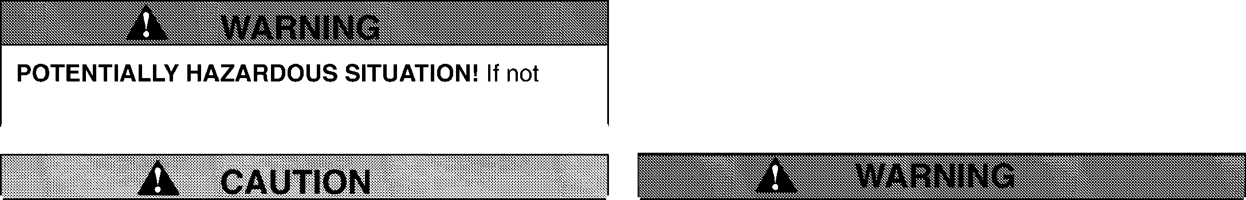

Understand the safety message. It contains important information about personal safety on or near the unit.

**A DANGER**

**IMMINENTLY HAZARDOUS SITUATION!** If not

avoided, WILL RESULT in death or serious injury.

avoided, COULD RESULT in death or serious injury.

##### PREPARATION

Before starting any removal of parts, proper preparation is very important for efficient work. A clean work area at the start of each job will allow you to perform service repairs easily and quickly.

To reduce the incidence of misplaced tools or parts, place removed components with all attaching hardware in the disassembled order on a clean work surface.

Organization is a key part of proper reassembly.

Tools, instruments and parts needed for the job should be gathered before work is started. Interrupting a job to locate tools or parts is a needless delay. A list of required special tools has been included in this manual.

##### SERVICE POSITION

**ALWAYS** block wheels and know that jack stands or blocks used are stable, strong, or secure and will hold the weight of the unit during maintenance.

To ensure the unit is positioned in the proper service position:

1. Place jack stands under rear transaxles only.
2. If jacks are not available, place support blocks under both transaxles at the rear of unit.

##### CLEANING AND STORAGE

**POTENTIALLY HAZARDOUS SITUATION!** If not

avoided, MAY RESULT in minor or moderate injury. It may also be used to alert against unsafe practices.

**AVOID SHARP EDGES** which can cut. Movement of parts can cut off fingers or a hand. Wrap blade(s), wear gloves and use extreme caution when servicing.

###### Safety Decals and Locations

ALWAYS replace missing or damaged safety decals. See Owner/Operator manual for safety decal locations.

###### Practices and Laws

Practice usual and customary safe working precautions, for the benefit of yourself and others. Understand and follow all safety messages. Be alert to unsafe conditions and the possibility or minor, moderate, or serious injury or death. Learn applicable rules and laws in your area.

###### Required Operator Training

Original purchaser of this unit was instructed by the seller on safe and proper operation. If unit is to be used by someone other than original purchaser; loaned, rented or sold, ALWAYS provide Owner/Operator

manual and any needed safety training before operation.

**IMPORTANT:** Never spray unit with water or store unit outdoors to help prevent sealed bearing rust or corrosion. Water can seep into sealed bearings and reduce component life. Bearings are sealed against dirt and debris only.

A unit that is excessively dirty should be cleaned before work starts. Cleaning will occasionally uncover trouble sources. Dirt and abrasive dust reduce the efficient work life of parts and can lead to costly replacement.

When taking unit out of extended storage:

1. Check for any damage or loose parts. Repair, replace or tighten hardware before operation, especially blade attachment bolts.
2. If a preservative fluid was used in fuel tank, drain and discard. Fill fuel tank with fresh new fuel.

01546200 Orig. 9/98 Ariens® 1-1

**INTRODUCTION 915 EZRIDER SERVICE MANUAL**

##### SAFETY RULES

###### Operation

Only trained adults may operate unit. Training includes actual operation.

###### Walk-Around Inspection

Inspect unit and work area before operation or service.

###### Clear Area

ALWAYS keep area of operation clear of all toys, pets and debris. Thrown objects can cause injury.

###### Visibility

ALWAYS operate unit when there is good visibility and light.

**Avoid Falls and Slippery Surfaces** ALWAYS be sure of your footing. Avoid wet, oily or uneven work areas and any rough terrain.

###### Safe Distances

Keep children and people away from unit during operation.

###### Speed Ranges

DO NOT operate at too fast a rate. DO NOT change engine govenor setting or over speed the engine.

###### Child Safety

Keep children out of work area and under the watchful care of an adult.

###### No Drugs or Alcohol

NEVER operate after or during the use of medicaion, drugs or alcohol. Complete and unimpaired attention is required when operating unit.

###### Safety Gear

Wear adequate winter gear, protective gloves and footwear. NEVER wear loose clothing or jewelry, and tie back long hair that may get caught in rotating parts.

Protect eyes, face and head from objects that may be thrown form unit.

###### Thrown Objects

ALWAYS stand clear of discharge area when operating unit. Deflected materials can cause injury.

###### Avoid Entanglement

ALWAYS keep hands away from all rotating parts during operation. ALWAYS keep feet away from all rotating parts during operation. Rotating parts can cut off body parts. Keep safety devices and guards in place and functioning properly. NEVER modify or remove safety devices.

###### Hazardous Slopes and Unit Roll Away

DO NOT operate on steep slopes. NEVER leave unit unattended on a slope.

###### Hot Surfaces

DO NOT touch parts which are hot. Allow parts to cool.

###### Exhaust Fumes

Fumes from the engine exhaust can cause death or serious injury. DO NOT run engine in an enclosed area.

###### Explosive Fuel

NEVER fill tank when engine is running, hot or unit is indoors. Fuel is highly flammable and its vapors can explode. ONLY use approved fuel containers. No smoking, No sparks and No Flames near fuel. Allow engine to cool before filling fuel tank.

###### Battery

AVOID electric shock. Objects contacting both battery terminals at the same time may result in injury and unit damage. DO NOT reverse battery connections.

AVOID explosive gases from battery. Poisonous battery fluid contains sulfuric acid and its contact with skin, eyes or clothing can cause severe chemical burns.

No flames, No sparks, No smoking near battery.

ALWAYS wear safety glasses and protective gear near battery.

DO NOT tip battery beyond a 45° angle in any direction. ALWAYS keep batteries out of the reach of children.

###### Parking

Remove the key when parking. Run unit a few minutes after mowing to clear discharge chute. ALWAYS shut off engine and remove key to prevent unauthorized use before leaving unit.

###### Service

Check controls often, see Owner/Operator manual for proper operation, service and adjustments.

###### Adjustments

Remove key, see service manual to repair any damage.

###### Abnormal Vibrations

Disengage clutch, stop engine, remove key and wait for all moving parts to stop before servicing, except where recommended.

###### Storage

DO NOT store unit inside a building with fuel in the fuel tank where any ignition sources are present. ALWAYS clean unit before extended storage. See engine manual for proper storage.



915 **EZRIDER SERVICE MANUAL**

## SECTION 2: SPECIFICATIONS

##### DOMESTIC AND INTERNATIONAL EZRIDER MODELS

Refer to the following charts for model specification information.

**MODEL No. 915001** **915002**

**DESCRIPTION NAME EZR 1440 EZR 1648**

**SPECIFICATIONS**

**915003**

**EZR 1540**

|  |  |  |  |  |  |
| --- | --- | --- | --- | --- | --- |
| Lenath | 71.88" (182.5cm) | | | | |
| Height | 44.7" (113.5cm) | | | | |
| Width | 44.5" (113.0cm) | | | | |
| Wheel Base | 42.0" (106.7cm) | | | | |
| Actual Weiaht | 588 lbs. (267 ka) | | | | |
| Battery | 12 Volt 290 C.C.A. | | | | |
| Hour Meter | Optional (71500100) | | | | |
| Seat | Hiqh Back | | | | |
| Brakes | Disc | | | | |
| Steerina | Castor Wheels | | | | |
| Turning Radius | O" | | | | |
| Tire Size |  | | | | |
| Front | 11.0x4.00-5 | | | | |
| Rear | 18x8.50-8 | | | | |
| Diaanostic Liahts | **N/A** | | | | |
| Engine | 14.0 HP OHV | I 16.0 HP OHV | I |  | 15.0 HP OHV |
| Manufacture |  | Briggs & Stratton | I |  | Kohler |
| Fuel & Capacity | Unleaded 3.5 Gal. | | | | |
| Idle RPM | 1800 RPM | | | | |
| Governed RPM | 3250 RPM | | | | |
| Crank Case Capacity (Oil Filter) | 56 oz. (1.66 liters) | | | | |
| Air Cleaner | Paper Element and Foam Precleaner | | | | |
| Charqing Capacity | 3/5 Amp Unrequlated | | | | |
| Fuel Filter | 120 Micron | | | | |
| Enaine Oil | Above 32 ° F (0 C) 30W & Below 32 ° F (0 C)5W30 | | | | |
| Spark Plug Gap | .030 Champion RC12YC | | | | |
| Transmission | Eaton | | | | |
| Speed-Forward Max. | 5.5 mph (8.8 km/hr) | | | | |
| Reverse Max. | 4.1 mph (6.6 km/ph) | | | | |
| Transmission Lube | Mobil DTE 26 | | | | |
| Drive Clutch | **N/A** | | | | |
| Allowable Added Weight | **N/A** | | | | |
| Rear Axle Maximum Load | **N/A** | | | | |
| Tire Pressure With Loads |  | | | | |
| Front/Rear-Lia ht | 10 - 12 psi (83-103kN/m 2) | | | | |
| Medium | 10 - 12 psi (83-103kN/m 2) | | | | |
| Heavy | 10 - 12 psi (83-103kN/m 2) | | | | |
| Lift System | Manual | | | | |
| Power Take Off | Electric | | | | |
| Attach men ts: |  | | | | |
| Mower Pan | 40" | I 48" |  | I | 40" |
| Baaaer 2 Bucket | 81500400 | I **N/A** |  | I | 81500400 |
| Sno-Thro | 81500100 | | | | |
| Dozer Blade | 81500200 | | | | |
| Mulching Kit | 73600100 | I 73401100 |  | I | 73600100 |



**SPECIFICATIONS 915 EZRIDER SERVICE MANUAL**

|  |  |  |  |
| --- | --- | --- | --- |
| **MODEL No.** | **915004** | **915005** | **915006** |
| **DESCRIPTION NAME** | **EZR 1648** | **EZR 1540** | **EZR 1640** |

|  |  |  |  |
| --- | --- | --- | --- |
| Length |  |  | 71.88" (182.5cm) |
| Heiqht |  |  | 44.7" (113.5cm) |
| **Width** |  |  | 44.5" (113.0cm) |
| 106.7cm) | | | |
| Actual Weiqht |  |  | 588 lbs. (267 kq) |
| Battery |  |  | 12 Volt 290 C.C.A. |
| Hour Meter |  |  | Optional (71500100) |
| Seat |  |  | Hiqh Back |
| Brakes |  |  | Disc |
| Steerinq |  |  | Castor Wheels |
| Turninq Radius |  |  | 0" |
| Tire Size | | | |
| Front |  |  | 11.0x4.00-5 |
| Rear |  |  | 18x8.50-8 |
| Diaqnostic Liqhts |  |  | **N/A** |
| Enqine | 16.0 HP OHV | I | 14.0 HP OHV I 16.0 HP OHV |
| Manufacture |  |  | Briqqs & Stratton |
| Fuel & Capacity |  |  | Unleaded 3.5 Gal. |
| Idle RPM |  |  | 1800 RPM |
| Governed RPM |  |  | 3250 RPM |
| Crank Case Capacity (Oil Filter) | 56 oz. (1.66 liters) | I | 64 oz. (1.9 liters) |
| Air Cleaner |  |  | Paper Element and Foam Precleaner |
| Charqinq Capacity |  |  | 3/5 Amp Unrequlated |
| Fuel Filter |  |  | 120 Micron |
| Engine Oil |  |  | Above 32 ° F (0C) 30W & Below 32° F (0C)5W30 |
| Spark Pluq Gap |  |  | .030 Champion RC12YC |
| Transmission |  |  | Eaton |
| Speed-Forward Max. |  |  | 5.5 mph (8.8 km/hr) |
| Reverse Max. |  |  | 4.1 mph (6.6 km/ph) |
| Transmission Lube |  |  | Mobil DTE 26 |
| Drive Clutch |  |  | **N/A** |
| Allowable Added Weiqht |  |  | **N/A** |
| Rear Axle Maximum Load |  |  | **N/A** |
| Tire Pressure With Loads | | | |
| Front/Rear-Light |  |  | 10 - 12 psi (83-103kN/m 2) |
| Medium |  |  | 10 - 12 psi (83-103kN/m 2) |
| Heavy |  |  | 10 - 12 psi (83-103kN/m 2) |
| Lift System |  |  | Manual |
| Power Take Off |  |  | Electric |
| Attach men ts: | | | |
| Mower Pan | 48" | I | 40" |
| Baaaer 2 Bucket | **N/A** | I | 81500400 |
| Sno-Thro |  |  | 81500100 |
| Dozer Blade |  |  | 81500200 |
| Mulching Kit | 73401100 | I | 73600100 |



**915 EZRIDER SERVICE MANUAL SPECIFICATIONS**

**MODEL No.**

**DESCRIPTION NAME**

915007 915008 915009

**EZR 1648 EZR 1540 EZR 1648**



Height Width Wheel Base

Actual Weiqht Battery

Hour Meter Seat Brakes Steerinq

Turning Radius Tire Size

Front Rear

Diaqnostic Liqhts Engine Manufacture

Fuel & Capacity Idle RPM Governed RPM

Crank Case Capacity (Oil Filter) Air Cleaner

Charqinq Capacity Fuel Filter

Enqine Oil Spark Plug Gap Transmission

Speed-Forward Max.

Reverse Max. Transmission Lube Drive Clutch

Allowable Added Weiqht Rear Axle Maximum Load Tire Pressure With Loads

Front/Rear-Liq ht Medium

Heavy Lift System

Power Take Off Attach men ts:

Mower Pan Baaaer 2 Bucket Sno-Thro

Dozer Blade Mulching Kit

44.7" (113.5cm)

44.5" (133.0cm) I 52.0" (132.0cm) I 60.0" (152.4cm)

42.0" (106.7cm)

588 lbs. (267 kq) 588 lbs. (267 kq) I 628 lbs. (385 kq)

12 Volt 290 C.C.A.

Optional (71500100) Hiqh Back

Disc

Castor Wheels

O"

11.0x4.00-5

18x8.50-8

##### N/A

16.0 HP OHV 15.0 HP OHV I 16.0 HP OHV

Briaas & Stratton Unleaded 3.5 Gal.

1800 RPM

3250 RPM

64 oz. (1 .9 liters) 56 oz. (1.66 liters) I 64 oz. (1.9 liters)

Paper Element and Foam Precleaner

3/5 Amp Unrequlated 120 Micron

Above 32° F *(0* C) 30W & Below 32 ° F *(0* C)5W30

.030 Champion RC12YC

Eaton Hydro Gear

* 1. mph (8.8 km/hr) 0-5.2 mph (8.4 km/hr)
  2. mph (6.6 km/ph) 0-3.6 mph (5.8 km/hr)

Mobil DTE 26 20W50

##### N/A N/A N/A

10 - 12 psi (83-103kN/m 2)

10 - 12 psi (83-103kN/m 2)

10 - 12 psi (83-103kN/m 2)

Manual Electric

48" 40" I 48"

**N/A** 81500500 I **N/A**

81500100

81500200 **N/A**

73401100 73600100 I 734600100



01546200 Orig. 9/98 Ariens® 2-5

**SPECIFICATIONS 915 EZRIDER SERVICE MANUAL**

|  |  |  |  |
| --- | --- | --- | --- |
| **MODEL No.** | **915010** | **915301** | **915302** |
| **DESCRIPTION NAME** | **EZR 1540** | **EZR 1440** | **EZR 1648** |

|  |  |  |
| --- | --- | --- |
| Lenqth |  | 71.88" (182.5cm) |
| Height |  | 44.7" (113.5cm) |
| Width | 52.0" (132.0cm) | 44.5" (113.0cm) |
| Wheel Base | I | 42.0" (106.7cm) |
| Actual Weiqht | 588 lbs. (267 kq) | 628 lbs. (385 kq) I 588 lbs. (267 kq) |
| Batterv | I | 12 Volt 290 C.C.A. |
| Hour Meter |  | Optional (71500100) |
| Seat |  | Hiqh Back |
| Brakes |  | Disc |
| Steerinq |  | Castor Wheels |
| Turninq Radius |  | O" |
| Tire Size | | |
| Front |  | 11.0x4.00-5 |
| Rear |  | 18x8.50-8 |
| Diaqnostic Liqhts |  | **N/A** |
| Enqine | 15.0 HP OHV I | 14.0 HP OHV I 16.0 HP OHV |
| Manufacture | Kohler I | Briaas & Stratton |
| Fuel & Capacity |  | Unleaded 3.5 Gal. |
| Idle RPM |  | 1800 RPM |
| Governed RPM | 3250 RPM I | 3050 RPM |
| Crank Case Capacitv (Oil Filter) | 64 oz. (1.9 liters) I | 56 oz. (1.66 liters) I 64 oz. (1.9 liters) |
| Air Cleaner |  | Paper Element and Foam Precleaner |
| Charqinq Capacity |  | 3/5 Amp Unrequlated |
| Fuel Filter |  | 120 Micron |
| Enqine Oil |  | Above 32° F (0 C) 30W & Below 32 ° F (0 C)5W30 |
| Spark Plua Gap |  | .030 Champion RC12YC |
| Transmission | Hydro Gear I | Eaton |
| Speed-Forward Max. | 0.5.2 mph (8.4 km/hr) I | 5.5 mph (8.8 km/hr) |
| Reverse Max. |  | 4.1 mph (6.6 km/ph) |
| Transmission Lube |  | Mobil DTE 26 |
| Drive Clutch |  | **N/A** |
| Allowable Added Weiqht | I | **N/A** |
| Rear Axle Maximum Load | I | **N/A** |
| Tire Pressure With Loads | | |
| Front/Rear-Liqht |  | 10 - 12 psi (83-103kN/m 2) |
| Medium |  | 10 - 12 psi (83-103kN/m 2) |
| Heavy |  | 10 - 12 psi (83-103kN/m 2) |
| Lift System |  | Manual |
| Power Take Off |  | Electric |
| Attachments: | | |
| Mower Pan | 40" | I 48" |
| Baqqer 2 Bucket | 81500500 I | 81500400 I **N/A** |
| Sno-Thro |  | 81500100 |
| Dozer Blade | **N/A** I | 81500200 |
| Mulching Kit | 73600100 | I 73401100 |

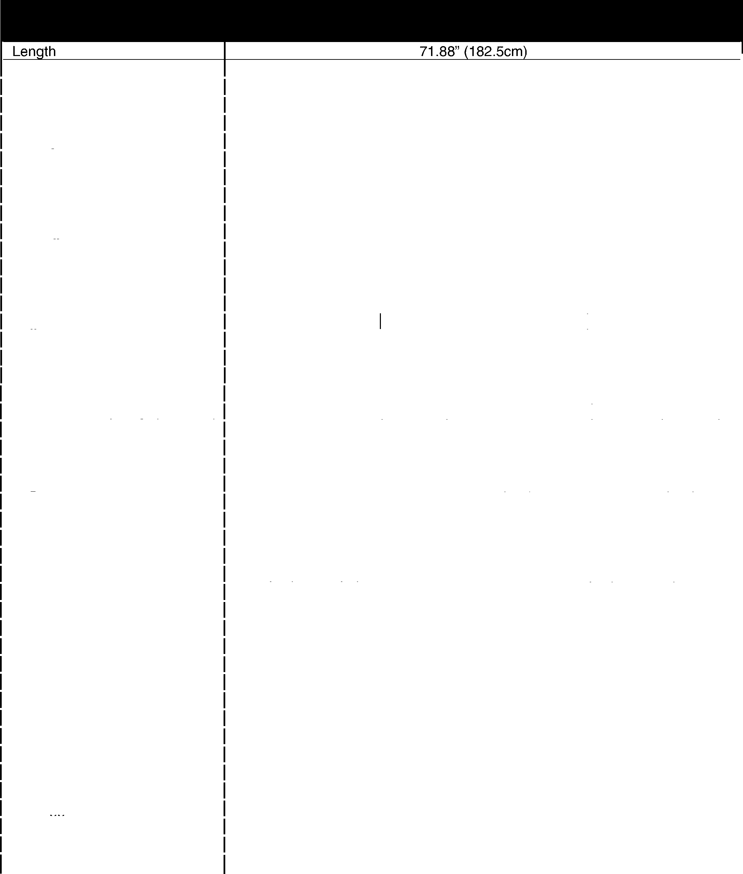**915 EZRIDER SERVICE MANUAL SPECIFICATIONS**

|  |  |  |  |
| --- | --- | --- | --- |
| **MODEL No.** | **915303** | **915304** | **915305** |
| **DESCRIPTION NAME** | **EZR 1440** | **EZR 1540** | **EZR 1648** |

|  |  |  |
| --- | --- | --- |
| Height | 44.7" (113.5cm) | |
| **Width** | 44.5" (113.0cm) | 52.0" (132.0cm) I 60.0" (152.4cm) |
| Wheel Base | 42.0" (106.7cm) | |
| Actual Weiqht | 588 lbs. (267 kq) | |
| Battery | 12 Volt 290 C.C.A. | |
| Hour Meter | Optional (71500100) | |
| Seat | High Back | |
| Brakes | Disc | |
| Steerinq | Castor Wheels | |
| Turninq Radius | O" | |
| Tire Size | | |
| Front | 11.0x4.00-5 | |
| Rear | 18x8.50-8 | |
| Diaqnostic Liqhts | **N/A** | |
| Enqine | 14.0 HP OHV 15.0 HP OHV I 16.0 HP OHV | |
| Manufacture | Briggs & Stratton | |
| Fuel & Capacity | Unleaded 3.5 Gal. | |
| Idle RPM | 1800 RPM | |
| Governed RPM | 3050 RPM | |
| Crank Case Capacity (Oil Filter) | 56 oz. (1.66 liters) I 64 oz. (1.9 liters) | |
| Air Cleaner | Paper Element and Foam Precleaner | |
| Charging Capacity | 3/5 Amp Unregulated | |
| Fuel Filter | 120 Micron | |
| Enqine Oil | Above 32 ° F *(0* C) 30W & Below 32 ° F *(0* C)5W30 | |
|  | | |
| Spark Plug Gap | .030 Champion RC12YC | |
| Transmission | Eaton | Hydro Gear |
| Speed-Forward Max. | 5.5 mph (8.8 km/hr) | 0-5.2 mph (8.4 km/hr) |
| Reverse Max. | 4.1 mph (6.6 km/ph) | 0-3.6 mph (5.8 km/hr) |
| Transmission Lube | Mobil DTE 26 | 20W50 |
| Drive Clutch | **N/A** | |
| Allowable Added Weight | **N/A** | |
| Rear Axle Maximum Load | **N/A** | |
| Tire Pressure With Loads | | |
| Front/Rear-Light | 10 - 12 psi (83-103kN/m 2) | |
| Medium | 10 - 12 psi (83-103kN/m 2) | |
| Heavy | 10 - 12 psi (83-103kN/m 2) | |
| Lift System | Manual | |
| Power Take Off | Electric | |
| Attach men ts: | | |
| Mower Pan | 40" I 48" | |
| Baaaer 2 Bucket | 81500400 | 81500500 I **N/A** |
| Sno-Thro | | 81500100 |
| Dozer Blade | 81500200 | **N/A** |
| Mulching Kit | 73600100 I 73401100 | |

**SPECIFICATIONS 915 EZRIDER SERVICE MANUAL**

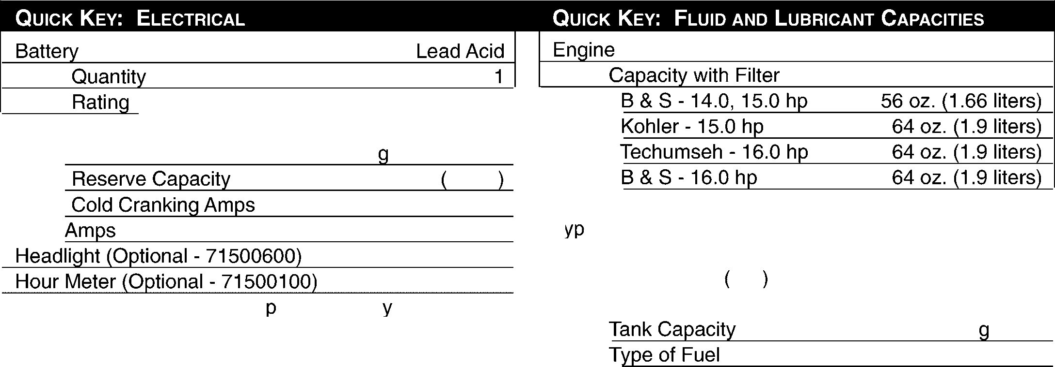

Fuse

Electrolite

12 Volt

Direct Current Ne ative Ground

35 minutes @80 ° F 27° C

290

30

12 Volt

12 Volt

S ecific Gravit 1.265 ± .05

Fuel Filter

120 Micron

3.5 allons Unleaded Gasoline

Grease Fittings Sten Mix Hi-Temp Grease P/N: 000367 - 10 pack of 14 oz. cartridges

Fuel

30W

5W30

Above 32 ° F (0 C) Below 32° F OC

T e of Oil

**915 EZRIDER SERVICE MANUAL INSTRUCTIONS & ADJUSTMENTS**

## SECTION 3: INSTRUCTIONS &ADJUSTMENTS

* 1. **FILLING THE FUEL TANK**

See Figure 2 for controls and features locations and figure 3 for filling the fuel tank.



**NEVER** fill tank when engine is running, hot or unit is indoors. Fuel is highly flammable and its vapors can explode!

ONLY use approved fuel containers. No smoking, No sparks, No flames on or near the unit. Allow engine to cool before filling fuel tank

**NOTE:** Clean up any spilled fuel before starting the engine.

1. Add fuel to the fuel tank as needed. See your engine manual for the correct type and grade of fuel.
2. Put the unit in an open and well ventilated area prior to refueling.
3. Stop the engine and set the parking brake.
4. Raise the seat and clean the fuel cap and in the area around the fuel cap. Remove the cap from the fuel tank.
5. Fill the fuel tank with the proper grade of fuel recommended by the engine manufacture. Be careful not to spill any fuel.
6. Install fuel cap on the fuel tank and tighten.
7. Clean up any spilled fuel before starting engine.

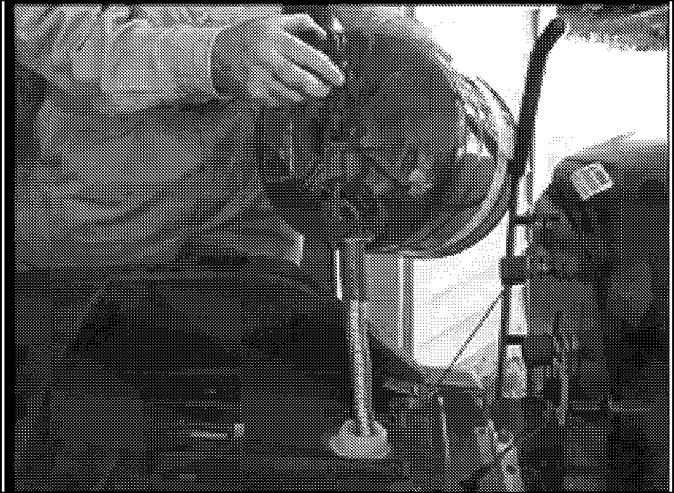

Figure 3

* 1. **GENERAL LUBRICATION**

Refer to Figure 4 and 5 for the locations of the grease fittings on the unit and the intervals at which to grease them.

All grease fittings should be greased at 25-hour intervals. Clean and inspect parts and replace as required.

1. Clean the fittings before attaching the grease gun.
2. Thoroughly clean and dry all parts with a suitable solvent.
3. Check all parts for wear and damage.
4. Replace all parts that are worn or damaged.
5. Use Sten Mix Hi-Temp Grease (a moly-lithium grease) or equivalent. Add grease until it appears at the ends of the bearing or ends of the shaft.
6. Every 25 hours apply motor oil to all pin connections, pivots points and areas where sliding occurs.

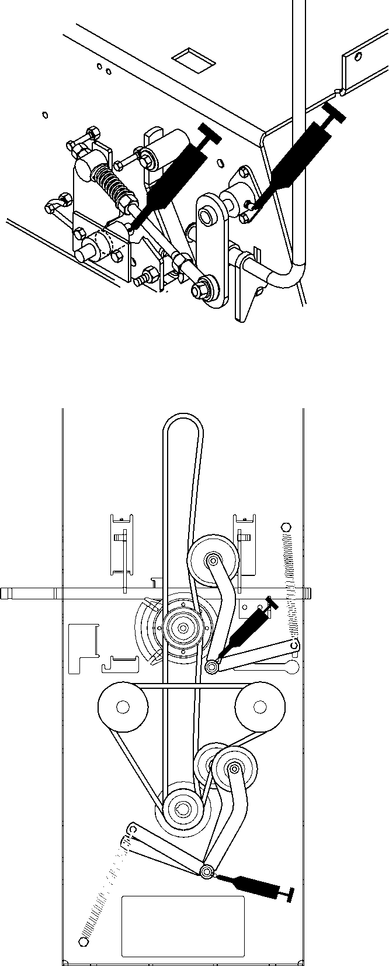

Figure 4

Figure 5

**INSTRUCTIONS & ADJUSTMENTS 915 EZRIDER SERVICE MANUAL**

* 1. CHECKING FASTENERS

Each day before operating the unit:

1. Check all nuts and other fasteners.
2. Replace fasteners that are missing of damaged.
3. Tighten all nuts and bolts to the torque listed in the torque chart noted unless noted differently.
   1. CHECKING ENGINE OIL

Check the engine oil daily prior to use.

**IMPORTANT:** Never operate the engine with the oil below the low mark on the dipstick.

See the engine manual for oil specifications and oil filter service instructions.

To check oil level: Refer to figure 6

1. Move the unit to level location. Tip seat forward and remove engine cover.
2. Clean around the dipstick and filler tube to prevent dirt from entering the engine.
3. Remove the dipstick and wipe off the oil on the depth stick.
4. Put the dipstick back into the engine and tighten in place and remove again.
5. When the dipstick is removed, note the oil level. Oil should be between the full and add mark.
6. Replace dipstick.
7. If required, add 5W30 below 40° or 30W above 40° . Do not over fill.
8. 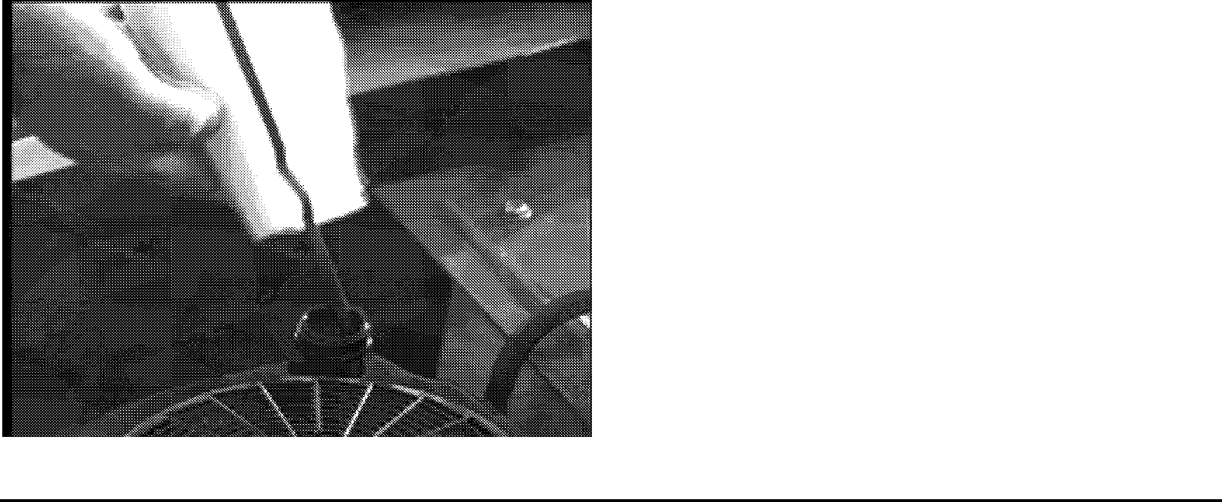Clean up any spillage that may have occurred. Replace engine cover and tip seat to the rear.

Figure 6

* 1. CHANGING OIL



**DO NOT** tough parts which are hot. Allow parts to cool before servicing.

Engine muffler and other parts will be hot if unit has been running.

1. Engine oil should be changed after the first five hours of operation and every 25 hours there after
2. Move the unit to a level and well ventilated area and set the parking brake.
3. If the engine is cold, let the unit run for five minutes.
4. When the engine is warm, stop the engine and remove the engine cover.
5. Clean the area around the dipstick and drain hose.
6. Put an open container that will hold one gallon of oil under the drain hose.
7. Open the drain valve.
8. Allow the engine oil to drain completely into the one gallon container. Remove container and contents for future recycling as required.
9. Close the oil drain valve.
10. If used; remove the oil filter.
11. Clean the oil filter port and install a new oil filter according to the instructions on the oil filter. Fill with new oil to the "full" mark on the dipstick.
12. Start and run the engine for one minute. Stop the engine and recheck the oil level and add as necessary.
13. Check for leakage at the drain plug and oil filter if used. Tighten the fittings as necessary if leakage occurs.
14. Reinstall the engine cover and latch in place, release the parking brake.
15. Return the unit into service.
    1. CHECKING ENGINE COOLING

Refer to Figure 7 for checking engine cooling.

**IMPORTANT:** To prevent severe damage to the engine, proper cooling will need to be maintained.

1. Check the air intake screen on the engine each day.
2. The air intake screen must be kept clean. Remove any grass, dirt, or debris that may have accumulated.
3. Check the engine cooling yearly.

**915 EZRIDER SERVICE MANUAL INSTRUCTIONS & ADJUSTMENTS**

1. Remove the engine blower housing and clean the outer surface of the engine.
2. Reinstall engine blower housing.

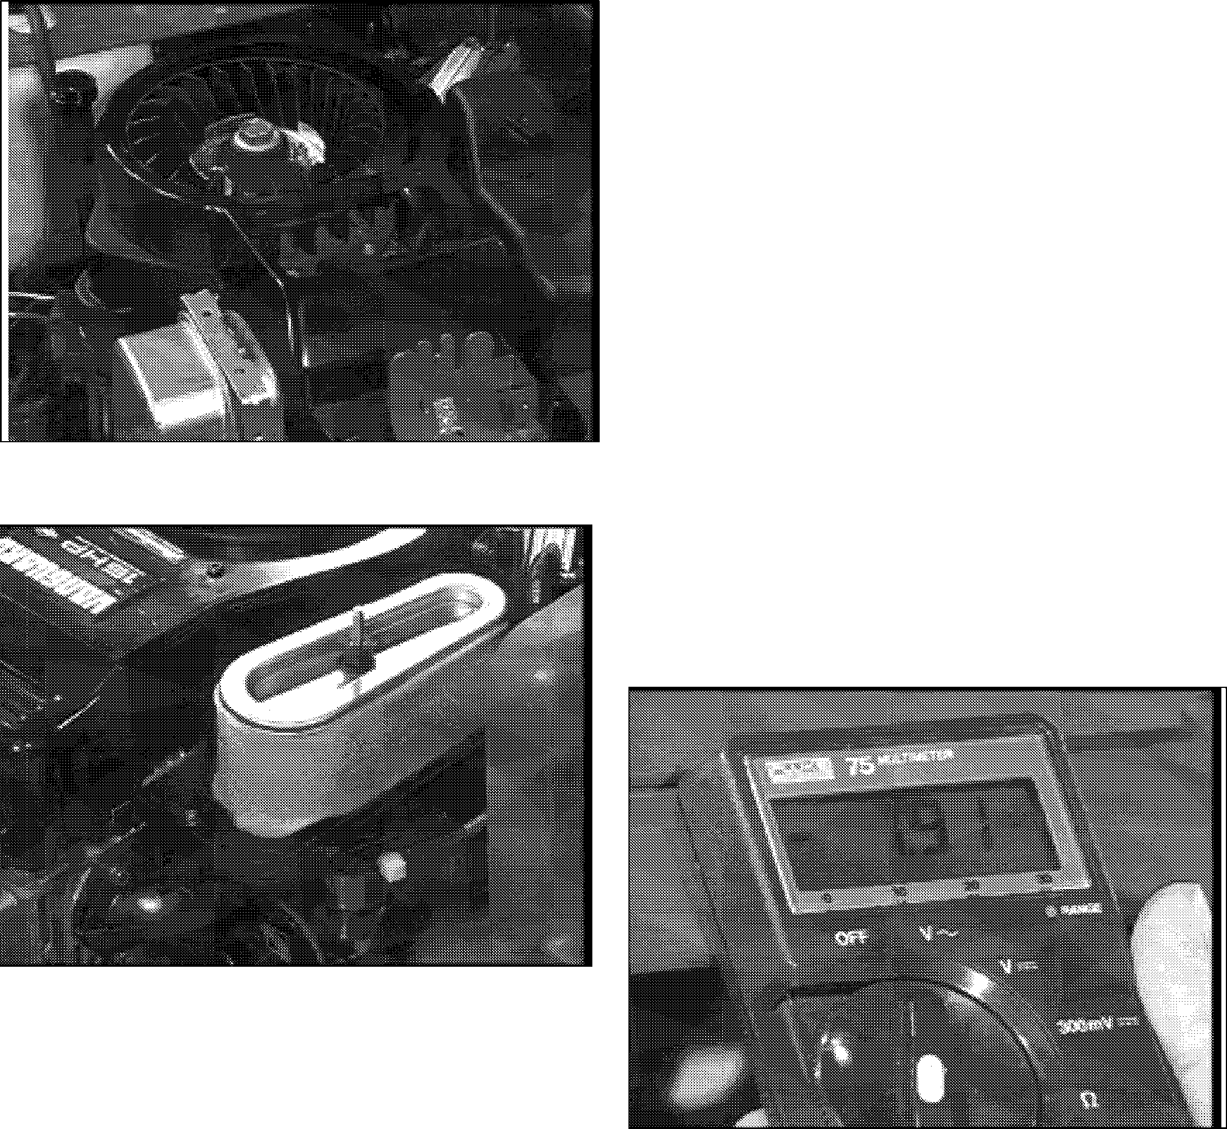**IMPORTANT:** Do not run the engine with the blower housing removed.

Figure 7

Figure 8

* 1. CLEANING THE AIR CLEANER

Refer to Figure 8 for cleaning the Air Cleaner

1. Check the air cleaner element every day.
2. Clean the air cleaner precleaner every 25 hours. See your engine manual for instructions.
3. Apply oil and reinstall over the paper air filter element.
4. Wipe out the air cleaner cover to remove any dirt build up in the cover.
5. Reinstall the cover over the air cleaner prior to operating the engine. See your engine manual
   1. CHANGING THE AIR CLEANER ELEMENT

Replace the air cleaner element when clogged or every 100 hours. Do not attempt to clean. See your engine manual for instructions.

* 1. CHECKING THE TIRES

Before each use, make a visual check of the tires. For correct air pressure see Section 2 for specifications.

* 1. CHECKING THE PTO CLUTCH

Refer to Figure 9 for checking the PTO.

###### Measure Clutch Coil Resistance

1. Turn engine and PTO switch off.
2. Disconnect clutch wire connections.
3. Select meter to check ohms.
4. Connect meter leads wires in clutch connector.
5. On PTO clutch part# 03601800, if the meter reads below 5.87 or above 7.87 ohms the clutch has failed and needs to be replaced.

On PTO clutch part# 03357900, if the meter reads below

1.98 or above 3.98 ohms the clutch has failed and needs to be replaced.

Figure 9

###### Measure Clutch Current Draw

1. Turn engine off.
2. Disconnect clutch wire connections and remove the power lead from the plug housing. Reconnect the plug housing to the PTO clutch.
3. Select meter to check amps (10 amp scale).
4. Connect on meter lead wire to the power lead of the

**INSTRUCTIONS & ADJUSTMENTS 915 EZRIDER SERVICE MANUAL**

clutch.

1. Connect the other meter lead wire to the terminal on the PTO clutch
2. Turn the ignition switch to run activate the seat switch and PTO switch to on.
3. On PTO clutch part# 03601800, the meter read 1.5 to 2.0 Amps

On PTO clutch part# 03357900, the meter read 3.5 to 4.5 Amps

If you find after completing the above steps the electric clutch is within factory specifications, the PTO clutch is not the source of the problem but the electrical system is.

* 1. **CHECKING THE TRANSMISSION FLUID**

Refer to Figure 10 for checking the transmission fluid.

The transaxle is filled and tested at the factory and should not require fluid when the unit is put into service.

1. Inspect the transaxle for leaks or damage to the housing. If leakage is observed, do not operate until the leakage is fixed.
2. Check the oil level and fill to the correct level if required.
   1. **PRIMING THE TRANSMISSION (EATON)**

Refer to Figure 10 for priming the transmission.

1. Check fluid level in the expansion tank, fill with Mobil DTE-26 oil or a detergent 30W oil.
2. Verify that transmission drive belt is not slipping.
3. Verify that control arms going to the transmissions are adjusted properly.
4. Verify that the parking brake is centered to release the transmission brake.
5. If the transmission operates irregularly the transmission needs to be bled of air in the system.
6. Verify that transmission lines and elbows are sloping upward toward the expansion tank, it may be necessary to remove straps holding hoses down.
7. Remove side panels and loosen control stops on both side of the cam arms, this will allow the transmission control arm to move through the full stroke of the transmission.
8. Cycle the unit from the full forward position to the full reverse position every 15 seconds for three minutes.
9. Verify fluid level in the expansion tank. If the fluid level is down, add fluid, then repeat step 8 until the fluid level remains at the proper level.

**NOTE:** An improvement in performance should be noticeable if all the air has been purged from the system.

1. If transmission fluid is down, add fluid. Then repeat step 8 until it remains at the proper level.
2. If no more improvement is noticed or fluid added, reassemble the unit and return to service.

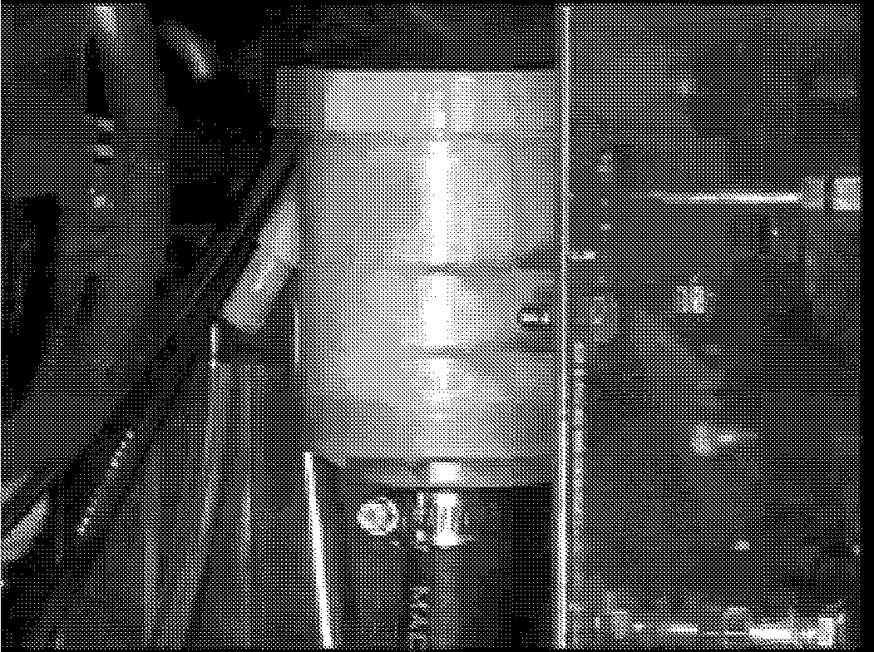

Figure 10 (Eaton transmission only)

* 1. **PRIMING THE TRANSMISSION (HYDROGEAR)**

Refer to Figure 11 and 12 for priming the transmission.

1. Check the oil level in the transaxle. The proper level should be 1.25" to 1.62" from the top of the transmission housing.

Note: If oil is required use 20W50 engine oil.

1. Verify that transmission drive belt is not slipping.
2. Verify that control arms going to the transmissions are adjusted properly.
3. Verify that the parking brake is release to the transaxles.
4. If the transmission operates irregularly the transmission needs to be bled of air in the system.
5. Engage (actuate) the bypass.
6. Stroke the control lever forward for five seconds and then reverse for five seconds. Do this three times in each direction. Figure 10 and 11
7. Return the control lever to neutral.
8. Disengage the bypass.
9. Stroke the control lever forward for five seconds and than reverse for five seconds. Do this three times in each direction.

Note: It may be necessary to repeat these steps to fully

**915 EZRIDER SERVICE MANUAL INSTRUCTIONS & ADJUSTMENTS**

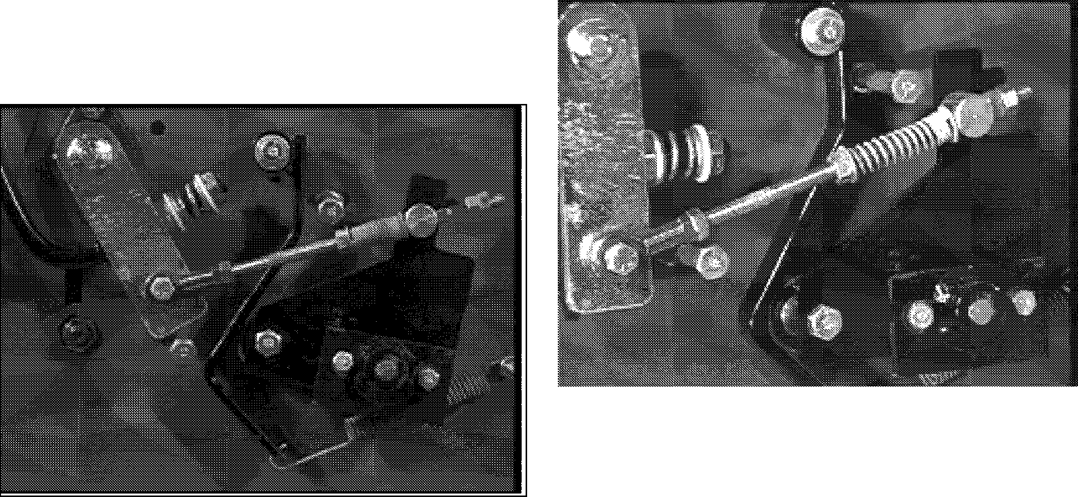purge the transaxle.

Check the oil level after fully purging the unit of air It should be between 1.25" and 1.62" from the top of the housing.

Figure 13

Figure 11 Forward cycle

Figure 12 Reverse cycle

* 1. **ADJUSTMENT OF TRANSMISSION NEUTRAL (EATON HYDRO)**

Refer to figure 13 and 14 for neurtal adjustment

1. Place jackstands under the rear of the units frame to support the rear of the machine with the drive wheels off the ground.
2. Remove the side shrouds to expose the shift linkage for adjustment.
3. Place the drive control arms in the neutral position and the PTO switch in the off position.
4. Start the engine and run at half throttle.
5. Loosen the two cap screws and lock nuts holding the upper speed control arm to the lower speed control arm.
6. 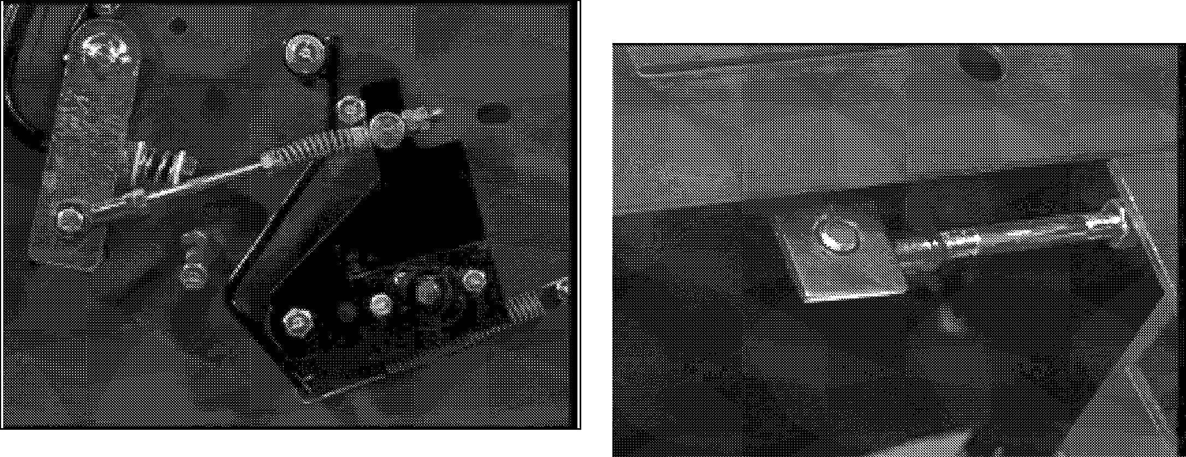 With the speed control arms hardware loose, adjust the upper ball joints to align the neutral detent and the neutral slot in the EZ Rider frame.

Figure 14

1. Adjust the lower ball joint assembly to align the lower speed control arm in a vertical mode.
2. When the transmission wheels are not turning and the lower control arm is in the vertical mode, tighten the two cap screws and lock nuts holding the control arms together.
3. Sit on the operators seat and cycle the shift linkage and verify that the system returns to neutral and the drive wheel does not turn.

**INSTRUCTIONS & ADJUSTMENTS 915 EZRIDER SERVICE MANUAL**

* 1. ADJUSTMENT OF TRANSMISSION NEUTRAL (HYDROGEAR HYDRO)

1. 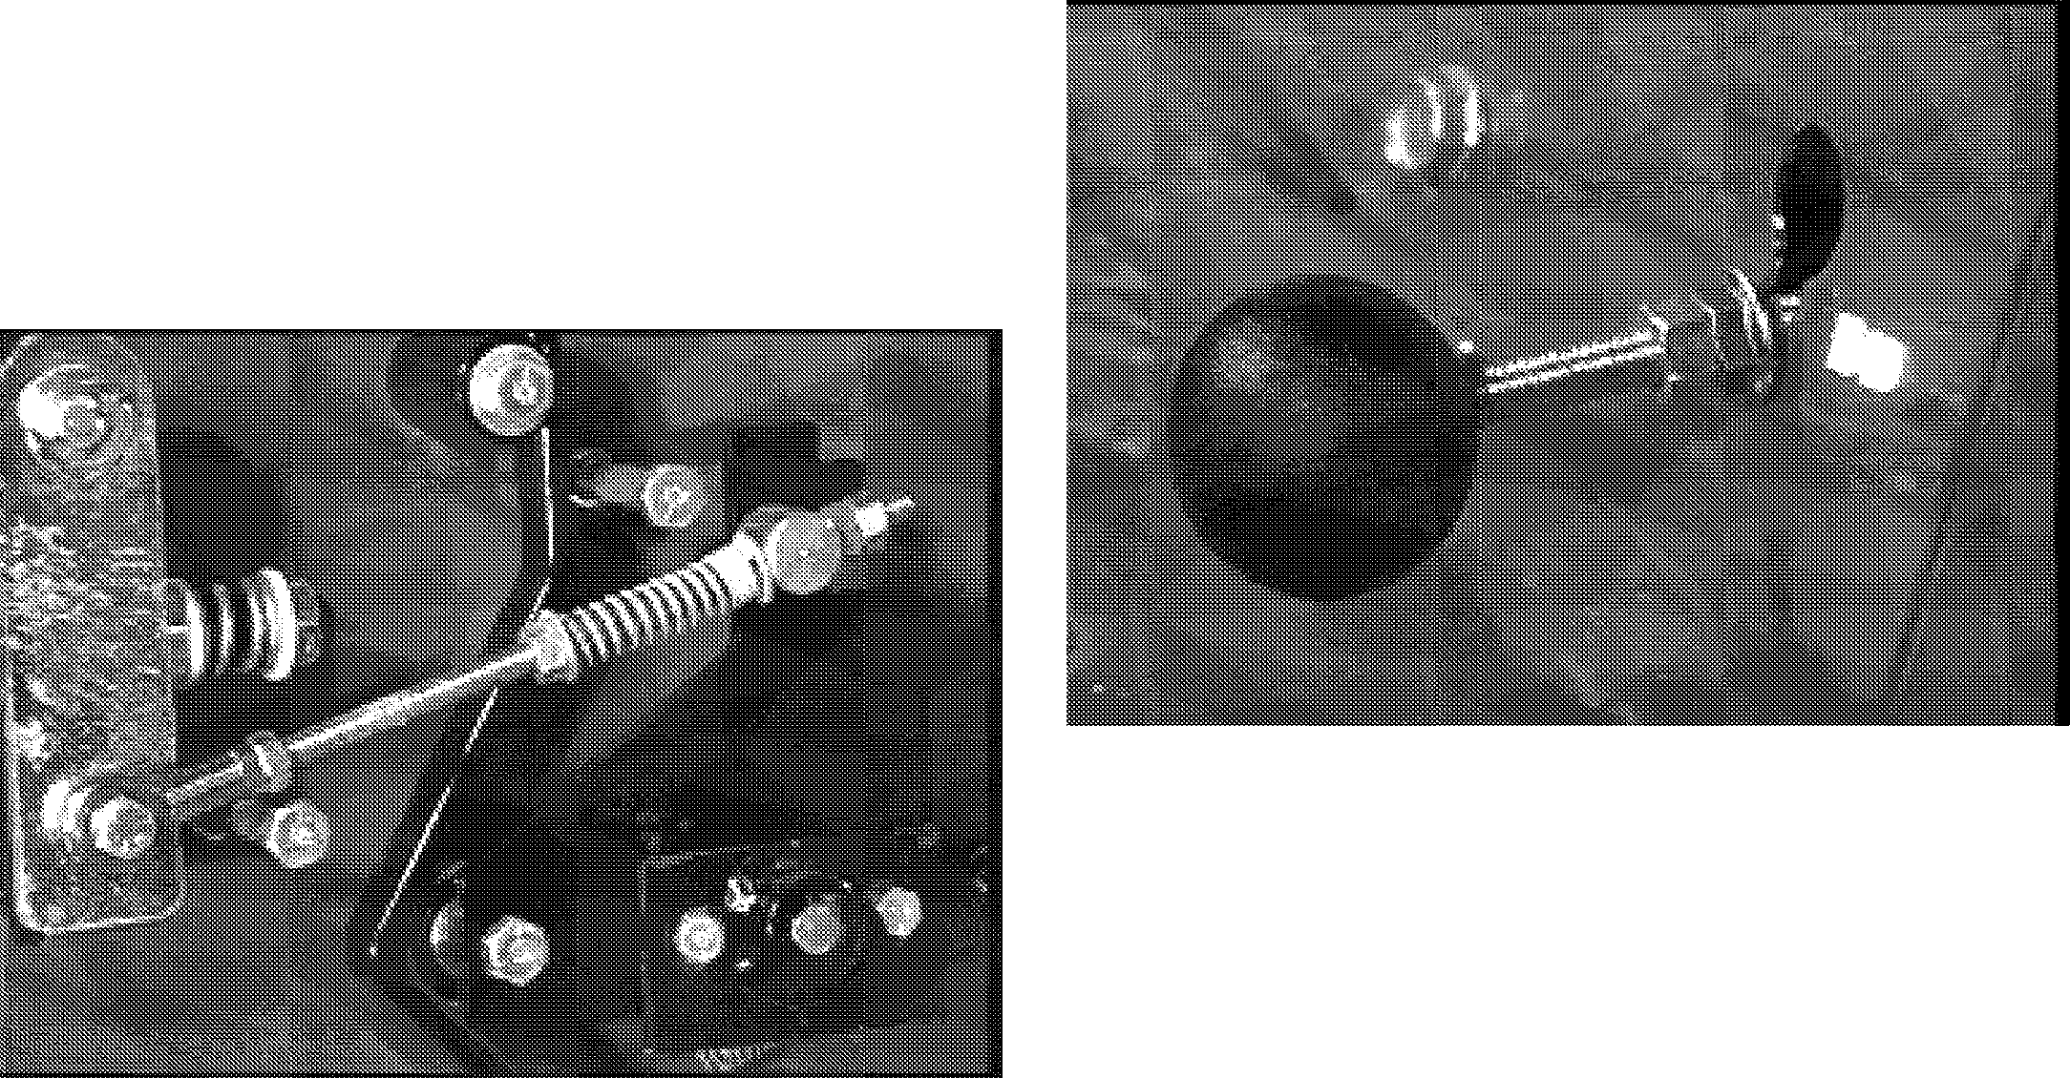 Place jackstands under the rear of the units frame to support the rear of the machine with the drive wheels off the ground.
2. Remove the side shrouds to expose the shift linkage for adjustment.
3. Place the drive control arm in the neutral position and the PTO switch in the off position. Figure 15

Figure 15

1. Start the engine and run at half throttle.
2. Loosen the two cap screws and lock nuts holding the upper speed control arm to the inside speed control arm.
3. With the speed control arms hardware loose, adjust the upper ball joints to align the neutral detent and the neutral slot in the EZ Rider frame.
4. Adjust the lower ball joint assembly to align the inside speed control arm in a horizontal position.
5. When the transmission wheels are not turning and the inside control arm is in the horizontal position, tighten the two cap screws and lock nuts holding the control arms together.
6. Sit on the operators seat and cycle the shift linkage and verify that the system returns to neutral and the drive wheel does not turn.
   1. ADJUSTMENT OF DIRECTIONAL CONTROL LEVERS

Adjustment of the speed control levers is to be done in conjunction with the adjustment of transmission neutral.

* 1. ADJUSTING THE BRAKE (HYDRO)

1. To adjust the brake, the parking brake knob will need to be pulled up in the travel slot until the nut on the rod can pass through the keyway. Figure 16

Figure 16

1. The knob will now need to be pulled forward till the nut is on the out side of the keyway slot.
2. Turn the nut on the rod threads until the rod can not move backward when it is dropped in the travel slot.
3. The brake is now adjusted for the engaged position and the machine will not roll.
4. To release the brake, pull up on the knob and push the rod backward into the machine.
5. The unit will now be free to roll if the dump valve is engaged.

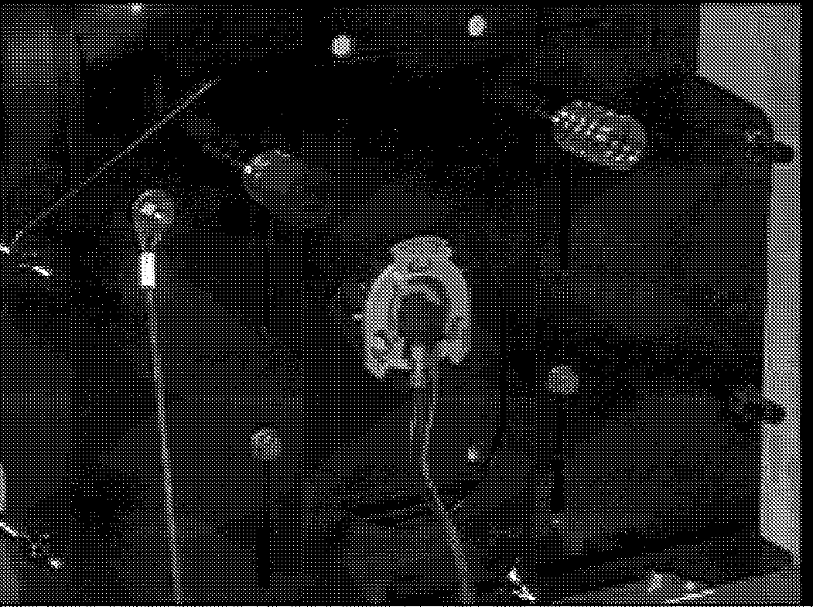

Figure 17

* 1. ADJUSTING THE OPERATOR'S SEAT

1. The operator's seat is mounted on adjustable seat plate and may be adjusted by loosening the mounting

**915 EZRIDER SERVICE MANUAL INSTRUCTIONS & ADJUSTMENTS**

hardware and moving the seat to the desired position. Figure 17

1. Tighten the seat hardware when in the desired position.
   1. 48" MOWER BELT REPLACEMENT

Refer to figure 18 for mower belt replacement

1. Remove belt covers hardware and belt covers.
2. Grasp belt on both sides of the right outboard spindle pulley, pull horizontally on the belt, and remove belt off the pulley.
3. Remove the belt from the pto clutch to the center pulley on the mower deck.
4. Release the mower deck belt idler tension spring from the anchor stop. Figure 19
5. Remove the mower belt from the spindles, tension idler and jackshaft.
6. Install new Ariens belt around jackshaft, tensing idler and spindles. Reinstall the idler tension spring.
7. Install the pto clutch belt from the clutch to the jackshaft.
8. Install the belt covers and cover hardware.

3.19 48"MOWER SPINDLE/JACKSHAFT LUBRICATION

1. Grease the mower spindles every 25 hours of operation or once a season by removing the plugs on

Figure 18

1. Remove belt cover hardware and belt covers.
2. Remove the belt from the pto clutch to the mower deck.

No lubrication is needed through the life of the machine.

3.21 TRANSAXLE BELT REPLACEMENT

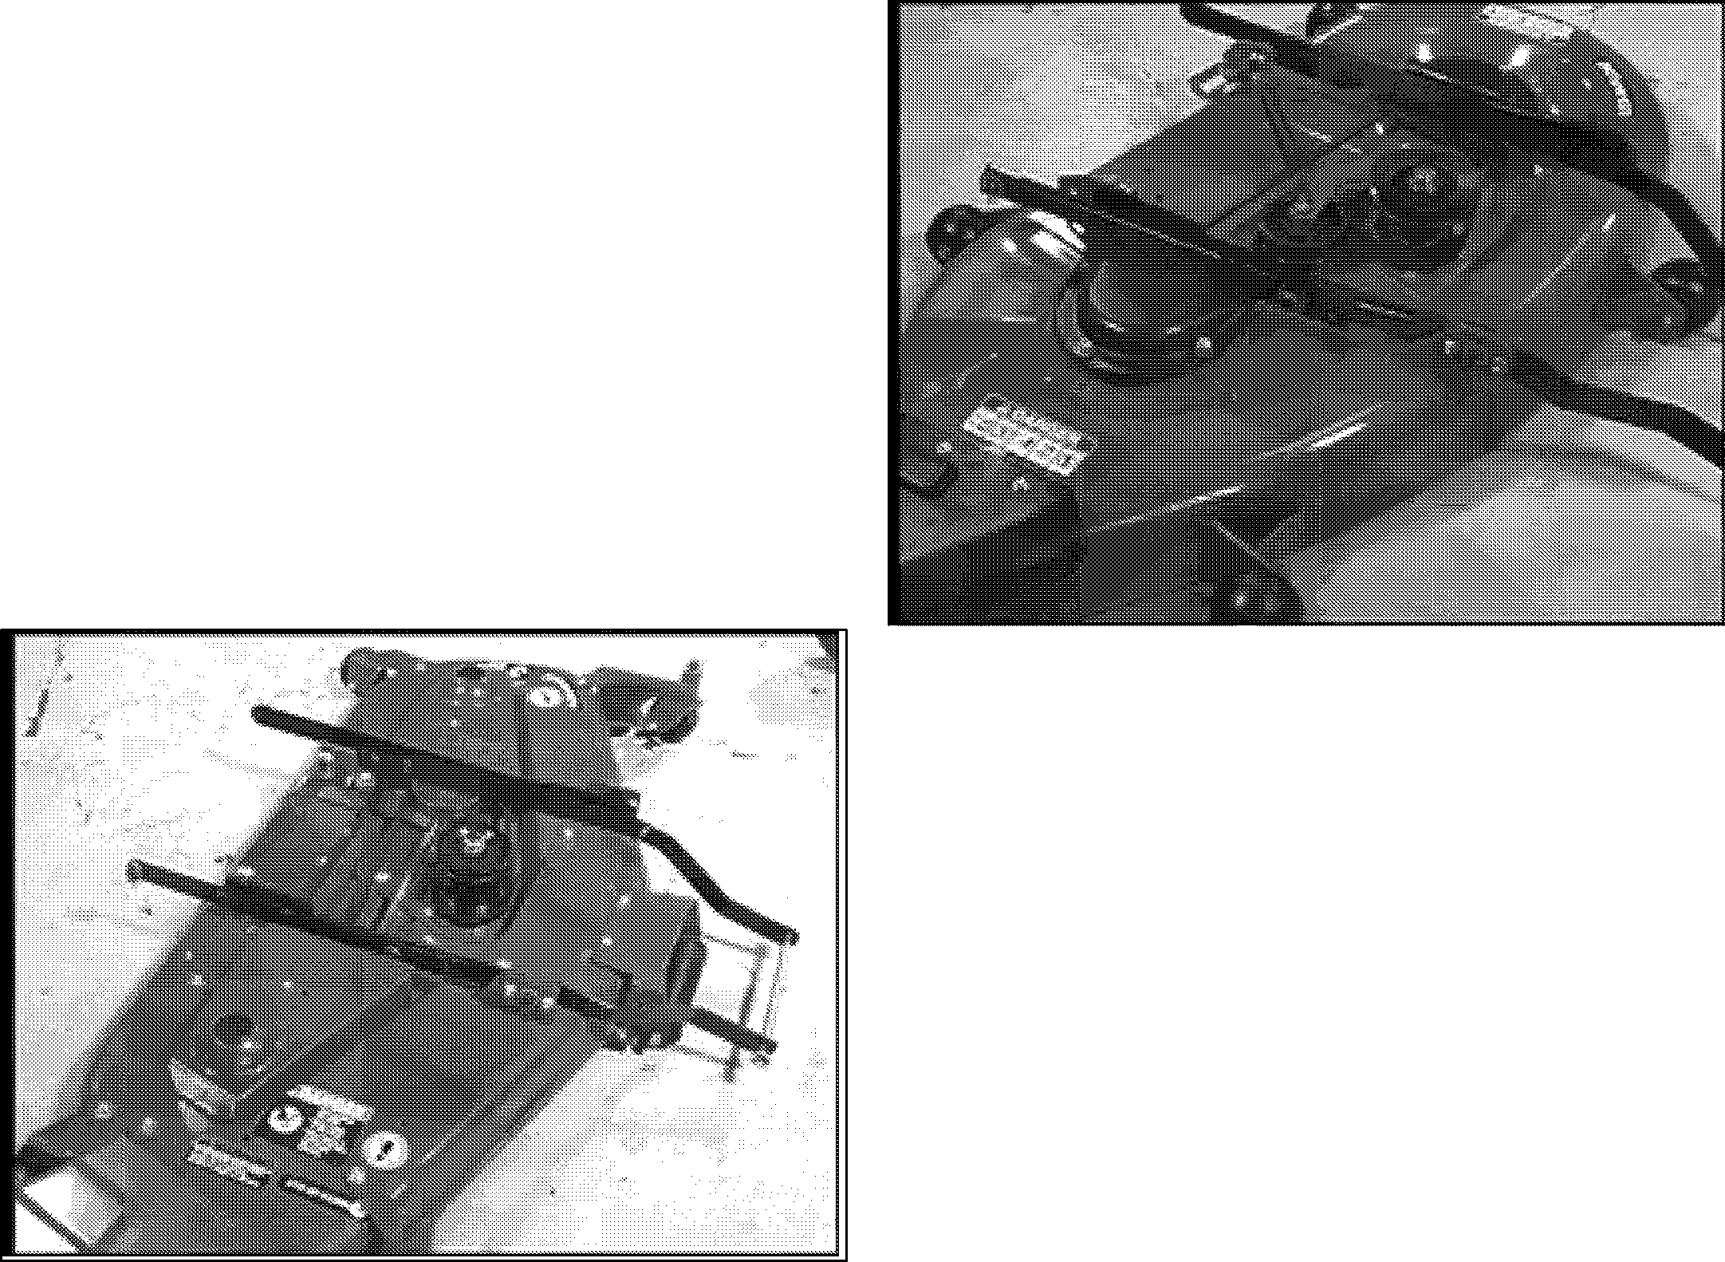

1. Remove the deck belt from center drive pulley , then idler and blade pulley.
2. Install new Ariens belt around center drive pulley, spring loaded idler, left hand pulley.
3. Grasp the belt with two hands, pull and loop over the right hand spindle pulley.
4. Reinstall the pto belt from the clutch and center pulley on the mower deck. Reinstall and secure belt covers with their respective hardware.

**3.18 40" MOWER BELT REPLACEMENT**

Figure 19

the spindle covers over the spindles.

1. Clean the grease fittings prior to attaching the grease gun.
2. See specifications for proper grease type.

**3.20 40"MOWER SPINDLE/JACKSHAFT LUBRICATION**

The mower deck spindles and jackshaft assemblies uses sealed prelubricated bearings.

Refer to Figure 20 For transaxle belt replacement

1. Disconnect the main idler spring from the spring anchor and remove the main drive belt from the

**INSTRUCTIONS & ADJUSTMENTS 915 EZRIDER SERVICE MANUAL**

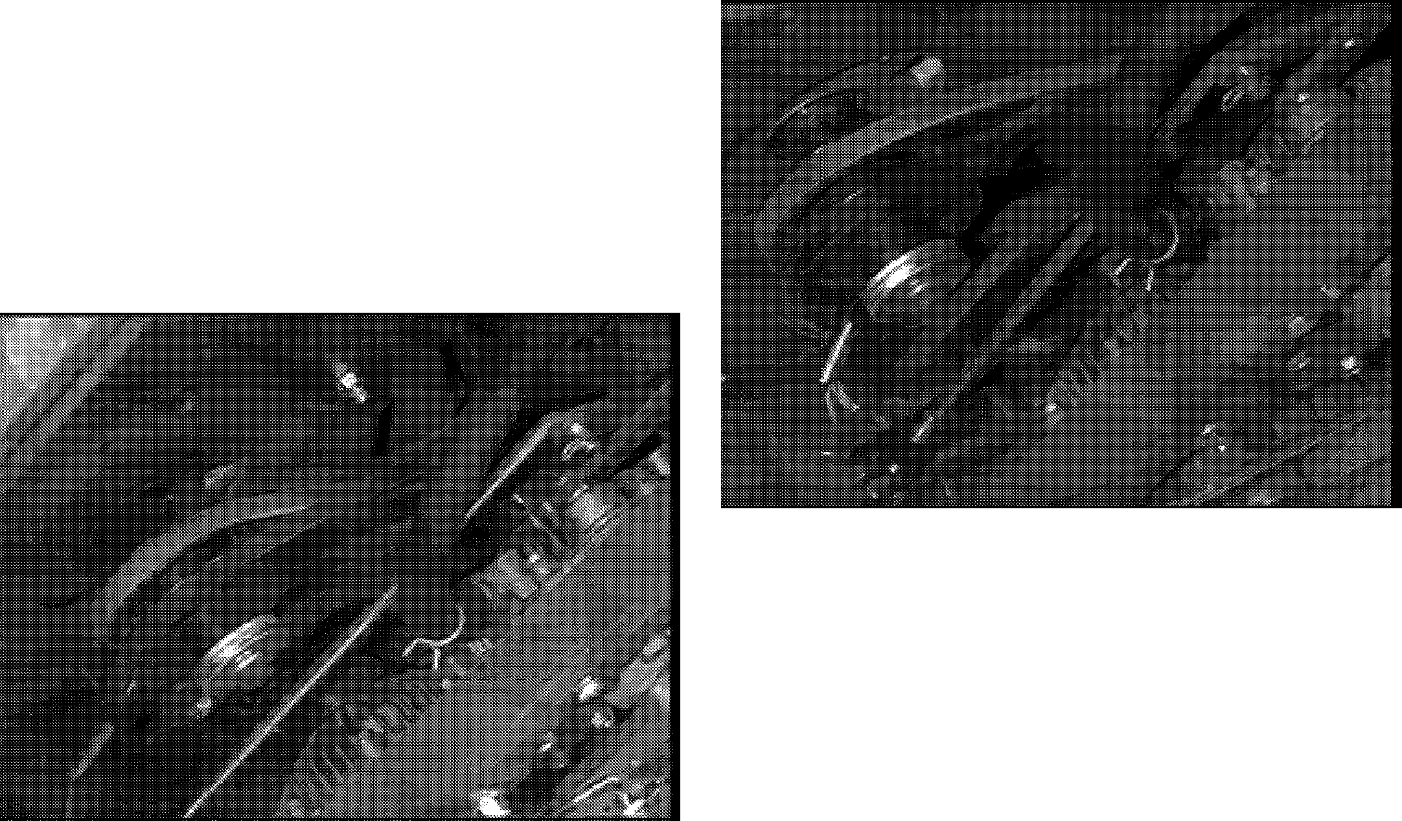

bottom of the engine pulley and the top of the transaxle drive sheaves.

2. Install new Ariens drive belt in reverse order.

**3.22 JACKSHAFT DRIVE BELT REPLACEMENT**

Refer to Figure 21 for jackshaft drive belt replacement

Figure 21

Figure 20

1. Remove the transaxle drive belt before removing the jackshaft drive belt.
2. Release the jackshaft idler tension spring form the spring anchor.
3. Remove the PTO clutch anchor stop from the frame and unplug the PTO clutch from the wire harness.
4. Remove the jackshaft drive belt from the engine sheave and than from the pulley on the jackshaft.
5. Replace the new belt in the reverse order.

**ENGINE 915 EZRIDER SERVICE MANUAL**

## SECTION 4: ENGINE

##### ENGINE TROUBLE SHOOTING

The following trouble shooting chart is to be used to isolate engine problems and give possible causes and corrective action responses.

The trouble shooting key is generic and can be used for several types of engines. Use only those possible causes and corrective actions that apply to the EZRider.



|  |  |  |
| --- | --- | --- |
| **TROUBLE**  **Black Exhaust** | **POSSIBLE CAUSES**  (Refer to Key Below)  1,20, 22, 25, 29, 31, 32, 33 | **CORRECTIVE ACTION**  repair or replace |
| **Blue/White Exhaust** | 4 20, 25 31, 33, 34 | repair or replace |
| **Difficult Starting** | 1,5, 7, 8, 9, 10, 20, 21, 22, 29, 31, 32, 33 | repair or replace |
| **Erratic Running** | 1,7, 8, 9, 10, 20, 21,23, 26, 29, 33, 59, 62 | repair or replace |
| **Excessive Fuel Consumption** | 1,20, 22, 23, 25, 29, 31, 32, 33 | repair or replace |
| **Excessive Crankcase Pressure HiClh Oil Pressure** | 25, 31, 33, 34, 45, 55  4, 41 | repair or replace repair or replace |
| **KnockinCI** | 22,26, 29, 31, 33, 36, 46, 59 | repair or replace |
| **Loss of Power or Svstem** | 1,8, 10, 20, 21, 22, 23, 25, 26, 31, 32, 33 | repair or replace |
| **Low Crankinq Power** | 2, 3, 4, 11 | repair or replace |
| **Low Oil Pressure** | 4, 36, 37, 39 | repair or replace |
| **Misfiring** | 10, 20, 25, 26, 28, 29, 32 | repair or replace |
| **Overheating** | 1, 19, 25 | repair or replace |
| **Poor Compression** | 25, 28, 29, 31, 32, 33, 34, 59 | repair or replace |
| **Starts and Stops** | 1,6, 10, 62 | repair or replace  see electrical systems  see enaine service manual |
| **Vibration** | 20, 23, 25, 26, 29, 33, 45, 49 | repair or replace |
| **Will Not Crank** | 2, 11, 45 | charge battery or replace |
| **Will Not Start** | 1, 10, 62 | repair or replace  see electrical systems  see engine service manual |

|  |  |  |  |  |
| --- | --- | --- | --- | --- |
| **TROUBLE SHOOTING KEY** | | | | |
| 1. Restriction in air cleaner | 22. | Incorrect grade of fuel | 43. | Faulty suction pipe |
| 2. Bad electrical connection | 23. | Sticking throttle/restricted movement | 44. | Choked oil filter |
| 3. Faulty starter motor | 24. | Exhaust pipe restriction | 45. | Bad solenoid switch |
| 4. Incorrect grade of lubricating oil | 25. | Leaking cylinder head gasket | 46. | Incorrect piston height |
| 5. Low cranking speed | 26. | Overheating | 47. | Damaged fan |
| 6. Fuel tank empty | 27. | Cold running | 48. | Faulty engine mounting |
| 7. Controls not in correct operation position | 28. | Incorrect tappet adjustment | 49. | Incorrectly aligned flywheel and/or flywheel |
| 8. Blocked fuel feed line | 29. | Sticking valves |  | housing |
| 9. Faulty fuel lift pump | 30. | Incorrect high pressure pipes | 50. | Faulty thermostat |
| 10. Choked fuel filter | 31. | Worn cylinder bores | 51. | Restriction in water jacket |
| 11. Battery capacity low | 32. | Pitted valves and seats | 52. | Loose fan belt |
| 12. Air in fuel system | 33. | Broken, worn or sticking piston ring(s) | 53. | Choked radiator |
| 13. Faulty fuel injection pump | 34. | Worn valve stems and guides | 54. | Faulty water pump |
| 14. Faulty fuel injectors or incorrect type | 35. | Restriction in air cleaner | 55. | Choked breather pipe |
| 15. Incorrect use of cold start equipment | 36. | Worn or damaged bearings | 56. | Damaged valve stem oil deflector (if fitted) |
| 16. Faulty cold start equipment | 37. | Insufficient oil in sump | 57. | Coolant level too low |
| 17. Broken fuel injection pump drive | 38. | Bad/defective oil temperature switch | 58. | Blocked sump strainer |
| 18. Incorrect fuel pump timing | 39. | Oil pump worn | 59. | Broken valve spring |
| 19. Incorrect valve timing | 40. | Pressure relief valve sticking open | 60. | Exhaust or vacuum pipe leak |
| 20. Poor compression | 41. | Pressure relief valve sticking closed | 61. | Bad or defective water temperature switch |
| 21. Blocked fuel tank vent | 42. | Broken relief valve spring | 62. | Bad spark plug(s) |

**915 EZRider SERVICE MANUAL ENGINE**

##### ENGINE REMOVAL

Refer to Figures 22 and 23 for engine removal and installation.

1. Remove the hood from the units engine.
2. Remove the negative cable from the battery.
3. Remove the main drive belt from the engine sheave by releasing the idler tension spring.
4. Remove the jackshaft drive belt from the engine sheave by releasing the tension spring from the right side of the transaxle sub frame.
5. Remove the throttle and choke control from the engine.
6. Remove the electrical wiring from the engine (charge lead, fuel solenoid lead, and magnet kill wire).
7. Remove Fuel line from engine first. Drain fuel from line back into fuel tank.
8. Remove the exhaust system from under the frame connect to the the exhaust port on the engine.
9. Remove the engine bolts.
10. Lift engine out of the unit and off the frame with a hoist (engine).
11. Service, overhaul, or replace engine as required.
12. If replacing engine with a new engine, the following items will have to be removed (if used) from engine. These items will not be included with a new engine:

Engine sheave and key, mounting hardware, and engine wiring harness.

##### ENGINE INSTALLATION

1. Check the engine base and unit frame for damage before installing the engine.
2. Place the throttle and choke controls, fuel line, and electrical wires out of the way prior to installing the engine.
3. Once the engine is bolted onto the frame, install the exhaust system and then tighten the mounting hardware.
4. Install the engine sheave and belts, electrical wiring, throttle, and choke controls.
5. Install the negative battery cable onto the battery.
6. Install the fuel line.
7. Fill engine with 30W above 32 ° F (0C) or 5W30 below 32 ° F (0C).
8. Install the engine cover, then test operation and function of the engine.

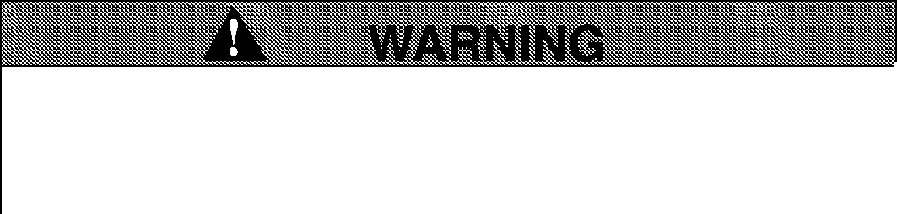

**AVOID EXHAUST FUMES!** DO NOT run engine in an enclosed area. ALWAYS provide good ventilation and wait until hazard has been removed.

1. Check the fluid levels as follows:
   1. Start the engine and allow it to heat to operating temperature. DO NOT operate engine for more than two minutes.
   2. Shut the engine off, wait for engine to cool, and be sure the engine oil level is between the full and add marks on the dipstick. If it is below the add mark, add recommended oil. DO NOT overfill.

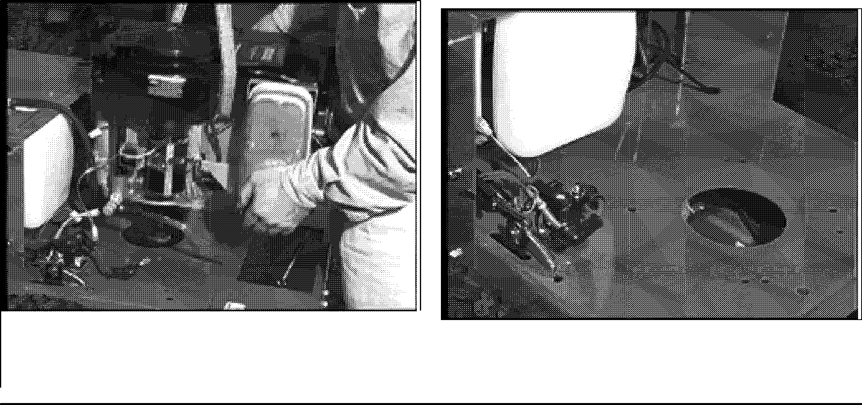

Figure 23

Figure 22

**DRIVE TRAIN 915 EZRIDER SERVICE MANUAL**

## SECTION 5: DRIVE TRAIN



* 1. HYDRO TRANSMISSION TROUBLE SHOOTING

The following trouble shooting chart is to be used to isolate hydro transmission problems and give possible causes and corrective action responses.

The trouble shooting key is generic and can be used for several types of transmissions. Use only those possible causes and corrective actions that apply to the EZRider.



|  |  |  |  |  |
| --- | --- | --- | --- | --- |
| **TROUBLE**  **Axles Will Not Turn** | **POSSIBLE CAUSES**  (Refer to Key Below)  1, 7, 8, 12, 16, 18, 28, 32, 38, 42, 46 | **CORRECTIVE ACTION**  repair or replace | | |
| **Difficult Starting** | 1, 6, 7, 8, 12, 16, 25,26, 28, 38, 42, 46, 55 | repair | or | replace |
| **Erratic Running** | 1, 4, 6, 7, 8, 12, 18, 25, 26, 28, 42, 46, 55 | repair | or | replace |
| **Jerky When Starting** | 1, 4, 7, 8, 12, 18, 28, 38, 46 |  | | |
| **Jumps Out of Gear** | N/A | repair | or | replace |
| **Knocking** | 4, 8, 12, 18, 28, 37, 42 | repair | or | replace |
| **Loss of Power or System** | 4, 12, 18, 28, 37, 42,46 |  | | |
| **Noisy** | 4, 12, 18, 26, 28, 32, 37, 42 | repair | or | replace |
| **Oil Leakage** | 4, 22, 51, 16 | repair | or | replace |
| **Operates Hot** | 4, 16, 28, 32, 35, 42 |  | | |
| **Operates in One Direction Only** | 1, 8, 12, 30, 46 |  | | |
| **Pump Failure** | 4, 12, 37 | repair | or | replace |
| **Speed Loss Under Load** | 1, 6, 11, 28, 37, 46, 51 | repair | or | replace |
| **Speed Loss Under Load** | 1, 4, 7, 12, 18, 28, 26 | repair | or | replace |
| **Will Not Drive** | 1, 7, 8, 18, 28, 37, 38, 46, 48 |  | | |
| **Will Not Shift** | | repair | or | replace |

|  |  |  |  |  |
| --- | --- | --- | --- | --- |
|  | | **TROUBLE SHOOTING KEY** |  | |
| 1. Inspect control linkage | 22. | Inspect hoses and lines for wear | 43. | Burrs on gearing |
| 2. Inspect acceleration valves | 23. | Inspect implement relief valve | 44. | Gears improperly installed |
| 3. Inspect charge check valves | 24. | Inspect charge pump | 45. | Forks & rod assembly incorrectly installec |
| 4. Incorrect grade of lubricating oil | 25. | Bad transmission pump | 46. | Shifting keys broken or damaged |
| 5. Low cranking speed | 26. | Overheating | 47. | Shifting washer in backwards |
| 6. Controls not in correct operation position | 27. | Cold running | 48. | Shifter/Brake shaft keyways damaged |
| 7. Belts are missing, to tight, loose or glazed | 28. | Bad transmission motor | 49. | Unit clutch not disengaging |
| 8. Overload of vehicle | 29. | Check system pressure | 50. | Shifter stop assembled backwards |
| 9. Replacement parts damaged | 30. | Shift rod grooves worn | 51. | Improper fit of case to cover |
| 10. Replacement parts improperly installed | 31. | Reverse chain broken | 52. | Dowel pins not installed |
| 11. Improperly torqued attaching screws | 32. | Damaged cooling fan | 53. | Differential bevel gears broken |
| 12. Air in hydraulic system | 33. | Inspect auxiliary relief valve | 54. | Spring in shifter weak or broken |
| 13. Broken shifter stop | 34. | Inspect cooling fan | 55. | Worn or stripped gear teeth |
| 14. Inspect charge check valves | 35. | Inspect transmission cooling fins |  |  |
| 15. Inspect acceleration valves | 36. | Worn or damaged bearings |  |  |
| 16. Check oil level-gear box sump or reservoir | 37. | Metallic pieces or foreign objects in unit |  |  |
| 17. Inspect heat exchanger | 38. | Inspect for loosely mounted components |  |  |
| 18. Inspect by-pass valve | 39. | Steering column loose or binding |  |  |
| 19. Inspect charge pressure | 40. | Pressure relief valve sticking open |  |  |
| 20. Inspect inlet filter | 41. | Pressure relief valve sticking closed |  |  |
| 21. Inspect charge relief valve | 42. | Broken relief valve spring |  |  |

**915 EZRIDER SERVICE MANUAL DRIVE TRAIN**

* 1. **FLUID RECOMMENDATIONS (EATON)**

Use premium Hydraulic oil having a viscosity equivalent to Mobil DTE-26 or SAE 20W-20, SAE 30 or SAE 40.

The fluid should be chemically stable, incorporating rust and oxidation inhibitors.

Assembly

Part Number Input Rotation

(CW or CCW)

Customer \

Part Numb XXX-XXX XXX

( if RequiredX4XXXX

Date Build Cc

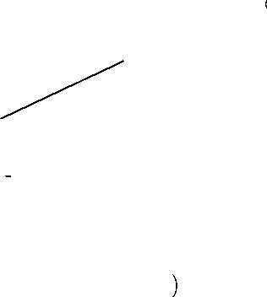XXXXXFactoJ mmxxx IkiebuiJ

Code

A reputable supplier can help you make the best

Original Build Factory Rebuild

( example - 010195 )( example - 010195 11

**l**

selection of hydraulic fluid for use in your Eaton transaxle.

**NOTE:** If the natural color of the fluid has become black or milky, it is possible that an overheating or water contamination problem exist.

01 01 95

L Year Day

**l_**

Month

01 01 95 11

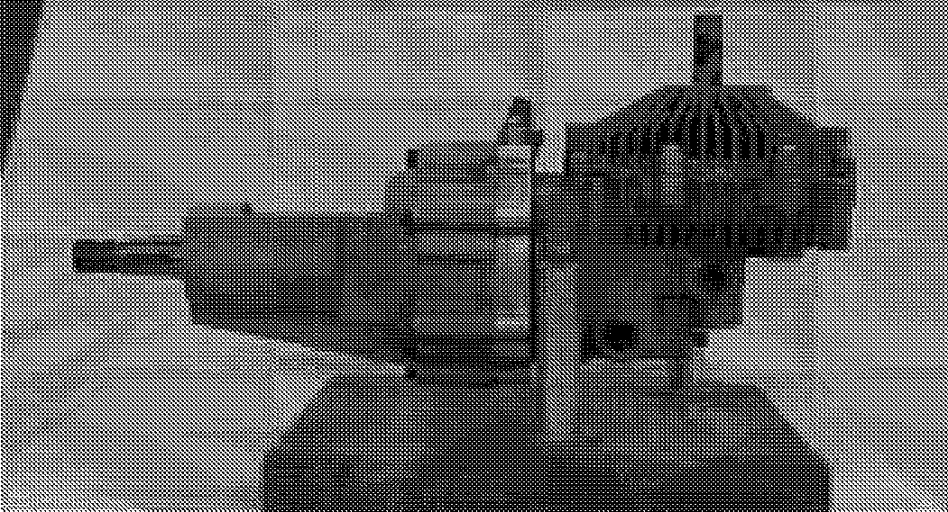Month

**ll**

Number c

Timer Rebuilt

* 1. **EATON HYDRO TRANSAXLE REMOVAL**

Refer to Figure 24 for removal of the transaxle.

1. Raise and support the rear of the unit on jack stands.
2. Remove the right and left wheels and set aside.
3. Release the main drive idler tension spring and remove the main drive belt from the unit.
4. Release the jackshaft drive idler tension spring from the right side of transaxle subframe .
5. Remove the ball joints on both transaxles and lower the shift arms. Remove the parking brake linkage from the left transaxle.
6. Do not change the ball joints center distance for reassembly.
7. Clamp off and remove the hydraulic hose at the expansion tank hose and filling on expansion tank.
8. Place a floor jack under the transaxle assembly to support the unit while removing the supporting hardware.
9. Remove the three cap screws on each side of the frame and lower the transaxle out of the frame.
   1. **AXLE CODES**

Repair information applies to the Eaton 788 series hydrostatic transaxle.

The transaxle identification information is located opposite the input shaft, on the back of the housing assembly.

Figure 24

* 1. **EATON TRANSAXLE REPAIR**

The following procedures describe complete disassembly and reassembly of the transaxle.

The level of cleanliness maintained while servicing the transaxle could affect its performance. Work in a clean area. After disassembly, wash all parts with clean solvent and blow dry with air. Inspect all mating surfaces.

Replace any damaged parts that could cause internal leakage. Do not use abrasive materials, paper, files or grinders on finished parts.

The following list indicates tools and supplies required for disassembly and reassembly of the transaxle:



•

•

•

•

•

•

•

•

•

•

•

•

•

•

•

3/8 in. Socket or end Wrench 1 in. Socket or end Wrench Ratchet Wrench

Torque Wrench 300 lb-in [34 Nm] 5/32 Hex Wrench

Small screwdriver ( 4 in. [102 mm] to 6 in. [150 mm] long)

No. 5 or 7 Internal Retaining Ring Pliers No. 4 or 5 External Ring Pliers

Pipe or Hydraulic Tubing (1 in. O.D. x 6 in. long)

Piece of pipe or Hydraulic Tubing

(1-1/8 in. [29mm] O.D. x 6 in. [150 mm] long) Small Arbor or Hydraulic press

3 or 4 Large Rubber Bands

Light Petroleum Jelly ( such as Vaseline ) Molybdenum Grease

Loctite 518 Master Gasket

**Tool and Supply List**

**DRIVE TRAIN 915 EZRIDER SERVICE MANUAL**

1. Seal all open ports before cleaning.
2. Thoroughly clean the transaxle exterior.

**NOTE:** Whenever a transaxle is disassembled, our recommendation is to replace all seals. Lubricate the new seals with petroleum jelly before installation. Use only clean, recommended hydraulic fluid on the finished surfaces during reassembly.

**NOTE:** It is best to drain the transaxle through the case drain port with the input shaft in the horizontal position.

Axle Housing ( Planetary Ass

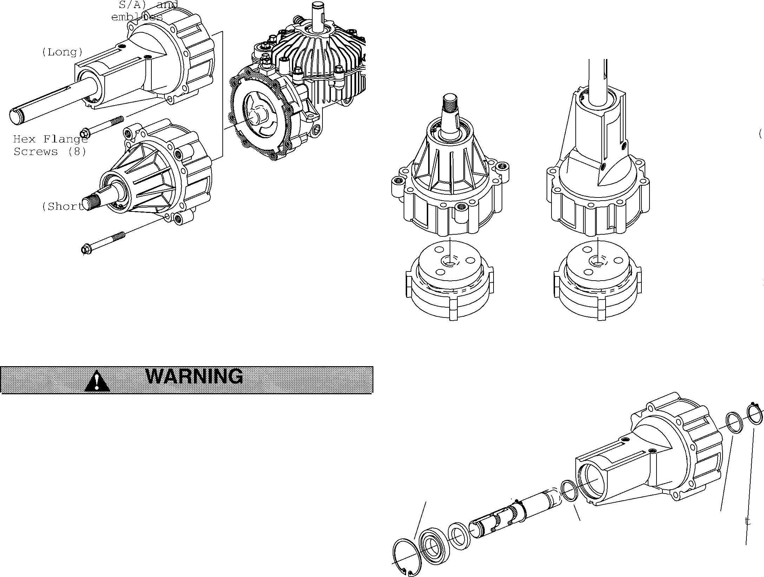

end of the axle shaft in the up position. Using a No. 5 or 7 internal retaining ring pliers, remove the ball bearing retaining ring from the axle housing.

1. Reposition the axle housing with the splined end of the axle in the up position. Using a No. 4 or 5 external retaining ring pliers, remove the retaining ring and thrust washer from the axle shaft.
2. Remove the axle from the axle housing by using a small press or by tapping the spline end of the axle shaft with a plastic head hammer. This will dislodge the seal and bearing from the axle housing.

(Short)

Axle Housing (Long)

Hex Flange Screws (8

Figure 26

Planetary Asse

* 1. **AXLE HOUSING DISASSEMBLY**

Refer to Figures 26 - 30 for axle housing disassembly and assembly.

Figure 27

Axle Housing

Axle Shaft with One Reta a Ring Remaining

**Ri**

1. Use a 3/8 inch socket or end wrench to remove the

Retaining

Thrust

Washer

Thrus Washer

**READ and Understand all Safety Rules.** Do not service the unit without instruction or taking the necessary safety precautions.

Be certain jack stands or blocks being used are stable and strong enough to support the weight of the unit.

eight hex flange screws from the axle housing

assembly.

1. After removing the flange screws, carefully remove the axle housing assembly from the housing

---.-----Radial Lip Bearing, Ball

Seal

Retaini

Ring

assembly.

IMPORTANT: Retain the planetary assemblies in the axle housing assembly during removal. Oil that has been contaminated must be replaced.

1. To disassemble the axle housing assembly, carefully position the axle housing assembly on a clean flat surface, then separate axle housing from the planetary assemblies (Figure 26).
2. Position the axle housing assembly with the output

Figure 28

**915 EZRIDER SERVICE MANUAL DRIVE TRAIN**

1. After separating the axle shaft from the axle housing, remove the ball bearing, seal and thrust washer from the axle shaft. The thrust washer may be in the axle housing.

**NOTE:** The retaining ring remaining on the axle shaft

inspection and cleaning, first remove the ring gear (from the secondary carrier/planet gears).

9. Put a slight squeeze on the secondary carrier planet gears, and remove the three secondary planet gears, and carrier.

need not be removed. 10. Turn the assembly over and remove the secondary

8. To disassemble the planetary assemblies for planet gears for inspection and cleaning.

Exploded View

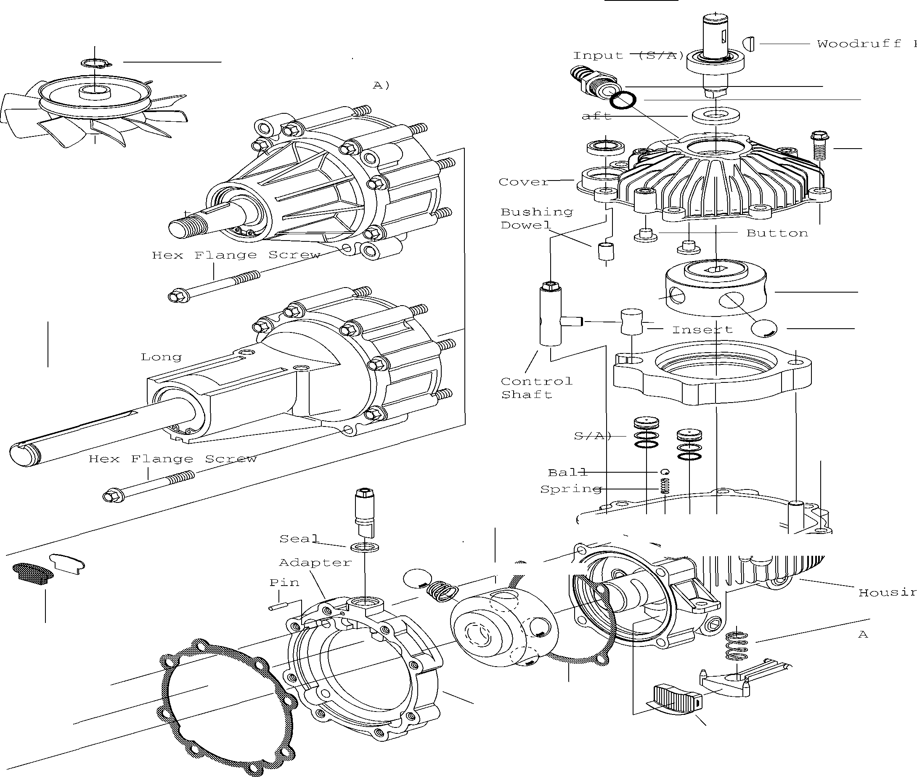

Retaining _____ Ring (Internal

Retaining

--- Fan/Sleeve

Ring

(S/

(External)

Shaft,

**Seal,**

Input Sh

**Seal,** Contro±-- Shaft

Barb Fit

0-rir

Sere, Self Tap

I Axle Housing

(S/A) - Shor

Pump RotoJ

Axle Housing (S/A) -

Ball Piste

- Cam Rir

Piston (

Brake Shaft -

Ball pis ton

Motor Ro tor

Gasket

I Spring

I

if-}J./,..'<J"JJi1! :Timiii-i

k'

l/2

Screw Self Tap

Fricti n Pad

(l or Piece)

I

Sprir

ctuat

Gasket

o:R

/

Push FilterPin

Sea

Adapter

Figure 30

**915 EZRIDER SERVICE MANUAL**

Retainin Bearing, Balling

Axle

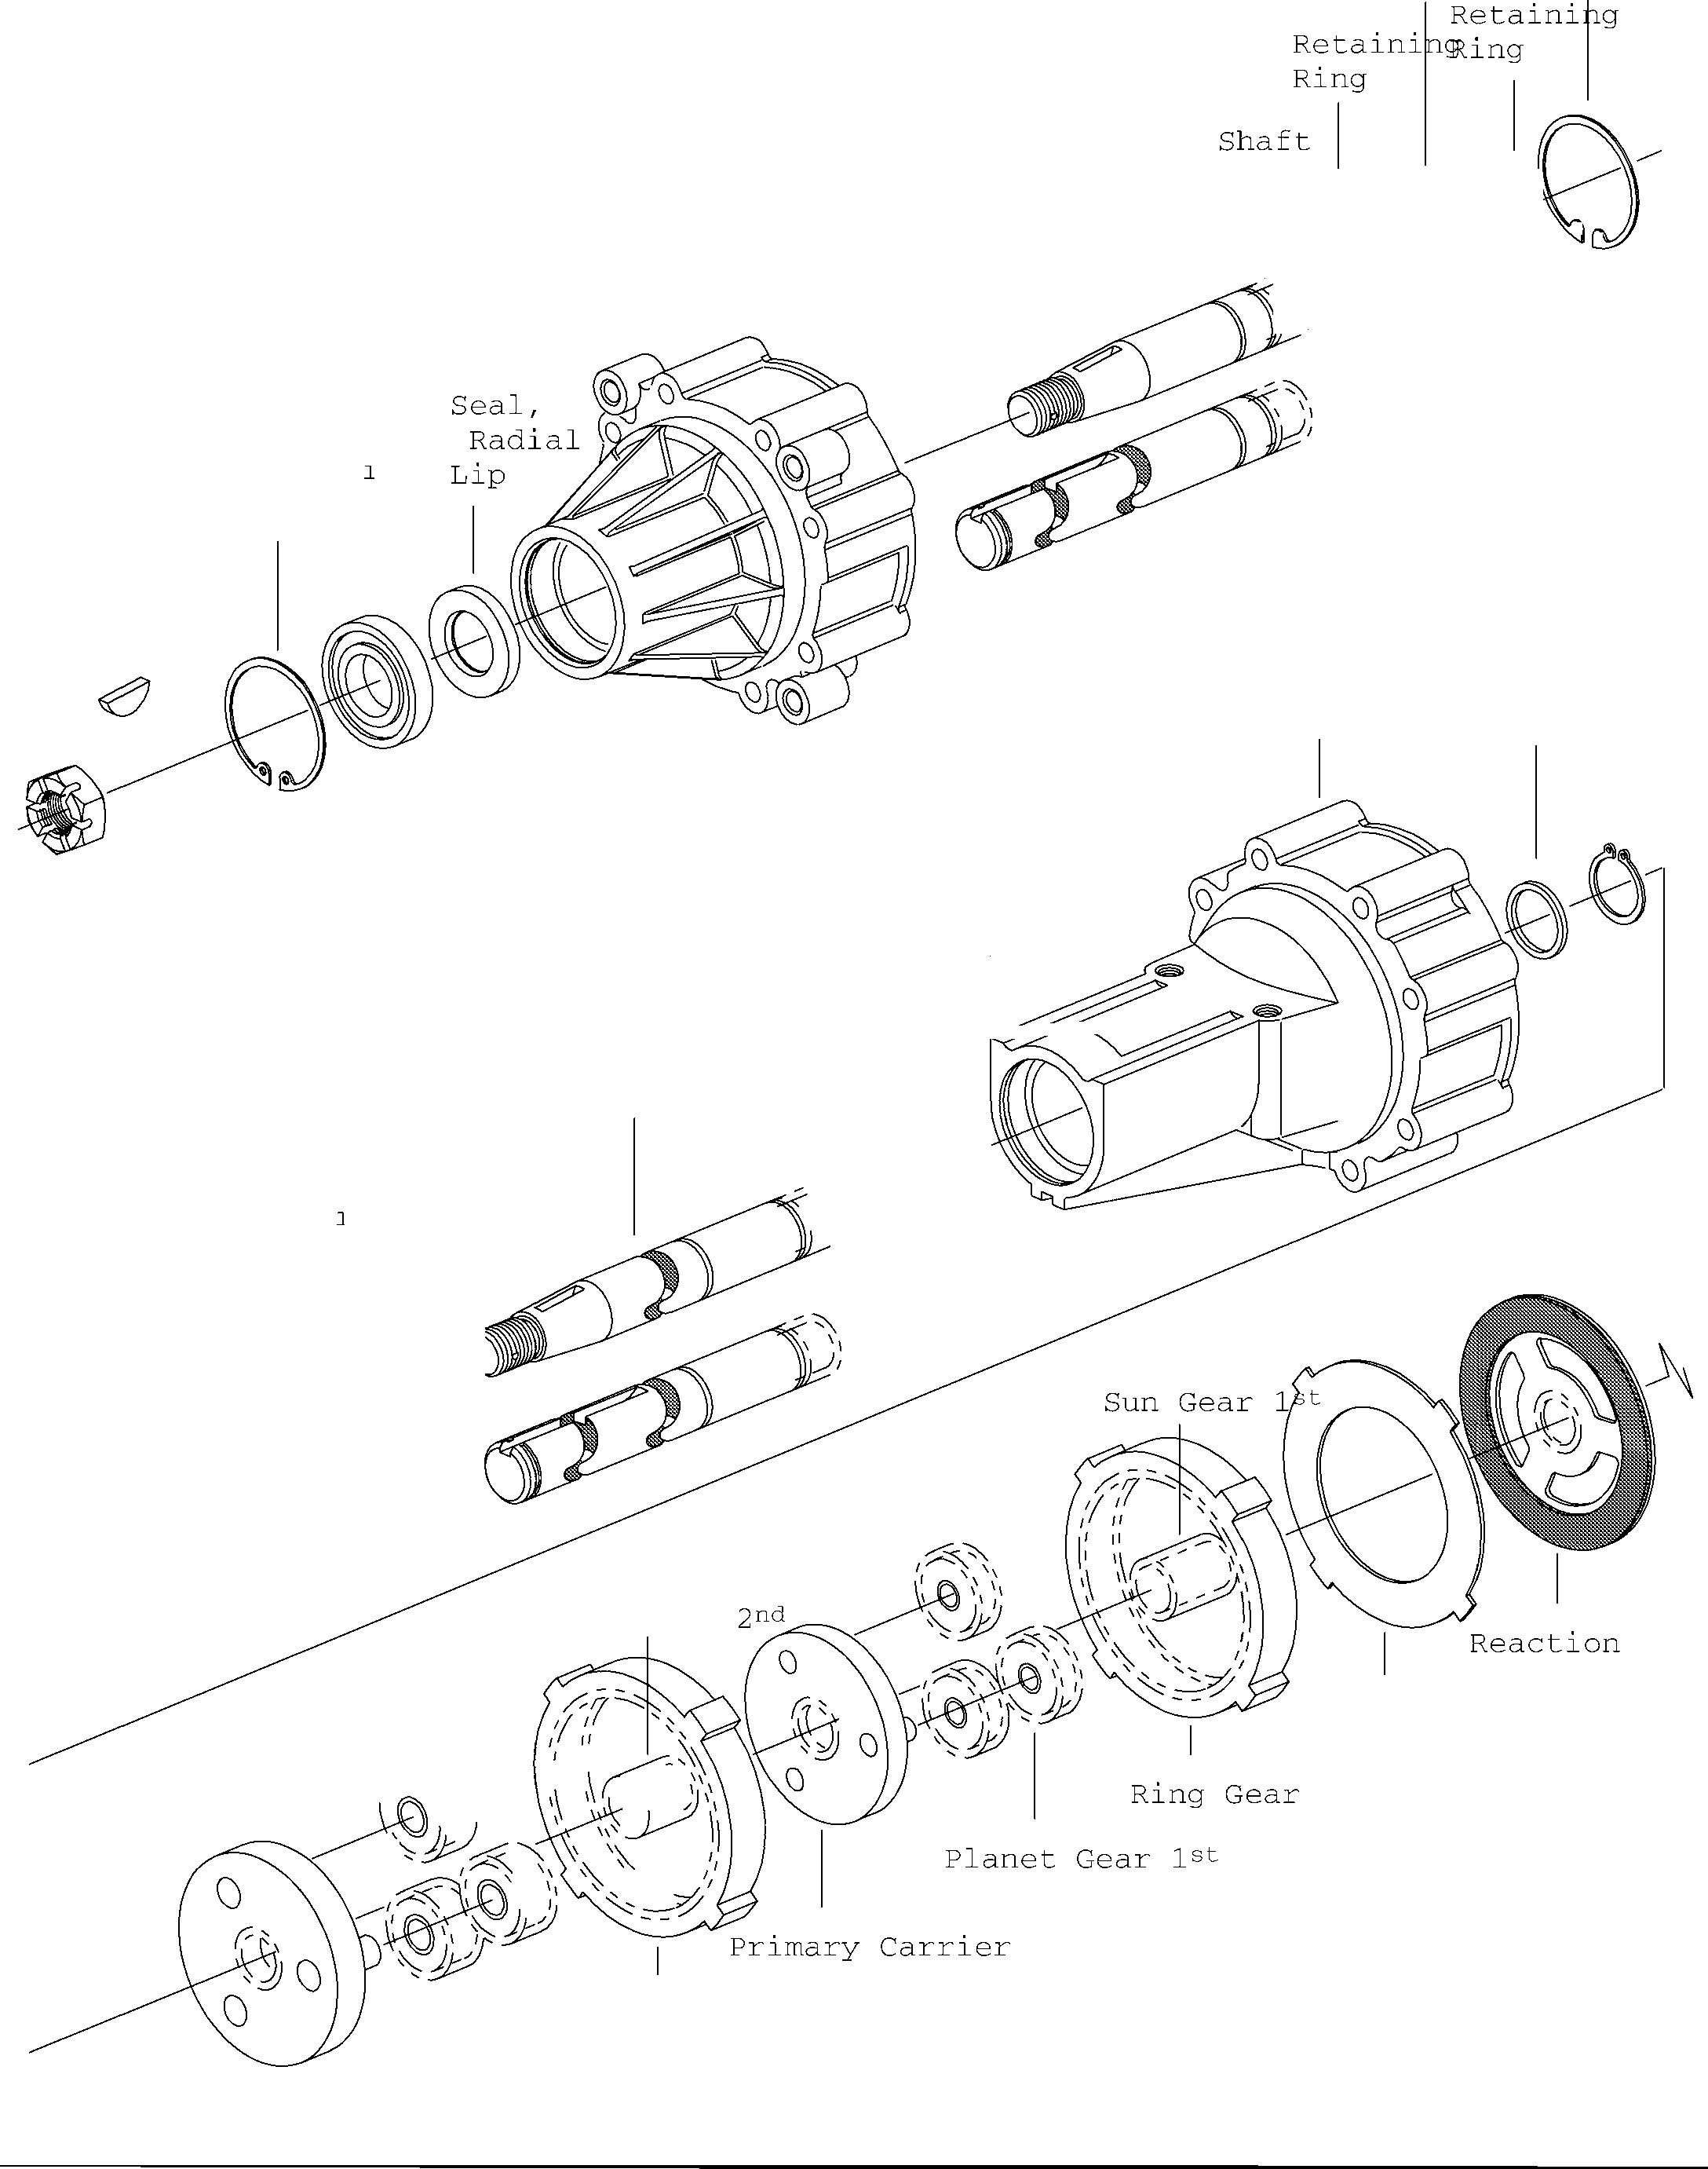

Slotted Hex

Nut

Woodruff Key

**Axle** Hous J n@X le Housing S/A - Sho t

Bearing, Ball I

Retain'ng Ring

Axle HousJng S/A - Lon9

*"') ··*

Retainin Ring

Thrust Axle Housing Washer

Slotted Hex

Nut

Woodruff Key

Bearing, Ball

Seal, Radial

Lip

Axle Shaft

Thrust Washer

: ;i n r --------=---"-'---

*,'otv-0*

Retain'ng Ring

I

*) ))*

Sun Gear

Plat

Backup Plate

Secondary Ca, [, _ _ ,

11

I I , , I,. .-:;:

\ \ \

\ *I* j'

/

,,.. ,,,,.

\ - '

\

\ \

I

"

'

Ring Gear

Planet Gear 2nd

**01546200 Orig. 9/98**

**Ariens®**

**5-22**

**DRIVE TRAIN 915 EZRIDER SERVICE MANUAL**

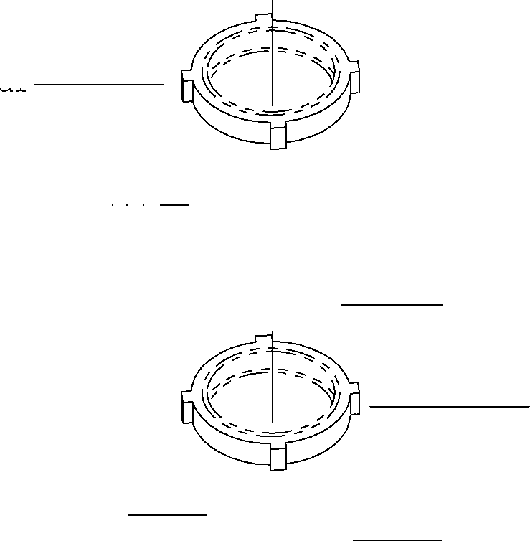Ring Ge=----

Secondary Carrier - Planet Gears, Sun Gear, SE

e ----

-----Ring GE

Primary Car= r"'-i"-e-r""- -

t --Planet Gears

Figure 31

1. Remove the sun gear and remaining ring gear.
2. Put a slight squeeze on the remaining carrier planet gear, remove planet gear and carrier from the backup plate.
3. Both the primary and secondary carrier assemblies. The planet gears may be removed for inspection and cleaning (Figure 31 ).
4. Remove the backup plate and reaction plate from the primary sun gear.
5. Remove the primary sun gear from the motor rotor assembly.
6. Remove the small friction brake pad assembly from its recessed pocket located in the adapter (brake shaft section).
7. Remove the gasket rom the adapter (brake shaft section).

**NOTE:** This gasket may have remained on the axle housing.

1. Remove the 4 self tapping screws from the adapter (brake shaft section), and remove this section and the gasket from motor rotor end of housing.
2. This adapter (brake shaft section) contains a pin to retain the brake shaft; drive this pin out and remove brake shaft. Shaft seal can be removed and replaced. Install brake shaft and pin.
   1. MOTOR ROTOR DISASSEMBLY

Refer to Figures 25-28 for motor rotor disassembly.

**IMPORTANT:** Use extreme care when removing the motor rotor assembly. The ball pistons are spring loaded in the bores and must remain intact because each ball piston is matched to its respective bore.

To remove the motor rotor assembly (Figure 24):

1. Place a separate motor race on top of the existing motor race in the housing assembly. Hold the separate race securely in position.
2. Carefully pull the motor rotor assembly outward until the ball pistons are fully engaged in the groove located in the center of the separate race.
3. Remove the rotor assembly and race together as a set, handling the motor rotor assembly only.

Motor Rotor /Ba I I

Friction

Pin

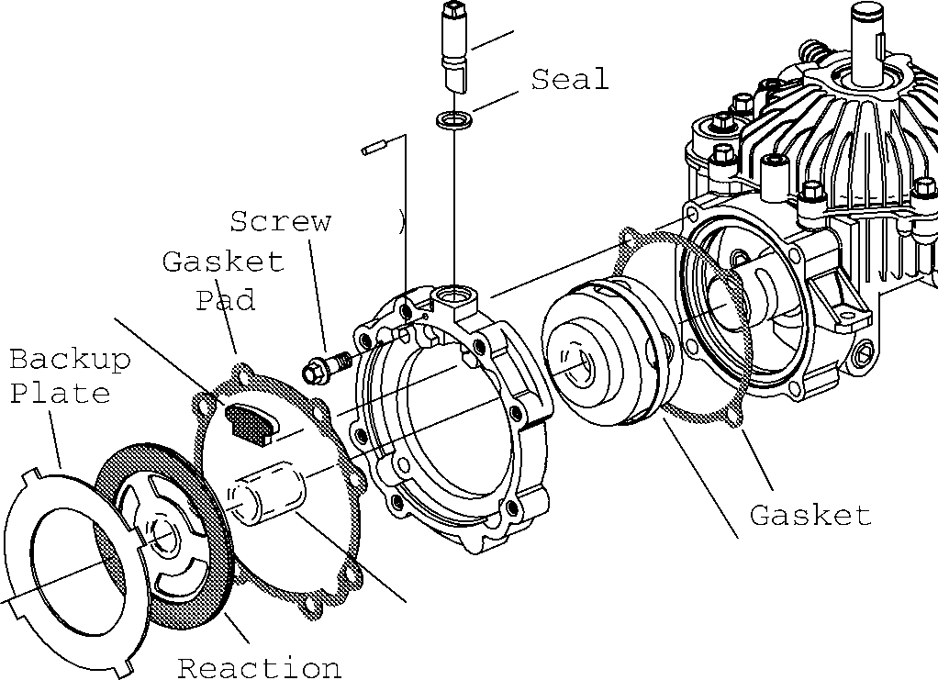\

Self Tap

**(4**

Brake Shaft

11

Motor

Figure 25

**NOTE:** If a separate motor race is not available, work a wide rubber band around the outside of the motor rotor to hold the ball pistons in their bores (Figure 25).

1. It is essential that the ball pistons be retained in their bores during handling. This is especially true for the motor rotor, as the motor ball pistons are spring loaded in the bores.
2. Reposition the housing assembly. Using a 3/8 inch socket or end wrench, remove the self tap screws

Sun \

Rotor/Ball (S

from the cover assembly.

Gear with Rubber B Pla(:Jeirs t)Z\dapter Bal 1 Retainer

Figure 24

1. With all self tap screw removed (7) carefully separate and remove the cover from the housing assembly.
2. Turn the cover assembly over and remove the two buttons.



**915 EZRIDER SERVICE MANUAL DRIVE TRAIN**

Barbed Hose ng

Q- --- Retaining Rii (J-I-- Input Shaft (

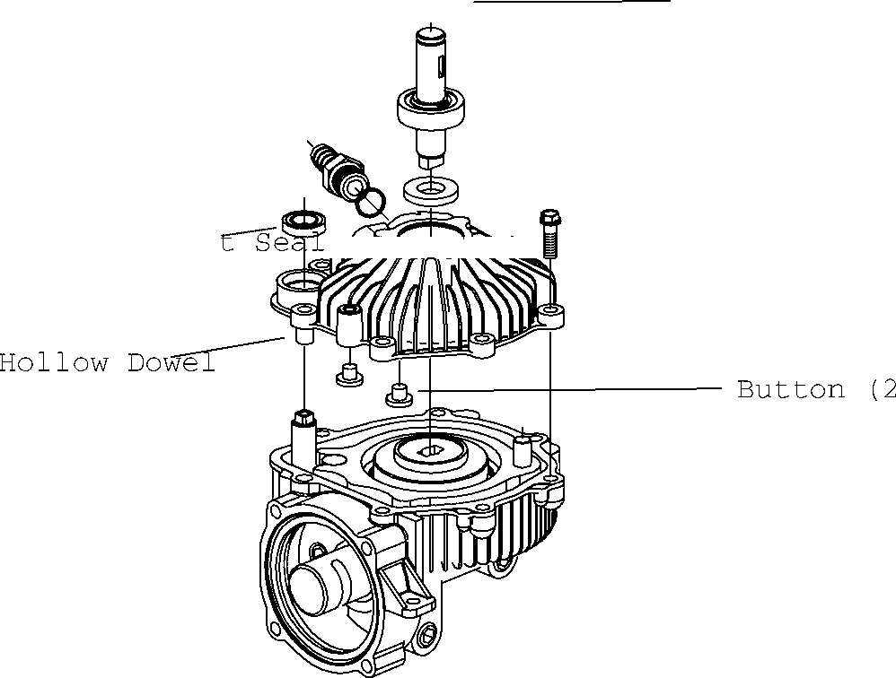-- Input Shaft S

**IMPORTANT:** When using a scraper to remove sealant, do not damage the sealing surfaces.

1. Remove the control shaft and insert from the housing and cam ring assembly.
2. Remove the cam ring insert from the control shaft.

Control Shaf !ll -- **Self** Tap Screw

-_Cover

Figure 26

**NOTE:** These two buttons may have dropped out in housing assembly during removal of the cover.

1. Using a No. 5 or 7 internal retaining ring pliers, remove the input shaft retaining ring.
2. Reposition and support the cover allowing room for shaft removal. With the input shaft in the down position, use a plastic head hammer or press to remove the input shaft assembly from the cover.
3. No further disassembly of the shaft and bearing assembly is required as they are serviced as an assembly.
4. Using a screwdriver or similar tool, drive the input seal from the cover.
5. To remove the control shaft seal, reposition the cover. Using a small screwdriver or similar tool, pry the control shaft seal from the cover.
6. Remove the Master Gasket material from the cover and housing. Carefully remove the flange sealant by using a scraper or cleaning solvent.
7. Remove the cam ring assembly. Do not remove the dowel pin pivot from the housing.
8. Carefully remove the pump rotor assembly from the housing, making sure the ball pistons are not dislodged from their bores.

**IMPORTANT:** It is essential that the pump rotor assembly remain intact during handling as each ball piston is matched to its respective bore.

1. Install a wide rubber band around the pump rotor to retain the ball piston in their bores.

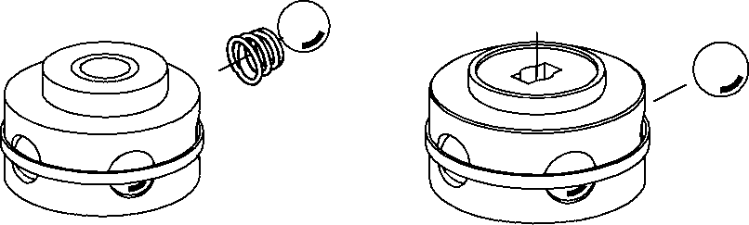

Motor Rotor/Ball (SM.i)mp Rotor/Ball (S/A)

Figure 28

* 1. **PUMP AND MOTOR ROTOR INSPECTION**

Refer to Figure 29 and 30 for Inspection.

1. Disassemble and Inspect the rotor assembly in the following manner.
2. Remove the piston balls from the rotor, one at a time, working clockwise from the letter stamped in the rotor face.
3. Place the piston balls in a prepared container ( use container such as an ice cube tray to hold the balls).

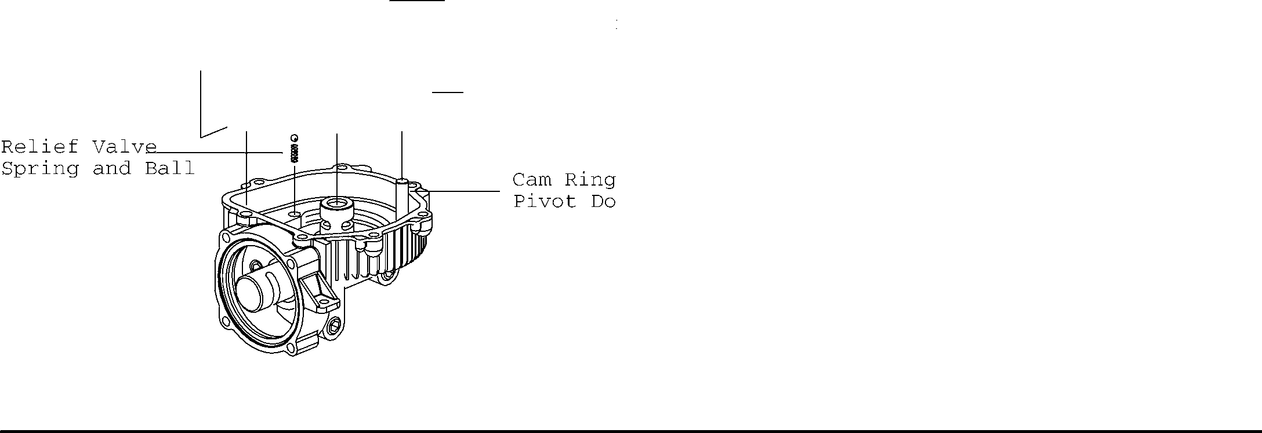

--

Control Sh-a-f-t--

Pump Rotor /B, (S/A) with R Band Retaine Control Shaft

Cam Ring U

**NOTE:** The balls must be replaced in the same bores from which they were removed because they are all select fit.

4.

5.

6.

7.

Figure 27

Check for broken or collapsed springs in the motor rotor.

When broken or collapsed springs are found with no other irregularities, the springs may be replaced individually without replacing the complete motor rotor assembly.

Inspect the piston balls. They must be smooth and completely free of any irregularities.

Inspect the rotor bores, rotor bushing and pintle journals for irregularities for excessive clearance.

**DRIVE TRAIN 915 EZRIDER SERVICE MANUAL**

1. The balls piston to rotor bore clearance is select fit electronically from .0002 inch [005mm] to .0006 inch [015mm]. When irregularities are noted, replace the complete rotor assembly.
2. Install the ball pistons in their matching bores. Hold them in place with a rubber band or separate race.
3. The pump and motor journals for any irregularities. If any are found, the housing must be replaced.
4. In most cases, we do not recommend removal of the dampening pistons for inspections or cleaning. Normal flushing should be all that is required for cleaning.

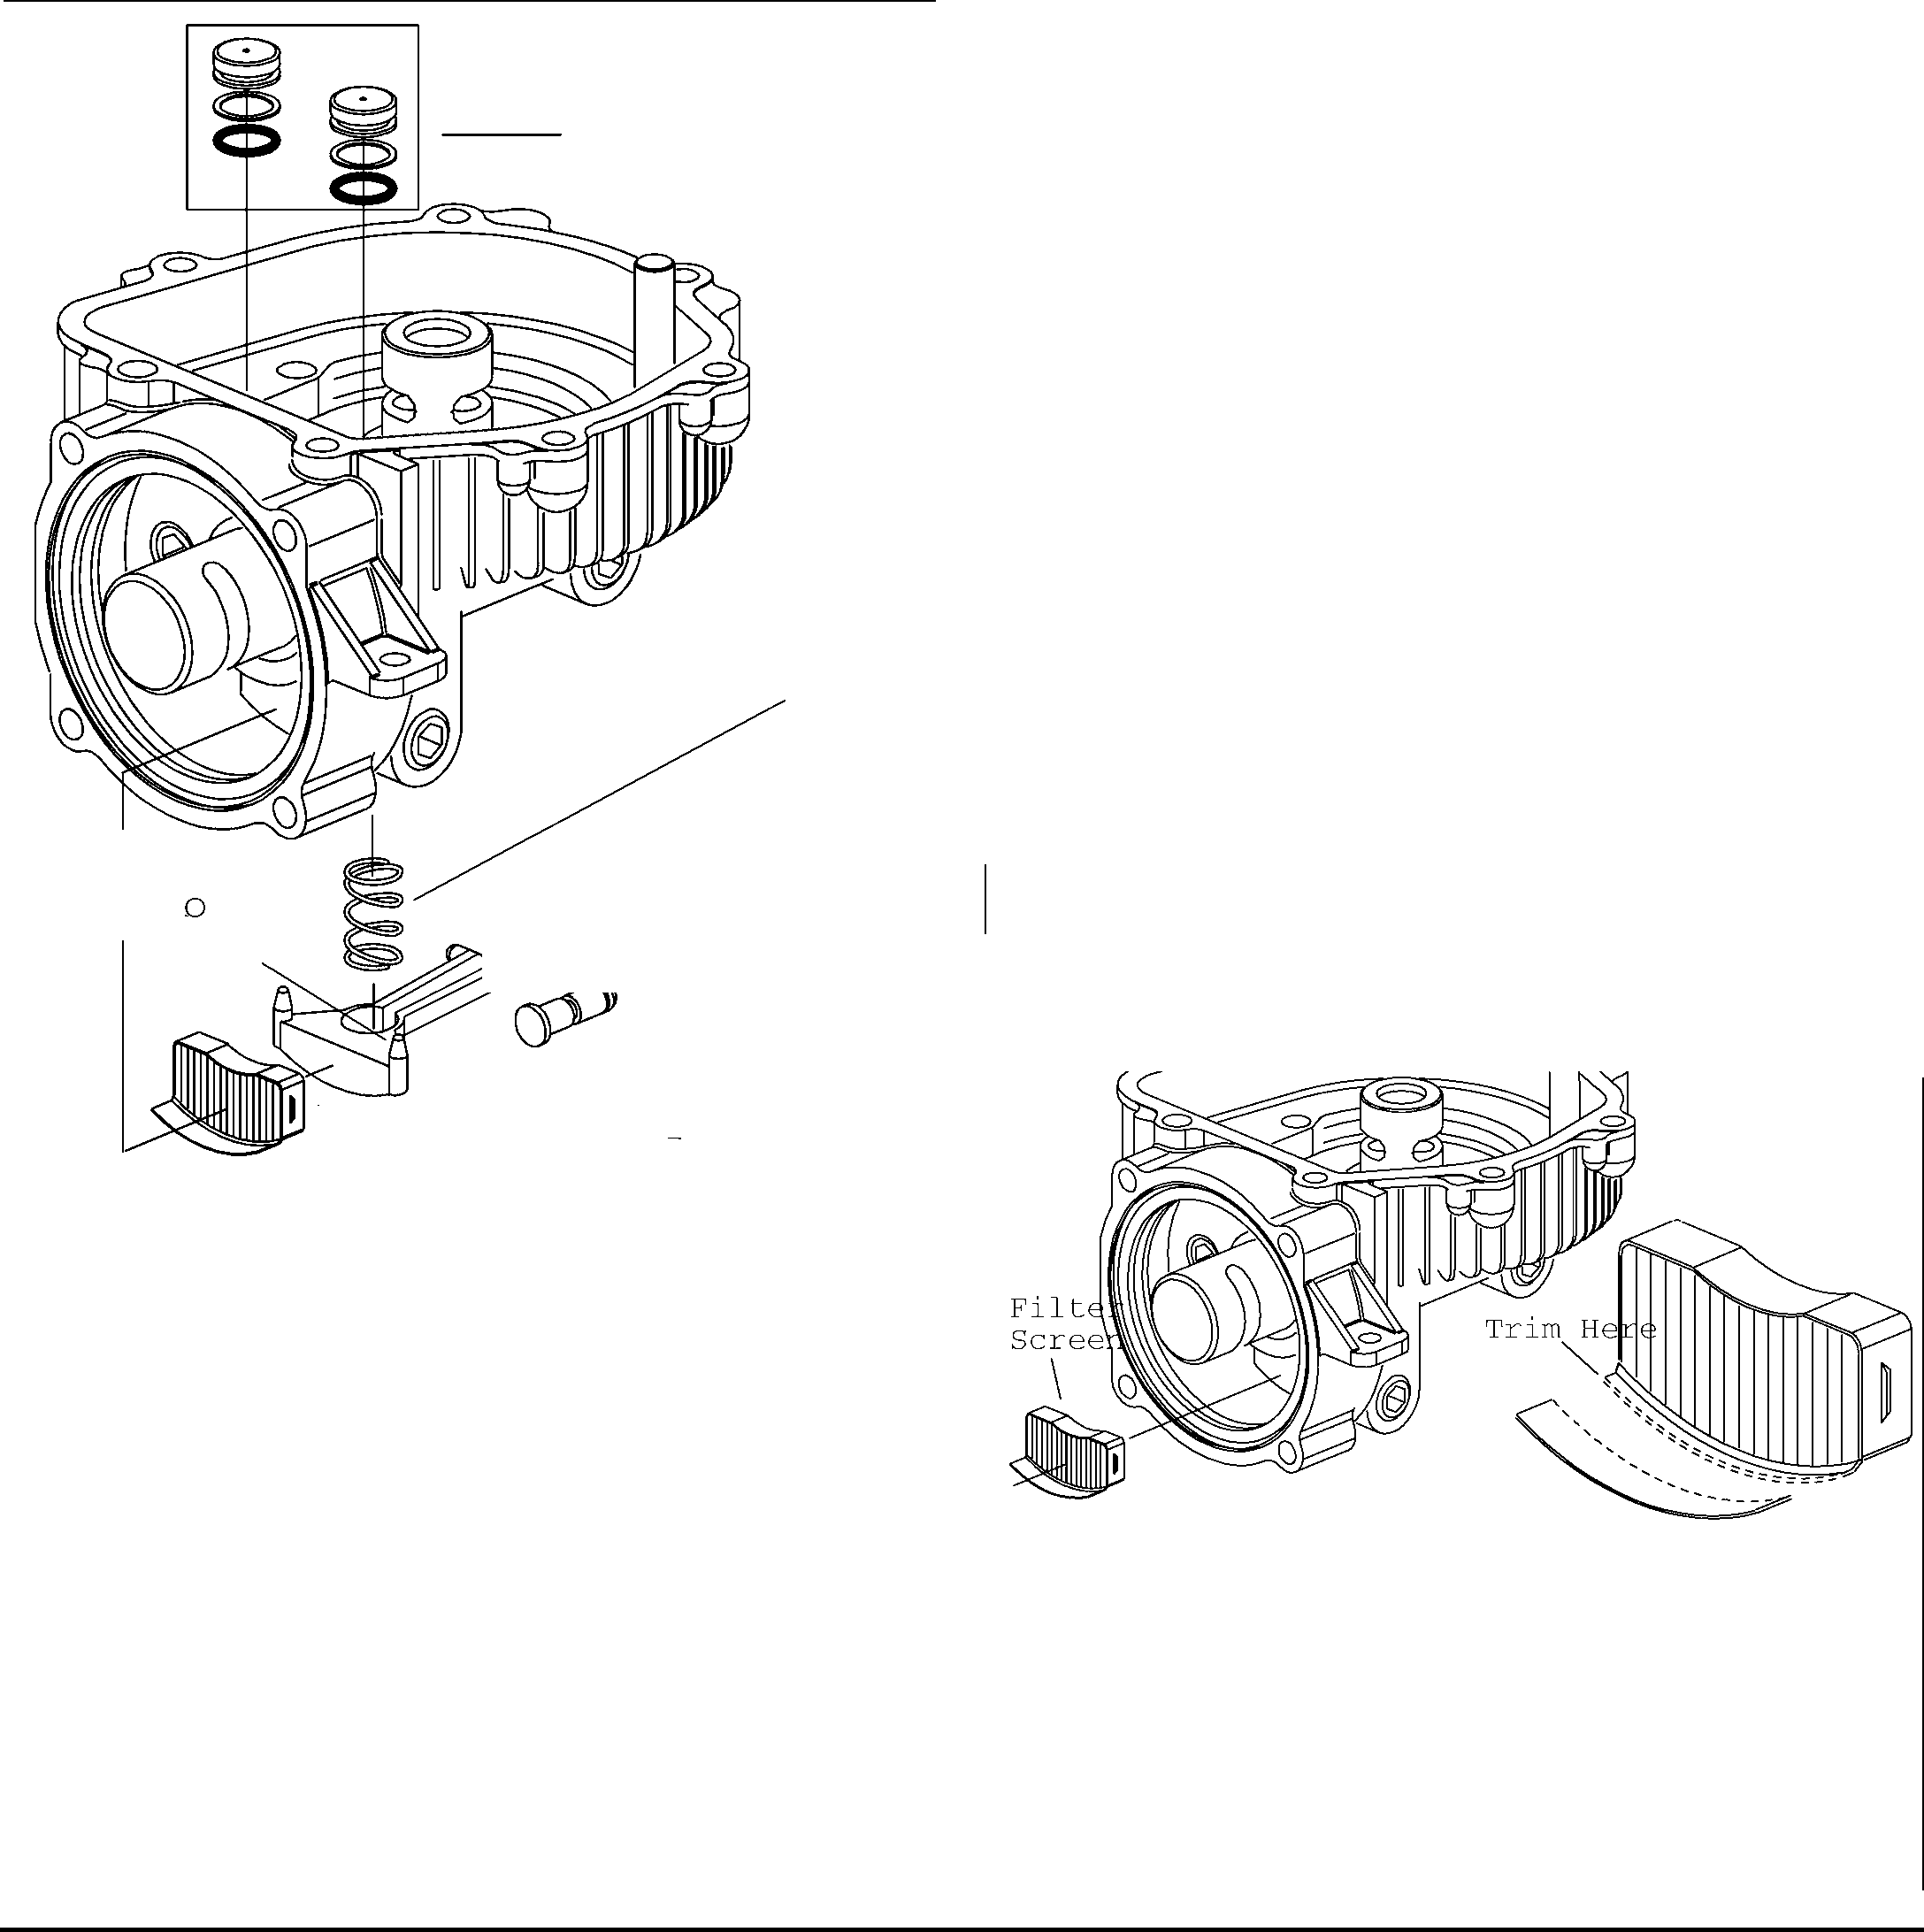

Dampening Pis

Sprir

Dump Valve Actuat r

Dump ValvE Actuator I

-

s e a

-Actuator

--------=--- Fi 1ter

Figure 30

- R etaining

Sc

* 1. TRANSAXLE DUMP VALVE

Refer to Figure 30 and 31 for the Transaxle Dump Valve

**NOTE:** Remove the dump valve assembly only if actuator is broken or actuator pin seal leaks.

1. Remove the filter unit from inside the housing cavity.
2. The actuator has two pivot pins that must be forced together, releasing it and the spring from the housing.
3. Remove the retaining ring from he actuator pin. This will allow the actuator pin to be removed from inside the housing cavity.
   1. TRANSAXLE REASSEMBLY

Refer to Figure 31-38 for the transaxle reassembly.

1. Before reassembling the transaxle, clean all parts and assemblies with clean solvent and blow them dry with compressed air. Inspect and replace all scratched or damaged parts.
2. Replace all gaskets, seals and seal rings. Lubricate all seals with petroleum jelly (Vaseline) for retention during assembly.
3. Freely lubricate all bearing and finished part surfaces with clean hydraulic fluid to provide lubrication at set- up.
4. Start reassembly with dump valve actuator if this valve needed repair; if no repairs were needed to these dump valve parts skip the appropriate steps.
5. Prelubricate actuator pin with hydraulic oil or petroleum jelly prior to installation onto actuator pin.
6. Coat quad seal with molybdenum grease after installation onto the actuator pin and before installation into housing.
7. Install spring and dump valve actuator into housing.
8. Test action of actuator pin and dump valve actuator. Actuator pin should force dump valve actuator to the maximum height of opening.
9. We do not recommend removal of the check valves for inspection or cleaning. Normal flushing should be all that is required to clean the valves.

Before Trim Filter After Trim

Figure 31

**915 EZRIDER SERVICE MANUAL DRIVE TRAIN**

1. Insert a new filter unit inside the housing cavity, **filter will have to be trimmed because of bearing race interference.** Press on the metal edge only, avoiding damage to filter element. The filter unit has a raised locking tab on two sides. These tabs will hold the filter in place only if filter unit is forced into the cavity far enough to lock filter into side grooves of the housing cavity.
   1. COVER REASSEMBLY
2. Lubricate and install the control shaft oil seal with the seal lip pointing inward. Press or drive the seal into the seal counterbore to shoulder.
3. Lubricate and install the input shaft seal with the seal lip pointing inward. Press or drive the seal to the bottom of seal pocket.

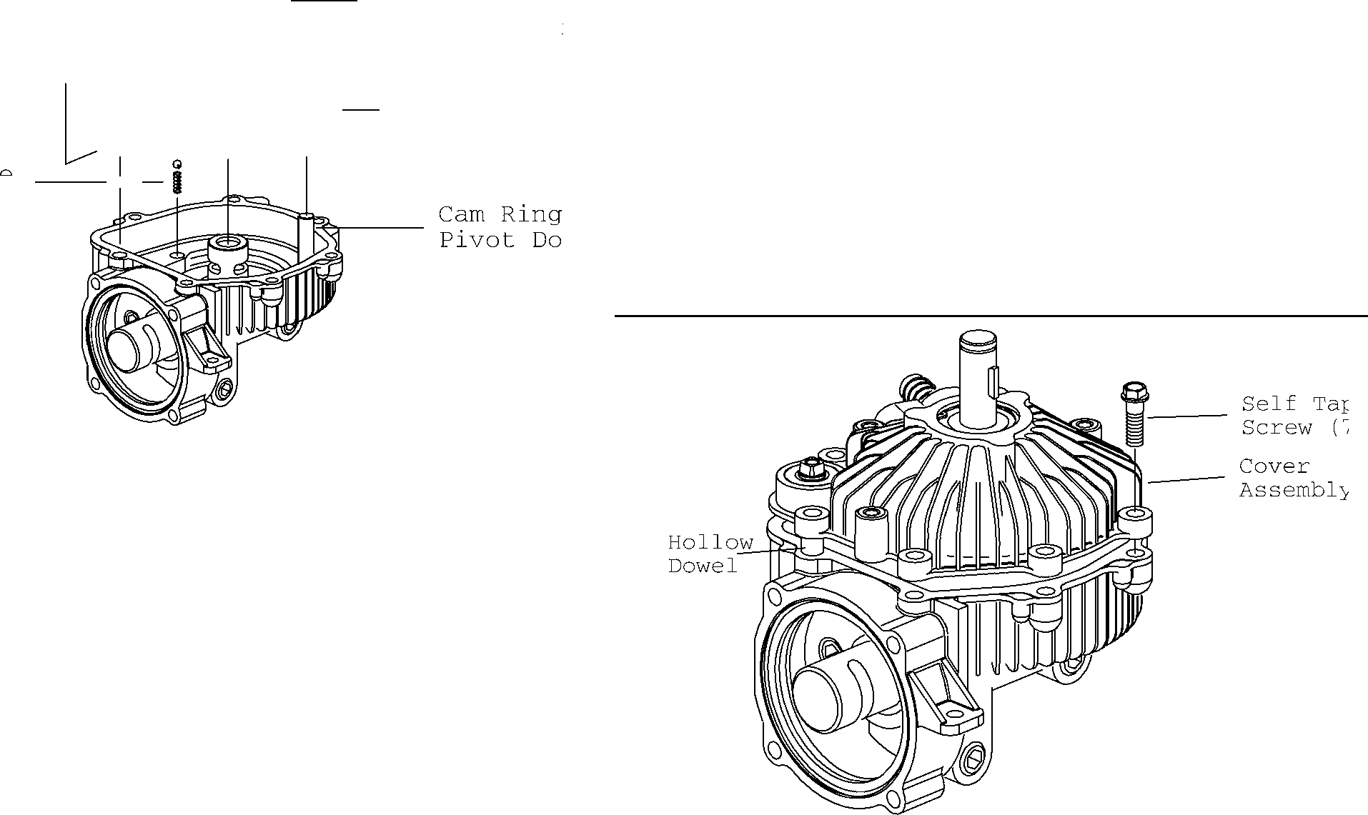

Control Sh-a-tt:-

Pump Rotor/B,

-- (S/A) with R

Band Retaine Control Shaft

Cam Ring (1

Relief Valv ---+-- Spring and Ball

Figure 32

1. Press or drive the input shaft assembly into the cover counterbore to shoulder.
2. Install the input shaft retaining ring, making sure it is firmly seated in the retaining ring groove. After installation of input shaft and retaining ring, shaft must turn freely by hand.
3. To help retain the buttons during assembly apply a small amount of petroleum jelly to them. Install the buttons in the holes located in cover.
4. Install the cam ring pivot dowel, cam ring and pump rotor in the pump journal side of the housing.
5. Remove the rubber band from the pump rotor assembly.
6. Install the cam ring insert on the control shaft pivot dowel.
7. Install the control shaft assembly, first aligning the cam ring insert with the cam ring assembly and then with the housing.

Figure 34

1. Dry up oil on the main housing and cover gasket surfaces using a small towel and rubbing alcohol, wipe the gasket surfaces dry, free of all oil residue.

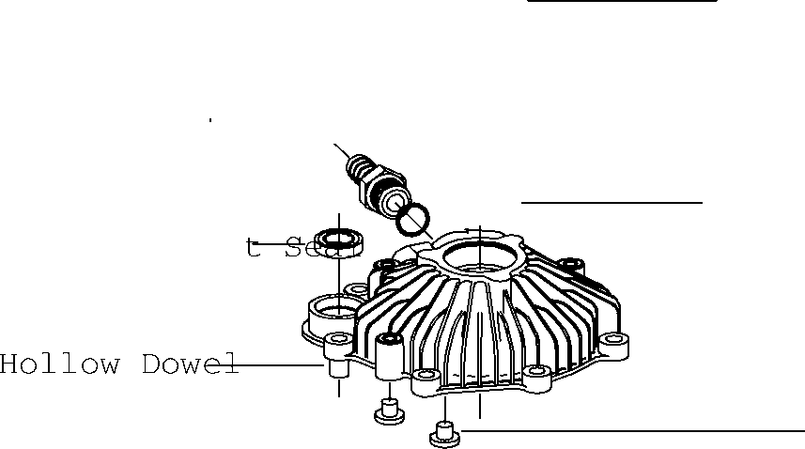

Barbed Hose Fitting i(

*a - -*

(Not Shown) ---------

J

l

Retaining

or ReservG-J..;(_

Input Shaft

- - - -

Input Shaft

Control Shaf

Cover

-------

Button

Figure 33

**NOTE:** Apply a continuous bead of liquid gasket (Loctite 518 Master Gasket) to the housing surface. The continuous bead size diameter should be 1,6 to 3,2 mm[1/16 to 1/8 inch]. Sealant curing time is one hour minimum before test and installation.

1. Install the cover assembly by carefully aligning it with the control shaft, cam ring pivot dowel and pump rotor drive.
2. After engaging the control shaft and pivot dowel in the cover assembly, carefully rotate the input shaft to engage the pump rotor drive tang.
3. When all mating parts are aligned and engaged, the cover assembly with hollow dowel installed will correctly position the cover and housing (figure 26).

01546200 Orig. 9/98 Ariens® 5-26

**DRIVE TRAIN 915 EZRIDER SERVICE MANUAL**

G) 0

0

1. Reposition the axle housing with the output end pointing upward. **Protecting the lip of the axle seal from the retaining ring groove and keyway.** Lubricate and install the seal with the lip pointing inward towards the axle housing.
2. Using a piece of pipe or hydraulic tubing (1.5 inch[38mm] O.D. x 6 inch [150mm] long), press the seal into the counterbore.
3. Again, using a piece of pipe or hydraulic tubing(1.125 inch [29MM] O.D. X 6 inch [150mm] long), press the ball bearing over the axle shaft and into the axle housing.
4. Using a pair of No. 5 or 7 internal retaining ring pliers, install the ball bearing retaining ring in the axle housing.

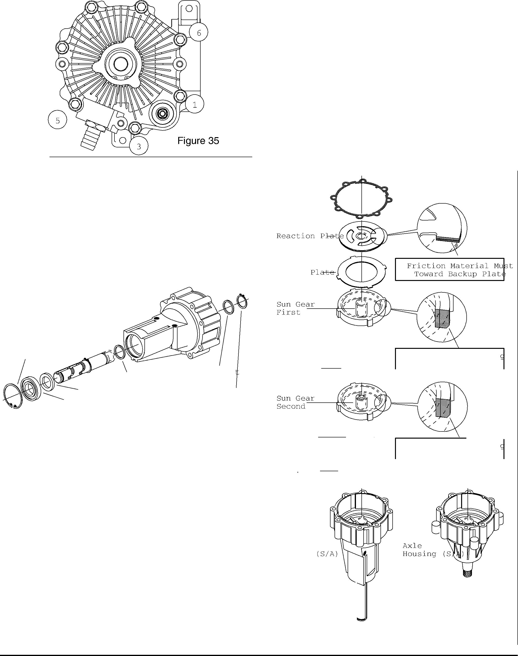

Gas ket------

Backup

Planet Gea

Co'")

Primary (First)f!:f: r:'.;:-{,

Primary Carrier(First)

Ring Gear Bevel Ede Toward Axle Shaft

Planet Gears (Second) --

*@J.* f",",9",'"

\C>

Ring Gear Bevel Ede Toward Axle Shaft

Secondar_y__ Carrier

Axle Housing

Axle Shaft

Figure 37

Axle Housing

Axle Shaft with One Reta 0

Ring Remaining

Retaining **R**

Thrust Washer Radial Lip Seal

Bearing, **Ball**

Thrus Washer

Retaini:

Ring

Figure 36

1. With the cover assembly in the proper position install the self tap screws (7) and alternately tighten to 125 lb-in [14Nm].
2. Torque each screw a second time to compensate for Master Gasket compression set.
   1. AXLE HOUSING REASSEMBLY

Refer to Figures 37-39 for axle housing reassembly.

1. Lubricate and install the thrust washer in the axle housing.
2. Lubricate and install the axle shaft into the axle housing.
3. Reposition the axle housing with the output end of the axle pointing downward. Install the inner thrust washer and axle shaft retaining ring.

**IMPORTANT:** Position retaining ring with flat side (opposite of the die rolled side) towards spline.

5-27 Ariens® 01546200 Orig. 9/98

**915 EZRIDER SERVICE MANUAL DRIVE TRAIN**

1. Lubricate and assemble the three planetary gears on the secondary carrier assembly.
2. Align the splines, install the secondary carrier assembly on the splined end of the axle shaft located in the housing assembly.
3. Please note that one side of each ring gear has a bevel on one side. This bevel side of the ring gear must be toward the output end of the axle shaft.
4. Install one of the two ring gears into the axle housing. Install by aligning the ears on the outside of the ring gear with the notches in the housing assembly.
5. Rotate the secondary carrier assembly planet gears to align with the ring gear teeth. When they are all in alignment, the ring gear will fall into place.
6. Shown in figure 38 are the first and second sun gears for 16: 1 Gear ratios.

L'.'.'.:::::::,

Motor Rotor

16:1 Ratio

**1ST** Sun Gear,

18T Sun Gear, SecondlST Sun Gear, Second

in

L'.'.'.:::::::,

Motor Rotor

23:1 Ratio

First 1ST Sun Gear, First

6m

fiffi

Output Shaft Output Shaft

Figure 38

1. Install the sun gear(second) into the secondary Planetary assembly.
2. Lubricate and assemble the three planetary gears on the primary carrier assembly.
3. Align the splines. Install the primary carrier assembly on the sun gear (second).
4. Install the next ring gear into the axle housing. Align the ears on the outside of the ring gear with the notches in the housing assembly.

**NOTE:** Rotate the primary carrier assembly so that the ring gear will fall into position.

1. Install the primary sun gear (first) into the primary planetary assembly.
2. Lubricate and install the backup plate in the axle housing assembly. Align the ears with the notches in the axle housing.
3. Align the splines, Install the reaction plate on the primary sun gear **(friction material must be toward backup plate).**

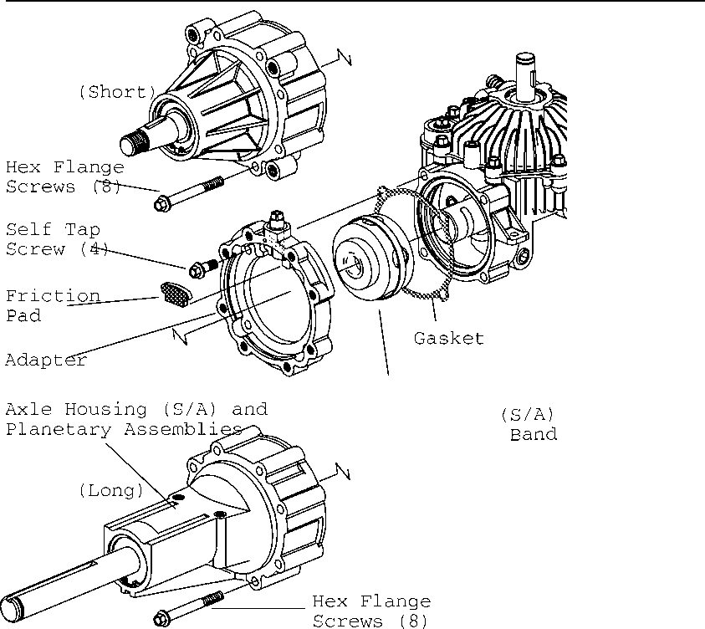

Motor Rotor/Eall with Rubber Ball Retainer

Figure 39

1. Install the motor rotor assembly.
2. Install the adapter with gasket and attach with flange screws(4). Torque screws to 14 NM [125 lb-in].
3. Install the friction brake pad into its recess located in the adapter.
4. Align the screw holes and notches, install the axle gasket on the axle housing assembly.
5. Use care to retain the planetary assemblies in position, and install the axle housing assembly on the pump housing. Install by first aligning the teeth of the primary sun gear with the teeth in the pump rotor assembly and then rotate the axle housing assembly to align the retaining screws holes.
6. Install the axle housing flange screws and torque to 125 lb-in [14 Nm].
7. Fill transaxle with an approved hydraulic fluid. The transaxle is now ready for test and installation



01546200 Orig. 9/98 Ariens® 5-28

**DRIVE TRAIN 915 EZRIDER SERVICE MANUAL**

##### TRANSAXLE REPLACEMENT

1. Mount the Eaton transmission into the transaxle subframe and mount with hardware removed earlier. Connect hoses and fill with oil. Let air breath out of line before tightening hose clamps.
2. Place the transaxle subframe with transaxles under the frame of the unit.
3. Raise and support the transaxle assembly inside of the frame and secure to the frame with the carriage bolts and nuts removed earlier.
4. Attach the hydraulic lines to the expansion tank, release the hose clamps stopping the oil flow.
5. Install the main drive belt and check belt routing for proper clearance on the top of the transaxles, reattach the drive belt idler tension springs.
6. Check for proper belt tension before proceeding and recheck belt routing.
7. Refill the transaxle oil expansion tank prior to bleeding air from the transaxle.
8. Verify that transmission lines and elbows are sloping upward toward the expansion tank. Remove straps holding hoses down if required.

##### TRANSAXLE AIR BLEEDING

Use the air bleeding procedure when unit has a loss of drive or ground speed.

This condition is caused by trapped air in the hydraulic system. If the air is not removed from the system; the drive will get progressively worse.

To bleed the transaxle:

1. Verify that the transmission belt is not slipping.
2. Verify that the control arms going to the transmissions are adjusted properly.
3. Place jackstands under the rear of the unit frame to support the unit with the drive wheel off the ground.
4. Check fluid level in the expansion tank, fill with Mobil DTE-26 oil or a detergent 30W oil.
5. Verify that the parking brake arm is centered to release the brake.
6. If the transmission operates irregularly the transmission needs to be bled.
7. Verify that the transmission lines and elbows are sloping upward toward the expansion tank. Remove straps holding the hoses down.
8. Remove the side panels and loosen control stops on both sides of the cam arm. This will allow the transmission control arm to move through the full motion of the transmission.
9. Cycle the unit from the full forward position to the full reverse position every 15 seconds for three minutes.
10. Verify the fluid level in the expansion tank.
11. If the transmission fluid level drops, add fluid. If the performance of the transmission improves, repeat bleeding procedures until no more fluid is needed to be added to the expansion tank.
12. Replace the transmission if no improvement is noted.

Transaxles full forward speed should be 110 - 120 rpm at the axle shaft.

##### HYDROGEAR FLUID RECOMMENDATIONS

The fluids used in Hydro-gear transaxles have been carefully selected, and only equivalent or better products should be used.

Typically, an engine oil with a minimum rating of 55 sus at 210° F and an API classification of SH/CD is recommended. A 20W-50 engine oil has been selected for use by the factory.

The grease used in the manufacture of Hydro-Gear products is a STENS Premium grease and should be substituted for with equivalent products only if it is not readily available in your area.

**NOTE:** This grease is not compatible with all grease types.

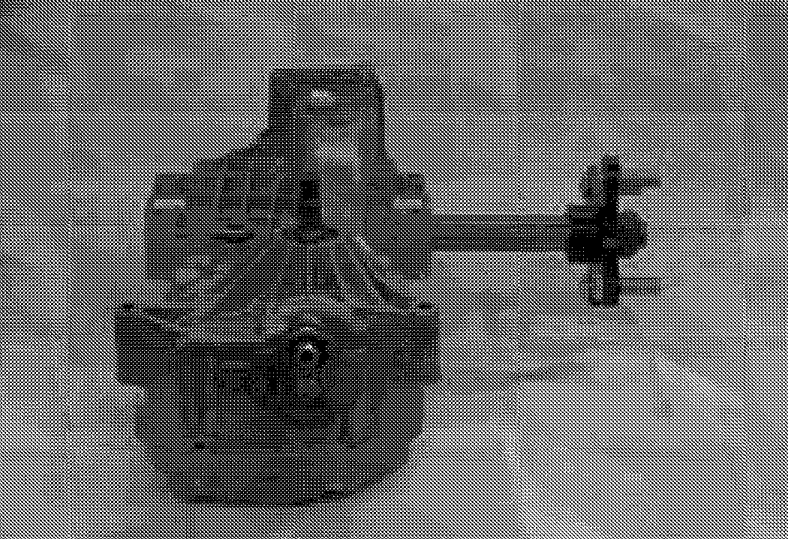

Hydrogear transaxle



5-29 Ariens® 01546200 Orig. 9/98

**915 EZRIDER SERVICE MANUAL DRIVE TRAIN**

##### HYDROGEAR REPAIR (MINOR)

Minor repairs may be performed, following the procedures in this section.

Cleanliness is a primary means of assuring satisfactory life of either new or repaired units. Cleaning parts by using solvent wash and air drying is usually adequate. As with any precision equipment, all parts must be kept free of foreign materials and chemicals.

Protect all exposed sealing surfaces and open cavities from damage and foreign material. The outer surfaces of the transaxle should be cleaned before beginning any repairs.

**Shaft Seals**

Lip type seals are used on the pump input shaft, the displacement control shaft and bypass actuator shaft of the transaxle. These seals can be replaced without major disassembly of the unit. Replacement of these seals will require removal of the transaxle from the machine frame.

To remove the input shaft seal carefully pull the seal out of the housing bore with a "hook" type tool or a slide hammer type puller. Care must be taken to avoid damage to the housing bore or to the shaft sealing surface.

Lubricate the new seal prior to installation with a petroleum jelly.

Wrap the shaft spline with a thin plastic or cellophane tape to prevent damage to the new seal lip during installation.

Slide the seal over the shaft and press it into the housing bore. Be careful not to damage the seal. The seal should seat against the retaining ring.

The displacement control shaft seal and bypass actuator shaft seal may be replaced following similar procedures.

##### HYDROGEAR REPAIR (MAJOR)

1. Drain the oil by removing the breather assembly and positioning the IHT so that the breather port is down to allow the oil to drain thoroughly.
2. Position and secure the IHT with the upper housing down to allow access to the ten housing assembly cap screws.
3. Remove the eight rear housing assembly cap screws.
4. Remove the ten bottom cover assembly screws.
5. Remove the toques head cap screw holding the brake arm to the transaxle case.

Remove the bottom and rear covers from the transaxle.

**NOTE:** The sealant will make the covers difficult to remove.

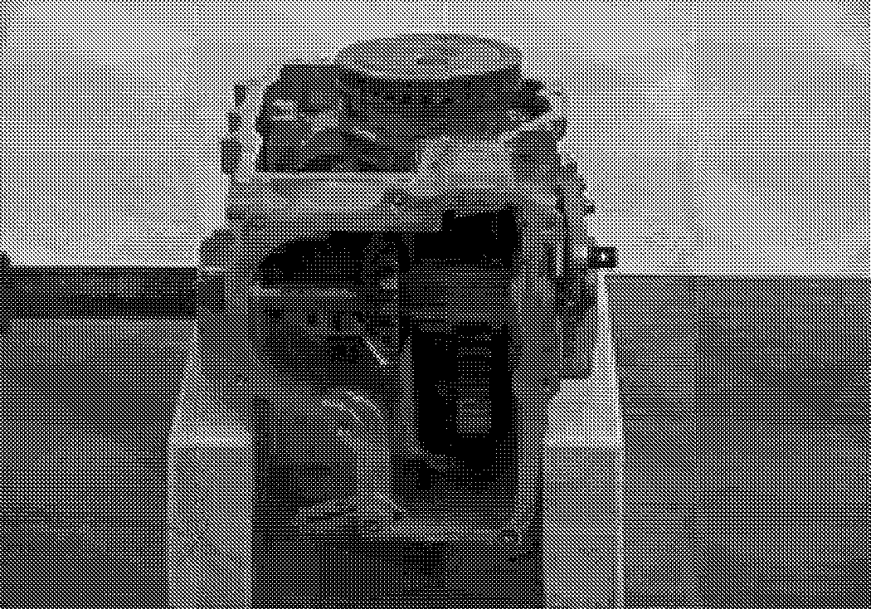

1. All components should remain in the upper housing (positioned down).

Remove the brake gear from the brake shaft.

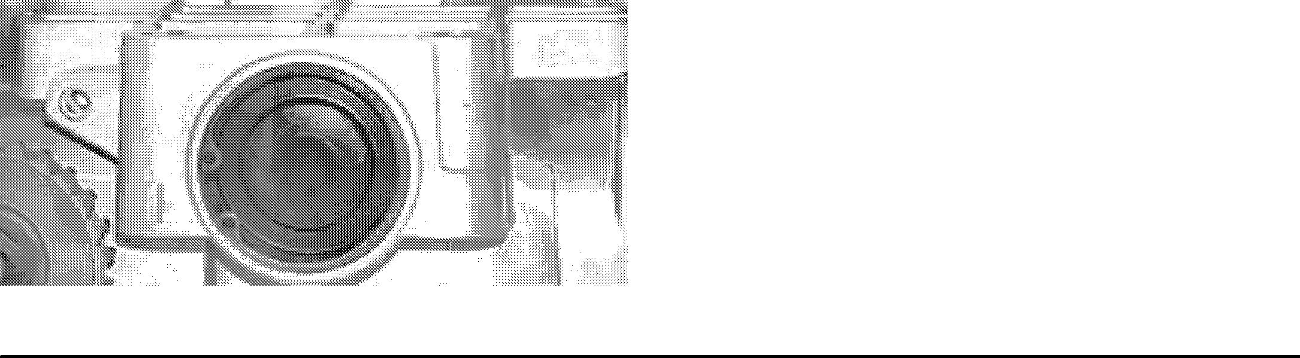

Seals

1. Remove the oil seals from the brakes shaft. Push out the brake shaft to remove the support bearing.

**NOTE:** Prior to reassembly the lower and rear covers must be thoroughly cleaned and old sealant must be removed.

**NOTE:** The lip seals must not be re-used during reassembly.

1. Inspect the final drive gear teeth for excessive wear or damage.

5-30 Ariens® 01546200 Orig. 9/98

**DRIVE TRAIN 915 EZRIDER SERVICE MANUAL**

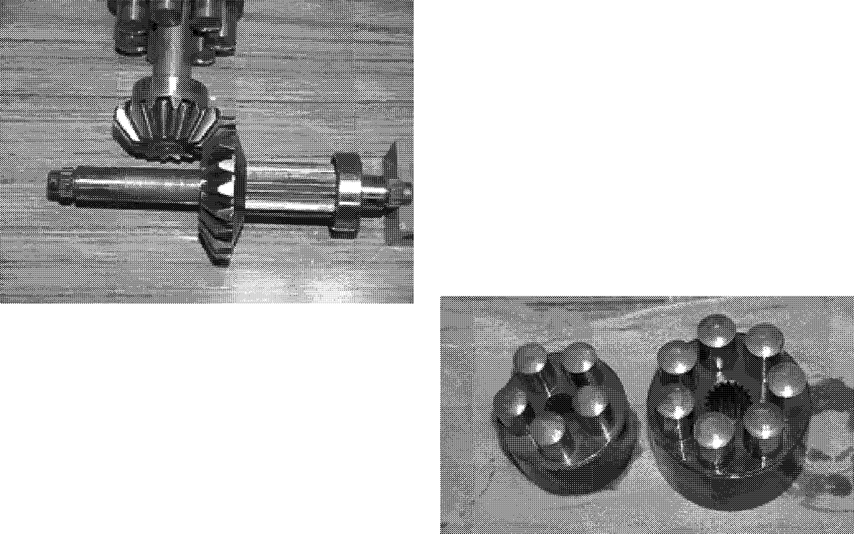**CAUTION:** The aligning pins, motor shaft, bypass plate, pump block and motor block assemblies are NOT retained to the center section or the upper housing and may become separated from the assembly during removal.

* 1. Remove the motor block assembly from the motor shaft and inspect for unusual wear or damage. The pistons should fit with very little side clearance in the block bores, but must slide freely.

**NOTE:** The correct bore diameter should be for the block is 0.6776 to 0.6784 and the pistons should be 0.6767 to 0.6770.

1. Inspect the brake gear internal splines for excessive wear or damage.
2. Inspect the brake cam for excessive wear and damage.

Replace brake gear and cam as a complete kit if excessive wear or damage is found, and inspect all other mating parts.

1. Using a 9/16" socket (or box end ) wrench, remove the three assembly bolts retaining the center section in the upper housing.

**CAUTION:** The pump and motor piston springs may push the center section assembly out of position while you remove these bolts.

* 1. Remove the motor shaft, washers and bypass plate from the center section and inspect for unusual wear or damage.

Inspect the center section running surfaces for unusual wear or damage.

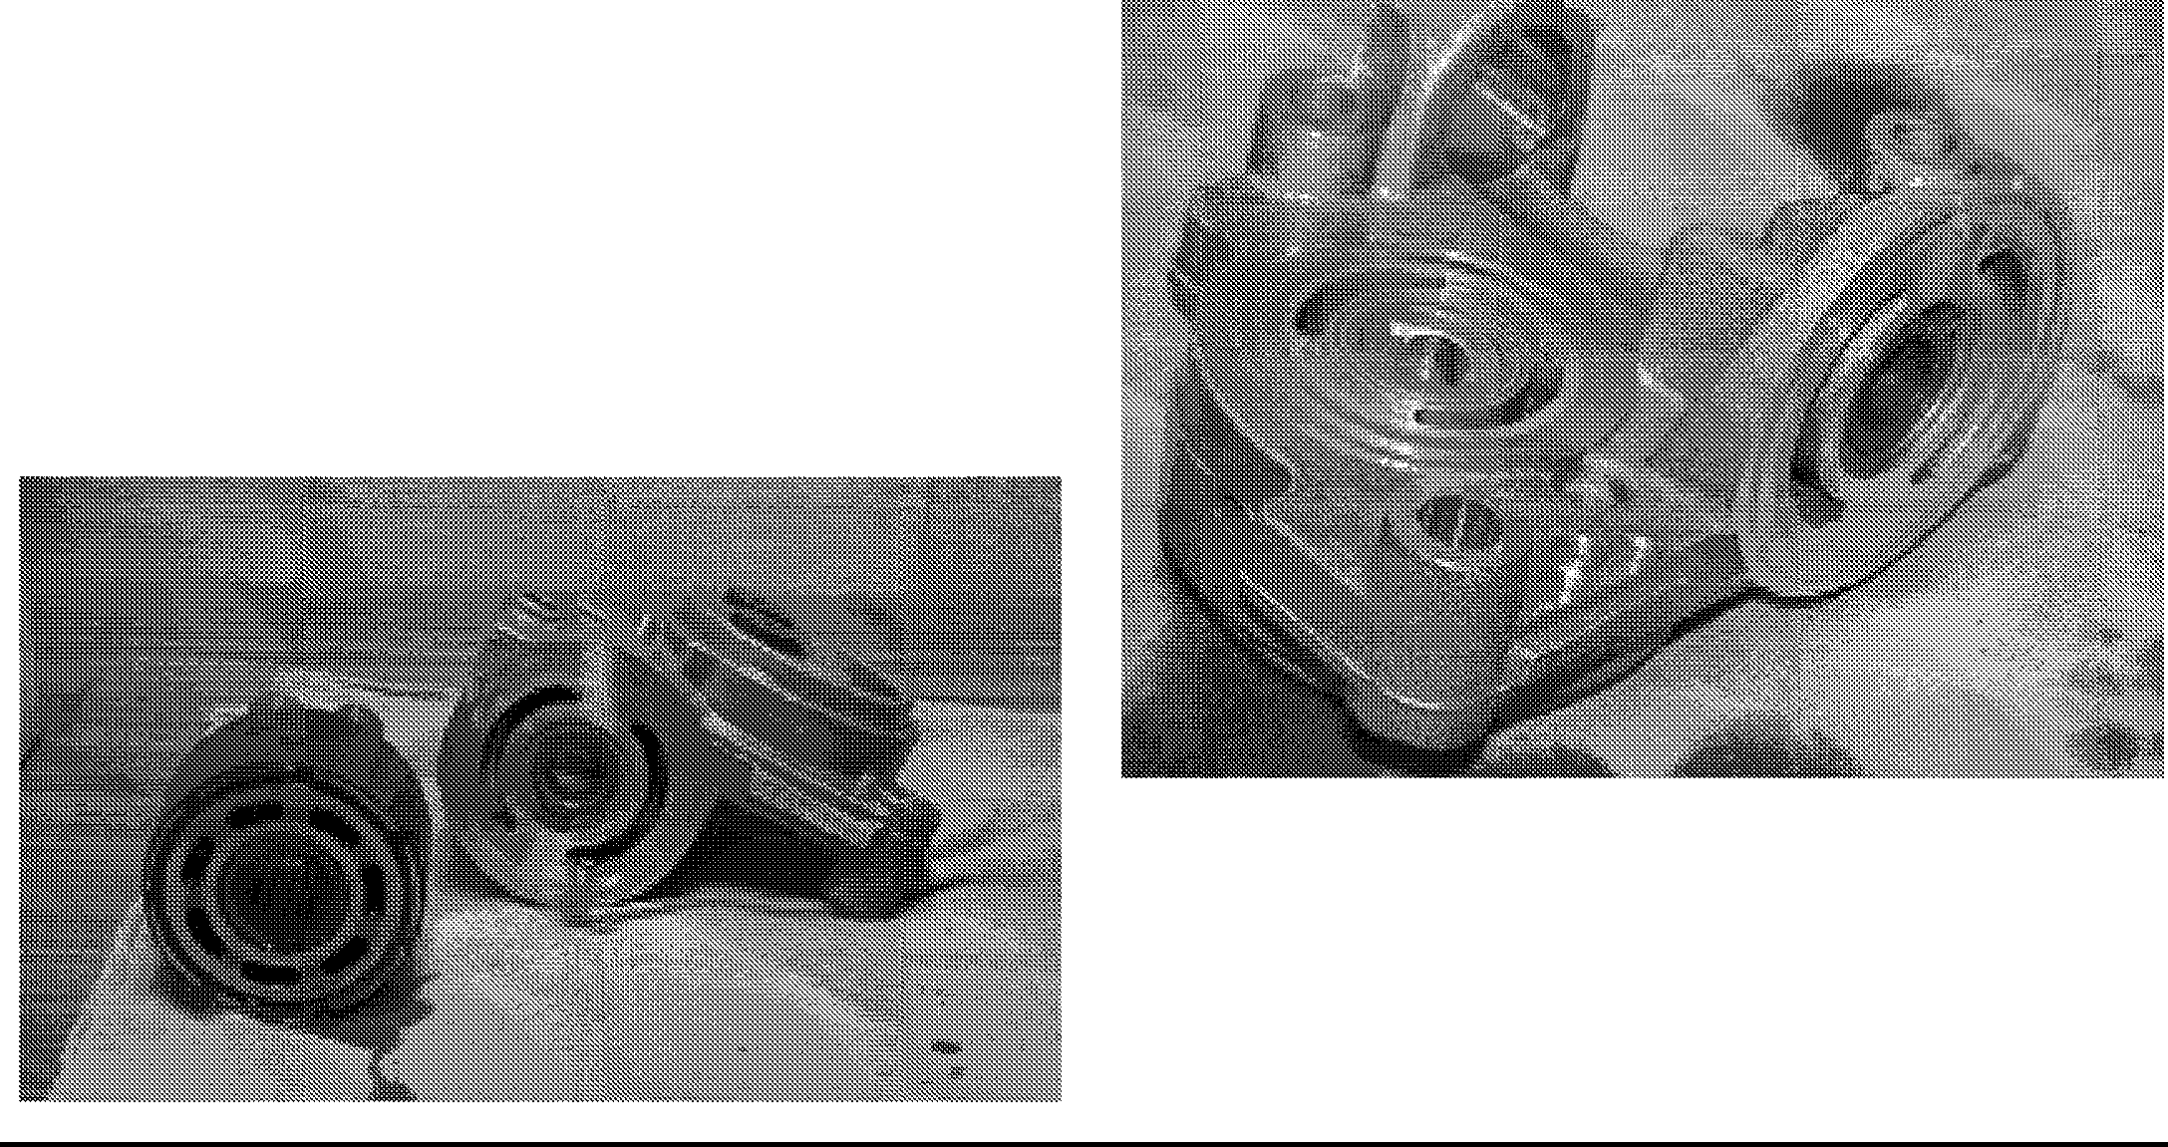

14. Remove the center section assembly from the housing. The pump block assembly should remain in the upper housing on the input shaft, but may stick to the center section. Check the check valve plate bolt torque, but do not remove. Two styles of check plates have been used, one has three bolts while the other has four. The one with four bolts should be torqued from 170 to 240 in. lbs. while the one with three bolts should be torqued from 135 to 185 in. lbs.

17. Remove the pump block assembly, block thrust washer and spring from the input shaft and inspect for unusual wear or damage. The pistons should fit

**915 EZRIDER SERVICE MANUAL DRIVE TRAIN**

with very little side clearance in the block bores, but must slide freely.

**NOTE:** The correct bore diameter for the block is 0.6295 to 0.6303 and the pistons should be 0.6288 to 0.6291.

1. Remove the motor thrust bearing assembly, swashplate kit and cradle bearing from the housing and inspect for unusual wear or damage.

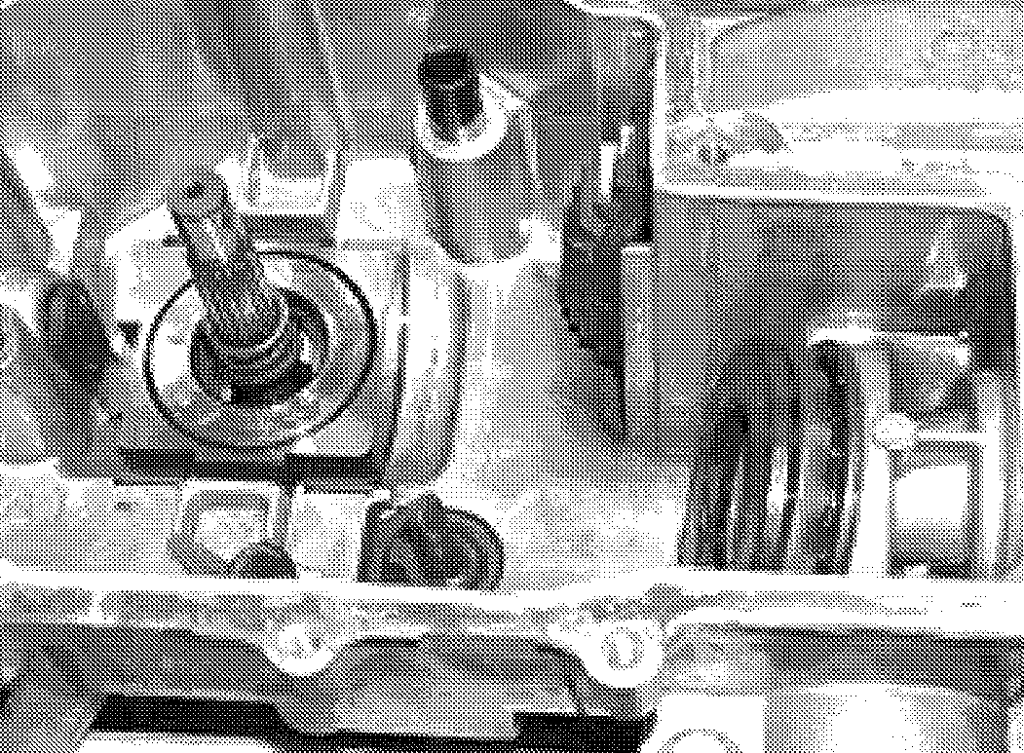

1. Remove the slot guide from the displacement control shaft.
2. Remove the bypass actuator from the housing.
3. Reposition the housing and remove the input shaft lip seal from the housing bore. A hook type tool may be used to pry the seal out. Care must be taken to avoid damage to the housing bore, shaft sealing surface or bearing. Once removed, the seal is not reusable.
4. Remove the input shaft bearing ring.
5. Remove the pump input shaft assembly from the housing.
6. Inspect the shaft and bearing for unusual wear or damage.
7. Reposition the top housing and remove the displacement control shaft and lip seal.

Inspect the housing for damage.

* 1. **REPLACEMENT OF PARTS**

All parts should be thoroughly cleaned in a suitable

solvent. All sealant material MUST be removed from the housing prior to reassembly.

Inspect all parts for damage, nicks or unusual wear patterns. Replace all parts having unusual, excessive wear or discoloration.

Inspect the sealing surfaces, bearing surfaces, and shaft splines. Polish the sealing areas on the shafts if necessary. **Replace any worn or damage parts.**

The running surfaces of the cylinder blocks **MUST** be flat and free from scratches. If scratches or wear are found on the running surface of the cylinder block or center section, polish or replace the parts. When polishing these surfaces, up to 0.0004" may be removed. If this is not sufficient to obtain a flat surface free of scratches, the part should be replaced.

Clean and lightly oil parts prior to assembly of the IHT.

Be sure to torque all threaded parts to the recommended torque levels.

Replace all a-rings and shaft seals.

**CAUTION:** Most parts have critical high tolerance surfaces. Care must be exercised to prevent damage to these surfaces during assembly. Protect exposed surfaces, opening and ports from damage or foreign material.

1. Install the displacement control shaft.
2. Install the pump input shaft assembly and retaining ring into the housing.
3. Install the pump shaft lip seal.
4. Reposition the upper housing and install the cradle bearings.
5. Install the slot guide block onto the displacement control shaft.
6. Install the swashplate assembly into the housing. The slot on the swashplate must engage the slot guide block on the displacement control shaft. Use a tool such as a screwdriver to hold the guide block in position while installing the swashplate.

**DRIVE TRAIN 915 EZRIDER SERVICE MANUAL**

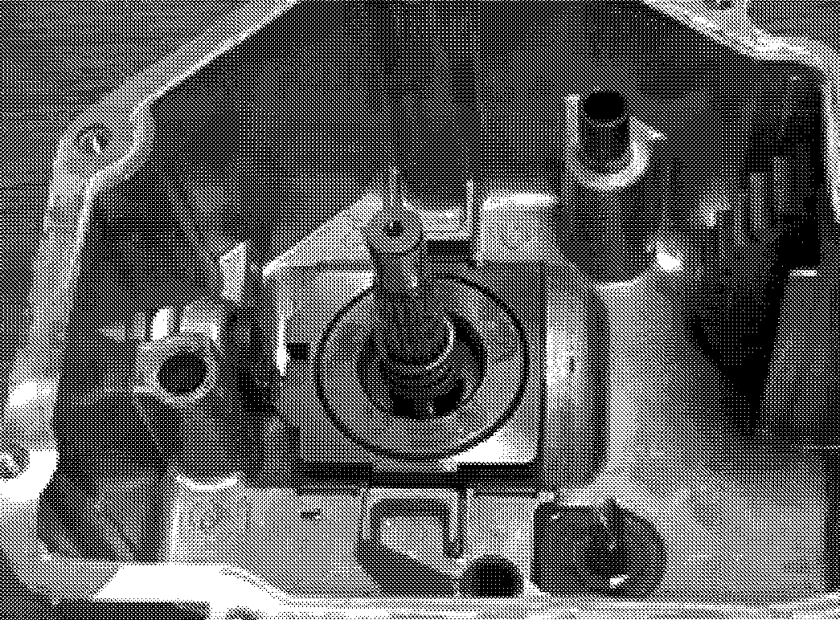

1. Install the thrust washer and pump block spring onto the pump shaft.

**NOTE:** To simplify the installation of the pump block, wrap a rubber band snugly around the pistons. This is intended to hold the pistons in their bores as the block kit is handled during installation.

1. With the swashplate in the neutral (0 angle),

lubricate the running surfaces and install the block kit onto the pump input shaft. Make sure the splines engage properly.

1. Install the aligning pins and the bypass actuator into the housing.
2. Install the bypass plate(small end first) into the center section.
3. Lubricate the running faces and install the motor block kit onto the motor shaft.
4. Position the washers and seal and install the center section assembly onto the aligning pins and pump input shaft.
5. Install the motor shaft into the center section.
6. Insert the two assembly bolts into the center section and press center section down onto the aligning pins and pump input shaft until seated on mounting bosses. While holding the center section in position, torque the bolts evenly from 525 to 700 in. lbs ..
7. Install the motor thrust bearing (with the thicker race towards the pistons) by compressing the piston springs and sliding the bearing assembly in to place.

**NOTE:** The tool being showed is an example of what you will need to compress the pistons and allow the bearing to be installed.

Apply the sealant to the lower and rear housing.

**NOTE:** Sealant must be of good quality, oil and heat resistant.

1. Position the lower and rear covers onto housing case onto the upper housing and secure with assembly bolts. Torque the bolts from 135 to 165 in. lbs.

**NOTE:** The group of bolts around the bottom and rear

covers of the housing have the same sequence number because the are installed simultaneously at our factory, the order in which you torque them should not be important.

After torquing all bolts, wipe off any excess sealant from the seam of the housing.

Reposition the transaxle assembly and check the bypass actuator and axle shaft for freedom of movement. The axle should not lock up but may be tight, while the bypass actuator must rotate freely.

Torque the nut on the brake bolt from 120 to 185 in. lbs.

1. Install a new lip seal on the displacement control shaft & bypass actuator shaft.
2. Install the control arm and friction pack.
3. Install the bypass actuator arm and retaining ring. Use care to avoid over extending the retaining ring.

Prior to adding oil to the IHT it is recommended that you test for leaks. This may be preformed with a small hand pump or by using compressed air and a regulator. Do not allow more than 10 PSI to be applied or seal damage may occur. To locate a leak, apply a soap mixture around the housing seam and at all lip seals.

**5.17 OIL FILL & START-UP PROCEDURES**

Fill the IHT with a 20W-50 engine oil. The correct volume for fill should be 2 1/2 quarts(80 ounces).

It is recommended that the unit be purged prior to installing into the tractor frame. The following is the suggested purging procedures for repaired transaxle.

**915 EZRIDER SERVICE MANUAL DRIVE TRAIN**

1. Spin the input shaft in a clockwise direction at 1000 - 1500 RPM. This may be performed in a drill press (or equivalent).
2. Engage (actuate) the bypass
3. Stroke the control lever forward for five seconds and then reverse for five seconds. Do this three times in each direction.
4. Return the control lever to neutral.
5. Disengage the bypass.
6. Stroke the control lever forward for five seconds and than reverse for five seconds. Do this three

times in each direction.

**NOTE:** It may be necessary to repeat these steps in the vehicle to fully purge the IHT.

Check the oil level after fully p[urging the unit of air. It should be between 1.25" and 1.62" from the top of the housing.

After installing the IHT, make sure all linkages and actuators are functioning properly.

5.19 HYDROGEAR TRANSMISSION REMOVAL

Place the unit on a flat surface and remove the negative lead from the battery and the spark plug lead from the spark plug.

Raise and block the unit frame on jack stands behind of the transaxle in the frame.

Remove the rear wheels by removing the lugs nuts holding the wheels to the axle hub.

Release the main drive belt tension spring and remove the main drive belt from the input sheave on top of the transaxles.

Release the parking brake control rod on the top of the units frame by pulling the hair pin and leasing the tension spring.

Tighten the shifting cam friction pack lock nut to hold the transaxle neutral position.

Remove the cap screw, flat washer and lock nut on the shift rod and remove the shift rod ball joint from the transaxle cam arm.

Do not remove or loosen the hardware on the transaxle sub-frame at this point.

Support the transaxles subframe with a floor jack from the rear of the tractor.

Remove the rear anchor strap from the transaxle subframe and the rear of the unit.

Remove the two right and left front anchor bolts holding the transaxle subframe to the tractor frame and remove the two rear anchor bolts from the left and right side holding the transaxle subframe to the unit's frame.

With the transaxle assembly removed from the unit's frame, place the axle assembly on a flat work surface.

5.20 HYDROGEAR TRANSMISSION INSTALLATION

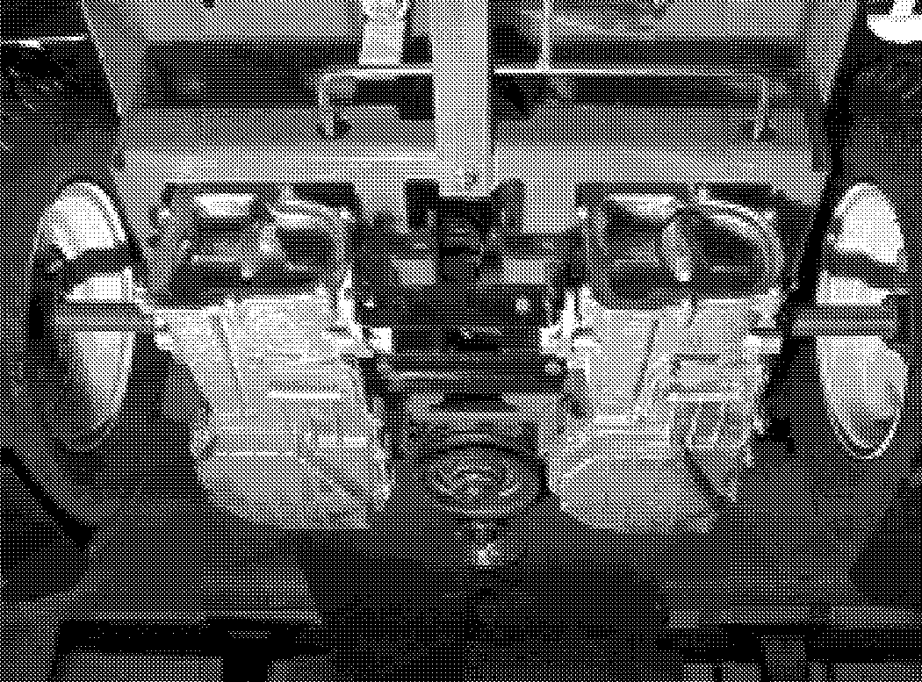

Before installing the transaxle assembly into the tractor frame with the axle subassembly installed the following items will need to be done.

Make sure the brake rod has two flat washers and a heavy coil spring installed on it before inserting the transaxle into the tractor frame.

Do not tighten any hardware until all the support hardware is installed.

**915 EZRIDER SERVICE MANUAL**

When all the hardware is in place, tighten to the appropriate torque according to the hardware torque chart.

Install the two flat washers compression spring and hair pin on the rear of the brake rod which return/release the brake arm.

Install the cap screw, flat washer and lock nut on the shift rod ball joint securing it to the transaxle shift cam.

install the main drive belt on the transaxle input sheave and check the belt routing on the idler arm and engine pulley and install idler arm tension spring.

install the dump valve rod and attach the ball knob.

Install the rear wheel with the lug nuts removed earlier.

###### Transaxle neutral adjustment.

Make sure that the rear of the unit is suspended before the unit is started.

Make sure that the interlock system is operational before proceeding.

Place a weight onto the seat to activate the seat to activate the seat switch.

**915 EZRIDER SERVICE MANUAL PTO**

## SECTION 6: TOWER TAKE OFF



* 1. PTO JACKSHAFT REMOVAL

Refer to figure 40 for the PTO Jackshaft.

1. Place the unit on a flat level surface, and lower the mower pan.
2. Open the dash panel by removing the two phillips head screws and tilt the dash panel forward exposing the battery and electrical system.
3. 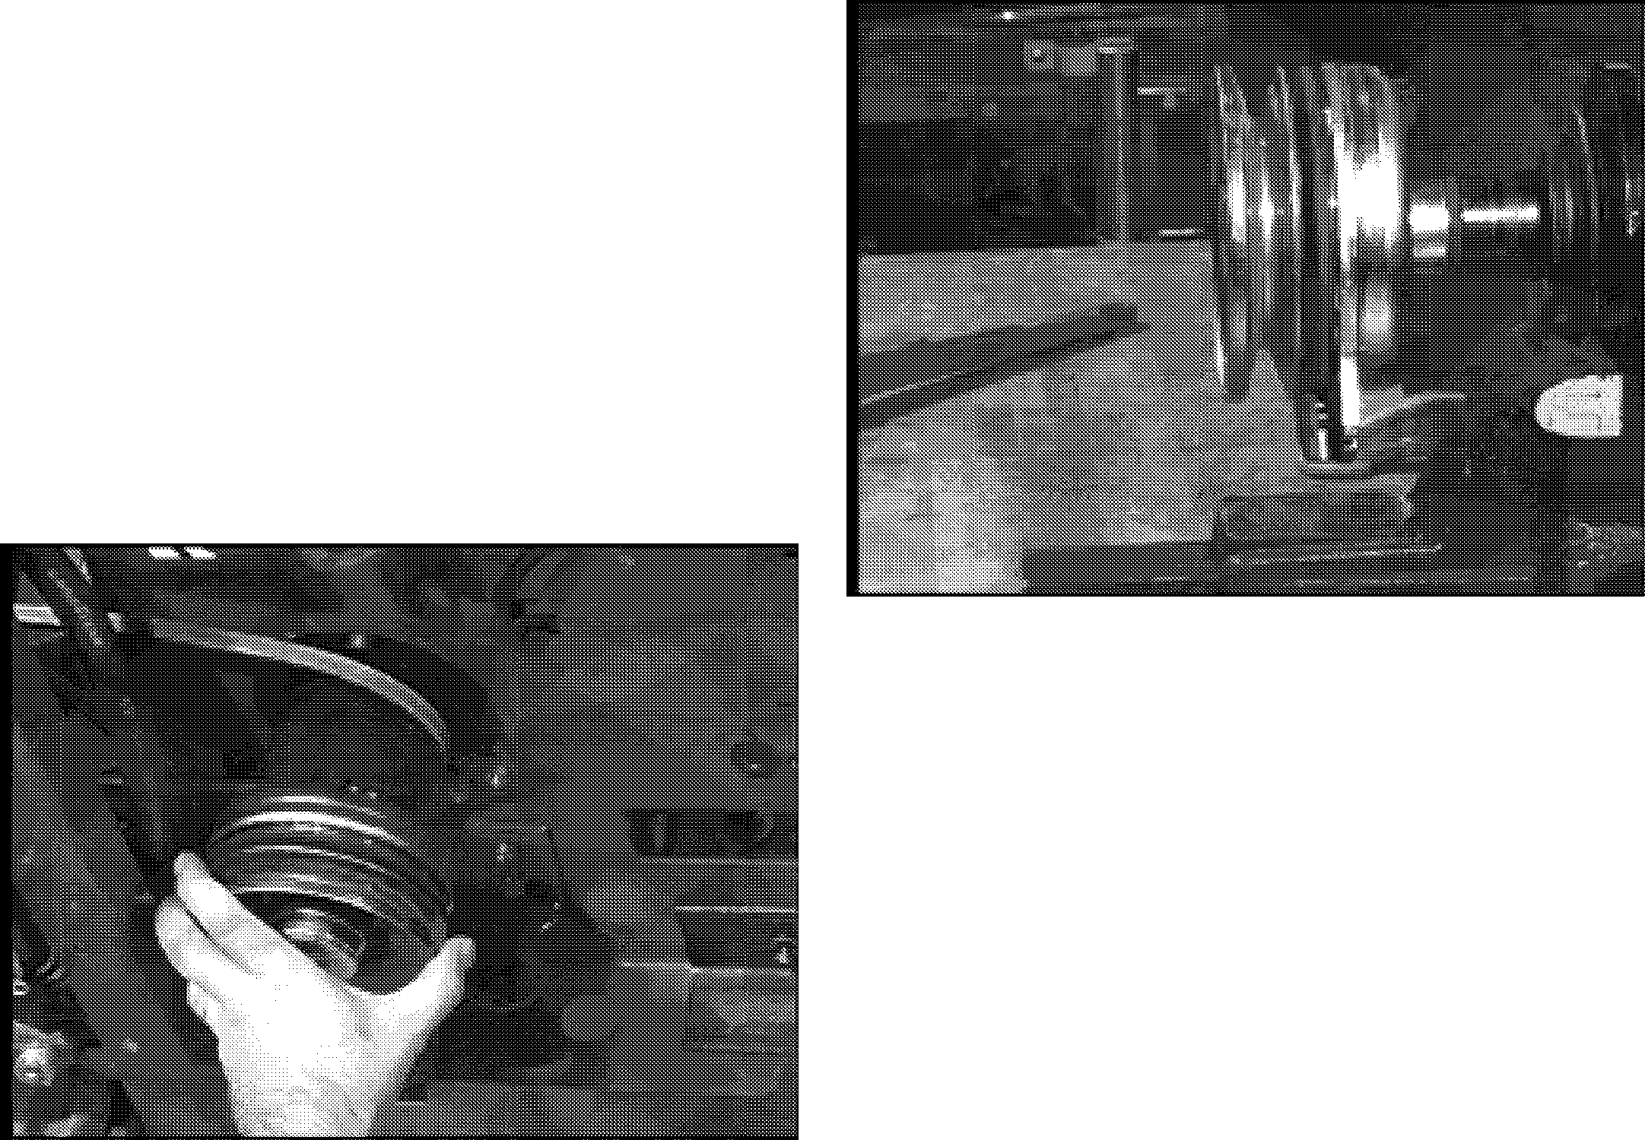Remove the negative lead from the battery, and the ignition coil lead from the spark plug(s) on the engine.
4. Support the unit on jack stands. Remove the right drive wheel.
5. Remove the jackshaft idler tension spring from the transaxle subframe frame.

Unplug the PTO clutch from the wire harness.

1. Remove the PTO drive belt from the PTO clutch and the top of the mower pan jackshaft.
2. Remove the four grade 5 cap screws on the top of the frame holding the jackshaft assembly into the frame.

Figure 40

* 1. PTO JACKSHAFT REPAIR

1. Place the jackshaft assembly on a workbench. Remove the grade 5 cap screw from the top of the jackshaft assembly, and the grade 5 cap screw from the bottom of the jackshaft assembly.
2. Remove the PTO clutch, the jackshaft sheave, and pull the spindle shaft out of the bearings that are pressed into the spindle housing.
3. Check spindle bearings for wear and replace as needed.
4. Insert the spindle shaft into the spindle housing. Hold in place with a flat washer, lock washer, and grade 5

cap screw. Treat the cap screw with Loctite# 271 in reassembly.

1. Add key to spindle shaft and install the jackshaft sheave.
2. Check electric PTO clutch for proper function and operation prior to installation on the spindle shaft.
3. Install the grade 5 cap screw in the bottom of the PTO clutch treated with Loctite# 271 and torque top and bottom cap screws to 40 ft. lbs.
   1. **PTO Jackshaft Installation**
4. Prior to installing the jack shaft assembly into the unit frame, check the condition of the clutch anchor strap. Repair or replace if necessary.
5. Place the jackshaft drive belt into the jackshaft sheave while reinstalling the PTO clutch jackshaft assembly into the frame of the unit.
6. Hold in place with four grade 5 cap screws removed earlier. Torque to 25 ft. lbs.
7. Reattach the jackshaft idler tension spring to transaxle subframe and plug the PTO wiring into the clutch.
8. Reinstall the right drive wheel. Remove the unit from the jack stands.
9. Install the PTO belt from the PTO clutch to the top of the mower deck jackshaft.
10. Rotate the mower deck blades by hand. Check the routing of the belt and function of the idlers.
11. Reattach the negative lead to the battery, and the ignition coil lead to the spark plug(s) on the engine.



01546200 Orig. 9/98 Ariens® 6-34

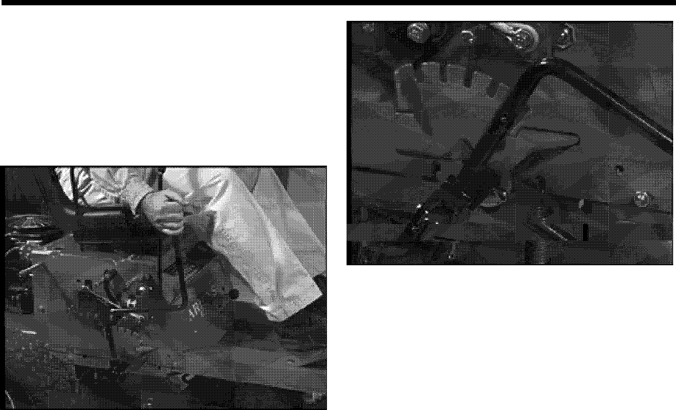**LIFT SYSTEM 915 EZRIDER SERVICE MANUAL**

## SECTION 7: LIFT SYSTEM

* 1. LIFT SYSTEM

Refer to Figures 41 and 42 for the Lift System.

The mower pan lift system is a manual list system controlled by the operator.

1. The lift handle is positioned on the right side of the frame with a quadrant to hold the mower pan in each desired cutting height.

Figure 42

Figure 41

* 1. LIFT SYSTEM REMOVAL

1. Remove the mower deck from the unit prior to lift system removal.
2. Place the lift handle in the lowest cutting height available. Move lift handle past the lowest cutting height and disconnect spring.
3. Remove the cotter pin in the end of the clevis pin holding the lift handle to the cross shaft.
4. Remove the cotter pins and large diameter washers on the right and left side of the frame holding the lift cross shaft in place.
5. Move the cross shaft to the right and down out of the frame and then to the left removing the cross shaft from the unit.
6. Check the large diameter washers and nylon bushings for wear and replace as necessary.
   1. LIFT SYSTEM INSTALLATION
7. Place the cross shaft into the frame with the long end to the right side.
8. Install the nylon bushings into the frame and a large diameter washer between the bushing and cotter pin through the corss shaft.
9. Attach the lift lever onto the end of the cross shaft on the right side of the frame with a clevis pin and cotter pin.
10. Raise the mower lift system and install the mower pan under the unit and attach it to the lift arms with washers and hair pins.

**915 EZRIDER SERVICE MANUAL FUEL SYSTEM**

## SECTION 8: FUEL SYSTEM



* 1. FUEL SYSTEM TROUBLE SHOOTING

The following trouble shooting chart is to be used to isolate Fuel System problems and give possible causes and corrective action responses.

The trouble shooting key is generic and can be used for several types of transmissions. Use only those possible causes and corrective actions that apply to the unit.

|  |  |  |  |  |
| --- | --- | --- | --- | --- |
| **TROUBLE**  **Hard Starting** | **POSSIBLE CAUSES**  (Refer to Key Below)  1, 3, 4, 6, 11, 12, 14, 16, 17, 18 | **CORRECTIVE ACTION**  clean, repair or replace | | |
| **Fuel Leak at Carburetor** | **5, 7,17** | repair | or | replace |
| **Engine Floods** | **5, 15, 17** | repair | or | replace |
| **Will not Idle** | **1,2,3,6** | repair | or | replace |
| **Rich Idle** | **1, 6, 14** | repair | or | replace |
| **Idles with Needle Closed** | **14** | repair | or | replace |
| **Hunts Erratic Idle** | **2,3,6, 7,12,13,14,15,18** | repair | or | replace |
| **Idles fast Lean** | **2,3, 7** | repair | or | replace |
| **Will no Accelerate** | **1,6, 11, 12, 14, 15, 16** | repair | or | replace |
| **Over rich Acceleration** | **1, 15** | repair | or | replace |
| **Hesitates** | **2,6, 11, 12, 16** | repair | or | replace |
| **Will no run at high speed** | **1, 11, 12, 14, 16** | repair | or | replace |
| **Low Power**  **Hunts at High Speed** | **1,3,11,14,15,16,17,18**  **3,6, 7,12,14,15,16,18** | repair repair | or or | replace replace |
| **Runs with needle Closed** | **14** | repair | or | replace |
| **Engine overspeeds** | **2,3, 7,14** | repair | or | replace |

**TROUBLE SHOOTING KEY**

* + 1. Plugged Air Filter
    2. Leaky Carburetor Gasket
    3. Throttle or Choke Shaft Worn
    4. Choke no functioning properly
    5. Plug atmospheric vent
    6. Air bleed restricted
    7. Damaged or leaky "O" rings
    8. Damage diaphragm
    9. Stuck or dirty ball check
    10. Diaphragm upside down
    11. Plugged tank or vent
    12. Fuel pick-up restricted
    13. Idler port restricted
    14. Damage adjustment needle and seat
    15. Incorrect float height
    16. Main nozzle restricted
    17. Dirty, stuck needle and seat
    18. Fuel inlet plugged
  1. FUEL PUMP

The impulse style fuel pump is the most commonly used fuel pump. Impulse fuel pumps may either be mounted

externally onto the carburetor fuel inlet or remotely mounted. These pumps are connected in the fuel line between the fuel supply and the carburetor or directly to the fuel inlet (Figure 43).

Impulse fuel pumps are operated by crankcase impulses created by the up and down movement of the piston. A hose called a pulse line connects the fuel pump diaphragm chamber and transmits the impulses to the pump diaphragm. The Impulses actuate the diaphragm and the flap valves to lift the fuel from the fuel tank to the

carburetor.

* 1. FUEL SYSTEM CONTAMINATION

Any time fuel contamination is found in the fuel system(dirt, water, algae, ect.) replace the fuel, fuel filter and flush the fuel lines. Remove the carburetor bowl and clean. Replace all items that cannot be cleaned.

Reassemble the fuel system and check for proper operation.

* 1. FUEL TANK

The fuel tank is made of composite material for long life with out breaking down from the additive used in today's blended fuels.

**ELECTRICAL SYSTEM 915 EZRIDER SERVICE MANUAL**

**SECTION 9: ELECTRICAL**



# TOOLS

There are some specialized tools and test equipment that are needed for electrical repair work. A brief description

of these follows.

**Long or needle nose pliers** - used to connect or bend wires and connectors in close quarters.

**Diagonal cutters** - used to cut wires or trim connections.

**Wire stripper/crimping tool** - available separately or as a combination tool. used to strip insulation from wires of various sizes, crimp terminals and connector on wires.

**Soldering gun or soldering iron** - used to solder all splices and connections to terminals, connector and ect. A soldering gun is faster and more convenient than waiting for a soldering iron to heat.

**Multimeter** - analog or digital to measure voltage, amperage and ohms.

Tachometer - used to measure engine speed. Required to properly test alternator and charging circuits where output is dependent upon engine speed.

**Heat gun** - used to shrink insulated tubing in place. Used to replace electrical tape or insulated sleeving. To use, place a piece of shrink tubing over a wire joint, heat with the heat gun, and it shrinks tightly around the joint to insulate it.

**Supplies** - electrical tape, rosin core solder (never use acid or acid core solder on electrical joints), an assortment of various size terminals, connector, insulated or heat shrink tubing (for use on joints and connections), and an assortment of automotive type wire (in several colors).

Ariens Company recommends that all work be done in a professional manner. The use of the tubing to cover joints and the soldering of connections contribute to a professional looking job. In addition to a pleasing appearance, repairs made in this manner are more likely to withstand vibration. (The weakest points in an

electrical system is at the joints where wires are attached. Vibration causes wires to flex at these points and eventually to break.)

Replace all defective components with Ariens Factory replacement parts only. Engine parts, such as rectifiers or alternator components should be secured through the nearest engine service center.

Ariens Company does not recommend attempting to repair electrical components. Most do not lend themselves to repair and you would have more money invested in "time of repair" than the part would cost and the results may not be as good.

* 1. ELECTRICAL MEASUREMENTS

In many electrical circuits, there is some visible effect which indicates that the circuit is functioning properly. A switch is turned "on" and a lamp lights. A key is turned, a starter motor runs and cranks the engine.

If the lamp does not light, or the starter motor does not run, some means of measuring voltage, current flow, resistance and continuity is needed, (continuity means there is a complete electrical path through the circuit or component.)

To know exactly what conditions exist in an electrical circuit requires AC and DC Voltmeter, AC and DC Ammeter, and an Ohmmeter.

Multimeter

A single, combination meter that does all of these things is available. Such a meter is called a Multimeter or Volt- Ohm-multitester (VOM). Meters of this kind are available in many forms and all change functions and ranges with switches, or by plugging test leads into different jacks.

Multimeter are available in two basic types, Analog and Digital.

Analog Meters

Analog Meters have a needle that moves across a scale to give a reading. The longer the scale, the easier it is to read and more accurate the reading will be. A jeweled movement is used in this type of meter and is more likely to be damaged by rough handling (except for overloaded Protected Meters) or by measuring high values that exceed the range set on the meter than a digital meter. They provide excellent service for the money as long as they are used with care.

Digital Meters

Digital Meters do not have a movement and are therefore more rugged. The reading shows up directly on a display window of some type. Since they read direct, no skill in reading the scale is required, nor is it necessary to set the range. The meter switches the ranges automatically. One has only to select the function DC Volts, AC

Ampere, Ohms,ect.), connect the test leads, and the reading is shown on the display. Because of the internal circuitry and the lack of a movement, these meters are not likely to be damaged by overloads.

In the discussions that follow, either type of meter may be used. Test procedures are the same. It is best to learn proper procedures, even though some meters may be more forgiving of mistakes. Where differences in use

may occur, they will be covered in the discussion.

**915 EZRIDER SERVICE MANUAL ELECTRICAL SYSTEM**

**Voltage Measurement**

There are two basic rules to be remembered when using a voltmeter. A voltmeter measures the voltage difference between the test leads and the voltmeter is always connected across the circuit under test.

**Current Measurement**

The two rules to remember when measuring current with an ammeter are; an ammeter measures the current that flows through the meter, and to measure current an ammeter must be connected into the circuit.

The latter rule means that the circuit must be opened, and the ammeter wired into it. Because this procedure is usually difficult, an ammeter is seldom used for troubleshooting.

**Resistance Measurement**

An Ohmmeter is used to make resistance measurements and to check continuity through wires and electrical components.

There is one rule to keep in mind when using a ohmmeter. The ohmmeter has a self contained battery and requires no external power. Using the ohmmeter on a circuit that has power applied may result in damage to the meter.

**IMPORTANT:** Disconnect the equipment battery when making Ohmmeter test or damage to the Ohmmeter may result.

An ohmmeter reads the resistance of whatever component is connected between the test leads. It can

be used to check wires, coils, light bulbs, or any item that conducts current.

* 1. **BATTERY**

Refer to Figure 44 for the Battery.

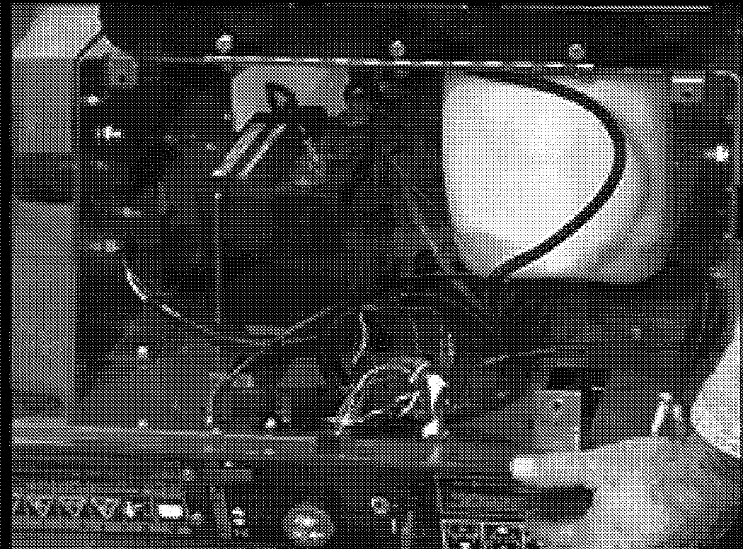

Figure 44

**SET-UP**

The Battery is dry charged. The dealer or customer must add electrolyte (sulfuric acid and water).

1. Remove the battery from the unit.
2. Remove all the vent caps from the battery and set the caps to one side
3. Take the electrolyte which should be 1.265 specific

gravity at ao° F, and fill each cell so that the electrolyte is level with the bottom of the fill ring.

1. The battery should stand for 1/2 hour. Now check electrolyte level in each cell again. If necessary add more electrolyte to bring the level up to the bottom of the ring.
2. Charge until all cells are gassing freely, and the specific gravity is constant over three successive readings taken at 30 minute intervals.
3. Immediately after charging check level of electrolyte. If the level is low add distilled water to bring it up to the required level.
4. Replace the vent caps. It is not necessary to tighten more than finger tight.
5. Wash off the battery to remove electrolyte which may have spilled.



**WEAR SAFETY GEAR** such as chemical resistant gloves and goggles before checking the battery.

**ELECTRIC SHOCK** may result in injury and/or damage to unit. DO NOT allow objects to come into contact with both terminals at the same time.

**REVERSE CONNECTIONS** may result in sparks which can cause death or serious injury. ALWAYS connect positive(+) cable FIRST and negative(-) cable SECOND.

**EXPLOSIVE GASES** from battery can cause death or serious injury. ALWAYS keep open flames, sparks, or smoking materials away from batteries.

**POISONOUS BATTERY FLUID** contains sulfuric acid and its contact with skin. eyes or clothing can cause severe chemical burns. ALWAYS wear safety glasses and protective gear near battery.

**DO NOT TIP** any battery beyond a 45° angle in any direction.

KEEP BATTERIES OUT OF REACH OF CHILDREN

**ELECTRICAL SYSTEM 915 EZRIDER SERVICE MANUAL**

**Battery Electrolyte First Aid**

Follow First Aid directions for contact with battery fluid.

**External Contact:** Flush with water.

**Eyes:** Flush with water for at least 15 minutes and get medical attention immediately!

**Internal Contact:** Drink large quantites of water. Follow with MIik of Magnesia, beaten egg or vegetable oil. Get medical attention immediately!

**IMPORTANT:** In case of internal contact, DO NOT induce vomiting!

**Inspection, Cleaning, Drying and Maintenance**

Inspect the top of battery, terminals, cables, terminal posts and case for any accumulation of dirt , corrosion cracks or loose or broken parts. Keep battery and its terminals clean. Inspect monthly to maintain best performance. Replace battery if damaged.

Remove corrosion from battery terminals and cable connections with a wire brush, then wash with a weak baking soda solution.

Scrub the exterior of the battery and cable terminals with a nonmetallic brush which has been dipped into a mixture of baking soda and water.

After cleaning, apply a this coat of grease or petroleum jelly to terminals and cable ends to retard corrosion.

Dry battery with a clean cloth.

Check the alternator voltage regulator output (if used) at every periodic maintenance inspection. *Over* charging is a common cause of battery failure.

**Electrolyte Level**

Every 25 hours or each week check electrolyte level of each cell by removing caps one at a time. The electrolyte level should be at level indicator. Use distilled water to fill each cell as required.

**IMPORTANT:** When distilled water is added to battery during freezing weather, it must be charged to mix water with electrolyte or water will remain at top and freeze.

**Charging**

ALWAYS follow information provided on battery by battery manufacturer. Contact battery manufacturer for extensive instructions to charge battery.

Place unit on a level surface, shut off engine and open battery compartment to gain access to battery.

Disconnect negative(-) cable first, then positive(=) cable.

To charge battery:

1. Loosen strap and *remove* battery from unit.
2. Place Battery on bench or other well ventilated place where electrolyte spill will not create damage.
3. Remove caps and fill each cell to level indicated with electrolyte at 1.230± specific gravity and 80° F(27° C).
4. Let battery stand for one half hour.
5. Check electrolyte level and add more if necessary.
6. Connect positive(+) lead of charger to positive(+) terminal, and negative(-) lead to negative(-) terminal.
7. Charge the battery at two and a half amps for ten hours or until all cells are gassing freely and the specific gravity is constant *over* three 30 minute intervals.

**Specific Gravity Check**

The specific gravity should be checked with a hydrometer.

A special temperature compensated hydrometer is used to read the battery's state of charge.

The reading on the hydrometer gauge should be *above*

1.225. If the reading falls below 1.225 specific gravity there will be an insufficient charge.

ALWAYS charge the battery until specific gravity of 1.265 is reached *over* 3 successive readings. Check monthly to ensure charge is maintained.

The approximate state of charge can be determined by the cell specific gravity or the rested open circuit voltage at room temperature and the charging time can be estimated. For example:

|  |  |  |  |
| --- | --- | --- | --- |
| **ocv** | **Specific Gravity** | % **of Charge** | **Charging Time** |
| 12.60 | 1.265 | 100% |  |
| 12.40 | 1.225 | 75% | 3 Hours |
| 12.20 | 1.180 | 50% | 7 Hours |
| 12.00 | 1.130 | 25% | 10 Hours |
| 11.80 | 1.100 | 0% | 12 Hours |

If using an automatic tapering 12 volt charger, choosing a good quality 5 to 10 amps. 15VDC minimum output charger and charge for 3 to 12 hours according to the battery state of charge (see table above) or until the specific gravity in each cell reaches 1.255 - 1.265

specific gravity at 80 degrees F.

If using a constant current charger, charge at 1 to 2 amperes for the time given on the table *above* or until full specific gravity is reached. Important: Charging at higher rates will damage the battery and cause excessive gassing and acid spewing.

**915 EZRIDER SERVICE MANUAL ELECTRICAL SYSTEM**

**Battery Charger**

Under normal conditions the engine alternator will keep the battery charged. When unit has set for an extended period of time without operation and the battery has been completely discharged, a battery charger will be required for recharging.

Before using a charger, an attempt can be made to recharge the battery using the engine alternator by jump starting the unit and allowing the engine to run.

**Jump Starting**

Jump starting, battery charging, or replacement is required when the starter motor will not crank the engine.



**FROZEN BATTERIES CAN EXPLODE** and result i

death or serios injury. **DO NOT** charge a frozen battery. Let the battery thaw out before putting on a charger.

**UNIT MOVEMENT** can result in death or serious injury. **NEVER** jump start unit directly to the starter or starter solenoid. Unit can move forward or backward and injure the person jump starting unit.

To jump start the battery:

1. Ensure battery is not frozen. If the fluid is frozen, remove battery from unit and allow it to thaw before charging.
2. The unit used for jump starting should have a 12 volt battery with at least 290 cold cranking amperes, and a negatively grounded system.
3. Connect the positive(+) jumper cable to the positive terminal of the discharged battery.
4. Connect the other end of the same jumper cable to the positive(+) terminal of the booster battery.
5. Connect one end of the second jumper cable to the negative (-) terminal of the booster battery.
6. Make the final jumper cable connection to the engine block or the furthest ground point away from the discharged battery.
7. Proceed to start unit.
8. Remove jumper cables in the reverse order of their connection: Remove cable from ground point, the negative (-) terminal of the booster battery, the positive(+) terminal of the booster battery and then the positive(+) terminal of the discharged battery.

**STORAGE**

During the off season it is important to have the battery in the same good condition or it will not deliver power when needed.

Make sure the battery is fully charged and the the electrolyte is to the proper level.

Make sure the battery is clean (both the case and the terminals.

After cleaning the terminals, spread petroleum jelly on the terminals to prevent loss of charge and prevent corrosion.

Leave the cables disconnected.

Keep the battery in a cool, dry area during the off season. This will slow down the loss of charge during non-use periods.

Check your battery monthly during the off season, if the battery has a low specific gravity apply a charge to it.

The battery is a perishable item and its should be stored properly to obtain a long, useful life.

Batteries not in use will self discharge and plates will sulfate permanently if not recharged. If the battery will not be used for more than three months, it should be

removed and stored in a cool, dry place. Any collection of dirt, grease or electrolyte should be removed from the top of the battery. The battery must be recharged monthly or when the cell specific gravity reads less than 1.255 specific gravity before reinstalling the battery in the spring. It should always be fully recharged.

**NOTE:** The specific gravity should be checked in each cell and should be the same for all cells. A variation in a cell reading could be an indiction of a problem, Subtract

.004 form 1.265 for each 1**o°** F below **ao°** F or add .004 to 1.265 for each 1**o°** F above **ao**0 F.

**ELECTRICAL SYSTEM 915 EZRIDER SERVICE MANUAL**

###### Switches

Switches either open a circuit to stop current flow or close and allow current to flow through.

A normally open (N.O.) switch prevents current flow until the switch is actuated, completing the circuit and allowing current to flow through it. An example is a light switch - the light are off until the switch is actuated and the lights go on.

A normally closed (N.C.) switch allow current to flow until the switch is actuated, breaking the circuit and stopping current flow through it. An example is an ignition switch that grounds the magneto when in the off position (completing the circuit) but opens the circuit when in the ON position allowing the engine to operate.

Switches are selected with regard to Current rating(contacts must be of sufficient size to carry the required current), Voltage rating (switches insulated for specific voltages), Case or housing (switches that are exposed to moisture and must be sealed to prevent moisture from entering), and Actuating type (push, pull, rotary, momentary contact or micro switches).

**NOTE:** Check that the connections to the switches are secure and that a switch is being activated properly before performing electrical test on switches. (Safety switches on speed selector and clutch levers may be out of adjustment and not activating.)

**IMPORTANT:** When checking switches electrically, remove them from their respective circuit by disconnecting the wires from the switch at the connector(s) before testing or damage could result to the meter or machine components.

When an ohmmeter or multimeter set on the ohms scale, check the switch for three things: continuity between contacts of a normally open switch that closes when the switch is activated: that contacts of a normally closed switch open when the switch is activated; and that there are no shorts between contacts or between contact and ground (switch case) that should not be there.

Variation from test results described indicates a defective switch.

**Normally Open Switch**

To test a normally open switch (key, headlight, safety or seat), connect the ohmmeter across the switch terminals. Meter should indicate open circuit (high resistance).

Activate the switch. The ohmmeter should read up scale to zero resistance (Close Circuit). This indicates the switch is operating properly. Also check from each terminal to the switch case (if case is metal). Reading should show high resistance indicating no short to ground.

**Normally Closes Switch**

To test a normally closed switch connect the ohmmeter across the switch terminals. Meter should indicate a close circuit (Zero Resistance). Activate the switch and the meter should move to open circuit (High Resistance). Check from each terminals to ground (Switch Case).

Meter should show open circuit (High Resistance).

**Ignition Switch**

Refer to figure 45 for the ignition switch.

**NOTE:** Refer to the circuit diagram of the unit involved to determine switch functions and test using the methods described.

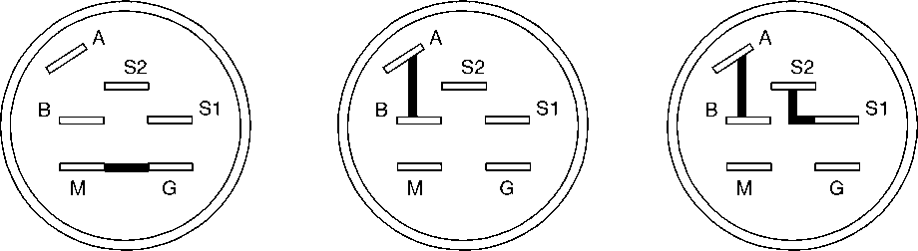The ignition switch incorporates a number of functions, Although not all functions are used on all equipment. The switch has three positions; OFF, RUN, and a momentary contact START position. use an ohmmeter to check continuity of the switch in each position.

**Key Switch**

(03602300)

OFF

RUN

START

Figure 45

**915 EZRIDER SERVICE MANUAL ELECTRICAL SYSTEM**

**OFF Position-** Should be continuity between contacts G and M. These connections ground the engine magneto and stop the engine in the OFF position.

**RUN Position** - Should be continuity between contacts B and A , these connections supply power to the rest of the wiring harness. Connections G and M open to each

other.

**START Position** - Hold switch in START position while testing. There should be continuity between contacts S1 and S2. These connections apply power to close the solenoid contacts and operate the starter motor.

In addition to the above test, place the switch in the run position and check between each contact and ground(metal case) to be sure no terminals are grounded. If the switch is operating properly, there will be no continuity between contacts other than those described.

* 1. Solenoid and Relays

Solenoid and relays are both magnetically operated devices. Both devices operate on the principle that passing a current of electricity through a coil of wire will create a magnetic field strong enough to attract a piece of iron or steel. Each device uses this principle in a slightly different manner.

**Relay** - a basic relay consist of a coil of wire wound around a soft iron (magnetic) core. When current is passed through the coil, the core is magnetized and pulls down on a magnetic lever. The lever in turn is attaches to several switch contacts which open or close other electrical circuits. In this fashion, a small current can control one or more larger electrical currents and actuate several other devices. I most cases a relay contact moves only a fraction of an inch and the magnetic pull is small.

**Solenoid** - A basic solenoid consists of a coil of wire wound around a hollow tube. A magnetic core slides in side the tube. When current is passed through the coil, the core is pulled into the solenoid with considerable force. With proper design, a solenoid can exert considerable force over a distance of several inches. A solenoid can therefore, pull a lever, close a heavy contact, or perform other jobs that require a straight line pull.

If a relay or solenoid fails to operate, the cause may be either electrical or mechanical.

To check electrically, connect a voltmeter across the coil of the device and activate the circuit that operates the relay or solenoid. If the meter indicates no voltage is applied, the cause is in the control circuit.

If the meter indicates proper voltage across the coil but the device does not function, remove the power, disconnect the wiring and check the continuity of the coil with an ohmmeter. The meter should indicate resistance, in the order of 3 to 5 ohms, if the coil is intact. A high resistance indicates an open coil and a defective device.

There are also a number of mechanical problems that may cause the problem.

The starter solenoid in the Ariens equipment is a sealed unit used to actuate the starter motor on the engines.

These solenoid may have three or four connections. The two large connections carry high current to operate the starter motor. The small connections are connected to the coil and carry the control current.

To check the solenoid, disconnect the cables to the starter motor, turn the ignition switch to the start position, and listen for the solenoid to snap inside contacts closed.

If no snap is heard, check across the coil with a voltmeter. The voltage should read 12 volts with the

ignition switch in the start position. If no voltage appears,

the defect is in the start circuit.

Relay

(03042800)

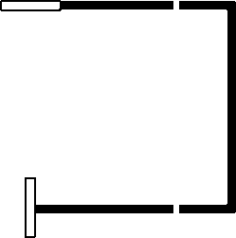

87

�86 8� 85 �

30

=

87

�86 89 85 �

30�

NOT ENERGIZED ENERGIZED

Figure 46

If the voltage is correct, turn off the power and check continuity of the coil with an ohmmeter. If the coil is open, the solenoid is defective and must be replaced.

I the coil has the proper voltage applied, and the continuity check indicates the coil is in intact, the solenoid plunger is stuck or the contacts are welded shut and the solenoid must be replaced.

If the solenoid snaps shut, but the starter does not operate, check across the large contacts with an ohmmeter. If there is no continuity when the solenoid snaps shut, the contacts are defective and the solenoid must be replaced.

**ELECTRICAL SYSTEM 915 EZRIDER SERVICE MANUAL**

* 1. LIGHTING CIRCUITS

Lighting circuits are simple circuits and easiest to trouble shoot in most equipment. They consist of the lights connected in parallel, a normally open switch, a protective fuse and a source of power (battery or engine Alternator).

If only one light is out, check the connector, then check the bulb for continuity (high resistance indicates a defective or burned out bulb).

If all the lights are out, Check the fuse for continuity (high resistance indicates a defective or blown fuse). If the fuse is blown, check for a short in the wiring and correct before replacing the fuse.

If the fuse and lamps are good, check the circuit with an AC/DC voltmeter.

* 1. FUSES

Fuses are connected in electrical circuits to protect the circuits from damage do to overload or short circuits. Fuses are a "weak link" in the circuit. They contain a metal link designed to melt when a certain current value is exceeded thus opening or disconnecting the wiring. The fuse is a one time device. Once the fuse blows or melts it must be discarded and replaced with a new fuse of the same valve.

Since the function of the fuse is to protect the circuit, **NEVER** attempt to defeat the protective device by bridging or replacing with a device of a higher current rating.

Electrical testing of these devices is simple, Since the device either conducts current (and is therefore functioning) or the device is open and is therefore defective. Use an ohmmeter to check for continuity.

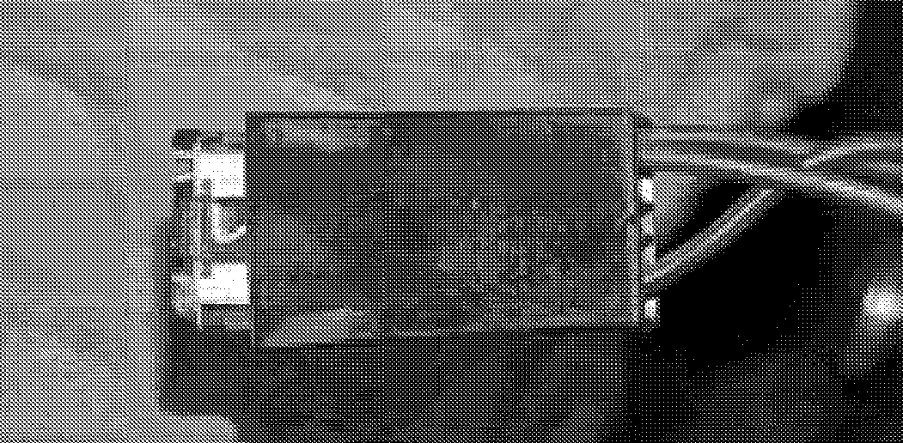Replace defective devices only with factory replacements parts.

* 1. DIDOES AND RECTIFIERS

Didoes are solid state, semiconductors devices. They contain no moving parts and conduct current better in one direction than the other. They are electrical "check

valves" and permit current flow in one direction, but not in the other.

Didoes allow current to flow through on circuit without "backing up" into another. In engine alternator circuits a diode is used to convert current which flows bach and forth **(AC)** in a circuit to current which flows only in one direction (DC). A device which converts alternating current to a direct current is call a **RECTIFIER.** A diode is on type of a rectifier.

To check a diode, isolate it from the circuit by disconnecting on end. With a multitester set on the lowest ohms scale setting, measure the resistance in one direction, reverse the test leads, and measure in the other direction. Readings should be high in one direction and low in the other.(lf the readings are low in both directions, the diode is shorted, and if the readings are high, the diode is open.) If the readings are the same in both directions, the diode is defective and must be replaced.

**IMPORTANT:** Didoes are marked to indicate polarity (a band on one end, an arrow on the side, or the fit on a holder only one way).

Rectifiers

A battery is charged through the use of an alternator located in or on the engine. A charging circuit contains a rectifier because alternator produce alternating (AC) current and batteries require direct current (DC) for charging.

The rectifier may be built into the engine or it may be an external part. It may also contain regulator to prevent overcharging the battery. ( servicing of rectifiers are built into the engine should be done by an approved engine manufactures service center. Such a service center has access to the information and parts required to test and repair or replace engine components, including rectifiers and regulators.

Units that contain both a rectifier and regulator are tested in a working circuit to make sure the regulator portion of the device is operating.



9-38 Ariens® 01546200 Orig. 9/98

**915 EZRIDER SERVICE MANUAL ELECTRICAL SYSTEM**

* 1. **Electric Clutch**

The electric clutch is used to turn on and off the attachment used on the tractor by use of a switch on the dash panel. The clutch is also designed so that a brake is applied to the output shaft when the clutch is disengaged (off).

The field coil is mounted to a bearing support and does not rotated. The rotor is attached to the power output shaft and rotates around the field assembly. The armature is attached to the output pulley. The armature assembly is held close to the rotor by the brake assembly. The clutch is engaged by applying current to the coil connection. This results in a current flowing through the coil, magnetizing the coil pulling the armature onto the rotor with sufficient force to hold the two pieces together, effectively connecting the output and the input shafts together. Pulling the armature against the rotor pulls it away from the brake, releasing the brake.

**Engine Electrical Components**

Engine servicing and repair should be referred to local engine manufactures service centers that have the service information and parts available to properly service the engine. Ariens dealers should be able to test engines and engine components to pinpoint troubles and narrow them down to properly advise the engine serviceman.

* 1. EZR ELECTRICAL

Initial check out: Make sure that all switches are in their proper position for starting: (A) PTO off. (B) transaxle in neutral position. (C) operator on the seat. If no battery voltage to start the engine. Start the checklist.

**STEP 1**

Check out the battery. Using a hydrometer on all the battery cells to see if one or more is bad. Also use a voltmeter to check for proper voltage. Replace the battery if necessary and/or charge to proper level.

**STEP2**

Use a voltmeter to make sure you have battery voltage to terminal (B) on the back side of the ignition switch in the off position. If you don't have battery voltage to terminal

(B) check the battery connection and the fuse in the red lead.

**STEP3**

With the ignition switch in the "run" position, check to see if the battery voltage is being transferred from terminal

(B) to terminal (A). Terminal (A) on the ignition switch supplies battery voltage to the back of the PTO switch on the purple lead and on to the neutral switches on the red/violet lead to terminal S2 on the ignition switch and to

terminal 85 on solenoid# 2. Terminal (A) also supplies battery voltage to terminal 30 and 85 on solenoid# 1 and on to the hour meter. When the operator is in the seat, battery voltage will transfer from terminal 30 to terminal 87 and on to the front terminal of the PTO switch and on to terminal 85 on solenoid # 2 in the yellow/red lead.

Battery voltage is supplied to the fuel shut off solenoid from terminal 85 on solenoid# 2.

**STEP4**

With the ignition switch in the start position, battery voltage is transferred from terminal S2 to S1. Terminal S1 transfers battery voltage to the one small terminal on the starter solenoid and goes to ground through the base of the starter solenoid.

PTO Clutch check out: Remove the wiring harness PTO clutch leads from the clutch. With a Multimeter check the clutch coil for resistance to see if the coil is good.

The clutch used on models 915001, 004, 008, 301, 303, 304 should have a coil resistance of (5.87 - 7.87) ohms. If the coil is bad the resistance will be higher or not at all.

The clutch used on models 915002, 003, 005, 006, 007,

009, 010, 302, 305 should have a coil resistance of (1.98

- 3.98) ohms. If the coil is bad the resistance will be higher or not at all.

Ignition switch check out: Battery voltage check in the "off" position, check for voltage at terminal "B". It should not be present on terminals A, S1, S2.

With the ignition switch in the "run" position, check for battery voltage at terminal B, A, S2. It should not be present at terminal S1.

With the ignition switch in the "start" position, check for battery voltage at terminals B, A, S2, S1.

PTO switch check out: The PTO switch is a push/pull switch with normal open and closed contacts. Power transfer should be checked with a voltmeter. The switch contacts should be checked with an Ohm meter with the wire harness plug removed. The light switch is similar to the PTO switch with only one set of contacts.

Diode check out: Diodes are checked with an ohm meter set on the diode check, and should only pass voltage in one direction. If it passes voltage in both directions or not at all the diode is bad and needs to be replaced.

**ELECTRICAL SYSTEM 915 EZRIDER SERVICE MANUAL**

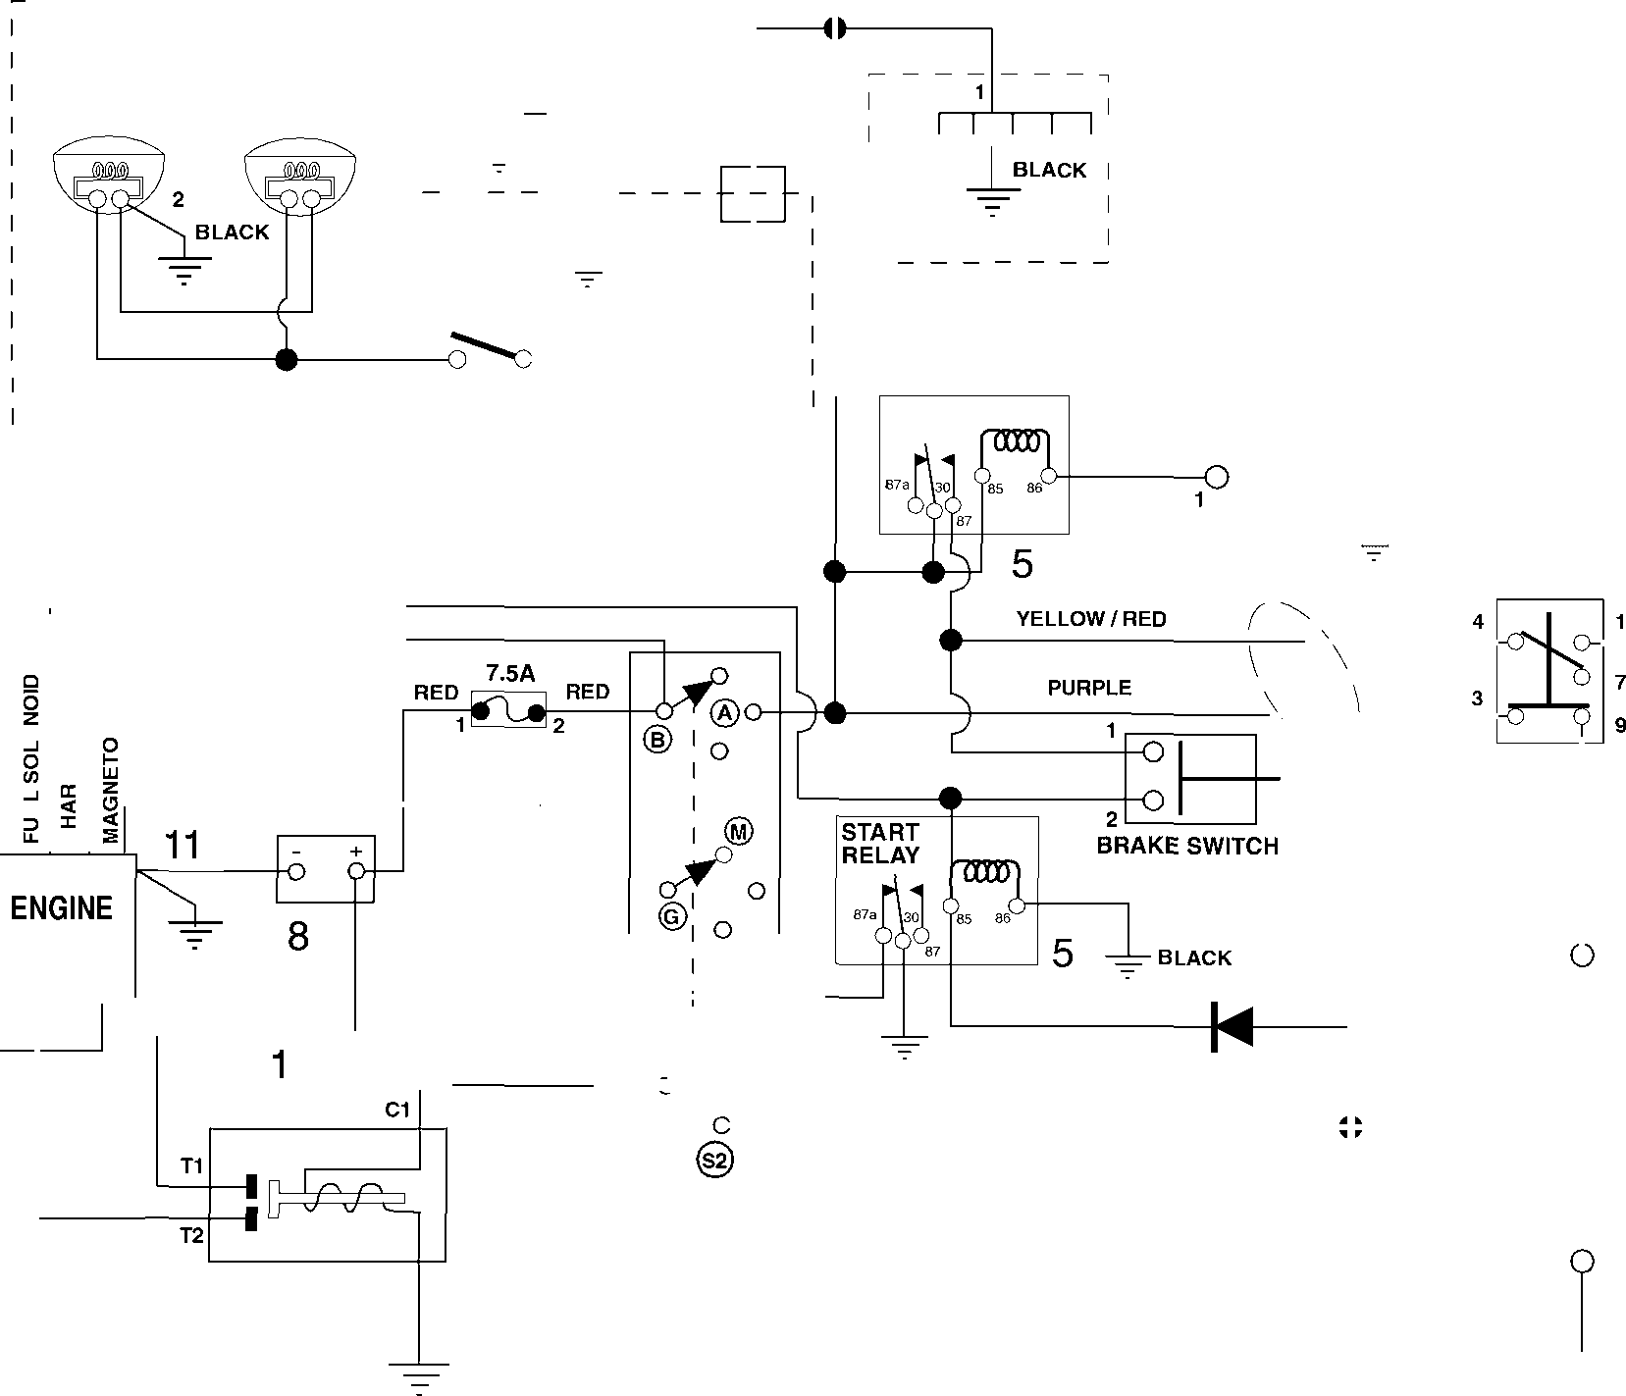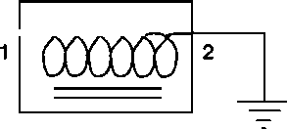

- 7

I

.I

*i*

**I HOUR 2 I METER**

**OPTIONAL**

---,--L

1 13

**PURPLE**

**PURPLE**

**PURPLE**

**PURPLE**

**SEAT RELAY**

**SEAT SWITCH**

**I OPTIONAL**

**_ _ _ _ _ _ _ _ _ _ _ _ _ _ _ _ _ _ _ _ _ _ _ _**

**I**

**J**

**PINK**

__L

12�

**YELLOW/RED**

**BLACK**

**PTO SWITCH**

**PTO CLUTCH**

**PURPLE/ WHITE**

**RED**

UJ

"UJ

"

**WHITE/ BLACK**

**17**

**'-.._ )**

6

9

**3**

**BLAC**

UJ

**BROWN/ YELLOW**

**2**

**BLACK**

**RED**

**YELLOW/RED**

**RED/VIOLET**

2

**STARTER**

**I**

� **LEFTHAND NEUTRAL SWITCH**

**BROWN**

**1**

- , f - { } 0

***@,,,a***

**BLACK**

**RED/VIOLET**

I

**WHITE**

**1**

**RED**

7

10

**C2**

**KEY SWITCH**

4

**2**

**RIGHT HAND NEUTRAL SWITCH**

2

**BLACK**

|  |  |  |  |  |
| --- | --- | --- | --- | --- |
| **ITEM** | **DESCRIPTION** |  | **ITEM** | **DESCRIPTION** |
| 1 | Positive Battery Cable |  | 8 | Battery |
| 2 | Neutral Switch |  | 9 | PTO Switch |
| 3 | PTO Clutch |  | 10 | Starter Solenoid |
| 4 | Ignition Switch |  | 11 | Negative Battery Cable |
| 5 | Relay |  | 12 | Seat Switch |
| 6 | Wire Harness |  | 13 | Hour Meter |
| 7 | Starter Cable |  | 17 | Fuse |

**915 EZRIDER SERVICE MANUAL ELECTRICAL SYSTEM**

**KEY SWITCH OFF RUN START**

|  |  |  |  |
| --- | --- | --- | --- |
| B | 11.50-13.00 | 11.50-13.00 | 11.50-13.00 |
| A |  | 11.50-13.00 | 11.50-13.00 |
| S-1 |  |  | 11.50-13.00 |
| S-2 |  | 11.50-13.00 | 11.50-13.00 |

NOTES: CONTACT RESISTANCE IS 0.1-0.3 OHMS WHEN CORRECT.

**SEAT SWITCH OFF RUN START**

|  |  |
| --- | --- |
| PINK | 11.50-13.00 11.50-13.00 |
| BLACK | CONNECTED TO GROUND |

NOTES: NORMALLY OPEN CONTACTS MANUALLY ACTIVATED. CONTACT RESISTANCE IS 0.1-0.3 OHMS WHEN CORRECT.

**PTO SWITCH OFF RUN START**

|  |  |  |  |
| --- | --- | --- | --- |
| YELLOW/RED |  | 11.50-13.00 | 11.50-13.00 |
| PURPLE/WHITE | CONNECTED TO PTO CLUTCH | | |
| PURPLE |  | 11.50-13.00 | 11.50-13.00 |
| BROWN/YELLOW |  | 11.50-13.00 | 11.50-13.00 |

NOTES: 2 SETS OF CONTACTS, ONE NORMALLY OPEN, ONE NORMALLY CLOSED. CONTACT RESISTANCE IS 0.1-0.3 OHMS WHEN CORRECT.

**ELECTRICAL SYSTEM 915 EZRIDER SERVICE MANUAL**

**NEUTRAL SWITCH OFF RUN START**

|  |  |
| --- | --- |
| BROWN/YELLOW | 11.50-13.00 11.50-13.00 |
| RED/VIOLET | 11.50-13.00 11 .50-13.00 |

NOTES: NORMALLY OPEN CONTACTS MANUALLY ACTIVATED. CONTACT RESISTANCE IS 0.1-0.3 OHMS WHEN CORRECT.

**RELAY #1 OFF RUN START**

|  |  |  |  |  |
| --- | --- | --- | --- | --- |
| PINK | 86 |  | 11.50-13.00 | 11 .50-13.00 |
| PURPLE | 85 |  | 11.50-13.00 | 11 .50-13.00 |
| YELLOW/RED | 87 |  | 11.50-13.00 | 11 .50-13.00 |
| 87A | |  | NOT USED | NOT USED |
| PURPLE (3) | 30 |  | 11.50-13.00 | 11.50-13.00 |

NOTES: PINS 85-86 COIL RESISTANCE 87-100 OHMS. PINS 30-87 NORMALLY OPEN. PINS 30-87A NORMALLY CLOSED. CONTACT RESISTANCE IS 0.1-0.3 OHMS WHEN CORRECT.

**RELAY #2 OFF RUN START**

|  |  |  |  |  |  |
| --- | --- | --- | --- | --- | --- |
| BLACK | 86 | I | 11.50-13.00 | I | 11 .50-13.00 |
| YELLOW/RED (2) | 85 | CONNECTED TO GROUND | | | |
| 87 | | I | NOT USED | I | NOT USED |
| WHITE/BLACK | 87A | CONNECTED TO IGNITION MODULE | | | |
| BLACK | 30 | CONNECTED TO GROUND | | | |

NOTES: PINS 85-86 COIL RESISTANCE 87-100 OHMS. PINS 30-87 NORMALLY OPEN. PINS 30-87A NORMALLY CLOSED. CONTACT RESISTANCE IS 0.1-0.3 OHMS WHEN CORRECT.

**915 EZRIDER SERVICE MANUAL ELECTRICAL SYSTEM**

**SOLENOID OFF RUN START**

|  |  |  |  |
| --- | --- | --- | --- |
| SMALL BROWN |  |  | 11.50-13.00 |
| SMALL BLACK | CONNECTOR TO GROUND | | |
| LARGE RED (BATTERY) | 11.50-13.00 | 11.50-13.00 | 11.50-13.00 |
| LARGE RED (STARTER) |  |  | 11.50-13.00 |

NOTES: NORMALLY OPEN CONTACTS (BIG TERMINALS) COIL RESISTANCE 3.0-5.0 OHMS. CONTACT RESISTANCE IS 0.1-0.3 OHMS WHEN CORRECT. ELECTRICALLY ACTIVATED.

PTO CLUTCH OFF RUN START

|  |  |
| --- | --- |
| PURPLE/WHITE | I I |
| BLACK | CONNECTED TO GROUND |

NOTES: COIL RESISTANCE Check clutch Specifications

BRAKE SWITCH OFF RUN START

|  |  |  |  |
| --- | --- | --- | --- |
| Yellow/Red, Yellow/Red |  | 11 .50-13.00 | 11.50-13.00 |
| Yellow/Red |  | 11 .50-13.00 | 11.50-13.00 |

NOTES: NORMALLY CLOSED CONTACTS MECHANICAL ACTIVATED. CONTACT RESISTANCE 0.1-0.3 OHMS. USED ON MODELS 915004,005, 006, 007, 008, 009, 010 302,303,304,305

**ELECTRICAL SYSTEM 915 EZRIDER SERVICE MANUAL**

The diagrams below show the various states of connection for electrical components. The solid lines on switches show continuity.

**NOTE:** All switches are viewed from the rear.

|  |  |  |  |  |  |  |  |  |
| --- | --- | --- | --- | --- | --- | --- | --- | --- |
| **Key Switch** | |  | **Relay** | | |  | | |
| (03602300) | |  | (03042800) | | |  | | |
|  | |  |  |  |  |  |  |  |
|  | 87 |  |  | 87 |  |
| �86 | 89 | 85 � | �86 | 8� | 85 � |
|  | 30� |  |  | 30 |  |
| OFF | RUN | START |  | | |  | | |
|  | |  | NOT ENERGIZED | | | ENERGIZED | | |
| **PTO Switch**  (00522100)  **3** 9  [HJ  *m*  4 1 7  DISENGAGED  (down position) | |  | **Neutral Switch** | | |  | | |
| **3** 9 | (01526100) | | |  | | |
| D D |  | | |  | | |
| HD |
| STEERING LEVER | | | STEERING LEVER | | |
| 4 1 7 |
| ENGAGED  (up position) | IN POSITION | | | OUT POSITION | | |
| (button up) | | | (button down) | | |
| **Seat Switch** | |  | **Brake Switch** | | |  | | |
| (03654200) | |  | (03657100) | | |  | | |
| OPERATOR OFF SEAT | | [8TI  OPERATOR  ON SEAT | DISENGAGED  (button down) | | | uT  ENGAGED  (button up) | | |



**915 EZRIDER SERVICE MANUAL MOWER ATTACHMENT**

## SECTION 10: MOWER ATTACHMENT



* 1. **40" AND 48" MOWER REMOVAL**

Refer to figure 46 and 47 for the 40" and 48" mowers

1. Remove the key from the ignition switch and the negative cable from the battery prior too removing the mower assembly.
2. Release the mower PTO belt tension by releasing the idler spring on the spring anchor under the frame. Lower the mower assembly and remove the hair pins and washers from the lift links.

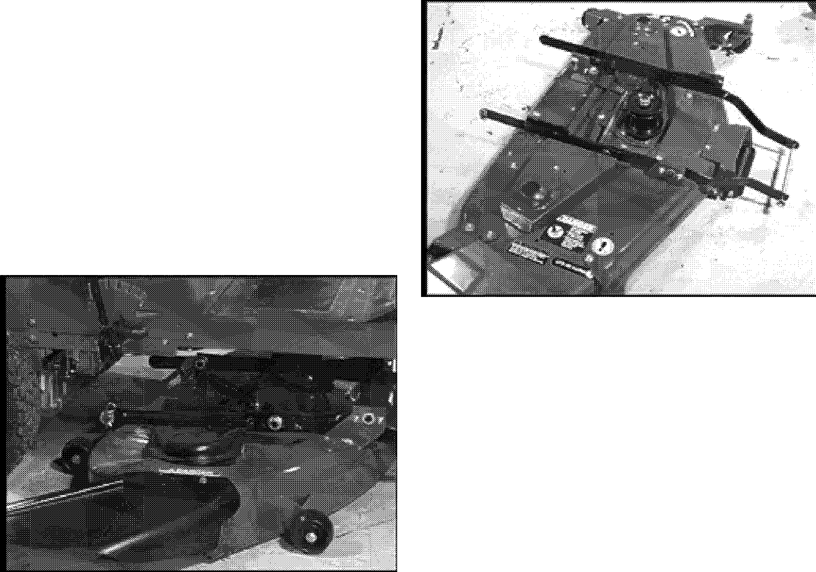

1. Remove the two hair pins from the rear support control arms on the mower support linkage.
2. Remove the mower deck drive belt from the PTO clutch and the top of the jackshaft assembly.
3. Slide the mower pan assembly forward to release the front hanger rod from the retainer hooks under the front axle.
4. Raise the front of the EZ Rider to provide clearance for the mower assembly and remove the mower from under the EZ Rider.

Figure 46

* 1. **40" AND 48" MOWER INSTALLATION**

1. Raise the front of the EZ Rider and position the mower deck under the tractor and hook the mower front support rod in the support hooks under the front axle.
2. Lower the front of the tractor, insert the rear support control arms into the rear support brackets, and secure with hair pins removed earlier.
3. Lower the mower lift mechanism and attach the mower lift links and secure with washers and hair pins removed earlier.
4. Attach the mower drive belt to the top of the mower jackshaft assembly and route the belt inside of the PTO idler, and on to the PTO clutch. Attach the PTO idler tension spring.
5. Check location and routing of the PTO belt before engaging the PTO clutch with engine running.
6. Reattach the battery negative cable to the battery and insert the ignition key into the ignition switch.

Figure 47

**9.3 40" MOWER SPINDLE REMOVAL**

1. With the mower deck removed from the EZ Rider, the disassembly of the mower may be done.
2. Remove the left side mower spindle cover.
3. Remove the mower deck blades hardware, mower deck blades, blade trays retainer hub, spindle key and bearing slinger.
4. Remove the mower deck spindle drive belt from the spindle sheaves.
5. Remove the mower deck left side support arms to provide clearance to remove the left spindle.
6. Remove the spindle sheaves and shaft assemblies.
7. Remove the mower spindle housings from the mower deck stamping.

### 48" Mower spindle Removal

1. With the mower deck removed from the EZ Rider, the disassembly of the mower may be done.
2. Remove the right and left side mower spindle cover.
3. Remove the mower deck blades hardware, mower deck blades, blade trays retainer hub, spindle key



**MOWER ATTACHMENT 915 EZRIDER SERVICE MANUAL**

and bearing slinger.

1. Remove the mower deck spindle drive belt from the spindle sheaves.
2. Remove the spindle sheaves from the shaft assemblies.
3. Remove the mower spindle housings from the mower deck stamping.

**10.4 40" SPINDLE REPAIR**

1. When the spindle housing has been removed from the mower deck the bearings may be removed from the housing.
2. Prior to removal of the bearings check for bearing damage and remove if necessary.
3. Attach a bearing puller to the bearing in the housing and remove the spindle bearings.
4. If the housing has been damaged replace the bearings and housings.
5. Press new bearings into the spindle housing with a press, make sure to insert the spacer tube into the housing before pressing the second bearing into place.

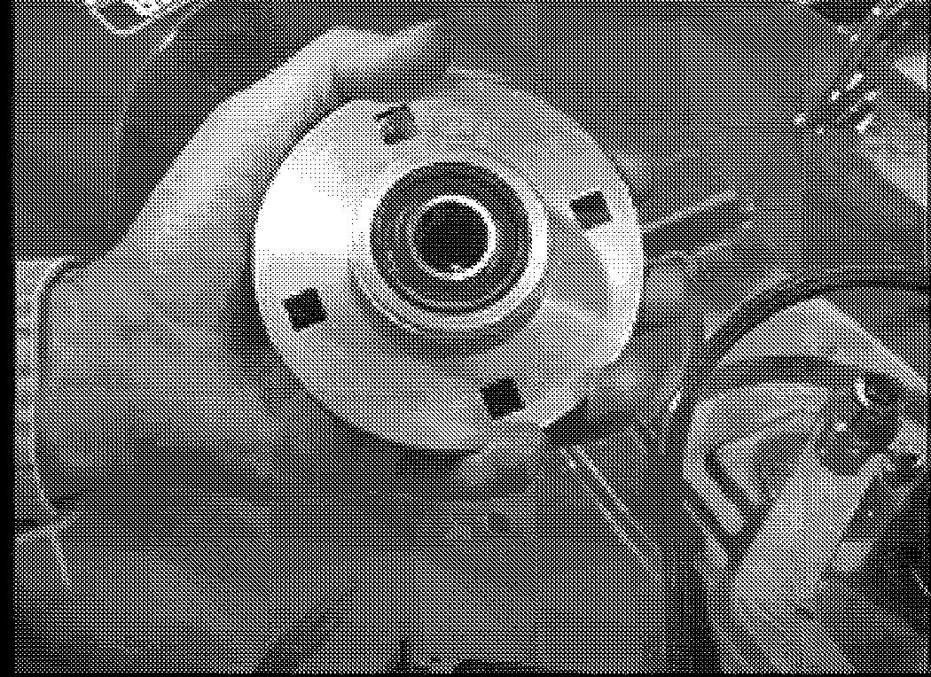

Figure 47

###### 48" Spindle Repair

1. When the spindle housing has been removed from the mower deck the spindle shaft and bearings may be removed from the housing.
2. Prior to removal of the bearings check for bearing damage and remove if necessary.
3. Push the spindle shaft and bearing in the housing out in a press.
4. If the housing has been damaged replace the spindle shaft, bearings and housings.
5. Press new bearings into the spindle housing with a press, make sure to insert the spindle shaft into the housing before pressing the second bearing into place.

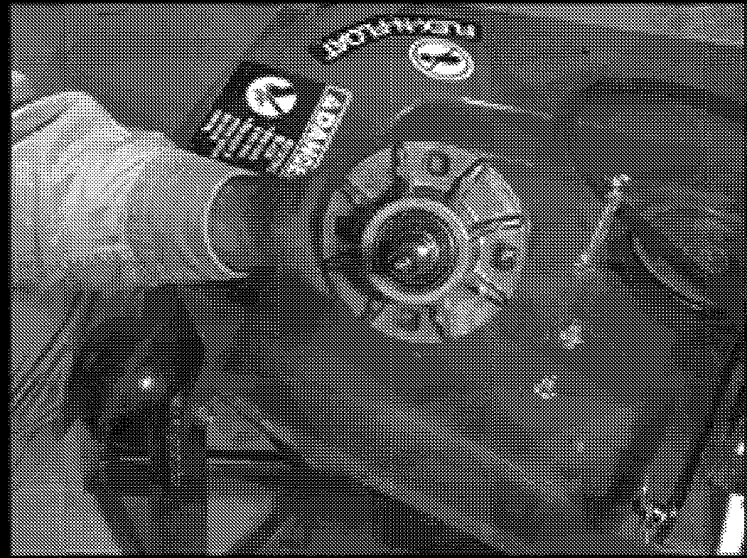

Figure 48

* 1. **40" SPINDLE INSTALLATION**

1. Place the spindle housings into the mower deck stamping and attach with new hardware.
2. Insert spindle shaft and sheave assemblies into the spindle housings with spacer washer under sheaves.
3. Reattach the right side mower support arms to the mower deck stamping.
4. Reattach the mower deck spindle drive belt.
5. Reinstall the bearing slinger, spindle key, retainer hub, blade trays, and mower deck blades with hardware removed earlier.
6. Check mower deck blades for clearance inside of the mower deck stamping and mounting flatness.

###### 48" Spindle Installation

1. Place the spindle housings into the mower deck stamping and attach with new hardware.
2. Attach the sheave onto the spindle shaft with a spacer washer under sheaves.
3. Reattach the mower deck spindle drive belt.
4. Reinstall the bearing slinger, spindle key, retainer hub, blade trays, and mower deck blades with hardware removed earlier.
5. Check mower deck blades for clearance inside of the mower deck stamping and mounting flatness.



**915 EZRIDER SERVICE MANUAL MOWER ATTACHMENT**

* 1. 40" JACKSHAFT REMOVAL AND REPAIR

Refer to Figure 49 for the Jackshaft.

1. Remove the mower deck idler tension spring from the spring anchor.
2. Remove the mower deck drive belt from the jackshaft assembly.
3. Remove the hardware holding the jackshaft assembly to the mower deck stamping, remove the assembly.
4. Remove the nylock nut on the top of the spindle assembly and remove the double pulley assembly.
5. Check the bearings, and spindle shaft for wear and replace the damage parts.
6. Bearings need to be removed with a bearing puller and replace with a bearing driver in a press.

**NOTE:** The bearings should have a light press fit to the bore of the pulley assembly, to tight of a press fit will preload the bearing and cause premature bearing failure.

1. Check idler arm pivot bushings for wear and movement, check the idler for run out and interferences.
2. Reassemble the double pulley assembly with the bearing spacer tube inside the assembly.
3. Place the double pulley assembly onto the spindle shaft and hold in place with a flat washer and nylock lock nut.

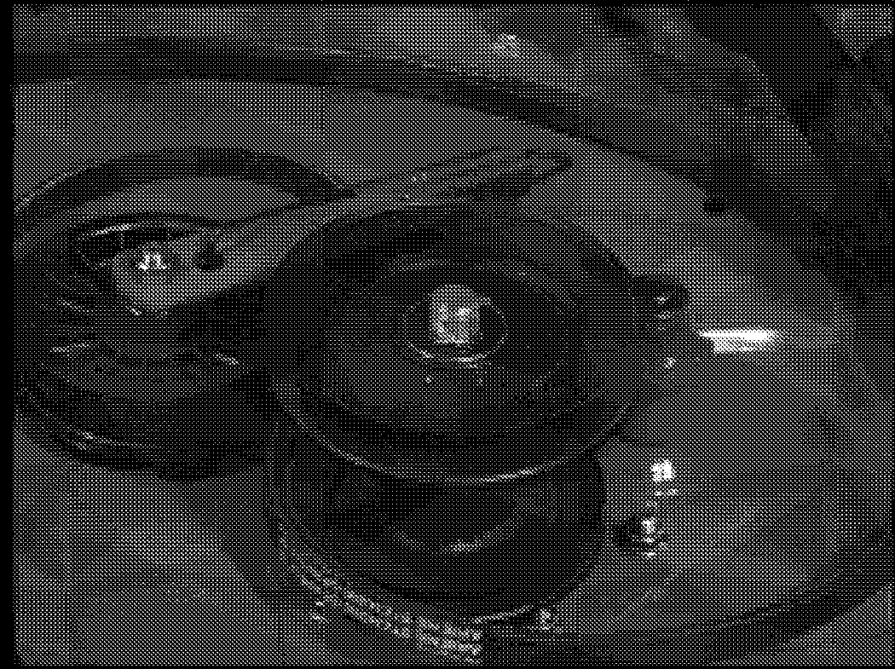

40" Jackshaft assembly

* 1. 40" JACKS HAFT INSTALLATION

1. Place the jackshaft assembly on the mower deck stamping and attach with new hardware ant torque according to the torque table.
2. Reinstall the mower spindle drive belt onto the jackshaft assembly and attach the mower deck idler tension spring to the spring anchor.
3. Rotate the mower jackshaft assembly and check routing of the belt and idler clearance to the mower deck stamping.



**915 EZRIDER SERVICE MANUAL APPENDIX**

## APPENDIX



A.1 MAINTENANCE SCHEDULE

The maintenance schedule shows the recommended schedule that should be performed on a regular basis. More frequent service may be required due to working conditions. (i.e. Heavy loads, high ambient temperatures, dusty conditions, or when airborne debris are present.)

See the engine manual for maintenance instructions. Use the chart below to record the actual hours on the hourmeter and date at which each service item is performed.

|  |  |  |  |  |  |
| --- | --- | --- | --- | --- | --- |
| **MAINTENANCE SCHEDULE** | | | | | |
| SERVICE PREFORMED | TIME INTERVALS BETWEEN SERVICE | | | | |
|  | DAILY  • | 25 HRS. | 50 HRS. | 100 HRS. | 500 HRS. |
| Check Engine Oil | • |  |  |  |  |
| Check Safety Interlock System | • |  |  |  |  |
| Check the Air Cleaner |  | • |  |  |  |
| Clean and Reoil Foam Air Filter |  | • |  |  |  |
| Change Engine Crankcase Oil |  | • |  |  |  |
| Check Tire Pressure |  | • |  |  |  |
| Check the Battery Fluid |  | • |  |  |  |
| Check the Battery |  | • |  |  |  |
| Check Fasteners and Brake Adjustment |  | • |  |  |  |
| Check Mower and Drive Belts |  |  | • |  |  |
| Lubricate All Pivot Points |  |  | • |  |  |
| Grease Steering System and Front Axle Spindles Grease Mower Spindles  Check Spark Plugs  Replace Fuel Filter Clean Engine |  |  | • | •  •  •  • |  |
| Replace Paper Air Filter |  |  |  |  |  |



01546200 Orig. 9/98 Ariens® A-1

**APPENDIX**

# A.2

**915 EZRIDER SERVICE MANUAL**

##### MAINTENANCE RECORD (CONTINUED)

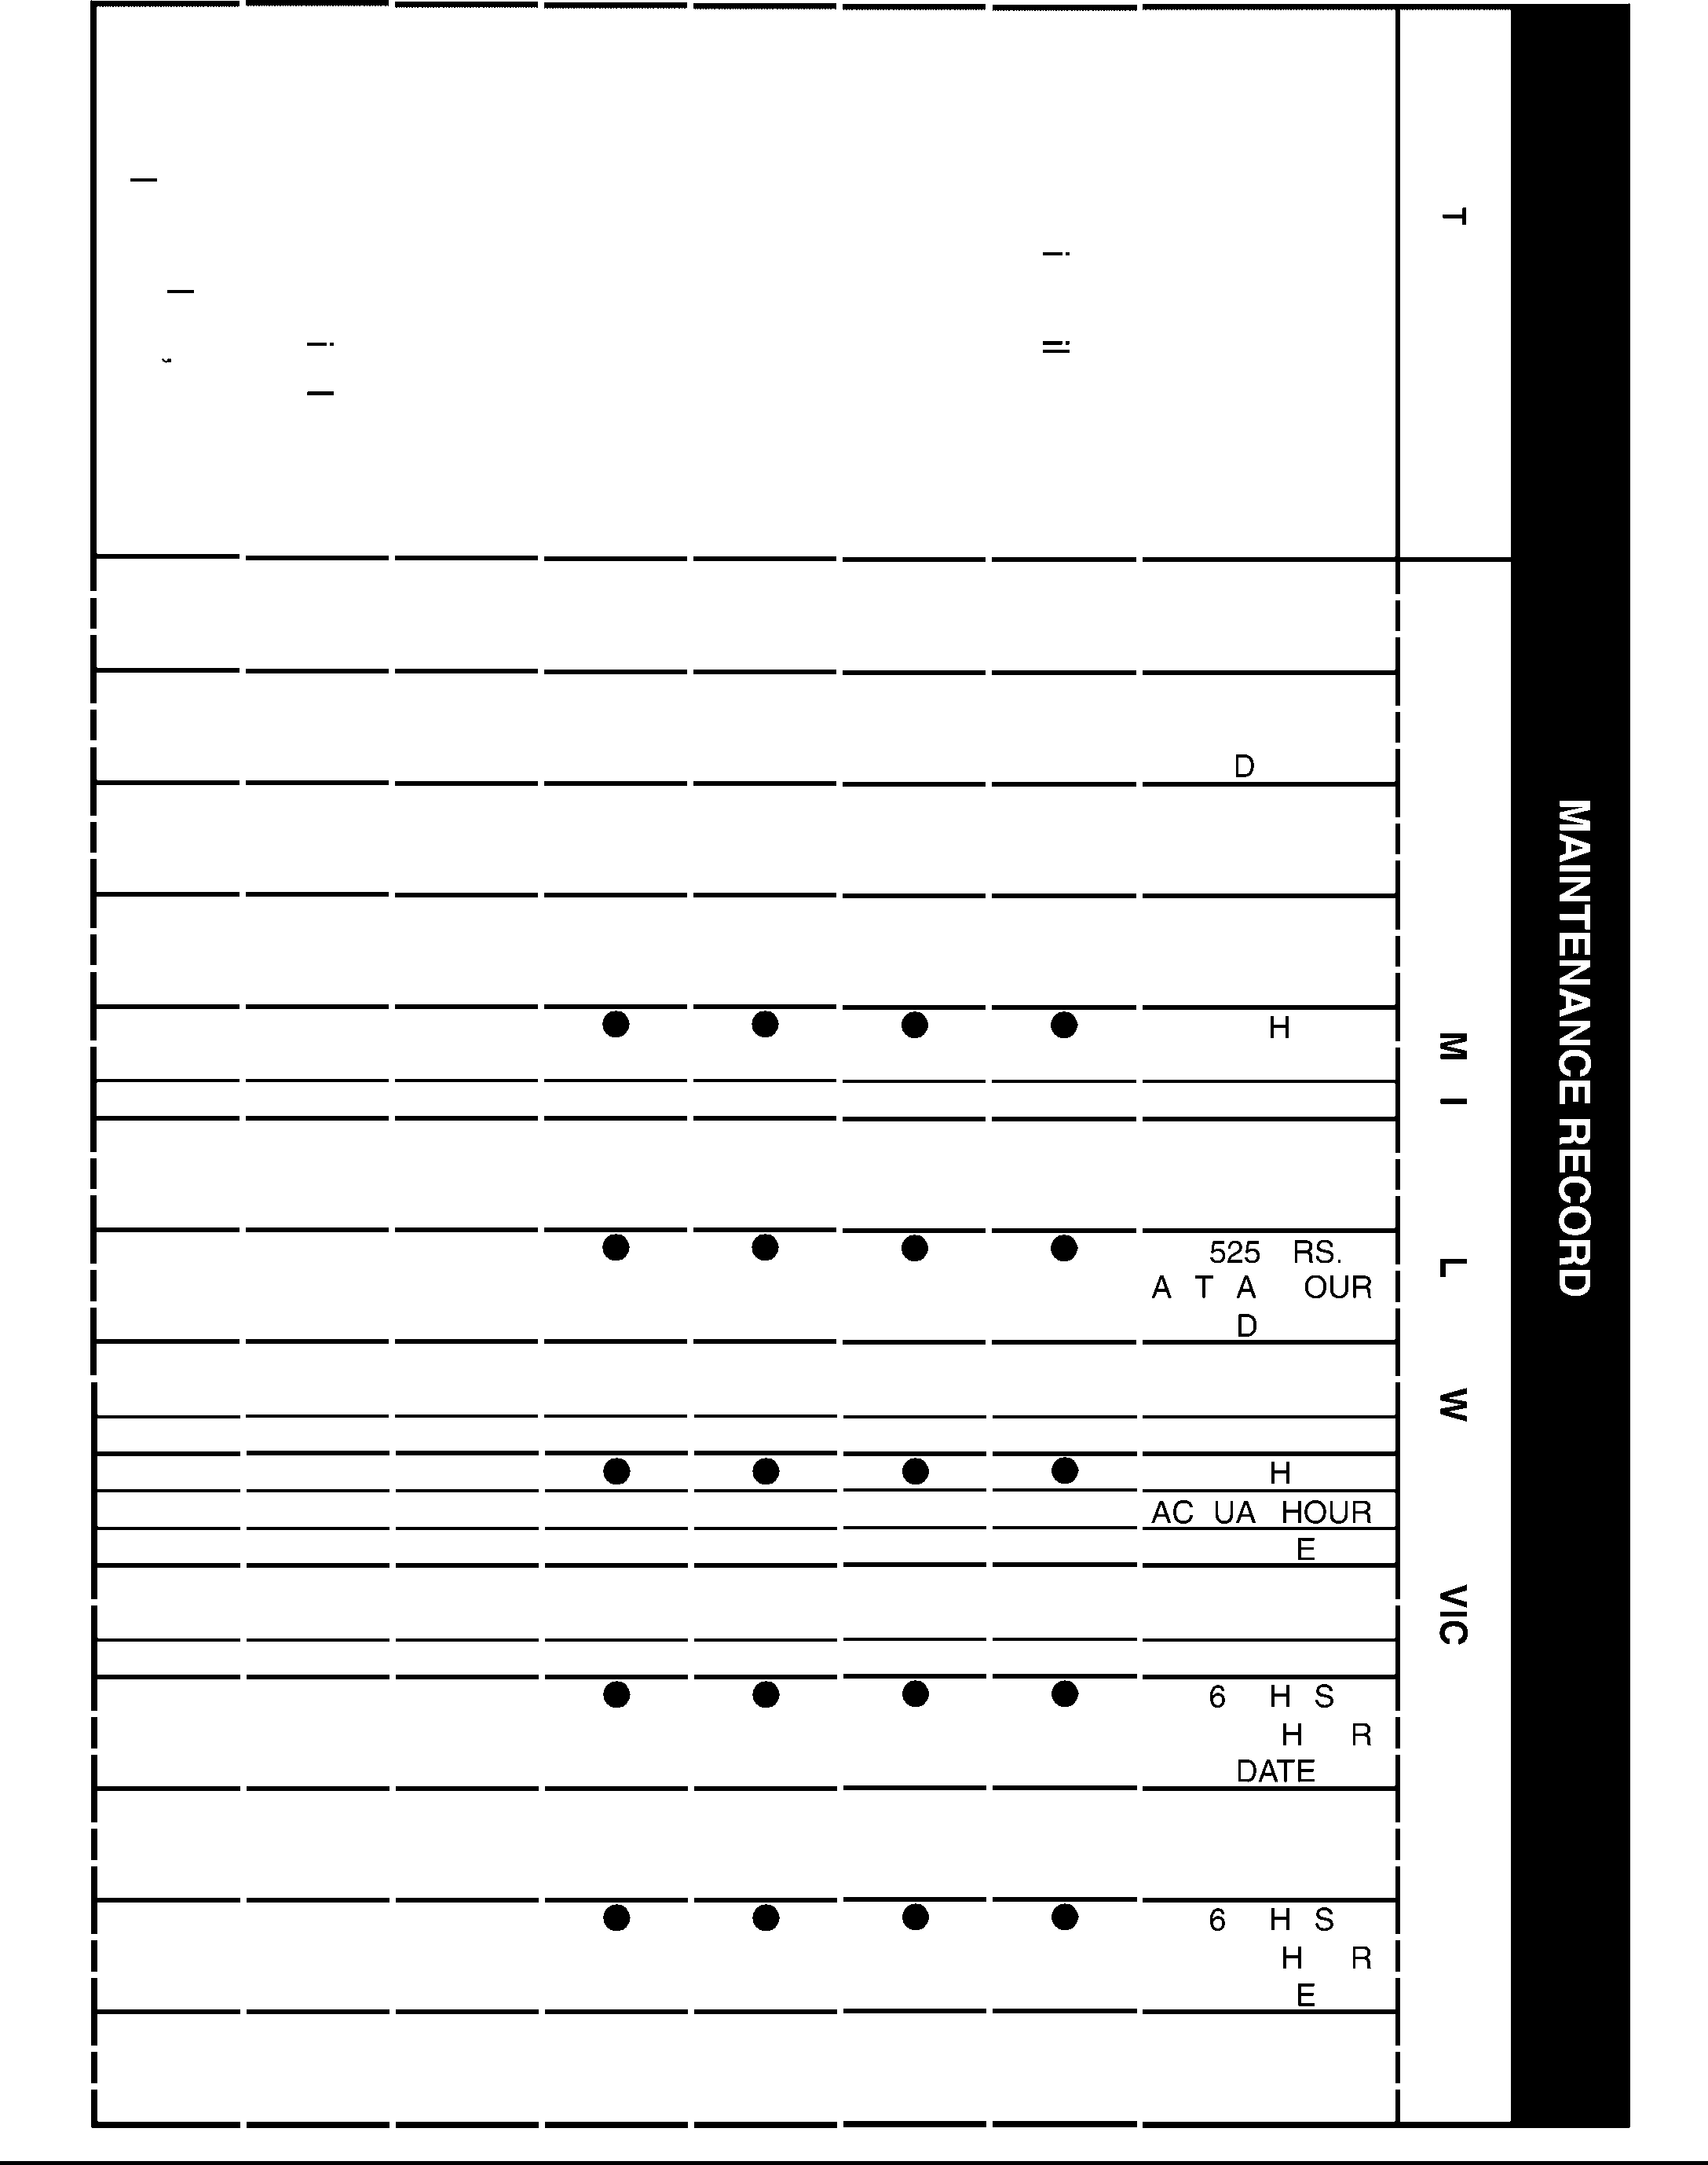***en***

|  |  |  |  |  |  |  |  |
| --- | --- | --- | --- | --- | --- | --- | --- |
| Pl ()  ::i : : ;  Cl. CD  "Tl C')  cA  CD (J)  "Tl "O  -- "·" Pl  ' I  © A  . ""O  C (Q (J)  .?.....  ::!!  ;:::;:  .**C** **D** | G )  CD  Pl (J) CD  s:  0  ::iE  .C D.  (J) "O  ::i  Cl.  CD  ***(J)*** | G)r  . C  CD O"  Pl -:::::!.  (J) C')  CD Pl  (J) CD  *co*-u  .-C..-D.o<-·  ::i -  (Q ""O (J)O ' (<J) --  - 3.  CD (J)  3 Pl  ::i  **Cl.** | ()  ::;  -CD  C')  A  ::; CD  .=..!..  CD  "..".O.. CD (J)  (J)  .C....  **CD**  • | Pl ()  ::i : : ;  Cl. CD  OJ C')  Pl A  -::i- CD  ' -< -OJ  "Tl Pl  c--C-D  Cl.'<  • | ()  ::;  -CD  C')  A  ::; CD  -"Tl  Pl  (J)  CD  ::i  C D.  (J)  • | ()  ::;  Pl  ::i  (Q CD  m  ::i  (Q  **::i**  CD  0  • | 375 HRS. |
|  |  |  |  |  |  |  | ACTUAL HOURS |
| • | • | • | • | • | • | • | DATE  400 HRS. |
|  |  |  |  |  |  |  | ACTUAL HOURS |
|  |  |  | • | • | • | • | ATE  425 HRS. |
|  |  |  |  |  |  |  | ACTUAL HOURS |
|  | • | • | • | • | • | • | DATE  450 HRS. |
|  |  |  |  |  |  |  | ACTUAL HOURS |
|  |  |  |  |  |  |  | DATE  475 RS. |
| • | • | • | • | • | • | • | ACTUAL HOURS DATE  500 HRS. |
|  |  |  |  |  |  |  | ACTUAL HOURS |
|  |  |  |  |  |  |  | DATE H |
|  |  |  |  |  |  |  | C U LH s |
|  | • | • | • | • | • | • | ATE 550 HRS. |
| • | • | • | • | • | • | • | ACTUAL HOURS DATE  575 RS.  T L s  DAT  600 HRS. |
|  |  |  |  |  |  |  | ACTUAL HOURS DATE  25 R. |
|  |  |  |  |  |  |  | ACTUAL OU s |
|  | • | • | • | • | • | • | 650 HRS. |
|  |  |  |  |  |  |  | ACTUAL HOURS |
|  |  |  |  |  |  |  | DATE  75 R. |
|  |  |  |  |  |  |  | ACTUAL OU s |
| • | • | • | • | • | • | • | DAT 700 HRS. |
|  |  |  |  |  |  |  | ACTUAL HOURS |
|  |  |  |  |  |  |  | DATE |

**m**

**:**<**c**

0

**m**

**0**

**OmJ "mti**

**:c**

**"Tl**

**0**

**::sc: m C**

**-I**

**m**

## z

**-I**

m

**:D**

j;

#### *en*

**CD**

m

**-I**

mm

**z *en* m**

**:D**

m

A-2

Ariens®

01546200 Orig. 9/98

**915 EZRIDER SERVICE MANUAL**

**APPENDIX**

* 1. MAINTENANCE RECORD

**CmJ)**

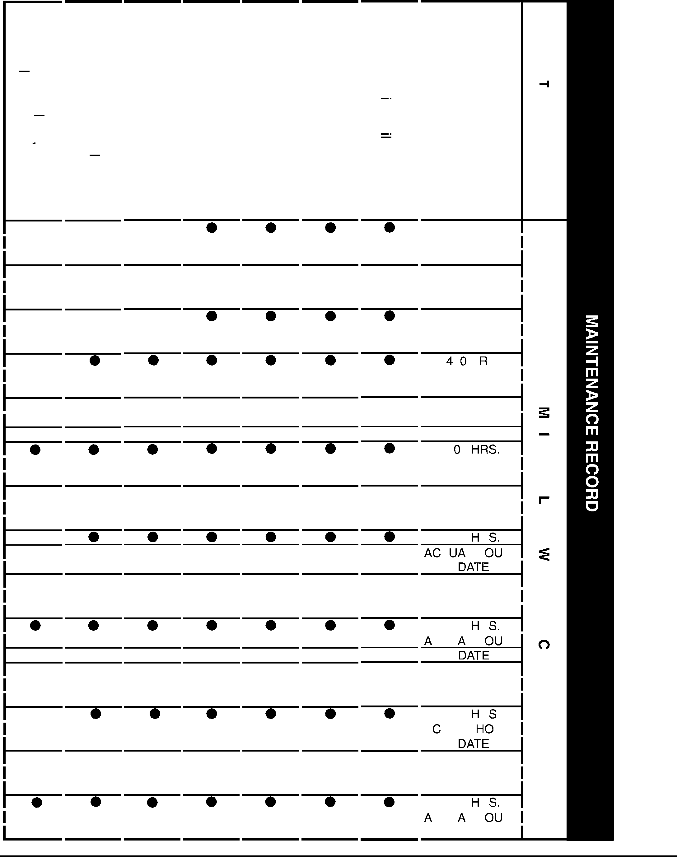

|  |  |  |  |  |  |  |  |
| --- | --- | --- | --- | --- | --- | --- | --- |
| Ill ( )  :C::Jl.::r  (D  "cT;l,:;;(-")  (D *C/)*  _"Tl."C  *ro*.I.l,l  *;,:;;-*  .... "'U  **c**C**o**  (/)  .?....  ::!!  ;:::;:  **(**..**D**.. | G )  (D  Ill  (/)  (D  :S::  0  (..D..  *Cl)*  "'2.  :::J  Cl.  **(D**  (/) | G)r  -, C  (D O'"  Ill --  (/) (")  CD Ill  *C*m*/)* -(Du  (**.-.**D**..-<**-**o**-  :::J-  co "'U  -C/)0  "(</) -3.-  CD (/)  Ill  3 :::J  Cl. | ( )  ::r  -(D  (")  *;,:;:-*  ::r  (D  .=..!.  **(D**  .".U..  **(D**  (/)  (/) **C**.... **(D** | Ill ( )  C:::lJ.::r  --(D  OJ(")  Ill ;,:;;-  - : : r  (D (D  '<--OJ  "TlIll  **c -**  C--Cl.'<D | ( )  ::r  (-D (")  *;,:;:-*  ::r  (D  -"Tl  Ill  (/)  (D  :::J  (D  cil | ( )  ::r Ill  :::J  co  (D  m  :::J  co  :::J  **(D**  0 | 375 HRS. |
|  |  |  |  |  |  |  | ACTUAL HOURS |
| • | • | • | • | • | • | • | DATE  400 HRS. |
|  |  |  |  |  |  |  | ACTUAL HOURS |
|  |  |  |  |  |  |  | DATE  425 HRS. |
|  |  |  |  |  |  |  | ACTUAL HOURS |
|  |  |  |  |  |  |  | DATE  5 H S. |
|  |  |  |  |  |  |  | ACTUAL HOURS |
|  |  |  | • | • | • | • | DATE  475 HRS. |
|  |  |  |  |  |  |  | ACTUAL HOURS DATE  5 0 |
|  |  |  |  |  |  |  | ACTUAL HOURS |
|  |  |  | • | • | • | • | DATE 525 HRS. |
|  |  |  |  |  |  |  | ACTUAL HOURS |
|  |  |  |  |  |  |  | DATE  550 R  T LH RS |
|  |  |  | • | • | • | • | 575 HRS. |
|  |  |  |  |  |  |  | ACTUAL HOURS |
|  |  |  |  |  |  |  | DATE  600 R |
|  |  |  | • | • | • | • | CTU LH RS  625 HRS. |
|  |  |  |  |  |  |  | ACTUAL HOURS |
|  |  |  |  |  |  |  | DATE  650 R. |
|  |  |  |  |  |  |  | A TUAL URS |
|  |  |  | • | • | • | • | 675 HRS. |
|  |  |  |  |  |  |  | ACTUAL HOURS |
|  |  |  |  |  |  |  | DATE  700 R |
|  |  |  |  |  |  |  | CTU LH RS |
|  |  |  |  |  |  |  | DATE |

**:**<**II**

0**m**

0

OJ

**m**

**"mtJ**

**:II**

**"Tl**

**0**

**:II**

is: **m C**

**--i**

**m**

## z

**--i**

**m**

### :c

#### *en*

**llJ**

m

**--i**

mm

**z *en* m**

**:**

<**c**

m

01546200 Orig. 9/98

Ariens®

A-3

**APPENDIX 915 EZRIDER SERVICE MANUAL**

##### SAFETY CONSIDERATIONS AND INSPECTION CHECK LIST

To protect yourself and others follow these considerations and utilize the Inspection data as it applies to your particular unit:

**Personal**

_ Make only adjustments and repairs you understand.

_ DO NOT smoke or operate engine during refueling.

_ Corrosion inhibitor contains alkali. Do not get substance in eyes. Avoid prolonged or repeated contact with skin. Do not take internally. In case of contact, immediately wash skin with soap and water, flood eyes with water for a minimum of 15 minutes. Get medical attention immediately. Keep out of reach of children.

_ Avoid prolonged and repeated skin contact with new and used engine oil. This contact may cause skin disorders and bodily injury. Wash thoroughly after contact. Keep out of the reach of children.

**Operational**

_ Before beginning adjustments, repairs, or maintenance place a "DO NOT Operate" tag in the opertor's seat or controls. Disconnect negative cable from battery.

_ DO NOT remove radiator cap while engine and coolant are hot. Coolant under pressure can be injected into eyes and skin causing severe burns.

_ Relieve pressure in fuel, oil, cooling and hydraulic lines before servicing. If a HIGH PRESSURE JET of fuel, oil, antifreeze, hydraulic system oil, etc. strikes your skin, get medical attention immediately.

**Engine**

_ Be user engine operation will not produce a concentration of toxic emissions.

_ DO NOT work on engine or equipment that is supported only by lift jacks or a hoist; use blocks or special stands.

_ DO NOT operate engine in the presence of a fuel spill or gas leak. Combustible vapors when drawn into the engine can cause engine over-speeding, an explosion, fire or personal injury and property damage.

_ DO NOT operate, clean, lubricate or adjust engine without correct training.

**Battery**

_ Keep sparks and fire away from batteries. Batteries produce hydrogen gas which can explode and cause severe injury or property damage.

**Wheels**

_ Tighten and adjust lug nuts properly.

_ Assure correct tire pressure.

_ Assure acceptable tire condition, tread, etc.

**Steering**

_ No excessive play.

_ No excessive wear and properly lubricated.

**Brakes**

_ Know how to stop unit in an emergency.

_ Assure proper adjustment.

_ Assure parking brake functions properly.

_ No pedal or control travel.

_ Rods, clevis pins, cotter pins, etc. correct.

**Tools**

Use the correct tools when replacing parts.

_ DO NOT pull on or pry the fan blades. Use approved methods and tools for manually rotating the engine.

**Replacement Parts**

Replace O-rings, seals, and gaskets whenever they are disturbed. Never mix new and old seals or O-rings regardless of condition. Always lubricate new seals and O-rings with 10W30 oil before installation.

_ Always use the same fastener part number (or equivalent) when replacing fasteners. Do not use a fastener of lesser quality if replacement is required.

**Inspection**

If hose end connections are damage, replace them. Damaged hose fittings restrict oil flow and the operation of the parts being served. Fittings showing signs of movement form their original position have failed and nuts be replaced.

_ Replace all used elastic locknuts with new parts.

_ Replace hoses if the following occur: Chafed outer cover

Concealed corrosion of wire reinforcement.

Ballooning

Kinked, crushed, stretched, or deformed.

**Cleaning**

Use cleaning fluids and solvents suitable for cleaning parts and do not risk the safety of the user. Certain types of fluids damage rubber parts and/or cause skin irritation.

_ NEVER use gasoline or other flammable materials when cleaning parts.

_ DO NOT use salt water or other corrosive liquid in the cooling system.



A-4 Ariens® 01546200 Orig. 9/98

**915 EZRIDER SERVICE MANUAL APPENDIX**

* 1. **METRIC & ENGLISH BOLT TORQUE SPECIFICATIONS CHART**

###### Tightening Torque for Fasteners

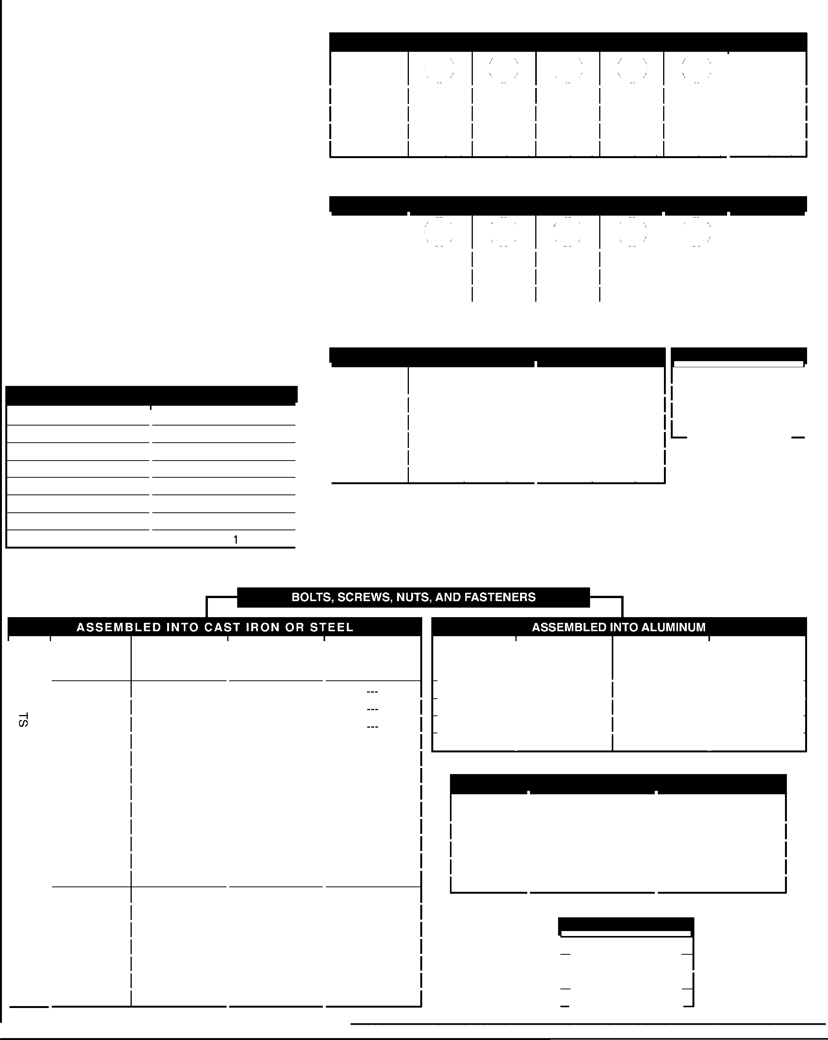

Ensure engine components do not loosen or separte. Tightening forces applied during assembly must be greater than the loosening forces (compression, vibration, expansion, etc.) created during engine/unit operation. ALWAYS use the highest tightening force consistent with the strength of the fastener and component.

Specific torque values will be given where component joint integrity is most critical. For fasteners which a specified torque is not given, use the Metric and English Bolt Torque Specifications Chart.

**NOTE:** ALWAYS libricate threads with the proper engine oil before assembly.

###### Decimals to Fractions Chart

Hardware descriptions are given in decimals. Refer to the chart below for common decimal to fraction conversions.

**Decimals to Fractions Chart**

|  |  |  |  |
| --- | --- | --- | --- |
| .063 | 1/16 | .563 | 9/16 |
| .125 | 1/8 | .625 | 5/8 |
| .188 | 3/16 | .688 | 11/16 |
| .250 | 1/4 | .750 | 3/4 |
| .313 | 5/16 | .813 | 13/16 |
| .375 | 3/8 | .875 | 7/8 |
| .438 | 7/16 | .938 | 15/16 |
| .500 | 1/2 | 1.00 |  |

### METRIC

**TIGHTENING TORQUE: N•m (lbf-in) + or - 10 %**

-- -- -- -- --

|  |  |  |  |  |  |  |  |
| --- | --- | --- | --- | --- | --- | --- | --- |
| HARDWARE SIZE | /.4.8 | 5.8 | /.8.8 | 10.9 | 12.9 | Noncritical  Fasteners Into Aluminum | |
| M4 | 1.2 (11) | 1.7 (15) | 2.9 (26) | 4.1 (36) | 5.0 (44) | 2.0 | (18) |
| MS | 2.5 (22) | 3.2 (28) | 5.8 (51) | 8.1 (72) | 9.7 (86) | 4.0 | (35) |
| M6 | 4.3 (38) | 5.7 (50) | 9.9 (88) | 14.0 (124) | 16.5 (146) | 6.8 | (60) |
| M8 | 10.5 (93) | 13.6 (120) | 24.4 (216) | 33.9 (300) | 40.7 (360) | 17.0 | (150) |

**TIGHTENING TORQUE: N•m (lbf-ft) + or - 10 %**

|  |  |  |  |  |  |  |  |  |
| --- | --- | --- | --- | --- | --- | --- | --- | --- |
| HARDWARE SIZE | .  . 4.8 . | * 5.8: | .   * 8.8 . | '.10.9 | :_12.9 | | Noncritical Fasteners  Into Aluminum | |
| M10 | 21.7 (16) | 27.1 (20) | 47.5 (35) | 66.4 (49) | 81.4 | (60) | 33.9 | (25) |
| M12 | 36.6 (27) | 47.5 (35) | 82.7 (61) | 116.6 (86) | 139.7 | (103) | 61.0 | (45) |
| M14 | 58.3 (43) | 76.4 (55) | 131.5 (97) | 184.4 (136) | 219.7 | (162) | 94.9 | (70) |

**OIL DRAIN PLUGS TIGHTENING TORQUE: N•m (English Equiv.) TORQUE CONVERSIONS**

|  |  |  |
| --- | --- | --- |
| SIZE | Into Cast Iron | Into Aluminum |
| 1/8" NPT | --- | 4.5 (40 lbf-in) |
| 1/4" | 17.0 (150 lbf-in) | 11.3 (100 lbf-in) |
| 3/8" | 20.3 (180 lbf-in) | 13.6 (120 lbf-in) |
| 1/2" | 27.1 (20 lbf-fll | 17.6 (13 lbf-ft) |
| 3/4" | 33.9 *(25* lbf-ft) | 21.7 (16 lbf-ft) |

N•m=lbf-in x 0.113

N•m=lbf-ft x 1.356

lbf-in = N• m x 8.85 lbf-ft = N•m x 0.737

HARDWARE GR:DE 0

|  |  |  |  |  |
| --- | --- | --- | --- | --- |
| rn  00rn  Q  rrn ►  Zr | SIZE #8-32 | 20 in. lb. | G R ; D E O  25 in. lb. | G R : D E O |
| #10-24 | 32 in. lb. | 40 in. lb. |  |
| #10-32 | 32 in. lb. | 40 in. lb. |  |
| .250 | 1/4-20 | 70 in. lb. | 115 in. lb. | 165 in. lb. |
| 1/4-28 | 85 in. lb. | 140 in. lb. | 200 in. lb. |
| .312 | 5/16-18 | 150 in. lb. | 250 in. lb. | 350 in. lb. |
| 5/16-24 | 165 in. lb. | 270 in. lb. | 30 ft. lb. |
| .375 | 3/8-16 | 260 in. lb. | 35 ft. lb. | 50 ft. lb . |
| 3/8-24 | 300 in. lb. | 40ft. lb. | 60 ft. lb. |
| .437 | 7/16-14 | 35 ft. lb. | 55 ft. lb. | 80 ft. lb. |
| 7/16-20 | 45 ft. lb. | 75 ft. lb. | 105ft. lb. |
| .500 | 1/2-13  1/2-20 | SO ft. lb.  70ft. lb. | 80ft. lb.  105 ft. lb. | **115 ft. lb.**  165 ft. lb. |
| .562 | 9/16-12 | 75 ft. lb. | 125 ft. lb. | 175ft. lb . |
| 9/16-18 | 100 ft. lb. | 165 ft. lb. | 230ft. lb. |
| .625 | 5/8-11 | 110 ft. lb. | 180 ft. lb. | 260ft. lb . |
| 5/8-18 | 140 ft. lb. | 230 ft. lb. | 330ft. lb. |
| .750 | 3/4-10 | 150 ft. lb. | 245 ft. lb. | 350ft. lb . |
| 3/4-16 | 200ft. lb. | 32511. lb. | 47011. lb. |

### ENGLISH

GR:DE 0 GR DE 0

|  |  |  |
| --- | --- | --- |
| HARDWARE SIZE |  | GR:DE 0 |
| #8-32 | 20 in. lb. 20 in. lb. | 20 in. lb. |
| #10-24 | 32 in. lb. 32 in. lb. | 32 in. lb. |
| 1/4-20 | 70 in. lb. 70 in. lb. | 70 in. lb. |
| 5/16-18 | 150 in. lb. 150 in. lb. | 150 in. lb . |

**OIL DRAIN PLUGS**

|  |  |  |
| --- | --- | --- |
| SIZE | Into Cast Iron Pans | Into Aluminum Pans |
| 1/4" | 150 in. lb. | 100 in. lb. |
| 3/8" | 180 in. lb . | 120 in. lb. |
| 1/2" | 20ft. lb. | 13 ft. lb. |
| 3/4" | 25 ft. lb. | 16 ft. lb . |

**TORQUE CONVERSIONS**

ft. lb. = in. lb. x 0.083

in. lb. = ft. lb. x 12 kgm =ft.lb. x 0.1383 N• m =ft.lb . x 1.3558

01546200 Orig. 9/98

Ariens®

A-5

**915 EZRIDER SERVICE MANUAL**

**THANK You**



###### YOUR SATISFACTION Is IMPORTANT

Questions? Please follow these helpful steps:

1. **Always Refer to the Manuals First.**
   1. Their detail will guide you through safe and proper operation and maintenance.
   2. They contain specifications on this product.
   3. If your questions are not answered in the manuals, go to step number two.
2. **Contact Your Dealer.**
   1. Our dealers will be happy to supply any service or advice required to keep this product operating at peak efficiency.
   2. A factory trained staff is available to support your equipment needs. They stock parts and lubricants manufactured with the same precision and skill as the original.
   3. To speed parts ordering when contacting your Dealer know the model and serial numbers, part numbers, quantities required and descriptions.
   4. If your questions are not resolved by the support staff, ask for the manager or owner.
3. **Service, Repair, Maintenance and Adjustments.**
   1. Before starting be sure all applicable manuals, tools, replacement parts and other materials required to complete the project are on hand.
   2. Refer to the Metric & English Bolt Torque Specifications Chart for tightening fasteners.
4. **Your Comments are Welcome.**
   1. Feel free to visit our Web Site at [www.ariens.com](http://www.ariens.com/) or e-mail us at [service@ariens.com.](mailto:service@ariens.com)

ifc

##### SERVICE AND REPLACEMENT PARTS

When ordering replacement parts, publications, or making service inquires, know the Model and Serial numbers of the unit, engine, clutch, etc.

Unit numbers are located on the product registration form in the unit literature package. They are printed on a serial number lable, located on the frame of unit (Fig. 1).

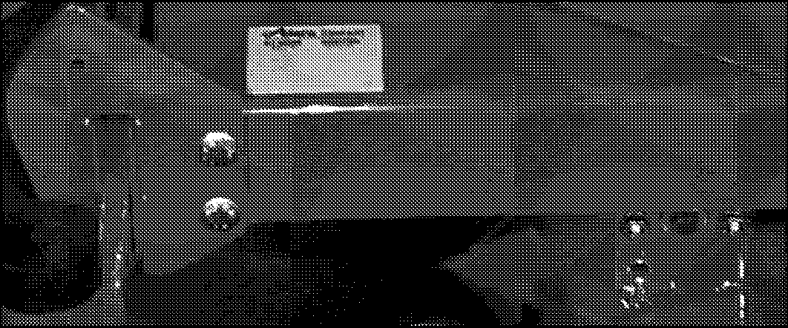

Figure 1

Record applicable model and serial numbers here:

Unit

Engine

Transmission

##### PRODUCT REGISTRATION

A warranty registration card must be filled out by the dealer, signed, and returned at sale. This card activates the warranty.

The replacement of any part on this unit with anything other than an authorized replacement part may adversely affect the performance, durability, or safety of this unit and may void the warranty.

All fittings, measurements, torque specifications, recommendations, and instructions are significant and approximations or substitutions must be avoided.

Improper service, repair, maintenance and/or adjustments attempted by anyone other than an Authorized Service Dealer may void warranty claims, damage unit and/or result in injury to operator and /or bystanders.

Claims meeting requirements during limited warranty period will be honored. To guarantee full warranty service, make sure the registration card has been returned.

Ariens® 01546200 Orig. 9/98



655 West Ryan Street• P.O. Box 157 • Brillion, WI 54110-0157 • 920-756-2141 • Fax: 920-756-4421