



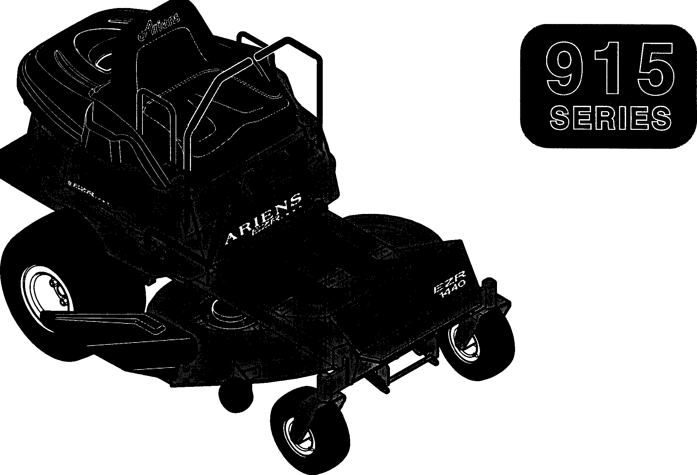**Parts Manual**

**MODELS**

**004 -1440**

**005 -1540**

**006 -1640**

**007 -1648**

**302 -1648**

**303 -1440**

01530300C Rev. 7/98

Supercedes 01530300,A,B

Printed in USA

**TABLE OF CONTENTS**

**MODELS SECTION 1**: **DECALS**

Model 915004 (EZR 1440)

1. HP Briggs & Stratton Serial No. 000101 and up

Model 915005 (EZR 1540)

1. HP Kohler

Serial No. 000101 and up

Model 915006 (EZR 1640)

1. HP Tecumseh

Serial No. 000101 and up

Model 915007 (EZR 1648)

16 HP Briggs & Stratton Van Guard Serial No. 000101 and up

**Model 915302 (EZR 1648** - **Export)** 16 HP Briggs & Stratton Van Guard Serial No. 000101 and up

Model 915303 (EZR 1440 - Export)

14 HP Briggs & Stratton Serial No. 000101 and up

Decals 2

SECTION 2: POWER PLANT

Clutch Shaft 4

Transmission and Wheels 6

Engine & Exhaust. 8

Belt Idlers 10

SECTION 3: MAIN FRAME

Frame 12

Seat, Support & Fuel Tank 14

Front Axle 16

Cover Assembly 18

SECTION 4: OPERATOR CONTROLS

Controls 20

Attachment Lift 22

Hanger Arm 24

SECTION 5: MOWER DECKS

40" Mower Deck 26

48" Mower Spindle 28

48" Mower Pan 30

SECTION 6: ELECTRICAL SYSTEM

Continuity Diagrams 32

1. HP Briggs & Stratton 33

16 HP Briggs & Stratton 34

1. HP Kohler 35
2. HP Tecumseh 36

**REFERENCE TABLE**

Hardware descriptions are given in decimals.

Decimals to Fractions

|  |  |  |  |
| --- | --- | --- | --- |
|  | | |  |
| .063 | 1/16 | .563 | 9/16 |
| .125 | 1/8 | .625 | 5/8 |
| .188 | 3/16 | .688 | 11/16 |
| .250 | 1/4 | .750 | 3/4 |
| .313 | 5/16 | .813 | 13/16 |
| .375 | 3/8 | .875 | 7/8 |
| .438 | 7/16 | .938 | 15/16 |
| .500 | 1/2 | 1.00 | 1 |

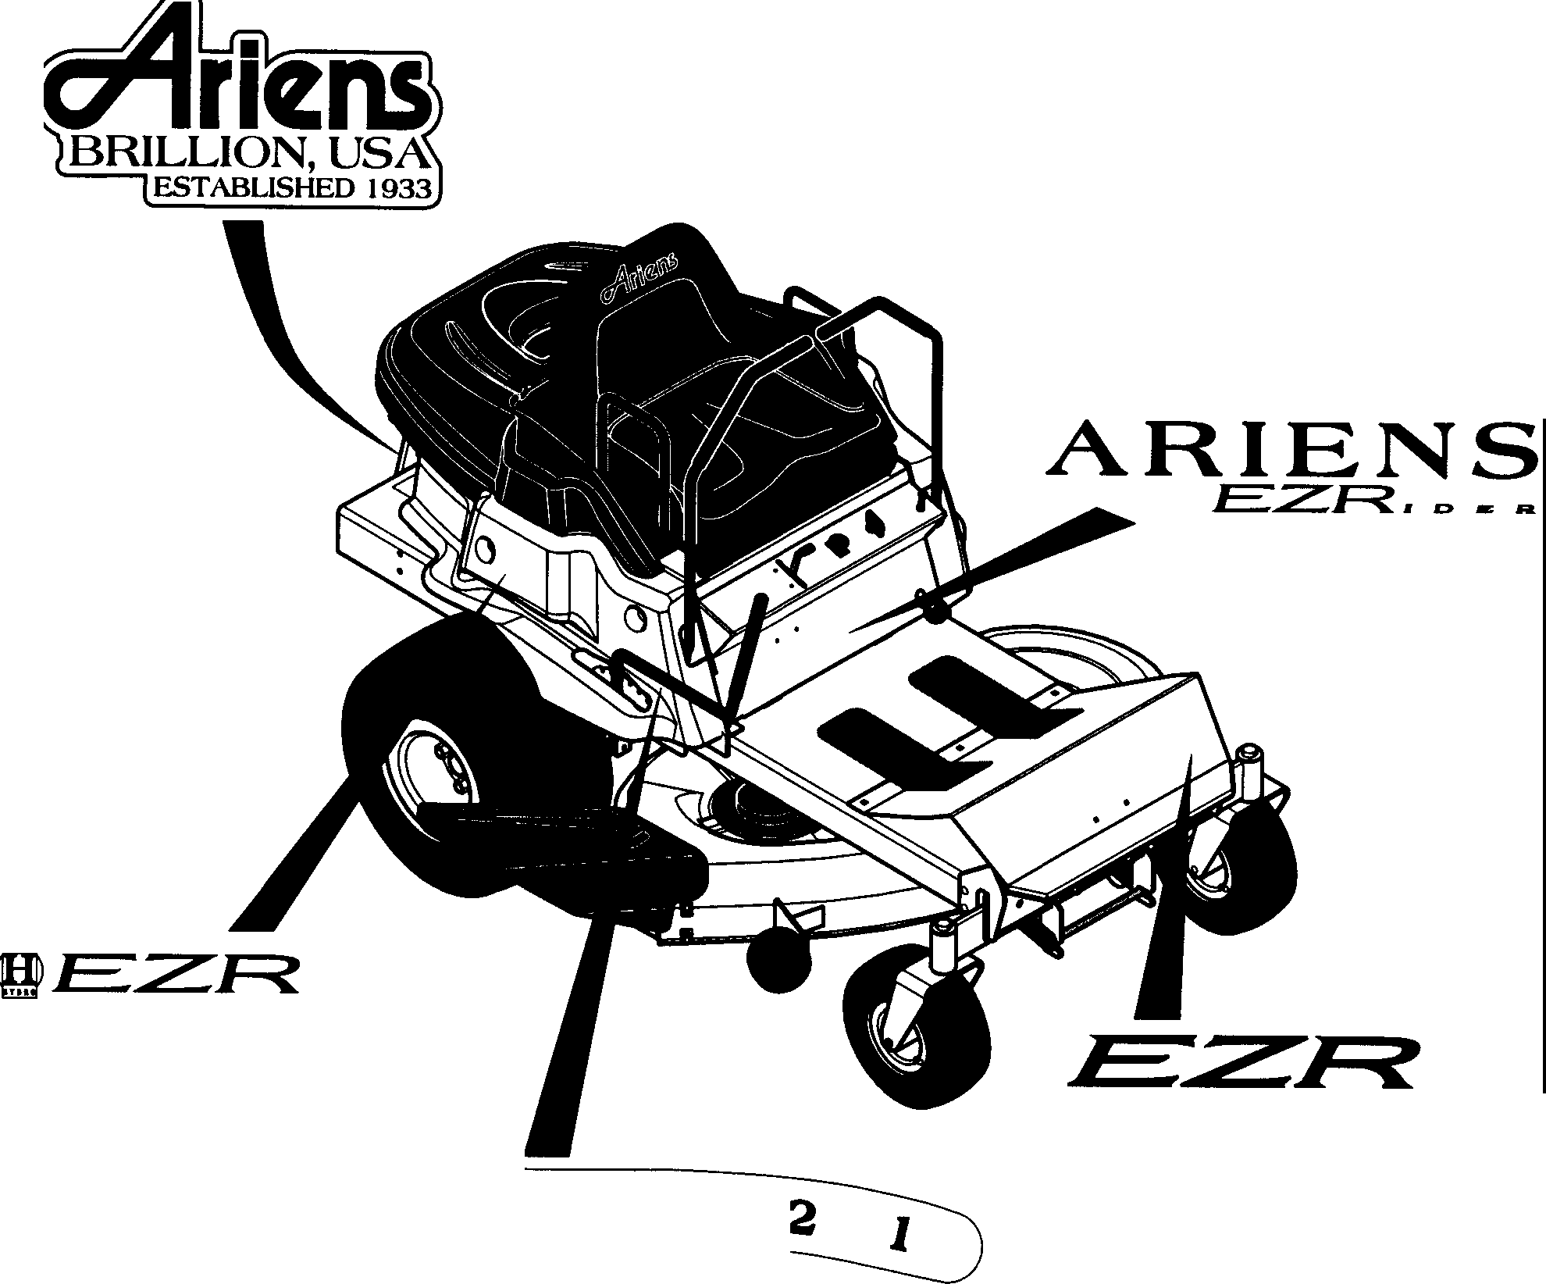

1

2

***lc::>£,R.***

5

***1440***

**5**

**4**

**3**

3

4

PE0171

|  |  |  |  |
| --- | --- | --- | --- |
| **Item No.** | **Part No.** | Qty. | **Description** |
| 1 | 07721400 | 1 | Decal-Ariens Est. 1933 |
| 2 | 07726800 | 1 | Decal-EZRider |
| 3 | 07726400 | 1 | Decal-1440 EZR (004,303) |
|  | 07726500 | 1 | Decal-1648 EZR (007,302) |
|  | 07726600 | 1 | Decal-1540 EZR (005) |
|  | 07730900 | 1 | Decal-1640 EZR (006) |
| 4 | 07729100 | 1 | Decal-Deck Lift |
| 5 | 07726300 | 2 | Decal-EZR Rider |
|  | Sets |  |  |
|  | 61503800 | 1 | EZR Decal Set 1 |
|  | 61504600 | 1 | EZR Decal Set 2 |

Models 004,005,006,303

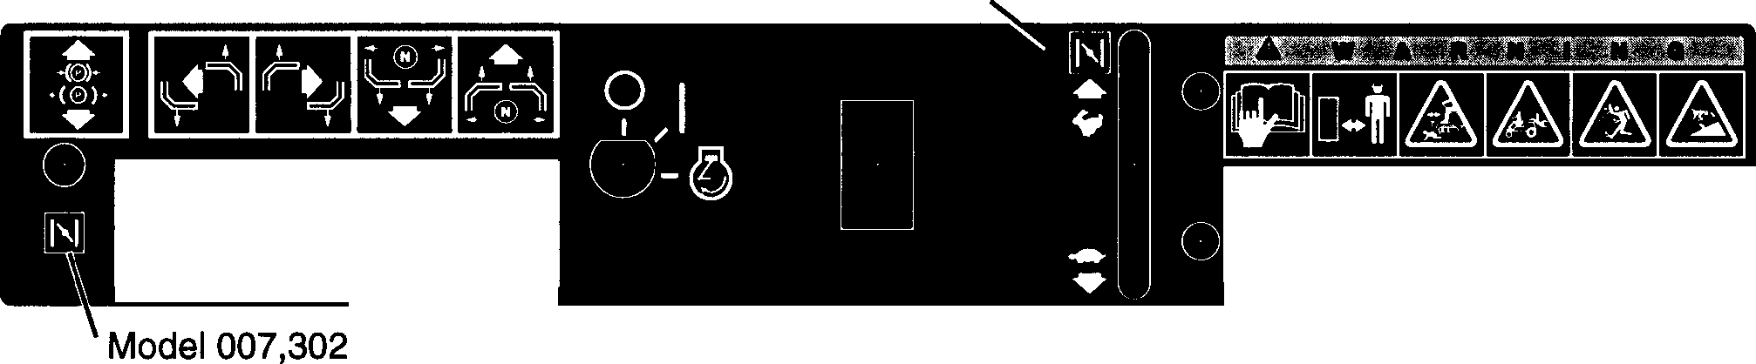

HI HHU 1';\/(,1!'.1' "ifAHT

l "-Pl 1,1-.1 '\"sll Lll'- \ 111>'-</ll :°'<l ll<l!\. lll \I I l<•:--.. lll\lJ', Lill< h ,->,ti I\ 1"-IIJ(l<" h ,)ql tlll lt>l<l 1 s[ llfl l>V.:'>.J H, !Ai'.l Al I r-,.,1 K! ,]ltHl'-J< 11 \ llh \kl !'s

SH LH\UH>lh.!IHH J ltl'l!!<J:-. f l<Jl'P!"l"-t \l t!l

BlI OH lllSMOl I!"< I 1:-.J<,

!!'st \l I IAIOd,, I\K'\1'1 lll,!S! AlI- I l{l ",]!l I OFJ­

f '-.( Ir'-.\- Hl Ml!\\-)..:)-;

II- \Al IIISI ',JUIS l,<!ll'-.t l l Hll I ',IH

,[()\>,[\

!,;J 11'

](l A:-,.1) J\'1.l i( !>UV.-..

11-<,1 l<\ I- IM H !>I->, II- ,t H!{o l\ Sl>I'>;<, \\HI:'-. II \l hlr-.t ,\'-;I) I l It',,!-..,,

I <>HI

|  |  |  |  |
| --- | --- | --- | --- |
| ll)A\lllllslHllll | Sl;'.Jl | H\ | A:s-;()!HAIII |
| \ l\"i\i11-; /: \\\',\\I ! l lll l 11 HI IIIIH>V. :<... lH lH! ti! '\Pl | | | |

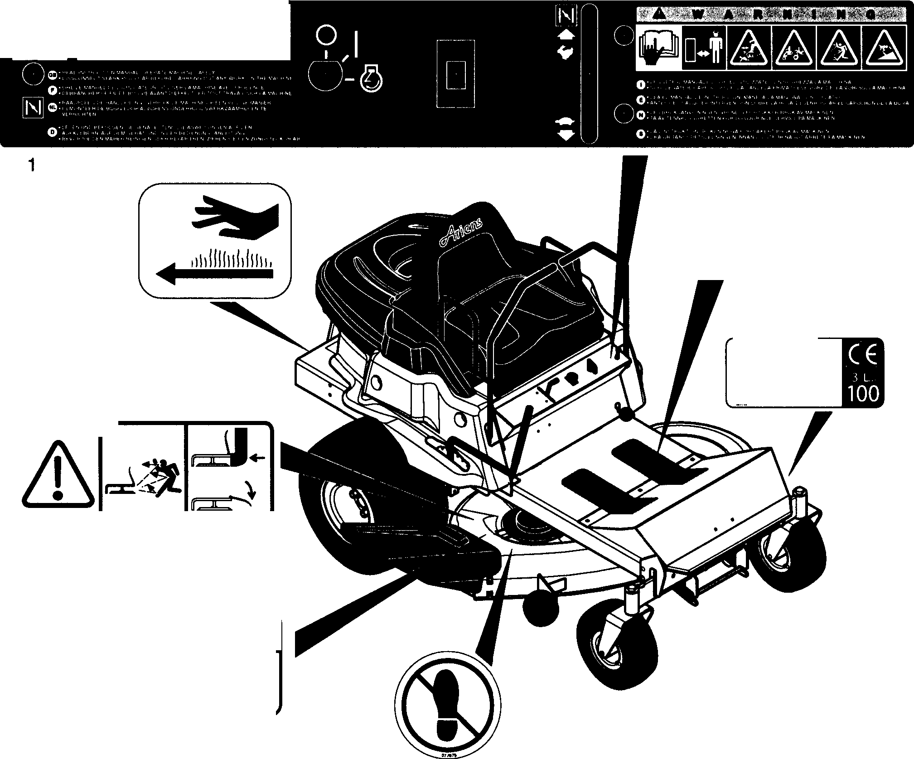

**II a111111**

.... :

. :-: :····

6

.

.

.. *:·=·*

.

*::·.*

·:-

.: .:·.:::• ...·._. ::·::··:=:

.

. . . . .·. :-:..

. .. . . :=-:·.

2

5

**KW 1.2 /2UOmin'1**

**Kg 215**

7

■,,•

4

***L***

□**-t**

**tt:13i**

**a**

PE0161

|  |  |  |  |
| --- | --- | --- | --- |
| **Item No.** | **Part No.** | **Qty.** | **Description** |
| 1  2  3  4  5  6  7 | 07728200  01528000  07767500  07729600  07730700  07843200  08171600  08172700 | 1  2  2  2  1  1  1  1 | Decal-EZR Control Nonskid Cover Decal-No Step  Decal-Mower Pan Head Decal-Discharge  Decal-Hot Surface  S/N Compliance Label EZR (303) S/N Compliance Label EZR (302) |

|  |  |  |  |
| --- | --- | --- | --- |
| **Item No.** | **Part No.** | **Qty.** | **Description** |
| 1 | 00506700 | 1 | Housing-Transmission Spindle |
| 2 | 05421500 | 2 | Bearing-Ball .984 x 2.04 x .59 |
| 3 | **01531300** | 1 | Jackshaft (004,303) |
|  | **01532100** | 1 | Shaft 1540/1648 (005,006,007,302) |
| 4 | **06423200** | 1 | **Washer-Flat-Steel.436 x 1.375 x.250** |
| 5 | **05915300** | 1 | Bolt-Hex .44-20 x 1.00 Grade 5 |
| 6 | **05913500** | 4 | Bolt-Hex .31-18 x .75 Grade 5 |
| 7 | **06303600** | 4 | Washer-Lock .313 x .078 |
| 8 | **00506800** | 1 | **Spacer 1.25 OD x 1.0 ID x 1.26** |
| 9 | **06602200** | 1 | Key-Square .25 x 1.00 x .25 |
| 10 | **07323600** | 1 | Sheave-Jackshaft |
| 11 | **01531400** | 1 | Spacer |
| **12** | **03601800** | 1 | Electric Clutch/Brake (004,303,) |
|  | **03357900** | 1 | Clutch/Brake-Electric (005,006,007,302) |
| **13** | **06426400** | 1 | Washer-Special .469 x 2.000 x .250 |
| **14** | **06300500** | 2 | Washer-Lock .438 x .133 |
| **15** | **05937500** | 1 | **Bolt-Hex .44-20 x 2.50(004,303)** |
|  | **05920500** | 1 | **Bolt-Hex .44-20 x 1.50(005,006,007,302)** |
| **16** | **07230800** | 1 | Belt-Jackshaft Drive |
|  | **07233900** | 1 | Belt-Engine to Jackshaft (51501800,51501900) |

###### 56

*I*

57

15

/

###### 28

14

\,,,,­

## oP

/

13

9

"11

PE0061

|  |  |  |  |
| --- | --- | --- | --- |
| **Item No.** | **Part No.** | Qty. | **Description** |
| 1 | 01533200 | 2 | Right Angle Transaxle |
| 2 | 06606300 | 2 | Key-Woodruff .250 x 1.00 x .438 |
| 3 | 06700400 | 2 | Pin-Cotter .12 x 1.0 |
| 4 | 03516900 | 2 | Spindle Cup |
| 5 | 06528300 | 2 | Nut-Slotted .75-20 |
| 6 | 01526800 | 2 | Hub |
| 7 | 06525400 | 4 | Nut-Hex .50-20 |
| 8 | 07144600 | 2 | Tire/Wheel 18 x 8.50-8 |
|  | 07144900 | 1 | Rim for 18 x 8.50-8 Tire |
|  | 07145100 | 1 | Tire 18 x 8.50-8 |
| 9 | 01519200 | 1 | Bracket-Transaxle |
| 10 | 05918100 | 4 | Bolt-Hex .31-18 x 1.00 Grade 5 |
| 11 | 06506200 | 4 | Nut-Locking-Nylon .312-18 Grade 2 |
| 12 | 05923400 | 4 | Bolt-Hex .38-16 x 3.25 Grade 5 |
| 13 | 06513500 | 4 | Nut-Locking-Nylon .375-16 Grade 2 |
| 14 | 06207800 | 4 | Bolt-Round Head Square Neck .38-16 x .75 Grade 5 |
| 15 | **01518400** | 1 | Expansion Tank |
| 16 | 05908200 | 2 | Bolt-Hex .25-20 x .75 Grade 5 |
| 17 | 06506600 | 2 | Nut-Locking-Nylon .250-20 Grade 2 |
| 18 | 01524100 | 2 | Hose |
| 19 | 06923500 | 6 | Clamp .88 Diameter Hose |
| 20 | 01517800 | 1 | Fitting-Tee 5/8 Beaded |
| 21 | 01524200 | 1 | Hose |
| 22 | 01519100 | 3 | Control Arm-Transmission |
| **23** | 05901500 | 3 | Bolt-Hex .25-28 x .75 Grade 5 |
| 24 | 06302500 | 3 | Washer-Lock .250 x .047 |
| 25 | 06412700 | 3 | Washer-Flat-Steel .281 x .620 x .065 |
| 26 | 00337700 | 1 | Hub Cap |
| 27 | 01537800 | 1 | Rod-Brake |
| 28 | 07515900 | 1 | Knob |
| 29 | 06503900 | 4 | Nut-Locking-Center .375-16 |
| 30 | 06504200 | 2 | Nut-Locking .312-18 |
| 31 | 01521000 | 1 | Plate-Transmission Link |
| 32 | 07402300 | 4 | Screw-Tapping .312-18 x 1.00 |
| 33 | 07401700 | 4 | Screw-Tapping .312-18 x .75 |
| 34 | 01521100 | 2 | Plate-Dump Valve |
| 35 | 06412300 | 8 | Washer-Flat-Steel .344 x .688 x .065 |
| 36 | 00607100 | 2 | Spacer Bushing .5 x .32 x .21 |
| 37 | 08335000 | 1 | Spring-Tension .062 x .50 x 3.1 |
| 38 | 01531100 | 1 | Link-Dump Valve |
| 39 | 01532200 | 1 | Rod-Dump Valve |
| 40 | 06702000 | 6 | Pin-Hair Internal .08 x .18 x 1.18 |
| 41 | 06814400 | 2 | Pin-Clevis 5/16 x .75 |
| 42 | 07405200 | 6 | Screw-Tapping .250-20 x .50 Hex Head Slotted |
| 43 | 04003800 | 1 | Tie Wrap |
| 44 | 06405600 | 2 | Washer-Flat-Steel .505 x .880 x .072 |
| 45 | 06414500 | 8 | Washer-Flat-Steel .390 x .750 x .125 |
| 46 | 06412300 | 2 | Washer-Flat-Steel .344 x .688 x .065 |
| 47 | 01528100 | 1 | Brake Arm |
| 48 | 01527800 | 1 | Brake Shaft |
| 49 | 07014700 | 1 | Yoke .31-24 x 2.250 |
| 50 | 06811800 | 1 | Pin-Clevis .312 x .822 |
| 51 | 01528300 | 2 | Fan |
| 52 | 01528400 | 2 | Pulley |
| 53 | 05706100 | 2 | Ring-Retaining-External .672 x .035 |
| 54 | 06610500 | 2 | Woodruff Key |
| 55 | 01528900 | 2 | Fitting 45° Elbow |
| 56 | 06507800 | 1 | Nut-Flange .312 - 18 |
| 57 | 06501500 | 1 | Nut.312 - 18 |

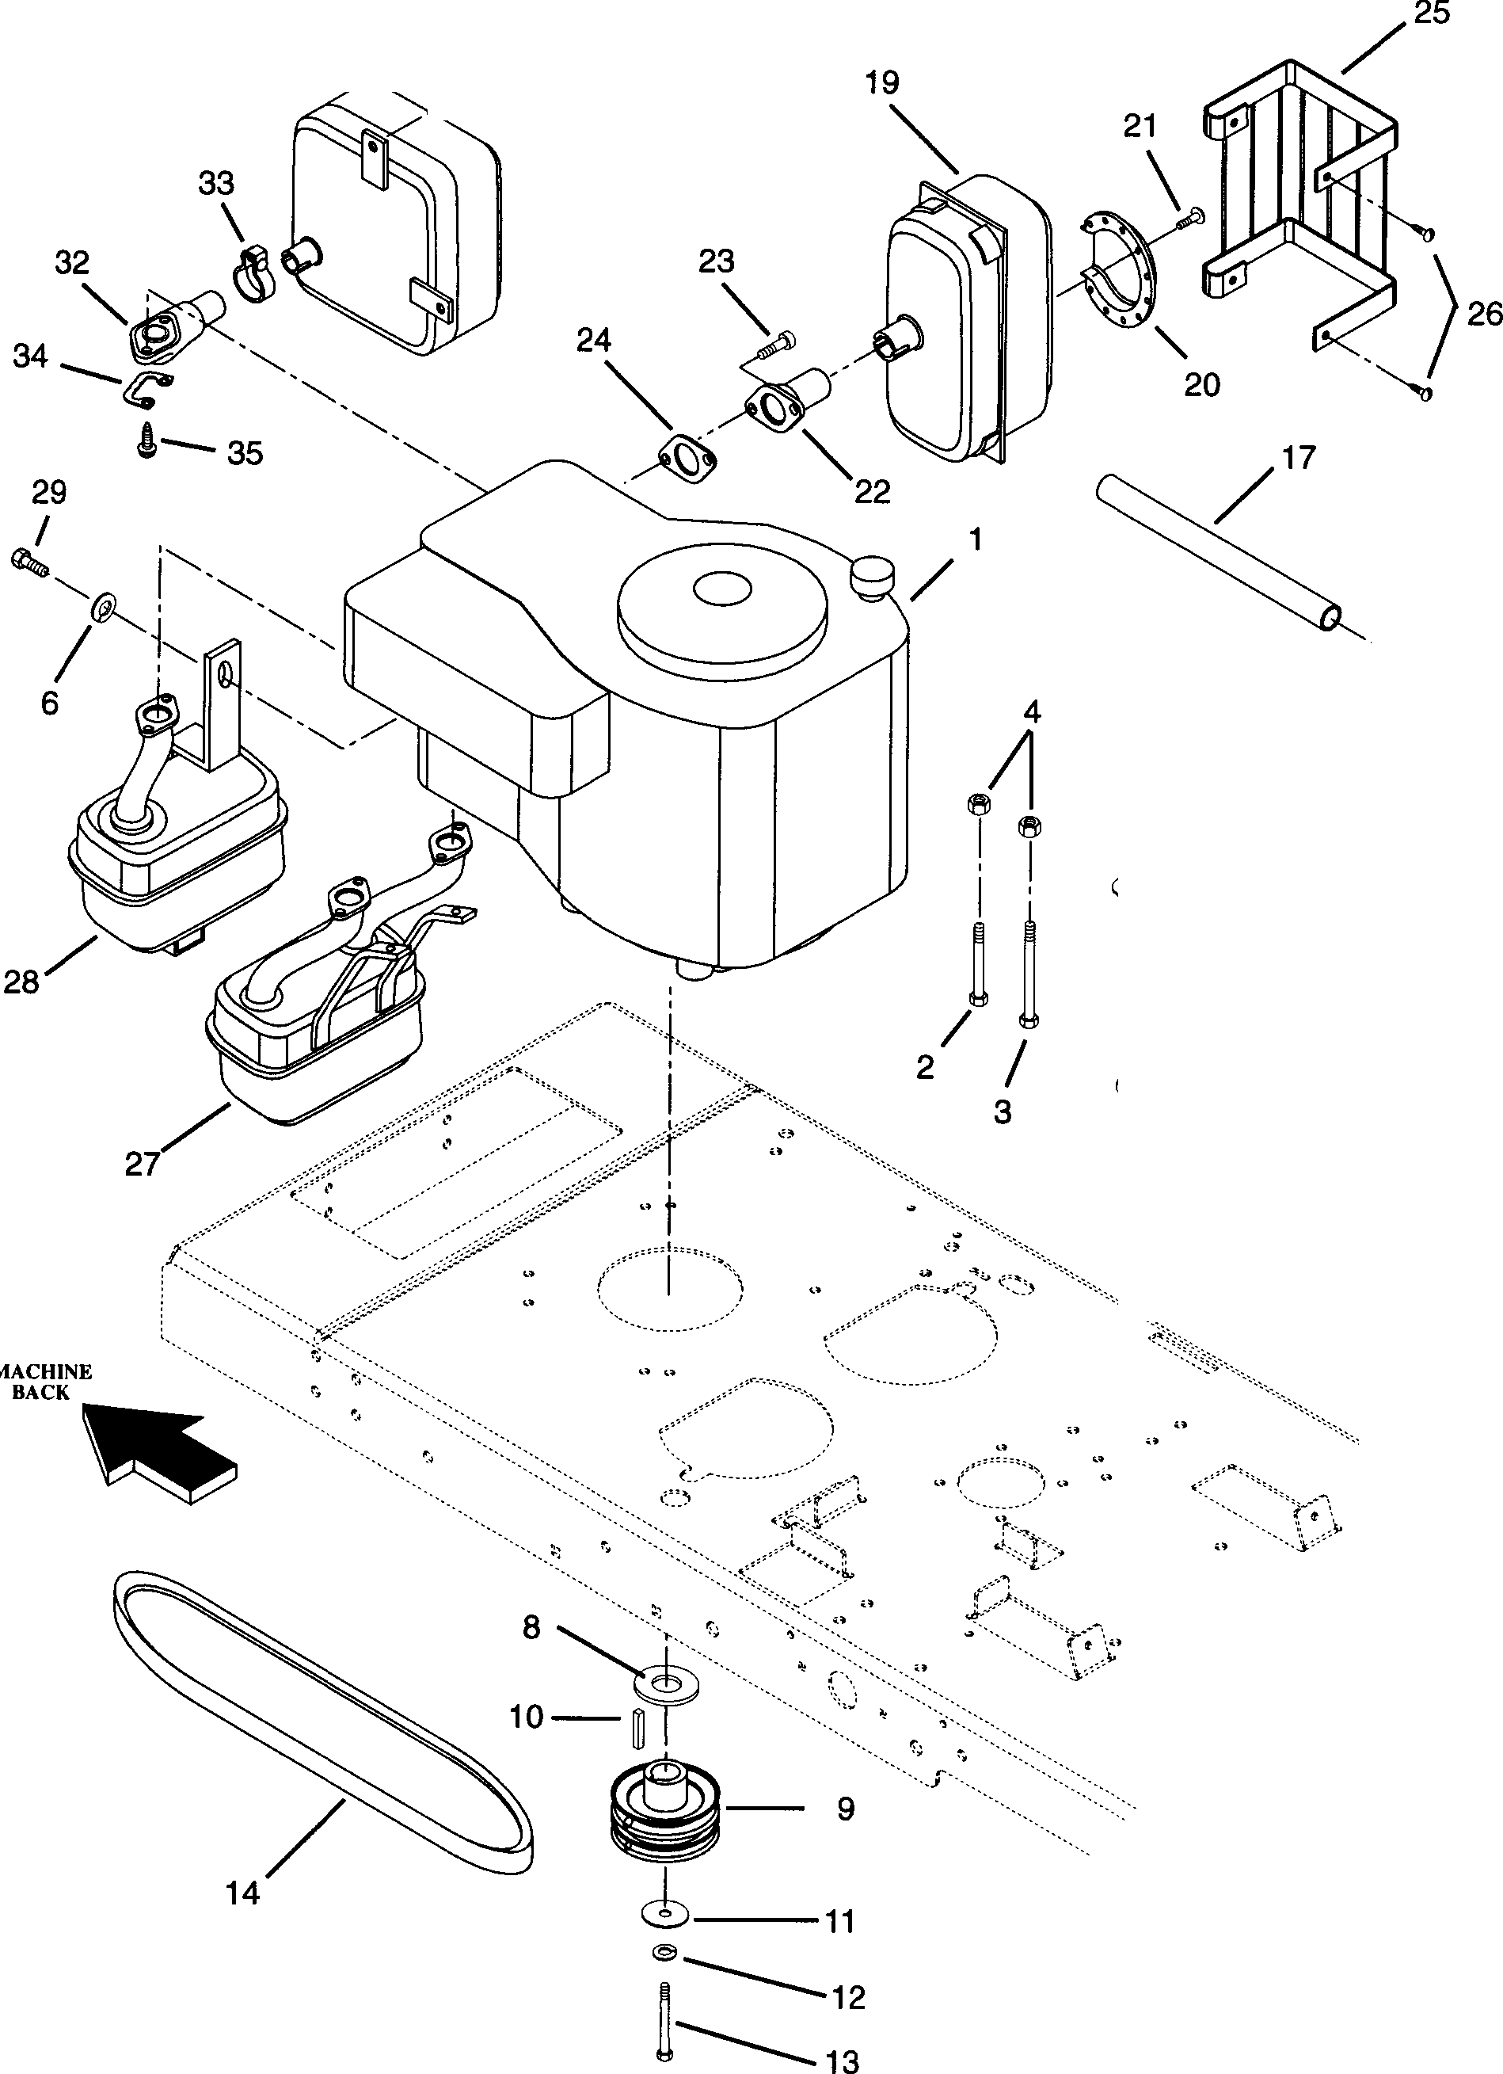

31

\

/ 30

.,/'

18

/

*J*

6

*I*

*"* **15**

@ 16

## I

I'

\ 1

5 \

7

PE0121

|  |  |  |  |
| --- | --- | --- | --- |
| **Item No.** | **Part No.** | Qty. | **Description** |
| 1 | 08243000 | 1 | Engine-14.0 B & S Vanguard (004,303) |
|  | 08245200 | 1 | Engine-15.0 Kohler OHV (005) |
|  | 08245100 | 1 | Engine-16.0 Tecumseh OHV (006) |
|  | 08241500 | 1 | Engine-16.0 B & S Vanguard (007,302) |
| 2 | 05913400 | 1 | Bolt-Hex .31-18 x 1.25 Grade 5 (004,303) |
|  | 05913400 | 3 | Bolt-Hex .31-18 x 1.25 Grade 5 (007,302) |
| 3 | 05914000 | 3 | Bolt-Hex .31-18 x 1.50 Grade 5 (004,303) |
|  | 05914000 | 1 | Bolt-Hex .31-18 x 1.50 Grade 5 (007,302) |
| 4 | 06504200 | 4 | Nut-Locking .312-18 (004,007,302,303) |
| 5 | 05931300 | 4 | Bolt-Hex Metric 8MM-1.25 x 25MM Grade 5 (005) |
| 6 | 06303600 | 5 | Washer-Lock .313 x .078 (005) |
| 7 | 07408800 | 4 | Screw-Tapping .375-16 x 1.25 Hex Washer Head (006) |
| 8 | 06430000 | 1 | Washer-Flat-Steel 1.062 x 2.000 x .134 |
| 9 | 07323500 | 1 | Pulley 3.75 w/1.00 Key |
| 10 | 06602600 | 1 | Key-Square .25 x 2.50 x .25 |
| 11 | 06426400 | 1 | Washer-Special .469 x 2.000 x .250 |
| 12 | 06300500 | 1 | Washer-Lock .438 x .133 |
| 13 | 05910300 | 1 | Bolt-Hex .44-20 x 1.25 Grade 5 |
| 14 | 07230700 | 1 | Belt-Transaxle Drive |
| 15 | 03493200 | 1 | Cock-Oil Drain |
| 16 | 03493100 | 1 | Adapter-Oil Drain |
| 17 | 01523400 | 1 | Tube Oil Drain |
| 18 | 07517300 | 1 | Cable Tie |
| 19 | 01523000 | 1 | Muffler B & S 496652 (004,303) |
| 20 | 01523200 | 1 | Deflector B & S 222573 (004,303) |
| 21 | 01523300 | 4 | Screw B & S 93705 (004,303) |
| 22 | 01523100 | 1 | Muffler Adaptor Pipe (004,303) |
| 23 | 05933100 | 2 | Screw-Cap .31-18 x .75 (004,303} |
| 24 | 03652700 | 1 | Gasket (004,303) |
| 25 | 01528200 | 1 | Muffler Guard (303) |
| 26 | 07401500 | 2 | Screw-Tapping .250-20 x .37 (303) |
| 27 | 01523600 | 1 | Muffler Assembly (007,302) |
| NS | 01538300 | 1 | Muffler Guard (302) |
| 28 | 01523500 | 1 | Muffler Kohler (005) |
| 29 | 05916800 | 1 | Bolt-Hex .31-18 x .50 Grade 5 (005) |
| 30 | 01537700 | 1 | Muffler Assembly (006) |
| 31 | 07404900 | 1 | Screw-Tapping .25-20 x .50 Hex Washer Head (006) |
| 32 | 01537600 | 1 | Manifold-Exhaust (006) |
| 33 | 06939000 | 1 | Clamp-Muffler |
| 34 | 01537500 | 1 | Plate-Lock |
| 35 | 07050800 | 2 | Screw Special (Manifold) |

----..........

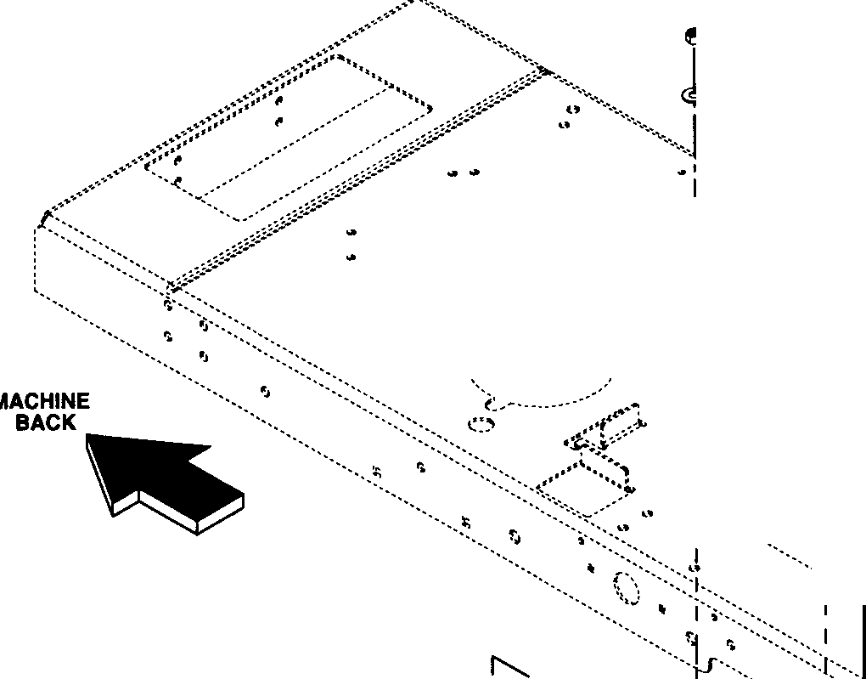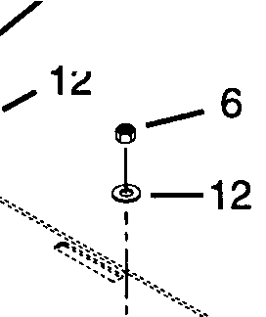

**e.--6**

6

...

*r····•-* )..

·-... _ ,,

...

......•.···

...,.......... .

··r .. l

I

'

I ••••::-:....... I ... UI

: ('··;<:: :

I --.-..;_,''- I

.,:;'-.: ..

.. I

..

·-..,•.

<i,·:::::::_t:\

:

···-.,.......,..............

--

···:::--,.•.•.,•..

- _._.._..

6 0 1

'- ! "-, '1 ·1··..........·.··.::::r,.:.·.··..".':'··... .. •••••••••••• ·.:.].

*1* ..I.,, I

' I ·····•.f... ····<:::··.. ..

....•··························••'

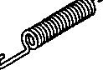\:ftt::9*:,i* 1/10 L::: !:·::r·

2,I ct// I

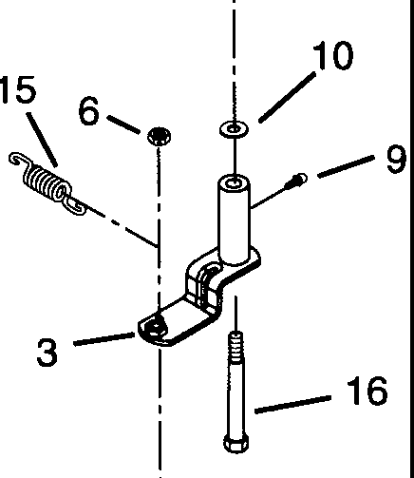5/U *I 9*

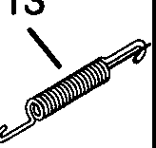

·1

8

a

**1**\**4**

**11-¥**

**®-17**

**-18**

PE0141

|  |  |  |  |
| --- | --- | --- | --- |
| **Item No.** | **Part No.** | **Qty.** | **Description** |
| 1 | **01536300** | 1 | Idler Arm Transmission/Engine |
| 2 | **01536200** | 1 | Idler Arm Clutch/Engine |
| 3 | **01536400** | 1 | Arm-Idler Pivot |
|  | **01544300** | 1 | Arm-Idler PTO Clutch to Mower (515018,515019) |
| 4 | **07308900** | 2 | **ldler-2.25 x.87** |
|  | **07325000** | 1 | Jackshaft Idler (515018,515019) |
|  | **07324900** | 1 | Transmission Idler (515018,515019) |
| 5 | **05914700** | 2 | Bolt-Hex .38-16 x 2.00 Grade 5 |
| 6 | **06513500** | 6 | Nut-Locking-Nylon .375-16 Grade 2 |
| 7 | **08332700** | 1 | Spring-Tension |
|  | **08334900** | 1 | Engine to Transaxle Spring (515018,515019) |
| 8 | **00592500** | 1 | Screw-Shoulder |
| 9 | **07012600** | 3 | **Fitting-Lube .25-28 x.256** |
| 10 | **06418000** | 3 | **Washer-Flat-Steel.520 x.827 x.062** |
| **11** | **07324100** | 1 | Idler-Flanged **3.50** |
|  | **07324700** | 1 | Idler-Flanged **4.00(515018,515019)** |
| **12** | **06414500** | 3 | Washer-Flat-Steel .390 x .750 x .125 |
|  | 06436200 | 1 | Washer-Flat-Steel .406 x .812 x .015 (515018,515019) |
| 13 | 08332800 | 1 | Spring-Tension |
|  | 08334800 | 1 | Engine to Transaxle Spring (515018,515019) |
| 14 | 00590800 | 1 | Screw-Shoulder .50 x 2.0 |
| 15 | 08333400 | 1 | PTO Idler Tension-Spring |
|  | 08334700 | 1 | PTO Idler Tension-Spring (515018,515019) |
| 16 | 07050500 | 1 | Bolt-Shoulder .50 x 3.75 |
|  | 07052100 | 1 | Bolt-Shoulder .50 x 3.50 (515018,515019) |
| 17 | 06404300 | 1 | Washer-Flat-Steel .406 **x.812 x** .065 |
| 18 | 05914700 | 1 | Bolt Hex .38-16 x 2.00 Grade 5 |
|  | 05958400 | 1 | Bolt-Hex .38-16 x 2.50 Grade 5 (515018,515019) |
| NS | 01544200 | 1 | Idler Arm Stop (515018,515019) |
| NS | 07509400 | 1 | Grip (515018,515019) |

# FRAME

**Mode!s915004 ,005,006,007 ,302,303**

2

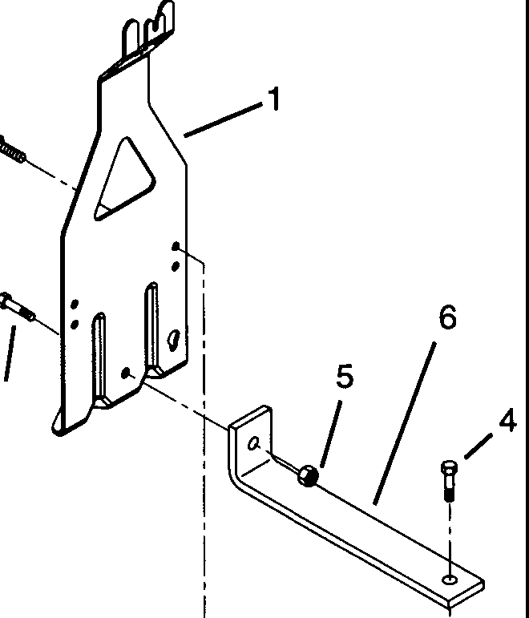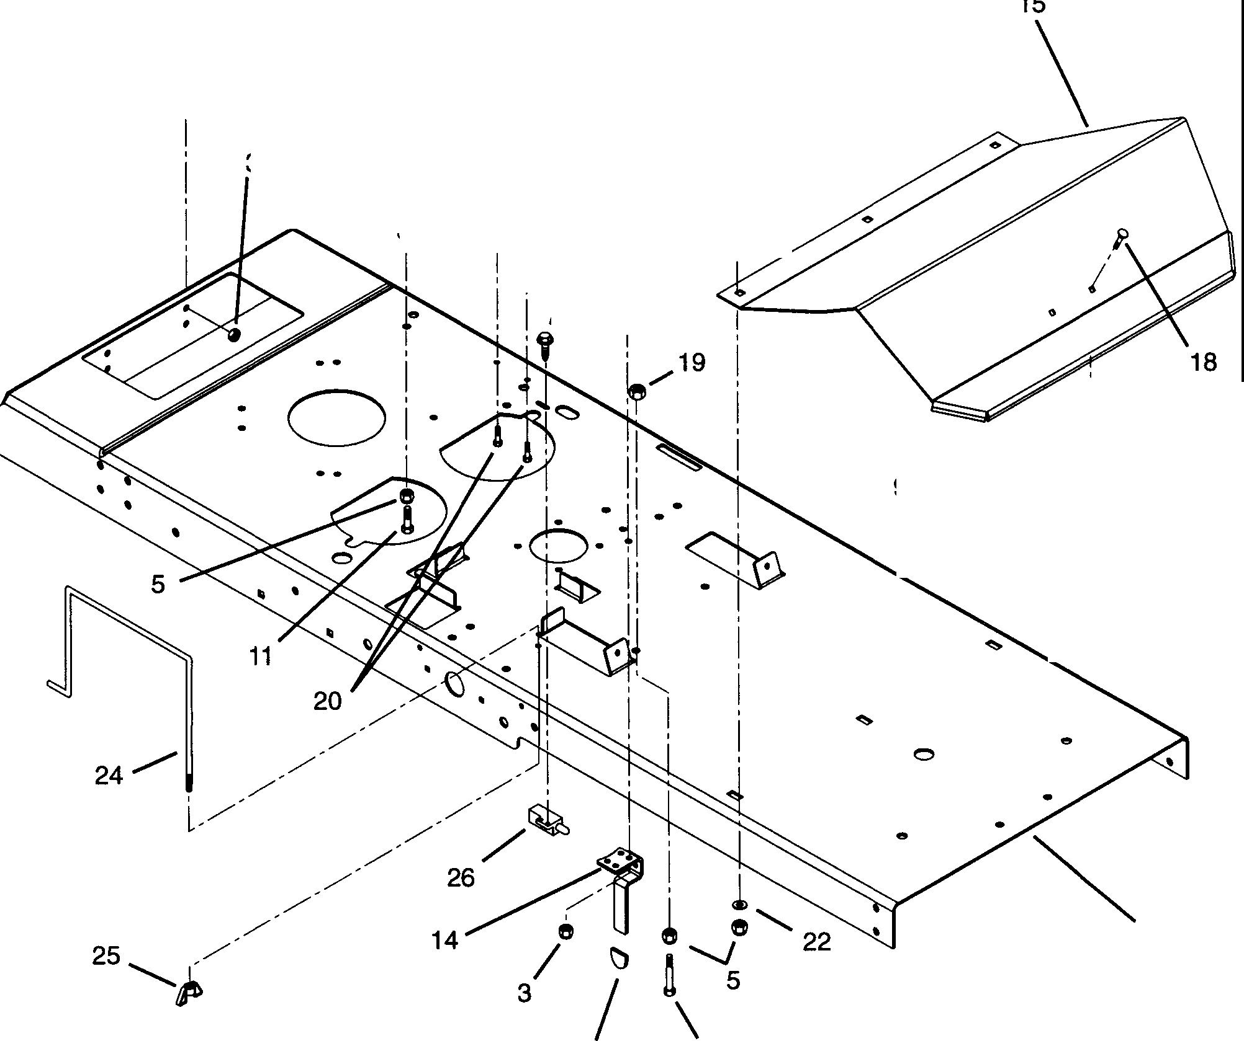

*I*

4

21

**J** 1\ **:f** a?'29

**.....**

**5** 30

**T*-**

12-• I ;-

a **s-21** 16

3 '

s' ,

I

! j 2 I

! j 27 /

#### ·/ V

##### I

A·.-17

I

9

' **'-a?'** • **i,,e**I

10

7

28 23

PE0031

### FRAME

**Models 915004,005,006,007,302,303**

|  |  |  |  |
| --- | --- | --- | --- |
| **Item No.** | **Part No.** | Qty. | **Description** |
| 1  2  3  4  5  6  7  8  9  10  11  12  **13**  14  15  16  17  18  19  20  21  **22**  23  24  25  26  27  28  29  30 | 01531800  05913500  06504200  05914500  06503900  01531900  01531500  03057700  05908200  06506600  05914700  06302600  06502600  01537900  01538000  06202800  01526700  06204200  06501800  05908200  06506600  06437700  05938400  01531000  06517500  03657100  07404500  07509400  06510000  06301800 | 1  6  6  2  11  1  1  1  2  4  1  1  1  1  1  3  1  2  1  2  3  3  1  1  1  1  2  1  2  2 | Hitch-Trailer  Bolt-Hex .31-18 x .75 Grade 5  Nut-Locking .312-18  Bolt-Hex .38-16 x 1.00 Grade 5  Nut-Locking-Nylon .375-16 Grade 2 Brace  Frame Solenoid  Bolt-Hex .25-20 x .75 Grade 5  Nut-Locking-Nylon .250-20 Grade 2  Bolt-Hex .38-18 x 2.00 Grade 5  Washer-Lock-External #10 ID x .022  Nut 10-32  Clutch Stop Foot Rest  Bolt-Round Head Square Neck .38-16 x 1.0 Grade 5 Bracket-Footrest  Bolt-Round Head Square Neck .25-20 x .75 Grade 5  Nut-Hex .375-16 Grade 2  Bolt-Hex .25-20 x .75 Grade 5  Nut-Locking-Nylon .25-20  Washer-Flat .38 x .875 x .160  Bolt-Hex .38-16 x 5.00 Grade 5 Battery Rod  Nut-Locking-Wing .250-20 Switch-Single Pole **N.O.**  Screw-Tapping 12-24 x .50 Hex Washer Head Grip  Nut-Jam .312-24  Washer-Lock-Internal .313 x .030 |

1

21

*I*

', "

I

'I

'

I

'

1'1

"'I "

'I

'I

I'

'

-"

"

"

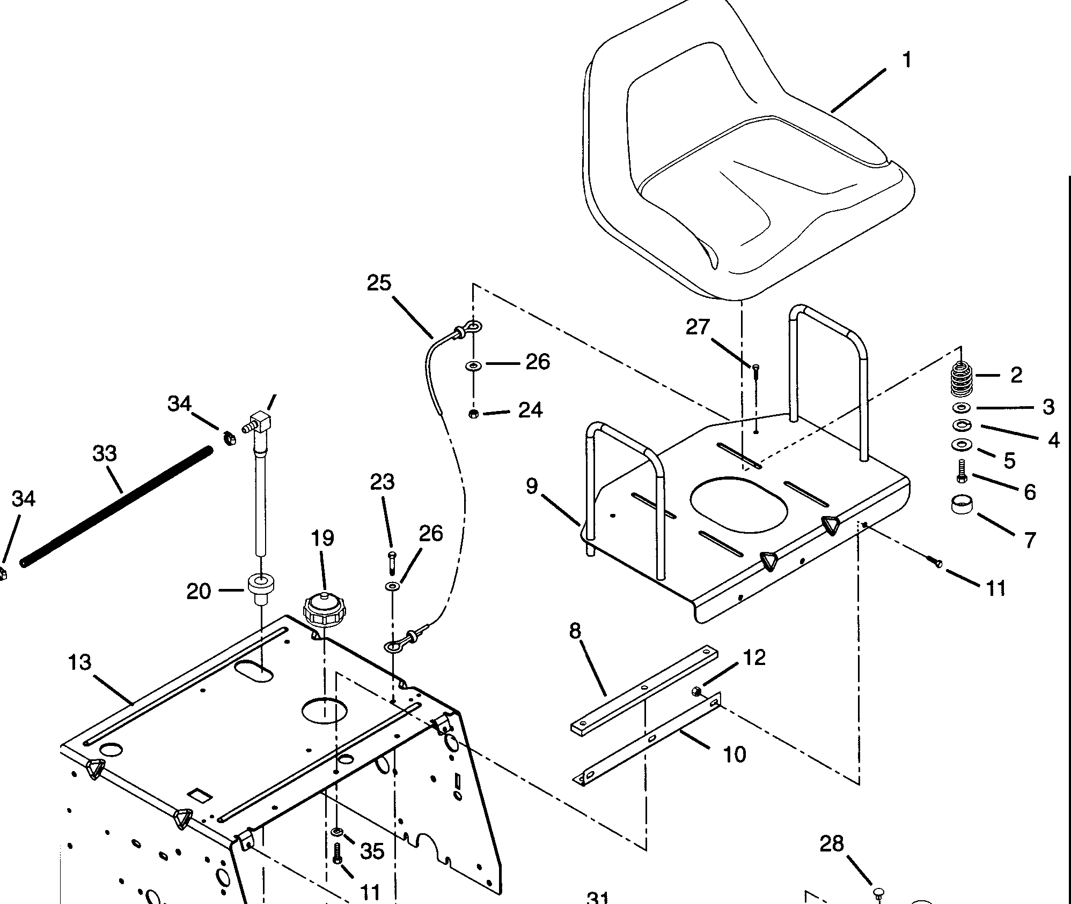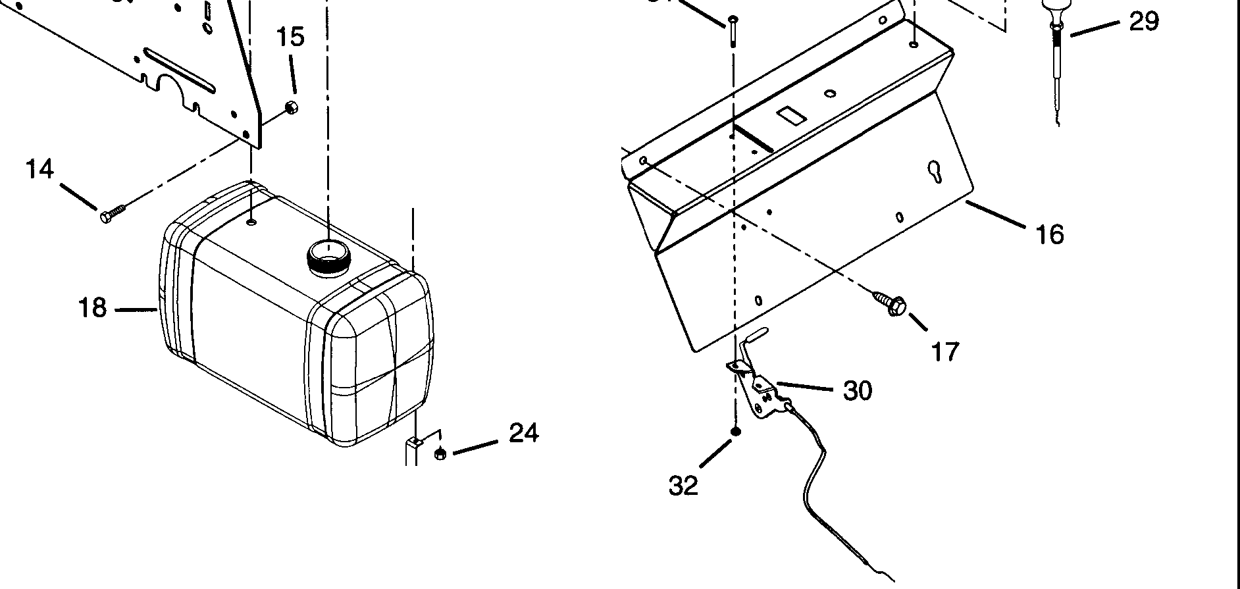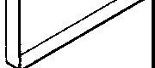

--22

PE0041

|  |  |  |  |
| --- | --- | --- | --- |
| Item No. | **Part No.** | Qty. | **Description** |
| 1 | 01522900 | 1 | Seat |
| 2 | 08328200 | 2 | Spring-Compression .148 x 1.23 x 2.41 |
| 3 | 06412300 | 2 | Washer-Flat-Steel .344 x .688 x .065 |
| 4 | **06303600** | 2 | Washer-Lock .313 x .078 |
| 5 | **06404400** | 2 | **Washer-Flat-Steel.38 x.875 x.179** |
| 6 | **05918100** | 2 | Bolt-Hex .31-18 x 1.00 Grade 5 |
| 7 | **07521600** | 2 | Tube Cap |
| 8 | **08952500** | 1 | Plate-Clamping |
| 9 | **01530500** | 1 | Seat Plate |
| 10  *n* | **03102800**  **05913500** | 1  6 | Hinge  Bolt-Hex .31-18 x .75 Grade 5 |
| **12** | **06506200** | 6 | Nut-Locking-Nylon .312-18 Grade 2 |
| **13** | **01530100** | 1 | Seat Support |
| **14** | **05914500** | 4 | Bolt-Hex .38-16 x 1.00 Grade 5 |
| **15** | **06503900** | 4 | Nut-Locking .375-16 Grade A |
| **16** | **01531200** | 1 | Control Panel |
| **17** | **07401400** | 4 | Screw-Tapping .31-18 x .50 |
| **18** | **01522100** | 1 | Fuel Tank |
| **19** | **03601900** | 1 | Fuel Cap |
| **20** | **07511400** | 1 | Bushing |
| **21** | **08893600** | 1 | Fitting-Tank |
| **22** | **08835900** | 2 | Strap-Fuel Tank |
| **23** | **05956000** | 4 | Bolt-Hex .25-20 x 2.00 Grade 5 |
| **24** | **06506600** | 5 | Nut-Locking-Nylon .250-20 Grade 2 |
| **25** | **01537300** | 1 | Seat Cable |
| **26** | **06421400** | 2 | Washer-Flat-Steel .328 x 1.0 x .094 |
| 27 | 05908200 | 1 | Bolt-Hex .25-20 x .75 Grade 5 |
| 28 | 00529900 | 1 | Hole Plug-Plastic .44 Hole (004,005,006,303) |
| 29 | 06926100 | 1 | Choke Control (005,302) |
| 30 | 06937600 | 1 | Cable-Throttle Control |
| 31 | 06113000 | 2 | Screw-Machine 10-24 x .50 |
| 32 | 06506500 | 2 | Nut-Locking 10-24 Nylon |
| 33 | 01525600 | 1 | Hose-Fuel 22" Long (004,006,303) |
|  | 01528600 | 1 | Hose-Fuel 6" Long (007,302) |
|  | 01525700 | 1 | Hose-Fuel 14" Long (005) |
| 34 | 06939100 | 2 | Hose Clamp |
| 35 | 06300300 | 3 | Washer-Locking .312 x .097 |

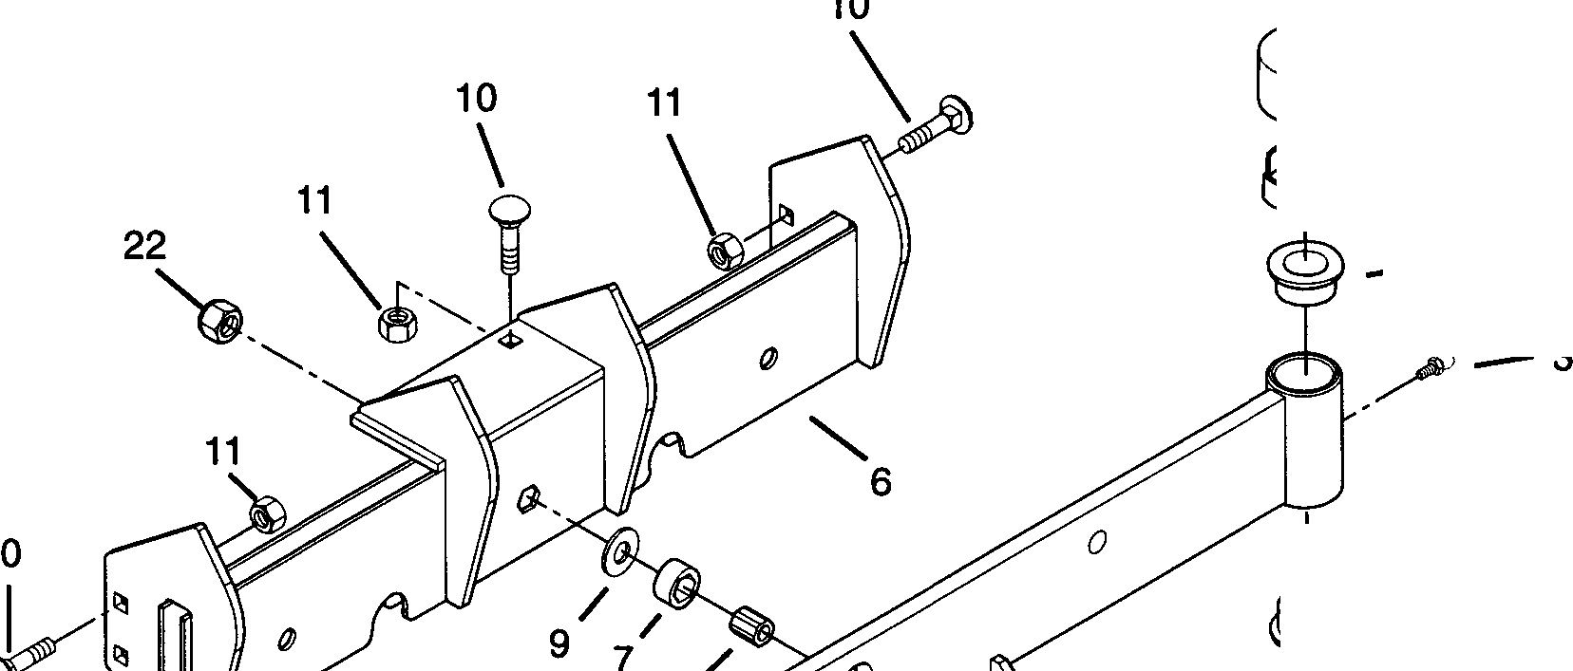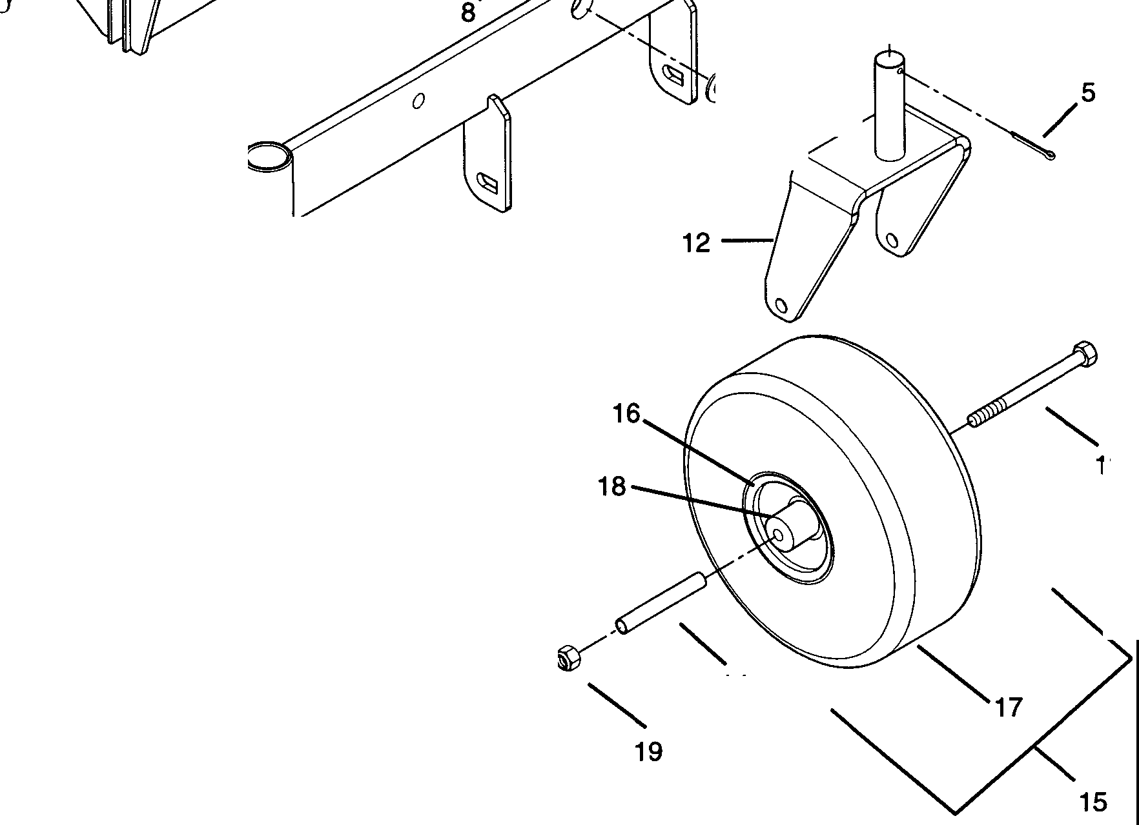

G--21

*€i:J3--4*

--2

I

'

-2

9

'

**20**

1-

13

**14**

PE0021

|  |  |  |  |
| --- | --- | --- | --- |
| **Item No.** | **Part No.** | **Qty.** | **Description** |
| 1  2  3  4  5  6  7  8  9  10  11  12  13  14  15  16  17  18  19  20  21  22 | 01522400  05520100  07012600  01535100  06704900  01538100  05522000  05522700  06421500  06207800  06503900  01504600  05938500  09105200  07144100  07145200  07145300  07145400  06512900  05916100  00337700  06513500 | 1  4  2  2  5  1  1  1  2  6  6  2  2  2  2  1  1  1  2  1  2  1 | Axle Weldment  Bushing-Flange 1.020 x 1.385 x .75 x 1.75  Fitting-Lube .25-28 x .256 Spindle Cup  Pin-Cotter .188 x 1.50 Axle Frame Weldment  Bushing-Sleeve .626 x 1.000 x .524  Bushing-Sleeve .377 x .623 x .775  Washer-Flat-Steel .38 x 1.50 x .125  Bolt-Round Head Square Neck .38-16 x .75 Grade 5 Nut-Locking .375-16 Grade A  Weldment-Caster Fork Bolt-Hex .50-13 x 6.50 Bushing-Caster Fork  Wheel & Tire 11 x 4.00-5 (Contains Items 16-18) Rim Assembly  Tire Bearing  Nut-Locking-Nylon .50-13 Grade 5  Bolt-Hex .38-16 x 1.75 Grade 5 Hub Cap  Nut-Locking-Nylon .375-16 Grade 2 |

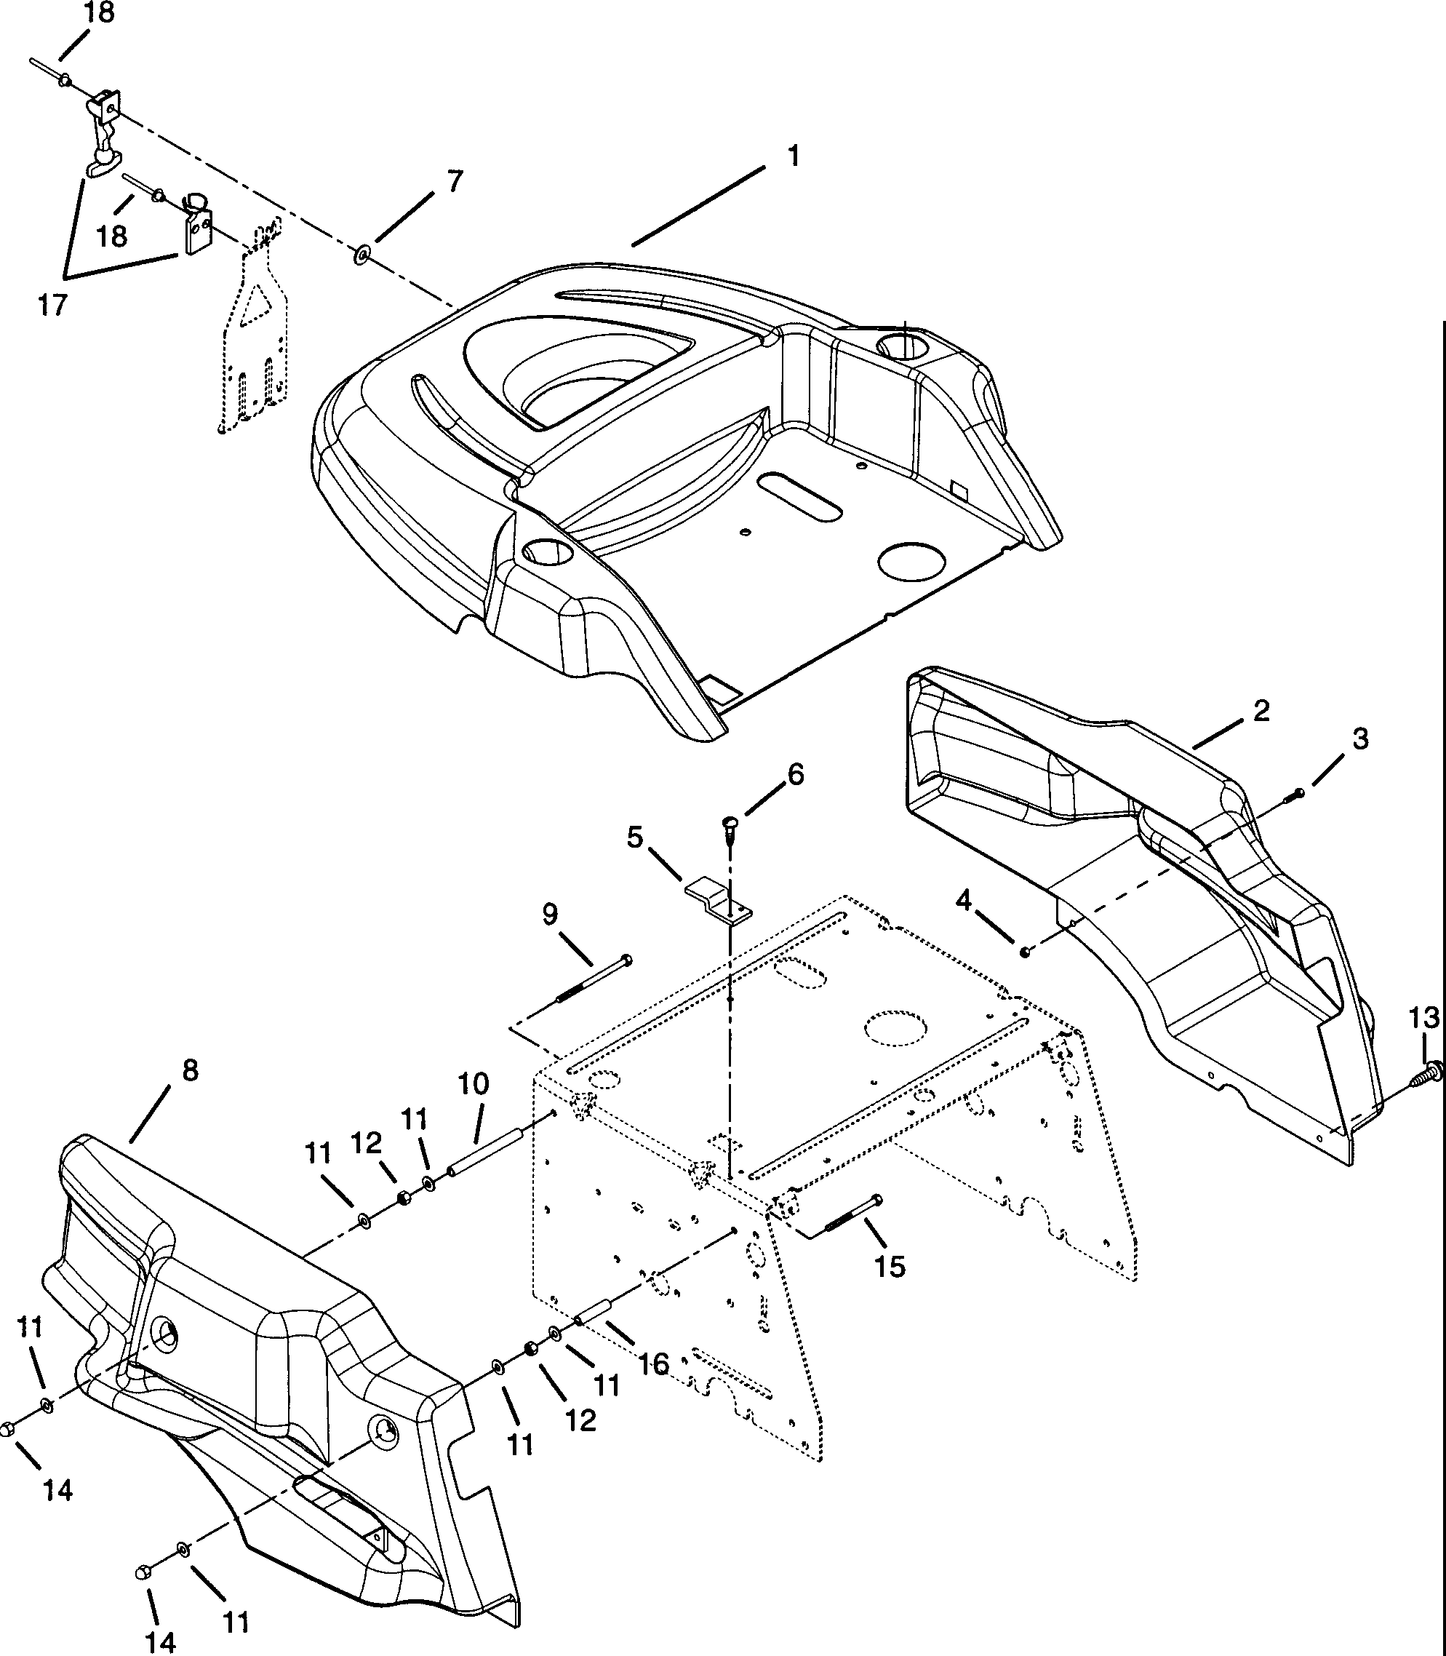§ **19**

I

PE0051

|  |  |  |  |
| --- | --- | --- | --- |
| **Item No.** | **Part No.** | Qty. | **Description** |
| 1  2  3  4  5  6  7  8  9  10  11  12  13  14  15  16  17  18  19 | 01537200  01537000  05918100  06506200  01530900  07405200  07010500  01537100  05923800  01524900  06412300  06501500  07401700  06534200  05912100  01525000  08704700  06813700  01528500 | 1  1  2  2  2  4  2  1  2  2  12  4  4  4  2  2  1  3  2 | Shroud-Top  Shroud-Side Left Hand  Bolt-Hex .31-18 x 1.00 Grade 5  Nut-Locking-Nylon .312-18 Grade 2 Clip  Screw-Tapping .25-20 x .50  Rivet-Burr .125 x .505 x .048 Shroud-Side Right Hand  Bolt-Hex .31-18 x 5.50 Grade 5 Spacer  Washer-Flat-Steel .344 x .688 x .065  Nut-Hex .312-18 Grade 2  Screw-Tapping-Hex Washer Head .312-18 x .75 Nut .31-18 Low Crown  Bolt-Hex .31-18 x 3.00 Grade 5 Spacer  Latch-Flexible Blind Rivet Cupholder |

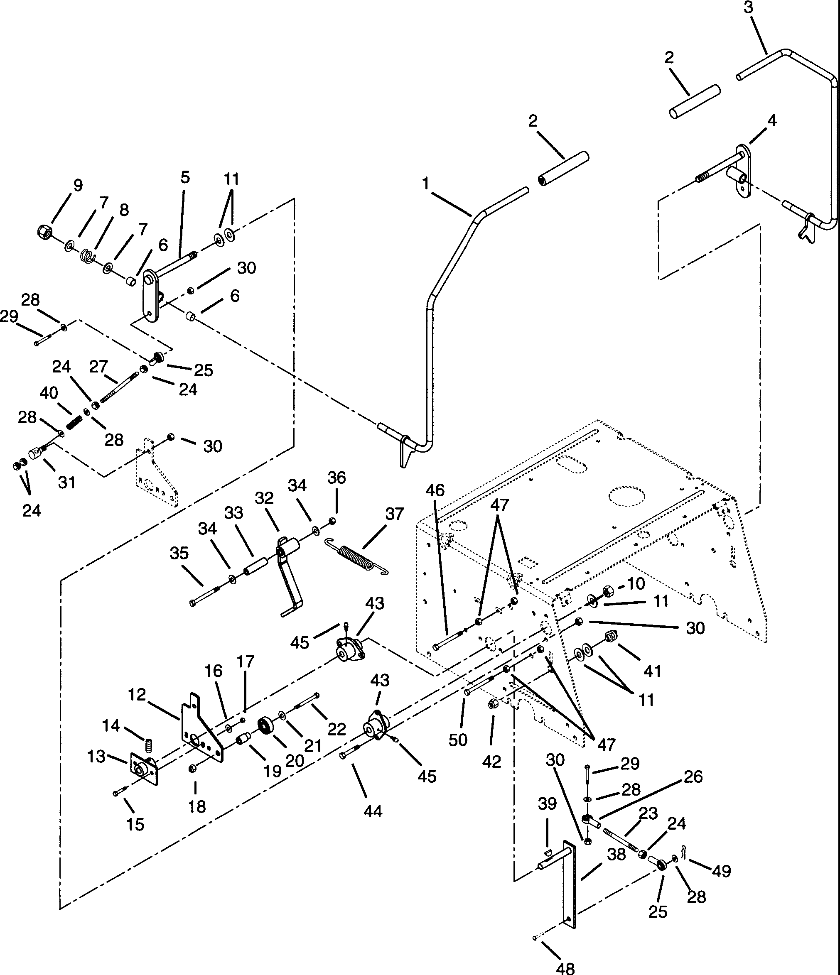

PE0101

|  |  |  |  |
| --- | --- | --- | --- |
| **Item No.** | **Part No.** | **Qty.** | **Description** |
| 1  2  3  4  5  6  7  8  9  10  11  12  13  14  15  16  17  18  19  20  21  22  23  24  25  26  27  28  29  30  31  32  33  34  35  36  37  38  39  **40**  **41**  **42**  **43**  **44**  **45**  46  47  48  49  50 | 01520800  01522200  01520900  01530700  01530600  00510500  00515700  00516200  06519700  06516400  06412000  09103100  01525500  06000800  05908200  06412700  06506600  06513500  09107200  05407900  06404300  05914700  01520500  06503100  08960700  09107800  01536000  06412300  05913400  06506200  01536100  09107400  08831500  06404300  05916000  06513500  08320200  01520600  06608600  **08333400**  **01526100**  **07015100**  **01522000**  **05918100**  **07012600**  05935200  06501800  06811800  06702000  05916000 | 1  2  1  1  1  4  4  2  3  2  10  2  2  2  4  4  4  2  2  2  2  2  1  10  4  2  2  8  2  14  2  2  2  4  2  2  2  2  2  2  2  2  4  4  4  2  8  2  2  2 | Right Hand Steer-Control Lever Grip  Weldment-Lever Left Hand Weldment-Rod Left Hand Weldment-Tube Right Hand Bushing-Nylon .5 x .625 x .5  Washer-Plastic .12 x .53 x 1.12 Spring-Compression  Nut-Locking-Center .500-13  Nut-Locking-Nylon .50-20  Washer-Flat-Steel .563 x 1.375 x .109 Arm-Speed Control  Arm-Speed Control Screw-Set .25-20 x .38  Bolt-Hex .25-20 x .75 Grade 5  Washer-Flat-Steel .281 x .620 x .065  Nut-Locking-Nylon .250-20 Grade 2  Nut-Locking-Nylon .375-16 Grade 2 Hub-Bearing Mount  Bearing-Ball .500 x 1.375 x .437  Washer-Flat-Steel .406 x .812 x .065  Bolt-Hex .38-16 x 2.00 Grade 5  Rod Transmission Control Right Hand Nut .312-24  Rod End-5/16" Female  Rod End-5/16-24 Left Hand, Female Rod  Washer-Flat-Steel .344 x .688 x .065  Bolt-Hex .31-18 x 1.25 Grade 5  Nut-Locking-Nylon .312-18 Grade 2 Rod Pivot  Weldment-Neutral Detent  Bushing-Sleeve .385 x .610 x 1.80  Washer-Flat-Steel .406 x .812 x .065  Bolt-Hex .38-16 x 2.75 Grade 5  Nut-Locking-Nylon .375-16 Grade 2  Spring-Tension .085 x .60 x 5.13 Weldment-Pump Control  Key-Woodruff .13 x .75 Spring  Switch-Neutral  Nut-Stamped .56-18 Bushing-Flanged  Bolt-Hex .31-18 x 1.00 Grade 5  Fitting-Lube .25-28 x .256  Bolt-Hex .38-16 x 3.00  Nut-Hex .375-16 Grade 2  Pin-Clevis .312 x .822  Pin-Hair Internal .08 x .18 x 1.18  Bolt-Hex .375-16 x 2.75 |

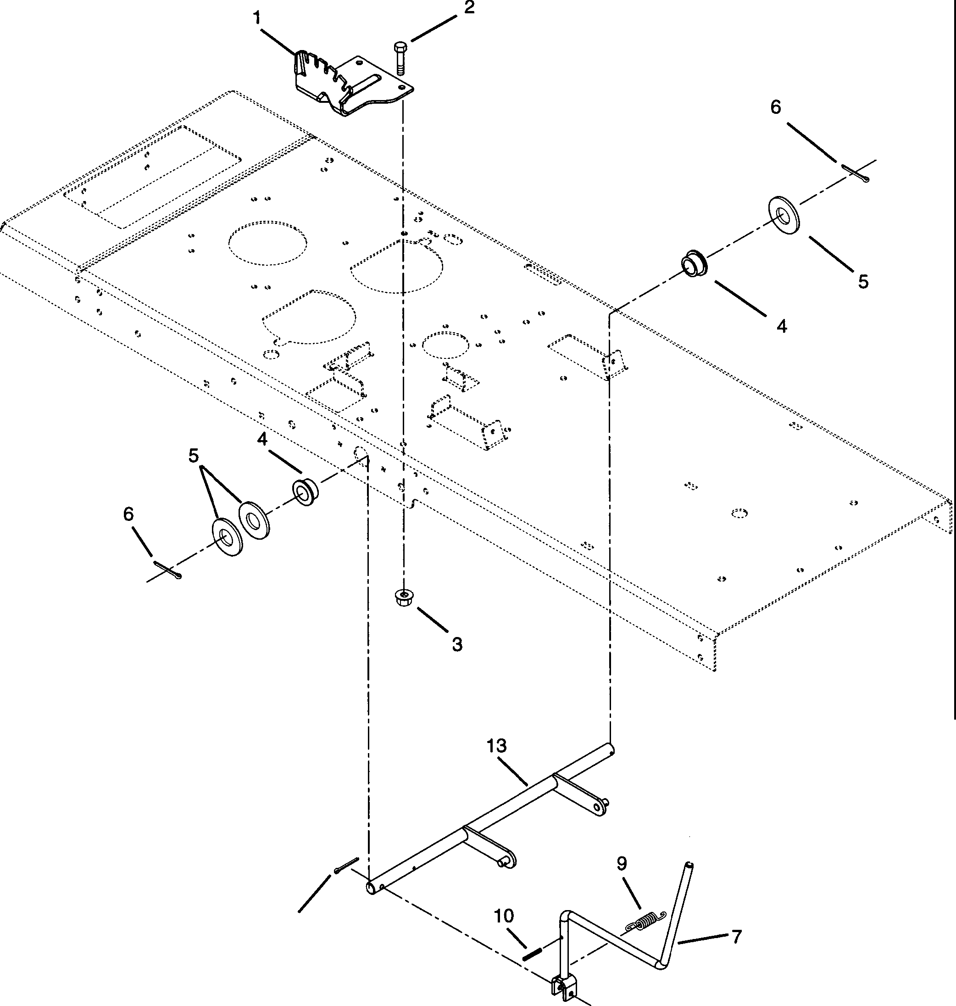*u--8*

12

*I�*

11

PE0151

|  |  |  |  |
| --- | --- | --- | --- |
| **Item No.** | **Part No.** | **Qty.** | **Description** |
| 1  2  3  4  5  6  7  8  9  10  11  12  13 | 01530800  05914500  06503900  05520100  06430000  06704900  01532000  07527500  08322900  05800600  06813300  06700400  01527500 | 1  2  2  2  3  2  1  1  1  1  1  1  1 | Detent Plate  Bolt-Hex .38-16 x 1.00 Grade 5  Nut-Locking .375-16  Bushing-Flange 1.020 x 1.385 x .75 x 1.75  Washer-Flat-Steel 1.062 x 2.000 x .134  Pin-Cotter .188 x 1.50 Lift Lever Weldment Grip  Spring-Tension .120 x 1.0 x 4.46  Pin-Roll .250 x 1.00 Clevis Pin  Pin-Cotter .12 x 1.0 Lift Shaft Weldment |

/2

4 '

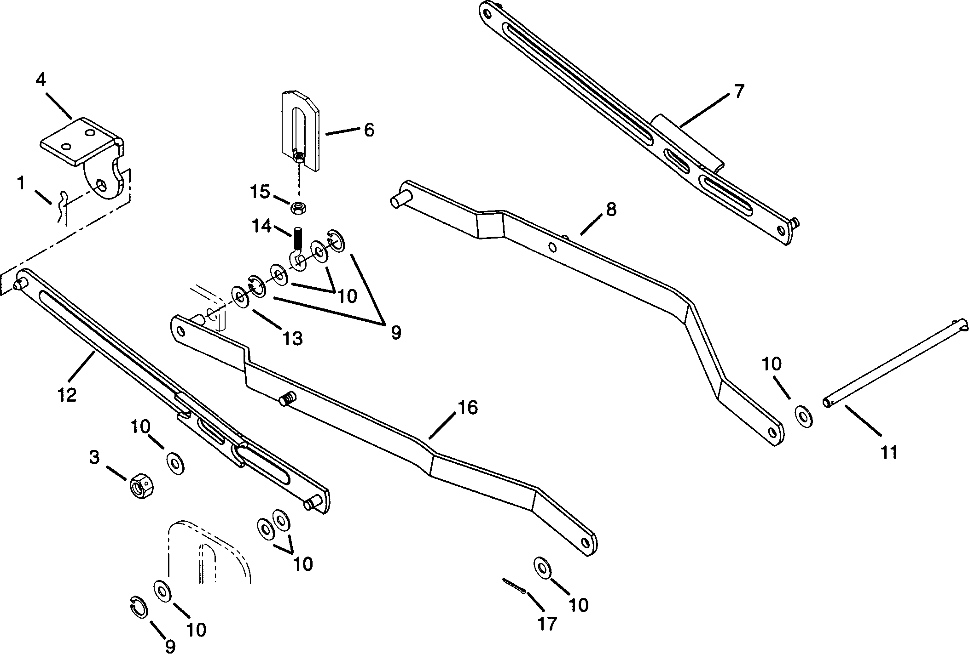

5---N

PE0111

|  |  |  |  |
| --- | --- | --- | --- |
| **Item No.** | **Part No.** | **Qty.** | **Description** |
| 1 | **06703700** | 2 | Pin-Hair External .12 x .31 x 2.37 |
| 2 | **05914500** | 4 | Bolt-Hex .38-16 x 1.00 Grade 5 |
| 3 | **06526700** | 2 | Nut-Locking-Center .625-11 Grade 2 |
| 4 | **01519500** | 2 | Left Hand-Rear Hanger |
| 5 | **06513500** | 4 | Nut-Locking-Nylon .375-16 Grade 2 |
| 6 | **03486400** | 2 | Adjuster Link |
| 7 | **01534900** | 1 | Rear Hanger-Left Hand |
| 8 | **01534700** | 1 | Left Hand-Lift Arm |
| 9 | **05717100** | 6 | Ring-Retaining-External .500 x .050 |
| 10 | **06400400** | **14** | Washer-Flat-Steel .656 x .312 x .095 |
| **11** | **01535900** | 1 | Pin |
| **12** | **01535000** | 1 | Rear Hanger-Right Hand |
| **13** | **06420100** | 2 | **Washer-Flat-Steel.531 x 1.250 x.100** |
| **14** | **03624500** | 2 | Hanger (004,005,006,303) |
|  | **07030000** | 2 | Hanger (007,302) |
| **15** | **06500100** | 2 | Nut-Jam .375-16 |
| **16** | **01534800** | 1 | Right Hand-Lift Arm |
| **17** | **06700400** | 1 | Pin-Cotter .12 x 1.0 |

20

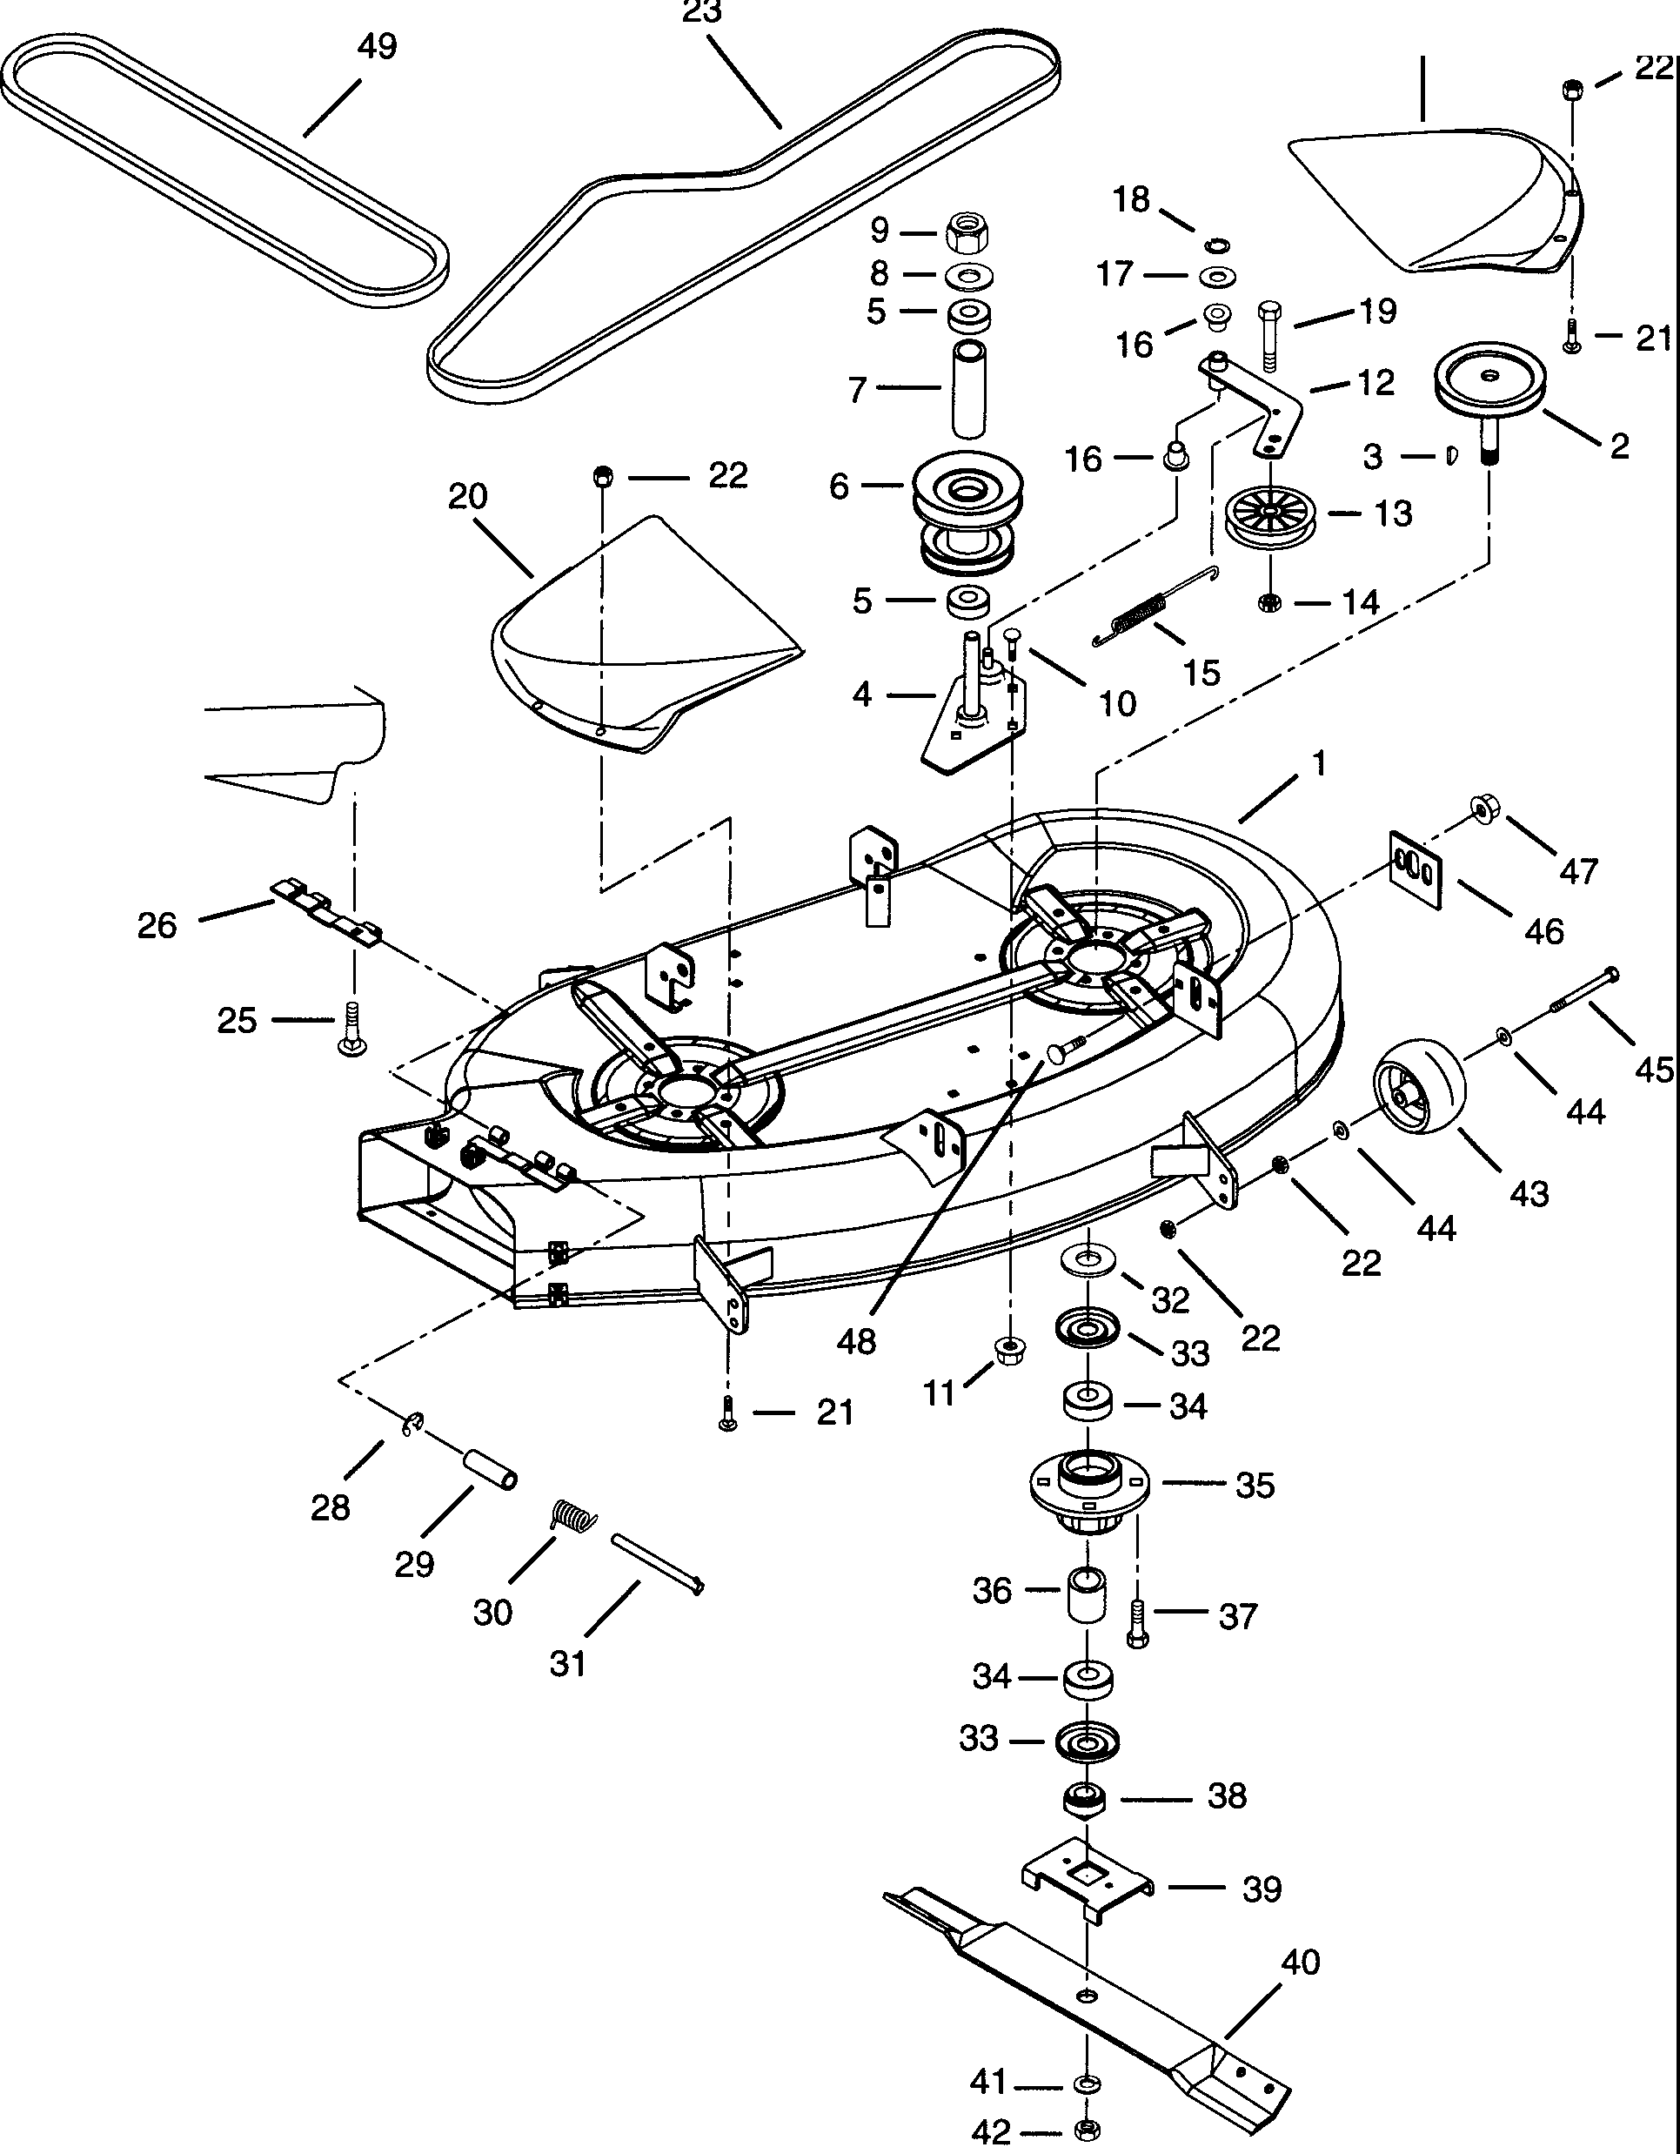

I

24 27

"

- *1*

"==.

## I

PE0131

**Models 915004,005,006,303**

|  |  |  |  |
| --- | --- | --- | --- |
| **Item Ne** | . **Part No.** | **Qty.** | **Description** |
| 1  2  3  4  5  6  7  8  9  10  11  12  13  14  15  16  17  **18**  **19**  **20**  21  **22**  **23**  **24**  **25**  **26**  **27**  **28**  **29**  **30**  **31**  **32**  **33**  **34**  **35**  **36**  **37**  **38**  **39**  **40**  **41**  **42**  **43**  **44**  45  46  47  48  49 | 51500100  51500200  03615400  03615300  06604200  03624900  05403900  03602200  03615500  06421200  06507700  06203300  06507800  01517500  07309300  06512200  08329000  05506300  06405600  **05710200**  **05915100**  **01520100**  **06202900**  **06503900**  **07212800**  **07234200**  **03609800**  **06205300**  **02709500**  **06505600**  **05706300**  **02202900**  **08307200**  **03624200**  **06408800**  **00341900**  **05412000**  **03625000**  **02526400**  **05914500**  **03037500**  **03485500**  **03624700**  **03611100**  **06300800**  **06502500**  **02745400**  **06400200**  05920800  01528700  06507800  06204100  07212300  07234200 | 1  1  1  1  2  1  2  1  1  1  1  4  4  1  1  1  1  2  1  1  1  2  11  **17**  **1**  1  1  2  1  2  1  1  1  1  2  4  4  2  2  3  2  2  2  2  2  2  4  8  4  2  4  4  1  1 | 40" Mower Deck w/Decals  40" Mower Deck Assembly Complete Left Spindle Sheave  Right Spindle Sheave  Key-Woodruff .188 x .625 x .31  Mount Plate 40"  Bearing-Ball .625 x 1.375 x .44 Jackshaft Pulley  Spacer .640 x .880 x 2.768  Washer-Flat-Steel .640 x 1.005 x .062  Nut-Locking-Nylon .658-18  Bolt-Round Head Square Neck .31-18 x .62 Nut-Flange .312-18  Idler Assembly Idler Arm  Nut-Locking Top .375-16  Spring-Tension .113 x .812 x 7.000  Bushing-Flange .500 x .625 x .187 x .750  Washer-Flat-Steel .505 x .880 x .072  Ring-Retaining-External .500 x .042  Bolt-Hex .38-16 x 1.50 Grade 5 Cover  Bolt-Round Head Square **Neck** .38-16 x 1.0 Nut-Locking .375-16  **V-Belt 4L-Section 63.1 x 17/32**  **V-Belt 4L-Section 63.1 x 17/32(515018)**  40 In Deflector  Bolt-Round Head Square **Neck** .25-20 x .50 Hinge Plate  Nut-Locking-Flange .250-20  Ring-Retaining-External .313 x .025 Bushing  Spring-Torsion .095 x .50 x 1.0 Pin  Washer-Flat-Steel .755 x 1.250 x .125 Bearing Slinger  Bearing-Ball .750 x 1.781 x .61 Sprindle Housing  Spacer .751 x 1.000 x 1.140  Bolt-Hex .38-16 x 1.00 Grade 5 Retainer Hub  Blade Tray 48  **Blade(004,005,006)**  Blade (303)  Washer-Lock .750 x .188  Nut-Jam .75-10 Roller  Washer-Flat-Steel .38 x .875 x .083  Bolt-Hex .38-16 x 3.50 Grade 5 Mower Adjustment Tab  Nut-Flange .312-18  Bolt-Round Head Square Neck .31-18 x .75 V-Belt 4L-Section 52-19/32 x 17/32  V-Belt 4L-Section 52-19/32 x 17/52 (515018) |

**Models 915007,302**

**4811 MOWER SPINDLE**

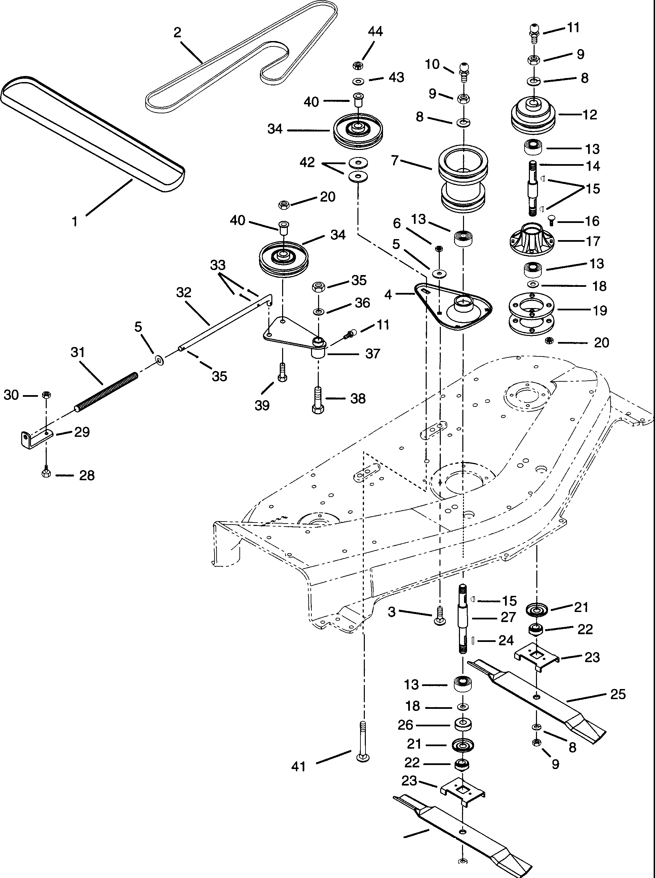25

#### s--

9-

PE0181

|  |  |  |  |
| --- | --- | --- | --- |
| **Item No.** | **Part No.** | **Qty.** | **Description** |
| 1 | 07233200 | 1 | Belt |
|  | 07234500 | 1 | 48" Clutch to Deck Belt (515019) |
| 2 | 07208100 | 1 | V-Belt 4L-Section 105.6 x 12 |
| 3 | **06201900** | 5 | Bolt-Round Head Square Neck .38-16 x .62 |
| 4 | **03434900** | 1 | Housing-Spindle |
| 5 | **06404300** | 2 | **Washer-Flat-Steel.406 x.812 x.065** |
| 6 | **06503900** | 5 | Nut-Locking .375-16 |
| 7 | **03446800** | 1 | Sheave |
|  | **01543300** | 1 | 48" Deck Sheave (515019) |
| 8 | **06300800** | 6 | Washer-Lock .750 x .188 |
| 9 | **06502500** | 6 | Nut-Jam .75-10 |
| **10** | **07012500** | 1 | Fitting-Lube .125 |
| **11** | **07012600** | 3 | **Fitting-Lube .25-28 x.256** |
| **12** | **03401800** | 2 | Sheave |
| **13** | **05412000** | 6 | Bearing-Ball .750 x 1.781 x .61 |
| **14** | **53115100** | 2 | Spindle Shaft w/Zerk |
| **15** | **06601400** | 5 | Key-Woodruff .188 x .62 x .25 |
| **16** | **06203500** | 8 | Bolt-Round Head Square Neck .38-16 x .75 |
| **17** | **03433500** | 2 | Spindle Housing |
| **18** | **06404100** | 5 | **Washer-Flat-Steel.754 x 1.000 x.032** |
| **19** | **03433600** | 4 | Spacer-Spindle |
| **20** | **06506000** | 9 | Nut-Locking-Jam-Center .375-16 |
| **21** | **00341900** | 3 | Bearing Slinger |
| **22** | **03037500** | 3 | Retainer Hub |
| **23** | **03485500** | 3 | Blade Tray 48 |
| **24** | **06601700** | 1 | Key-Square .188 x .625 x .188 |
| **25** | **03123759** | 3 | Blade |
| **26** | **06408800** | 1 | Washer-Flat-Steel .755 x 1.250 x .125 |
| 27 | 53402400 | 1 | Spindle Shaft w/Zerk & Key |
| 28 | 05916800 | 1 | Bolt-Hex .31-18 x .50 Grade 5 |
| 29 | 03418800 | 1 | Bracket |
| 30 | 06504200 | 1 | Nut-Locking .312-18 |
| 31 | 08301800 | 1 | Spring-Compression .106 x .63 x 12.0 |
| 32 | 03433900 | 1 | Rod-Idler Spring |
| 33 | 06700100 | 4 | Pin-Cotter .09 x .75 |
| 34 | 00542700 | 2 | Idler-Plastic 4.75 OD x .50 ID |
| 35 | 06504600 | 1 | Nut-Locking-Center .50-13 |
| 36 | 06405600 | 1 | Washer-Flat-Steel .505 x .880 x .072 |
| 37 | 53401000 | 1 | Idler Arm w/Zerk |
| 38 | 05901000 | 1 | Bolt-Hex .50-13 x 1.50 Grade 2 |
| 39 | 07006300 | 1 | Bolt-Button Head .38-16 x 1.25 Grade 5 |
| 40 | 03114500 | 2 | Spacer-Flanged .390 x .500 x .781 x .875 |
| 41 | 06217900 | 1 | Bolt-Round Head Square Neck .38-16 x 2.00 |
| 42 | 06424800 | 2 | Washer-Hardened-Throttle .390 x 1.50 x 1.25 |
| 43 | 06400200 | 1 | Washer-Flat-Steel .38 x .875 x .083 |
| 44 | 06513500 | 1 | Nut-Locking-Nylon .375-16 Grade 2 |

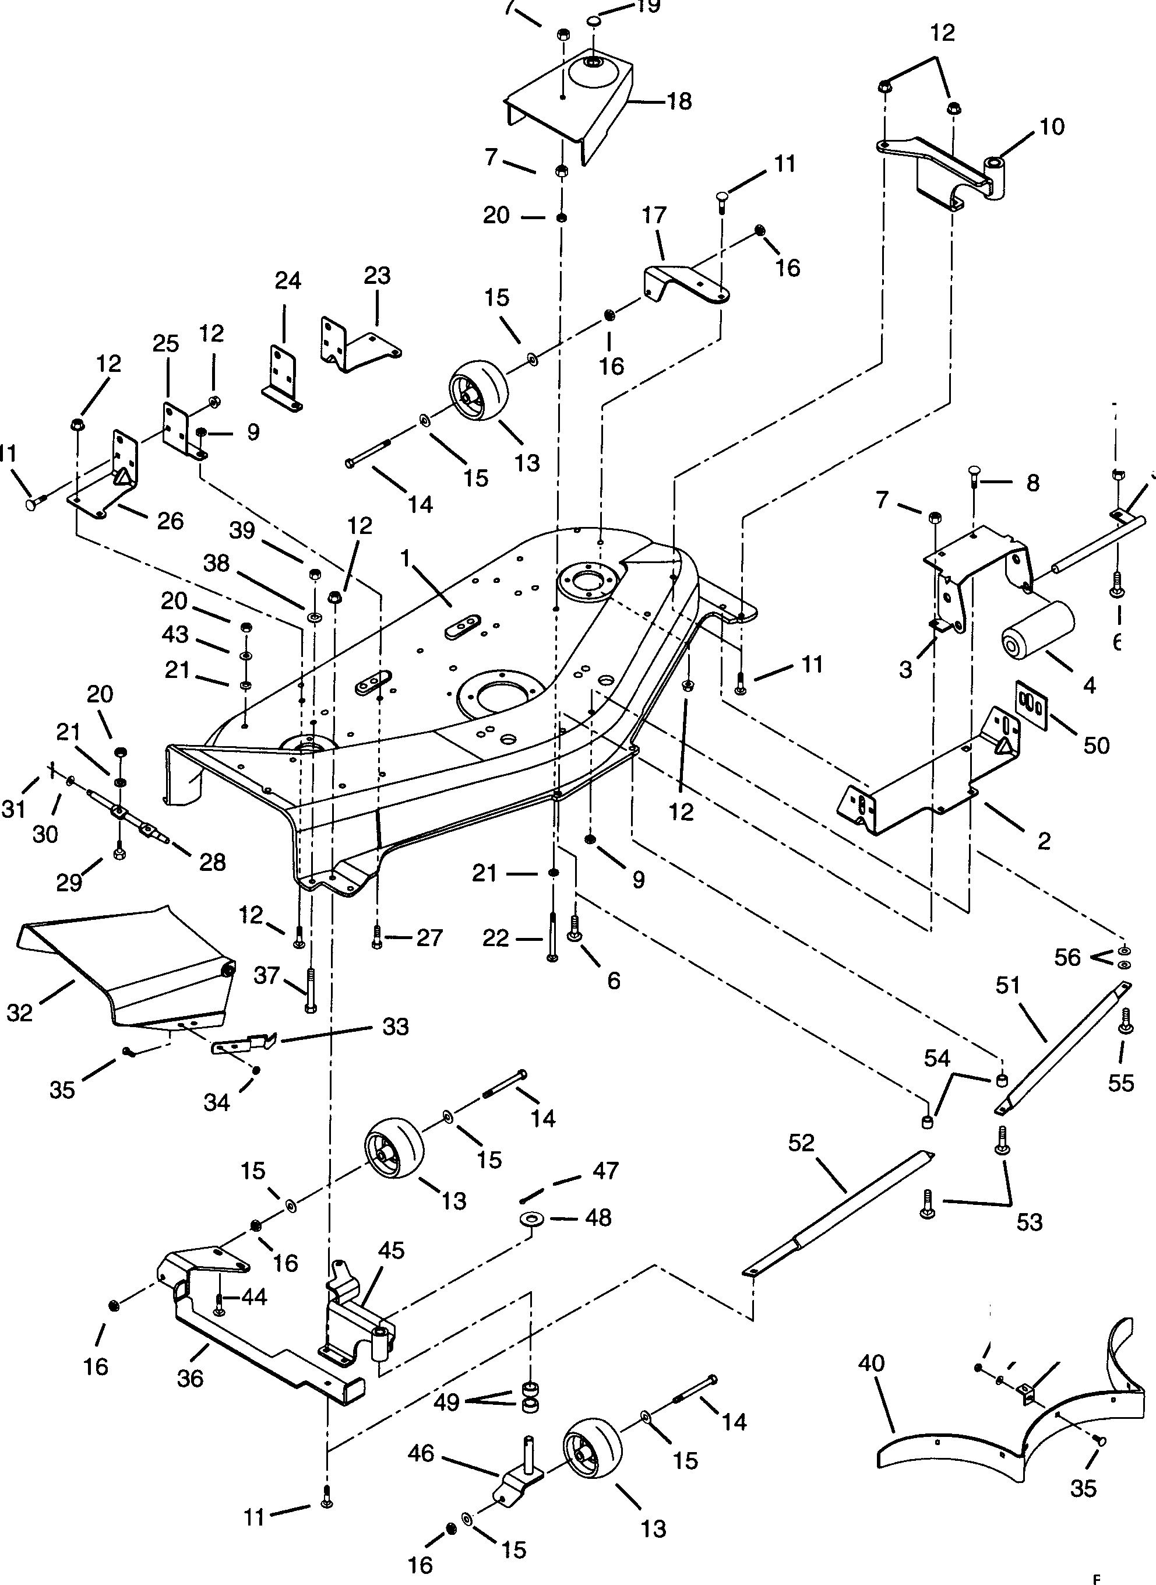 

**Models 915007,302**

7

I

5

###### I

6

34 42

/ / 41

**'s.....**

PE0191

|  |  |  |  |
| --- | --- | --- | --- |
| **Item Ne** | . **Part No.** | **Qty.** | **Description** |
| 1  2  3  4  5  6  7  8  9  10  11  12  13  14  15  16  17  18  19  20  21  22  23  24  25  26  27  28  29  30  31  32  33  34  35  36  37  38  39  40  41  42  43  44  45  46  47  48  49  50  51  52  53  54  55  56 | 53401700  01521200  03435100  03114100  03435200  06201100  06504200  06208300  06512900  01535600  06204100  06204100  06507800  02745400  05920800  06400200  06503900  01535300  03482300  03482400  07504000  06501500  06300300  06208700  01521500  01521600  01521400  01521300  05930000  03405800  05913500  06404300  06700100  03034900  00318500  06504000  06205300  01535400  05921600  06300400  06501800  03434259  03434300  06412700  06400700  06201500  01535500  01534600  06700600  06403900  05504700  01528700  03667200  03667300  06202300  01529600  06215900  06414500 | 1  1  1  1  1  2  9  2  3  1  10  9  10  4  4  8  6  1  1  1  2  6  6  2  1  1  1  1  1  1  2  1  1  1  1  9  9  1  1  1  1  1  7  7  2  2  1  2  2  2  4  2  1  1  2  2  1  2 | Mower Pan Head w/Decals 48" Front Hanger  Bracket-Roller Roller  Roller Shaft  Bolt-Round Head Square Neck .31-18 x .75 Grade 5 (007)  Nut-Locking .312-18  Bolt-Round Head Square Neck .50-13 x .75 Nut-Locking-Nylon .50-13 Grade 5 Weldment-Left Front  Bolt-Round Head Square Neck .31-18 x .75 (007)  Bolt-Round Head Square Neck .31-18 x .75 (302)  Nut-Flange .312-18 Roller  Bolt-Hex .38-16 x 3.50 Grade 5  Washer-Flat-Steel .38 x .875 x .083  Nut-Locking .375-16 Bracket-Left Rear  Belt Cover Right Hand 48" Belt Cover Left Hand 48" Button Plug 1.0  Nut-Locking .312-18 Grade 2  Washer-Lock .312 x .097  Bolt-Round Head Square Neck .31-18 x 3.25 Left Hand Rear Hanger  Left Hand Rear Hanger Support Right Hand Rear Hanger Support Right Hand Rear Hanger  Bolt-Hex .50-13 x 1 Grade 5 Hinge Pin  Bolt-Hex .31 x .75 Grade 5  Washer-Flat-Steel .406 x .812 x .065  Pin-Cotter .09 x .75 Chute Extension Flat Spring  Nut-Locking-Center .250-20  Bolt-Round Head Square Neck .25-20 x .50 Weldment-Right Rear  Bolt-Hex .38-16 x 2.50 Grade 2  Washer-Lock .375 x .155  Nut-Hex .375-16 Grade 2 Baffle  Baffle Tab  Washer-Flat-Steel .281 x .620 x .065  Washer-Flat-Steel .312 x .734 x .065  Bolt-Round Head Square Neck .312-18 x 1.00 Weldment-Right Front  Caster Fork Weldment Pin-Cotter .18 x 1.25  Washer-Flat-Steel .630 x 1.00 x .062  Bushing-Sleeve .625 x .750 x .500 Mower Adjustment Tab  Guard-Foot-Left Hand (302)  Guard-Foot-Right Hand (302)  Bolt-Round Head Square Neck .31-18 x 1.50 (302)  Spacer .375 x .688 x .500 (302)  Bolt-Round Head Square Neck .31-18 x 1.25 (302)  Washer-Flat-Steel .390 x .750 x .125 (302) |

**Models 915004,005,006,007,302,303,304**

The diagrams below show the various states of connection for electrical components. The solid lines on switches show continuity.

**NOTE:** All switches are viewed from the rear.

|  |  |  |  |
| --- | --- | --- | --- |
| **Key Switch**  (03602300)    OFF RUN | START | **Relay**  (03042800}  =87    NOT ENERGIZED | 87  0s 0':f'f:' 85  30n  LI  ENERGIZED |
| **PTO Switch**  (00522100)  3 9  [HJ  m  4 1 7  DISENGAGED  (down position) | 3 9  D D  [HJ D  4 1 7  ENGAGED  (up position) | **Neutral Switch**  (01526100)  STEERING LEVER IN POSITION  (button up) | STEERING LEVER OUT POSITION  (button down) |
| **Seat Switch** |  | **Brake Switch**  (03657100)    DISENGAGED  (button down) | ENGAGED  (button up)  PE0210 |
| (03654200) |  |
| IT] | [8] |
| OPERATOR | OPERATOR |
| OFF SEAT | ON SEAT |

Models 915004,303

BLACK

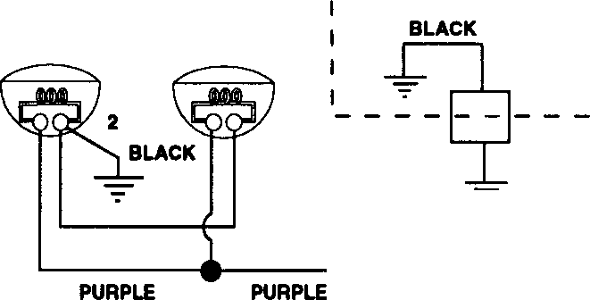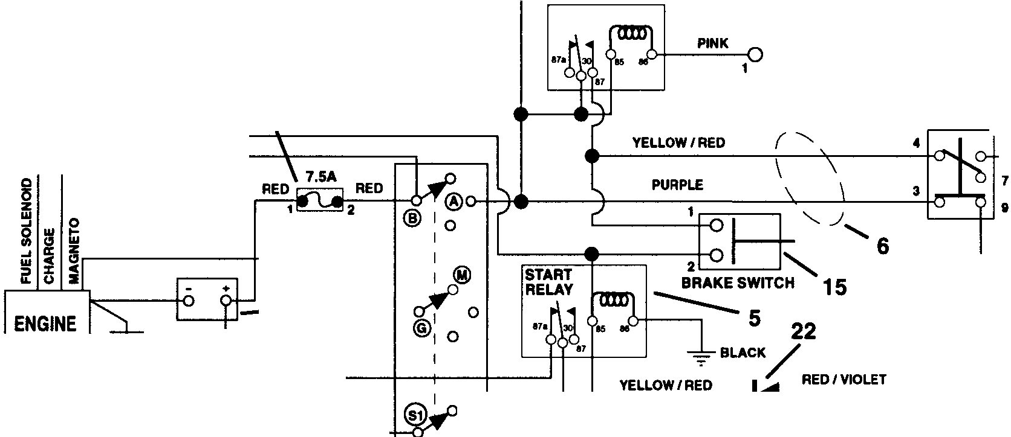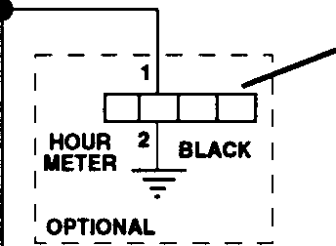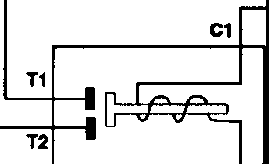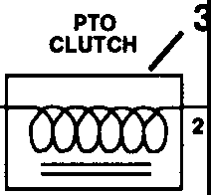

- 7

13

PURPLE

PURPLE

SEAT RELAY/ 5

SEAT SWITCH

_,l_/

12

I OPTIONAL JI

YELLOW/ RED 16

RED

BLACK

PTO **g**

SWITCH/

1 PURPLE / WHITE

WHITE/ BLACK

8

14

>-S-TAA-T-ER....-,

-=::-- ~11

BLACK

RED

-1

21

BROWN

:IL:;:

BROWN/ YELLOW

**WHITE**

RED

\

7

21

L---

KEY

4,17,18,19,20

RIGHTHAND NEUTRAL SWITCH

*I*

10

SWITCH

C2

|  |  |  |  |
| --- | --- | --- | --- |
| 0 | BLACK | RED/VIOLET |  |
|  |  | | 1 |
|  | | | <**2** |

BLACK

PEOOB2

|  |  |  |  |
| --- | --- | --- | --- |
| **Item No.** | **Part No.** | **Qty.** | **Description** |
| 1 | 08987000 | 1 | Cable-Battery to Solenoid |
| 2 | 01526100 | 2 | Switch-Neutral |
| 3 | 03601800 | 1 | Electric Clutch/Brake |
| 4 | 03602300 | 1 | Key Switch |
| 5 | 03042800 | 2 | Relay |
| 6 | 01536500 | 1 | Wire Harness 1440 |
| 7 | 00145900 | 1 | Start Cable 6.75" |
| 8 | 03621100 | 1 | Battery w/Tube |
| 9 | 00522100 | 1 | Switch-Clutch With Retainer Ring |
| 10 | 03057700 | 1 | Solenoid |
| 11 | 03111100 | 1 | Ground Cable |
| 12 | 03654200 | 1 | Switch-Seat |
| 13 | 03492700 | 1 | Hour Meter (Optional) |
| 15 | 03657100 | 1 | Switch-Brake |
| 14 | 02530700 | 1 | Rubber Pad |
| 15 | 03657100 | 1 | Switch-Brake |
| 16 |  | 1 | 7.5AMP Fuse |
| 17 | 02460700 | 1 | Key-w/Cap |
| 18 | 07517700 | 1 | Cap-Ignition Switch |
| 19 | 06517400 | 1 | Nut-Panel .562-24 |
| 20 | 06302900 | 1 | Washer-Lock Internal .563 x .040 |
| 21 | 03384700 | 4 | Boot-Insulator |
| 22 | 03081200 | 1 | Diode |

Models 915007,302

-----------7 13

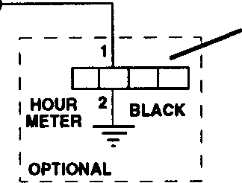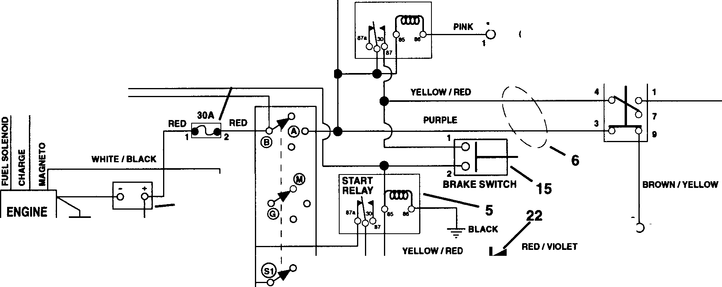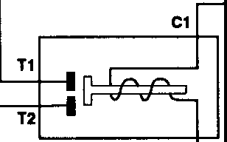

I

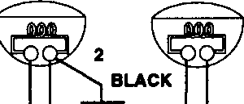!_ --

OPTIONAL

PURPLE PURPLE

PURPLE

PURPLE

SEAT RELAY/ 5

I

I

SEAT SWITCH

###### _L/

**12**

I_ ,

YELLOW/ RED **16**

RED

BLACK

PTO **g**

SWITCH/

3

' '-

PTO CLUTCH

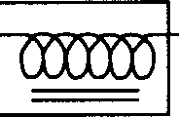BLACK

STARTER

\

RED

B C;-11

RED

**8**

14

BROWN

-

**KEY**

SWITCH

**4,17,18,19,20**

:I

WHITE

|  |  |  |  |
| --- | --- | --- | --- |
| 0 | BLACK | RED/VIOLET |  |
|  | , | | 1 |
|  | | | <  **2** |

L:JJi!f

RIGHTHAND NEUTRAL SWITCH

7 *I* C2

21 **10**

**BLACK** PE0091

|  |  |  |  |
| --- | --- | --- | --- |
| **Item No.** | **Part No.** | Qty. | **Description** |
| 1 | 08987000 | 1 | Cable-Battery to Solenoid |
| 2 | 01526100 | 2 | Switch-Neutral |
| 3 | 03357900 | 1 | Clutch-Electric |
| 4 | 03602300 | 1 | Key Switch |
| 5 | 03042800 | 2 | Relay |
| 6 | 01536800 | 1 | Wire Harness 1648 |
| 7 | 02743300 | 1 | Start Cable 22" |
| 8 | 03621100 | 1 | Battery w/Tube |
| 9 | 00522100 | 1 | Switch-Clutch With Retainer Ring |
| 10 | 03057700 | 1 | Solenoid |
| 11 | 03111100 | 1 | Ground Cable |
| 12 | 03654200 | 1 | Switch-Seat |
| 13 | 03492700 | 1 | Hour Meter (Optional) |
| 14 | 02530700 | 1 | Rubber Pad |
| 15 | 03657100 | 1 | Switch-Brake |
| 16 |  | 1 | 30AMP Fuse |
| 17 | 02460700 | 1 | Key-w/Cap |
| 18 | 07517700 | 1 | Cap - Ignition Switch |
| 19 | 06517400 | 1 | Nut-Panel .562 x .040 |
| 20 | 06302900 | 1 | Washer-Lock Internal .563 x .040 |
| 21 | 03384700 | 4 | Boot-Insulator |
| 22 | 03081200 | 1 | Diode |

- 7

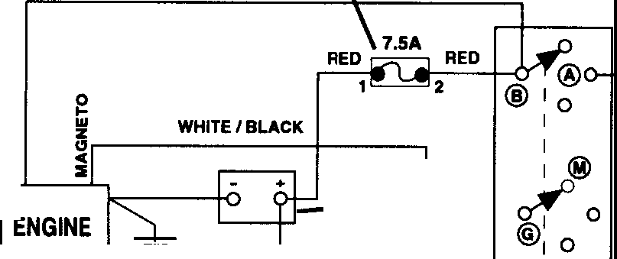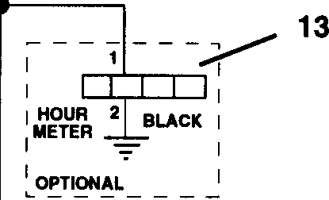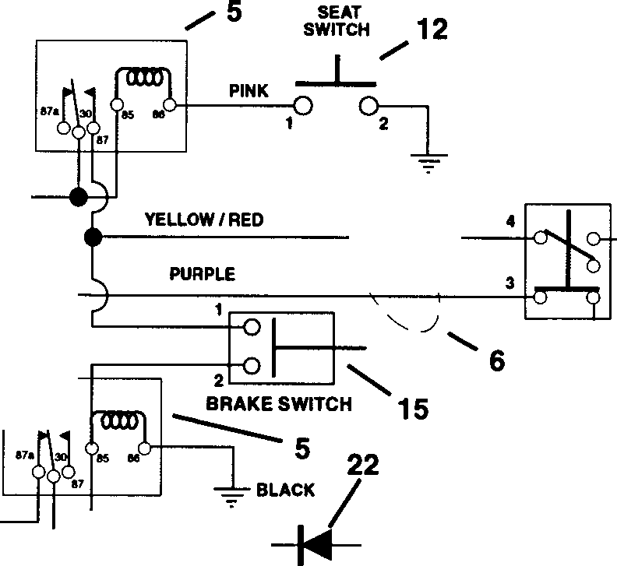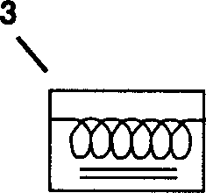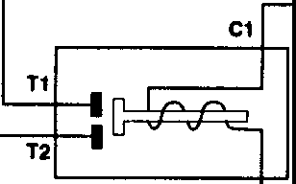

Model 915005

PURPLE

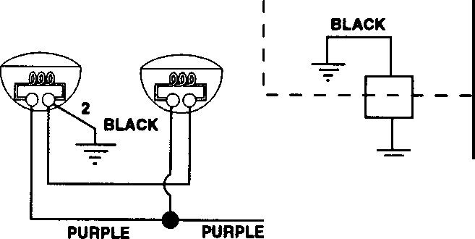

PURPLE

SEAT RELAY

I OPTIONAL JI

16

BLACK

PTO **9**

SWITCH/

PTO CLUTCH

I

w

STARTER

RED

-c;:- ... 11

BLACK

RED

8

14

-1

21

BROWN

START RELAY

0 **BLACK**

YELLOW/RED

*(* ~~-----~~

RED,<VIOLET

1 PURPLE / WHITE

7

**9**

BROWN/YELLOW

I

**L** LEFTHAND

2

I

N:: iL

1

BLACK

RED

\ *I* C2

0--+------R-ED/-VIO-LET-----

**-KE-Y '4,17,18,19,20**

@

**SWITCH**

**2** WHITE

1

2

RIGHTHAND NEUTRAL SWITCH

7 **10**

**21**

**BLACK**

PE0072

|  |  |  |  |
| --- | --- | --- | --- |
| **Item No.** | **Part No.** | **Qty.** | **Description** |
| 1 | 08987000 | 1 | Cable-Battery to Solenoid |
| 2 | 01526100 | 2 | Switch-Neutral |
| 3 | 03357900 | 1 | Clutch-Electric |
| 4 | 03602300 | 1 | Key Switch |
| 5 | 03042800 | 2 | Relay |
| 6 | 01536600 | 1 | Wire Harness 1540 |
| 7 | 02743300 | 1 | Start Cable 22" |
| 8 | 03621100 | 1 | Battery wff ube |
| 9 | 00522100 | 1 | Switch-Clutch With Retainer Ring |
| 10 | 03057700 | 1 | Solenoid |
| 11 | 03111100 | 1 | Ground Cable |
| 12 | 03654200 | 1 | Switch-Seat |
| **13** | 03492700 | 1 | Hour Meter (Optional) |
| **14** | 02530700 | 1 | Rubber Pad |
| 15 | 03657100 | 1 | Switch-Brake |
| 16 |  | 1 | 7.5AMP Fuse |
| 17 | 02460700 | 1 | Key-w/Cap |
| 18 | 07517700 | 1 | Cap-Ignition Switch |
| **19** | 06517400 | 1 | Nut-Panel .562-24 |
| 20 | 06302900 | 1 | Washer-Lock Internal .563 x .040 |
| 21 | 03384700 | 4 | Boot-Insulator |
| 22 | 03081200 | 1 | Diode |

Model 915006

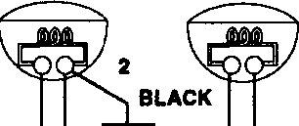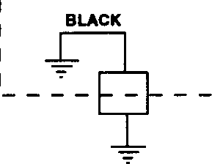

**BLACK**

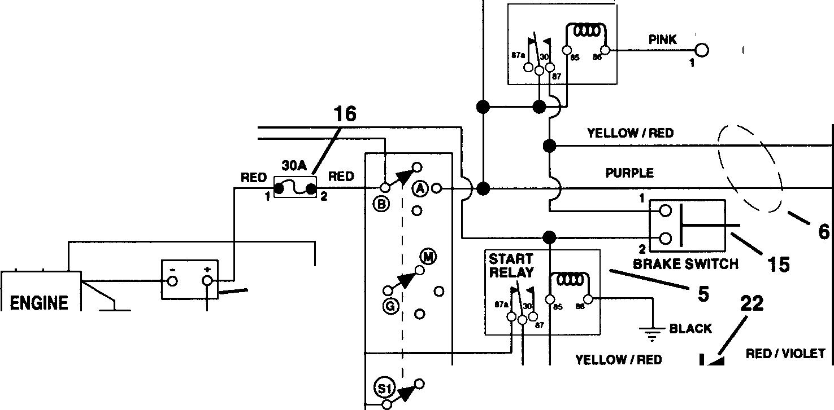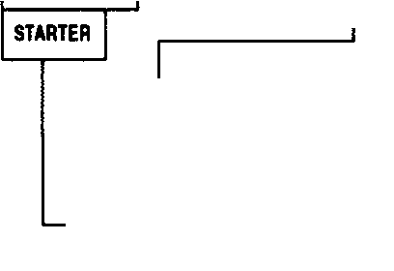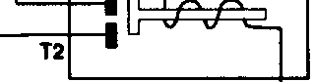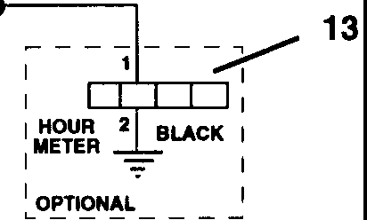

- 7

**PURPLE**

PURPLE

**SEAT RELAY/ 5**

I

SEAT SWITCH

---1.,_/

**12**

PURPLE

PURPLE

I OPTIONAL jI

YELLOW/RED

**BLACK**

**RED**

Q

0**z**

0..,. "**w**

e**w**

z

WHITE/ BLACK

i u **:I**

**w** :c **C**

"

**-=::---..11**

**BLACK**

RED

**8**

**14**

**-1**

**21**

**BROWN**

**RED**

\

7

**21**

**KEY**

SWITCH

-

**4,17,18,19,20**

*I*

**10**

C2

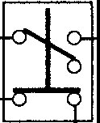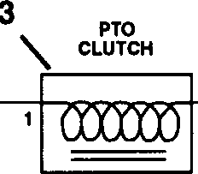

PTO **g**

SWITCH/

7

**9**

:I i£!f

**BROWN/** YELLOW

WHITE

|  |  |  |  |
| --- | --- | --- | --- |
| 0 | **BLACK** | RED/VIOLET |  |
| @ |  | | 1 |
|  | | | <2 |

RIGHTHAND NEUTRAL SWITCH

**BLACK**

PE0201

|  |  |  |  |
| --- | --- | --- | --- |
| **Item No.** | **Part No.** | **Qty.** | **Description** |
| 1 | 08987000 | 1 | Cable-Battery to Solenoid |
| 2 | 01526100 | 2 | Switch-Neutral |
| 3 | 03357900 | 1 | Clutch-Electric |
| 4 | 03602300 | 1 | Key Switch |
| 5 | 03042800 | 2 | Relay |
| 6 | 01518900 | 1 | Wire Harness 1540 |
| 7 | 02743300 | 1 | Start Cable 22" |
| 8 | 03621100 | 1 | Battery w/Tube |
| 9 | 00522100 | 1 | Switch-Clutch With Retainer Ring |
| 10 | 03057700 | 1 | Solenoid |
| 11 | 03111100 | 1 | Ground Cable |
| 12 | 03654200 | 1 | Switch-Seat |
| 13 | 03492700 | 1 | Hour Meter (Optional) |
| 14 | 02530700 | 1 | Rubber Pad |
| 15 | 03657100 | 1 | Switch-Brake |
| 16 |  | 1 | 7.5AMP Fuse |
| 17 | 02460700 | 1 | Key-w/Cap |
| 18 | 07517700 | 1 | Cap-Ignition Switch |
| 19 | 06517400 | 1 | Nut-Panel .562-24 |
| 20 | 06302900 | 1 | Washer-Lock Internal .563 x .040 |
| 21 | 03384700 | 4 | Boot-Insulator |
| 22 | 03081200 | 1 | Diode |



655 West Ryan Street• P.O. Box 157 • Brillion, WI 54110-0157 • 414-756-2141 • Fax 414-756-4421

*Ask Your Dealer For Information On These Other Fine Ariens Products*

* Front and Rear Tine Tillers
* Walk-Behind Lawn Mowers
* Zero-Turning Radius Mowers
* Rear Engine Riding Mowers
* Yard and Garden Tractors
* Commercial Walk-Behind and Riding Mowers
* Sno-Thros